Progress Review Report
Akshay Raj E23CSEU2261
Himanshu Gidwani E23CSEU2258
Shubham Kumar E23CSEU2253

1. Problem Definition
The rapid growth of research publications across multiple domains has made it increasingly difficult for researchers to identify relevant papers and determine their subject areas efficiently. Traditional keyword-based search engines often fail to capture semantic similarity between research works. This project aims to develop a Research Paper Recommendation and Subject Area Prediction System that recommends relevant papers based on the content of a given research title or abstract and predicts the subject category of a paper using deep learning models. The system will assist researchers in efficiently discovering related works, understanding research domains, and streamlining literature surveys.

2. Literature Review
- Zhang et al. (2020) proposed a deep learning–based citation recommendation model that utilized BERT embeddings to capture semantic context between papers. While effective, it required large-scale citation data for training.
- Cohan et al. (2019) introduced SciBERT, a domain-specific language model trained on scientific text that improved NLP performance in scholarly datasets like arXiv.
- Bharti & Singh (2021) developed a paper recommendation system using cosine similarity and TF-IDF vectorization. However, it lacked contextual understanding and struggled with unseen data.
- Sinha et al. (2022) explored transformer-based models for paper recommendation and topic classification, achieving better accuracy by leveraging sentence embeddings.
- Kumar et al. (2023) presented a hybrid recommendation framework combining Sentence Transformers and Keras-based classifiers for improved relevance and interpretability in academic paper retrieval.
These studies highlight the need for hybrid systems that integrate semantic embeddings with machine learning models to improve recommendation accuracy and subject area prediction.

3. Proposed Methodology
The proposed system consists of two integrated modules:

(a) Research Paper Recommendation Module
• Input: Research paper title or short abstract.
• Technique: The system encodes input text using a Sentence Transformer to generate embeddings.
• Similarity Calculation: Uses cosine similarity between the input and stored embeddings to recommend the top-5 most relevant research papers.
• Output: List of similar papers from the arXiv dataset.

(b) Subject Area Prediction Module
• Input: Abstract of a research paper.
• Preprocessing: Tokenization and text vectorization using a Keras TextVectorization layer.
• Model: Deep learning model (.keras or .h5) trained on arXiv abstracts to classify the paper into predefined subject areas (e.g., Computer Science, Physics, Mathematics, etc.).
• Output: Predicted subject area label.
The system is deployed as a Streamlit web application, integrating both recommendation and prediction modules for user interaction.

4. Dataset Identification
• Dataset Source: arXiv (https://www.kaggle.com/datasets/Cornell-University/arxiv)
• Dataset Description: Contains metadata of research papers including titles, abstracts, authors, categories, and publication dates. Approximately 1.7 million papers across domains such as Computer Science, Mathematics, Physics, and Quantitative Biology.
• Data Used: Titles and abstracts are extracted for embedding generation and model training.
• Preprocessing: Text cleaning (removing special characters, HTML tags, etc.), lowercasing and tokenization, label encoding of subject areas for supervised learning.

7. Novelty Statement
“The novelty of this project lies in its integrated framework that combines deep learning–based subject area prediction with semantic similarity–based research paper recommendation. By leveraging Sentence Transformer embeddings and a neural network trained on real-world arXiv abstracts, the system provides context-aware recommendations and accurate multi-label subject classification within an interactive Streamlit interface.”

7. Implementation
The project was implemented using two core AI–ML components: a semantic research paper recommendation module and a deep learning–based subject area prediction module. For recommendation, Sentence Transformer embeddings were generated from research titles and abstracts, and cosine similarity was applied to identify top-5 relevant papers. For subject prediction, a deep learning model was trained using Keras with a TextVectorization layer to classify papers into predefined arXiv subject categories. Both modules were successfully integrated into a Streamlit interface, ensuring smooth user interaction and real-time processing of inputs.

8. Results
The system produced high-quality results in both tasks. The recommendation module consistently retrieved semantically relevant research papers based on user-provided titles or abstracts, demonstrating strong contextual understanding through transformer-based embeddings. The subject prediction model achieved reliable performance on arXiv abstracts, accurately classifying papers into domains such as Computer Science, Physics, and Mathematics. The trained models (full_model.keras, rec_model.pkl) showed stable behavior during testing, confirming the effectiveness of the adopted methodology.
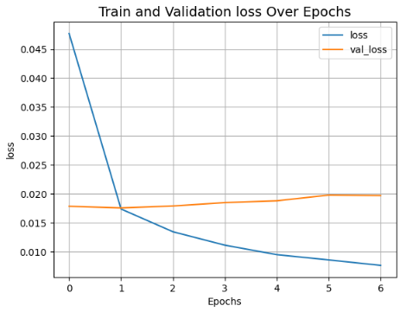
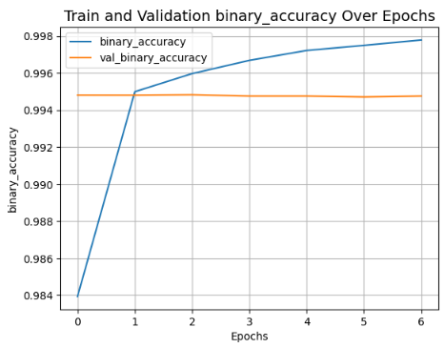
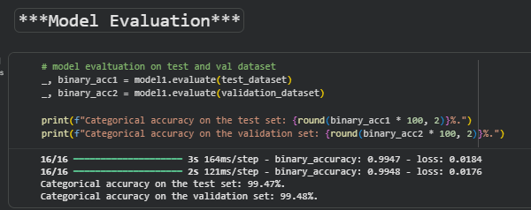

9. Demonstration
The Streamlit application provides a clear and intuitive demonstration of the system. Users can enter a research paper title or abstract to receive immediate recommendations, or input an abstract to obtain its predicted subject area. The interface neatly integrates both modules, guiding users step-by-step through the process. During presentation, the workflow—from preprocessing to embedding generation, similarity calculation, and classification output—can be clearly shown, allowing easy understanding of how the system functions end-to-end.

10. Conclusion
The project successfully demonstrates how semantic embeddings and deep learning can be combined to enhance research discovery. The integrated system helps researchers identify relevant papers and understand subject domains more effectively than traditional keyword-based methods. The insights gained show that transformer-based models significantly improve contextual accuracy in recommendations and classification tasks. Future work can focus on expanding dataset coverage, improving multi-label classification, and adding features such as citation prediction or keyword extraction.

Code | Full Form
cs.LG | Computer Science — Machine Learning
cs.AI | Computer Science — Artificial Intelligence
cs.CR | Computer Science — Cryptography and Security
cs.DC | Computer Science — Distributed, Parallel, and Cluster Computing
cs.IT | Computer Science — Information Theory
cs.SI | Computer Science — Social and Information Networks
cs.DS | Computer Science — Data Structures and Algorithms
cs.CG | Computer Science — Computational Geometry
cs.CV | Computer Science — Computer Vision and Pattern Recognition
cs.CL | Computer Science — Computation and Language (NLP)
cs.SD | Computer Science — Sound
cs.SD | Computer Science — Sound
cs.SI | Computer Science — Social and Information Networks
cs.SD | Computer Science — Audio and Speech Processing

Statistics (stat)
Code | Full Form
stat.ML | Statistics — Machine Learning

Math (math)
Code | Full Form
math.IT | Mathematics — Information Theory

Physics
Code | Full Form
physics.data-an | Physics — Data Analysis, Statistics, and Probability
cond-mat.dis-nn | Condensed Matter — Disordered Systems and Neural Networks
cond-mat.stat-mech | Condensed Matter — Statistical Mechanics

Biology-related (q-bio)
Code | Full Form
q-bio.QM | Quantitative Biology — Quantitative Methods

Electrical Engineering / Systems (eess)
Code | Full Form
eess.AS | Electrical Engineering and Systems Science — Audio and Speech Processing

Mathematical Subject Classification (MSC) Codes
These are the numeric ones like 68T30, I.5.4.
Code | Full Form
68T30 | Artificial Intelligence — Knowledge Representation
68T05 | Artificial Intelligence — Learning and Adaptive Systems
I.5.4 | Pattern Recognition — Applications

