Using ALV, display Header details.  
•    When double clicked on document-number display item data corresponding to document number.  
•    Double clicked on payer number in header table. Go to transaction ‘xd03’and skip the first screen and display payer details.  
•    Double clicked on material number in item table. Go to transaction ‘mm03’and display material details

REPORT zprem_newassignment.  
DATA : it_vbrk TYPE  TABLE OF zxvbrk,  
       wa_vbrk LIKE LINE OF it_vbrk,  
       it_vbrp TYPE  TABLE OF zxvbrp,  
       wa_vbrp LIKE LINE OF it_vbrp.  
DATA v_vbeln TYPE vbeln.  
  
DATA : lt_fcat TYPE slis_t_fieldcat_alv,  
       lw_fcat LIKE LINE OF lt_fcat.  
*DATA sy_sub TYPE i.  
SELECT-OPTIONS s_vbeln FOR v_vbeln.  
  
  
  
START-OF-SELECTION.  
  PERFORM get_data.  
  
  
  PERFORM display.  
  
  
END-OF-SELECTION.  
  
  
FORM get_data .  
*  DATA lw_makt LIKE LINE OF it_makt.  
  
  
  
  SELECT * FROM zxvbrk INTO TABLE it_vbrk WHERE vbeln IN s_vbeln .  
*  sy_sub = sy-subrc.  
  
  
  
ENDFORM.  
  
FORM display .  
  
  
  
*  DATA t_sort TYPE slis_t_sortinfo_alv.  
*  
*  DATA lw_sort TYPE slis_sortinfo_alv.  
*  
  lw_fcat-col_pos = 1.  
  lw_fcat-fieldname = 'VBELN'.  
  lw_fcat-tabname = 'IT_VBRK'.  
  lw_fcat-seltext_m = 'Document Number'.  
  lw_fcat-outputlen = 20.  
*  lw_fcat-edit_mask = '==MATN1'.  
  APPEND lw_fcat TO lt_fcat.  
  
  
  
  lw_fcat-col_pos = 2.  
  lw_fcat-fieldname = 'FKDAT'.  
  lw_fcat-tabname = 'IT_VBRK'.  
  lw_fcat-seltext_m = 'Billing Date'.  
  lw_fcat-outputlen = 15.  
*  lw_fcat-edit_mask = '==ISOLA'.  
  APPEND lw_fcat TO lt_fcat.  
  CLEAR lw_fcat.  
  
  
  
  lw_fcat-col_pos = 3.  
  lw_fcat-fieldname = 'KUNRG'.  
  lw_fcat-tabname = 'IT_VBRK'.  
  lw_fcat-seltext_m = 'Payer'.  
  lw_fcat-outputlen = 30.  
  APPEND lw_fcat TO lt_fcat.  
  
  
  
  lw_fcat-col_pos = 4.  
  lw_fcat-fieldname = 'NETWR'.  
  lw_fcat-tabname = 'IT_VBRK'.  
  lw_fcat-seltext_m = 'Net VAlue'.  
  lw_fcat-outputlen = 20.  
  APPEND lw_fcat TO lt_fcat.  
  
  
  
  
  
  CALL FUNCTION 'REUSE_ALV_GRID_DISPLAY'  
    EXPORTING  
*     I_INTERFACE_CHECK        = ' '  
*     I_BYPASSING_BUFFER       = ' '  
*     I_BUFFER_ACTIVE          = ' '  
      i_callback_program       = 'ZPREM_NEWASSIGNMENT'  
      i_callback_pf_status_set = 'PF_STATUS'  
      i_callback_user_command  = 'USER_COMMAND'  
*     I_CALLBACK_TOP_OF_PAGE   = ' '  
*     I_CALLBACK_HTML_TOP_OF_PAGE       = ' '  
*     I_CALLBACK_HTML_END_OF_LIST       = ' '  
*     I_STRUCTURE_NAME         = 'ZBILLING'  
*     I_BACKGROUND_ID          = ' '  
*     I_GRID_TITLE             =  
*     I_GRID_SETTINGS          =  
*     IS_LAYOUT                =  
      it_fieldcat              = lt_fcat  
*     IT_EXCLUDING             =  
*     IT_SPECIAL_GROUPS        =  
*     it_sort                  = t_sort  
*     IT_FILTER                =  
*     IS_SEL_HIDE              =  
*     I_DEFAULT                = 'X'  
*     I_SAVE                   = ' '  
*     IS_VARIANT               =  
*     IT_EVENTS                =  
*     IT_EVENT_EXIT            =  
*     IS_PRINT                 =  
*     IS_REPREP_ID             =  
*     I_SCREEN_START_COLUMN    = 0  
*     I_SCREEN_START_LINE      = 0  
*     I_SCREEN_END_COLUMN      = 0  
*     I_SCREEN_END_LINE        = 0  
*     I_HTML_HEIGHT_TOP        = 0  
*     I_HTML_HEIGHT_END        = 0  
*     IT_ALV_GRAPHICS          =  
*     IT_HYPERLINK             =  
*     IT_ADD_FIELDCAT          =  
*     IT_EXCEPT_QINFO          =  
*     IR_SALV_FULLSCREEN_ADAPTER        =  
*     O_PREVIOUS_SRAL_HANDLER  =  
* IMPORTING  
*     E_EXIT_CAUSED_BY_CALLER  =  
*     ES_EXIT_CAUSED_BY_USER   =  
    TABLES  
      t_outtab                 = it_vbrk  
    EXCEPTIONS  
      program_error            = 1  
      OTHERS                   = 2.  
  IF sy-subrc <> 0.  
* Implement suitable error handling here  
  ENDIF.  
  
  
  
ENDFORM.  
  
  
  
AT SELECTION-SCREEN.  
  
  
  
  
FORM user_command USING r_ucomm LIKE sy-ucomm  
  
  
  
                        rs_selfield TYPE slis_selfield.  
  
  
  CLEAR lt_fcat.  
  IF r_ucomm EQ '&IC1' AND rs_selfield-fieldname EQ 'VBELN'.  
    SELECT * FROM zxvbrp INTO TABLE it_vbrp WHERE vbeln = rs_selfield-value.  
    lw_fcat-col_pos = 1.  
    lw_fcat-fieldname = 'POSNR'.  
    lw_fcat-tabname = 'IT_VBRP'.  
    lw_fcat-seltext_m = 'Billing item'.  
    lw_fcat-outputlen = 20.  
    APPEND lw_fcat TO lt_fcat.  
  
  
  
    lw_fcat-col_pos = 2.  
    lw_fcat-fieldname = 'MATNR'.  
    lw_fcat-tabname = 'IT_VBRP'.  
    lw_fcat-seltext_m = 'Material number'.  
    lw_fcat-outputlen = 15.  
    APPEND lw_fcat TO lt_fcat.  
    CLEAR lw_fcat.  
  
  
  
    lw_fcat-col_pos = 3.  
    lw_fcat-fieldname = 'FKLMG'.  
    lw_fcat-tabname = 'IT_VBRKP'.  
    lw_fcat-seltext_m = 'Quantity'.  
    lw_fcat-outputlen = 30.  
    APPEND lw_fcat TO lt_fcat.  
  
  
  
    lw_fcat-col_pos = 4.  
    lw_fcat-fieldname = 'VRKME'.  
    lw_fcat-tabname = 'IT_VBRP'.  
    lw_fcat-seltext_m = 'Unit'.  
    lw_fcat-outputlen = 40.  
    APPEND lw_fcat TO lt_fcat.  
    lw_fcat-col_pos = 4.  
    lw_fcat-fieldname = 'NETWR'.  
    lw_fcat-tabname = 'IT_VBRP'.  
    lw_fcat-seltext_m = 'Net VAlue'.  
    lw_fcat-outputlen = 30.  
    APPEND lw_fcat TO lt_fcat.  
  
  
  
    CALL FUNCTION 'REUSE_ALV_GRID_DISPLAY'  
      EXPORTING  
*       I_INTERFACE_CHECK        = ' '  
*       I_BYPASSING_BUFFER       = ' '  
*       I_BUFFER_ACTIVE          = ' '  
        i_callback_program       = 'ZPREM_NEWASSIGNMENT'  
        i_callback_pf_status_set = 'PF_STATUS'  
        i_callback_user_command  = 'USER_COMMAND'  
*       I_CALLBACK_TOP_OF_PAGE   = ' '  
*       I_CALLBACK_HTML_TOP_OF_PAGE       = ' '  
*       I_CALLBACK_HTML_END_OF_LIST       = ' '  
*       I_STRUCTURE_NAME         =  
*       I_BACKGROUND_ID          = ' '  
*       I_GRID_TITLE             =  
*       I_GRID_SETTINGS          =  
*       IS_LAYOUT                =  
        it_fieldcat              = lt_fcat  
*       IT_EXCLUDING             =  
*       IT_SPECIAL_GROUPS        =  
*       IT_SORT                  =  
*       IT_FILTER                =  
*       IS_SEL_HIDE              =  
*       I_DEFAULT                = 'X'  
*       I_SAVE                   = ' '  
*       IS_VARIANT               =  
*       IT_EVENTS                =  
*       IT_EVENT_EXIT            =  
*       IS_PRINT                 =  
*       IS_REPREP_ID             =  
*       I_SCREEN_START_COLUMN    = 0  
*       I_SCREEN_START_LINE      = 0  
*       I_SCREEN_END_COLUMN      = 0  
*       I_SCREEN_END_LINE        = 0  
*       I_HTML_HEIGHT_TOP        = 0  
*       I_HTML_HEIGHT_END        = 0  
*       IT_ALV_GRAPHICS          =  
*       IT_HYPERLINK             =  
*       IT_ADD_FIELDCAT          =  
*       IT_EXCEPT_QINFO          =  
*       IR_SALV_FULLSCREEN_ADAPTER        =  
*       O_PREVIOUS_SRAL_HANDLER  =  
*   IMPORTING  
*       E_EXIT_CAUSED_BY_CALLER  =  
*       ES_EXIT_CAUSED_BY_USER   =  
      TABLES  
        t_outtab                 = it_vbrp  
*   EXCEPTIONS  
*       PROGRAM_ERROR            = 1  
*       OTHERS                   = 2  
      .  
    IF sy-subrc <> 0.  
* Implement suitable error handling here  
    ENDIF.  
  
  
  
  
*    SET PARAMETER ID 'MAT' FIELD rs_selfield-value.  
*    CALL TRANSACTION 'MM03'.  
  ENDIF.  
  
  IF r_ucomm EQ '&IC1' AND rs_selfield-fieldname EQ 'MATNR'.  
    SET PARAMETER ID 'MAT' FIELD rs_selfield-value.  
    CALL TRANSACTION 'MM03'.  
  ENDIF.  
  IF r_ucomm EQ '&IC1' AND rs_selfield-fieldname EQ 'KUNRG'.  
    SET PARAMETER ID 'KUN' FIELD rs_selfield-value.  
    CALL TRANSACTION 'XD03' AND SKIP FIRST SCREEN.  
  ENDIF.  
  
ENDFORM.  
  
  
  
FORM pf_status USING rt_extab TYPE slis_t_extab .  
  
  
  
*  IF sy-sub EQ '4'.  
  SET PF-STATUS 'STANDARD' EXCLUDING 'PDF'.  
*  ELSE.  
*  SET PF-STATUS 'STANDARD' .  
*  ENDIF.  
ENDFORM.

HEADER DATA

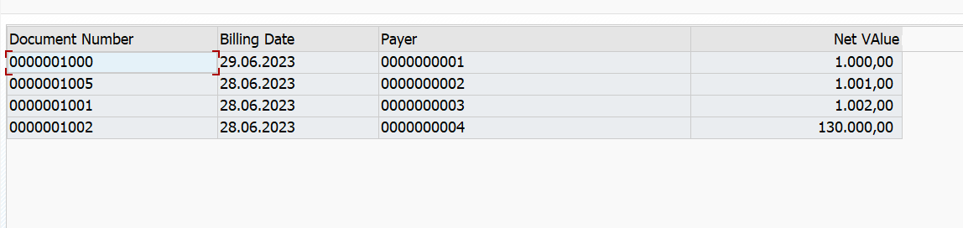

ITEM DATA

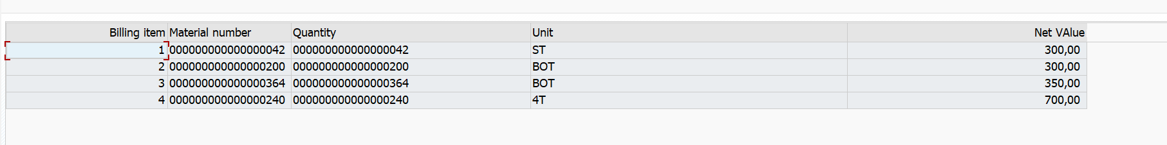

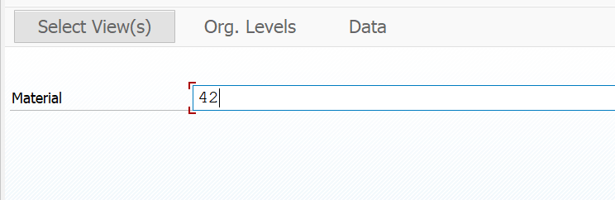

MATERIAL DATA

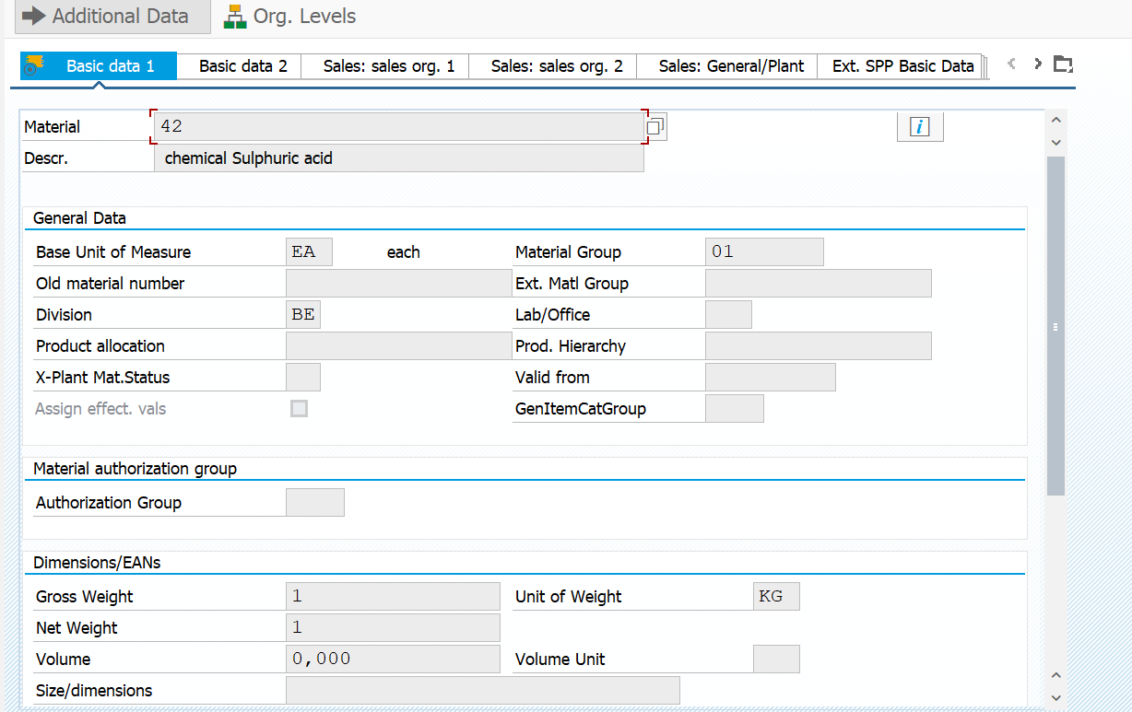

PAYER DATA

