## **必需的库：**

Python 3.6  
numpy 1.15.2  
scikit-image 0.14.0  
PIL 5.2.0  
PyTorch 0.4.0  
torchvision 0.2.1  
glob

SSIM 损失改编自 [pytorch-ssim](https://github.com/Po-Hsun-Su/pytorch-ssim/blob/master/pytorch_ssim/__init__.py)。

**用法：**

1.从GitHub克隆源代码

!git clone <https://github.com/NathanUA/BASNet.git>

Cloning into 'BASNet'...

remote: Enumerating objects: 204, done.

remote: Total 204 (delta 0), reused 0 (delta 0), pack-reused 204

Receiving objects: 100% (204/204), 1.97 MiB | 30.98 MiB/s, done.

Resolving deltas: 100% (100/100), done.

%cd BASNet

1. 下载预训练权重

%pip install gdown

Requirement already satisfied: gdown in /usr/local/lib/python3.6/dist-packages (3.6.4)

Requirement already satisfied: requests in /usr/local/lib/python3.6/dist-packages (from gdown) (2.23.0)

Requirement already satisfied: six in /usr/local/lib/python3.6/dist-packages (from gdown) (1.15.0)

Requirement already satisfied: tqdm in /usr/local/lib/python3.6/dist-packages (from gdown) (4.41.1)

Requirement already satisfied: idna<3,>=2.5 in /usr/local/lib/python3.6/dist-packages (from requests->gdown) (2.10)

Requirement already satisfied: urllib3!=1.25.0,!=1.25.1,<1.26,>=1.21.1 in /usr/local/lib/python3.6/dist-packages (from requests->gdown) (1.24.3)

Requirement already satisfied: certifi>=2017.4.17 in /usr/local/lib/python3.6/dist-packages (from requests->gdown) (2020.12.5)

Requirement already satisfied: chardet<4,>=3.0.2 in /usr/local/lib/python3.6/dist-packages (from requests->gdown) (3.0.4)

import os

import gdown

os.makedirs('./saved_models/basnet_bsi', exist_ok=True)

gdown.download('https://drive.google.com/uc?id=1s52ek_4YTDRt_EOkx1FS53u-vJa0c4nu',

'./saved_models/basnet_bsi/basnet.pth',

quiet=False)

---------------------------------------------------------------------------

TimeoutError Traceback (most recent call last)

File d:\Anaconda\envs\pytorch\Lib\site-packages\urllib3\connection.py:198, in HTTPConnection._new_conn(self)

197 try:

--> 198 sock = connection.create_connection(

199 (self._dns_host, self.port),

200 self.timeout,

201 source_address=self.source_address,

202 socket_options=self.socket_options,

203 )

204 except socket.gaierror as e:

File d:\Anaconda\envs\pytorch\Lib\site-packages\urllib3\util\connection.py:85, in create_connection(address, timeout, source_address, socket_options)

84 try:

---> 85 raise err

86 finally:

87 # Break explicitly a reference cycle

File d:\Anaconda\envs\pytorch\Lib\site-packages\urllib3\util\connection.py:73, in create_connection(address, timeout, source_address, socket_options)

72 sock.bind(source_address)

---> 73 sock.connect(sa)

74 # Break explicitly a reference cycle

TimeoutError: [WinError 10060] 由于连接方在一段时间后没有正确答复或连接的主机没有反应，连接尝试失败。

...

--> 688 raise ConnectTimeout(e, request=request)

690 if isinstance(e.reason, ResponseError):

691 raise RetryError(e, request=request)

ConnectTimeout: HTTPSConnectionPool(host='drive.google.com', port=443): Max retries exceeded with url: /uc?id=1s52ek_4YTDRt_EOkx1FS53u-vJa0c4nu (Caused by ConnectTimeoutError(<urllib3.connection.HTTPSConnection object at 0x000001E54EA15430>, 'Connection to drive.google.com timed out. (connect timeout=None)'))

Output is truncated. View as a scrollable element or open in a text editor. Adjust cell output settings...

3.运行 basnet_test.py

!python basnet_test.py

python: can't open file 'd:\\BASNet-master\\demo\\basnet_test.py': [Errno 2] No such file or directory

4.显示结果

from PIL import Image

from IPython.display import display

img_input = Image.open('/content/BASNet/test_data/test_images/0003.jpg')

display(img_input)

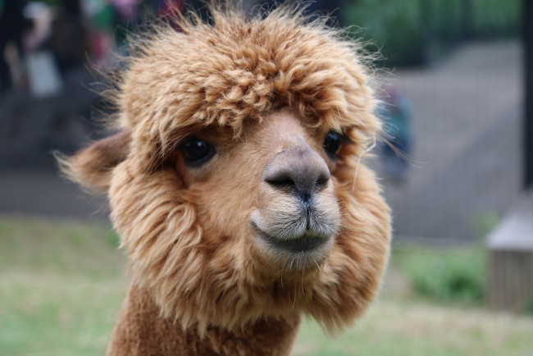

img_output = Image.open('/content/BASNet/test_data/test_results/0003.png')

display(img_output)

