* **Protocol for 2nd experiment**:
  + *Objectives*:
    1. Observe the linear relation between concentration and absorbance using the same spectrophotometer but in 2 different configurations
    2. Compare this linear relation for the two methods (R^2 coefficient, std)
    3. Compare the absolute values of absorbance with the 2 methods
  + Use the 2 leds with different distances (23mm of light path difference), see fig. spectro 2
    1. LED 1 – 120mm = diameter of the cylinder (with 6mm of Plexiglas)
    2. LED 2 – 97mm = shorter distance (with 8mm of Plexiglas)
  + Protocol:
    1. Measure 300mL with a graduate cylinder and weigh approximately 24mg of colorant Methylene Mx985 (n° 53)
    2. Start with 300mL with a concentration of ~80mg/L (82.7mg/L in our case since the mass of colorant is 24.8mg) of colorant.
    3. Perform measurement with the spectro 2. Take a sample to measure the absorbance with the spectro 1 using a 1mL pipette.
    4. Collect the data by connecting the devices to the computer. The spectro 2 is in kinetic mode with 5 + 1 measurement while the spectro 1 is in ‘acquiring sample’ mode with 1+1 measurement.
    5. Add 100mL of water. Perform points 3 and 4 again until reaching 1000mL. The maximum concentration is therefore 82.7mg/L which corresponds roughly to the upper limit of the domain where the linear relation between absorbance and concentration is observed when using the spectrophotometer.
  + Data and results are available in [Results_Azul53_2.xlsx](Spectrophotometer/Experiment/Experimento2_Variacion_Distancia_Azul53/Results_Azul53_2.xlsx). Christian showed me how to use the scale and helped me realize the experiment.
  + Errors
    1. for the concentration: $C=C\left(m,V\right)=\frac{m}{V} \left[\frac{mg}{L}\right]=> ΔC=\frac{∂C}{∂m} \left(m- \overline{m}\right)+\frac{∂C}{∂V} \left(V-\overline{V}\right)=\frac{Δm}{V} ∓ \frac{m}{V^{2}}ΔV=>err_{C-rms}=\sqrt{{\left(\frac{Δm}{V}\right)}^{2}+{\left(\frac{m}{V^{2}}ΔV\right)}^{2}}$
    2. for the absorbance: $A=A\left(I_{0}, I_{i}\right)=\log_{10}\left[\frac{I_{0}}{I_{i}}\right]=>ΔA=\frac{1}{\log\left(10\right)} \left[\frac{ΔI_{0}}{I_{0}}∓ \frac{ΔI_{i}}{I_{i}}\right]=>err_{A-rms}=\frac{1}{\log\left(10\right)} \sqrt{{\left(\frac{ΔI_{0}}{I_{0}}\right)}^{2}+{\left(\frac{ΔI_{i}}{I_{i}}\right)}^{2}}$

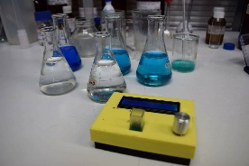

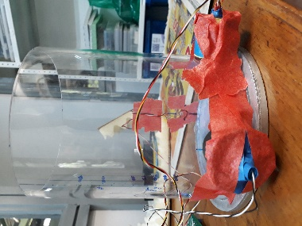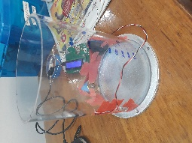

Figure 2: Spectro 2 with 2 LEDs with different distances to the receptor.

Figure 2: Spectro 1

* + Errors:
    1. concentration: reading of the scale (+/- 0.1mg) and half of the resolution of the graduated cylinder (+/- 5mL) each time volume was added. RSS method for cumulative effect of the errors.
    2. Absorbance: error = 1 time std of the sequence of measurement
  + *Conclusion*:
    1. The lack of power of the first LED does not allow us to calculate the absorbance (almost all the light is blocked by the medium). Moreover, since the LED is not facing the receptor, less power is emitted in towards it.
    2. Linear regression with R^2 = 0.999 (as in <https://github.com/Hackuarium/simple-spectro>) and R^2 = 0.953 for the spectro 1 and 2 (2nd LED) respectively. However, the responsivity is different: slopes of 0.0063 and 0.0473.