# Lab Diary

*Gives a brief description of the main tasks done each day as well as the what remains to be done.*

## May 21st

* Defining my role in the project: design of the spectrophotometer which has to measure the absorptivity of the medium
  + 2 solutions:
    1. Inside
       - The problem of the deposit/biofilm on the wall/plastic surface can occur -> is it a problem
    2. Outside
       - absorptivity of the glass wall has to be taken into account -> calibration
       - biofilm/deposit on the wall -> problem
  + Constraints:
    1. Distance between receptor and emitter can be adjusted (in best case scenario) and remain constant during operation.
    2. Structure is easy to fix or replace -> better having the spectro outside
    3. Distance shouldn’t be too big -> medium can be quite opaque
    4. The surface protecting the receptor and the emitter should be easy to
    5. Height position of the device: as 300mL < V < 1200mL -> position sub the 300mL limit (valid for the current version (4th) version of the bio used in the lab)
* Defining my objectives

## May 22nd

* Downloaded Arduino
* Reading the documentation of the spectro on github
* Soldering first PCB with Camilo
* Two problems encountered:
  + Problem connecting the new soldered PCB (v 1.6.0) and the old one to the computer (v 1.4.1): not detected by the computer.
  + The component MCP1703CB I have does not correspond to the design of the PCB (it has 4 connectors while the card has 3)

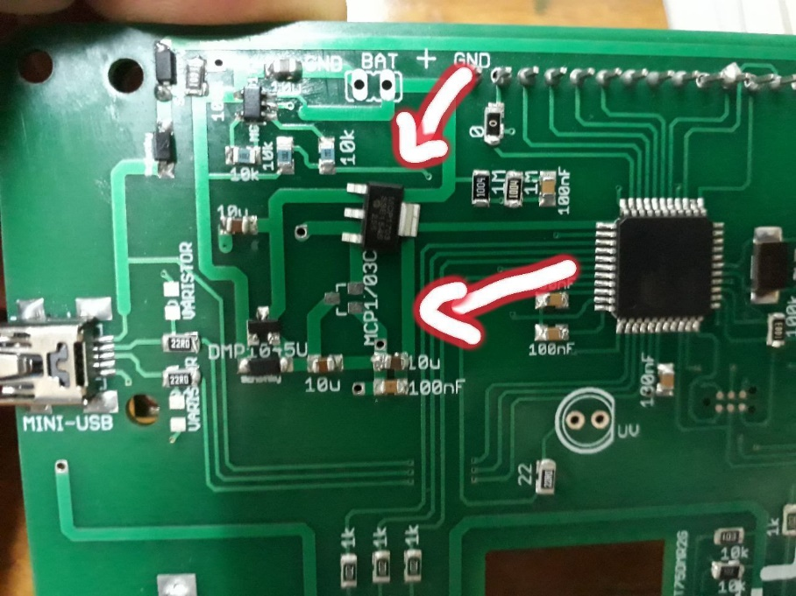

## May 23rd

* Luc:
  + I have the version SOT223 instead of SOT233 for the component MCP1703CB
  + Solder bootloader (has 6 connectors) to PCB -> check if card is detected and recognized by the computer
* Thinking about the design of the probe
  + Must be feasible with either CNC (2 axes) or 3D printing (better for this application)

## May 24th

* The biofilm becomes thicker from day to day
* Absorbance is measured with the spectrophotometer every 2 hours (wavelength is ?nm), after the feeding phase only (Tuesdays)
* The 5mm RGB led dimensions:

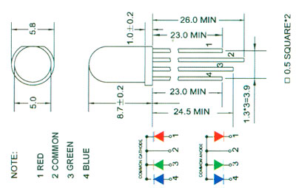

* Connected PCB version 1.6.0 to computer successfully after solving the following problems:
  + A MCP1703 was soldered whereas it should have been a BSP75 (a BSP75N was soldered, which is equivalent)
  + A MCP1703 SOT89 was soldered instead of a MCP1703 SOT 23A (with cables)
  + Burning the bootloader
* Running the Arduino program on my computer

## May 25th

* Problem for the design of the spectro:
  + Presence of biofilm
  + If the distance is too big between the receptor and the emitter:
    1. To much absorption by the medium
    2. If the absorption is not too important, reflection from objects outside and around the bioreactor may influence the measurement -> a change of the location or of the objects surrounding the bioreactor may impact on the measurement (?)
* After discussing with Julien, we came up with a new idea of design to consider the presence of a biofilm:
  + Requires 2 LEDs -> hacking
  + Measuring absorbance over 2 different distances; assuming linearity and subtracting the shorter path absorbance to the longer path absorbance -> we obtain the absorbance of the medium
  + To have 2 LEDs -> hacking the UV emitter to turn it into a blue emitter.
* Specifications of the cylinder (bioreactor):
  + Diameter: 120mm (outer) – 114mm (inner) ; 3mm thick
  + Depth: 147mm
  + Height of liquid when volume is minimum (300mL):
* Completed BOM

## May 28th

* Sketch of the 1st design with dimensions in mm

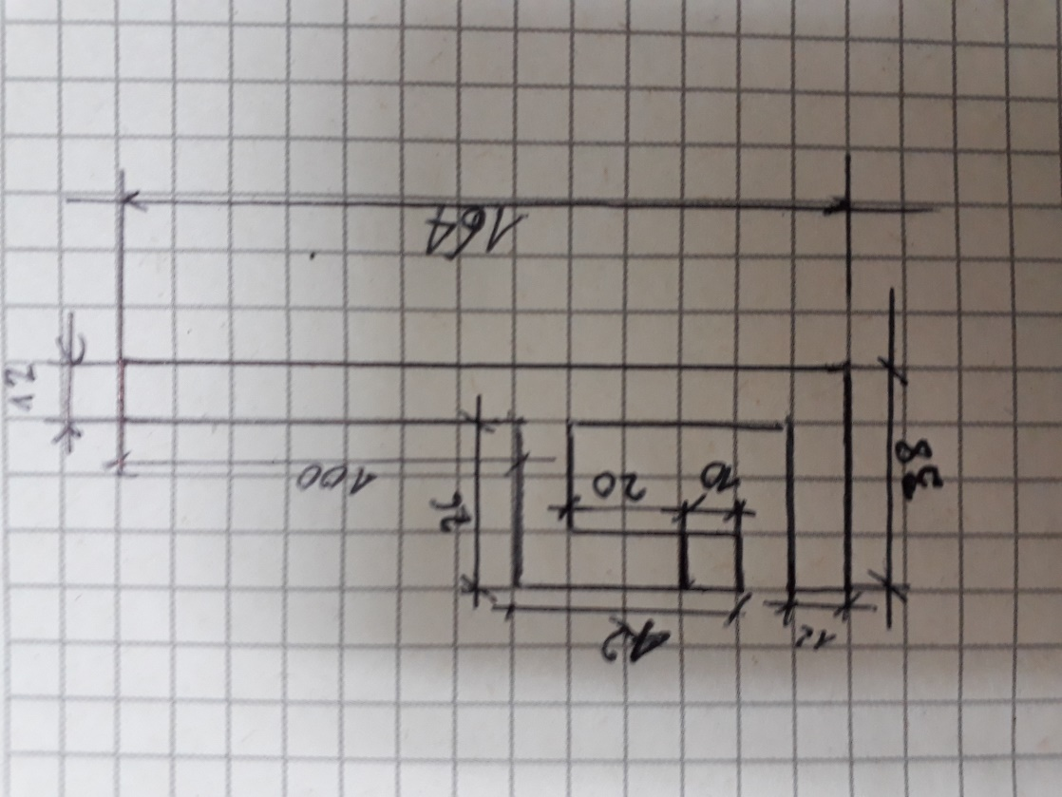

* 1st experiment with colorant blue 53
  + *Objective*: compare the measurements of the absorbance of the lab-spectro and our spectro when assessing the concentration of a colorant.
  + 5 measurements of absorbance across the whole diameter (distance is 120mm) with blue led only (460 – 470nm with peak at 465nm). See Excel spreadsheet Results_Azul_1.xlsx
  + Measured absorbance was zero for the 2 lowest concentrations when using the spectro ‘maison’. Maybe the distance should have been longer or the power lower?
  + *Conclusion*: the experiment was MISLED and UNSUCCESSFUL. Since for a given concentration, the blank and the test acquisition are done in the same conditions, absorbance should have been 0 for every measurement, which was not the case. The absorbance could not be calculated as as I didn’t record the values of the intensity of the signal (obtained with the command ‘d’ in the Arduino command board).
* Note on absorbance: directly proportional to thickness of a sample and the concentration of the absorbing material.
* UV LED was replaced by a RGB LED with only blue component

## May 29th

* Plexiglas absorbs UV (~65%)
* Going through the Arduino code
* Location of the receptor and LEDs should be as close as possible to the stirrer
* **Protocol for 2nd experiment**:
  + *Objectives*:
    1. Observe the linear relation between concentration and absorbance using the same spectrophotometer but in 2 different configurations
    2. Compare this linear relation for the two methods (R^2 coefficient, std)
    3. Compare the absolute values of absorbance with the 2 methods
  + Use the 2 leds with different distances (23mm of light path difference), see fig. spectro 2
    1. LED 1 – 120mm = diameter of the cylinder (with 6mm of Plexiglas)
    2. LED 2 – 97mm = shorter distance (with 8mm of Plexiglas)
  + Protocol:
    1. Measure 300mL with a graduate cylinder and weigh approximately 24mg of colorant Methylene Mx985 (n° 53)
    2. Start with 300mL with a concentration of ~80mg/L (82.7mg/L in our case since the mass of colorant is 24.8mg) of colorant.
    3. Perform measurement with the spectro 2. Take a sample to measure the absorbance with the spectro 1 using a 1mL pipette.
    4. Collect the data by connecting the devices to the computer. The spectro 2 is in kinetic mode with 5 + 1 measurement while the spectro 1 is in ‘acquiring sample’ mode with 1+1 measurement.
    5. Add 100mL of water. Perform points 3 and 4 again until reaching 1000mL. The maximum concentration is therefore 82.7mg/L which corresponds roughly to the upper limit of the domain where the linear relation between absorbance and concentration is observed when using the spectrophotometer.
  + Data and results are available in Results_Azul53_2.xlsx. Christian showed me how to use the scale and helped me realize the experiment.
  + Errors
    1. for the concentration:
    2. for the absorbance:

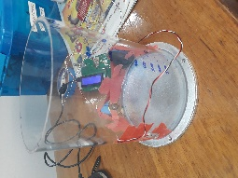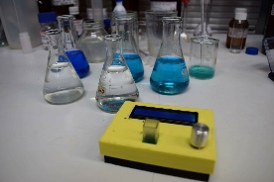spectro 1 spectro 2

* + Errors:
    1. concentration: reading of the scale (+/- 0.1mg) and half of the resolution of the graduated cylinder (+/- 5mL) each time volume was added. RSS method for cumulative effect of the errors.
    2. Absorbance: error = 1 time std of the sequence of measurement
  + *Conclusion*:
    1. The lack of power of the first LED does not allow us to calculate the absorbance (almost all the light is blocked by the medium).
    2. Linear regression with R^2 = 0.999 (as in <https://github.com/Hackuarium/simple-spectro>) and R^2 = 0.953 for the spectro 1 and 2 (2nd LED) respectively. However, the responsivity is different: slopes of 0.0063 and 0.0473.

## May 30th

* Problem with the experiment: the LED 2 (shortest distance) is not powerful enough for such a concentration -> the ideal distance (such that enough power is transmitted through de medium -> value greater than 100 at least) depends on concentration/opacity and power of the led.
* The 2 LEDs don’t have the same power -> can we change one of the resistances to have the same power?

## May 31st

* *Question*: Internal reflection at the surface of the liquid adds up to the light intensity measured by the receptor. If so, when the height of the liquid changes, the reflective component of the light reaching the receptor should vary. But is this variation critical, particularly if we consider that what surrounds the bioreactor changes as well? -> Experiment to quantify the influence of reflection first and then the influence of the surrounding, e.g. blue objects around.
* *Idea*: instead of varying the distance, we can vary the intensity of the light by varying the resistance!!
* Analyzing the results of experiment 2, plots, writing protocol.

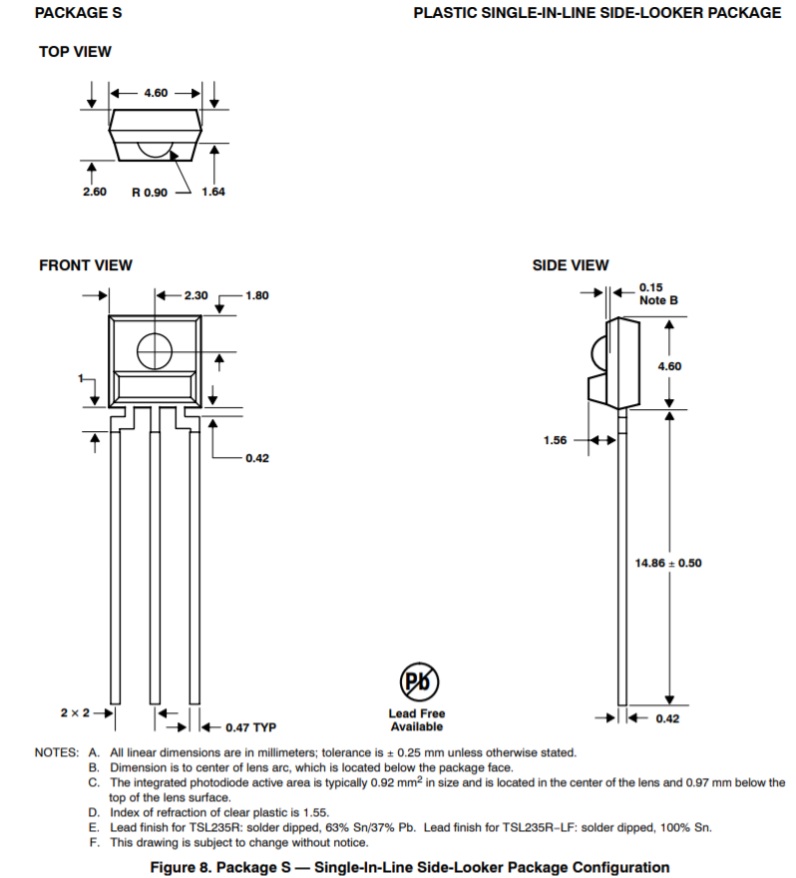

## June 1st

* 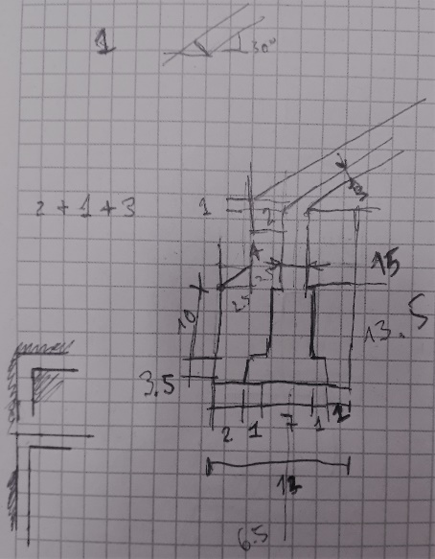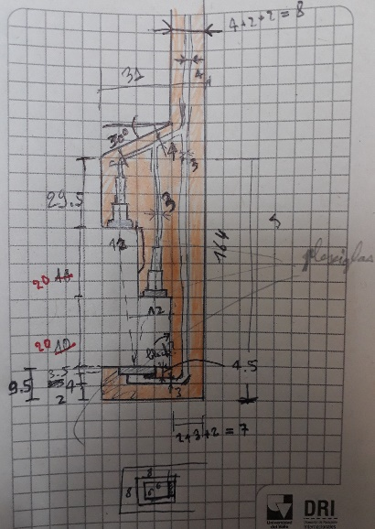first drafts:
* Editing the SPECTRO_PLONGEUR2.fstd file. I faced some problems while designing, that took me a lot of time to solve.
* Convert FreeCAD file extension for 3D printing: <https://www.freecadweb.org/wiki/Manual:Preparing_models_for_3D_printing>
* Downloaded *Slic3r*

## June 5th

* Influence of light coming from the exterior of the bioreactor
* Experiment 3 with both LEDs at equal power. Results and graphs are given in Results_Blue53_3.xlsx
* Conclusion
  + Sometimes, data are not coherent -> perform the sequence again. Can be detected automatically -> the calculated absorbance for the 6 tests must be 0 +/- 0.005 for example
  + Each time |abs.| > 0.01, re-perform the sequence
  + Higher reproducibility of the results of spectro 1 (probably more protected from external light) with R^2 close to 0.999 while for the spectro 2, 0.966 and 0.792 are obtained for the longer and shorter distances respectively. Even though that the power of the light is higher, the results are still not satisfying (in the best case, one would expect to get R^2 = 0.999).
  + For the second LED, which is not directly facing the receptor but is closer to it, the intensity reaching the receptor is lower. Phenomena of reflection and diffusion may cause this loss of power. One could change its direction but then, more reflection at the plexiglass wall would occur. It seems necessary to think of another design, such as the version 2, which will be developed.
  + Problem if other devices are in the bio -> can’t use the whole space
  + Lack of reproductibility

## June 6th

* Correcting the first 3D prototype of the probe structure.
* To improve for next version:
  + Larger and deeper channels
  + Thicker structure (reduce deformation at cooling)
  + Rounding the edges

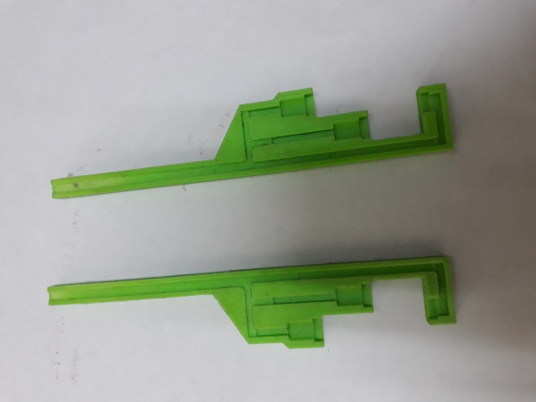

Figure 1: 3D printing of version 2

## June 7th

* The first prototype (of the 2nd version) allowed me to see the problems of the current design:
  + Deformation of the structure occurs due to cooling, particularly where the structure is the finest
  + how to make the spectro-plongeur waterproof
  + The idea of pasting 8x8mm squares of Plexiglas to protect the LEDs and the receptor is not a good way to keep the structure waterproof.
* Getting started with github <https://git-scm.com/book/en/v2/Getting-Started-Getting-Help>

## June 8th

* Thinking of the design for the 3rd version
* Discussion with Prof. Asfur who suggested to insert a thin pad between the 2 other pads and use screws to tight the whole. The LED cavity can be made waterproof using O-ring (5mm inner diameter) while for the receptor, a cylindrical crystal should be inserted in the cavity to protect the receptor (unless another type of receptor can be found).
* Actualizing the modifications needed for the 3rd version:
  + Larger and deeper channels
  + Thicker structure (reduce deformation at cooling)
  + Rounding edges
  + 3 locations for screws
  + Square cavity for the 8x8mm Plexiglas to be replaced by round hole for O-rings of 5mm ID and 2mm width (see <https://www.mcmaster.com/#o-rings/=1d76o27>)
  + Create thin pad
  + Change 1 of the thicker pad so that the channels for the cables is only in the other pad -> so that the thin pad is in one part.
  + Round crystal to protect the receptor and limit diffusion

## June 12th

* dimensions of the holes: <https://fr.wikipedia.org/wiki/Trou_de_passage>

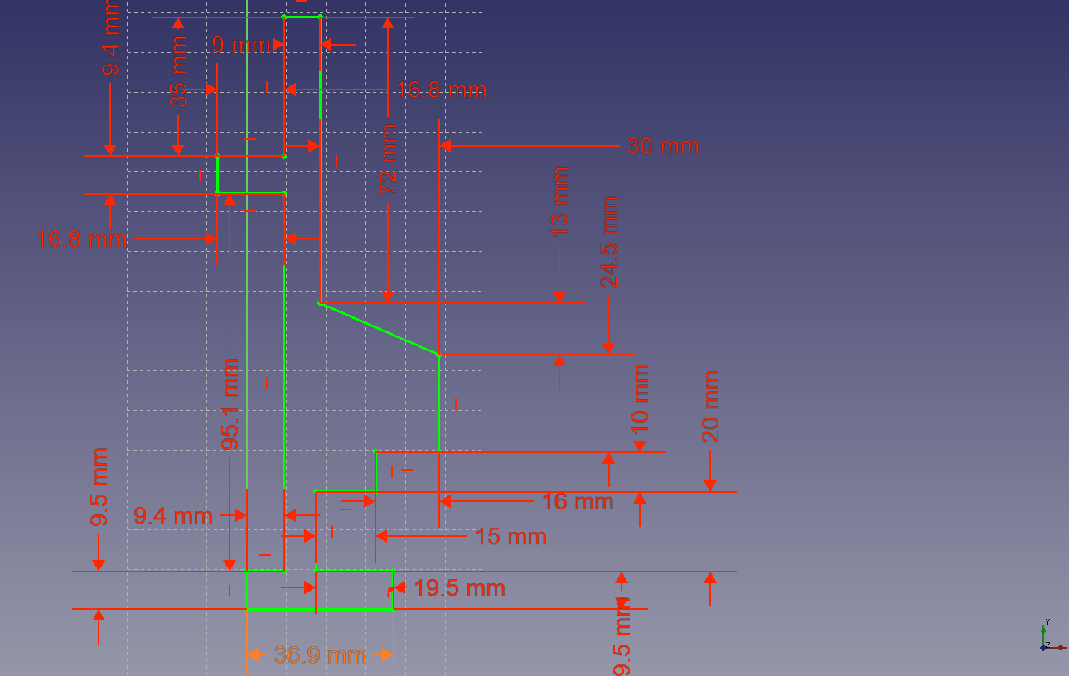

* change dimensions such that the light rays from each LED reach the receptor with the same angle.

## June 13th

* CAD of the 3 parts
* Exporting STL files
* Gcode for 3D printing

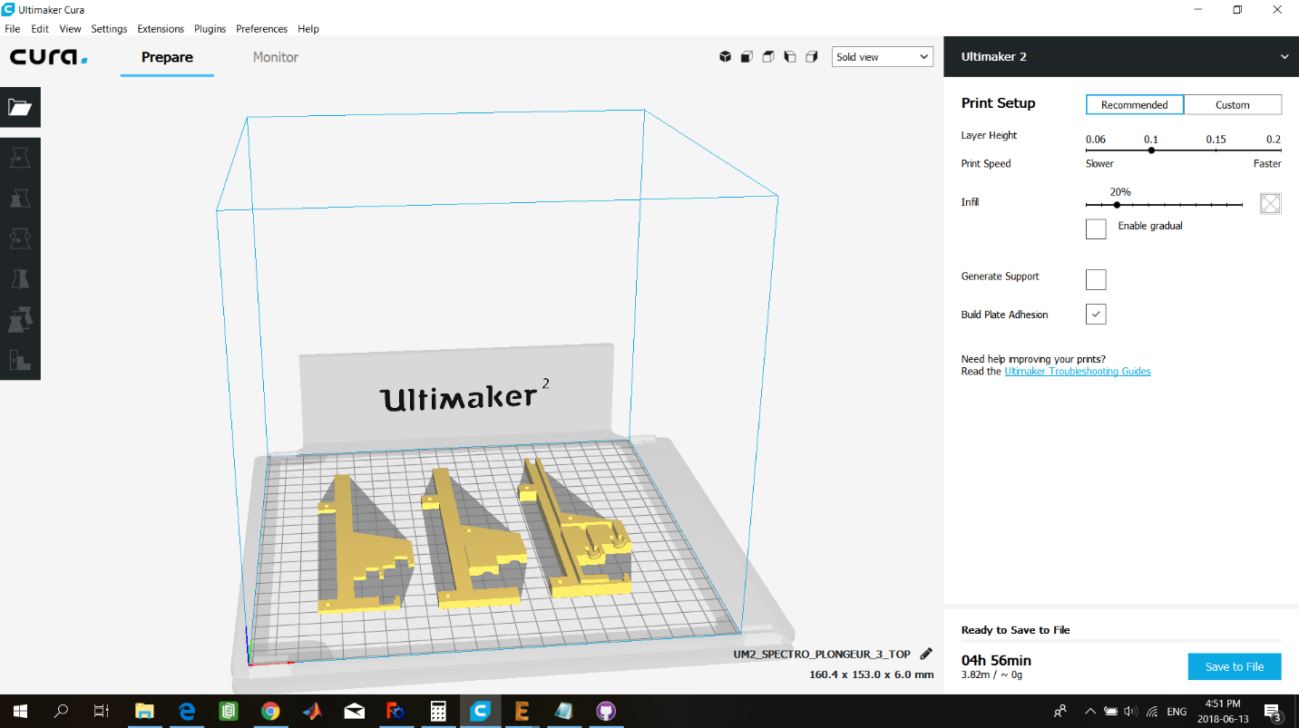

## June 14th

* Shopping list for Marie-Joe
* Design of spectro3 seems to be too complicated according to Julien and might be to expensive. Let’s keep it simple.
* Using Plexiglas:

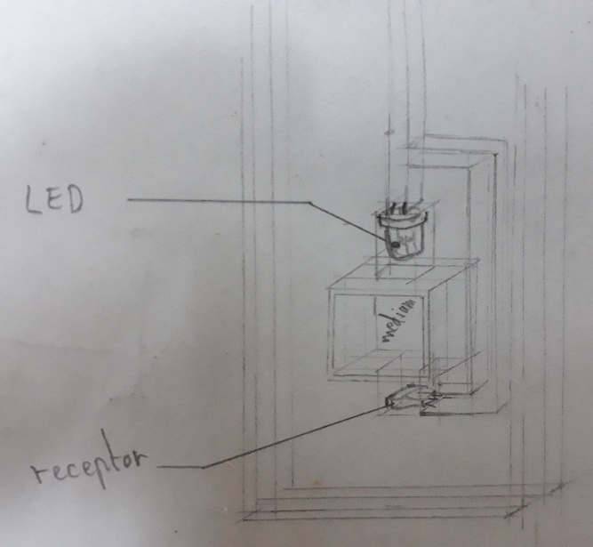

This design imitates the original design of the simple-spectro. The LED and the receptor are inserted in a Plexiglas patch wich is comprised between 2 other Plexiglas patches on each side.

## June 15th

* Reading about parametric design in FreeCAD: <https://www.freecadweb.org/wiki/Manual:Parametric_objects>
* Designing the simpler version (v.4)
* Should the light-to-frequency converter be protected?
* Limit volume occupation -> version with 2 slabs of Plexiglas
* Export in STL file

## June 18th

* Designing an even simpler version (v. 5)
* Problem: what is the minimal thickness of Plexiglas one can have?

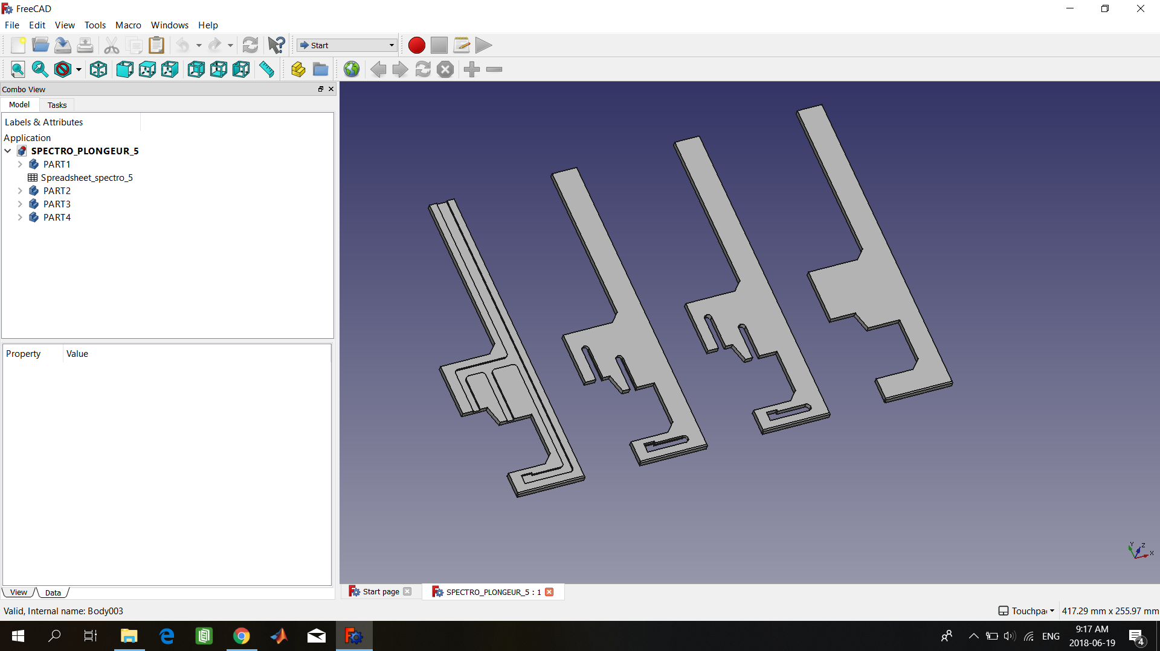

Figure 2: v.6 of the spectro-plongeur with, from left to right, part 1, 2, 3 and 4.

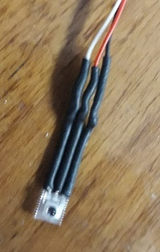

## June 19th

* Soldering sheaths on the LEDs’ and receptor’s pins
* Reading about the designing with acrylic
* Idea: flow cell spectrophotometer <http://zippypickle.com/wp/2016/03/01/flow-cell-spectrophotometer/>

## June 20th

* Getting familiar with easel.inventables
* Creating flat sketches of the parts
* Generating g-code from .svg files in

## June 21st

* Assembly procedure:
  + Add glue to part 1
  + Insert the two leds and the receptor in the channels of part 1
  + Paste parts 1 and 2 and stick them together with a wrench, making sure the cables fit in the channels
  + Paste part 3
  + Paste part 4
  + Place the whole in between wrenches to make sure the assembly is waterproof.
  + Paste each of the leds to its channel’s entry
  + Test if everything is working properly

## June 22nd

* Beginning soldering the second PCB

## June 23rd

* Testing the CNC to cut Plexiglas: we first reduced the speed, believing the poor quality of the cutting was due to a high displacement speed of the drill. Then we tried to cut a square using the multi-pass technique, always going through the whole thickness at once. We ended up cutting the part with five 6mm depth pass (recommendation found ni internet), which gave the best result.
* Cutting the SPECTRO-PLONGEUR v.6 (flat .svg or 3D .stl version?) with the CNC

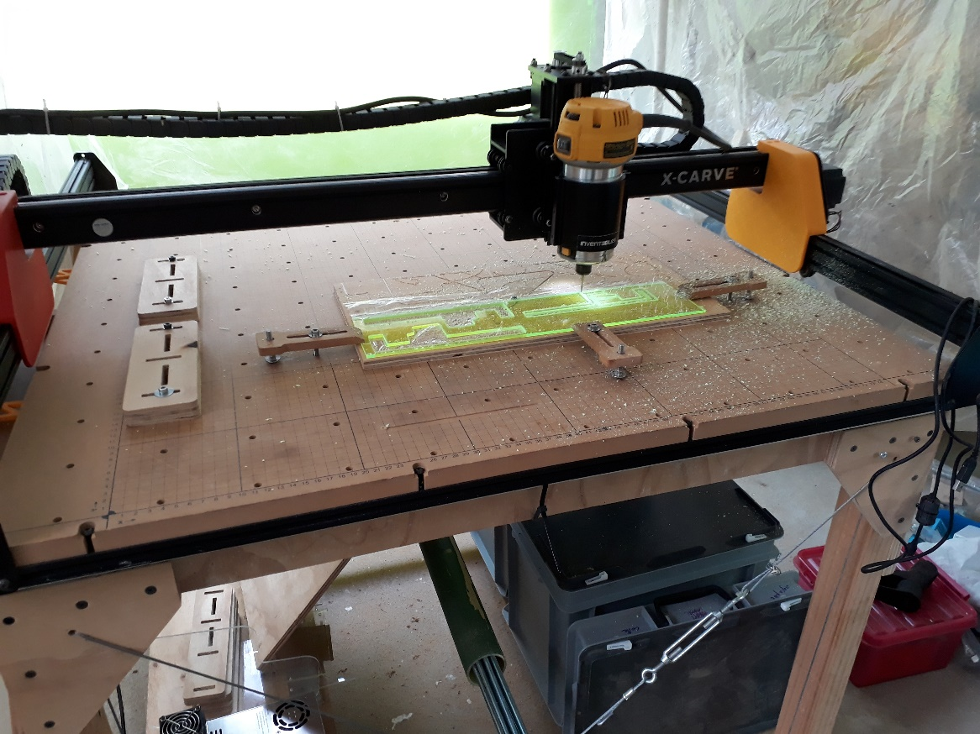

Figure 3: cutting acrylic with Julien's CNC – SPECTRO_PLONGEUR v.6

## June 25th

* Showing around to Marie-Joe for her first day in Univalle
* Building the SPECTRO-PLONGEUR
* **Improvement for next version**
  + 3 slabs instead of 4
  + Longer deep channels for LEDs and receptor
  + Use blue LEDs
  + Create hole for connexion (>= 7 pins) at the top
  + Thinner channel for receptor (-1mm)
  + Round channels’ edges
  + Thinner structure: LEDs closer to each other, shorter distance

## June 26th

* Helping Marie-Joe with paperwork
* Checking connexions of RaspberryPI 2 (no wifi) and 3 (wifi)
* Finding the instructions of use for Veracril (Acrilico liquid autopolimerizable con cross link + acrilico autopolimerizable self-curing acrylic – acrylic resin) – I ended up mixing the two products with roughly 1 to 1 proportion.
* Pasting the 3 parts together, adding some veracril on the rim/edge of the LEDs to ensure impermeability.

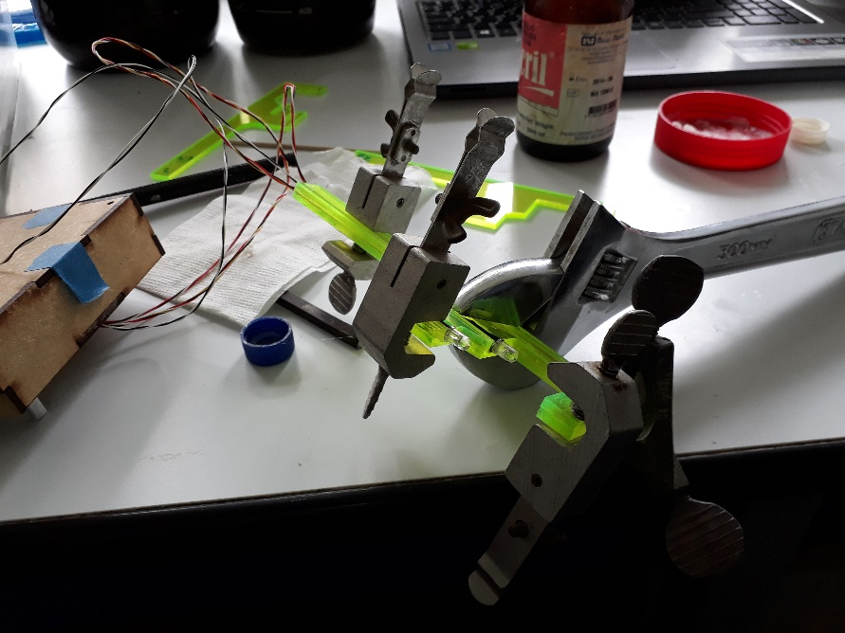

Figure 4: pasting the acrylic slabs

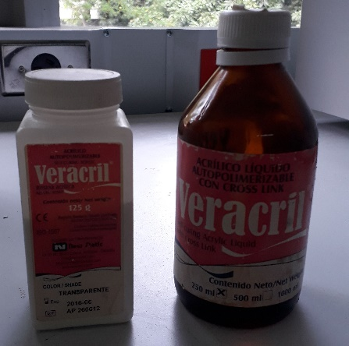

Figure 5: Veracril

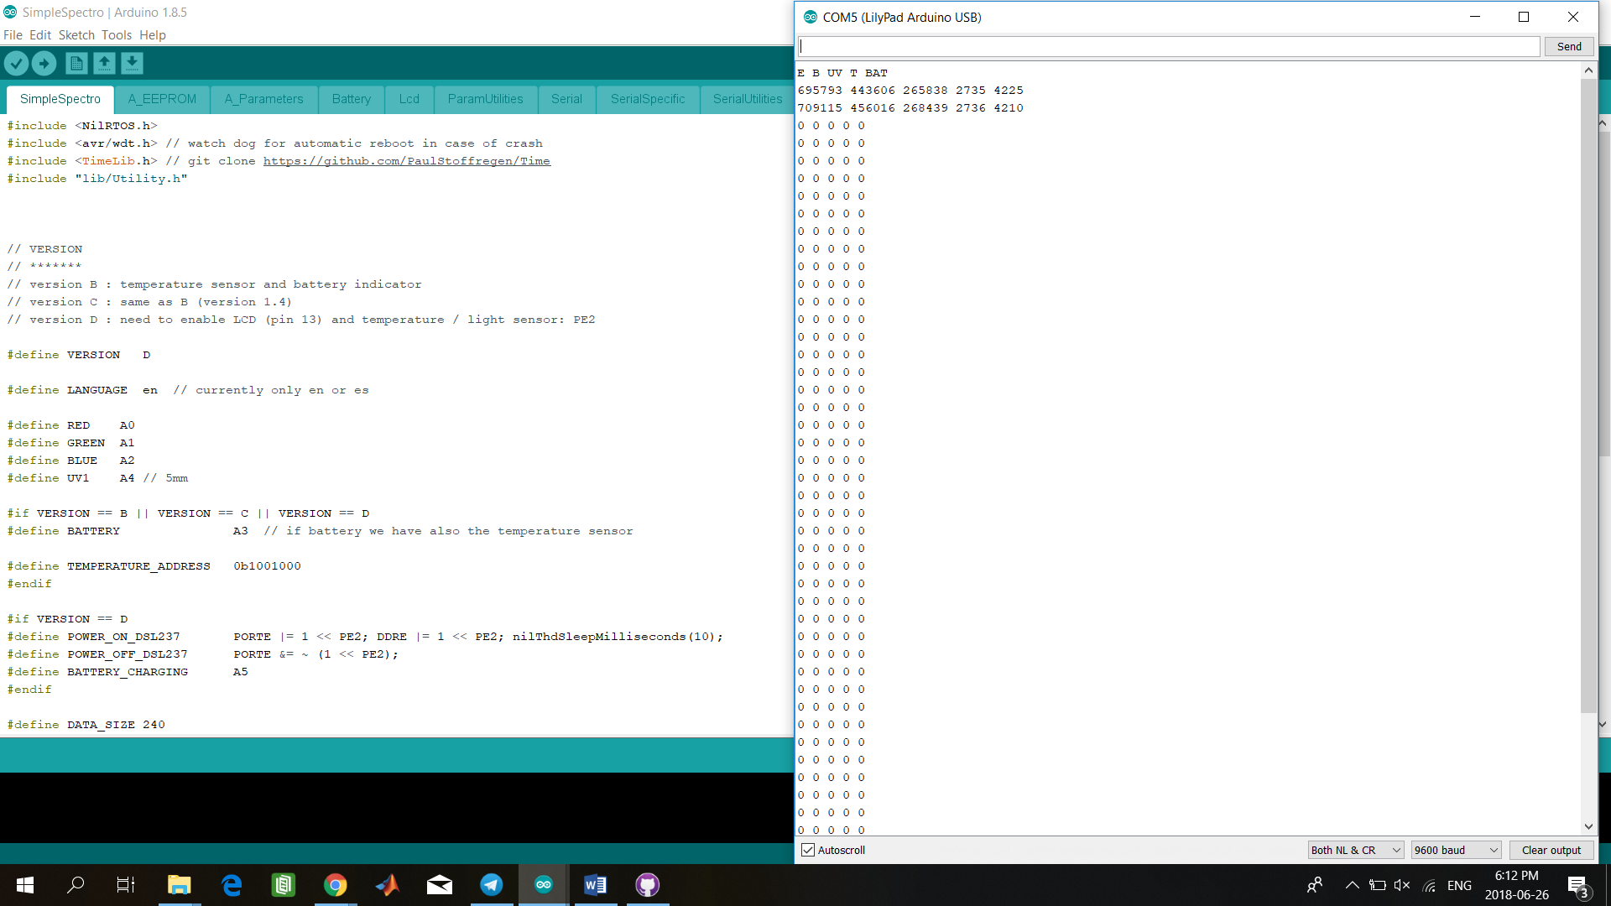

## June 27th

* Buidling 2nd bio
* Testing impermeability: not waterproof -> adding new layers of resin
  + Improve the paste technique to ensure it is waterproof
  + Use silicone ??

## June 28th

* Blood type test in
* SPECTRO-PLONGEUR is still not waterproof
* Testing the 2nd bioreactor:
  + Works: temp probe and PCB temp probe
  + Does not work: stepper (tested 2 different ones), left pump, error log fail 190440 (flash memory -> reformat -> log fail 0)
* Read/modify/revise:

<https://github.com/Bioreactor/Bioreactor_v4/blob/master/docs/making/assembling/index.md>

## June 29th

* Adding a layer of silicone on the SPECTRO-PLONGEUR -> needs a whole day to dry off
* Problem with the flash memory of the bioreactor, no program can be uploaded to the Lilypad. Finally, we found out that by changing computer and disconnecting the pumps and the motor, the test memory program (testMemory.ino) could be uploaded.
* Motor does not spin but vibrates, whatever the value of Z (motor enabled or not). We tested 2 of the 3 motors available (the 3rd one has a 6 pins connection instead of 4)

## July 3rd

* The SPECTRO-PLONGEUR seems to be finally waterproof as no water enters when it is submersed for 1 hour
* Solving the problem with the motor
* “Montage:
  + Material: slabs (6.1, 6.2, 6.3 and 6.4), 2 blue LEDs, cables, receptor, silicone glue, Veracril - autopolimerizable self-curing acrylic, small recipient (plastic bottle cap), thin wood stick
    1. Insert cables, receptor and LEDs in

## July 4th

* Experiment 4 with SPECTRO v.6 and simple-spectro
  + Determine if the distance from the led to the receptor is appropriate
  + Determine if the absorbance calculated by the difference of absorbance of the 2 LEDs is correlated with the absorbance measured by the simple-spectro

## To do next

* Create v. 7 of spectro
* What’s fluorescence?
* Manual of use + BOM
* Read manuals for bio <https://github.com/Bioreactor/Bioreactor_v4/blob/master/docs/making/assembling/index.md>
* Build and operate second bio
* Revise <https://github.com/Bioreactor/Bioreactor_v4/blob/master/docs/arduino/parameters.md>
* PCB hacking specifications
* design box for PCB
* build spectro-plongeur
* perform experiment with spectro v5
* (Solder second PCB)
* Is the presence of a biofilm a problem for the spectro
* Experiment 4: test the spectro v5 with same protocol as experiment 2 and 3.
* Experiment 5: evolution of the absorbance with bacteria concentration (instead of pigment) and comparison with data from spectro used in the lab by Dany.
* Write documentation on how to build the spectro-plongeur
* Write a protocol for the assessment of the concentration in real conditions, i.e. when the spectro is used to measure bacteria concentration -> e.g. which reference value must be considered? Calibration protocol? What is the accuracy needed? Data acquisition?
* Modify Eagle file of the PCB -> new version
* Change BOM (blue LEDs only, no UV nor RGB LEDs, resistances for the LEDs differs, 7 wires needed to connect to the emitters and receptor)
* Create a program for automatic measurement:
  + Calibration with void and initial concentration (2 avg values)
  + Measurement every 2h (?) during the growing phase
  + Synchronization with the bioreactor
  + Error management:
    1. A part of it is already managed by the device itself
    2. Measurement is accepted if calculated absorbance over 5+1 measurements is 0.00 +/- 0.005 ; measurement repeated 10s later ; if after 5 sequences, no good value, keep the lowest one & send error message
    3. Same as 2 if getting: inf or NA ; if no value is obtained, send error message with the latest value measured (NA or inf)

Modification of the PCB:

* Input for UV -> becomes input for blue led
* Blue led instead of RGB (?)
* Change the resistances of the RGB or the UV to have the same power as the “UV”: from 1000 Ohms to 22 Ohm. For the future design, we should consider replacing both resistances with ~220 Ohm instead, as 22 Ohm is too low and may lead to high current and dissipation when used with a blue led instead of a UV led.
* Replace RGB LEDs by blue LEDs (from 4 to 2 pins only on the PCB)

Modification of software:

* Measurement is accepted if calculated absorbance over 5+1 measurements is 0.00 +/- 0.005 (for example)