# Protocol – Results – Conclusion of Experiments 2 and 3

*Note: the 1st experiment is note documented since it was mislead and served more as a test to create the protocol for the following experiments, i.e. the 2nd and the 3rd one.*

* **Protocol for the 2nd and 3rd experiments**:
  + Objectives:
    1. Observe the linear relation between concentration and absorbance using the same spectrophotometer but in 2 different configurations
    2. Compare this linear relation for the two methods (R^2 coefficient, std)
    3. Compare the absolute values of absorbance with the 2 methods
  + Protocol:
    1. Use the 2 leds with different distances (23mm of light path difference), see fig. spectro 2
    2. LED 1 – 120mm = diameter of the cylinder (with 6mm of Plexiglas)
    3. LED 2 – 97mm = shorter distance (with 8mm of Plexiglas)
    4. Measure 300mL with a graduate cylinder and weigh approximately 24mg of colorant Methylene Mx985 (n° 53)
    5. Start with 300mL with a concentration of ~80mg/L (82.7mg/L and 84.7mg/L in our case since the mass of colorant is 24.8mg in the 2nd experiment and 25.4mg/L in the 3rd one) of colorant.
    6. Perform measurement with the spectro 2. Take a sample to measure the absorbance with the spectro 1 using a 1mL pipette.
    7. Collect the data by connecting the devices to the computer. The spectro 2 is in kinetic mode with 5 + 1 measurement while the spectro 1 is in ‘acquiring sample’ mode with 1+1 measurement.
    8. Add 100mL of water. Perform points 3 and 4 again until reaching 1000mL. The maximum concentrations are therefore 82.7mg/L and 84.7mg/L which correspond roughly to the upper limit of the domain where the linear relation between absorbance and concentration is observed when using the spectrophotometer.
  + Data and results are available in [Results_Azul53_2.xlsx](Spectrophotometer/Experiment/Experimento2_Variacion_Distancia_Azul53/Results_Azul53_2.xlsx). Christian showed me how to use the scale and helped me realize the experiment.
  + Errors
    1. for the concentration: $C=C\left(m,V\right)=\frac{m}{V} \left[\frac{mg}{L}\right]=> ΔC=\frac{∂C}{∂m} \left(m- \overline{m}\right)+\frac{∂C}{∂V} \left(V-\overline{V}\right)=\frac{Δm}{V} ∓ \frac{m}{V^{2}}ΔV=>err_{C-rms}=\sqrt{{\left(\frac{Δm}{V}\right)}^{2}+{\left(\frac{m}{V^{2}}ΔV\right)}^{2}}$
    2. for the absorbance: $A=A\left(I_{0}, I_{i}\right)=\log_{10}\left[\frac{I_{0}}{I_{i}}\right]=>ΔA=\frac{1}{\log\left(10\right)} \left[\frac{ΔI_{0}}{I_{0}}∓ \frac{ΔI_{i}}{I_{i}}\right]=>err_{A-rms}=\frac{1}{\log\left(10\right)} \sqrt{{\left(\frac{ΔI_{0}}{I_{0}}\right)}^{2}+{\left(\frac{ΔI_{i}}{I_{i}}\right)}^{2}}$

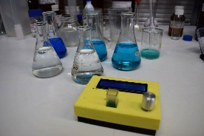

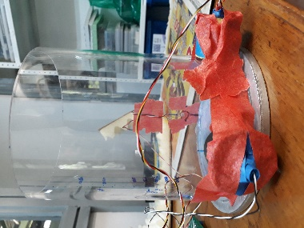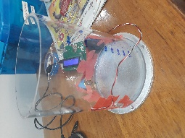

Figure 2: Spectro 2 with 2 LEDs with different distances to the receptor.

Figure 2: Spectro 1

* + Uncertainties
    1. concentration: reading of the scale (+/- 0.1mg) and half of the resolution of the graduated cylinder (+/- 5mL) each time volume was added. RSS method for cumulative effect of the errors.
    2. Absorbance: error = 1-time std of the sequence of measurement
* **Results of the 2nd**
* **Results of the 3rd experiment**
* **Conclusion experiment 1**:
  + The lack of power of the first LED does not allow us to calculate the absorbance (almost all the light is blocked by the medium). Moreover, since the LED is not facing the receptor, less power is emitted in towards it.
  + Linear regression with R^2 = 0.999 (as in <https://github.com/Hackuarium/simple-spectro>) and R^2 = 0.953 for the spectro 1 and 2 (2nd LED) respectively. However, the responsivity is different: slopes of 0.0063 and 0.0473.
* **Conclusion experiment 2**:
  + Sometimes, data are not coherent -> perform the sequence again. Can be detected automatically -> the calculated absorbance for the 6 tests must be 0 +/- 0.005 for example
  + Each time |abs.| > 0.01, re-perform the sequence
  + Higher reproducibility of the results of spectro 1 (probably more protected from external light) with R^2 close to 0.999 while for the spectro 2, 0.966 and 0.792 are obtained for the longer and shorter distances respectively. Even though that the power of the light is higher, the results are still not satisfying (in the best case, one would expect to get R^2 = 0.999).
  + Additionally, the offset of the linear regression is reasonably close to 0 only for the spectro 1: its value is -0.0092 in this case, while it reaches 0.43 and 0.66 for the 2 other case. One may also add a constraint of intersection on the linear regression, which however reduces the correlation of determination.
  + For the second LED, which is not directly facing the receptor but is closer to it, the intensity reaching the receptor is lower. Phenomena of reflection and diffusion may cause this loss of power. One could change its direction but then, more reflection at the plexiglass wall would occur. It seems necessary to think of another design, such as the version 2, which will be developed.