Note: 2nd LED not working since sample sp1

Blank: reading: 0.01 for blue 1 ? (long distance?) (creation time) (sp0)

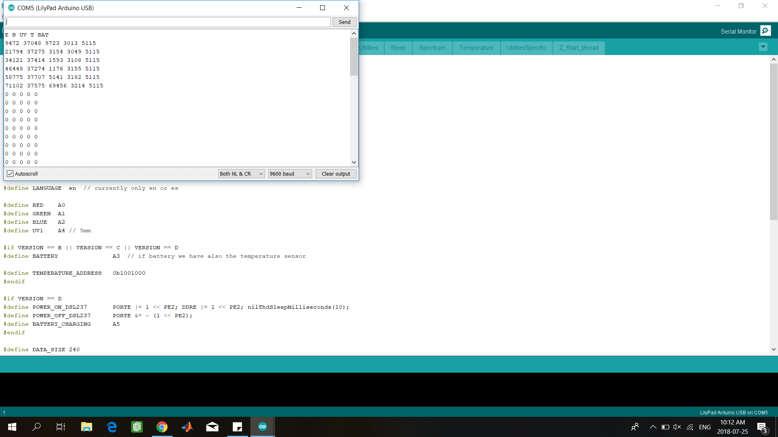

Right after inoculation (blue : 0.00, UV : nan) 10:16

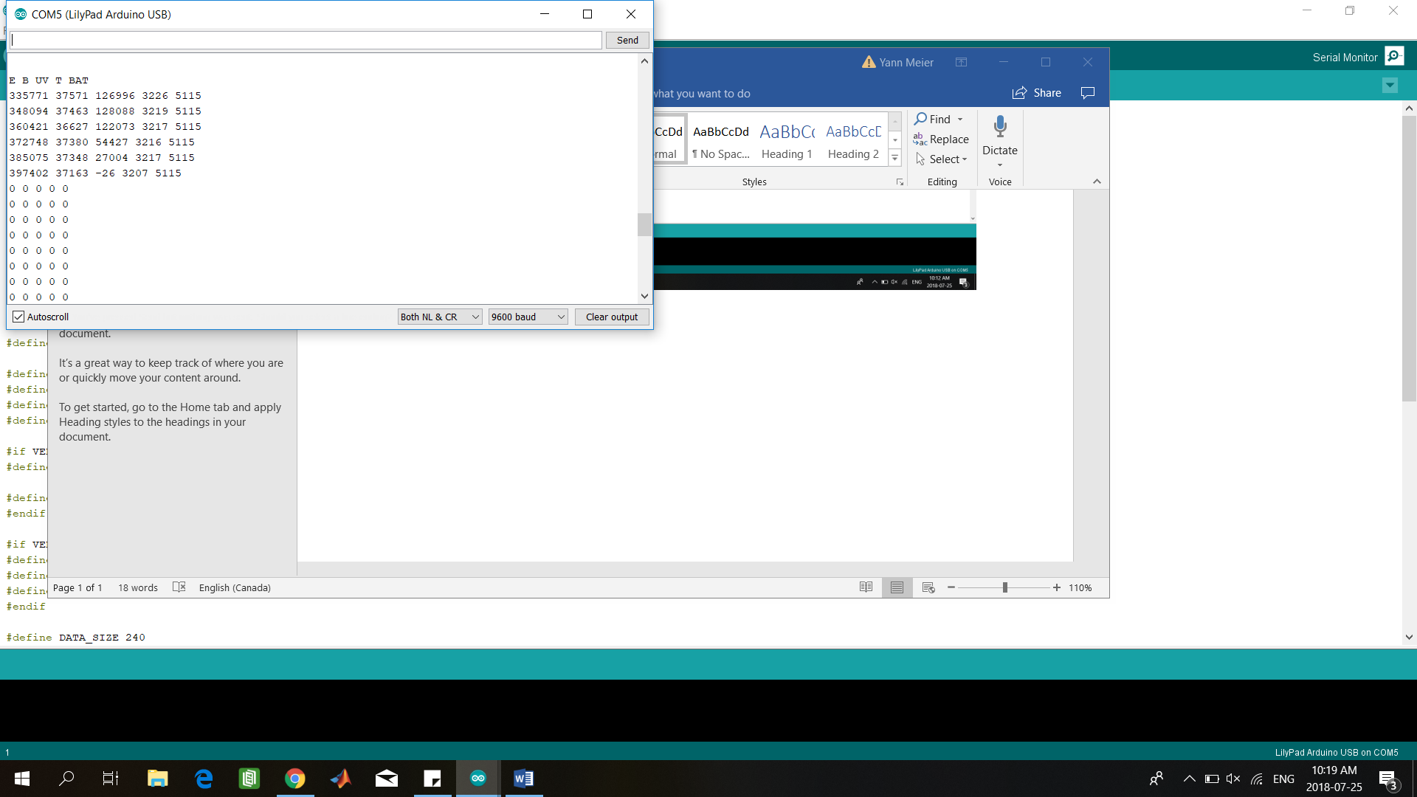

First measurement (after blank) of spectro1 : 10:23: (sp1)

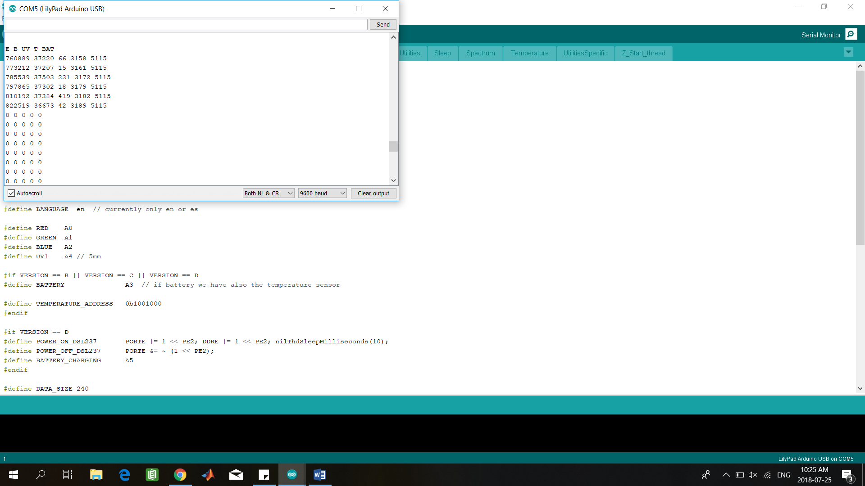

Reperform (10:27) (sp1bis) (blue1 0.00, UV inf)

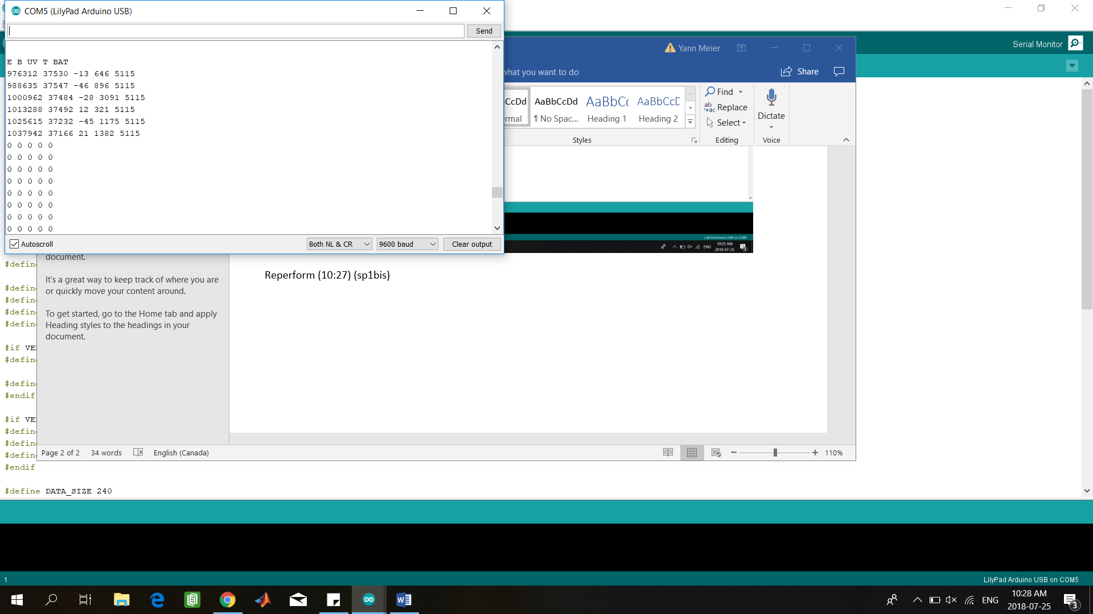

10:37 – blue1 0.00, UV -0.30

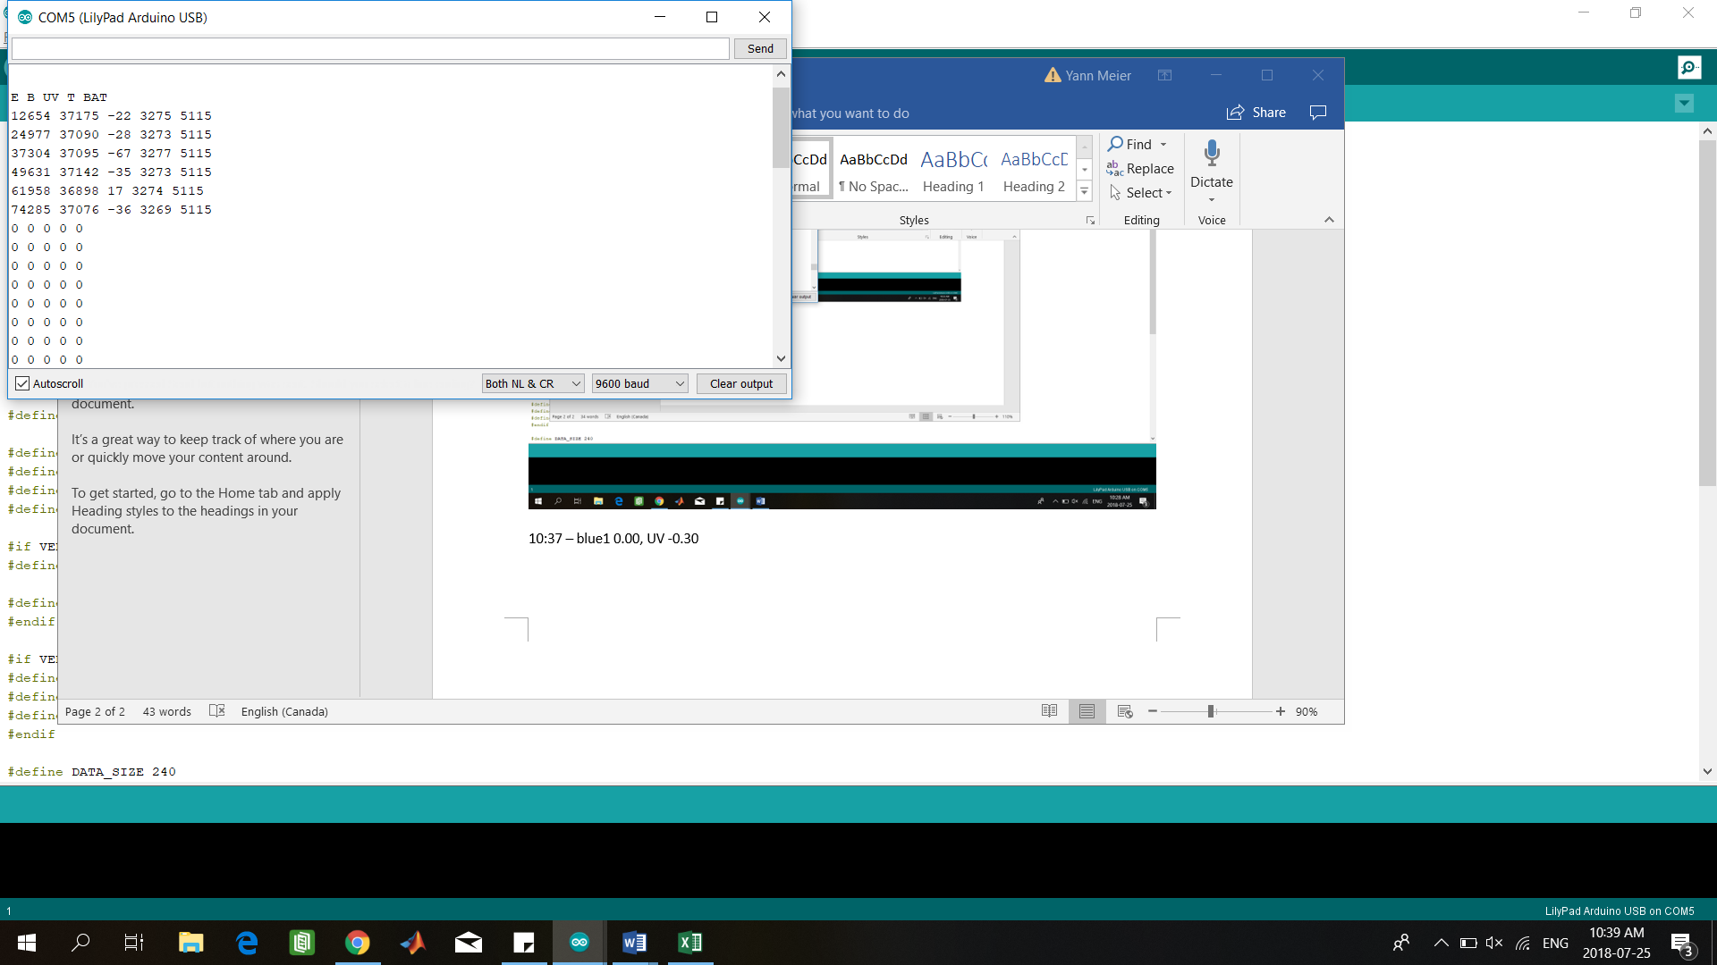

Sp2 – 10:11 – blue1: 0.00 – UV: nan

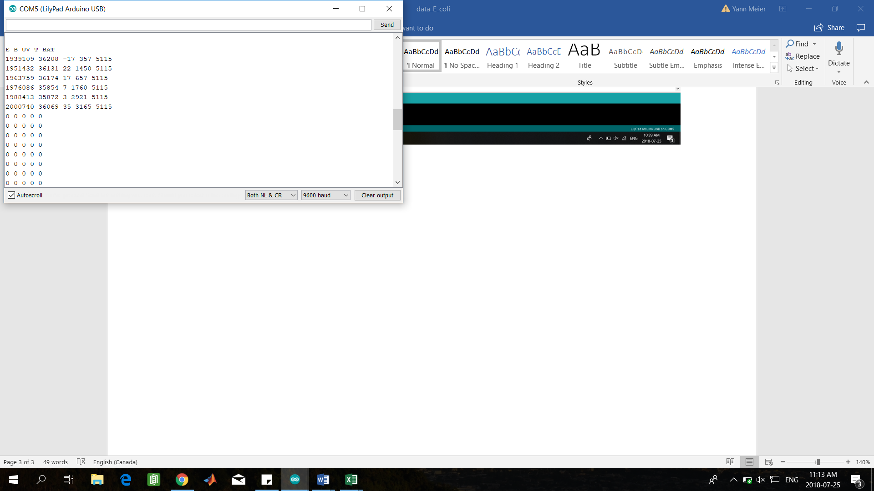

Additional measurement – 11:29 – blue1 0.01 – UV inf

