**ABOUT THE DATASET**

Airbnb, Inc. is an American San Francisco-based company operating an online marketplace for short-term homestays and experiences. The company acts as a broker and charges a commission from each booking. This project is about Airbnb’s New York City Market.

Welcome to New York City (NYC), one of the most-visited cities in the world. As a result, there are many Airbnb listings to meet the high demand for temporary lodging for anywhere between a few nights to many months.

The dataset which consists of two .csv files and one .xlsx file can be found here [New York City Airbnb Market | Kaggle](https://www.kaggle.com/datasets/ebrahimelgazar/new-york-city-airbnb-market).

**PROJECT QUESTIONS**

* What is the average price, per night, of an Airbnb listing in NYC?
* How does the average price of an Airbnb listing, per month, compare to the private rental market?
* How many adverts are for private rooms?
* How do Airbnb listing prices compare across the five NYC boroughs?

**DATA CLEANING**

From the Airbnb_price dataset:

* Used Power Query’s extract text before delimiter function to extract only the numerical values from the price column.
* Used Power Query’s split column by delimiter function to split “nbhood_full” into Borough and Neighbourhood columns.

From the Airbnb_room_type dataset:

* Capitalized each word in the room type column for consistency.
* Fixed the #Name? errors in the description column by removing the equal to sign that preceeded the texts

**ANSWERS TO PROJECT QUESTIONS**

Check my [GitHub page](https://github.com/AkwasiTp/Airbnb-New-York-City-Market/blob/main/README.md) for access to the interactive Power BI report and more.

* The average price of Airbnb listing in NYC is $141.78
* Monthly comparison between Average price for All Listings vs Private Room:

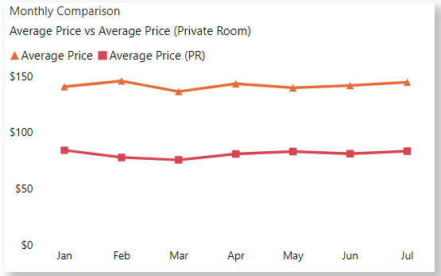

* Private rooms have 11,356 adverts.
* Price comparison across the five NYC boroughs:

* The most expensive listing is a private room in Brooklyn, East Flatbush which costs $7,500.

**ANALYSIS REPORT**

