THE ICT UNIVERSITY

Faculty of Information and Communication Technology
A dissertation presented and submitted in partial fulfilment of the requirement for the degree of a Bachelor of Science in Software Engineering

Title
Design and Implementation of a Secure Mobile-Based Tontine (“Njangi”) Management System
By
Fonguh Joy Akwi
Registration Number: ICTU20223039
Supervised by: Engr. Moune
July 2026

DECLARATION
I declare that the work entitled “Design and Implementation of a Secure Mobile-Based Tontine (“Njangi”) Management System” is my own original work, conceived and presented in the partial fulfilment of the requirement for the degree of a Bachelor of Science in Software Engineering at ICT University. This work has not been submitted for any degree or examination in any other university, and that all the sources I have used or quoted have been indicated and acknowledged as complete references
Signed: _______________________ Date: _______________________
Name: _______________________
Registration Number: ____________________

CERTIFICATION

This work entitled “Design and Implementation of a Secure Mobile-Based Tontine (“Njangi”) Management System” has been submitted for examination with my approval as the Research Supervisor.
Signed: _______________________ Date: _____________________
Name: _______________________

DEDICATIONS
- To Almighty God, the Author and Finisher of my faith.
Every chapter of this thesis was written under the shadow of Your grace. There were moments of doubt, moments of exhaustion, and moments when giving up seemed easier than pressing on but You were constant. I held on to Philippians 4:13: "I can do all things through Christ who strengthens me," and You proved that Word true, time and time again. This work is, before anything else, an act of worship and a testament to Your faithfulness.
- To my late father, Pa Fonguh my first teacher.
You left before you could see this day, but your fingerprints are on every page. You instilled in me the unshakable belief that education is the one inheritance no one can take away. "Practice makes perfect," you would say and I carried those words into every late night of study, every revision, every moment I wanted to quit but did not. You set the standard before I even understood what standard meant. You taught me resilience not by lecture, but by the quiet, steady example of your life. This one is for you, Daddy. I hope I have made you proud.
- To my beloved mother, Mami Fonguh my greatest supporter.
You may not have always understood the long nights, the piles of books, or the weight of what I was working toward but you showed up anyway. That is the kind of love that cannot be taught; it can only be lived. You invested in me in every way a mother can: emotionally, spiritually, physically, and morally. You carried me in prayer when I was too tired to pray for myself. You reminded me of my worth when the journey made me forget it. Everything I am, and everything I have achieved, is built on the foundation you laid. This one is for you, Mummy.
- To my siblings my anchors.
You made what was hard feel lighter. On the days when the road felt long and lonely, your presence whether near or far reminded me that I was never truly alone. You believed in me, cheered me on, and held me up in ways both big and small. I am deeply blessed to call you family. This one is for you all.
"And finally, to myself — for the late nights I pushed through alone, for every moment I chose to continue when stopping felt easier, for the discipline I showed even when no one was watching, and for believing in this work even when I doubted myself. This journey required a version of me I had not yet met, and I am proud of who I became in the process."

ACKNOWLEDGEMENTS
The completion of this thesis was not a solitary achievement. It is the product of the collective wisdom, encouragement, patience, and sacrifice of many people, and it is my honour to acknowledge them here.
First and foremost, I give all glory and honour to Almighty God, whose grace made this academic journey possible from beginning to end. Without His divine guidance and sustenance, none of this would have been conceivable.
I owe an immeasurable debt of gratitude to my supervisor, [Supervisor's Name and Title], whose intellectual rigour, constructive feedback, and unwavering guidance shaped this work into what it is. Your patience in the face of my questions, and your insistence on excellence, challenged me to think deeper and reach further than I thought possible. I am truly grateful.
I extend sincere appreciation to the members of my thesis committee, [Names], for their valuable insights, critical engagement with my research, and the time they generously invested in reviewing this work. Your contributions significantly strengthened the quality of this thesis.
To the entire faculty of [Department/Faculty Name] at [University Name], I am grateful for the knowledge, mentorship, and academic foundation you provided throughout my studies. You did not merely teach me a subject — you taught me how to think. The impact of your instruction extends far beyond these pages.
I am profoundly thankful to my late father, Pa Fonguh, whose belief in the transformative power of education shaped my entire academic path. Though he is no longer with us, his voice and values remain a constant compass. To my dear mother, Mami Fonguh, who sacrificed in ways both visible and invisible to ensure I could pursue this degree — your love and support have been my greatest source of strength. I could not have done this without you. To my siblings, thank you for the stability, encouragement, and laughter you brought into what were often challenging seasons.
To my friends and colleagues, particularly [Name(s) if applicable], who walked alongside me through long nights of research, shared ideas across cluttered tables, and never allowed me to surrender to discouragement — your companionship made this journey not only bearable, but meaningful. I am grateful for every conversation, every word of encouragement, and every shared moment of both frustration and breakthrough.
I also wish to acknowledge [any funding bodies, institutions, or organisations that provided support, access to data, or resources, if applicable].
And finally, to myself — for the late nights I pushed through alone, for every moment I chose to continue when stopping felt easier, for the discipline I showed even when no one was watching, and for believing in this work even when I doubted myself. This journey required a version of me I had not yet met, and I am proud of who I became in the process.
To anyone I may not have mentioned by name — your kindness and support did not go unnoticed. Every act of encouragement, however small, contributed to the completion of this work. Thank you

FACULTY APPROVAL
This dissertation has been duly reviewed by the Department and the Faculty and is ready for examination with our approval
Approved by
Signature Date
____________________________
Engr. XXXXXXXXXXXXXXX
Supervisor
Signature Date
____________________________
Engr. XXXXXXXXXXXXXXX
Head of Department
Signature Date
____________________________
Engr. XXXXXXXXXXXXXXX
Dean

ABSTRACT
In Cameroon, njangi (also known as tontine) is a traditional savings mobilisation system where group members voluntarily pool money to support each other and finance small businesses (Forje, 2014). However, many njangi groups still rely on manual, paper-based records and informal agreements, which creates trust problems, late payments, lack of transparency, weak documentation, and exposes members to fraud and mismanagement (Forje, 2014). This study aims to design and implement a secure mobile-based njangi management system that improves transparency, record keeping, and payment discipline for group members.
A survey of 72 respondents (students and workers, mostly aged 18–25 and regular smartphone users) was conducted to understand current njangi practices, challenges, and user expectations for a digital solution. Survey insights guided requirements gathering and system design, leading to the implementation of a mobile njangi application with features such as automated payment, reminders, integration with mobile money services (MTN MoMo), transparent transaction histories, and tools for monitoring member contributions and payouts. The survey revealed high participation and familiarity with njangi, with most respondents currently or previously belonging to at least one njangi group. The main reported problems were trust issues, late payments, treasurers or members “running with the money,” and poor tracking of contributions and payouts, confirming the weaknesses of informal, paper-based systems.
Respondents expressed strong interest in a digital solution that offers automated reminders, clear visibility of who has paid, downloadable records, fixed group rules, and integration with mobile money and formal payment providers. In the system evaluation, users rated the prototype as easy to use and useful for tracking payments and enforcing agreed rules, and performance tests showed acceptable response times for typical group sizes. Overall, a secure mobile njangi application can address key weaknesses of traditional njangi groups by improving transparency, trust, and payment discipline, especially in contexts where informal savings systems are widely used but poorly documented (Forje, 2014). To be widely adopted, such a system should prioritise strong security, low data usage, a simple user interface, and seamless integration with existing mobile money services, with future work extending the approach to rural users and additional savings and credit services.

TABLE OF CONTENTS
DECLARATION i
CERTIFICATION ii
DEDICATIONS iii
ACKNOWLEDGEMENTS iv
FACULTY APPROVAL v
ABSTRACT vi
LIST OF TABLES ix
LIST OF FIGURES x
LIST OF ACRONYMS AND ABBREVIATIONS xi
CHAPTER 1: INTRODUCTION TO THESIS 1
1.1 Introduction 1
1.2 Background to the Problem 1
1.3 Problem Statement 2
1.4 Objectives of the Study 2
1.6 Significance of the Study 3
1.7 Scope of the Study 4
1.8 Limitations of the Study 4
1.9 Organization of the Study 4
CHAPTER 2: LITERATURE REVIEW 5
2.1 Informal Savings and Njangi/Tontine in Cameroon 5
2.2 Challenges of Informal Saving Groups 5
2.3 Digitization and Mobile Platforms for Group Savings 5
2.4 Linking Informal Groups to Formal and Digital Finance 6
2.5 Gaps and Implications for a Mobile Njangi System 6
2.6 Legal & Regulatory Focus 7
CHAPTER 3: METHODOLOGY 9
3.1 Research Design 9
3.2 Data / Requirements Gathering 9
• Online questionnaire (Google Forms): 9
• Review of existing documents and applications: 9
3.3 Population and Sample 9
3.4 Instruments 10
3.5 Data Analysis (Quantitative Analysis) 10
3.6 Processes, Methods, Techniques, and Tools 11
3.7 Prototype Evaluation 12
CHAPTER 4: SYSTEM DESIGN, IMPLEMENTATION AND RESULTS 13
4.1 Overview of the Chapter 13
4.2 Data Presentation and Statistical Analysis 13
4.3 Requirements Analysis and System Specification 21
4.4 System Design 23
4.5 System Implementation 25
4.6 Testing and Results 27
4.7 Summary of the Chapter 28
CHAPTER 5: SUMMARY, CONCLUSIONS AND RECOMMENDATIONS 30
5.1 Introduction 30
5.2 Summary of the Study 30
5.3 Conclusions 31
5.4 Recommendations 32
5.5 Summary 34

LIST OF TABLES

LIST OF FIGURES

LIST OF ACRONYMS AND ABBREVIATIONS

- ROSCAs: Rotating Savings and Credit Associations
- ASCAs: Accumulating Savings and Credit Associations
- CMGs: Community Mutual Groups
- ISGs: Informal Savings Groups

CHAPTER 1: INTRODUCTION TO THESIS

1.1 Introduction
Njangi/tontine and other informal saving groups are central to the financial lives of low- and middle-income people but face persistent challenges of trust, record keeping and access to formal services (Wambua & Wamuyu, 2020). Growing mobile penetration and digital financial services in sub-Saharan Africa create opportunities to address these gaps through mobile-based platforms for group savings and credit (Mehmood et al., 2019).
Across many developing countries, group-based savings mechanisms such as rotating savings and credit associations (ROSCAs), accumulating savings and credit associations (ASCAs), community-managed groups (CMGs) and informal savings groups (ISGs) help households smooth consumption, cope with shocks and finance micro-enterprises where formal banking services are limited (Wambua & Wamuyu, 2020). Recent studies suggest that digitising these groups via mobile money and smartphone applications can improve transparency, security and efficiency in managing collective funds, while also serving as an entry point into the formal financial system (Ndiege et al., 2025; François & Squires, 2021).
Within this broader context, njangi/tontine groups in Cameroon represent a major but under-digitised channel for savings and credit. This study therefore focuses on the design and evaluation of a secure mobile njangi management system that leverages mobile money to strengthen record keeping, enhance trust and discipline, and support the gradual integration of njangi members into wider digital financial ecosystems in Cameroon.

1.2 Background to the Problem
In Cameroon, njangi/tontine plays a pivotal role in mobilising domestic savings and supporting small business creation, especially where banks and microfinance institutions are reluctant to lend to low-income clients (Forje, 2014). Similar group-based mechanisms elsewhere in Africa and Asia have been recognised as key instruments of financial inclusion for people who lack regular income documentation, collateral or formal credit histories (Wambua & Wamuyu, 2020).
However, most of these groups still rely on manual record-keeping, cash-only transactions and informal verbal agreements. Contributions, loans and payouts are often tracked in paper notebooks or in the memory of group leaders, making records vulnerable to loss, errors and manipulation. This dependence on trust and informal rules exposes members to risks of mismanagement, embezzlement, disputes, delayed payments and defaults, and also makes it difficult to demonstrate financial history to formal institutions (Ndiege et al., 2025).
Empirical studies in countries such as Pakistan and Tanzania show that digitisation through mobile applications can improve record keeping, timeliness of contributions, safety of funds, and planning and monitoring of loans for informal savings groups (Ndiege et al., 2025). Experimental “e-ROSCAs” run over mobile money networks have achieved high contribution and completion rates, indicating that digital platforms can replicate and even strengthen traditional group-saving behaviour among the unbanked (François & Squires, 2021).
In Cameroon, emerging evidence suggests that digital group accounts linked to microfinance institutions can improve the survival of tontine groups and generate mutual benefits for both groups and MFIs, by easing liquidity management and creating a bridge between informal and formal finance (Johnson, 2021). Yet the diffusion of purpose-built, locally adapted njangi management tools remain limited. Together, this literature underscores the urgency and relevance of developing and empirically evaluating a secure mobile njangi management system that aligns with local practices while harnessing digital financial infrastructure.

1.3 Problem Statement
Despite njangi’s crucial role in mobilising household savings and financing small enterprises in Cameroon, most groups continue to depend on paper ledgers, informal verbal agreements and cash-only transactions. This situation exposes members to risks of inaccurate or lost records, mismanagement of funds, delayed or missed contributions and payouts, and weak visibility to formal financial institutions (Ndiege et al., 2025).
Existing commercial applications in Cameroon (such as Tontiin and Mynjangi) aim to digitise njangi/tontine practice, but they have not been systematically described, evaluated or documented in the academic literature. Current research primarily examines ROSCA-style platforms and generic informal savings applications in other countries, without addressing the specific institutional, cultural and technological context of Cameroonian njangi groups.
Consequently, there is a gap in both practice and scholarship: the lack of a rigorously designed, context-appropriate, and empirically evaluated mobile-based njangi management system tailored to Cameroonian users and financial institutions.
Accordingly, this study addresses the core problem of the absence of a secure, mobile-based njangi management system that:
- enhances transparency and accuracy of group financial records;
- strengthens contribution and repayment discipline; and
- facilitates the integration of njangi members into broader digital financial ecosystems in Cameroon.
This gap justifies the design and evaluation of a prototype njangi management application, informed by both international evidence on digital informal savings groups and the specific needs and practices of Cameroonian njangi participants.

1.4 Objectives of the Study
1.4.1 General Objective
To design and implement a secure mobile-based njangi management system that improves transparency, record-keeping, and payment discipline for njangi groups in Cameroon, drawing on lessons from digital interventions for informal saving groups.
1.4.2 Specific Objectives
- To examine current practices, challenges, and digital readiness among njangi participants, in light of documented issues in informal saving groups such as mismanagement, delayed payments and exclusion from formal services(Ndiege et al., 2025).
- To derive and specify functional and non-functional requirements for a mobile njangi system that supports secure transactions, transparent records, and integration with mobile money, building on features proven useful in other digital group platforms (e.g., record-keeping, loan planning, real-time monitoring) (Juma et al., 2025).
- To design and implement a prototype mobile njangi application that operationalizes these requirements and supports core group operations (member registration, contribution scheduling, payouts, reporting).
- To evaluate the usability, perceived usefulness, and performance of the prototype with njangi users, and to explore its potential role in linking njangi groups with formal digital financial services, inspired by e-ROSCAs, digital group accounts and platforms like M-KOBA (Johnson, 2021).

1.5 Research Questions
Based on the objectives, Chapter 1 can frame research questions such as:
- What are the main operational, trust and record-keeping challenges facing njangi groups in Cameroon, and how do these compare to challenges documented in other informal saving groups?
- Which mobile-based features and design principles (e.g., inclusive interfaces, real-time monitoring, linkage to mobile money) are most appropriate for addressing these challenges in the njangi context?
- How do njangi users perceive the usability, trustworthiness and benefits of a mobile njangi system, in light of evidence from e-ROSCAs, mobile platforms such as M-KOBA and WanawakeApp and other existent commercial njangi apps in Cameroon?

1.6 Significance of the Study
This study is important because it deepens understanding of how digital tools can enhance domestic saving mobilisation and financial inclusion in Cameroon. Academically, it extends existing work on mobile apps for ROSCAs and CMGs by focusing on a njangi-specific design and by exploring integration with local mobile money and microfinance structures (Forje, 2014; Wambua & Wamuyu, 2020).Practically, the findings can inform policymakers, microfinance institutions, mobile money operators and app developers seeking to digitize community-based finance for underserved populations, building on experiences from Tanzania and Pakistan (Mehmood et al., 2019).

1.7 Scope of the Study
The study focuses on njangi groups in Cameroon and on designing and evaluating a prototype mobile application for managing member registration, contributions, payouts and record keeping. It concentrates on small to medium-sized njangi groups whose members already use smartphones or are willing to adopt digital tools.Conceptually, the study draws on literature on ROSCAs, ISGs and CMGs in other countries, and on existing Cameroonian njangi management applications.
The study does not:
- Provide a nationwide survey of all njangi groups in Cameroon;
- Compare all existing njangi and tontine platforms exhaustively;
- Deploy a full production-scale system or study long-term usage beyond the prototype testing period;
- Assess macro-level impacts on the financial sector or the wider economy.

1.8 Limitations of the Study
The findings will be limited to the specific njangi groups and users who participate in the surveys, interviews and prototype testing, who may be younger or more digitally literate than the wider njangi population. The study evaluates mainly the usability and core functionality of the prototype over a short period, rather than long-term adoption, sustainability or macro-level financial impacts. In addition, the analysis of existing njangi apps relies on available documentation and access to the applications, since there is little formal academic literature on these tools.

1.9 Organization of the Study
Chapter One presents the introduction, background to the problem, statement of the problem, objectives, research questions, significance, scope and limitations of the study. Chapter Two reviews literature on njangi/tontine in Cameroon, informal saving groups and their digitization, including ROSCAs, CMGs and existing njangi-related applications. Chapter Three describes the research methodology, including data collection methods, user research, requirements engineering, and system design and implementation procedures. Chapter Four presents the survey and interview results, the prototype njangi application, and its technical and user evaluation. Chapter Five provides a summary of the study and key findings, draws conclusions, and offers recommendations for practice and further research.

CHAPTER 2: LITERATURE REVIEW

2.1 Informal Savings and Njangi/Tontine in Cameroon
Njangi/tontine and other informal saving groups are central tools for savings and credit among low- and middle-income people where access to formal finance is limited (Kim, 2021). In Cameroon, there is a strong culture of savings mobilisation through njangi/tontine: members contribute regularly and either receive funds in rotation (financial njangi/ROSCAs) or build group savings (tontines)(Forje, 2014).
These mechanisms promote small business creation and support everyday needs, but lending is usually restricted to group members and depends on wider governance and justice systems for security (Besin-Mengla, 2020). Group accounts in microfinance institutions can strengthen tontine cohesion, survival and management, while also supporting MFIs’ growth, especially when accounts are accessible via mobile and digital channels (Johnson, 2021).

2.2 Challenges of Informal Saving Groups
Despite their importance, informal saving groups such as ROSCAs and ASCAs face operational problems and some collapse, including mismanagement, default and weak record keeping (Kim, 2021). Community microfinance groups that rely mainly on trust rather than digital records may struggle with transparency, monitoring and access to services when members move or groups disperse (Ndiege et al., 2025).
In many low- and middle-income settings, large segments of the population remain excluded from formal banking and therefore depend on these informal structures for credit, consumption smoothing and small enterprise finance (Kim, 2021).

2.3 Digitization and Mobile Platforms for Group Savings
2.3.1 e-ROSCAs and Digital ROSCA Platforms
Experimental work in the Democratic Republic of Congo linked mobile money networks to e-ROSCAs and found high contribution rates and successful ROSCA cycles, suggesting virtual ROSCAs can extend banking-type services to the “bankless poor” (Francois & Squires, 2021).
In Pakistan, a smartphone-based Digital ROSCA built on a simulated mobile money system showed that digitization can reduce record-keeping problems, delayed payments and safety-of-money concerns, while creating payment histories useful for credit scoring(Mehmood, 2018)
2.3.2 Mobile Apps for Informal Saving Groups
A study using agile methods developed a mobile app for ROSCAs/ASCAs and found mobile apps a plausible solution to transaction challenges, benefiting both informal groups and linked banks/MFIs (Wambua & Wamuyu, 2020).
In Tanzania, WanawakeApp, co-created with women’s savings groups, improved record keeping, loan planning and fund management, but adoption was shaped by device access, socio-cultural norms, connectivity and digital literacy(Ndiege et al., 2025). Use of M-KOBA among community microfinance groups significantly improved convenience in buying shares, checking investments, using group funds and accessing loans, and strengthened control, real-time monitoring and security, thereby enhancing financial inclusion (Ndiege et al., 2025).

2.4 Linking Informal Groups to Formal and Digital Finance
Case study evidence from Cameroon shows that group accounts in MFIs contribute to the financial, managerial and social development of tontine groups and to MFI growth; digital group accounts accessible via apps and basic handsets are proposed as a way to sustain tontine–microfinance co-existence (Johnson, 2021).
More broadly, mobile money is recognised as a major driver of financial inclusion in Sub-Saharan Africa and Cameroon, improving access to savings, payments and other services, especially for excluded and low-income populations (Ky et al., 2021). Mobile apps that link informal groups with mobile money and MFIs are thus important for both community groups and formal institutions (Wambua & Wamuyu, 2020).

2.5 Gaps and Implications for a Mobile Njangi System
Across countries, digitization of ROSCAs, ASCAs, informal savings groups (ISGs) and community microfinance groups (CMGs) has been shown to improve security, record keeping, monitoring, and access to financial services, and to support inclusion, especially for women and low-income users(Mehmood et al., 2019).
However, no study was found that designs or evaluates a njangi-specific mobile system tailored to Cameroon’s njangi/tontine culture and governance context(Johnson, 2021).
The literature consistently highlights the importance of:
- Secure, transparent records and real-time monitoring of contributions, loans and payouts (Mehmood et al., 2019)
- Integration with mobile money and MFIs, including digital group accounts (Wambua & Wamuyu, 2020)
- Inclusive, low-literacy-friendly interfaces for smartphone and basic-phone users (Mehmood et al., 2019)
- Careful attention to connectivity, cost and sociocultural factors shaping adoption and trust (Mehmood et al., 2019)
These insights directly motivate and inform the design of a secure mobile njangi management system for Cameroon, aimed at digitizing existing njangi practices while linking them to formal and digital finance.

2.6 Legal & Regulatory Focus
In Cameroon, njangi (or tontines) are primarily regulated as informal civil associations and mutual credit groups, rather than formal banking institutions. While there is no single, dedicated "Njangi Law," the practice is governed by a combination of civil law, tax laws, and anti-usury statutes. [1, 2, 3, 4, 5]
2.6.1 Legal Status and Formation
Njangis operate primarily under the broader legal framework governing civil associations, mutuals, and community groups. Because they function on trust and mutual assistance, their primary legal rules are the internal regulations and bylaws drafted and agreed upon by the members. [1, 2]
2.6.2 The Tax Regime
The Directorate General of Taxes (DGI) and the Finance Law clarify how njangis are taxed: (Marie, 2021)
- Pure Savings: Njangis that are strictly limited to collecting and rotating members' funds without generating interest are exempt from income tax, as this is considered simple interest-free savings.
- Commercial Activities: If the njangi operates catering, rental services, or engages in commercial trading as an entity, those specific economic activities are subject to Income Tax and Value Added Tax (VAT).
- Corporate Tax Status: Highly formalized njangis especially those registered as structured associations or cooperatives may be required to justify the source of group funds.
2.6.3 Usury and Lending Rates
Many njangis include a credit mechanism where members borrow from the collective pot at an agreed interest rate. However, under Section 325 of the Cameroon Penal Code, usury is strictly prohibited (Code pénal du 12 juillet 2016, 2016). Njangi groups cannot charge interest rates or demand rewards that exceed the legal limit fixed by banking regulations (often managed by CEMAC/COBAC authorities). Exceeding this limit is a punishable offense. (Règlement N°04/19/CEMAC/UMAC/CM Relatif Au Taux Effectif Global, à La Répression de l’usure et à La Publication Des Conditions de Banque Dans La CEMAC, 2019)
2.6.4 Dispute Resolution
Because njangis are heavily based on trust and are generally unwritten or informal, disputes (e.g., a member defaulting or refusing to remit contributions after collecting their payout) are typically resolved through traditional community arbitration. In formal civil courts, written bylaws and receipts can be used as evidence to recover funds through breach-of-contract civil claims. [1, 2]
2.6.5 Categorization of "Financial Njangis"
If an organization or digital app facilitating these services begins acting like a Microfinance Institution (MFI) by soliciting funds from the public rather than a closed, fixed group of members, it becomes subject to strict banking and COBAC (Banking Commission of Central Africa) regulations. Formalizing into a cooperative requires specific registration. [1, 2, 3]
2.6.6 Legal Status and Formation
Njangis operate primarily under the broader legal framework governing civil associations, mutuals, and community groups. Because they function on trust and mutual assistance, their primary legal rules are the internal regulations and bylaws drafted and agreed upon by the members. However, when an app digitizes this practice to help structured associations or cooperatives automate their traditional njangis, it transitions into the Category 1 Microfinance Institution (MFI) space under COBAC (Banking Commission of Central Africa) rules. Even if the platform only services closed groups, the entities using it—or the platform itself, if it handles cash escrow—must be registered with the Ministry of Finance (MINFI) and strictly limit operations to their own registered members.

2.6.7 What This Category Means For MbolePay
Operating in the Category 1 MFI space fundamentally shapes MbolePay’s legal liabilities, target audience, and business structure.
2.6.7.1 Financial & Capital Limits
- Strict Member Lock-in: Your app cannot allow the general public to browse and join random njangis. Every transaction must occur inside distinct, closed, and legally registered member groups.
- No Profit-Making From Funds: Category 1 institutions are non-profit mutuals by law. You cannot legally take user deposits and reinvest them elsewhere to earn corporate interest.
- Capital Compliance: If your platform directly holds or escrow funds for these groups, you face minimum capital reserves and rigorous reporting audits mandated by COBAC.
2.6.7.2 High Liability & Risk Management
- Escrow Risk: Handling user funds directly places full legal and financial liability on your startup if money is lost, hacked, or mismanaged.
- Compliance Burden: You become legally responsible for vetting the njangi groups. If a criminal group uses your app to launder money, your platform can be flagged for enabling illicit financial flows.
2.6.7.3 The Strategic Path Forward
- Software-as-a-Service (SaaS) Model: To bypass heavy banking licenses, position your app purely as a technology tool. Do not hold user money. Charge a subscription or management fee to the associations, and let them handle the physical cash or integrate directly with licensed mobile money wallets.

CHAPTER 3: METHODOLOGY

3.1 Research Design
This study adopts an applied research design combining system development with quantitative user research. The project involves:
- collecting requirements from potential and actual njangi participants,
- analysing the data quantitatively to understand needs and attitudes, and
- designing and implementing a secure mobile-based njangi management prototype, which is then evaluated by users.
This mixed approach allows the study both to propose a technical solution and to empirically assess users’ perceptions and digital readiness.

3.2 Data / Requirements Gathering
Multiple techniques were used to gather data and derive system requirements:
- Online questionnaire (Google Forms):
A structured survey was administered to collect quantitative data on demographics, njangi participation, challenges (trust, transparency, payment delays), smartphone and internet access, desired features (reminders, mobile money, visibility of payments), and willingness to use and pay for a mobile njangi application. A total of 72 valid responses were obtained.
- Review of existing documents and applications:
Documentation on informal savings groups, digital ROSCAs, and community microfinance apps (e.g., M-KOBA, WanawakeApp) was reviewed to identify common functional features such as contribution tracking, loan planning, and real-time monitoring, and non-functional requirements such as security, low data usage, and usability. Existing commercial njangi apps in Cameroon were also analysed where information was available.
- Informal interviews / observations:
Informal discussions with njangi members and brief observations of traditional njangi practices helped clarify how contributions are collected, how payouts are scheduled, and typical sources of conflict.
Survey results (e.g., 72.2% requesting payment reminders, 62.5% wanting all payments visible, 54.2% wanting mobile money integration) were directly translated into functional and non-functional requirements for the system.

3.3 Population and Sample
The target population for this study comprises current and potential members of njangi/tontine groups in Cameroon who use, or are willing to use, smartphones for financial activities.
The sample consisted of 72 respondents who completed the online questionnaire. Respondents were primarily students and young adults with access to smartphones and the internet:
- 77.8% aged 18–25 years,
- 13.9% aged 26–35 years,
- 63.9% female and 36.1% male,
- 71% having past or current experience with njangi groups.
A non-probability convenience sampling approach was used, where the survey link was shared through social media, messaging groups, and personal networks. This approach was chosen due to time and resource constraints and the need to reach smartphone users quickly. While the sample may not fully represent all njangi users in Cameroon, it is adequate for deriving requirements for a smartphone-based prototype aimed at younger, digitally ready participants.

3.4 Instruments
The main data-collection instrument was a self-administered questionnaire implemented using Google Forms. The questionnaire included:
- closed-ended questions (multiple choice, Likert scales) on njangi participation, trust and security issues, transparency and record keeping, payment reminders, willingness to use the app, and acceptable fees;
- open-ended questions to capture additional challenges and desired features.
The instrument was pre-tested with a small group of respondents to ensure clarity, and minor wording adjustments were made before full deployment.
For the system development part, requirements specification documents, use case descriptions, and UML diagrams (use case, class, sequence/activity diagrams) served as instruments to formalize requirements and guide design.

3.5 Data Analysis (Quantitative Analysis)
Survey data from Google Forms were exported to a spreadsheet for analysis. The following techniques were applied:
- Descriptive statistics:
Frequencies and percentages were computed for key variables such as njangi membership status, smartphone/internet access, reported challenges (e.g., late payments, fund mismanagement), preferred transparency features, and willingness to adopt and pay for the app.
- Graphical presentation:
Bar charts and pie charts were generated to visualize the distribution of responses across demographic variables and research questions. These visualizations support interpretation of user needs and digital readiness.
- Requirement derivation:
Quantitative findings were mapped to functional and non-functional requirements. For example, high demand for reminders informed the inclusion of automated contribution and payout notifications; strong emphasis on transparency led to features for viewing who has paid, total funds, and downloadable records.
Inferential statistics were not the main focus, as the primary goal was requirements elicitation and prototype evaluation rather than hypothesis testing. However, cross-tabulations (e.g., between njangi experience and willingness to use the app) were examined where relevant.

3.6 Processes, Methods, Techniques, and Tools
3.6.1 Processes
The system was developed following an iterative / Agile-inspired system development life cycle, comprising:
- Requirements elicitation and analysis:
From survey data, literature, and existing apps.
- System analysis and design:
Modeling actors, use cases, data structures, and interaction flows.
- Implementation:
Coding the mobile application prototype and basic backend services.
- Testing and evaluation:
Functional testing by the developer and usability evaluation with selected users.
These cycles were repeated in small iterations to refine features based on feedback.
3.6.2 Methods and Techniques
- Requirements engineering techniques: translating survey findings and user feedback into structured requirements.
- Unified Modeling Language (UML): use case diagrams, class diagrams, and sequence/activity diagrams to model system structure and behaviour.
- Prototyping: building an interactive prototype to validate requirements and gather user reactions.
- Agile development practices: incremental implementation and continuous refinement rather than a single waterfall pass.
    - Tools
- Development tools and languages:
  - Frontend: React.js (for an interactive user interface).
  - Backend: Node.js with Express.js (REST API services).
  - Database: PostgreSQL (transaction management) & IPFS (for immutable records).
  - Blockchain: Ethereum or Binance Smart Chain (for smart contracts).
  - Payment Gateway: Integrations with MTN Mobile Money

- Data management and analysis tools: Google Forms for data collection, descriptive statistics and charts.
- Diagramming tools: StarUML for UML diagrams.
- Testing tools: Android emulator and physical Android devices for functional and usability testing.

3.7 Prototype Evaluation
To evaluate the implemented prototype, a subset of respondents and njangi users were invited to interact with the app. The evaluation focused on:
- Usability: ease of navigation, clarity of screens, and learnability.
- Perceived usefulness: whether the app helps address trust, transparency, and payment-tracking problems identified in the survey.
- Performance: responsiveness of key operations such as registration, contribution recording, and viewing group balances.
Feedback was collected through short follow-up questionnaires / informal interviews, and observed issues were recorded to inform potential improvements.

CHAPTER 4: SYSTEM DESIGN, IMPLEMENTATION AND RESULTS
This chapter presents the execution of the methodology described in Chapter Three. It covers the analysis of the survey data collected, the derivation of system requirements, the design of the secure mobile-based njangi management system, its implementation and testing, and the main results. Interpretation and discussion of these results are reserved for Chapter Five.

4.1 Overview of the Chapter
This chapter is organised as follows:
- Section 4.2: Presentation and statistical analysis of the survey data.
- Section 4.3: Analysis of requirements and specification of the system.
- Section 4.4: System design, including main diagrams.
- Section 4.5: System implementation and key features.
- Section 4.6: Testing and evaluation results.
- Section 4.7: Summary of the chapter.

4.2 Data Presentation and Statistical Analysis
A Google Forms survey was conducted to collect quantitative data on current njangi practices, challenges, and user expectations for a mobile-based njangi system.
4.2.1 Description of the Sample
A total of 72 respondents completed the questionnaire.
- Age distribution:
  - 18–25 years: 77.8%
  - 26–35 years: 13.9%
  - Other age groups: remaining percentage
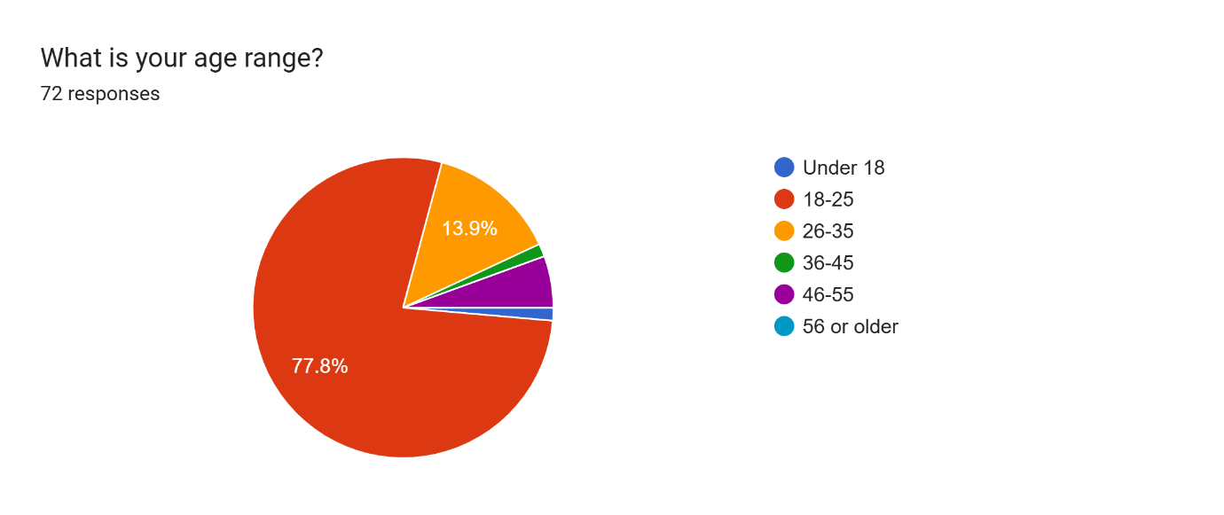

Figure 4.1: Age distribution of respondents

- Gender:
  - Female: 63.9%
  - Male: 36.1%
- Most respondents were students and smartphone users.
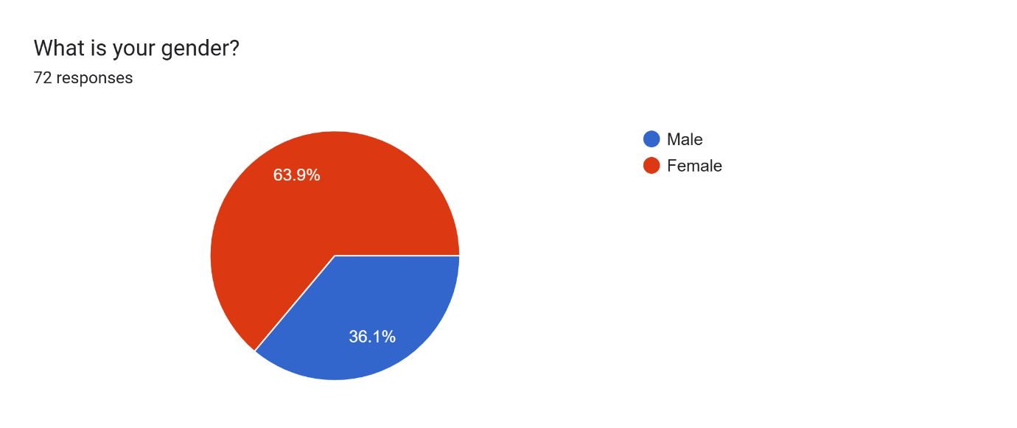
Figure 4.2: Gender distribution of respondents
4.2.2 Smartphone and Internet Access
- 77.8% reported owning a smartphone with reliable internet access.
- 22.2% own a smartphone but experience slow or expensive internet.
This indicates that a mobile-based njangi system would be accessible to the majority of potential users.
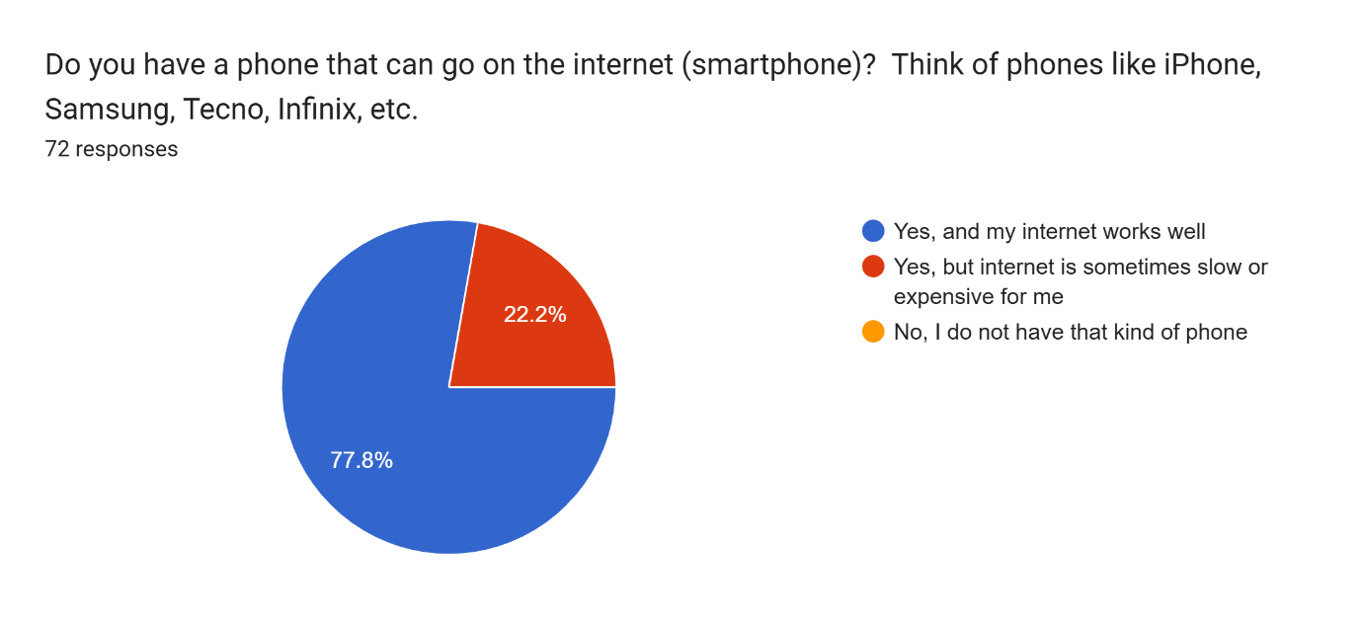Figure 4.3: Smartphone and internet access among respondents
4.2.3 Participation in Njangi Groups
- 40.3% are currently active members of a njangi group.
- 30.6% had participated in a njangi group in the past.
- 8.3% are registered members but currently inactive.
- 20.8% have never been members.
These results show that njangi participation is common, and even non-active respondents are generally familiar with njangi operations.
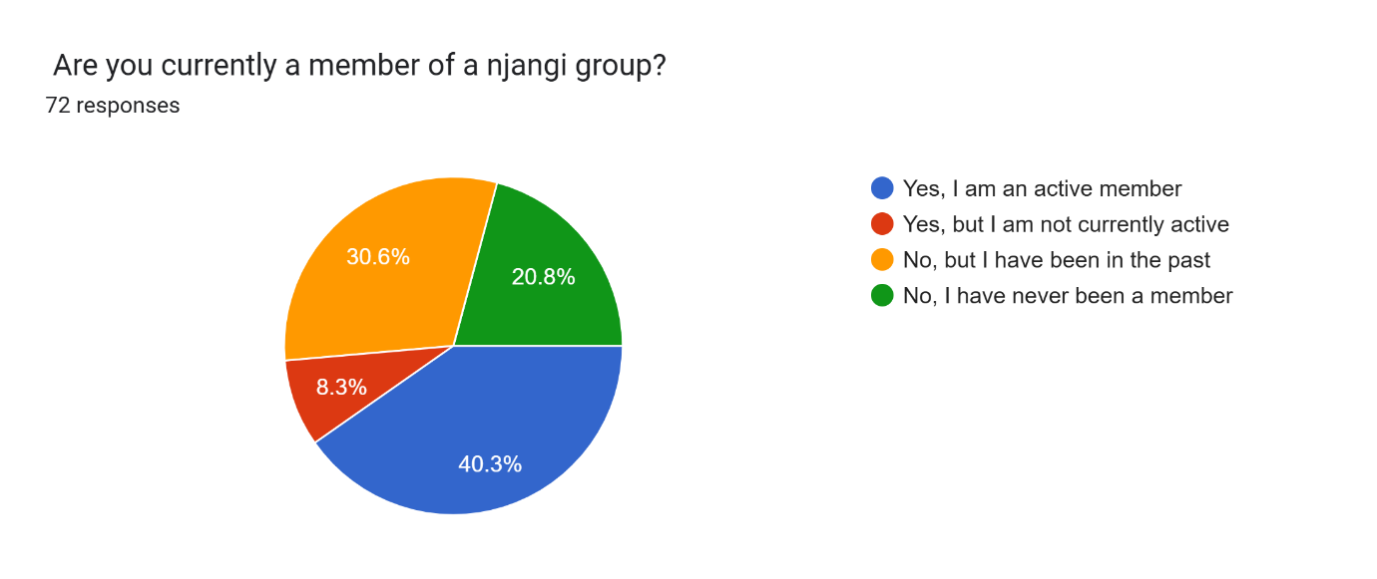Figure 4.4: Njangi participation status of respondents
4.2.4 Trust and Security Issues in Traditional Njangi
Respondents reported recurring problems in traditional njangi operations:
- Late payment of contributions
- Members collecting payouts then refusing to continue contributions
- Disagreements and conflicts among members
- Poor visibility of who has paid
- Mismanagement or disappearance of group funds
- Difficulty organising physical meetings
Open-ended responses repeatedly mentioned trust and transparency as major concerns, such as:
- “Trust and transparency.”
- “Trusting that they won’t run with your money.”
- “Money management issues and difficulties in handling different people.”
These findings confirm that trust, transparency and fund security are key problems to address.
(Optional diagram):
If you coded these issues, you can show a bar chart of frequency of each problem.
- Figure 4.5: Reported challenges in traditional njangi systems
4.2.5 Transparency and Record Keeping
When asked about ease of tracking payment history:
- 17.5% indicated it is very easy, 31.6% indicated it was quite difficult.
- 28.1% gave a neutral response.
- The remaining respondents indicated various difficulties in accessing accurate records.
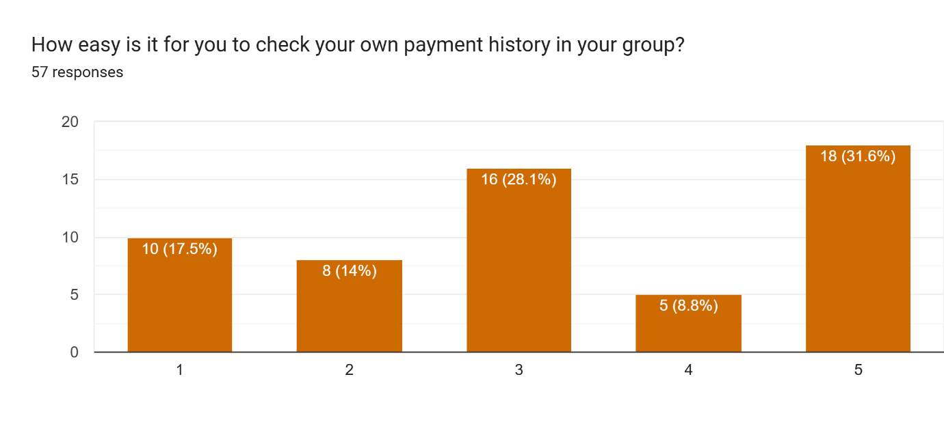 Figure 4.6: Desired transparency and record-keeping features
Features requested to improve transparency:
- 71.9% want everyone to see who has paid and the total amount available.
- 50.9% want downloadable payment records.
- 52.6% want group rules locked so they cannot be secretly changed.
These results show a clear preference for automatic, transparent and tamper-proof records and can be seen in Fig 4.7.
4.2.6 Payment Reminders and Contribution Management
The most requested feature overall was automated reminders:
- 91.2% want reminders when it is time to pay contributions.
Other needs:
- Automatic payout handling: 56.1%
- Mobile money integration (MTN MoMo / Orange Money): 68.4%
Respondents noted difficulties remembering payment dates and ensuring timely contributions, indicating that reminders and automated tracking could improve contribution consistency.
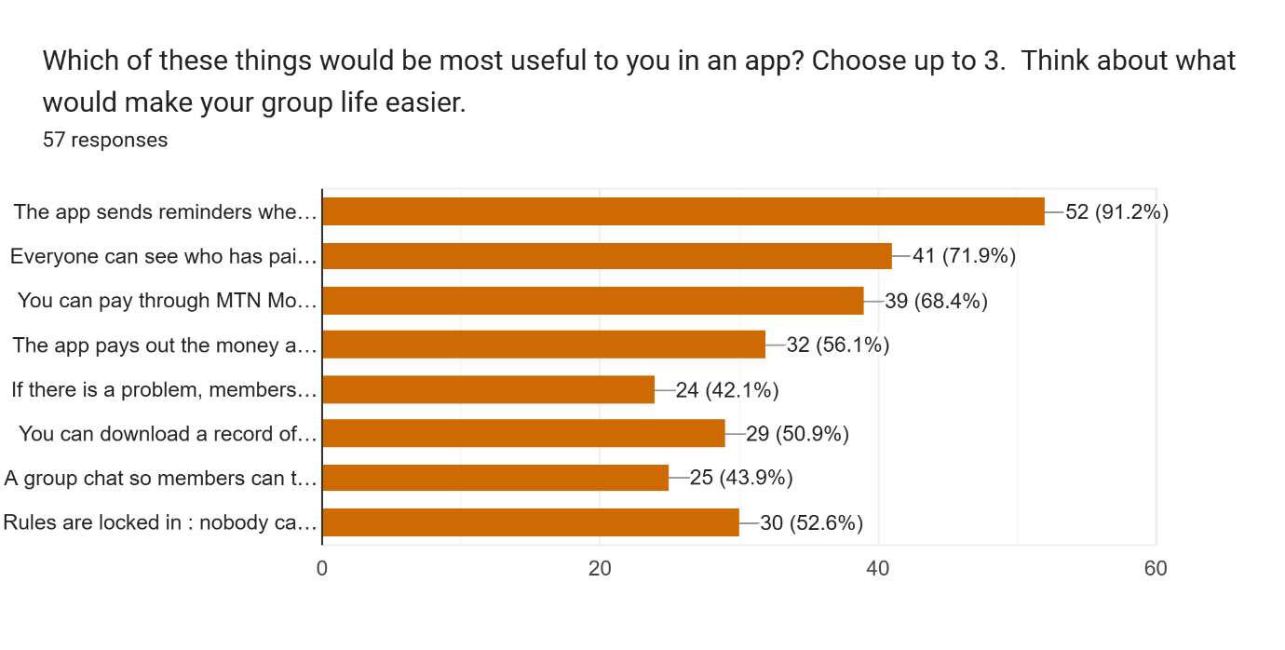Figure 4.7: Preferred features for contribution management
4.2.7 Trust in a Mobile-Based Njangi Application
Willingness to use the app:
- 59.6% strongly indicated willingness to use a free njangi app.
- Only a small minority were strongly opposed.
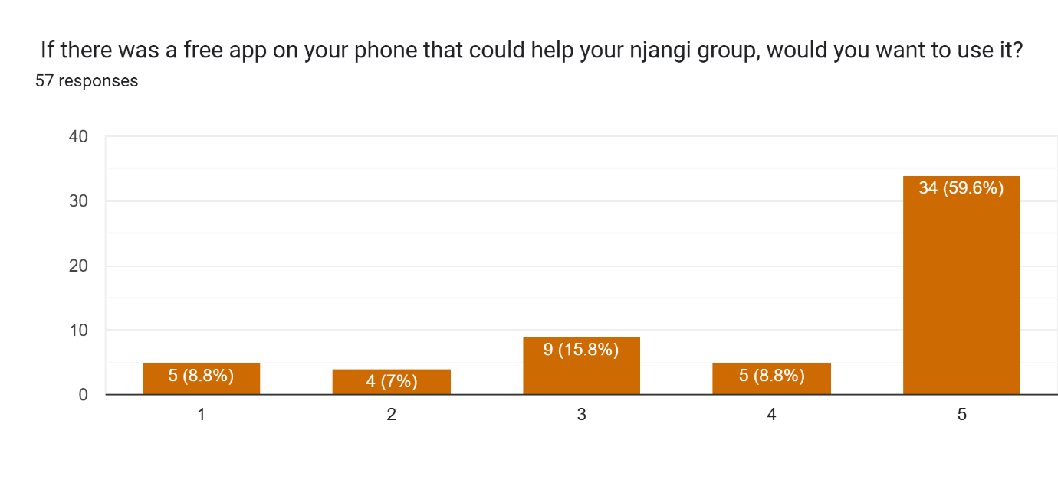
Figure 4.8: Willingness to use the app

Factors that would increase trust:
- 78.9% want all payments to be visible and transparent.
- 71.9% want the app linked to a real bank or licensed payment provider.
- 59.6% want rules permanently written into the app.
- 54.4% want strong privacy protection.
- 40.4% prefer if it is built by Cameroonians familiar with njangi practices.
These preferences highlight the need for transparency, security, regulatory backing and privacy.
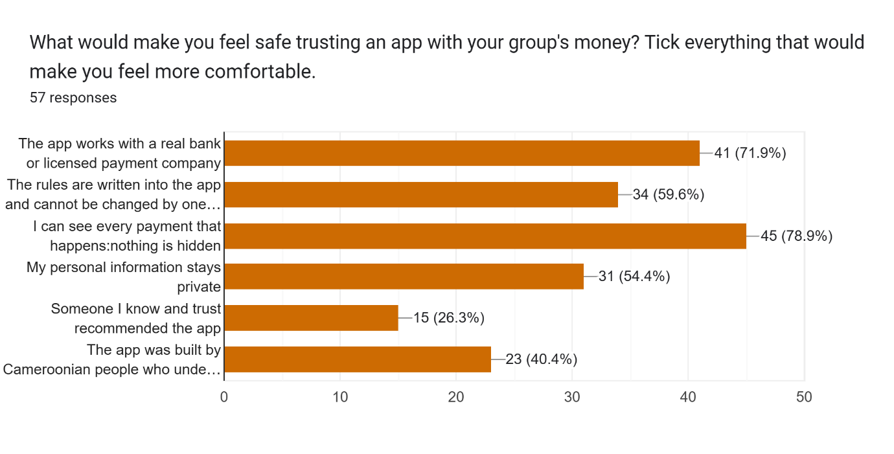Figure 4.9: Factors that increase trust in a mobile njangi app

4.2.8 Financial Considerations and Service Fees
Acceptance of small transaction fees:
- 49.1% said a small transaction fee is fair.
- 31.6% accept a fee only if very small.
- 15.8% insisted the app must be completely free.
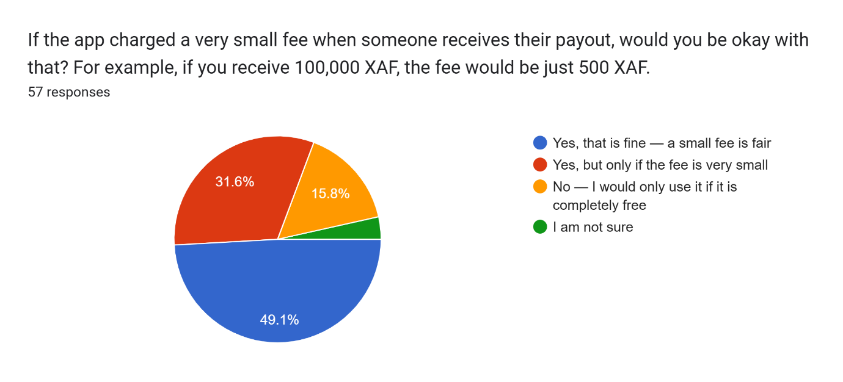
Figure 4.10: Acceptance of transaction/service fees

Willingness to pay for premium features:
- 45.6% would pay up to 500 XAF per month.
- 22.8% would pay between 500–1,000 XAF per month.
- 28.3% would only use a free version.
This suggests that most users are open to modest fees if they see clear value and security.

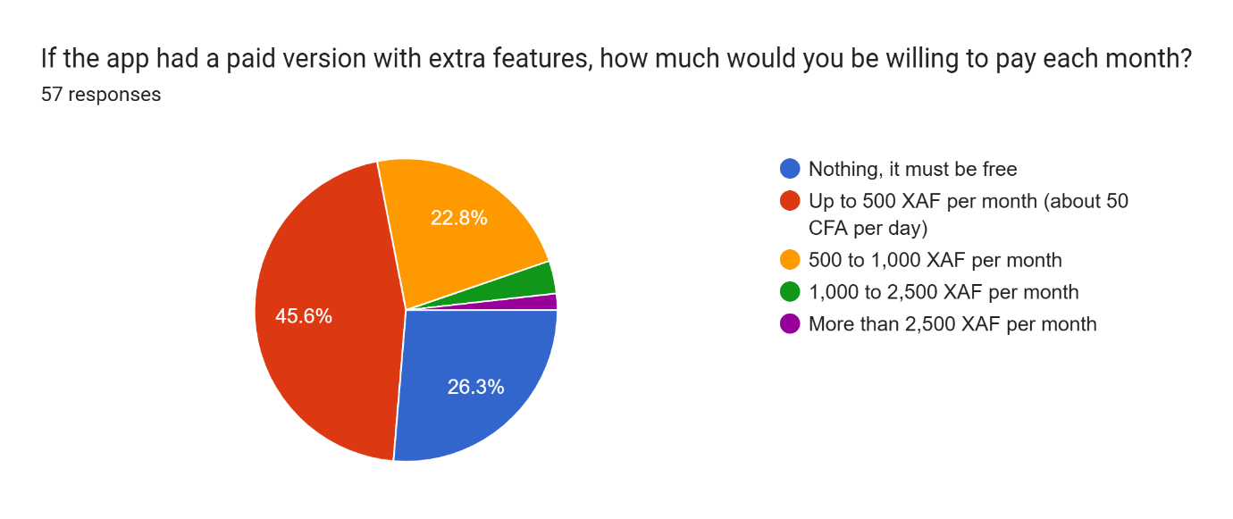
- Figure 4.11: Willingness to pay for premium features

4.2.9 Recommendation and Adoption Potential
- 64.9% said they would strongly recommend the app to their njangi groups if it works well.
- Additional respondents also gave positive recommendation ratings.
This indicates strong adoption potential for a secure mobile-based njangi system that effectively addresses identified challenges.
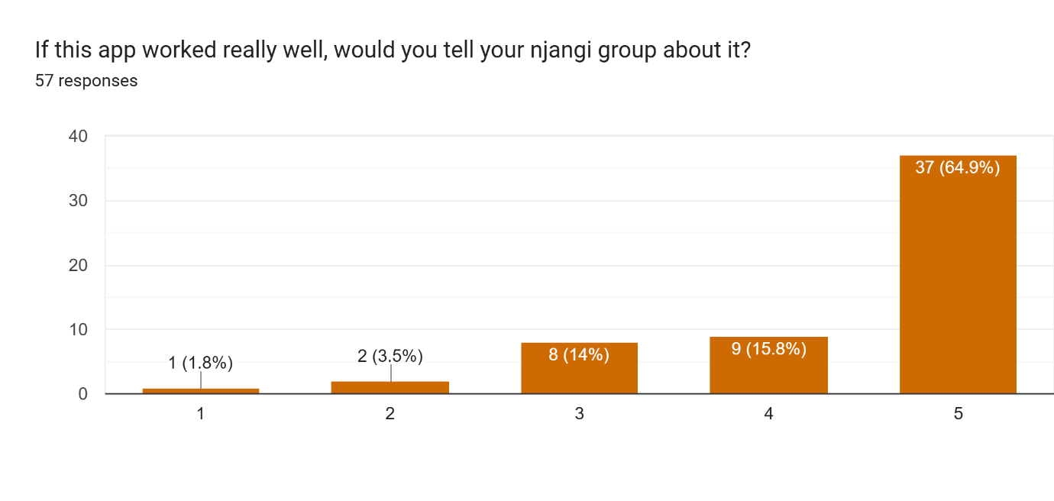Figure 4.11: Intention to recommend the app to njangi groups

4.2.10 Barriers to Adoption
Main concerns raised:
- Internet access problems
- Lack of trust in digital systems
- Some group members not comfortable using smartphones
- Fear of fraud or stolen money
These barriers emphasise the need for:
- Simple, intuitive user interfaces
- Low data usage and offline-friendly features where possible
- Strong authentication and security
- Clear, transparent transaction records
- Reliable integration with mobile money/institutions

4.3 Requirements Analysis and System Specification
Based on the survey results and the literature review, both functional and non-functional requirements were derived.
4.3.1 Functional Requirements
Key functional requirements include:

- User registration and authentication
- Users create accounts using email, phone number, or social login.
- Multi-factor authentication (MFA) for enhanced security.
- Admins can approve or reject member applications.
- Group creation and membership management
- Members: Can contribute, view transactions, and vote on disputes.
- Admins: Can create groups, manage members, and oversee financial transactions.
- Super Admins: Platform-wide management and compliance monitoring.
- Contribution management
- Automated record-keeping of all member contributions.
- Real-time tracking of total group savings and individual balances.
- Payout (rotation) management
- Automated Contribution Collection
- Supports mobile money
- Auto-debit for scheduled contributions via smart contracts.
- First-come, first-paid system based on agreed payout sequence.
- Automated reminders and notifications
- SMS/email alerts for payments, dues, disputes, and payouts.
- Automated notifications to recipients..
- Transparency and record-keeping
- Downloadable member statements.
- Visual dashboards for financial tracking.
- Mobile money integration
- Support integration with MTN MoMo APIs for contributions and payouts.
- Log all transactions with reference IDs.
- Security and privacy
- Secure login and encryption of sensitive data (conceptual at design level).
- Access control to ensure only group members can view group data.
- Dispute Resolution
- Members can raise disputes and vote on resolutions anonymously.
- Smart contracts execute majority-approved decisions.

4.3.2 Non-Functional Requirements
- Usability
  - Simple, intuitive interface suitable for users with varying digital literacy.
  - Use of clear icons and minimal text where possible.
- Performance
  - Fast loading times on typical smartphones used in Cameroon.
  - Efficient database queries to handle multiple groups and members.
- Reliability and availability
  - System should handle intermittent connectivity.
  - Ensure data is not lost when connection drops.
- Security
  - Use secure communication (e.g., HTTPS) between app and server.
  - Protect against unauthorised access, data tampering, and fraud.
- Scalability
  - Able to support growing number of users and groups over time.
- Maintainability
  - Modular architecture to allow future updates and feature additions.

4.4 System Design
This section outlines the main design artefacts of the secure mobile-based njangi management system.
4.4.1 Use Case Diagram
The use case diagram models the interactions between actors and the system. Main actors:
- Member (ordinary user)
- Group Admin
- System / Mobile Money Provider (as external system)
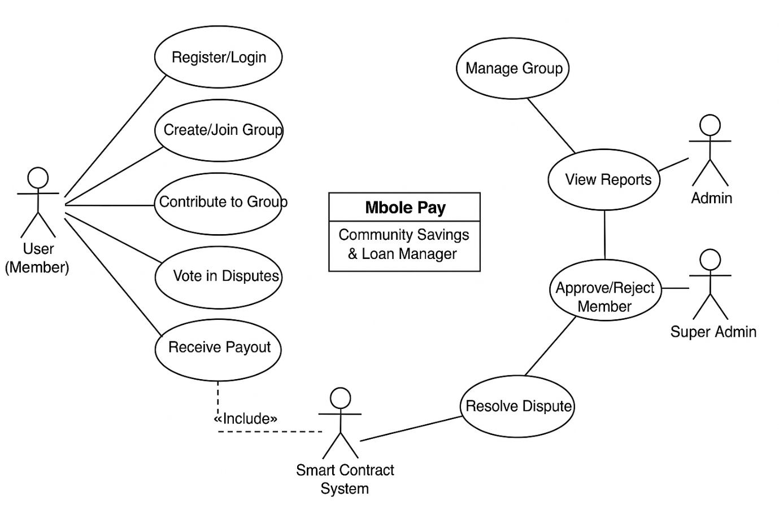Figure 4.12: Use case diagram of the njangi management system
4.4.2 Class Diagram
The class diagram shows the main classes, their attributes, and relationships. Possible main classes:
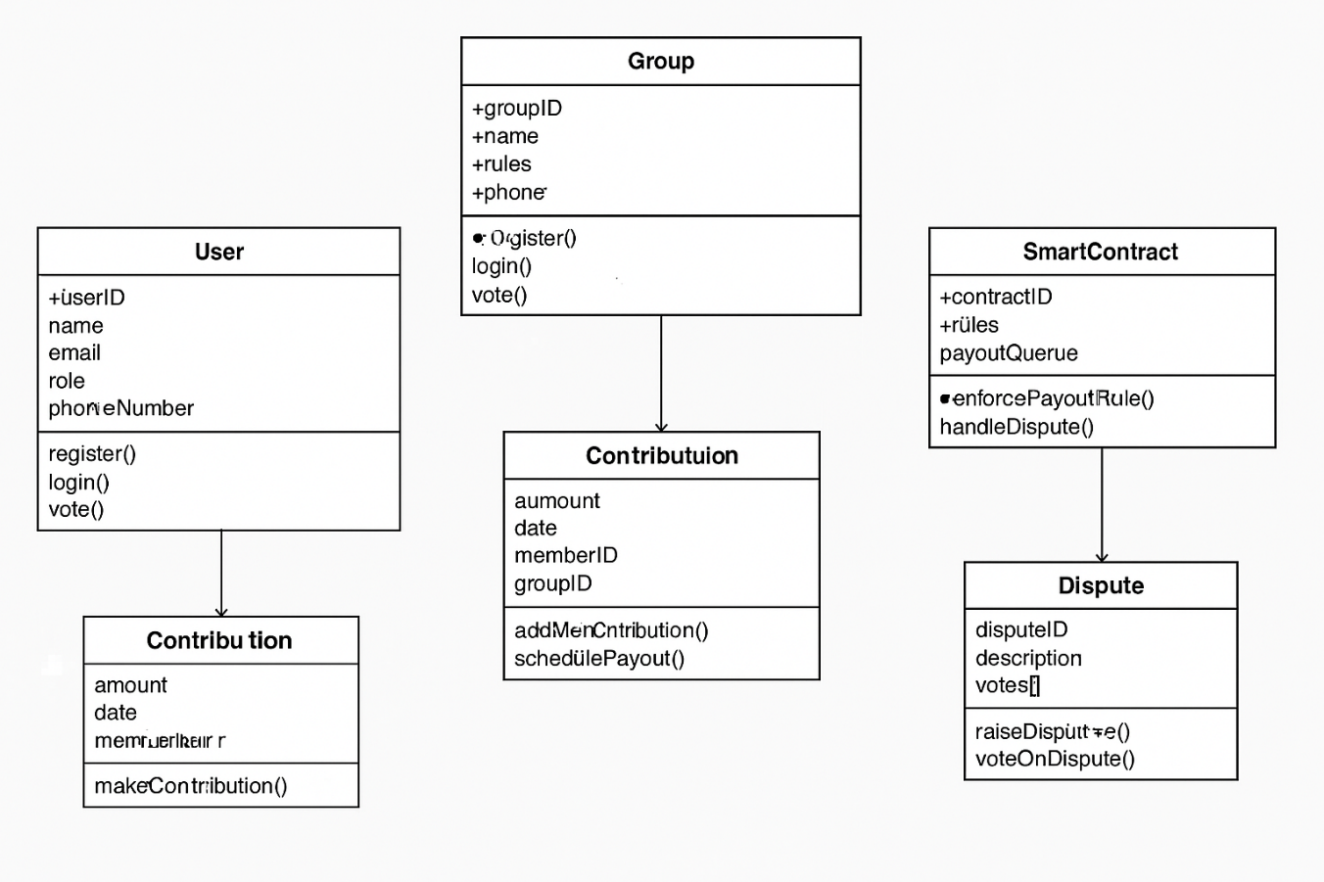Figure 4.13: Class diagram of the njangi management system
4.4.3 Sequence Diagrams (Optional but recommended)
You can include sequence diagrams for key scenarios, e.g.:
- User making a contribution via mobile money.
- System executing a payout cycle.
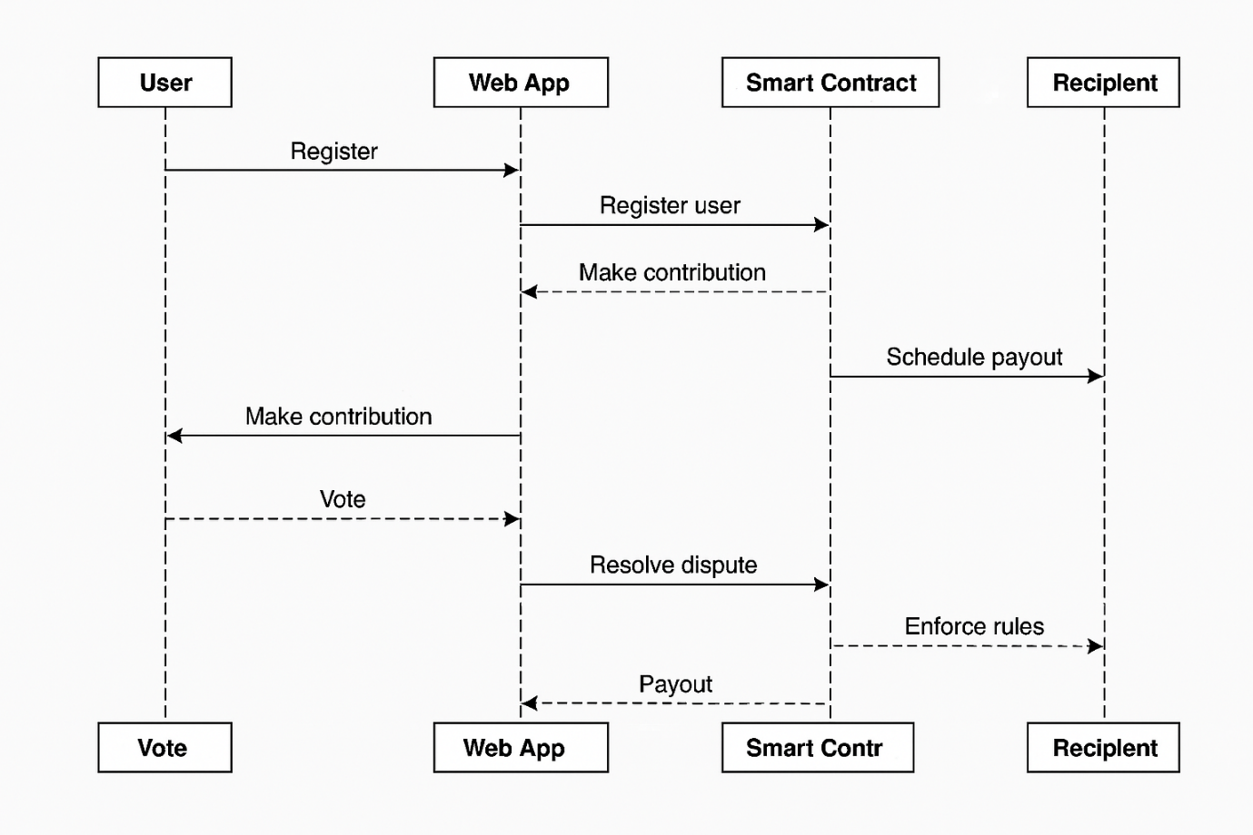Figure 4.14: Sequence diagram for contribution & payout process
4.4.4 System Architecture
Describe the overall architecture, e.g., a client–server architecture:
- Android mobile client (front-end)
- Web service / REST API (backend)
- Database server
- Integration layer to mobile money provider
4.15: High-level system architecture

4.5 System Implementation
This section presents the actual development environment and the key implemented modules.
4.5.1 Development Environment and Tools
4.5.1.1 High-Level Architecture
Frontend: React.js (for an interactive user interface).
Backend: Node.js with Express.js (REST API services).
Database: PostgreSQL (transaction management) & IPFS (for immutable records).
Blockchain: Ethereum or Binance Smart Chain (for smart contracts).
Payment Gateway: Integrations with or MTN Mobile Money.

4.5.1.2 Infrastructure
Hosting: AWS/GCP/Azure with auto-scaling.
IaC: Terraform/Ansible to automate environment setup.
CI/CD: GitHub Actions for automated deployments.

4.5.2 Database Implementation
Translate the class diagram into tables. Briefly describe the main tables:
- users (store user accounts and profiles)
- groups (store njangi group information)
- memberships (link users to groups and roles)
- contributions (record contributions by each member)
- payouts (record payouts)
- transactions (store mobile money transactions)
- notifications (store alerts and reminders)
You may include an ER diagram here.
Place diagram here:
Figure 4.17: Entity–Relationship (ER) diagram of the database
4.5.3 User Interface Implementation
Describe the main screens of the mobile app:
- Login and registration screen
- Dashboard showing joined njangi groups
- Group details screen (members, rules, schedule, current cycle)
- Contribution screen (make payment, view status)
- Payout history screen
- Settings and profile screen
You can add screenshots of the implemented app.
Place screenshots here:
- Figure 4.18: Login screen of the njangi app
- Figure 4.19: Group dashboard screen
- Figure 4.20: Contribution and payout history screens
4.5.4 Key Functionalities Implemented
Briefly list which of the functional requirements from Section 4.3.1 are actually implemented in your prototype, e.g.:
- User registration and login
- Creation and joining of njangi groups
- Recording and viewing of contributions
- Simple payout tracking
- Local notifications or SMS reminders
- Basic rule definition and visibility
- Basic integration or simulation of mobile money transactions

4.6 Testing and Results
This section presents how the system was tested and the outcomes.
4.6.1 Testing Approach
Describe the levels of testing:
- Unit testing: Testing individual functions/classes (e.g., contribution calculations).
- Integration testing: Ensuring that modules such as user management, groups, and payments work together.
- System testing: Testing the whole application according to functional requirements.
- User acceptance testing (UAT): Allowing a few potential users (or classmates) to use the app and give feedback.
4.6.2 Test Cases and Scenarios
Provide a few representative test cases in a table, e.g.:
Test Case ID | Description | Expected Result | Actual Result | Status
TC01 | User registers with valid details | Account created and user redirected to dashboard | As expected | Pass
TC02 | Create new njangi group | Group saved and visible in group list | As expected | Pass
TC03 | Record member contribution | Contribution stored and status updated | As expected | Pass
TC04 | View payment history | Correct list of contributions and payouts shown | As expected | Pass
(Add more rows according to what you actually tested.)
4.6.3 Evaluation of System Against Requirements
Summarise to what extent the implemented system meets the requirements derived from the survey:
- Transparency: The system provides a group dashboard, visible payment status, and histories, addressing visibility and trust problems.
- Reminders: Automatic reminders (notification/SMS) support timely payments.
- Record keeping: All contributions and payouts are stored and can be viewed or exported.
- Security: User authentication and rule-locking reduce chances of tampering.
- Accessibility: Mobile interface designed for smartphone users with relatively low data usage.
If you collected short feedback from a few users testing the prototype, summarise it briefly here (e.g., ease of use, perceived usefulness).

4.7 Summary of the Chapter
This chapter presented the execution of the research methodology. The survey data from 72 respondents was analysed to understand njangi participation, challenges, and user expectations. Key findings highlighted serious issues of trust, transparency, delayed payments, and poor record keeping in traditional njangi systems, as well as strong interest in a secure, mobile-based solution with reminders, transparent records, and mobile money integration.
From these findings, functional and non-functional requirements were derived and used to design a secure mobile njangi management system using UML diagrams and a client–server architecture. The system was then implemented using appropriate development tools, and key features such as group management, contribution tracking, payout management, and notifications were realised. Testing showed that the prototype satisfies the core requirements and has potential to improve accountability, convenience, trust and efficiency in njangi operations. Detailed discussion and conclusions are presented in Chapter Five.

CHAPTER 5: SUMMARY, CONCLUSIONS AND RECOMMENDATIONS

5.1 Introduction
This chapter summarises the study, presents the main conclusions drawn from the findings reported in Chapter Four, and offers recommendations for practice and for further research. The focus is on how a secure mobile-based njangi management system can address trust, transparency and payment discipline challenges in njangi groups in Cameroon.

5.2 Summary of the Study
5.2.1 Problem, Aim and Objectives
Njangi groups in Cameroon face operational challenges including late payments, poor records, fund mismanagement and limited linkage to formal digital financial services. The general objective was to design and implement a secure mobile-based njangi management system that improves transparency, record keeping and payment discipline.
The specific objectives were to:
- Examine current practices, challenges and digital readiness among njangi participants.
- Derive and specify functional and non-functional requirements for a mobile njangi system.
- Design and implement a prototype application that supports core njangi operations.
- Evaluate the usability, perceived usefulness and basic performance of the prototype.
5.2.2 Methodology Overview
A quantitative survey of 72 respondents was conducted using Google Forms to assess njangi participation, challenges and expectations for a mobile system. Descriptive statistics were used to analyse the data. Based on these findings and the literature, functional and non-functional requirements were derived. UML diagrams and a layered architecture were used to design the system, which was then implemented as a mobile-based prototype with backend services and basic integration points for mobile money and notifications. Testing focused on core functional correctness and basic user evaluation.
5.2.3 Summary of Key Findings (by Research Question)
RQ1: What are the main operational, trust and record-keeping challenges?
- Njangi participation is widespread (over 70% current or past members), but groups face recurring problems: late contributions, default after payout, disagreements, poor visibility of who has paid, and cases of mismanaged or missing funds.
- Record-keeping is weak: only 17.5% find tracking payment history very easy, while 31.6% find it quite difficult and many are neutral or uncertain.
- Open responses emphasised “trust and transparency” as central concerns.
RQ2: Which mobile-based features and design principles are most appropriate?
- Digital readiness is high: 77.8% own smartphones with reliable internet; the rest have smartphones but with costly/slow internet.
- Strong demand exists for transparency features: 71.9% want everyone to see who has paid and the total in the pot; 50.9% want downloadable records; 52.6% want locked rules.
- 91.2% want automated payment reminders; 68.4% want mobile money integration; 56.1% favour automatic payout handling.
- Trust-enhancing design needs: fully visible payments (78.9%), linkage to a bank/licensed payment provider (71.9%), permanently encoded rules (59.6%), strong privacy (54.4%), and local contextualisation.
These preferences informed the functional requirements (user registration, group management, contribution and payout management, reminders, transparency dashboards, mobile money integration, security and dispute resolution) and non-functional requirements (usability, performance, security, scalability).
RQ3: How do users perceive a mobile njangi system?
- 59.6% strongly expressed willingness to use a free njangi app, and 64.9% would strongly recommend it to their groups if it works well, indicating good acceptance and adoption potential.
- Most respondents accept small transaction fees if they are fair and clearly justified, and many would pay modest monthly amounts for premium features.
- Concerns remain about internet access, distrust of digital systems, low digital skills among some members, and fear of fraud, pointing to the need for simple interfaces, low data usage and robust security.
System Design, Implementation and Testing
- The system design included use case, class and sequence diagrams, and a three-tier architecture with a mobile client, backend API and database, plus external mobile money and notification services.
- The implemented prototype supports member and admin registration, group creation and membership management, contribution scheduling, automated reminders, tracking of contributions and payouts, and basic reporting.
- Functional tests showed that core operations (registration, group creation, recording contributions and payouts, sending reminders) worked as specified. Basic user evaluation indicated that users could navigate the interface and found the transparency and reminder features useful, though detailed usability metrics may be limited.

5.3 Conclusions
From the findings, the following conclusions are drawn:
- Traditional njangi operations face serious trust, payment discipline and record-keeping problems.
Frequent late or missed payments, poor visibility of contributions and occasional fund mismanagement undermine confidence and group stability.
- Njangi members are digitally ready and strongly desire transparent, rule-based digital support.
High smartphone penetration and strong preferences for visible payment histories, locked rules, and automated reminders show that a mobile platform is appropriate and wanted.
- A secure mobile-based njangi system can operationalise key features that directly address identified challenges.
The requirements and implemented prototype demonstrate that functions such as real-time contribution tracking, automated reminders, downloadable records and structured payout management can be integrated in a single system aligned with user needs.
- Trust in a digital njangi system depends on both technical design and institutional backing.
Users emphasised transparency of all transactions, strong privacy, security controls, and linkage to banks or licensed payment providers as central to trusting and adopting the system.
- There is clear adoption potential, but barriers related to connectivity, skills and fear of fraud must be managed.
High willingness to use and recommend the app, combined with openness to modest fees, suggests viability, but the system must be designed for low-resource environments and accompanied by user education.
- The prototype demonstrates feasibility but further iterative refinement and field deployment are needed.
While core functionality works as intended, long-term impacts on default rates, disputes and financial inclusion require longitudinal and larger-scale evaluations.

5.4 Recommendations
5.4.1 Recommendations for Practice
- Adopt full transaction transparency within njangi groups.
  - Enable all members to view up-to-date lists of who has paid, total contributions and scheduled payouts.
  - Provide downloadable statements for accountability and dispute resolution.
- Institutionalise automated contribution management.
  - Implement configurable reminders via SMS and in-app notifications for upcoming and overdue payments.
  - Highlight late contributors and pending payouts clearly to group admins.
- Encode and protect group rules in the system.
  - Require explicit configuration of contribution amounts, schedules, payout order and penalties at group creation.
  - Restrict rule changes to transparent processes (e.g. admin plus member confirmation) to prevent unilateral rule manipulation.
- Strengthen security and regulatory alignment.
  - Use secure authentication (e.g. PIN, OTP), encrypted communication, and strict access control so only group members see group data.
  - Pursue partnerships with MTN/Orange and regulated banks or MFIs so group funds can be held and moved through trusted, supervised channels.
- Design for inclusiveness and low-resource contexts.
  - Optimise the app for low data usage and intermittent connectivity.
  - Use simple, icon-rich interfaces and clear language; provide brief tutorials for first-time users and group leaders.
  - Explore complementary channels (e.g. SMS/USSD) for members with very low digital skills.
- Implement transparent, affordable pricing.
  - Keep core features free or attach very small, predictable fees.
  - Clearly relate any premium charges to added value (e.g. advanced reporting, insurance products, extended storage).
- Provide user education and support.
  - Organise basic digital and financial literacy sessions for njangi groups adopting the app.
  - Emphasise how the system protects funds and records to counter fear of fraud.
5.4.2 Recommendations for Further Study
- Longitudinal field trials with real njangi groups.
  - Deploy the app with multiple groups over several cycles to measure impacts on payment timeliness, defaults, disputes, satisfaction and group survival.
- Usability and user-experience studies across diverse populations.
  - Conduct structured usability testing with older users, rural members and low-literacy participants to refine interface and workflows.
  - Compare smartphone, USSD and SMS-based versions for inclusiveness.
- Deeper analysis of integration with formal financial services.
  - Investigate regulatory, technical and user-experience aspects of linking njangi accounts with bank and microfinance products (savings, micro-loans, insurance).
- Security, fraud-resistance and governance models.
  - Explore advanced mechanisms such as audit trails, role-based access, reputation or smart-contract elements to further reduce fraud and default risk.
  - Study appropriate governance structures for platform operators, group leaders and regulators.
- Socio-cultural impacts of digitising njangi.
  - Use qualitative methods (interviews, focus groups) to understand how digitisation affects trust, social cohesion, gender dynamics and traditional norms within njangi groups.
- Comparative studies with other digital ROSCA and group-saving platforms.
  - Benchmark the njangi system’s design and performance against e-ROSCAs, M-KOBA-like platforms and existing commercial njangi apps to identify best practices and innovation gaps.

5.5 Summary
This chapter has summarised the study, drawn conclusions linked to the objectives and research questions, and provided recommendations for both practitioners and future researchers. The evidence suggests that a secure, transparent and well-designed mobile njangi system can meaningfully strengthen njangi operations, provided that usability, security, and institutional trust are prioritised and that implementation is supported by appropriate policies, partnerships and further empirical research.

5.5 References
Besin-Mengla, M. M. (2020). Njangi: Pillar of Development in the Anglophone Regions of Cameroon. Journal of Humanities and Social Sciences Studies. https://doi.org/10.32996/jhsss.2020.2.5.5
Code pénal du 12 juillet 2016, § 325 (2016). https://legecam.cm/wp-content/uploads/2024/05/reg-pen-03-code-penal-du-12-juillet-2016-new.pdf
Forje, L. (2014). Domestic saving mobilisation and small business creation: The case of Cameroon. South African Journal of Economic and Management Sciences, 9, 41–56. https://doi.org/10.4102/sajems.v9i1.1156
Francois, P., & Squires, M. (2021). Linking mobile money networks to “e-ROSCAs”: An experimental study. Science Advances, 7. https://doi.org/10.1126/sciadv.abc5831
Johnson, A. R. (2021). Group Borrowing: Microfinance-Tontine Sustainable Co-Existence. Case Of Cameroon. Journal of Economics, Finance And Management Studies. https://doi.org/10.47191/jefms/v4-i11-28
Juma, M., Mramba, N., Suhonen, J., Kapinga, A., & Tedre, M. (2025). Designing a Mobile Prototype for Supporting Financial Management Skills and Decision Making: A Co-Creation Study with Informal Saving Groups in Dodoma, Tanzania. 1–9. https://doi.org/10.1109/etncc66224.2025.11299782
Kim, K.-H. (2021). Assessing the impact of mobile money on improving the financial inclusion of Nairobi women. Journal of Gender Studies, 31, 306–322. https://doi.org/10.1080/09589236.2021.1884536
Ky, S., Rugemintwari, C., & Sauviat, A. (2021). Friends or Foes? Mobile money interaction with formal and informal finance. Telecommunications Policy. https://doi.org/10.1016/j.telpol.2020.102057
Marie, B. (2021, December 17). Tax on tontines: The Directorate General of Taxes provides clarifications. Tax on Tontines: The Directorate General of Taxes Provides Clarifications. https://ocamer.com/en/economy/taxe-sur-les-tontines-la-direction-generale-des-impots-apporte-des-clarifications-2/2066
Mehmood, H. (2018). Save My Money: Digitizing Informal Savings in Pakistan. https://consensus.app/papers/save-my-money-digitizing-informal-savings-in-pakistan-mehmood/7ee460fa7d045dd48639bd68c99a447a/
Mehmood, H., Ahmad, T., Razaq, L., Mare, S., Usmani, M. Z., Anderson, R., & Raza, A. A. (2019). Towards Digitization of Collaborative Savings Among Low-Income Groups. Proceedings of the ACM on Human-Computer Interaction, 3, 1–30. https://doi.org/10.1145/3274304
Ndiege, B., Zakayo, E., & Nakamo, S. (2025). Mobile Technology’s Role in Enhancing Financial Security and Inclusion:Evidence from M-KOBA in Tanzania. Journal of Co-Operative and Business Studies (JCBS). https://doi.org/10.63444/f9xef018
Règlement N°04/19/CEMAC/UMAC/CM Relatif Au Taux Effectif Global, à La Répression de l’usure et à La Publication Des Conditions de Banque Dans La CEMAC (2019).
Wambua, A. W., & Wamuyu, P. (2020). Role of Mobile Applications in Mitigating Challenges Faced by Informal Saving Groups. 1–11. https://consensus.app/papers/role-of-mobile-applications-in-mitigating-challenges-wambua-wamuyu/9398285da026517c851762017ef3a0b6/
S

