View

Here is user interface for view design.

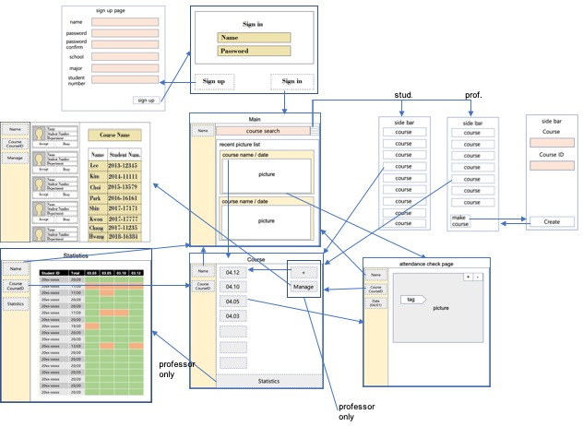

The functionality and the requirement of for each page are described as below.

1. Sign in Page(‘/)

- Sign in

2. Sign up Page(‘/signup)

- Sign up new user

- User can select the type(professor or student)

- (student) Get `name`, `password`, `school`, `major`, `student-id` as user inputs

- (professor) Get `name`, `password`, `school`, `major` as user inputs

3. Main Page(‘/user)

- Show pictures in recent order

- If the user clicks the picture, the user moves to the Attendance check page

- If the user clicks `menu` button, the side bar contains links to course page appears

- If the user types course id that professor gives him/her, the course is added to user’s course

4. Course Page(‘/user/course)

- Show buttons that contain date of class in recent order and (student only) simple statistics

- If the user clicks the button, the user moves to the Attendance check page at that date

- If the user clicks the user button on left side bar, user moves to the Main page

(Professor Only)

- If the user clicks the statistics button, the user moves to the Statistics page

- If the user clicks the manage button, the user moves to the Manage page

- If the user clicks the upload(+) button, show pop-up for uploading picture

5. Class Page(‘/user/course/class)

- Show pictures of that date

- If the user clicks +/- button, the picture is zoomed in/out

- If the user moves the tag to him/her, his/her attendance is checked

- If there is duplicated tag on one person, the page give alert

- If the user clicks the user button on left side bar, user moves to the Main page

- If the user clicks the course button on left side bar, user moves to the Course page

(Professor Only)

6. Course Manage Page(‘/user/course/manage)

- Show participants and candidate for course

- If the users clicks accept/deny the candidate is accepted/denied

- If the user clicks the user button on left side bar, user moves to the Main page

- If the user clicks the course button on left side bar, user moves to the Course page

(Professor Only)

7. Course Statistics Page(‘/user/course/statistics)

- Show students’ attendance statistics

- If the user clicks the user button on left side bar, user moves to the Main page

- If the user clicks the course button on left side bar, user moves to the Course page

Controller

Here is controller design.

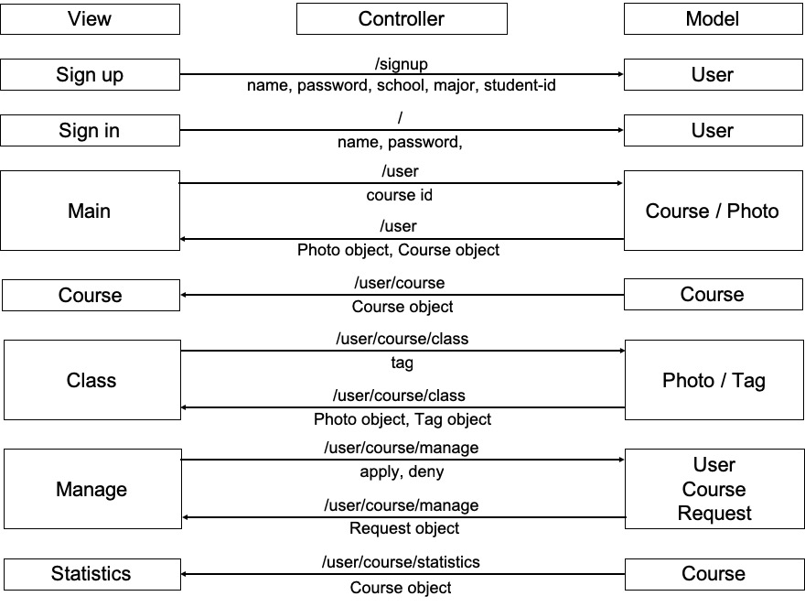

Left side is view part (frontend) and right side is model part (backend). Left-to-right arrow represents http request with user inputs from view, and right-to-left arrow represents http response with data from model. Above the arrow, there is an API that controller uses to transfer JSON data below the arrow.

Frontend Relations

Here are the relations between components.

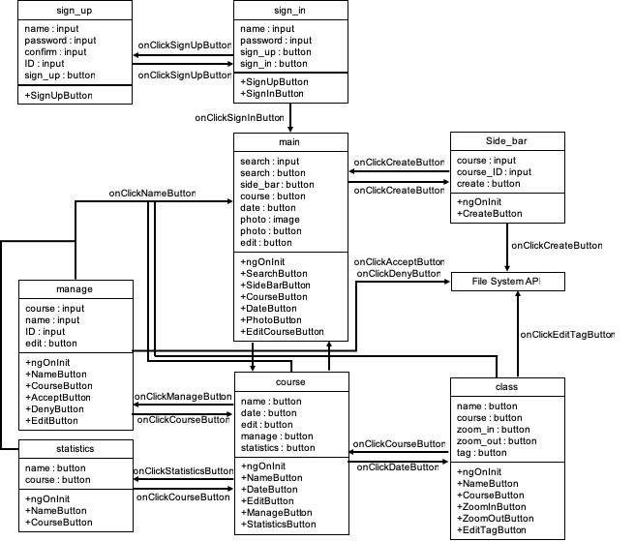

Here are the relations between services and components.

