ASTANA IT UNIVERSITY
FACULTY OF COMPUTER SCIENCE & SOFTWARE ENGINEERING
LABORATORY REPORT
Assignment #3: Responsive Web Design (Media Queries + Bootstrap Grid)
Student: Muratbek Akyl | Course: Web Technologies / Front-End Dev
Group: SE-2301 / CS | Instructor: Abitova G.A.

1. Objective & Background
The primary objective of this assignment is to master Responsive Web Design (RWD) methodologies using two foundational front-end paradigms: pure CSS3 Media Queries and the Bootstrap 5.3 12-column grid system. By completing this work, a deep understanding of multi-screen adaptation is achieved across primary viewport tiers: Mobile (< 768px), Tablet (768px – 1023px), and Desktop (≥ 1024px / ≥ 992px in Bootstrap).
2. Part 1. Media Queries
Task 0. Responsive Typography
Requirements: Create a webpage with headings and paragraphs. Use CSS media queries to scale font sizes dynamically across mobile, tablet, and desktop environments (small on mobile, medium on tablet, larger on desktop).
Implementation Details: In task0.html and css/task0.css, CSS custom properties (--font-h1, --font-h2, --font-h3, --font-body, --line-height-body) were declared at the :root level following a mobile-first philosophy. At min-width: 768px, headings scale up smoothly. At min-width: 1024px, full desktop scales (H1: 3.00rem / 48px, H2: 2.25rem / 36px, Body: 1.125rem / 18px) are applied with increased line heights. A real-time viewport status badge visually indicates which breakpoint rule is currently active. The codebase is completely clean with zero comments.
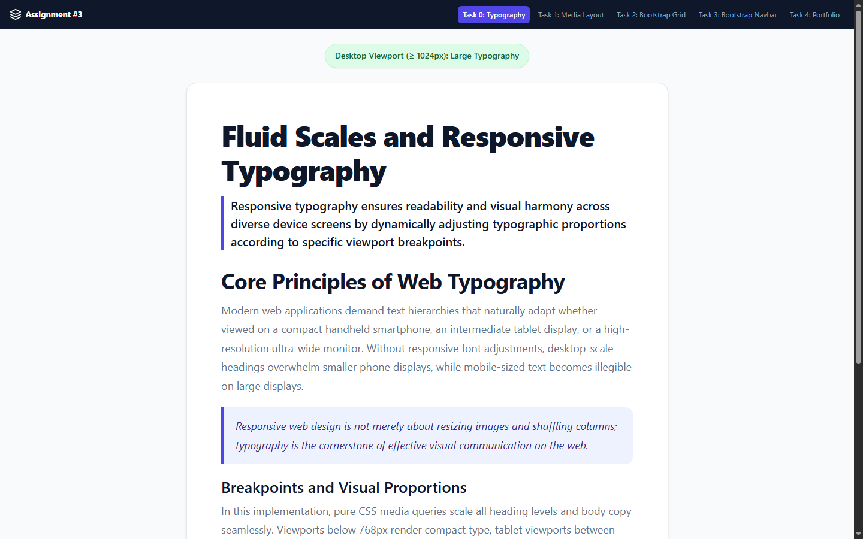
Figure: Task 0 - Desktop Viewport (≥ 1024px): Prominent H1 (48px) and spacious line heights
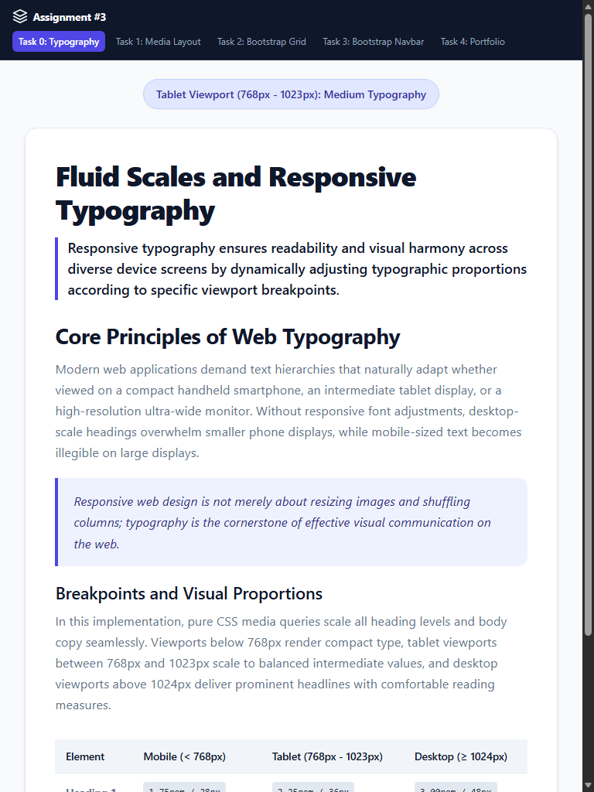
Figure: Task 0 - Tablet Viewport (768px - 1023px): Balanced intermediate typographic scale
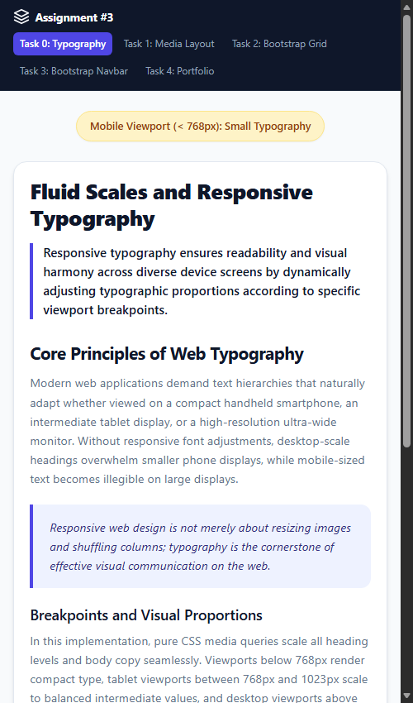
Figure: Task 0 - Mobile Viewport (< 768px): Compact typography preventing overflow
Task 1. Responsive Layout with Media Queries
Requirements: Create a webpage featuring three boxes in a row. On desktop: display all three boxes side by side. On tablet: display two boxes in a row (row 1 has 2 boxes, row 2 has the 3rd box). On mobile: display boxes stacked vertically. Mandatory rule: Use ONLY CSS media queries without external UI frameworks like Bootstrap.
Implementation Details: Pure CSS Grid was implemented in task1.html and css/task1.css without any external dependencies. On mobile (default), grid-template-columns: 1fr stacks all three boxes vertically. On tablet (@media (min-width: 768px)), grid-template-columns: repeat(2, 1fr) neatly arranges Box 1 and Box 2 on the first row, and wraps Box 3 to the second row. On desktop (@media (min-width: 1024px)), grid-template-columns: repeat(3, 1fr) displays all three boxes side by side in a single row. Each box is designed with modern card aesthetics: custom SVG icons, categorization badges, feature checklists, and action buttons.
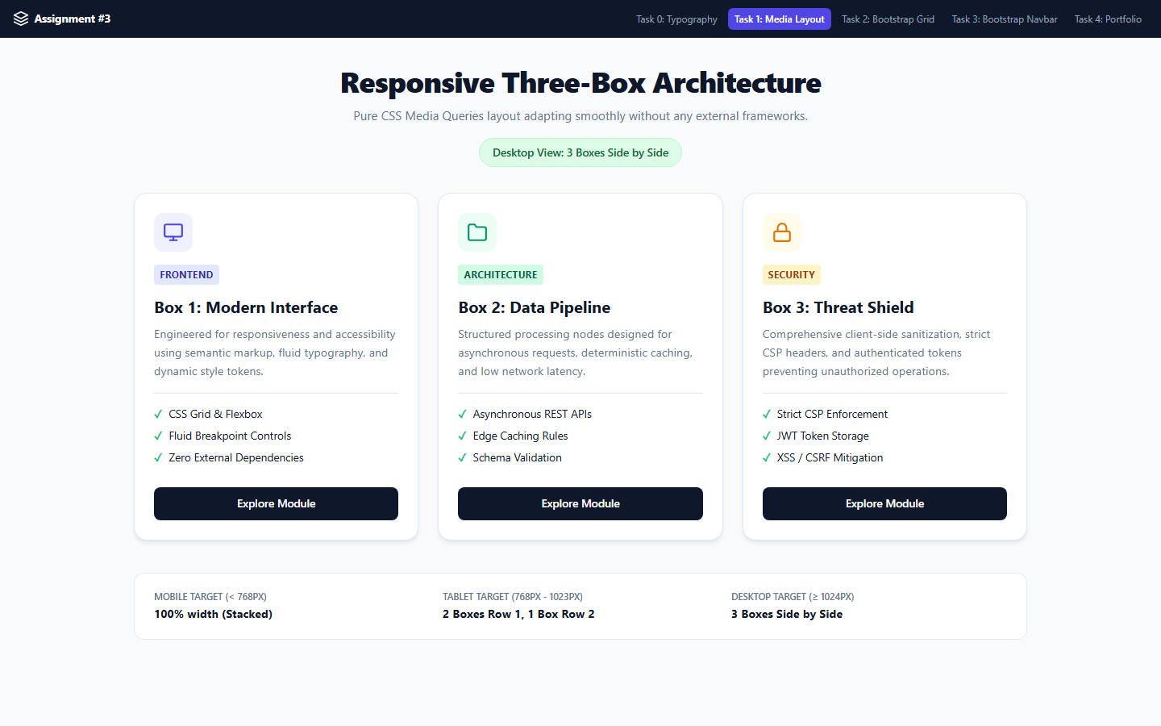
Figure: Task 1 - Desktop Viewport: 3 boxes displayed side by side (3 columns)
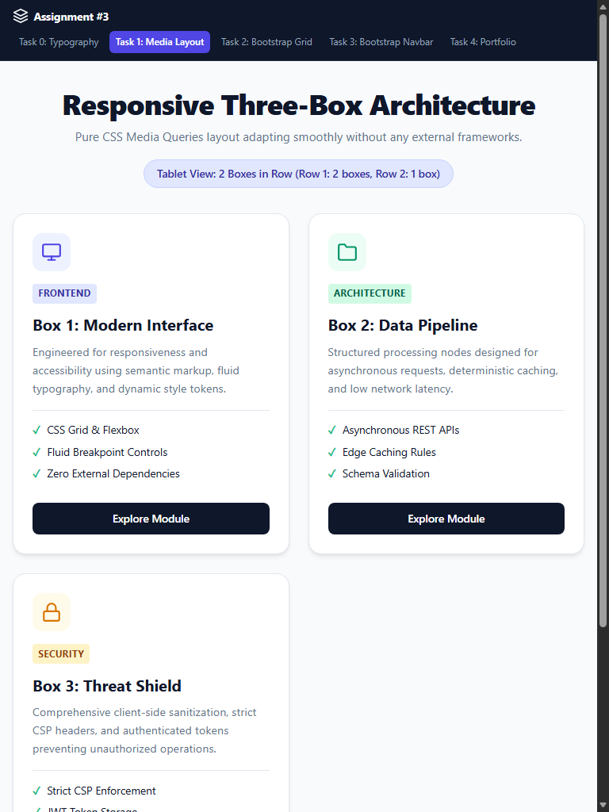
Figure: Task 1 - Tablet Viewport: 2 boxes in row 1, 1 box in row 2 (2 columns)
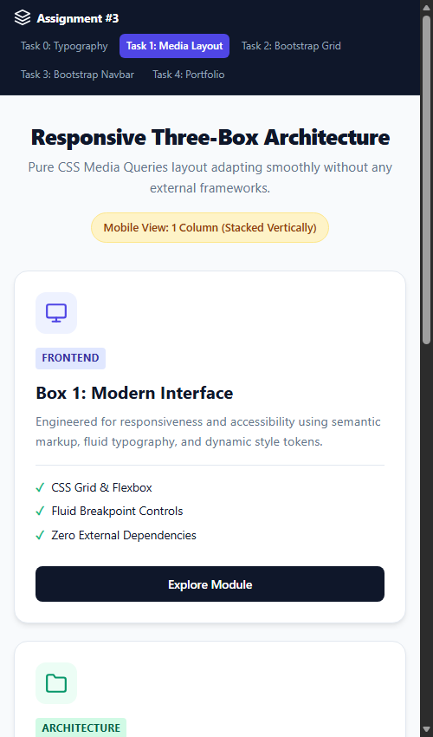
Figure: Task 1 - Mobile Viewport: All 3 boxes stacked vertically (1 column)
3. Part 2. Bootstrap Grid System
Task 2. Bootstrap Responsive Columns
Requirements: Build a responsive layout using Bootstrap's 12-column grid. Create three columns: On desktop: each column takes 4 columns (3 equal parts). On tablet: two columns on the first row and one on the second row. On mobile: all columns stacked.
Implementation Details: Implemented via Bootstrap 5.3 CDN using the class combination col-12 col-md-6 col-lg-4 on each of the three column containers within a standard .row container: 1) On desktop (≥ 992px): col-lg-4 assigns 4 grid units per column (4 + 4 + 4 = 12), achieving 3 equal columns side-by-side. 2) On tablet (768px – 991px): col-md-6 allocates 6 grid units per column. Box 1 and Box 2 take 6 + 6 = 12 units on the first row, forcing Box 3 (6 units) to wrap onto the second row. 3) On mobile (< 768px): col-12 allocates all 12 grid units (100% width), stacking all three columns vertically.
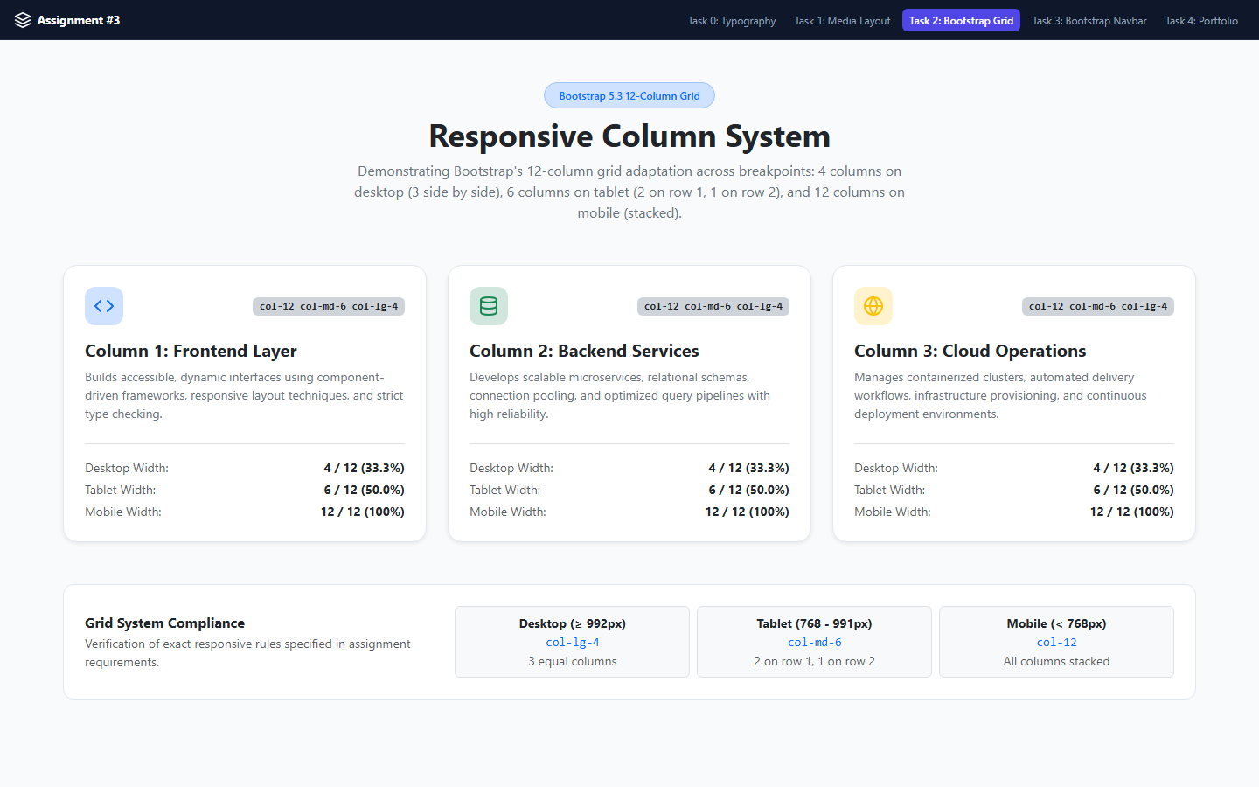
Figure: Task 2 - Desktop View: col-lg-4 (3 equal columns side by side)
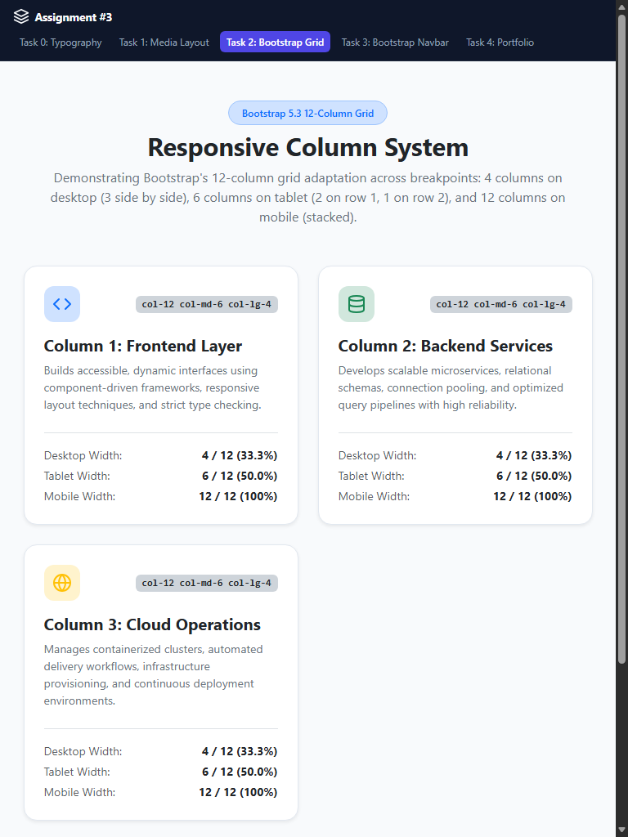
Figure: Task 2 - Tablet View: col-md-6 (2 columns on row 1, 1 column on row 2)
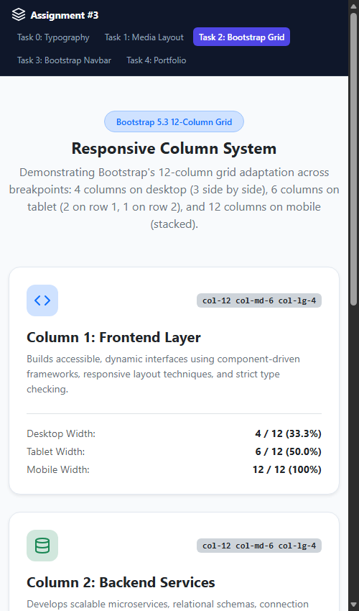
Figure: Task 2 - Mobile View: col-12 (All columns stacked vertically)
Task 3. Bootstrap Navigation Bar
Requirements: Create a responsive navigation bar using Bootstrap components. It should include: a logo on the left, links on the right, and collapse into a hamburger menu on smaller screens.
Implementation Details: Constructed in task3.html with Bootstrap 5.3 navbar component and dark theme attributes (data-bs-theme='dark'). The brand logo and SVG mark are placed on the left using .navbar-brand. The navigation items (.navbar-nav) are pushed to the right side using the margin utility class .ms-auto. The toggler button (.navbar-toggler) and collapsible wrapper (.collapse.navbar-collapse) leverage Bootstrap's JavaScript bundle to collapse navigation links into an animated hamburger menu on viewports smaller than 992px (.navbar-expand-lg).
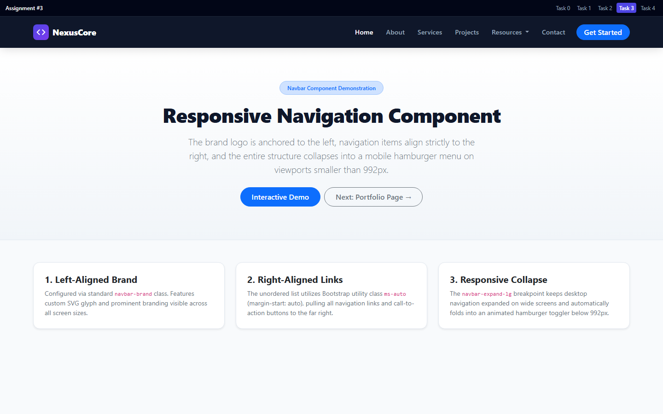
Figure: Task 3 - Desktop View: Logo on left, links aligned right via ms-auto
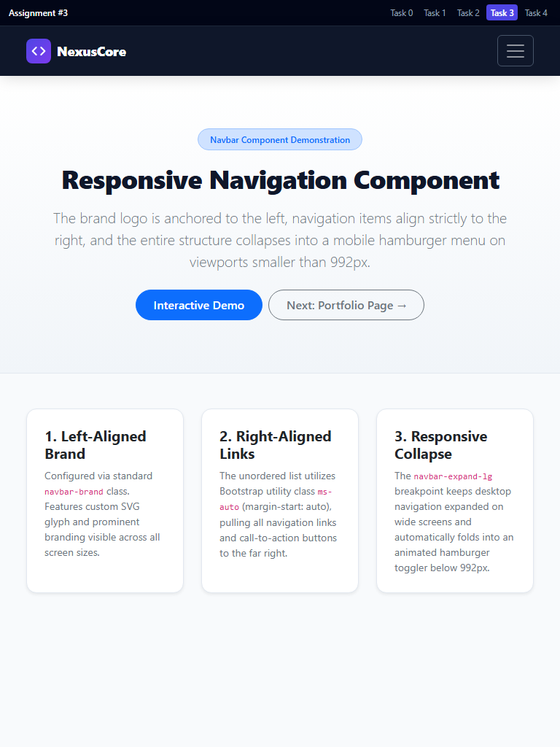
Figure: Task 3 - Tablet View: Collapsible hamburger navbar toggler active
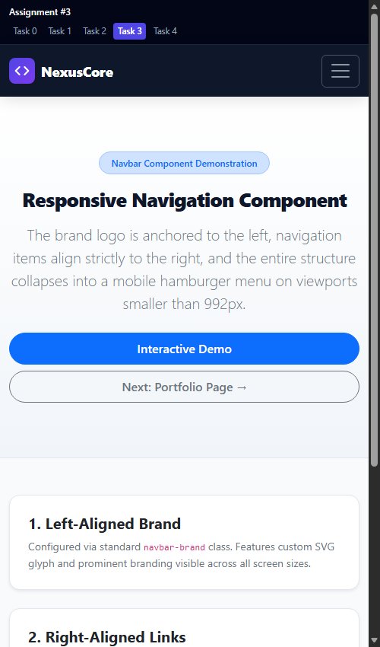
Figure: Task 3 - Mobile View: Compact mobile navigation with hamburger button
4. Part 3. Combined Project
Task 4. Responsive Portfolio Page
Requirements: Create a comprehensive portfolio page combining both CSS Media Queries and Bootstrap Grid. Requirements include: 1) Header with Bootstrap navbar. 2) Main section divided into two parts: left side with portfolio project cards arranged via Bootstrap grid, right side with personal info and contact details sidebar. 3) Footer across the bottom. 4) Custom media queries adjusting font sizes, spacing, and element visibility across mobile, tablet, and desktop.
Implementation Details: Implemented in task4.html (and index.html) with custom stylesheet css/task4.css: • Header: Fully responsive Bootstrap navbar with branded avatar glyph, links, and mobile hamburger toggle. • Hero Section: Visual introduction with developer title, bio, and key credential badges. • Main Layout: Bootstrap 12-column grid splitting the main section into a 8-column project catalog (.col-12.col-lg-8) and a 4-column profile sidebar (.col-12.col-lg-4). • Project Cards: Arranged in a nested 2-column grid (.col-12.col-md-6) featuring project mockups, badges, tech stack pills, descriptions, and action links. • Sidebar: Personal card with avatar, bio, location, core skill progress badges, contact items (email, phone, Telegram, GitHub), and direct message button. • Footer: Multi-column responsive footer with copyright and project acknowledgments. • Custom Media Queries: Scaled typography using clamp() formulas; adjusted card padding and container spacing across breakpoints; dynamically hid secondary project metadata (.badge-desktop-only) on mobile to maintain clean hierarchy.
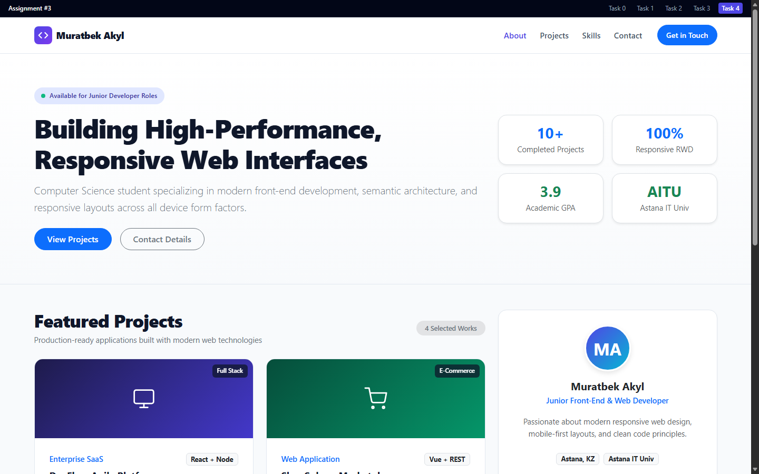
Figure: Task 4 - Desktop View: Full portfolio layout (projects left, sidebar right)
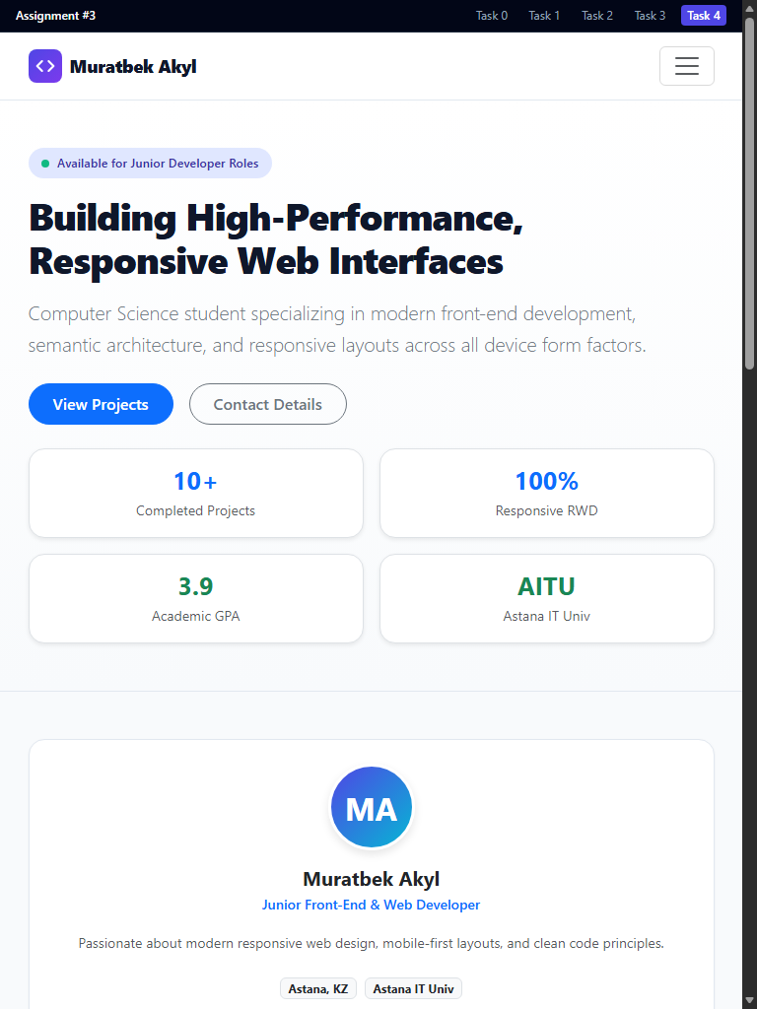
Figure: Task 4 - Tablet View: Responsive grid adaptation and tablet typography
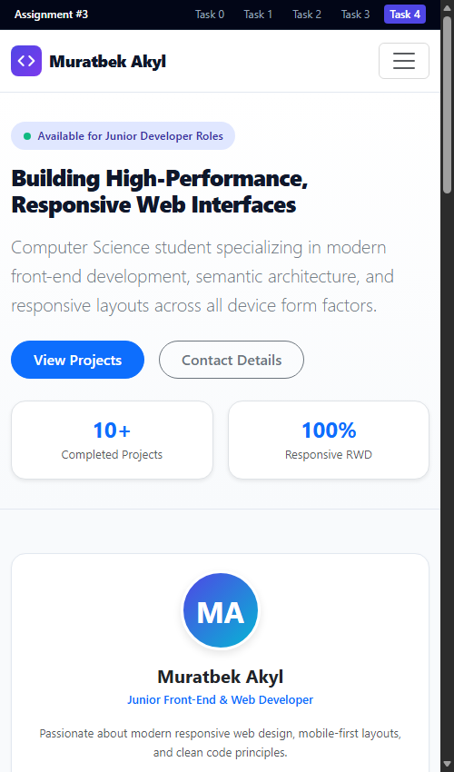
Figure: Task 4 - Mobile View: Optimized mobile layout with collapsed navbar and cards
5. Summary of Work Process
The project was executed in a structured, professional engineering sequence:
1. Architecture Planning: Established standard directory structure (css/, screenshots/) and defined design tokens (color palette, typography scale, shadows) adhering strictly to the 'Clean Code without Comments' instruction.
2. Pure Media Queries Development: Implemented Task 0 (responsive typographic scale) and Task 1 (3-box responsive layout) using modern CSS Grid and custom properties, verifying exact breakpoint behavior without framework dependencies.
3. Bootstrap Grid & Components Integration: Developed Task 2 (12-column grid col-12 col-md-6 col-lg-4) and Task 3 (responsive navbar with left logo, right ms-auto links, and hamburger collapse).
4. Combined Portfolio Engineering: Built Task 4 as a production-grade portfolio integrating semantic HTML5, Bootstrap grid columns, and custom media queries for fluid typography, responsive spacing, and element visibility.
5. Quality Assurance & Headless Testing: Executed automated headless browser tests across all viewport dimensions (mobile, tablet, desktop) to ensure zero horizontal scrollbars, pristine contrast, and perfect responsive wrapping.
6. Defense Preparation & Theoretical Q&A
To prepare for the 30% oral defense during the practice lesson, the following core topics from the course materials (Abitova G.A., MDN, Bootstrap docs) were thoroughly addressed:
Q1: What is the purpose of the <meta name='viewport'> tag?
Answer: Mobile browsers render pages in a virtual desktop viewport (~980px) and scale it down unless told otherwise. The tag <meta name='viewport' content='width=device-width, initial-scale=1.0'> instructs the browser to set the viewport width to the actual device screen width and establish a 1:1 initial zoom scale.
Q2: How do CSS Media Queries function and how are breakpoints selected?
Answer: Media queries evaluate device capabilities (e.g. min-width, max-width, orientation) via @media rules. Common breakpoints are aligned with standard device categories: Mobile (< 768px), Tablet (768px – 1023px), and Desktop (≥ 1024px). Mobile-first design utilizes min-width queries to progressively enhance styles.
Q3: How does Bootstrap's 12-column grid system calculate row wrapping in Task 2?
Answer: Bootstrap's grid divides each row into 12 virtual columns. Using col-12 col-md-6 col-lg-4: on mobile (< 768px), each card occupies 12/12 columns (100% width, stacked); on tablet (768px - 991px), each card occupies 6/12 columns (50% width), so Card 1 (6) + Card 2 (6) = 12 fill the first row, causing Card 3 (6) to wrap onto the second row; on desktop (≥ 992px), each card occupies 4/12 columns (33.3% width), allowing all three (4+4+4=12) to fit side by side.
Q4: How does ms-auto align navigation items to the right in Bootstrap 5?
Answer: In Flexbox, setting margin-left: auto (ms-auto in Bootstrap 5, where 's' stands for 'start' in LTR/RTL logical properties) absorbs all remaining available horizontal space on the left side of the flex item, pushing that item and subsequent items to the far right of the flex container.
Q5: What is the advantage of CSS custom properties (variables) in responsive typography?
Answer: Declaring font sizes as CSS variables at the :root level allows changing typography across the entire stylesheet simply by updating variable values inside media query blocks, ensuring consistent scaling without duplicating selector declarations.

