Assignment #2 - Factory Method & Abstract Factory
Course | Software Design Patterns
Topic | Factory Method & Abstract Factory
Programming Language | Java 17
Option | Vehicle Factory
Student | Khafiz Akylzhan

1. Introduction
In this assignment I used two creational design patterns in one vehicle topic: Factory Method and Abstract Factory. I chose the Vehicle Factory option because it gives a simple way to see the difference between creating one object and creating a group of related objects.
For the Factory Method part, my program creates vehicles. I have a Vehicle interface and two implementations: TwoWheeler and FourWheeler. I also have VehicleFactory, TwoWheelerFactory, and FourWheelerFactory. Each concrete factory creates one vehicle.
For the Abstract Factory part, I used vehicle parts. A vehicle family in my project has an Engine and a Wheel. The Sport family contains SportEngine and SportWheel. The City family contains CityEngine and CityWheel. SportPartsFactory creates the Sport family, and CityPartsFactory creates the City family.
The easiest way for me to remember the difference is: Factory Method creates one product. Abstract Factory creates a family of related products.

2. UML Class Diagrams

2.1 Factory Method
Figure 1 shows my Factory Method structure. Vehicle is the common product interface. TwoWheeler and FourWheeler are the real products. VehicleFactory contains createVehicle(). TwoWheelerFactory creates TwoWheeler, and FourWheelerFactory creates FourWheeler.
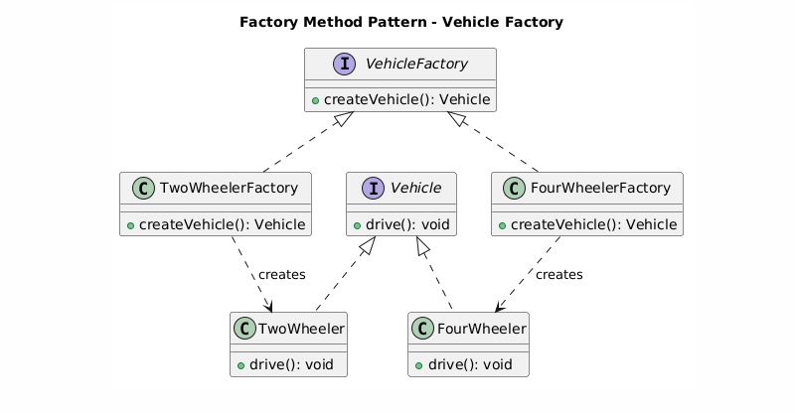
Figure 1. Factory Method UML diagram.

2.2 Abstract Factory
Figure 2 shows my Abstract Factory structure. Engine and Wheel are interfaces for the two product types. VehiclePartsFactory says that every parts factory must create an Engine and a Wheel. The concrete factories decide which family is created.
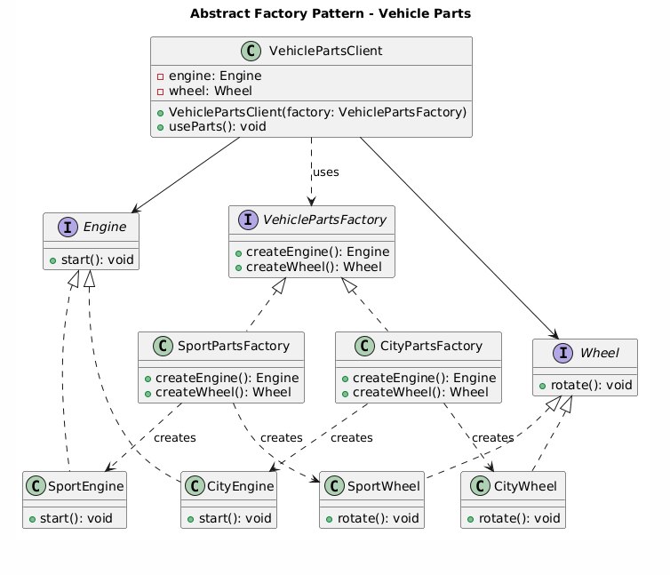
Figure 2. Abstract Factory UML diagram.
SportPartsFactory creates SportEngine and SportWheel. CityPartsFactory creates CityEngine and CityWheel. VehiclePartsClient works with VehiclePartsFactory, Engine, and Wheel, so it does not need to create the concrete parts itself.

3. Clean Code Principles
I tried to keep the project simple and readable. These are five Clean Code ideas that I used in my implementation.

3.1 Meaningful Names
I used names that show what a class or method does. For example, createEngine() creates an engine, createWheel() creates a wheel, and SportPartsFactory creates sport parts. This is clearer than names such as Factory1 or create1().
public interface VehiclePartsFactory {
Engine createEngine();
Wheel createWheel();
}

3.2 Work with Interfaces
VehiclePartsClient receives VehiclePartsFactory instead of one specific factory. It also stores Engine and Wheel instead of SportEngine or CityEngine. Because of this, the same client can work with both families.
public VehiclePartsClient(VehiclePartsFactory factory) {
engine = factory.createEngine();
wheel = factory.createWheel();
}

3.3 No Large if/else in the Client
I did not put product-selection logic inside VehiclePartsClient. The client does not ask whether the family is Sport or City. I pass the required factory to it, and that factory creates the correct products.
VehiclePartsFactory sportFactory = new SportPartsFactory();
VehiclePartsClient sportClient = new VehiclePartsClient(sportFactory);
VehiclePartsFactory cityFactory = new CityPartsFactory();
VehiclePartsClient cityClient = new VehiclePartsClient(cityFactory);

3.4 Small Methods
The factory methods are short and have one job. createEngine() creates only an engine, and createWheel() creates only a wheel. This makes the code easy to read.
public Engine createEngine() {
return new SportEngine();
}
public Wheel createWheel() {
return new SportWheel();
}

3.5 DRY - Don't Repeat Yourself
I use one VehiclePartsClient for both families instead of making one client for Sport and another client for City. The common code for using the parts is written once.
public void useParts() {
engine.start();
wheel.rotate();
}

4. Conclusion
This project helped me see the practical difference between the two patterns. I would use Factory Method when I need factories that create one product type. In my project, TwoWheelerFactory creates a TwoWheeler and FourWheelerFactory creates a FourWheeler.
I would use Abstract Factory when I need a complete family of related products. In my project, the Sport factory creates a sport engine and sport wheel, while the City factory creates a city engine and city wheel.
The patterns add more classes to the project, but they also keep object creation organized. For me, the main rule is simple: one product means Factory Method; a family of products means Abstract Factory.

5. GitHub Repository
Repository: https://github.com/Akylzhan9837/factory_patterns_assignment_sdp_2

