WaterMe

Enable Alarm

Version 1.0

Revision History

|  |  |  |  |
| --- | --- | --- | --- |
| **Date** | **Version** | **Description** | **Author** |
| 31/Mai/2017 | 1.0 | First Version | Paul Giesa |
| 13/Juni/2017 | 1.1 | Espresso test added | Olga Akymenko |
|  |  |  |  |
|  |  |  |  |

Table of Contents

1. Use-Case Name 4

1.1 Brief Description 4

2. Flow of Events 4

2.1 Basic Flow 4

3. Espresso test 5

4. Preconditions 5

5. Postconditions 5

6. Function Points 6

Enable Alarm

# Use-Case Name

## Brief Description

The user can decide whether the buzzer should make sounds when the humidity level is critical.

## Mockup

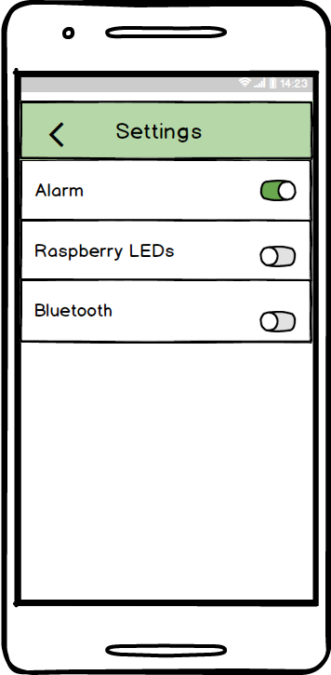

# Flow of Events

## Basic Flow

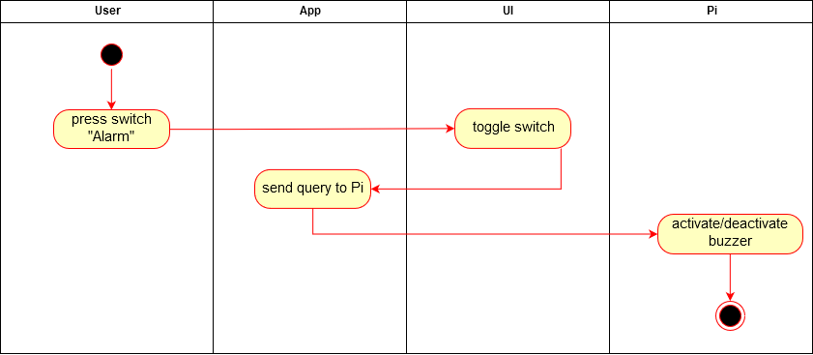

# Espresso test

**package** com.project.gta.demo;  
  
  
**import** android.support.test.espresso.ViewInteraction;  
**import** android.support.test.rule.ActivityTestRule;  
**import** android.support.test.runner.AndroidJUnit4;  
**import** android.test.suitebuilder.annotation.LargeTest;  
  
**import** org.junit.Rule;  
**import** org.junit.Test;  
**import** org.junit.runner.RunWith;  
  
**import static** android.support.test.espresso.Espresso.*onView*;  
**import static** android.support.test.espresso.action.ViewActions.click;  
**import static** android.support.test.espresso.matcher.ViewMatchers.*isDisplayed*;  
**import static** android.support.test.espresso.matcher.ViewMatchers.withId;  
**import static** android.support.test.espresso.matcher.ViewMatchers.*withParent*;  
**import static** android.support.test.espresso.matcher.ViewMatchers.withText;  
**import static** org.hamcrest.Matchers.allOf;  
  
@LargeTest  
@RunWith(AndroidJUnit4.**class**)  
**public class** UCEnableAlarm {  
  
 @Rule  
 **public** ActivityTestRule<MainMenu> **mActivityTestRule** = **new** ActivityTestRule<>(MainMenu.**class**);  
  
 @Test  
 **public void** uCEnableAlarm() {  
 ViewInteraction appCompatButton = *onView*(  
 *allOf*(*withId*(R.id.***BTNsettings***), *withText*(**"Settings"**),  
 *withParent*(*allOf*(*withId*(R.id.***mainmenu***),  
 *withParent*(*withId*(R.id.***activity_main_menu***)))),  
 *isDisplayed*()));  
 appCompatButton.perform(*click*());  
  
 ViewInteraction switch_ = *onView*(  
 *allOf*(*withId*(R.id.***SWsounds***), *isDisplayed*()));  
 switch_.perform(*click*());  
  
 }  
  
}

# Preconditions

The app needs an active connection to the Pi. Also the user has to enter the “Settings Menu”.

# Postconditions

Either the alarm is activated or deactivated.

# Function Points

