**WaterMe**

**Use-Case Specification: Enable LED**

**Version 1.3**

**Revision History**

|  |  |  |  |
| --- | --- | --- | --- |
| **Date** | **Version** | **Description** | **Author** |
| 01/Nov/2016 | 1.0 |  | Chris Todt  Olga Akymenko  Paul Giesa |
| 28/Nov/2016 | 1.1 | Added postcondition and .feature file  minor changes | Chris Todt |
| 01/Mai/2017 | 1.2 | Added FP-Calculation | Olga Akymenko |
| 14/Juni/2017 | 1.3 | UC changed/Mockup added | Olga Akymenko |

**Table of Contents**

**See LEDs 4**

Brief Description 4

|  |  |
| --- | --- |
| **Flow of Events** | **4** |
| Basic Flow | 4 |
| Alternative Flows | 5 |
| **Expresso test** | **5** |
| **Preconditions** | **5** |
| Enable LEDs in App | 5 |
| **Postconditions** | **5** |
| See humidity level | 5 |
| **FP-Calculation** | **5** |
| **Extension Points** | **5** |

**Use-Case Specification: Enable LED**

**1. Enable LED**

**1.1 Brief Description**

The LEDs controlled by the Raspberry Pi indicate the humidity level of the plant. That’s why the user can

gain information about the humidity level very quickly.

**1.2** **Mockup**

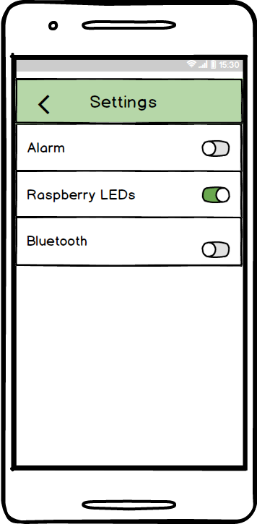

**2. Flow of Events**

**2.1 Basic Flow**

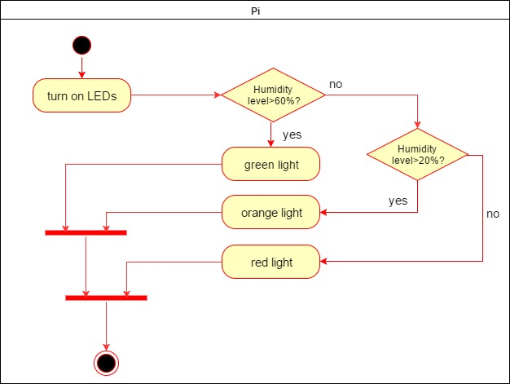

**2.2 Alternative Flows**

(n/a)

**3. Expresso Test**

**package** com.project.gta.demo;  
  
  
**import** android.support.test.espresso.ViewInteraction;  
**import** android.support.test.rule.ActivityTestRule;  
**import** android.support.test.runner.AndroidJUnit4;  
**import** android.test.suitebuilder.annotation.LargeTest;  
  
**import** org.junit.Rule;  
**import** org.junit.Test;  
**import** org.junit.runner.RunWith;  
  
**import static** android.support.test.espresso.Espresso.*onView*;  
**import static** android.support.test.espresso.action.ViewActions.click;  
**import static** android.support.test.espresso.matcher.ViewMatchers.*isDisplayed*;  
**import static** android.support.test.espresso.matcher.ViewMatchers.withId;  
**import static** android.support.test.espresso.matcher.ViewMatchers.*withParent*;  
**import static** android.support.test.espresso.matcher.ViewMatchers.withText;  
**import static** org.hamcrest.Matchers.allOf;  
  
@LargeTest  
@RunWith(AndroidJUnit4.**class**)  
**public class** UCEnableLED {  
  
 @Rule  
 **public** ActivityTestRule<MainMenu> **mActivityTestRule** = **new** ActivityTestRule<>(MainMenu.**class**);  
  
 @Test  
 **public void** uCEnableLED() {  
 ViewInteraction appCompatButton = onView(  
 allOf(withId(R.id.BTNsettings), withText(**"Settings"**),  
 withParent(allOf(withId(R.id.mainmenu),  
 withParent(withId(R.id.activity_main_menu)))),  
 isDisplayed()));  
 appCompatButton.perform(click());  
  
 ViewInteraction switch_ = onView(  
 allOf(withId(R.id.SWled), isDisplayed()));  
 switch_.perform(click());  
  
 }

**4. Preconditions**

**4.1 Enable LEDs in App**

The user has to enable the LEDs in the settings menu of the app (see UC Change Settings). Otherwise the

LEDs are not activated.

**5. Postconditions**

**5.1 See humidity level**

The user can see the humidity level of the plant by looking at the LEDs.

**6. FP-Calculation**

Calculation of DET/RET/FTR: [DET/RET/FTR Table](https://github.com/AkymenkoOlga/WaterMe/blob/master/Function%20Points%20Calculation/Calculation%20_DET_RET_FTR.JPG)

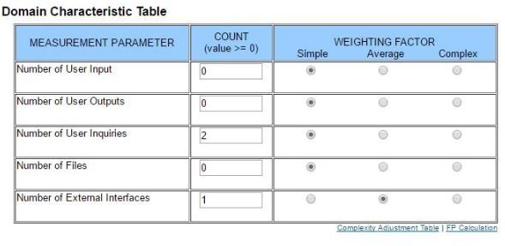

**7. Extension Points**

(n/a)