WaterMe

Request Humidity

Version 1.1

Revision History

|  |  |  |  |
| --- | --- | --- | --- |
| **Date** | **Version** | **Description** | **Author** |
| 31/Mai/2017 | 1.0 | First version | Paul Giesa |
| 13/Juni/2017 | 1.1 | Tests added | Olga Akymenko |
|  |  |  |  |
|  |  |  |  |

Table of Contents

1. Use-Case Name 4

1.1 Brief Description 4

1.2 Mockup 4

2. Flow of Events 5

2.1 Basic Flow 5

3. Espresso test 5

4. Preconditions 7

5. Postconditions 7

6. FP-Calculation 7

Show Humidity Diagram

# Use-Case Name

## Brief Description

The user is able to receive the current humidity level.

## Mockup

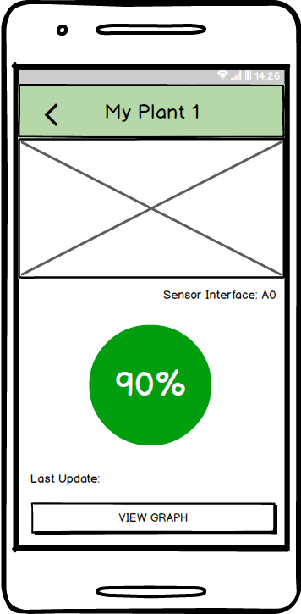

# Flow of Events

## Basic Flow

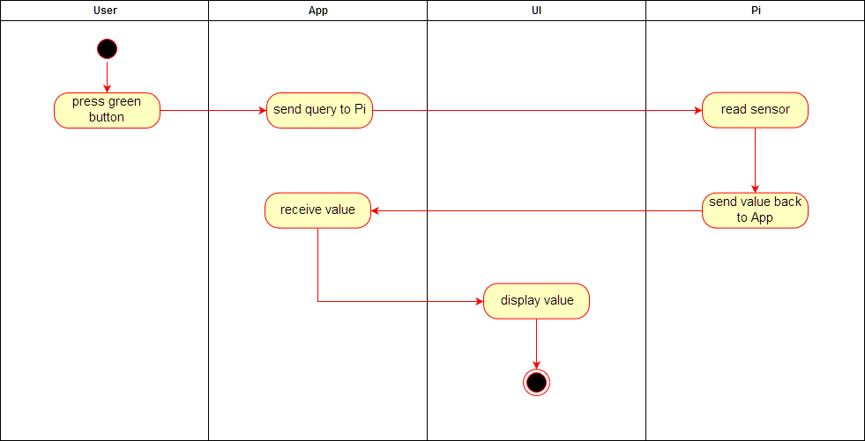

# Espresso test

**package** com.project.gta.demo;  
  
  
**import** android.support.test.espresso.ViewInteraction;  
**import** android.support.test.rule.ActivityTestRule;  
**import** android.support.test.runner.AndroidJUnit4;  
**import** android.test.suitebuilder.annotation.LargeTest;  
  
**import** org.junit.Rule;  
**import** org.junit.Test;  
**import** org.junit.runner.RunWith;  
  
**import static** android.support.test.espresso.Espresso.*onView*;  
**import static** android.support.test.espresso.action.ViewActions.click;  
**import static** android.support.test.espresso.matcher.ViewMatchers.*isDisplayed*;  
**import static** android.support.test.espresso.matcher.ViewMatchers.withContentDescription;  
**import static** android.support.test.espresso.matcher.ViewMatchers.withId;  
**import static** android.support.test.espresso.matcher.ViewMatchers.*withParent*;  
**import static** android.support.test.espresso.matcher.ViewMatchers.withText;  
**import static** org.hamcrest.Matchers.allOf;  
  
@LargeTest  
@RunWith(AndroidJUnit4.**class**)  
**public class** UCVisitHelpMenu {  
  
 @Rule  
 **public** ActivityTestRule<MainMenu> **mActivityTestRule** = **new** ActivityTestRule<>(MainMenu.**class**);  
  
 @Test  
 **public void** uCVisithelpMenu() {  
 ViewInteraction appCompatButton = *onView*(  
 *allOf*(*withId*(R.id.***BTNhelp***), *withText*(**"Help"**),  
 *withParent*(*allOf*(*withId*(R.id.***mainmenu***),  
 *withParent*(*withId*(R.id.***activity_main_menu***)))),  
 *isDisplayed*()));  
 appCompatButton.perform(*click*());  
  
 ViewInteraction appCompatButton2 = *onView*(  
 *allOf*(*withId*(R.id.***BTNhelpBluetoothPi***), *withText*(**"Enable Bluetooth and connect Pi"**), *isDisplayed*()));  
 appCompatButton2.perform(*click*());  
  
 ViewInteraction appCompatImageButton = *onView*(  
 *allOf*(*withContentDescription*(**"Nach oben"**),  
 *withParent*(*allOf*(*withId*(R.id.***action_bar***),  
 *withParent*(*withId*(R.id.***action_bar_container***)))),  
 *isDisplayed*()));  
 appCompatImageButton.perform(*click*());  
  
 ViewInteraction appCompatButton3 = *onView*(  
 *allOf*(*withId*(R.id.***BTNhelp***), *withText*(**"Help"**),  
 *withParent*(*allOf*(*withId*(R.id.***mainmenu***),  
 *withParent*(*withId*(R.id.***activity_main_menu***)))),  
 *isDisplayed*()));  
 appCompatButton3.perform(*click*());  
  
 ViewInteraction appCompatButton4 = *onView*(  
 *allOf*(*withId*(R.id.***BTNhelpInstallPi***), *withText*(**"Install Pi"**), *isDisplayed*()));  
 appCompatButton4.perform(*click*());  
  
 ViewInteraction appCompatImageButton2 = *onView*(  
 *allOf*(*withContentDescription*(**"Nach oben"**),  
 *withParent*(*allOf*(*withId*(R.id.***action_bar***),  
 *withParent*(*withId*(R.id.***action_bar_container***)))),  
 *isDisplayed*()));  
 appCompatImageButton2.perform(*click*());  
  
 ViewInteraction appCompatButton5 = *onView*(  
 *allOf*(*withId*(R.id.***BTNhelp***), *withText*(**"Help"**),  
 *withParent*(*allOf*(*withId*(R.id.***mainmenu***),  
 *withParent*(*withId*(R.id.***activity_main_menu***)))),  
 *isDisplayed*()));  
 appCompatButton5.perform(*click*());  
  
 ViewInteraction appCompatButton6 = *onView*(  
 *allOf*(*withId*(R.id.***BTNhelpAddPlant***), *withText*(**"Add plant"**), *isDisplayed*()));  
 appCompatButton6.perform(*click*());  
  
 ViewInteraction appCompatImageButton3 = *onView*(  
 *allOf*(*withContentDescription*(**"Nach oben"**),  
 *withParent*(*allOf*(*withId*(R.id.***action_bar***),  
 *withParent*(*withId*(R.id.***action_bar_container***)))),  
 *isDisplayed*()));  
 appCompatImageButton3.perform(*click*());  
  
 ViewInteraction appCompatButton7 = *onView*(  
 *allOf*(*withId*(R.id.***BTNhelp***), *withText*(**"Help"**),  
 *withParent*(*allOf*(*withId*(R.id.***mainmenu***),  
 *withParent*(*withId*(R.id.***activity_main_menu***)))),  
 *isDisplayed*()));  
 appCompatButton7.perform(*click*());  
  
 ViewInteraction appCompatButton8 = *onView*(  
 *allOf*(*withId*(R.id.***BTNhelpAskus***), *withText*(**"Ask Us"**),  
 *withParent*(*allOf*(*withId*(R.id.***activity_help_menu***),  
 *withParent*(*withId*(android.R.id.***content***)))),  
 *isDisplayed*()));  
 appCompatButton8.perform(*click*());  
  
 ViewInteraction appCompatImageButton4 = *onView*(  
 *allOf*(*withContentDescription*(**"Nach oben"**),  
 *withParent*(*allOf*(*withId*(R.id.***action_bar***),  
 *withParent*(*withId*(R.id.***action_bar_container***)))),  
 *isDisplayed*()));  
 appCompatImageButton4.perform(*click*());  
  
 }  
  
}

# Preconditions

The app needs an active connection to the Pi. Also the user has to enter the “Single Plant Menu”.

# Postconditions

The green button will show the humidity.

# FP-Calculation

