**WaterMe**

**Use-Case Specification: Visit about menu**

**Version 1.3**

**Revision History**

|  |  |  |  |
| --- | --- | --- | --- |
| **Date** | **Version** | **Description** | **Author** |
| 28/Nov/2016 | 1.0 | Document created | Chris Todt |
| 08/Dez/2016 | 1.1 | Added Espresso test | Chris Todt |
| 01/Mai/2017 | 1.2 | Added FP | Olga Akymenko |
| 14/Juni/2017 | 1.3 | Changed tests | Olga Akymenko |

**Table of Contents**

**Use-Case Name 4**

Brief Description 4

|  |  |
| --- | --- |
| **Flow of Events** | **4** |
| Basic Flow | 4 |
| Alternative Flows | 4 |
| **Espresso test** | **5** |
| **Special requirements** | **6** |
| **Preconditions** | **6** |
| Installed App | 6 |
| **Postconditions** | **6** |
| See about menu | 6 |
| **Extension Points** | **6** |
| **FP Calculation** | **6** |

**Use-Case Specification: Visit about menu**

**1. Use-Case Name**

* 1. **Brief Description**

The user can view an about menu with several informations about the application and the company.

* 1. **Mockup**

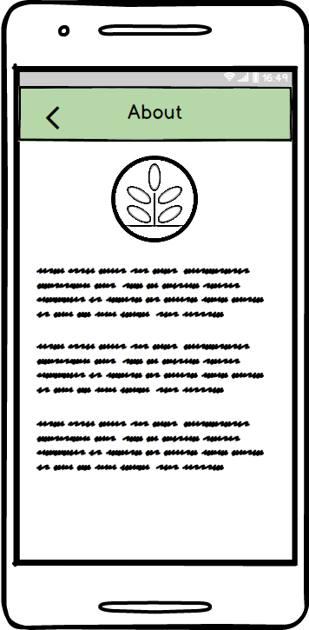

**2. Flow of Events**

**2.1 Basic Flow**

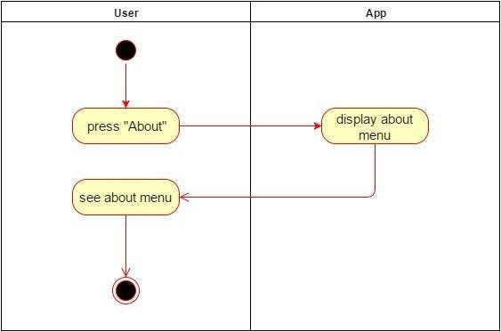

**2.2 Alternative Flows**

(n/a)

**3. Espresso test**

**package** com.project.gta.demo;  
  
  
**import** android.support.test.espresso.ViewInteraction;  
**import** android.support.test.rule.ActivityTestRule;  
**import** android.support.test.runner.AndroidJUnit4;  
**import** android.test.suitebuilder.annotation.LargeTest;  
  
**import** org.junit.Rule;  
**import** org.junit.Test;  
**import** org.junit.runner.RunWith;  
  
**import static** android.support.test.espresso.Espresso.onView;  
**import static** android.support.test.espresso.action.ViewActions.click;  
**import static** android.support.test.espresso.matcher.ViewMatchers.isDisplayed;  
**import static** android.support.test.espresso.matcher.ViewMatchers.withId;  
**import static** android.support.test.espresso.matcher.ViewMatchers.withParent;  
**import static** android.support.test.espresso.matcher.ViewMatchers.withText;  
**import static** org.hamcrest.Matchers.allOf;  
  
@LargeTest  
@RunWith(AndroidJUnit4.**class**)  
**public class** UCVisitAboutMenu {  
  
 @Rule  
 **public** ActivityTestRule<MainMenu> **mActivityTestRule** = **new** ActivityTestRule<>(MainMenu.**class**);  
  
 @Test  
 **public void** uCVisitAboutMenu() {  
 ViewInteraction appCompatButton = onView(  
 allOf(withId(R.id.BTNabout), withText(**"About"**),  
 withParent(allOf(withId(R.id.mainmenu),  
 withParent(withId(R.id.activity_main_menu)))),  
 isDisplayed()));  
 appCompatButton.perform(click());  
  
 }  
  
}

**4. Special requirements**

(n/a)

**5. Preconditions**

**5.1 Installed App**

The user has to be in the main menu.

**6. Postconditions**

**6.1 See about menu**

The user can see the about menu.

**7. FP Calculation**

Calculation of DET/RET/FTR: [DET/RET/FTR_Table](https://github.com/AkymenkoOlga/WaterMe/blob/master/Function%20Points%20Calculation/Calculation%20_DET_RET_FTR.JPG)

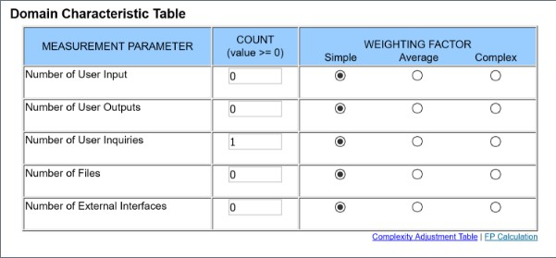

**8. Extension Points**

(n/a)