**WaterMe**

**Use-Case Specification: Visit help menu**

**Version 1.4**

**Revision History**

|  |  |  |  |
| --- | --- | --- | --- |
| **Date** | **Version** | **Description** | **Author** |
| 06.12.2016 | 1.0 |  | Paul Giesa |
| 07.12.2016 | 1.1 | Added mockup | Chris Todt |
| 08.12.2016 | 1.2 | Added Espresso test | Chris Todt |
| 08.06.2017 | 1.3 | Update Mockup | Chris Todt |
| 14.06.2017 | 1.4 | Update Mockup/Tests | Olga Akymenko |

**Table of Contents**

|  |  |
| --- | --- |
| **Visit help menu** | **4** |
| Brief Description | 4 |
| Mockup | 4 |

|  |  |
| --- | --- |
| **Flow of Events** | **6** |
| Basic Flow | 6 |
| **Espresso test** | **7** |
| **Special Requirements** | **9** |
| **Preconditions** | **9** |
| Main Menu | 9 |
| **Postconditions** | **9** |
| **Extension Points** | **9** |

**Use-Case Specification: Visit help menu**

**1. Visit help menu**

**1.1 Brief Description**

In case the user does not know how to set up the Pi or other hardware, connect to the pi, add new plant or has other questions he can visit the help menu

**1.2 Mockup**

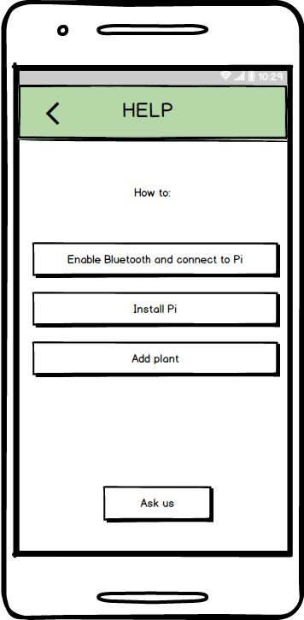

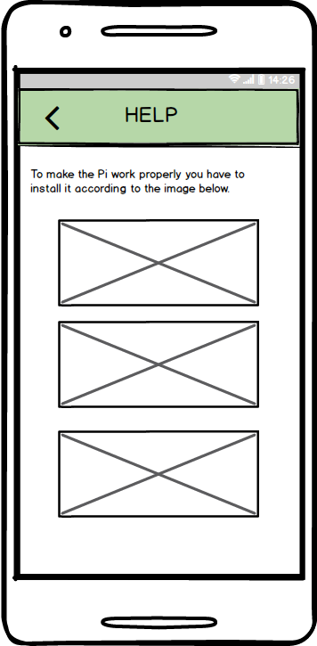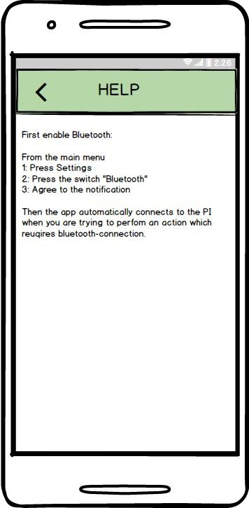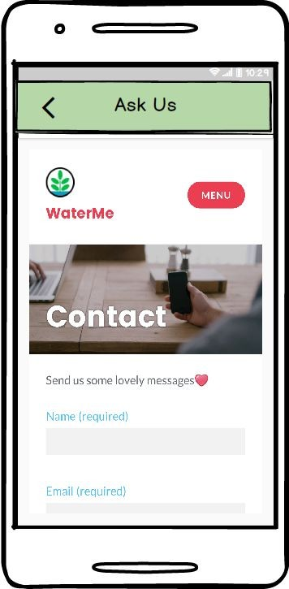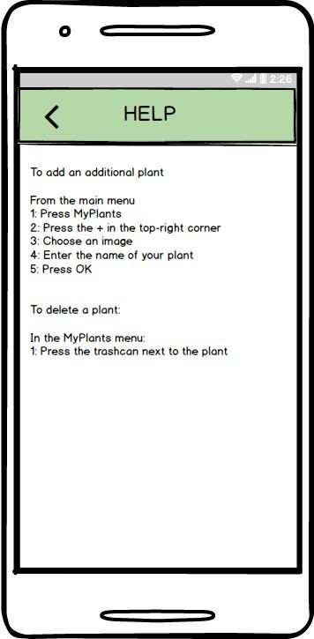

Confidential ©GTA-Group, 2016 Page 5

**2. Flow of Events**

**2.1 Basic Flow**

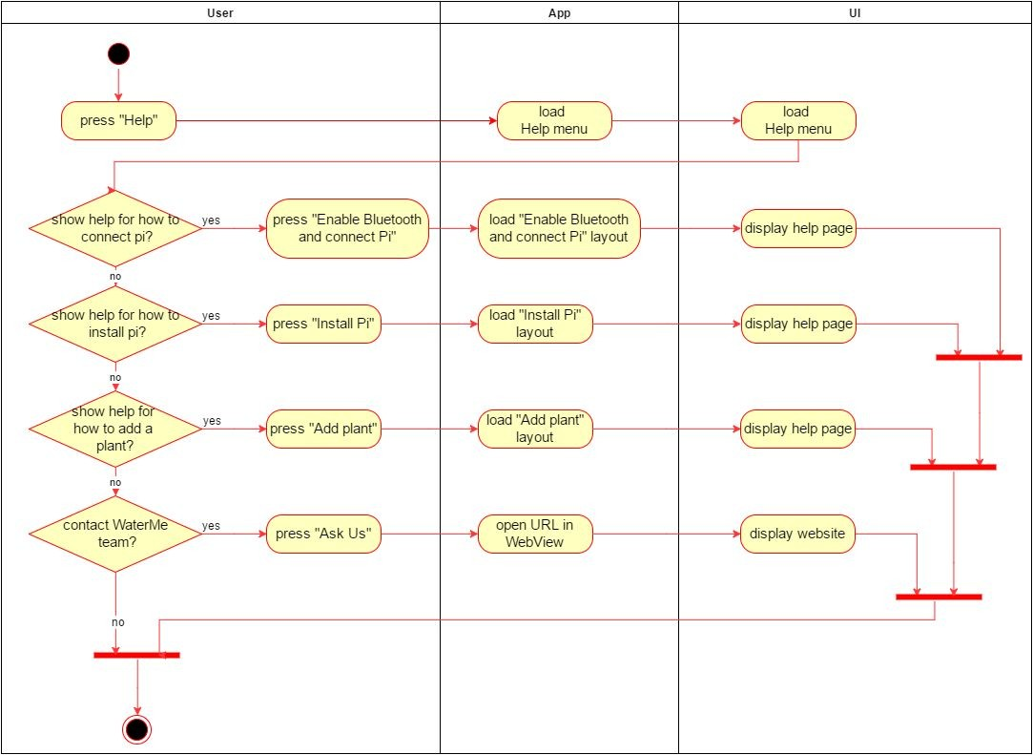

**3. Espresso test**

**package** com.project.gta.demo;  
  
  
**import** android.support.test.espresso.ViewInteraction;  
**import** android.support.test.rule.ActivityTestRule;  
**import** android.support.test.runner.AndroidJUnit4;  
**import** android.test.suitebuilder.annotation.LargeTest;  
  
**import** org.junit.Rule;  
**import** org.junit.Test;  
**import** org.junit.runner.RunWith;  
  
**import static** android.support.test.espresso.Espresso.*onView*;  
**import static** android.support.test.espresso.action.ViewActions.click;  
**import static** android.support.test.espresso.matcher.ViewMatchers.*isDisplayed*;  
**import static** android.support.test.espresso.matcher.ViewMatchers.withContentDescription;  
**import static** android.support.test.espresso.matcher.ViewMatchers.withId;  
**import static** android.support.test.espresso.matcher.ViewMatchers.*withParent*;  
**import static** android.support.test.espresso.matcher.ViewMatchers.withText;  
**import static** org.hamcrest.Matchers.allOf;  
  
@LargeTest  
@RunWith(AndroidJUnit4.**class**)  
**public class** UCVisitHelpMenu {  
  
 @Rule  
 **public** ActivityTestRule<MainMenu> **mActivityTestRule** = **new** ActivityTestRule<>(MainMenu.**class**);  
  
 @Test  
 **public void** uCVisithelpMenu() {  
 ViewInteraction appCompatButton = *onView*(  
 *allOf*(*withId*(R.id.***BTNhelp***), *withText*(**"Help"**),  
 *withParent*(*allOf*(*withId*(R.id.***mainmenu***),  
 *withParent*(*withId*(R.id.***activity_main_menu***)))),  
 *isDisplayed*()));  
 appCompatButton.perform(*click*());  
  
 ViewInteraction appCompatButton2 = *onView*(  
 *allOf*(*withId*(R.id.***BTNhelpBluetoothPi***), *withText*(**"Enable Bluetooth and connect Pi"**), *isDisplayed*()));  
 appCompatButton2.perform(*click*());  
  
 ViewInteraction appCompatImageButton = *onView*(  
 *allOf*(*withContentDescription*(**"Nach oben"**),  
 *withParent*(*allOf*(*withId*(R.id.***action_bar***),  
 *withParent*(*withId*(R.id.***action_bar_container***)))),  
 *isDisplayed*()));  
 appCompatImageButton.perform(*click*());  
  
 ViewInteraction appCompatButton3 = *onView*(  
 *allOf*(*withId*(R.id.***BTNhelp***), *withText*(**"Help"**),  
 *withParent*(*allOf*(*withId*(R.id.***mainmenu***),  
 *withParent*(*withId*(R.id.***activity_main_menu***)))),  
 *isDisplayed*()));  
 appCompatButton3.perform(*click*());  
  
 ViewInteraction appCompatButton4 = *onView*(  
 *allOf*(*withId*(R.id.***BTNhelpInstallPi***), *withText*(**"Install Pi"**), *isDisplayed*()));  
 appCompatButton4.perform(*click*());  
  
 ViewInteraction appCompatImageButton2 = *onView*(  
 *allOf*(*withContentDescription*(**"Nach oben"**),  
 *withParent*(*allOf*(*withId*(R.id.***action_bar***),  
 *withParent*(*withId*(R.id.***action_bar_container***)))),  
 *isDisplayed*()));  
 appCompatImageButton2.perform(*click*());  
  
 ViewInteraction appCompatButton5 = *onView*(  
 *allOf*(*withId*(R.id.***BTNhelp***), *withText*(**"Help"**),  
 *withParent*(*allOf*(*withId*(R.id.***mainmenu***),  
 *withParent*(*withId*(R.id.***activity_main_menu***)))),  
 *isDisplayed*()));  
 appCompatButton5.perform(*click*());  
  
 ViewInteraction appCompatButton6 = *onView*(  
 *allOf*(*withId*(R.id.***BTNhelpAddPlant***), *withText*(**"Add plant"**), *isDisplayed*()));  
 appCompatButton6.perform(*click*());  
  
 ViewInteraction appCompatImageButton3 = *onView*(  
 *allOf*(*withContentDescription*(**"Nach oben"**),  
 *withParent*(*allOf*(*withId*(R.id.***action_bar***),  
 *withParent*(*withId*(R.id.***action_bar_container***)))),  
 *isDisplayed*()));  
 appCompatImageButton3.perform(*click*());  
  
 ViewInteraction appCompatButton7 = *onView*(  
 *allOf*(*withId*(R.id.***BTNhelp***), *withText*(**"Help"**),  
 *withParent*(*allOf*(*withId*(R.id.***mainmenu***),  
 *withParent*(*withId*(R.id.***activity_main_menu***)))),  
 *isDisplayed*()));  
 appCompatButton7.perform(*click*());  
  
 ViewInteraction appCompatButton8 = *onView*(  
 *allOf*(*withId*(R.id.***BTNhelpAskus***), *withText*(**"Ask Us"**),  
 *withParent*(*allOf*(*withId*(R.id.***activity_help_menu***),  
 *withParent*(*withId*(android.R.id.***content***)))),  
 *isDisplayed*()));  
 appCompatButton8.perform(*click*());  
  
 ViewInteraction appCompatImageButton4 = *onView*(  
 *allOf*(*withContentDescription*(**"Nach oben"**),  
 *withParent*(*allOf*(*withId*(R.id.***action_bar***),  
 *withParent*(*withId*(R.id.***action_bar_container***)))),  
 *isDisplayed*()));  
 appCompatImageButton4.perform(*click*());  
  
 }  
  
}

**4. Special Requirements**

(n/a)

**5. Preconditions**

**5.1 Main Menu**

The user has to be in the main menu to access the help menu

**6. Postconditions**

(n/a)

**7. Extension Points**

(n/a)