WaterMe

Members

* Olga Akymenko
* Paul Giesa
* Chris Todt

E-Mail: paul.giesa@arcor.de

Overall UC diagram

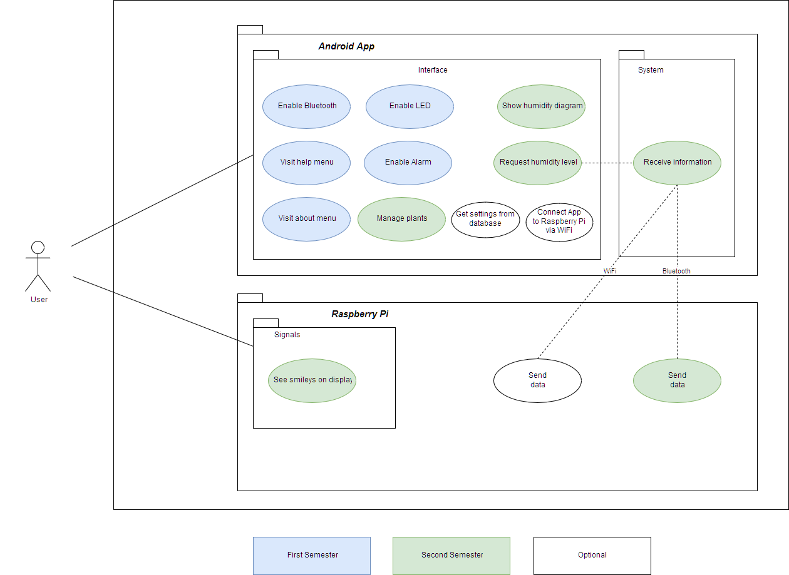

|  |  |
| --- | --- |
| Name | Hours of work |
| Chris Todt | 69,2 |
| Olga Akymenko | 42,8 |
| Paul Giesa | 76,3 |