Educational Game Design for an Interactive Experience

Tim Nguyen
Supervisor: Catharine Oertel
École Polytechnique Fédérale de Lausanne, Switzerland, 2018

Abstract
The main goal of this project was to create a product that will allow young students to learn how to interact with each other or with other persons in the context of their apprenticeship.
While the environment can vary depending on where the students are learning, our objective is to create a platform that could adapt to any possible situations. In this educational game, the user is immersed in a story and meet multiple different characters. Depending on the choices the player has decided to take will derive different scenarios. The goal is to learn how people would react to what the user has decided to say or do and to see the multiple possible consequences. This paper relates a step-by-step process to build such a project using Unity.

1 Introduction
Interactions with other peers can sometimes be a challenge for some people. Many situations can be possible: how to talk politely to a new client in a shop, how to approach other colleagues, how to welcome someone new that just arrived, and so on. For young students, being successful in an apprenticeship and in the future by building a prosperous career might be facilitated by having a large network of peers.
All of these everyday applications may seem easy to handle for some people, but for others who have more difficulties with communicating, creating an interactive experience where they would have the opportunity to train can be a great solution!
Having the possibility to make mistakes and exercise social interaction with non-player characters through an educative platform may help to improve a person’s self-confidence and experience over time. Furthermore, a “gamification” of this experience could be a way to arouse the interest of the users and to encourage them to continue their learning.

2 Aims
The goal of this project is not only to create this kind of educative game using Unity and C#, but also to make it “adaptive”, meaning that anyone who wants to create an experience in a certain environment, with certain characters and dialogues should be able to do it easily using this project. Hence, the main challenges will be to find a way to handle varying resources so any experience can be created and to explain in this paper each component of the project so any user who wants to create a customized experience can make it easily.
As an example, the process of building such a project has been made in a hospital context.

3 Inspiration
Similar experiences already exist in the industry of gaming. A lot of people have been reading Choose Your Path Story Books since their childhood and now this concept has been transferred by many developers into video games. What makes this kind of entertainment so popular is the possibility to test different scenarios and see their consequences, which is not possible in real life. This project has been inspired by this kind of game play, where the user is immersed in an adventure where she or he is master of what happens throughout the story.
[add more text?]

3.1 Visual Novels
A more specific type of game that fully inspired this project is the Visual Novel, which is an interactive game genre, originated in Japan. It consists of a text-based story with narrative style of literature and interactivity aided by visual components.
Visual Novels are distinguished from other game types by their typical minimal game play. Generally, the majority of player actions is limited to clicking to read the narrative text. At some points, the user has the possibility to choose between different answers which might or might not influence the rest of the story.

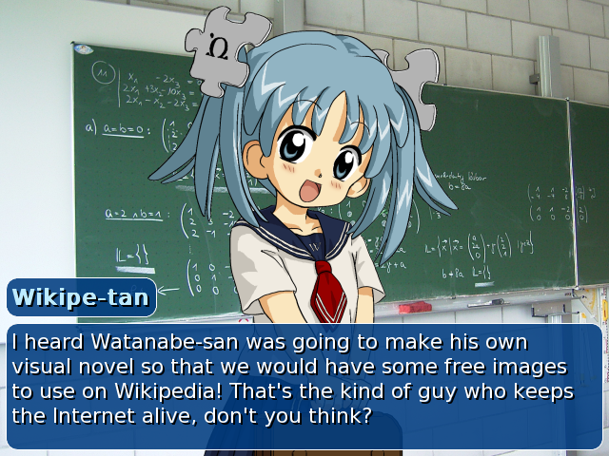

A classic interface for such a game is a background representing the environment where the story takes place, a dialogue box containing the narrative texts, and a sprite of a character with whom the user interacts.
Even with a simplistic game play, this kind of entertainment has met a lot of success and despite the huge progress in the industry of gaming, this format has been preserved.

3.2 Episodic Adventure Games

With the actual improvement of computer graphics, this kind of experience has been derived into episodic graphic adventure games, which significantly extends the user actions, giving now the possibility to walk in a 3D world, and gives access to animations of a better quality.
While the main interactions are still limited to make choices throughout a story, the success of this type of game remains intact. This indeed points out the entertaining potential of a “multiple paths story game”.

[show famous 3D games]

4 Design
Inspired by many popular interactive games, a first sketch of the design was made, with respect to a hospital environment as an example. Hence, the following choices and thoughts made in this paper have been based on this. The following sections explain the choices made to design the game for this particular case. However, they can totally be changed to adapt with the type of story.

4.1 Environment
4.1.1 Backgrounds
The backgrounds were found on websites sharing photographs with free license. In this case, real photographs were used and converted into a more “cartoon-ish” style to fit with the overall components that will be described later.

4.1.2 Choice of colors

4.2 Characters
The characters were hand-drawn and colorized using Krita.

5 Implementation
5.1 Tools & Resources
5.1.1
This project was mainly created using Unity and C#.

5.1.2 Handling the data
The main resource in this project is a set of dialogues that will be displayed in the game. The texts has been stored in a csv file, since it is a format that is quite easy to handle and also because it gives a nice visualization of the dialogues and all the other complementary information.
The number of columns and their names is predefined. However, it is still possible to modify them in a quite easy way. For our demo, we have chosen the following structure.
[show image]
- sceneID: Identifies a scene
- character: The character's name who is speaking
- dialogue: The text dialogue that the user will read
- good_answer: The good answer the user can give
- neutral_answer:

5.1.3 CSV2Table
Since we are working in Unity, the first thing we needed was to write a parser that would read the csv file and store everything in a nice and clean table. The free CSV2Table Asset (https://assetstore.unity.com/packages/tools/utilities/csv2table-36443) on the Asset Store allows to generate a C# code for a CSV parser. The program takes as input the csv file that is displayed on the left panel, then generates the corresponding code to parse its content on the right panel. It then stores the csv data into a structured table, and has functions to access this data. In addition to that, it also has functions to find rows that matches to a specific query.
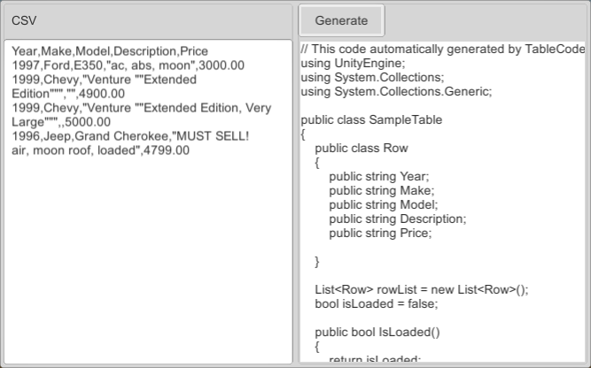

As an example

5.2 User Interface
5.2.1
5.2.2
5.2.3 Animations & Sounds
5.3 Game Play
5.3.1

5.3.2 Score Manager

References

Concept of the game
  - Inspirations
- Design
  - Environment
    - Backgrounds
    - Choice of colors
  - Characters
- Creating the game
  - Importing the data
  - Creating the UI
- Story Timeline
  - Tree choices
  - Dialogue Manager
- Useful links

