Machine Learning

What is Machine Learning ?
« The field of study that gives computers the ability to learn without being explicitly programmed. » (Arthur Samuel)

« A computer program is said to learn from experience E with respect to some class of tasks T and performance measure P, if its performance at tasks in T, as measured by P, improves with experience E. » (Tom Mitchell)

Two broad classifications : Supervised Learning & Unsupervised Learning

Supervised Learning
- We are given a data set and already know what our correct output should look like
- => relationship between the input and the output
- Categorized into « Regression » and « Classification » Problems :
  - Regression Problem : We try to predict results within a continuous output
Ex. : Predict prize of a house given a data set about size of houses
  - Classification Problem : We try to predict results in a discrete output
Ex. : Given a patient with a tumor, predict if the tumor is malignant or begnin

Unsupervised Learning
- We approach a problem with little or no idea of what our result should look like
- We derive a structure from data without knowing the effect of the variables
- No feedback based of the prediction results
- Ex. : Take a collection of 1 millions genes and find a way to group them

Model representation

x^{(i)} : input variable
y^{(i)} : output variable
(x^{(i)}, y^{(i)}) : training set
h : X -> Y
h(x) : hypothesis

Cost Function (or « Squared error function/Mean squared error »)
- Measures the accuracy of the hypothesis function
=> « How well the hypothesis function fit into a given data »
- Takes the average difference of all the results of the hypothesis with inputs from x's and the actual output y's.
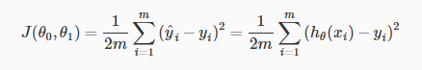

The goal is to minimize the cost function to get the best hypothesis possible

Gradient Descent
- Used to estimate the parameters in the hypothesis function
- Ajusts the value of the parameters by minimizing the cost function J.
- The gradient descent algorithm is :

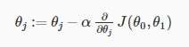
Repeat until convergence :
  - j : feature index number
  - α : learning rate
/!\ The update of each parameters should be simultaneous ! /!\
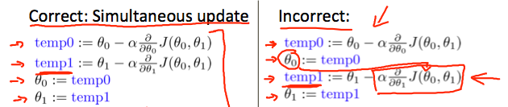
- We want the derivative to reach zero (θ1 := θ1 − α∗0)
- If α is too small, Gradient Descent can be very slow and so inefficient
- If α is to large, Gradient Descent can overshoot the minimum and may fail to converge, and even diverge

Gradient Descent for Linear Regression (« Batch Gradient Descent »)
- Better than normal Gradient Descent because it converges to only one global minima
- When specifically applied te the case of Linear Regression, the Gradient Descent equation can be derived. The new algorithm of the Gradient Descent would be :

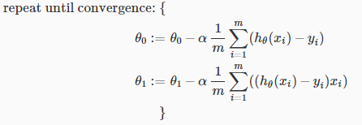
- m : size of the training set
- We separated θ₀ and θ₁ due to the derivative

Multivariate Linear Regression

