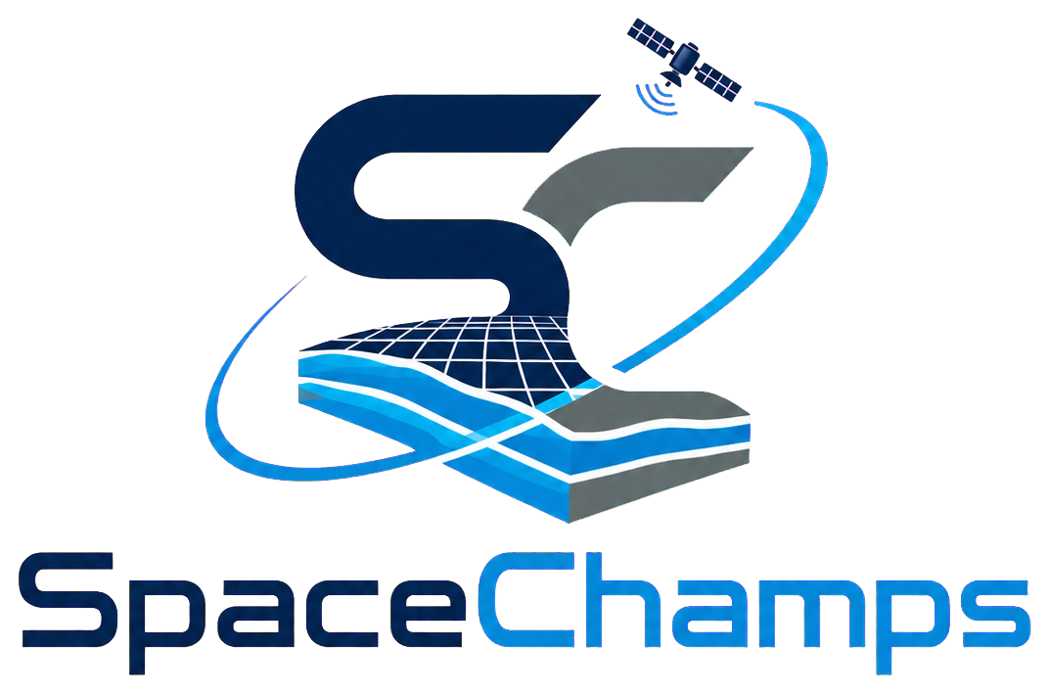
COMPANY PROFILE | 2026
Advanced Drone, LiDAR &
Geospatial Intelligence
Precision data for smarter decisions, stronger infrastructure, and faster project delivery.
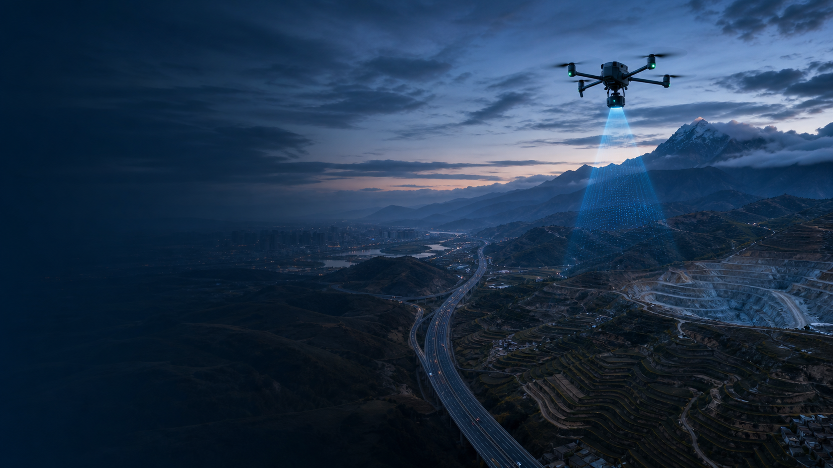
CAPTURE REALITY. DELIVER CERTAINTY.
Jakarta, Indonesia | Doha, Qatar | Southeast Asia & Middle East

SPACECHAMPS COMPANY PROFILE

Precision data. Smarter decisions.
SpaceChamps turns complex terrain and infrastructure into decision-ready geospatial intelligence.
OUR PURPOSE Make high-precision geospatial data accessible, reliable, and actionable for the projects that shape our world.

Founded in 2012, SpaceChamps is a drone-based LiDAR, aerial mapping, and geospatial intelligence company serving clients across Southeast Asia and the Middle East. We combine deep field expertise, industry-leading sensors, RTK positioning, and AI-powered processing to transform real-world conditions into clear, decision-ready project intelligence.
Our work supports planning, design, construction, inspection, monitoring, and asset management at every stage. From a single-site survey to a long-range regional mapping mission, every engagement is built around accuracy, operational safety, rapid turnaround, and practical deliverables that teams can use immediately.
14+ | 500+ | 250+ | 98.7%
Years of experience | Projects delivered | Enterprise clients | Data quality target
MISSION
To deliver accurate, reliable, and actionable geospatial intelligence that helps organizations plan smarter, build faster, and operate with total confidence in their data.
VISION
To become the most trusted name in field-to-insight geospatial intelligence across emerging markets and fast-growing economies.

SPACECHAMPS COMPANY PROFILE

Comprehensive geospatial solutions
A complete service portfolio spanning field capture, mapping, modelling, monitoring, inspection, and delivery — each capability available independently or combined into a single end-to-end program.
CAPABILITY | WHAT IT DELIVERS
LiDAR Data Acquisition | High-density point clouds and precise elevation data for complex, vegetated, or hard-to-access sites.
Topographical Surveys | Terrain, contour, and engineering survey deliverables that give design teams confidence from day one.
Aerial Photogrammetry | High-resolution imagery, orthomosaics, and photogrammetric 3D reconstruction with measurable detail.
DTM & DSM Models | Detailed terrain and surface models engineered for analysis, design, planning, and earthwork decisions.
Orthomosaic Mapping | Georeferenced, measurable maps that deliver instant, clear site intelligence for any stakeholder.
Corridor Surveys | Linear mapping for roads, railways, pipelines, and powerline routes — accurate over long distances.
Construction Monitoring | Repeatable progress tracking, change detection, and volumetric reporting across project timelines.
Mining & Quarry Surveys | Stockpile volumes, pit analysis, haul-road monitoring, and operational intelligence for active sites.
Agriculture & Environment | Crop health, land classification, environmental mapping, and change detection for sustainable decisions.
Infrastructure Inspection | Safe, close-range aerial inspection of structures, corridors, and critical assets — no scaffolding required.
Long-Endurance VTOL | Extended-range missions for remote locations, large-area coverage, and time-critical regional projects.
Deployment & Support | Mission planning, field operations, QA, delivery, and ongoing technical support from a dedicated team.
FLEXIBLE ENGAGEMENT Every service can be delivered independently or combined into a complete capture-to-delivery program tailored to the project scope.

SPACECHAMPS COMPANY PROFILE

Built for mission-critical sectors
Our workflows are purpose-built for organizations that depend on accurate, timely site intelligence to make high-stakes decisions under real-world pressure.
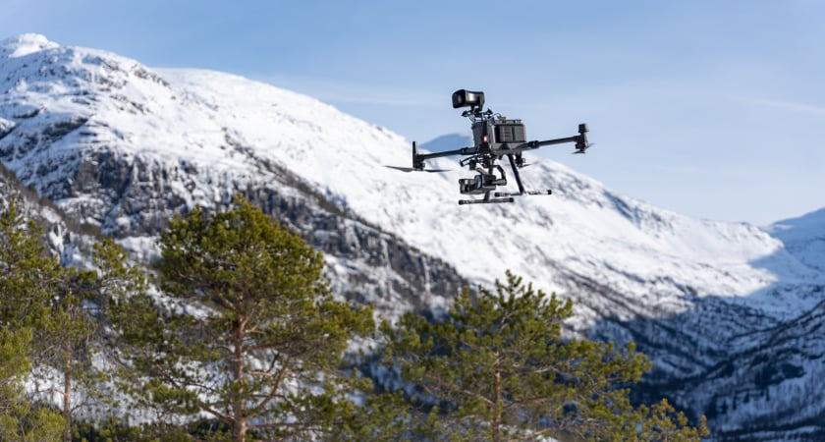
SECTOR | TYPICAL APPLICATIONS
Government & public agencies | Base mapping, land administration, urban planning, disaster readiness, and public asset intelligence at scale.
Engineering & design firms | Survey-grade inputs for feasibility studies, concept design, detailed engineering, and construction verification.
Construction companies | Progress monitoring, cut-and-fill analysis, as-built documentation, and real-time site coordination.
Mining & quarry operators | Pit mapping, stockpile volumes, haul-road monitoring, and operational decision support for active extraction.
Agriculture & environment | Crop and land analysis, environmental impact mapping, change detection, and ongoing site monitoring.
Infrastructure developers | Corridor mapping, structural inspection, digital asset models, and lifecycle intelligence for critical networks.
Across every sector, the objective remains the same: reduce uncertainty, strengthen coordination, and give decision-makers a reliable digital view of the physical world — so projects move forward with confidence.

SPACECHAMPS COMPANY PROFILE

Advanced equipment. Intelligent workflows.
A field-proven technology stack carefully selected for centimeter-level accuracy, hardware reliability, and operational flexibility across diverse environments and mission profiles.
PLATFORM | ROLE | OPERATIONAL VALUE
 | DJI Matrice 350 RTK  Enterprise UAV | All-weather field operations | RTK positioning | up to 55-minute flight time | dual-battery workflow
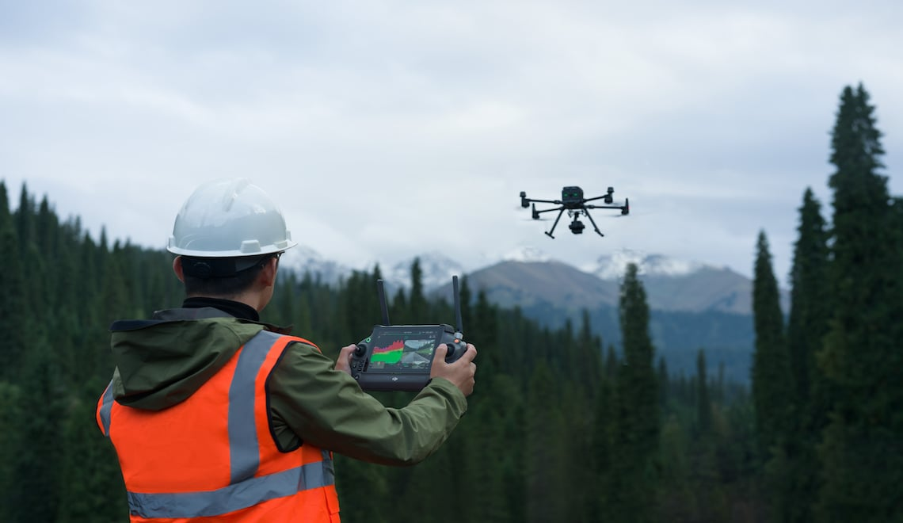 | DJI Zenmuse L2  LiDAR payload | Multi-return scanning | integrated RGB imaging | precise point-cloud capture | terrain mapping
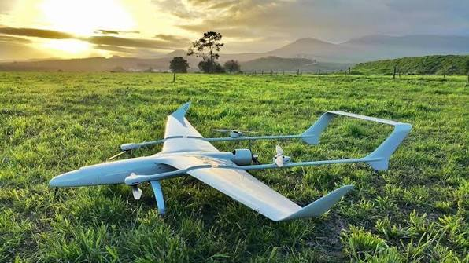 | Long-Endurance VTOL  Large-area mapping | 4+ hour endurance | 500+ sq km mission potential | runway-free operation | autonomous launch and recovery
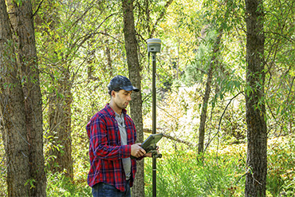 | Trimble R12i  GNSS RTK receiver | IMU tilt compensation | multi-constellation tracking | centimeter-level positioning | all-weather use
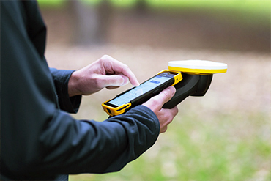 | Trimble TDC6  Mobile GIS & field data | Rugged field collection | connected workflows | sunlight-readable display | mobile GIS delivery
TECHNOLOGY PRINCIPLE Match the right platform, sensor, positioning method, and processing workflow to each mission — never a one-size-fits-all package.

SPACECHAMPS COMPANY PROFILE

From takeoff to decision-ready delivery
A controlled, end-to-end workflow that keeps quality, speed, and accountability visible at every stage — from initial planning through to final handover.

01 | Mission planning | Define objectives, accuracy, site constraints, flight paths, control strategy, and safety protocols.
02 | Drone deployment | Capture LiDAR, high-resolution imagery, thermal data, or GNSS control using the selected platform.
03 | Field quality control | Validate coverage, positioning, sensor health, and data completeness before leaving site.
04 | Cloud processing | Generate point clouds, imagery products, terrain models, and classified datasets.
05 | AI analysis & QA | Classify features, extract measurements, flag anomalies, and verify outputs against specifications.
06 | Delivery & support | Package decision-ready maps, models, GIS files, and reports with technical handover support.
TYPICAL DELIVERABLES
Point clouds | orthomosaics | DTM and DSM | contours and CAD-ready survey data | 3D reality models | GIS layers | volumetric reports | inspection records | interactive web visualizations

SPACECHAMPS COMPANY PROFILE

Quality engineered into every stage
Accuracy is not a final checkpoint. It is engineered into every phase — planning, capture, processing, analysis, and delivery — with repeatable QA controls and documented accountability throughout.
  GNSS control & verification |   Connected field data workflows
CONTROL LAYER | HOW QUALITY IS PROTECTED
Survey control | RTK/GNSS positioning, ground control points, and mission-specific accuracy planning before takeoff.
Field assurance | On-site validation of coverage, sensor health, image quality, and data completeness before leaving the site.
Processing assurance | Automated classification, feature extraction, and repeatable QA checkpoints with documented traceability.
Delivery assurance | Specification review, documented outputs, structured deliverables, and hands-on technical handover support.
AI WITH HUMAN OVERSIGHT Automation accelerates classification and feature extraction, while experienced specialists remain fully accountable for final quality and accuracy.

SPACECHAMPS COMPANY PROFILE

Built on precision and partnership
SpaceChamps has grown by combining technical discipline with an uncompromising commitment to client outcomes — delivering work that teams can trust, on time, every time.
CORE VALUES
VALUE | WHAT IT MEANS IN PRACTICE
Precision | Centimeter-level thinking applied to every dataset, every decision, and every deliverable we produce.
Innovation | Practical, early adoption of advanced hardware, AI, and cloud workflows that give clients a real edge.
Reliability | Consistent quality, transparent communication, and disciplined delivery — project after project, year after year.
Partnership | A collaborative approach that works as a seamless extension of the client's own team and objectives.
OUR JOURNEY
2012 | SpaceChamps founded by survey professionals and drone pilots committed to a higher data standard.
2015 | First international expansion, establishing multi-region project delivery capabilities.
2018 | Advanced LiDAR sensors and RTK positioning integrated, raising the bar for field accuracy.
2021 | Cloud-based AI processing launched for automated classification and rapid feature extraction.
2024 | 500+ delivered projects milestone reached across government, engineering, and enterprise sectors.
2026 | 14 years of operations, serving clients across Southeast Asia and the Middle East with a growing fleet and team.
REGIONAL FOOTPRINT Operational headquarters in Jakarta, Indonesia and a branch office in Doha, Qatar — with active service coverage across Southeast Asia and the Middle East.


LET'S WORK TOGETHER
Ready to map what matters next?
Tell us about your site, project objectives, required accuracy, timeline, and preferred deliverables. The SpaceChamps team will respond within one business day with a proposed scope, crew plan, and processing approach tailored to your mission.
WHATSAPP | +62 838-5209-4053
EMAIL | engwarsame16@gmail.com
LOCATIONS | Jakarta, Indonesia | Doha, Qatar
PRECISION IN EVERY POINT.
© 2026 SpaceChamps. All rights reserved.

