

THE
KASHF UL ASRAAR
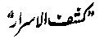
(THE KASHF OF (ENTIRE) MYSTERIES)
AUTHORED BY (In Persian):
THE SULTAN-UL-ARIFEEN , THE SULTAN-UL-FAQAR
HAZRAT SULTAN BAHU
MAY HIS SECRET BE SANCTIFIED


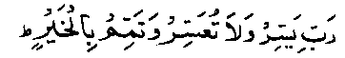
(DEC. 2009)

*** Warning! ***
Please note without prior written permission, in shape of authorized legal document, from us and Mr. Zaheer, any kind of publishing of Hazrat Sultan Bahu ® Books translated by Mr. Zaheer is not allowed and also it is not allowed to print in shape of Book, CD or web as long as you don’t get direct permission from us and from Mr. Zaheer personally in legal/document
**** Copyrights ® 2009 All Rights reserved by www.Hazratsultanbahu.com ****

FOREWORD

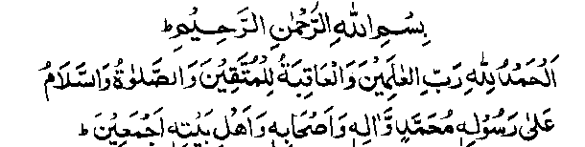
After the Second Edition of the English translation of the Noor ul Huda Klaan the Second Edition of the translation of The Kashf ul Asraar is being humbly presented for the gladness of Allah Almighty and that the Sultan-ul-Arifeen the Sultan-ul-Faqar Hazrat Shaikh Pir Sultan Bahu Rahmatu-Allahe Ta-aala Alaihe may be pleased with this servant.
Many thanks to the Webmaster (www.hazratsultanbahu.com) for his marvelous service in providing the most authentic books and translations through his blessed website! As Translator, I have great respect and regard for Janab Dr. K. B. Naseem Sahib Rahmatu-Allahe Ta-aala Alaihe. The translations of the auspicious books of Hazrat Sultan Bahu Rahmatullah, done by this worthless translator are for those people, who cannot read and understand Persian and Urdu languages. We have kept the Original Shape and Matter of the Persian Books in our English Translations. Direct link has been given for the concerned page of the Persian Book and Urdu on every page of English Translation for reference and convenience of the reader.
There are many Terms of Tasawvuf that are so comprehensive and deep which cannot be translated in English with words of equal weight because of many reasons the main is that the English Language takes its roots from the Christianity and as such replacing the Terms of Islam and Sufism with English words may mislead the readers. And in case these Terms are not given any meanings at all, then the reader reading English Translations may face a lot of difficulties as there are chances that he might have no prior knowledge or has very little understanding of Sufism and Islam and he may leave reading the books in the very beginning if at least some support is not given to him by the translator. In order to overcome this, the humble translator has used the original Terms and has given their very general and basic meanings (and annotations) of the respective Sufi Terms and at the end of every page just to assist the reader. Separate chapters and many pages may be needed for explanation of each Term and as such a word or a few words do not cover the full scope of a Term. After receiving feedbacks from our worthy readers and in order to make the Translations more authentic and more useful for the respectable readers, the style of presentation has been changed by this humble translator and now instead of giving meanings with brackets in the main text, the literal meanings as well as some text from the books with reference of Page Numbers have been added at the end of each page so that the person who needs, he may consult the relevant Page of English Translation for more understanding. However, Janab Webmaster Sahib is trying to find another way by which the reader will be able to know the meaning of any Term by just clicking over it in the main text. This will be his genius that he will use this unique thing.
Please be careful, genuine, truthful, respectful, clean and Pure (holy) while reading these sacred and numinous books.
For any error, omission or overlooking I seek forgiveness of Allah Jalla Jalaluhu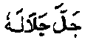 and very humbly look forward to the graciousness of the esteemed Court of Janab Sultan-ul-Arifeen - the Sultan-ul-Faqar - the Sayyed ul Konain - the Aalim and the Aamil and the Knight-Rider and the Kaamil and the Accomplished and the Complete and the Comprehensive and the Light of Right Guidance Murshid - the Wali-Allah Aulia-Allah Faqeer - the Sarwari-Qadiri - the Master of Jalaal and Jamaal - the Mureed and the original Viceroy of Janab Ghaus ul Azam Hazrat Shah Muhyiddeen Shaikh Abdul-Qadir-Jelaani May his secret be sanctified - the Mustafa Saani - the Mujtabaa Aakhir-Zamaani - the Spiritual Farzand of the Holy Prophet of Allah Hazrat Muhammad Sal Allahu Alaihe Wa Aa-lehee Wa-sallam and the Ummahaat ul Momineen - Hazrat Pir Sakhi Sultan Bahu May his secret be sanctified, who’s Surname is A’waan and is the son of Hazrat Bazaid Rahmatu-Allahe Ta-aala Alaihe and Hazrat Mai Raasti Rahmatu-Allahe Ta-aala Alaiha; to accept this humble service.
All Translations are absolutely Free for the Readers. I have done my duty and demand nothing from anybody except the favor of Hazrat Sultan-ul-Arifeen Burhaan ul Waasileen Muqtadaa e Kaamileen Fanaa Fi Ain e Zaat e Yaa Hu Hazrat Shaikh ul Haq wa Deen Hazrat Pir Sultan Bahu Qaddas-Allah Sirru-hul Aziz.

May Allah keep Pakistan safe against all blights and all hardships and keep us safe against the evil of every Fitna and every threat and grant success in Both-the-Worlds to all those who have contributed for this work! Ameen!
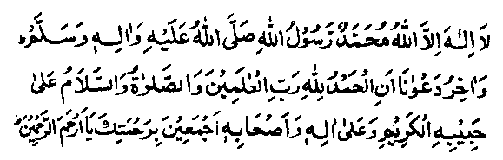
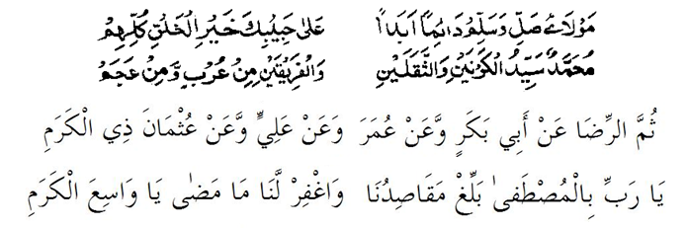

Regards,
worthless - Zaheer,
First Edition: Dec. 2009.
REVIEWED 20 MAY 2015

CONTENTS

- REFERENCE OF PERSIAN TEXT PAGE a
- FOREWORD PAGE b
- HAMD WA NAAT PAGE 01
- INTRODUCTION PAGE 02
- DAWAT THROUGH SURAH AL MUZZAMMIL PAGE 03
- VISUALIZATION PAGE 05
- HAZIRAAT PAGE 06
- DAWAT DUA-E-SAIFI AND SURAH AL MUZZAMMIL PAGE 07

PAGE NO.

REFERENCE OF PERSIAN TEXT

THIS TRANSLATION IS BASED ON THE PERSIAN MANUSCRIPTS OF THE BOOK COLLECTED BY DR. K. B. NASEEM RH. AND HIS TEAM OF HAZRAT SULTAN BAHU (RH) ACADEMY FROM DIFFERENT SOURCES ALL OVER PAKISTAN AND PRINTED IN SHAPE OF BOOK BASED ON THE MOST AUTHENTIC ONES. THIS BOOK WAS BASED ON THE PERSIAN SCRIPT OF MUHAMMAD SHAHBAZ OF 1341 HIJRAH AND FAQEER ALTAF HUSAIN QADIRI SARWARI OF RABI UL AWWAL 1400 HIJRAH AND WAS PRINTED WITH URDU TRANSLATION BY DR. K. B. NASEEM RH. ALL MATERIAL FOR TRANSLATION INTO ENGLISH WAS PROVIDED TO THIS WORTHLESS SERVANT BY HAZRATSULTABAHU.COM

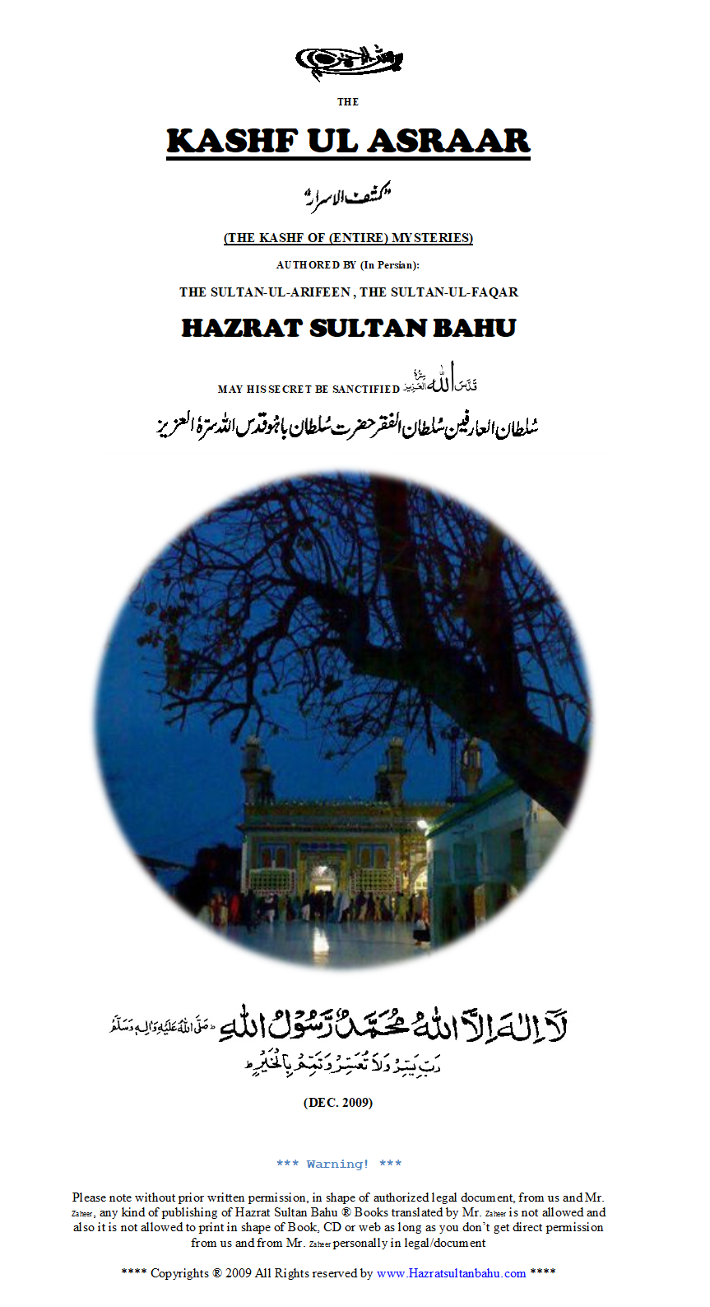
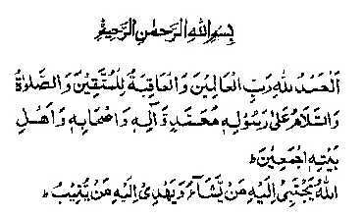
IN THE NAME OF ALLAH, THE BENEFICENT, THE MERCIFUL

All praise be to Allah, Lord of the Worlds (1:2) and lo! The good end is for those, who keep their duty (unto Him) (7:128) and Darood and Salaam be upon the Prophet of Allah Almighty - Muhammad Sal Allahu Alaihe Wa Aa-lehee Wa-sallam, on his entire Progeny, on his Companions Radhi-ya-Allahu Ta-aala Anhum and his Household Radhi-ya-Allahu Ta-aala Anhum collectively.

“Allah chooses for Himself (as a chosen and favorite bondman) whom He wills and guides unto Himself who turns (towards Him)” (42:13)”

Countless and limitless Darood that cause the conscience illuminated be upon the Anwaar of the
Continue reading compete book visit
https://en.hazratsultanbahu.com/en/books-ka-1-Kashful%20Asrar%20Kashf%20ul%20Asrar%20English.php
or
https://www.HazratSultanBahu.com/english/
Or
https://www.haqbahu.com/english/

HazratSultanBahu.com Publications English LIST OF BOOKS
(Click on Book name to read complete book)

- Noor ul Huda Klaan (Oct. 2009)  - Kashf ul Asraar (Dec. 2009)  - Risala e Ruhi Shareef (July 2010)  - Muhabbat ul Asraar (Feb. 2010)  - Taigh e Barhana (Feb. 2010)  - Didaar Bakhsh (Khurd) (Jan. 2010)  - Majalisat un Nabi Sal Allahu Alaihe Wa Aa-lehee Wa-sallam (Jan. 2010)  - Aurang Shahi (Jan. 2010)  - Ganj ul Asraar (Feb. 2010)  - Noor ul Huda (Khurd) (Feb. 2010)  - Kaleed ut Tauheed (Khurd) (Mar. 2010)  - Muhkumul Faqara (Mar. 2010)  - Didaar Bakhsh (Klaan) (Mar. 2011)  - Ain ul Arifeen (Apr. 2011)  - Dewaan e Bahu (Farsi) (Mar. 2012)  - Miftah ul Arifeen (Apr. 2011)  - Taufeeq ul Hidayat (Feb. 2012)  - Kaleed e Jannat (Apr. 2012) | - Qurb e Didaar (May. 2012)  - Fazal ul Liqaa (Jun. 2012)  - Asraar ul Qadiri (Jul. 2012)  - Muhik ul Faqar (Khurd) (Oct. 2012)  - Jamey ul Asraar (Dec. 2012)  - Emir ul Konain (Apr. 2013)  - Aqal-Baidar (Nov. 2009)  - Ain ul Faqar (Feb. 2012)  - Muhik ul Faqar (Klaan) (Nov. 2013)  - Irfaan (Volume I) (Jul. 2014)  - Irfaan (Volume II) (Feb. 2015)  - Anwaar e Sultani (Aug. 2014)  - Makhzan al Asraar (May. 2015)  - Safrang-e-Faqeer (Jun  - Malfuzat Hazrat Sultan Bahu  - Hazrat Sultan Bahu Life  - Visualization of the Name of Allah  - Get Spiritual Power direct from Hazrat Sultan Bahu

To read all books in English visit
https://www.HazratSultanBahu.com/english/
Or
https://www.haqbahu.com/english/

HazratSultanBahu.com Publications Urdu Translation with Persian LIST OF BOOKS
(Click on Book name to read complete book)

- Noor ul Huda Qalan  - Kashful Asrar  - Risala Roohi Sharif  - Mahabbatul Asrar  - Taig Brahna  - Didar Buksh (Khurd)  - Majalsatul Nabi  - Orung Shahi  - Ganjul Asrar  - Noorul Huda (khurd)  - Qalide Tohid  - Muhakumul Faqara  - Dedar Baksh (Qalan)  - Anul Arfien  - Dewane Bahu  - Muftahul Arfien  - Tofiqe Hadiat  - Qalide Jannat | - Qurbay Dedar  - Fazalul Laqa  - Asrarul Qadri  - Muhikkal Faqar Khurd  - Jamiaul Asrar  - Amerul konan  - Aqal Baydar  - Anul Faqar  - Mhikal Faqar Qalan  - Abyat e bahoo  - Malfuzat Hazrat Sultan Bahu  - Hazrit Sultan Bahu Life  - Tasavver Asmi Allah Zat  - The way to get Spiritual Power Direct From Hazrat Sultan Bahu  - Quran

To read all books in Urdu with Persian visit

https://www.HazratSultanBahu.com/books/
Or
https://www.haqbahu.com/page/

Major Topics of Book
Noor ul Huda (Qalan), Noor ul Huda Qalan, Noor ul Huda klaan, Noor ul Hudakalan, Noor ul Huda kalaan, Noorul Huda, Noor ul Huda, Noor ul Hudaa, Kashful Asrar, Kashf ul Asraar, Kashf ul Asrar, Kashf-ul-Asrar, Kashful Asrar, Risala Roohi Sharif, Risala e Ruhi Shareef, Risala e Roohi Sharif, Risala e Roohi Sharif, Rasala Rohi Sheriff, risala ruhi, Mahabbatul Asrar, Muhabbat ul Asraar, Mohabbat ul Asrar, Muhabbat-ul-Asrar, Mohabbat ul Asrar, Mohabbat ul Israr, Mahabbatul Asrar, muhabbatul asraar, Taig Brahna, Didar Buksh (Khurd), Didaar Bakhsh (Khurd), Deedar Baksh Khurd, didar buksh khurd, Majalsatul Nabi, Majalisat un Nabi Sal Allahu Alaihe Wa Aa-lehee Wa-sallam, Majalis At un Nabee Sal Allahu Alaihi Wa Aa-alaihi Wa-sallam, Majalis At un Nabee Sal Allahu Alaihi Wa Aa-alaihi Wa-sallam, Majalisat un Nabi, majaalis un nabi, Orung Shahi, Aurang Shahi, aurang shaahi, Ganjul Asrar, Ganj ul Asraar, Ganj ul Asrar, Ganj-ul-Asrar, Noorul Huda (khurd), Noor ul Huda (Khurd), Noor-ul-Huda (Khurd), Noor ul Huda Khurd, Qalide Tohid kt, Kaleed ut Tauheed (Khurd), Kaleeda-ul-Toheed, Kaleed ul Tauheed (Khurd), Kaleed-ul-Tauheed (Khurd), kaleed tauheed, Muhakumul Faqara, Muhkumul Faqara, muhqam ul fuqar, Dedar Baksh (Qalan), Didaar Bakhsh (Klaan), Deedar Bakhsh (Kalam), didar buksh kalan, Anul Arfien, Ain ul Arifeen, Dewane Bahu, Dewaan e Bahu (Farsi), Deewan-e-Bahu, dewanebahu, Muftahul Arfien, Miftah ul Arifeen, Miftah-ul-Arifeen, MIFTAHUL ARIFEEN, MIFTAH UL AFIRIN, Tofiqe Hadiat, Taufeeq ul Hidayat, Taufeequl Hidayat, Tofiqe Hadiat, taufiq hedaayat, Qalide Jannat, Kaleed e Jannat, Kaleed-e-Jannat,kaleede jannat, Qurbay Dedar, Qurb e Didaar, Qurb e Deedar, Qurb-e-Deedar, qurbay dedar, Fazalul Laqa, Fazal ul Liqaa, Fazal-ul-Liqaa, fazl ul laqa, Asrarul Qadri, Asraar ul Qadiri, Asraar-ul-Qadiri, Asrar ul Qadri, Israr-e-Qadri, Muhikkal Faqar Khurd, Muhik ul Faqar (Khurd), Muhik-ul-Faqar (Khurd), Mahk ul Faqr (Khurd), Mahk-ul-Faqr (Khurd), mahqul fuqar (khurd), Jamiaul Asrar, Jamey ul Asraar, Jami al-asrar, jamiul asraar, Amerul konan, Emir ul Konain, Ameer-ul-Konain, Aqal Baydar, Aqal-Baidar, Aqal Baidar, Aqal-e-Bedar, Aql e Baidar, Aql-e-Baidar, aql baidaar, Anul Faqar, Ain ul Faqar, Ain-ul-Faqar, Ain-ul-Faqr, Ain ul Faqr, Mhikal Faqar Qalan, Muhik ul Faqar (Klaan), Mehk ul Faqr Kalan, Mahak-ul-Faqr (Kalan), Muhik ul Faqr (Kaln), mhikal faqar qalan, Tasavver Asmi Allah Zat, Malfuzat Hazrat Sultan Bahu, Hazrit Sultan Bahu Life, The way to get Spiritual Power Direct From Hazrat Sultan Bahu, Abyat e bahoo, abyat bahoo, abyat e bahu, Abyat e bahoo, abyat bahu, kalam bahu, kalam bahoo, Abyat-e-Bahoo, chambey di booti, bait, Punjabi Poetry, Kalam, sultan bahu kalam, kalam sultan bahu, kalam e bahu, quran, The Holy Quran, Al Quran Karim, Al-Quran, The Noble Quran. Hazrat Sultan Bahu, Hazrat Sultan Bahoo, haqbahu, haq bahu, Hadrat Sultan bahu, haq bahoo, sultan bahu, sultan bahoo, sakhi sultan bahoo, sakhi sultan bahu, haq bahoo sultan, bahoo sultan, bahu sultan. library, sultan bahu punjabi, books, novel, sultan bahu, beautifull lyrics, afsany, sultan bahoo, sultan bahu poetry in punjabi, sultan bahu books, sultan bahu poetry, sultan bahu shrine, sultan bahu kalam in punjabi, sultan bahu family tree, sultan bahu mazar, sultan bahu quotes, sultan bahu map, sultan bahu darbar, sultan bahu kalam, Hazrat Sultan Bahu Darbar, darbar, ki qawali, latest, ki karamat, kalam nusrat fateh ali, reading, sultan bahu poetry in punjabi, sultan bahu kalam nusrat fateh ali khan, sultan bahu kalam, 10], hazrat sultan bahu books, hazrat sultan bahoo books Irfaan, Erfan, Irfan, Irfaan Volume I, Irfan Vol 1, Irfaan, Erfan, Irfan, Irfaan Volume II, Irfan Vol 2, Makhzan al Asraar, Makhzan al Asrar, dua e saifi, duae saifi, dua e safi, duae safi, Dua-e-Saifi, Dua Saifi, dua e saifi sharif, dua e saifi full, dua e saifi download, dua e saifi in english, dua e saifi in hindi , dua e saifi roman, Visualization of the Name of Allah, Visualization of ISM ALLAH, VISUALIZATION OF THE PERSONAL NAME OF ALLAH, TASAWAR ISM E ALLAH ZAAT, allah Infographics, Malfoozat, Malfuzat, Malfūzāt, Malfozat

