# This picture for question number 1- 2

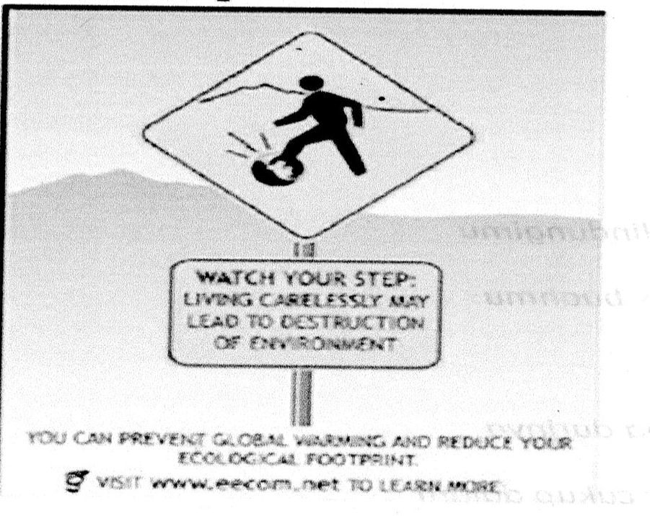

1. What is the topic of the poster?
   1. Safety
   2. Environment
   3. Health
   4. Art
   5. Sport
2. What is the meaning of the message in the poster?
   1. We have to step slowly
   2. We have to watch our step
   3. We have to be careful to step
   4. We have to watch our step carelessly
   5. We have to have to live carelessly to destruct environment

# This text is for questions 3 to 5

Recycling is a collection, processing, and reuse of materials that would otherwise be thrown away. Materials ranging from precious metals to broken glass, from old newspapers to plastic spoons, can be recycled. The recycling process reclaims the original material and uses it in new products.

In general, using recycled materials to make new products costs less and requires less energy than using new materials. Recycling can also reduce pollution, either by reducing the demand for high-pollution alternatives or by minimizing the amount of pollution produced during the manufacturing process.

Paper products that can be recycled include cardboard containers, wrapping paper, and office paper. The most commonly recycled paper product is newsprint. In newspaper recycling, old newspapers are collected and searched for contaminants such as plastic bags and aluminum foil. The paper goes to a processing plant where it is mixed with hot water and turned into pulp in a machine that works much like a big kitchen blender. The pulp is screened and filtered to remove smaller contaminants. The pulp then goes to a large vat

where the ink separates from the paper fibers and fl oats to the surface. The ink is skimmed off, dried and reused as ink or burned as boiler fuel. The cleaned pulp is mixed with new wood fibers to be made into paper again.

Experts estimate the average office worker generates about 5 kg of wastepaper per month. Every ton of paper that is recycled saves about 1.4 cu m (about 50 cu ft) of landfill space. One ton of recycled paper saves 17 pulpwood trees (trees used to produce paper).

1. The following things can be recycled, EXCEPT....
   1. Precious metals
   2. Broken glass
   3. Old newspapers
   4. Plastic spoons
   5. Fresh vegetables and fruits
2. Which of the following is NOT the benefit of recycling?
   1. It costs much money for the process of recycling
   2. It costs less to make new products
   3. It requires less energy
   4. It can reduce pollution
   5. It reduces the demand for high-pollution alternatives
3. What is the third step of recycling paper products?
   1. Collect and search for contaminants such as plastic bags and aluminium foil
   2. Mix the paper with hot water in a blender which turns it into pulp
   3. Screen and filter the pulp to remove smaller contaminants
   4. Put the pulp to a large vat to separate the ink from the paper fibres
   5. Mix the pulp with new wood fibres to be made into paper again

# This text is for questions 6 to 8

**We Should Change the Payment System**

Nowadays, the system of payment gradually changes. Most people use debit cards instead of cash to make payment. They think it is more effective, efficient, easier, and simpler. However, there are still arguments about the use of debit cards as a method of payment.

Well, if you use the card, you will say that the card is so practical. You don‟t need to count how much you should pay. When paying in cash, people are afraid of making mistakes in counting the bank note for both the payment and the change. With debit cards the mistakes is made smaller.

Moreover, you should know that the debit cards are safer than money. Suppose you bring a lot of money when travelling. If it is lost or stolen, you will be left with nothing in your hands. However, if you bring a debit card, you can just phone the bank which issues the card to block it.

On the other hand, people who disagree on the use of debit card will say that its use is so limited. When you buy something in a traditional market, or a vendor, for example, can you pay using a credit card? Of course not.

Another thing is that, if you want to use the card, you should make a purchase at minimum amount. If you make less than the minimum transaction, you cannot make use the card.

For those reasons we think that credit cards are not fully effective as a means of payment. We should trace the incoming and ongoing money in our account. Besides, we have to control our habit of buying first, paying alter habit. Otherwise, without being realized we are charged a lot. You don‟t have to use credit cards if not necessary.

1. What is the text about?
   1. Differences between payments by cash and credit cards.
   2. The disadvantages of paying in cash.
   3. The advantages of using credit cards.
   4. The advantages of using debit cards.
   5. Different payment systems.
2. According to the text, one advantage of using the debit card is that….
   1. it cannot be stolen.
   2. it is as practical as using cash.
   3. we can use it everywhere for shopping.
   4. the possibility of mistakes in counting is smaller.
   5. we can make a purchase at minimum amount.
3. What is paragraph 3 about?
   1. debit cards for travelling
   2. the advantage of debit cards over cash.
   3. the safety system of debit cards
   4. what to do when you lose cash.
   5. how to bring a debit card.

# Read the text and answer the questions number 9 to 10

CAPTAIN PHILIPS-Captain Philips is an upcoming 2013 American biographical action thriller film directed by Paul Greengrass based upon the book, A Captain „s Duty: Somali the starring Tom hanks. It is produced by Scott Rudin, dan Brunetti, and Michael De luca. The film tells a biopic of merchant mariner Captain Richard Phillips, who was taken host a for several days by Somali Pirates when the container ship Maersk Alabama which sailed from southtern Oman down along the Coast of Somalia and then to Kenya was hijacked in 2009.

Captain Richard Philips (Tom Hanks), a veteran merchant mariner, still lives in his native New England, and he‟s a plain spoken family man full of anxiety about the economically bleak new world his kids are facing. When his wife (Catherine Kenner) drops him of at the airport, we can see reverse her. The film then cuts to Somalia, a land of dust and property, where the pirates are recruited for their mission as if they were migrant farm workers lining up to be chosen for that day‟s labor. Greengrass doesn‟t have to fill in much about the violent, chaotic breakdown of Somalia to let us know that these men have little choice. The film does not generate quite the same level of excruciating suspense as some of green grass‟ previous triumphs, but it nonetheless holds us hostage as it proceeds as for the four Somali immigrants, they are remarkably effective in their first professional acting gigs.

1. The text is a review of a ….
   1. song
   2. book
   3. novel
   4. movie
   5. painting
2. According to the text, Captain Philips ….
   1. travelled from Somalia to Kenya to find a ship
   2. hijacked a container ship
   3. hijacked many ships in Somalia
   4. was a hostage by Somalia pirates
   5. was a sailor in southern Oman

# Read the text and answer the questions number 11 to 14

Uday and Qusay are killed and the delighted British and American governments suggest that Iraq will be a safer place. Yes, the Iraqis may well feel safer. And - with the dictator's

brutal sons out of the way forever more confident about continuing the resistance against the American occupiers.

Shortly before their deaths were announced, Richard Gephardt, Democrat presidential hopeful, delivered a blistering attack on Bush's foreign policy which was driven, he said, by "machismo" and "arrogant unilateralism". Bush, he continued, had treated U.S. allies "like so many flies on America's windshield". He added: "Foreign policy isn't a John Wayne movie."

The attack on the villa where Saddam's sons were hiding might be seen as driving home

the point. Instead, the announcement that they had been killed by the U.S. troops in a shoot- out is welcomed by Tony Blair as "great news".

1. The text mainly discusses about ........
   1. Uday and Qusay who killed U.S. troops
   2. Uday and Qusay who are killed by U.S. troops
   3. Richard Gephardt who attacked Bush's domestic policy
   4. The attack on the villa where Saddam Husein was hiding
   5. Tony Blair who is welcomed by Saddam's sons, Uday and Qusay
2. The main idea of paragraph 3 is that ........
   1. U.S. troops killed Saddam in the attack on the villa.
   2. Uday and Qusay had killed U.S. troops and Tony Blair.
   3. Tony Blair attacked the villa where Saddam's sons were hiding.
   4. Saddam was killed by Tony Blair and U.S. in Saddam's sons' villa.
   5. The announcement of Saddam's son's death is welcomed by Tony Blair.
3. Which statement is correct according to the text?
   1. John Wayne movie was presented to Bush arrogantly.
   2. Tony Blair received the "great news" of Bush and Gephardt's death.
   3. John Wayne was a movie star who attacked the villa of Saddam's sons.
   4. Richard Gephardt attacked Bush's foreign policy after uday and Qusay's death.
   5. The news of uday and Qusay's death made the British and American government pleased
4. "The attack on the villa where Saddam's sons were hiding might be seen as driving home the point." (Paragraph 3)

The word attack has similar meaning to ........

* 1. Raise
  2. Resist
  3. Shield
  4. Defend
  5. Withdraw

# The text is for questions number 15 to 17

Dear Tamara,

Hi there. How are things with you? It‟s good to know that you are doing fine in business. Have you received my postcard? I am now sitting in my hotel room writing a letter to you about my wonderful holiday. I think this is the most wonderful holiday have I ever had. There are a lot of interesting tourist objects to visit, beautiful local art and craft, tasty traditional food, and much more. It‟s Thursday today. I can‟t believe this my last day. I wish I could spend more time here. I am certain I will stay longer on my next visit. I‟ll be home about 3 p.m. tomorrow if the flight is on time. On Monday I must go back to work. I can‟t wait to show my video to my class. Okay, that‟s all for now. Send my love to your children.

Best wishes from, Linda

1. The letter tells us about ….
   1. Linda‟s holiday in Bali
   2. Tamara‟s letter
   3. Linda‟s favorite places
   4. Tamara‟s plan for Bali
   5. Tamara‟s video documents
2. The letter shows that Linda ….
   1. Has not eaten the day before
   2. Bought all beautiful local art
   3. Has tried the traditional food
   4. Did not have nice holiday
   5. Asked Tamara to join her vacancy
3. “… the most wonderful holiday …” The word “wonderful” has the same meaning with ….
   1. Usual
   2. Awesome
   3. Poor
   4. Hateful
   5. Worse

# The text is for questions number 18 to 19

Thailand : Forty-two passengers were injured and two were missing after two boats carrying Thai and foreign tourists collided in the popular island beach party, police said Sunday. The speedboats were ferrying tourists to Pha-Nganisland for a “fullmoon” party, a monthly event that attracts thousands of young, mostly western tourists. Provincial police officer AdipongTapee said of the 42 travellers injured, 39 were hospitalized including four Brotons, four Australians and four Singaporeans. Also among them were Irish, Norwegian, Malaysian and Thai tourists, he said. The boats collided and overturned before midnight Saturday, throwing the passengers into the rough sea water just off the island, the website Of The Nation newspaper said.

1. What is the news about?
   1. A full moon party on a tourist boat
   2. A beach party inPha-Ngan island
   3. The missing tourists in Thailand
   4. A collision between two boats
   5. An accident on a speedboat
2. “… of the 42 travelers injured, …” (paragraph3)The word „travelers‟ means people who are…
   1. Having fun
   2. Joining club
   3. Going together
   4. Touring on the boat
   5. Visiting a western area

# The following text is for questions number 20 to 23.

A part time chef in the chinese restaurant in the Sahid Hotel. I would apply for the job.

There is another Vacancy a waiter in Italian restaurant. Being a waiter is boring.

1. What job would she applied for?
   1. A Chinese teacher
   2. A chef
   3. A restaurant manager
   4. A waiter
   5. Hotel manager
2. What media realized the advertisement?
   1. A magazine
   2. RRI Radio
   3. A newspaper
   4. Television
   5. A bulletin
3. What is the text about ?
   1. Unmarried women
   2. Career women
   3. Married women
   4. Women's position in a company
   5. Women's lives
4. What things are still important to many women?
   1. Position in the company
   2. Satisfaction in career
   3. Having time for children
   4. Career in the company
   5. Marriage and children

# The following text is for questions number 24 to 28.

**Pineapple Stew Ingredients:**

* 1 pineapple cut into dices
* 3 glasses of water
* 1 glass of granulated sugar

# Directions:

* Boil water until boiled.
* Then add sugar, cinnamon, and clovers.
* Bring it to boil and add the pineapples.
* Wait until you can smell the pineapple.
* Remove from heat and serve cold.

1. The recipe tells you how to make ….
   1. ingredients
   2. granulated sugar
   3. dice
   4. pineapple stew
   5. pineapple ice
2. What ingredients are needed to make pineapple stew?
   1. Dice, glass, sugar
   2. Pineapples, dice, water
   3. Pineapples, water, sugar
   4. pineapple and sugar
   5. Glass, water, sugar
3. How much sugar do we need?
   1. 1 glass
   2. 2 glasses
   3. 3 glasses
   4. 3 spoons
   5. 1 cup
4. When do we have to stop boiling the pineapple?
   1. When the water is boiled
   2. After sugar, cinnamon, and clovers are added
   3. When we smell the pineapple
   4. After we remove the stew from heat
   5. Boil water until boiled.
5. How should you serve the pineapple stew?
   1. It is served cold
   2. It is served uncooked
   3. It is served hot
   4. e. It is served boil
   5. It is served raw

A supporter of the national education bill displays a sign reading "Endorse the national education

bill right now" to every motorist passing the back gate of the House of Representatives compound in Senayan, Central Jakarta. Thousands of members from Islamic groups gathered outside the compound on Tuesday demanding that the bill be endorsed.

1. The topic of the passage is about ........
   1. national education
   2. education bill
   3. supporters of the bill
   4. a supporter's idea
   5. a public demand
2. . " that the bill be endorsed"

The word endorsed is closest in meaning to ........

* 1. Talked
  2. Discussed
  3. Approved
  4. Decided
  5. resumed