Penguins Report

David Keyes

2024-01-12

# Introduction

We are writing a report about the **Palmer Penguins**. These penguins are *really* amazing. There are three species:

* Adelie
* Gentoo
* Chinstrap

## Bill Length

We can make a histogram to see the distribution of bill lengths.

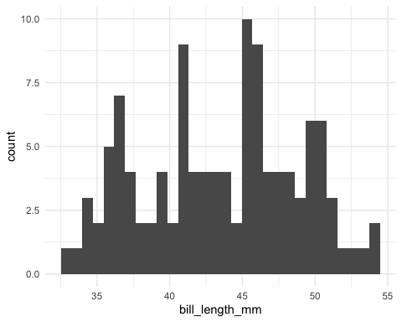

The chart shows the distribution of bill lengths. The average bill length is 43.5412281 millimeters.