Bundle Your Functions Together in Your Own R Package

In the late 2010s, Travis Gerke and Garrick Aden-Buie were working on the Collaborative Data Services Core team at the Moffitt Cancer Center. Researchers throughout Moffitt needed to access data from several highly secure databases, and Gerke and Aden-Buie were in charge of helping them. Initially, Gerke and Aden-Buie would write R code for each researcher. But they quickly realized that they were reusing the same code over and over. Why not instead share the code with the researchers so they could run it themselves?

In Chapter 12, I said that creating functions was a better approach than copying code. That is true, but only partially so. The even better approach is to create those functions and then bundle them into a custom R package. That’s exactly what Travis Gerke and Garrick Aden-Buie did. And by making a package with functions to access databases, they simplified their own work, and that of the researchers they supported. No longer did researchers have to ask for help. They could now install the package Gerke and Aden-Buie had made and use its functions themselves.

In this chapter, I discuss how to make your own R package. While privacy concerns preclude me demonstrating the package that Travis Gerke and Garrick Aden-Buie made, they walked me through the development of a simple package that includes a custom ggplot theme. I’ve drawn from this conversation to show how I could take the theme_dk() function I made in Chapter 12 and add it to my own package. Making your own R package may seem daunting, but if you know how to make your own functions, you’re halfway there. This chapter will guide you through the rest of your journey to making your own package.

How to Create a Package

In Chapter 12, I said you should make a function when you’ve copied code three times. How do you know whether functions you write should be put into a package? The answer is simple: if you plan to use the function in multiple projects, put it into a package. You may find yourself copying functions from one project to another. Or perhaps you have a set of functions you’ve saved in a functions.R file that you copy into each new project you work. Both are good indications that you’re ready for a project (Travis Gerke said that a functions.R file “screams ‘make a package’”). In Chapter 12, I made a custom ggplot theme. I want to use theme_dk() in any project where I make data visualization so let’s put it in a package.

Starting the Package

To create a package in RStudio, go to the File menu, then select New Project. From there, select New Directory. You’ll be given a list of options, one of which is R Package. Select that and you’ll then need to give your package a name (I’m going to call mine dk) and decide where you want it to live on your computer. You can leave everything else as is.

[F13001.png]

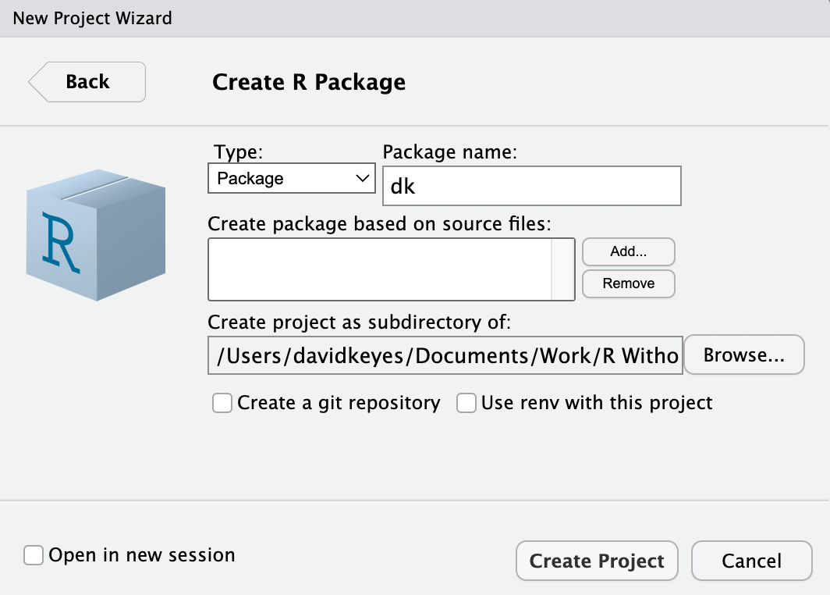

* + - * 1. The RStudio menu for creating your package

RStudio will now create and open my package. There are a few files in the package already, including hello.R, which has a prebuilt function called hello() that, when run, prints the text “Hello, world!” in the console. Let’s get rid of it and a few other default files so we’re starting with a clean slate. I’ll delete hello.R, NAMESPACE, and the hello.Rd file in the man directory.

Much of the work we’ll do working with our package relies on the usethis and devtools packages. Install those using install.packages() if you don’t already have them installed. Once you’ve done that, you’re ready to add a function to the package. To do so, run the use_r() function from the usethis package. I typically run functions from usethis and devtools in the console because I only need to run them once. I also tend to run them with the syntax package::function(), which makes it possible to use a function without loading the package (it’s also how we have to refer to functions in our package, as we’ll see below). Here’s how I would run the use_r() function:

usethis::use_r("theme")

This function will create a file called theme.R in the R directory with the name you give it as an argument (all functions in a package go in files in the R folder). I can open up the file and add code to it. I’ll begin by copying the theme_dk() function I created in Chapter 12:

theme_dk <- function(show_grid_lines = TRUE,

show_axis_titles = TRUE) {

custom_theme <- theme_minimal() +

theme(panel.grid.minor = element_blank(),

axis.ticks = element_blank(),

axis.title = element_text(size = 12,

color = "grey50"),

axis.title.x = element_text(margin = margin(t = 10)),

axis.title.y = element_text(margin = margin(r = 10)),

axis.text = element_text(size = 12,

color = "grey50"),

plot.title.position = "plot",

plot.title = element_text(size = 20,

face = "bold",

margin = margin(b = 8)),

plot.subtitle = element_text(size = 14,

color = "grey50"),

legend.text = element_text(size = 12),

legend.position = "top")

if (show_grid_lines == FALSE) {

custom_theme <- custom_theme +

theme(panel.grid.major = element_blank())

}

if (show_axis_titles == FALSE) {

custom_theme <- custom_theme +

theme(axis.title = element_blank(),

axis.title.x = element_blank(),

axis.title.y = element_blank())

}

custom_theme

}

Because we developed theme_dk() in Chapter 12, we know it works. But we need to change it in a few ways to make it work in a package. The easiest way to figure out what changes we need to make is to use built-in tools to check that our package is built correctly.

Checking our Package

To test that our package works, run the function devtools::check(). This runs what is known as R CMD check, which makes sure that others can install your package on their system. Running R CMD check on the dk package gives us a long message. The last part is the most important:

── R CMD check results ─────────────── dk 0.1.0 ────

Duration: 9.5s

❯ checking DESCRIPTION meta-information ... WARNING

Non-standard license specification:

What license is it under?

Standardizable: FALSE

❯ checking for missing documentation entries ... WARNING

Undocumented code objects:

‘theme_dk’

All user-level objects in a package should have documentation entries.

See chapter ‘Writing R documentation files’ in the ‘Writing R

Extensions’ manual.

❯ checking R code for possible problems ... NOTE

theme_dk: no visible global function definition for ‘theme_minimal’

theme_dk: no visible global function definition for ‘theme’

theme_dk: no visible global function definition for ‘element_blank’

theme_dk: no visible global function definition for ‘element_text’

theme_dk: no visible global function definition for ‘margin’

Undefined global functions or variables:

element_blank element_text margin theme theme_minimal

0 errors ✔ | 2 warnings ✖ | 1 note ✖

Let’s review the output from bottom to top. The line “0 errors ✔ | 2 warnings ✖ | 1 note ✖” gives us the three levels of issues with our package. Errors are the most severe (meaning others won’t be able to install your package), followed by warnings and notes (both of which may cause problems for others). It’s best practice to eliminate all errors, warnings, and notes. Let’s start with the note, which shows up in this section:

❯ checking R code for possible problems ... NOTE

theme_dk: no visible global function definition for ‘theme_minimal’

theme_dk: no visible global function definition for ‘theme’

theme_dk: no visible global function definition for ‘element_blank’

theme_dk: no visible global function definition for ‘element_text’

theme_dk: no visible global function definition for ‘margin’

Undefined global functions or variables:

element_blank element_text margin theme theme_minimal

To understand what R CMD check is saying, we need to explain a bit about how packages work.

Adding Dependency Packages

When you install a package using the install.packages() function, it often takes a while. That’s because, while you are telling R to install one package, that single package likely uses functions from other packages. In order to have access to these functions, R will install these packages (known as dependencies) for you. It would be a pain if, every time you installed package, you had to manually install a whole set of dependencies. But in order to make sure that the appropriate packages are installed for any users of the dk package, we have to make a few changes.

When we run R CMD check, we are told that we have several “Undefined global functions or variables” and “no visible global function definition” for various functions. This is because we are attempting to use functions from the ggplot2 package, but we haven’t specified that these functions are from ggplot2. I can use this code because I have ggplot2 installed, but we can’t assume that others will have ggplot2 installed. In order to ensure the code will work, we need to install ggplot2 for users when they install the dk package. To do this, we run the use_package() function from the usethis package as follows:

usethis::use_package(package = "ggplot2")

After I run the use_package() code in the console, I get the following message:

✔ Setting active project to '/Users/davidkeyes/Documents/Work/R Without Statistics/dk'

✔ Adding 'ggplot2' to Imports field in DESCRIPTION

• Refer to functions with `ggplot2::fun()`

The first line tells me that it is working in the dk project. The second line tells me that the DESCRIPTION file has been edited. This file provides meta information about the package we’re developing. If we open up the DESCRIPTION file (it’s in the root directory of our project), we see the following:

Package: dk

Type: Package

Title: What the Package Does (Title Case)

Version: 0.1.0

Author: Who wrote it

Maintainer: The package maintainer <yourself@somewhere.net>

Description: More about what it does (maybe more than one line)

Use four spaces when indenting paragraphs within the Description.

License: What license is it under?

Encoding: UTF-8

LazyData: true

Imports:

ggplot2

Way down at the bottom, look for the line that says “Imports:” followed by “ggplot2” on the next line. This indicates that, when a user installs the dk package, the ggplot2 package will also be installed for them. It’s important to note that, while I use the tidyverse package (this meta package contains multiple packages, of which ggplot2 is just one) when working on my own computer, when making your own package you want to have it install the individual packages needed to make it run.

Referring to Functions Correctly

We’ll return to the DESCRIPTION file in a bit, but for now, let’s take a look at this line: “Refer to functions with ggplot2::fun()”. It is telling us that, in order to use functions from other packages in the dk package, we need to refer to them in a unique way. By specifying both the package name and the function name, you ensure that the correct function is used at all times. It is rare, but there are functions with identical names across multiple packages. Using this syntax avoids any ambiguity. Remember when we ran R CMD check and got this?

Undefined global functions or variables:

element_blank element_text margin theme theme_minimal

This is because we were using functions without saying what package they come from. All of the functions listed here come from the ggplot2 package so I can add ggplot2:: before them as follows:

theme_dk <- function(show_grid_lines = TRUE,

show_axis_titles = TRUE) {

custom_theme <- ggplot2::theme_minimal() +

ggplot2::theme(panel.grid.minor = ggplot2::element_blank(),

axis.ticks = ggplot2::element_blank(),

axis.title = ggplot2::element_text(size = 12,

color = "grey50"),

axis.title.x = ggplot2::element_text(

margin = ggplot2::margin(t = 10)

),

axis.title.y = ggplot2::element_text(

margin = ggplot2::margin(r = 10)

),

axis.text = ggplot2::element_text(size = 12,

color = "grey50"),

plot.title.position = "plot",

plot.title =

ggplot2::element_text(size = 20,

face = "bold",

margin = ggplot2::margin(b = 8)

),

plot.subtitle = ggplot2::element_text(size = 14,

color = "grey50"),

legend.text = ggplot2::element_text(size = 12),

legend.position = "top")

if (show_grid_lines == FALSE) {

custom_theme <- custom_theme +

ggplot2::theme(panel.grid.major = ggplot2::element_blank())

}

if (show_axis_titles == FALSE) {

custom_theme <- custom_theme +

ggplot2::theme(axis.title = ggplot2::element_blank(),

axis.title.x = ggplot2::element_blank(),

axis.title.y = ggplot2::element_blank())

}

custom_theme

}

Now that I’ve specified that the various functions I’m using come from ggplot2, I can run the devtools::check() function again. When I do so, I now see that the notes have gone away.

❯ checking DESCRIPTION meta-information ... WARNING

Non-standard license specification:

What license is it under?

Standardizable: FALSE

❯ checking for missing documentation entries ... WARNING

Undocumented code objects:

‘theme_dk’

All user-level objects in a package should have documentation entries.

See chapter ‘Writing R documentation files’ in the ‘Writing R

Extensions’ manual.

0 errors ✔ | 2 warnings ✖ | 0 notes ✔

However, I can see that there are still two warnings that I need to deal with. Let’s do that next.

Adding Documentation

Let’s look now at the “checking for missing documentation entries” warning. This warning is telling us that we need to add documentation of our theme_dk() function. One of the benefits of creating a package is that you can add documentation to help others use your code. In the same way that users can type ?theme_mimimal() and see documentation about that function, we want them to also be able to type ?theme_dk() and learn how it works.

To create documentation for theme_dk(), we’ll use what’s known as Roxygen, which is a way to create documentation of functions in R packages using a package called roxygen2. To get started, place your cursor anywhere in the function. Then, go to the Code menu and select Insert Roxygen Skeleton, as seen in Figure 13-2 below.

[F13002.png]

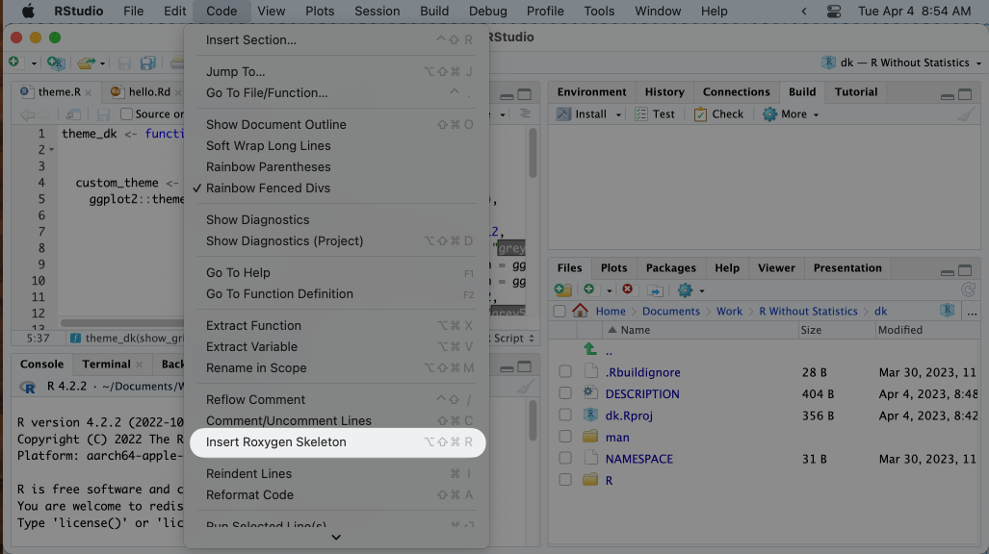

* + - * 1. The menu item to insert Roxygen skeleton

Doing this will add some text above the theme_dk() function that looks like this:

#' Title

#'

#' @param show_grid_lines

#' @param show_axis_titles

#'

#' @return

#' @export

#'

#' @examples

This text is the skeleton of what is needed to create documentation of the theme_dk() function. Each line starts with the special characters #', which indicate we’re working with Roxygen. We can now go in and edit the Roxygen text to create our documentation. Starting at the top, I’ll replace Title with a sentence that describes my function.

#' David Keyes's custom ggplot theme

Next, you can see lines with the text @param. Roxygen automatically looks at the arguments in our function and creates a line for each one. On each line, we want to describe what the argument does. I can do this as follows.

#' @param show_grid_lines Should grid lines be shown (TRUE/FALSE)

#' @param show_axis_titles Should axis titles be shown (TRUE/FALSE)

Going down the Roxygen skeleton, we next see @return. This is where we tell the user what the dk_theme() function returns. In our case, it is a complete ggplot2 theme, which I document as follows:

#' @return A complete ggplot2 theme

Below @return is @export. We don’t need to change anything here. Most functions in a package are known as “exported functions,” meaning they are available to users of the package (in contrast, internal functions, which are only used by the package developers, do not have @export in the Roxygen skeleton).

The last section is @examples. This is where you can give examples of code that users can run to learn how the function works. Doing this introduces some complexity and isn’t required so I’m going to skip it. If you do want to learn more, Chapter 17 of the second edition of Hadley Wickham and Jenny Bryan’s book R Packages is a great place to learn about adding examples.

Now that we’ve added the documentation with Roxygen, there’s one more step: running devtools::document(). This will do two things:

1. **Create a** theme_dk.Rd **file in the** man **directory**. This file is the documentation of our theme_dk() function in the very specific format that R packages require You’re welcome to look at it, but you can’t change it since it is read only.
2. **Create a** NAMESPACE **file**. This file lists the functions that your package makes available to users. My NAMESPACE file now looks like this:

# Generated by roxygen2: do not edit by hand

export(theme_dk)

The theme_dk() function is now almost ready for users.

Editing the DESCRIPTION File

We can run devtools::check() again to see if we have fixed the issues that led to the warnings. Doing so shows that the warning about missing documentation is no longer there. However, we do still have one warning.

❯ checking DESCRIPTION meta-information ... WARNING

Non-standard license specification:

What license is it under?

Standardizable: FALSE

0 errors ✔ | 1 warning ✖ | 0 notes ✔

This warning is telling us that we haven’t given our package a license. For packages made publicly available, choosing a license is important (for information on how to choose the right one for your package, see <https://choosealicense.com/>). It’s less important since we’re developing a package for our personal use, but we can still select one. I’ll use the MIT license (it allows people to do essentially whatever they want with the code) by running usethis::use_mit_license() (the usethis package has similar functions for other common licenses). Doing so returns the following:

✔ Setting active project to '/Users/davidkeyes/Documents/Work/R Without Statistics/dk'

✔ Setting License field in DESCRIPTION to 'MIT + file LICENSE'

✔ Writing 'LICENSE'

✔ Writing 'LICENSE.md'

✔ Adding '^LICENSE\\.md$' to '.Rbuildignore'

The use_mit_license() function handles a lot of the tedious parts of adding a license to our package. Most importantly for us, it specifies the license in the DESCRIPTION file. If I open up that file, I can see confirmation that I’ve added the MIT license.

Package: dk

Type: Package

Title: What the Package Does (Title Case)

Version: 0.1.0

Author: Who wrote it

Maintainer: The package maintainer <yourself@somewhere.net>

Description: More about what it does (maybe more than one line)

Use four spaces when indenting paragraphs within the Description.

License: MIT + file LICENSE

Encoding: UTF-8

LazyData: true

Imports:

ggplot2

RoxygenNote: 7.2.3

In addition to the license, the DESCRIPTION file contains meta data about the package. We can make a few changes to change the Title, add an Author and Maintainer, and add a Description. My final DESCRIPTION file might look something like this:

Package: dk

Type: Package

Title: David Keyes's Personal Package

Version: 0.1.0

Author: David Keyes

Maintainer: David Keyes <david@rfortherestofus.com>

Description: A package with functions that David Keyes may find

useful.

License: MIT + file LICENSE

Encoding: UTF-8

LazyData: true

Imports:

ggplot2

RoxygenNote: 7.2.3

Having made these changes, let’s run devtools::check() one more time to make sure everything is in order. When I do so, I get exactly what I hope to see:

0 errors ✔ | 0 warnings ✔ | 0 notes ✔

We’ve not got a package with one working function in it. If you wanted to add additional functions, you would follow the same exact procedure:

1. Create a new .R file with usethis::use_r() (you can also combine multiple functions in a single .R file).
2. Developer your function using the package::function() syntax to refer to functions from other packages.
3. Add any dependency packages with use_package().
4. Add documentation of your function.
5. Run devtools::check() to make sure you did everything correctly.

Your package can contain a single function, like dk, or as many functions as you want.

Installing the Package

Having developed our package, we’re now ready to install and use it. When you’re developing your own package, installing it for your own use is relatively straightforward. Simply run devtools::install() and the package will be ready for you to use in any project.

Of course, if you’re developing a package, you’re likely doing it not just for yourself, but for others as well. The most common way to make your package available to others is with the code-sharing website GitHub. The details of how to put your code on GitHub are beyond what we can cover here, but the book Happy Git and GitHub for the useR by Jenny Bryan is a great place to get started. I’ve pushed the dk package to GitHub and you can find it at <https://github.com/dgkeyes/dk>. If you or anyone else wants to install it, simply run the code remotes::install_github("dgkeyes/dk") (make sure you have the remotes package installed first). Once you or others install the dk package, anyone can just add the line library(dk) in any R code then use the theme_dk() function. We can recreate the penguin bill length and depth histogram from Chapter 12 with the following code.

library(dk)

library(tidyverse)

library(palmerpenguins)

penguins %>%

ggplot(aes(x = bill_length_mm,

y = bill_depth_mm,

color = island)) +

geom_point() +

labs(title = "A histogram of bill length and depth",

subtitle = "Data from palmerpenguins package",

x = "Bill Length",

y = "Bill Depth",

color = NULL) +

theme_dk()

Figure 13-3 shows the visualization (which is identical to that seen in Figure 12-1) that this code produces.

[F13003.pdf]

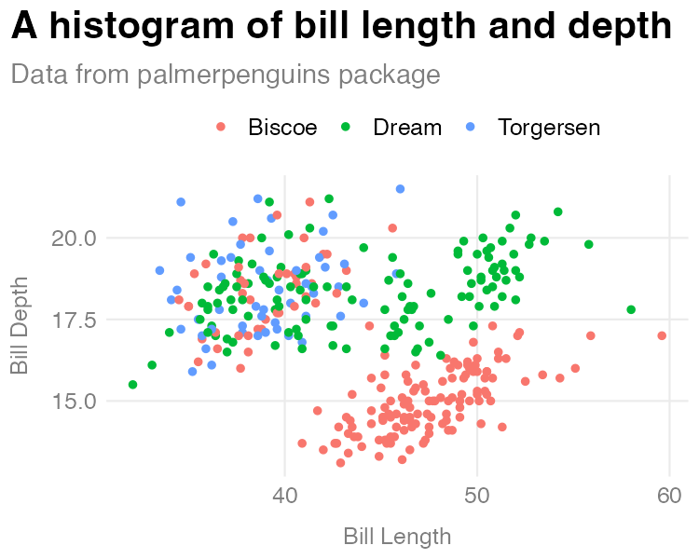

* + - * 1. A histogram made with the theme_dk() function from the dk package

The histogram may be identical, but the process was not. While I had to manually define and run the code to create theme_dk() in Chapter 12, here I only have to run library(dk) and I have access to the theme_dk() function. And the great thing is that, if I were to make changes to theme_dk(), users can simply reinstall the dk package to get access to the most up-to-date functions.

In Conclusion: You’re Already Ready to Make Your Own R Package

In my conversation with Travis Gerke and Garrick Aden-Buie of the Moffitt Cancer Center I had a realization: the name package refers to packaging up of several things that allow you and others to reliably run your code. A package is a set of functions, instructions to automatically install of dependency packages, and code documentation. If you write code that you share with others through a functions.R file, it may or may not work on their computer. They may not have the necessary packages installed. They may be confused about how arguments work and not know where to go. If you put your functions in a package, they are close to guaranteed to work. And users will have built-in documentation to help them use the functions on their own.

Creating your own R package may seem scary, but it’s not as complicated as you might think. In 2021, experienced package developer and educator Malcolm Barrett gave a talk titled “You’re Already Ready: Zen and the Art of R Package Development.” The abstract for the talk resonated deeply with me:

Many believe package development is too advanced for them or that they have nothing to offer. A fundamental belief in Zen is that you are already complete, that you already have everything you need. I’ll talk about why your project is already an R package, why you’re already an R package developer, and why you already have the skills to walk the path of development.

I hope, after reading this chapter, this message resonates with you as well.

Making packages can help you as an individual. Creating a ggplot theme like I did in this chapter, for example, can allow you to easily use it on any data visualization you make. Packages can be especially beneficial for organizations. This is exactly what Travis Gerke and Garrick Aden-Buie found during their time at the Moffitt Cancer Center. Accessing databases was so complicated that many people got stuck at that point. But when Gerke and Aden-Buie provided them with a package that contained functions to easily access the databases, Moffitt researchers began to do more with R. Gerke described the transformation: “People got to actually write code and do the data queries instead of handling administrative silliness.” Developing packages can allow more advanced users to help those with less experience using R. Aden-Buie told me that packages create “a number of gradual on-ramps for people who are getting more skills in coding.” Because more people are able to use these on-ramps, they come to see the value of using code.

What’s more, developing packages allows you as the package developer to shape how others work. Say you make a ggplot theme that follows the principles of high-quality data visualization (see Chapter 2). If you put this theme in a package, you can give others an easy way to follow these principles. Garrick Aden-Buie calls this a “happy path.” If you create a package, you can guide people on the happy path that you think is best. Packages are a way to ensure that others use best practices without them even being aware they are doing so.

Making your own R package is not as hard as you might think and comes with many benefits. Packages make it easy to reuse code across projects, allow you to help others, and encourage best practices. If you haven’t ever made your own R package, now’s the time to give it a try.