Principles of Data visualization

In the spring of 2021, nearly all of the American West was in a drought. By April of that year, officials in Southern California had declared a water emergency, citing unprecedented conditions.

This wouldn’t have come as news to those living in California and other Western states. Drought conditions like those in the West in 2021 are becoming increasingly common. Yet communicating the extent of problem remains difficult. How can we show the data in a way that accurately represents it while making it compelling enough to get people to take notice?

This was the challenge that data-visualization designers Cédric Scherer and Georgios Karamanis took on in the fall of 2021. Commissioned by the magazine Scientific American to create a data visualization of drought conditions over the last two decades in the United States, they turned to the ggplot2 package to transform what could have been dry data (pardon the pun) into a visually arresting and impactful graph.

In this chapter, I show how Scherer and Karamanis made their data visualization. We begin by looking at why the data visualization is effective. Next, we talk about the grammar of graphics, a theory to make sense of graphs that underlies the ggplot2 package that Scherer, Karamanis, and millions of others use to make data visualization. We then return to the drought graph, recreating it step-by-step using ggplot2. In the process, we pull out some key principles of high-quality data visualization that you can use to improve your own work.

The Drought Visualization

There was nothing unique about the data that Scherer and Karamanis used. Other news organizations had relied on the same data, from the National Drought Center, in their stories. But Scherer and Karamanis visualized it in a way that it both grabs attention and communicates the scale of the phenomenon. Figure 2-1 shows a section of the final visualization. Showing four regions over the last two decades, the increase in drought conditions, especially in California and the Southwest, is made apparent.

[F02001.pdf]

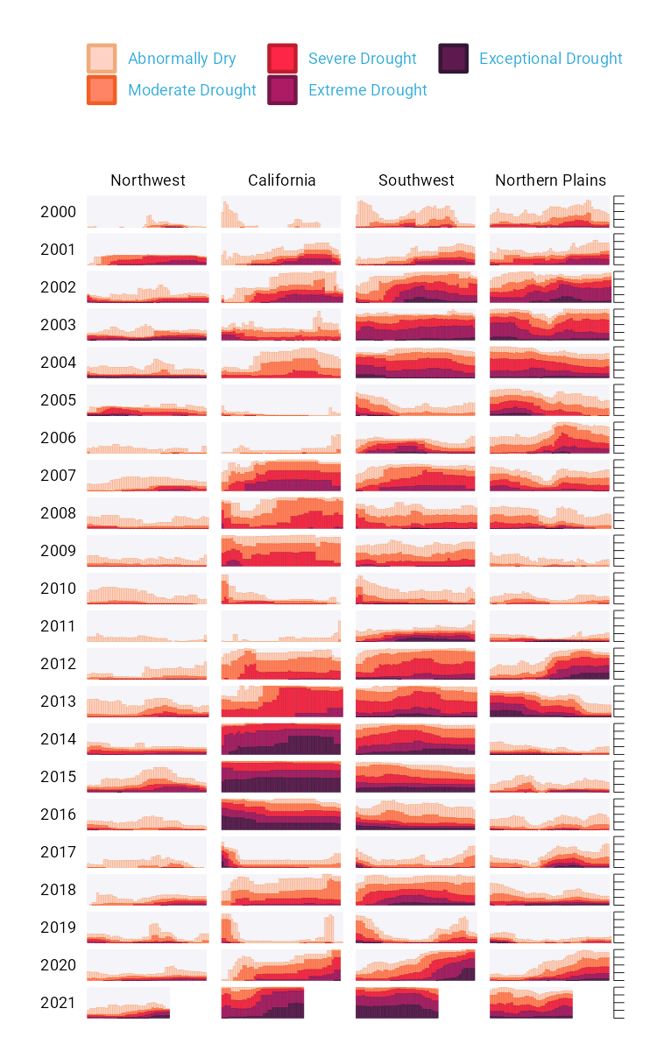

* + - * 1. A section of the final drought visualization. If you’re incredibly eagle-eyed, you’ll see a few minor elements that differ from the version published in Scientific American. These are things I had to change to make the plots fit in this book (for example, altering the text size and putting legend text on two rows) or things that Scientific American added in post-production (such as annotations).

To understand why this visualization is effective, let’s break it down into pieces. At the broadest level, the data visualization is notable for its minimalist aesthetic. There are, for example, no grid lines and few text labels, as well as little text along the axes. What Scherer and Karamanis have done is remove what statistician Edward Tufte, in his 1983 book The Visual Display of Quantitative Information, calls chartjunk. Tufte wrote (and researchers, as well as data visualization designers since, have generally agreed) that extraneous elements often hinder, rather than help, our understanding of charts.

Need proof that Scherer and Karamanis’s decluttered graph is better than the alternative? Figure 2-2 shows a version with a few small tweaks to the code to include grid lines and text labels on axes. Prepare yourself for clutter!

[F02002.pdf]

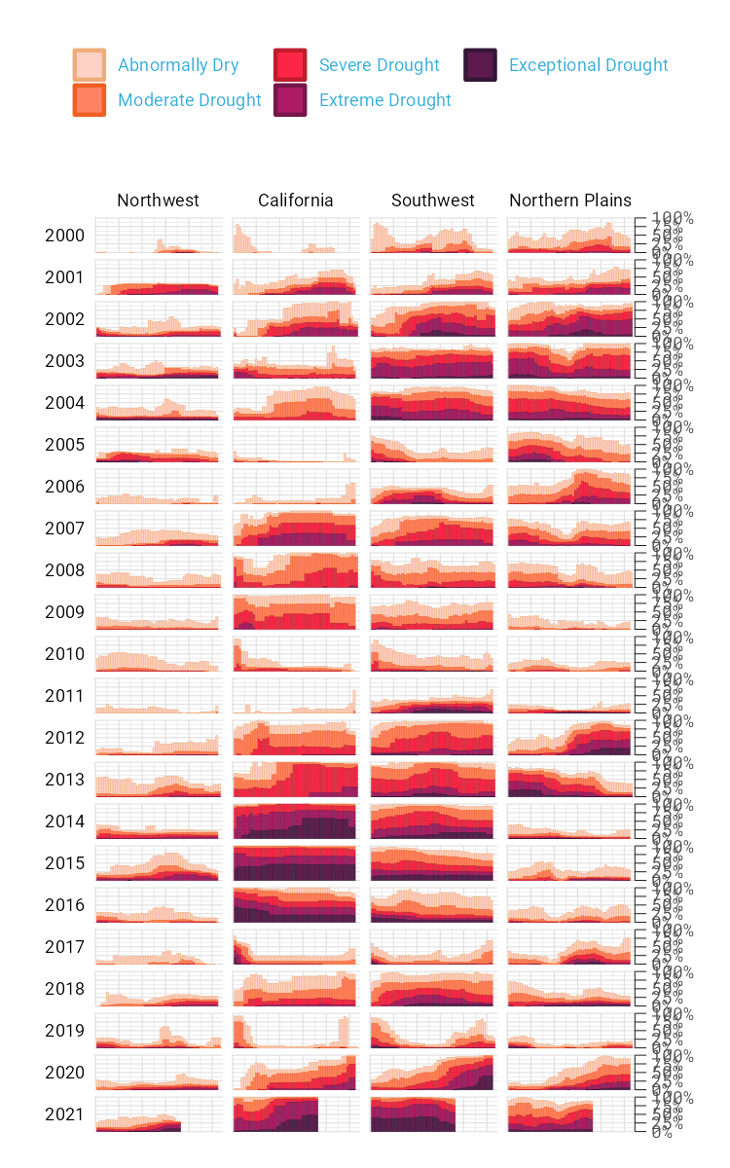

* + - * 1. The cluttered version of the drought visualization

Again, it’s not just that this cluttered version looks worse. The clutter actively inhibits understanding. Rather than focus on overall drought patterns (the point of the graph), our brain gets stuck reading repetitive and unnecessary axis text.

One of the best ways to reduce clutter is to break a single chart into what are known as small multiples. When we look closely at the data visualization, we see that it is not one chart but actually a set of charts. Each rectangle represents one region in one year. If we filter to show the Southwest region in 2003 and add axis titles, we can see in Figure 2-3 that the x axis shows the week while the y axis shows the percentage of that region at different drought levels.

[F02003.pdf]

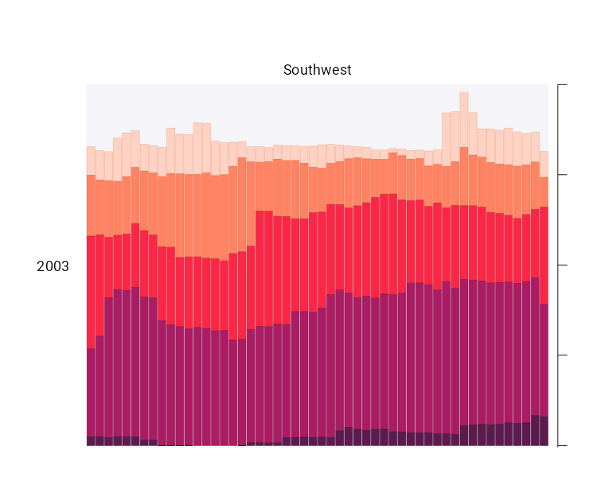

* + - * 1. A drought visualization for the Southwest in 2003

Zooming in on a single region in a single year also makes the color choices more obvious. The lightest bars show the percentage of the region that is abnormally dry while the darkest bars show the percentage in exceptional drought conditions. These colors, as we’ll see shortly, are intentionally chosen to make differences in the drought levels visible to all readers.

When I asked Scherer and Karamanis to speak with me about this data visualization, they initially told me that the code for this piece might be too simple to highlight the power of R for data visualization. No, I told them, I want to speak with you precisely because the code is not super complex. The fact that Scherer and Karamanis were able to produce this complex graph with relatively simple code shows the power of R for data visualization. And it is possible because of a theory called the grammar of graphics.

The Grammar of Graphics

If you’ve used Excel to make graphs, you’re probably familiar with the menu shown in Figure 2-4. When working in Excel, your graph-making journey begins by selecting the type of graph you want to make. Want a bar chart? Click the bar chart icon. Want a line chart? Click the line chart icon.

[F02004.png]

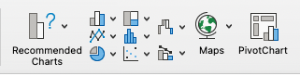

* + - * 1. The Excel chart chooser menu

If you’ve only ever made data visualization in Excel, this first step may seem so obvious that you’ve never even considered the process of creating data visualization in any other way. But there are different models for thinking about graphs. Rather than conceptualizing graphs types as being distinct, we can recognize the things that they have in common and use these commonalities as the starting point for making them.

This approach to thinking about graphs comes from the late statistician Leland Wilkinson. For years, Wilkinson thought deeply about what data visualization is and how we can describe it. In 1999, he published a book called The Grammar of Graphics that sought to develop a consistent way of describing all graphs. In it, Wilkinson argued that we should think of plots not as distinct types à la Excel, but as following a grammar that we can use to describe any plot. Just as English grammar tells us that a noun is typically followed by a verb (which is why “he goes” works, while the opposite, “goes he,” does not), knowledge of the grammar of graphics allows us to understand why certain graph types “work.”

Thinking about data visualization through the lens of the grammar of graphics allow us to see, for example, that graphs typically have some data that is plotted on the x axis and other data that is plotted on the y axis. This is the case no matter whether the graph is a bar chart or a line chart, for example. Consider Figure 2-5, which shows two charts that use identical data on life expectancy in Afghanistan.

[F02005.pdf]

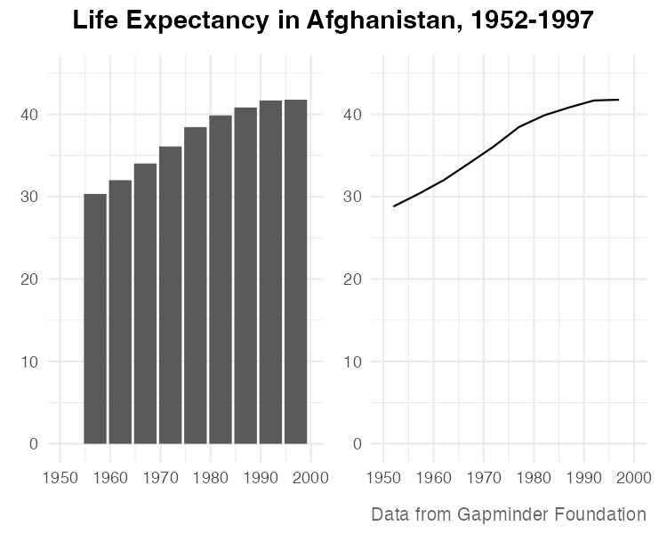

* + - * 1. A bar chart and a line chart showing identical data on Afghanistan life expectancy

While they look different (and would, to the Excel user, be different types of graphs), Wilkinson’s grammar of graphics allows us to see their similarities. (Incidentally, Wilkinson’s feelings on graph-making tools like Excel became clear when he wrote that “most charting packages channel user requests into a rigid array of chart types.”)

When Wilkinson wrote his book, no data visualization tool could implement his grammar of graphics. This would change in 2010, when Hadley Wickham announced the ggplot2 package for R in an article titled “A Layered Grammar of Graphics.” By providing the tools to implement Wilkinson’s ideas, ggplot2 would come to revolutionize the world of data visualization.

Working With ggplot2

The ggplot2 R package (which I, like nearly everyone in the data visualization world, will refer to simply as ggplot) relies on the idea of plots having multiple layers. Let’s walk through some of the most important layers. We’ll begin by selecting variables to map to aesthetic properties. Then we’ll choose a geometric object to use to represent our data. Next we’ll change the aesthetic properties of our chart (the color scheme, for example) using a scale_ function. And finally we’ll use a theme_ function to set the overall look-and-feel of our plot.

The First Layer: Mapping Data to Aesthetic Properties

When creating a graph with ggplot, we begin by mapping data to aesthetic properties. All this really means is that we use things like the x or y axis, color, and size (the so-called aesthetic properties) to represent variables. To make this concrete, we’ll use the data on life expectancy in Afghanistan, introduced in the previous section, to generate a plot. Here’s what this data looks like:

#> # A tibble: 10 × 6

#> country continent year lifeExp pop gdpPercap  
#> <fct> <fct> <int> <dbl> <int> <dbl>  
#> 1 Afghanistan Asia 1952 28.8 8425333 779.  
#> 2 Afghanistan Asia 1957 30.3 9240934 821.  
#> 3 Afghanistan Asia 1962 32.0 10267083 853.  
#> 4 Afghanistan Asia 1967 34.0 11537966 836.  
#> 5 Afghanistan Asia 1972 36.1 13079460 740.  
#> 6 Afghanistan Asia 1977 38.4 14880372 786.  
#> 7 Afghanistan Asia 1982 39.9 12881816 978.  
#> 8 Afghanistan Asia 1987 40.8 13867957 852.  
#> 9 Afghanistan Asia 1992 41.7 16317921 649.  
#> 10 Afghanistan Asia 1997 41.8 22227415 635.

If we want to make a chart with ggplot, we need to first decide which variable to put on the x axis and which to put on the y axis. Let’s say we want to show life expectancy over time. That means we would use the variable year on the x axis and the variable lifeExp on the y axis. To do so, we begin by using the ggplot() function:

ggplot(  
 data = gapminder_10_rows,  
 mapping = aes(  
 x = year,  
 y = lifeExp  
 )  
)

Within this function, we tell R that we’re using the data frame gapminder_10_rows. This is the filtered version we created from the full gapminder data frame, which includes over 1,700 rows of data. The line following this tells R to use year on the x axis and lifeExp on the y axis. When we run the code, what we get in Figure 2-6 doesn’t look like much.

[F02006.pdf]

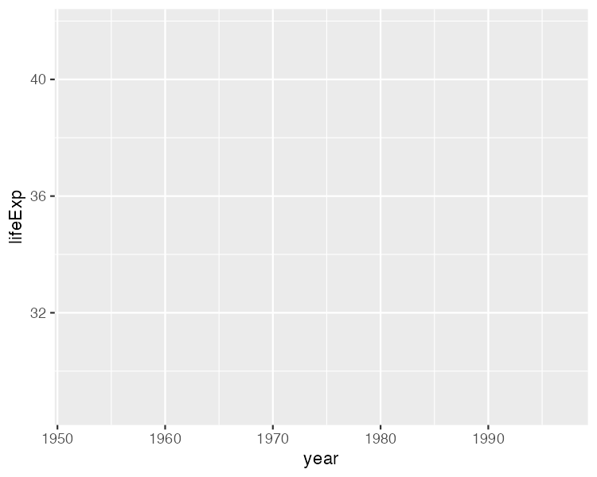

* + - * 1. A blank chart

But, if you look closely, you can see the beginnings of a plot. Remember that x axis using year? There it is! And lifeExp on the y axis? Yup, it’s there too. I can also see that the values on the x and y axes match up to our data. In the gapminder_10_rows data frame, the first year is 1952 and the last year is 1997. The range of the x axis seems to have been created with this data, which goes from 1952 to 1997, in mind (spoiler: it was). And lifeExp, which goes from about 28 to about 42 will fit nicely on our y axis.

The Second Layer: Choosing the geoms

Axes are nice, but we’re missing any type of visual representation of the data. To get this, we need to add the next layer in ggplot: geoms. Short for geometric objects, geoms are functions that provide different ways of representing data. For example, if we want to add points, we use geom_point():

ggplot(  
 data = gapminder_10_rows,  
 mapping = aes(  
 x = year,  
 y = lifeExp  
 )  
) +  
 geom_point()

Now, in Figure 2-7, we see that people in 1952 had a life expectancy of about 28 and that this value rose through every year in our data.

[F02007.pdf]

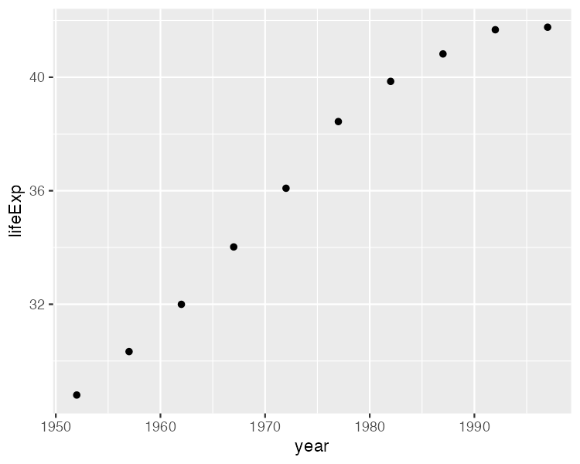

* + - * 1. The same chart but with points added

Let’s say we change our mind and want to make a line chart instead. Well, all we have to do is replace geom_point() with geom_line():

ggplot(  
 data = gapminder_10_rows,  
 mapping = aes(  
 x = year,  
 y = lifeExp  
 )  
) +  
 geom_line()

Figure 2-8 shows the result.

[F02008.pdf]

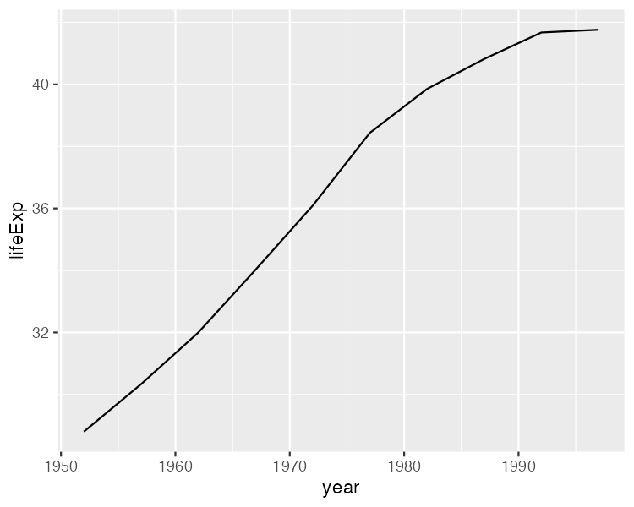

* + - * 1. The data as a line chart

To really get fancy, what if we add both geom_point() and geom_line()?

ggplot(  
 data = gapminder_10_rows,  
 mapping = aes(  
 x = year,  
 y = lifeExp  
 )  
) +  
 geom_point() +  
 geom_line()

This code generates a line chart with points, as seen in Figure 2-9.

[F02009.pdf]

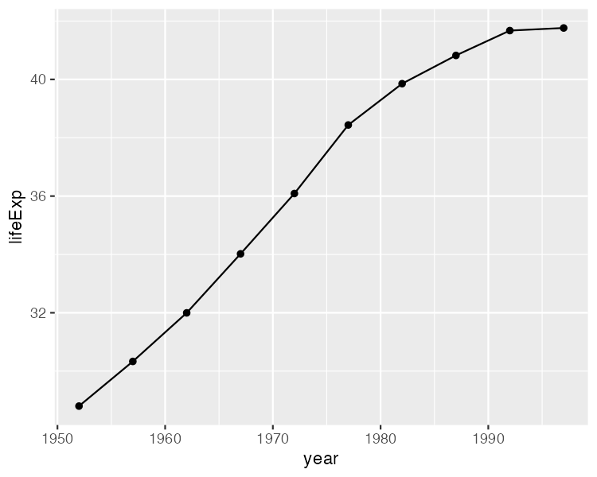

* + - * 1. The data with points and a line

We can extend this idea further, as seen in Figure 2-10, swapping in geom_col() to create a bar chart:

ggplot(  
 data = gapminder_10_rows,  
 mapping = aes(  
 x = year,  
 y = lifeExp  
 )  
) +  
 geom_col()

Note that the y axis range has been automatically updated, going from 0 to 40 to account for the different geom.

[F02010.pdf]

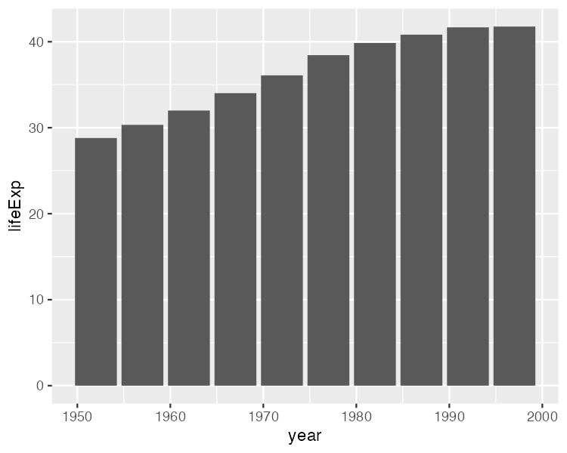

* + - * 1. The data as a bar chart

As you can see, the difference between a line chart and a bar chart isn’t as great as the Excel chart-type picker might have us think. Both can have the same aesthetic properties (namely, putting years on the x axis and life expectancies on the y axis). They simply use different geometric objects to visually represent the data.

The Third Layer: Altering Aesthetic Properties

Before we return to the drought data visualization, let’s look at a few additional layers that can help us can alter our bar chart. Say we want to change the color of our bars. In the grammar of graphics approach to chart-making, this means mapping some variable to the aesthetic property of fill. (Slightly confusingly, the aesthetic property of color would, for a bar chart, change only the outline of each bar). In the same way that we mapped year to the x axis and y to lifeExp, we can also map fill to a variable, such as year:

ggplot(  
 data = gapminder_10_rows,  
 mapping = aes(  
 x = year,  
 y = lifeExp,  
 fill = year  
 )  
) +  
 geom_col()

The result is shown in Figure 2-11. We see now that, for earlier years, the fill is darker, while for later years, it is lighter (the legend, added to the right of our plot, shows this).

[F02011.pdf]

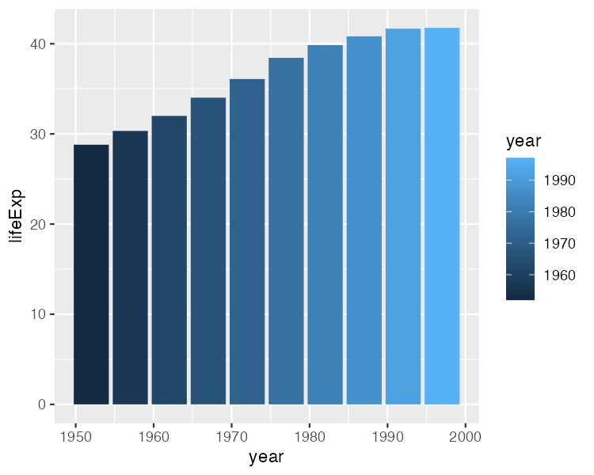

* + - * 1. The same chart, now with added colors

What if we want to change the fill colors? For that, we use a new scale layer. In this case, I’ll use the scale_fill_viridis_c() function. The c at the end of the function name refers to the fact that the data is continuous, meaning it can take any numeric value:

ggplot(  
 data = gapminder_10_rows,  
 mapping = aes(  
 x = year,  
 y = lifeExp,  
 fill = year  
 )  
) +  
 geom_col() +  
 scale_fill_viridis_c()

This function changes the default palette to one that is colorblind-friendly and prints well in grayscale. The scale_fill_viridis_c() function is just one of many that start with scale_ and can alter the fill scale.

The Fourth Layer: Setting a Theme

A final layer we’ll look at is the theme layer. This layer allows us to change the overall look-and-feel of plots (plot backgrounds, grid lines, and so on). Just as there are a number of scale_ functions, there are also a number of functions that start with theme_. Here, we’ve added theme_minimal():

ggplot(  
 data = gapminder_10_rows,  
 mapping = aes(  
 x = year,  
 y = lifeExp,  
 fill = year  
 )  
) +  
 geom_col() +  
 scale_fill_viridis_c() +  
 theme_minimal()

Notice in Figure 2-12 that this theme starts to declutter our plot.

[F02013.pdf]

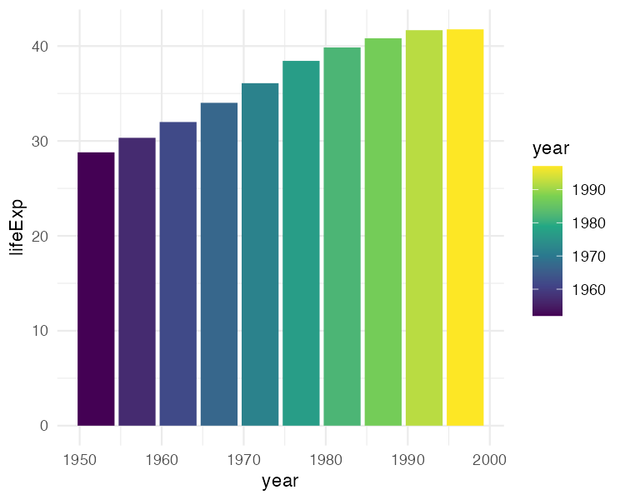

* + - * 1. The same chart with theme_minimal() added

We’ve now seen why Hadley Wickham described the ggplot2 package as using a layered grammar of graphics. It implements Wilkinson’s theory through the creation of multiple layers. First, we select variables to map to aesthetic properties, such as x or y axes, color, and fill. Second, we choose the geometric object (or geom) we want to use to represent our data. Third, if we want to change aesthetic properties (for example, to use a different palette), we do this with a scale_ function. Fourth, we use a theme_ function to set the overall look-and-feel of our plot.

We could improve the plot we’ve been working on in many ways. But rather than adding to an ugly plot, let’s instead return to the drought data visualization by Cédric Scherer and Georgios Karamanis. Going through their code will show us some familiar aspects of ggplot and reveal tips on how to make high-quality data visualization with R.

Recreating the Drought Visualization with ggplot

The drought visualization code relies on a combination of ggplot fundamentals and some less-well-known tweaks that make it really shine. In order to understand how Scherer and Karamanis made their data visualization, we’ll start out with a simplified version of their code. We’ll build it up layer by layer, adding elements as we go.

Plotting One Region and Year

Let’s start by looking at just one region (the Southwest) in one year (2003). First, we filter our data and save it as a new object called southwest_2003.

southwest_2003 <- dm_perc_cat_hubs %>%  
 filter(hub == "Southwest") %>%  
 filter(year == 2003)

We can take a look at this object to see the variables we have to work with:

southwest_2003 %>%  
 slice(1:10)  
#> # A tibble: 10 × 7  
#> date hub category perce…¹ year week max_w…²  
#> <date> <fct> <fct> <dbl> <dbl> <dbl> <dbl>  
#> 1 2003-12-30 Southwest D0 0.0718 2003 52 52  
#> 2 2003-12-30 Southwest D1 0.0828 2003 52 52  
#> 3 2003-12-30 Southwest D2 0.269 2003 52 52  
#> 4 2003-12-30 Southwest D3 0.311 2003 52 52  
#> 5 2003-12-30 Southwest D4 0.0796 2003 52 52  
#> 6 2003-12-23 Southwest D0 0.0823 2003 51 52  
#> 7 2003-12-23 Southwest D1 0.131 2003 51 52  
#> 8 2003-12-23 Southwest D2 0.189 2003 51 52  
#> 9 2003-12-23 Southwest D3 0.382 2003 51 52  
#> 10 2003-12-23 Southwest D4 0.0828 2003 51 52  
#> # … with abbreviated variable names ¹​percentage, ²​max_week

The date variable represents the start date of the week in which the observation took place. The hub variable is the region, and category is level of drought (a value of D0 indicates the lowest level of drought, while D5 indicates the highest level). The percentage variable is the percentage of that region that is in that drought category, ranging from 0 to 1. The year and week variables are the observation year and week number (beginning with week 1). The max_week variable is the maximum number of weeks in a given year.

Now we can use this southwest_2003 object for our plotting:

ggplot(  
 data = southwest_2003,  
 aes(  
 x = week,  
 y = percentage,  
 fill = category  
 )  
) +  
 geom_col()

In the ggplot() function, we tell R to put week on the x axis and percentage on the y axis. We also use the category variable for our fill color. We then use geom_col() to create a bar chart in which the fill color of each bar represents the percentage of the region in a single week at each drought level. You can see the result in in Figure 2-13.

[F02014.pdf]

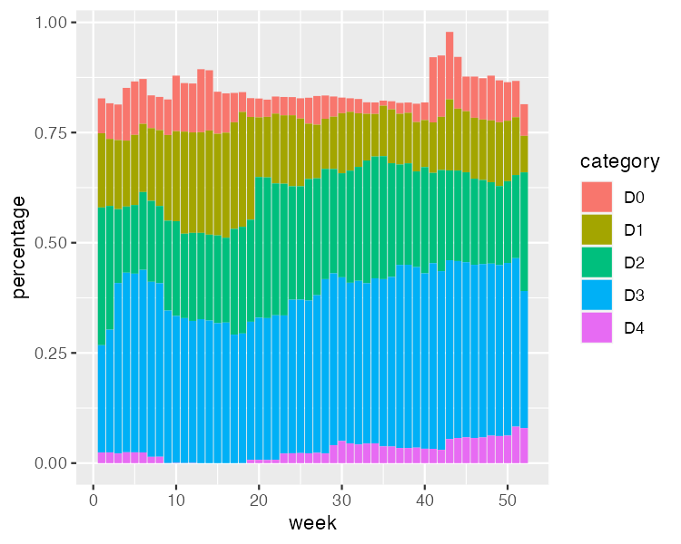

* + - * 1. One year and region of the drought visualization

The colors don’t match the final version of the plot, but we can start to see the outlines of Scherer and Karamanis’s data visualization.

Changing Aesthetic Properties

Scherer and Karamanis next selected different fill colors for their bars. To do so, they used the scale_fill_viridis_d() function. The d here means that the data to which the fill scale is being applied has discrete categories, called D0, D1, D2, D3, D4, and D5:

ggplot(  
 data = southwest_2003,  
 aes(  
 x = week,  
 y = percentage,  
 fill = category  
 )  
) +  
 geom_col() +  
 scale_fill_viridis_d(  
 option = "rocket",  
 direction = -1  
 )

They used the argument option = "rocket" to select the rocket palette (the function has several other palettes). Then they used the direction = -1 argument to reverse the order of fill colors so that darker colors mean higher drought conditions.

Scherer and Karamanis also tweaked the appearance of the x and y axes:

ggplot(  
 data = southwest_2003,  
 aes(  
 x = week,  
 y = percentage,  
 fill = category  
 )  
) +  
 geom_col() +  
 scale_fill_viridis_d(  
 option = "rocket",  
 direction = -1  
 ) +  
 scale_x_continuous(name = NULL,   
 guide = "none") +  
 scale_y_continuous(name = NULL,   
 labels = NULL,   
 position = "right")

On the x axis, they removed both the axis title (“week”) using name = NULL and the 0–50 text with guide = "none". On the y axis, they removed the title and text showing percentages using labels = NULL, which functionally does the same thing as guide = "none". They also moved the axis lines themselves to the right side using position = "right". These axis lines are only apparent as tick marks at this point but will become more visible later. Figure 2-14 shows the result of these tweaks.

[F02016.pdf]

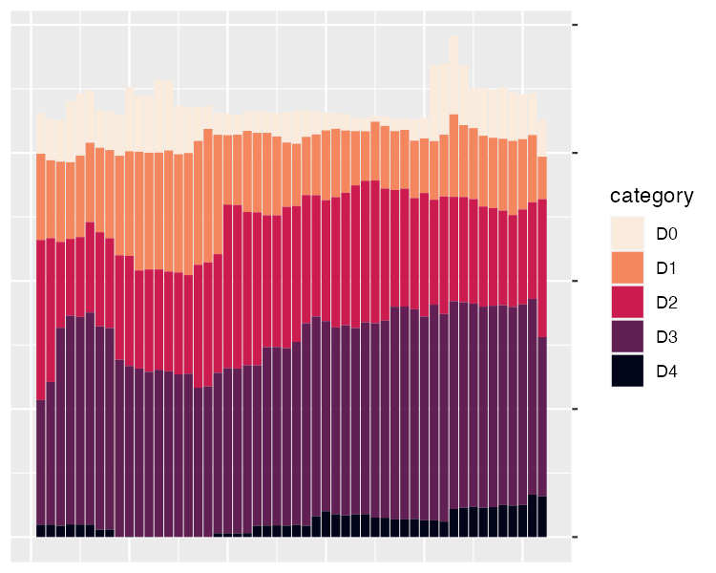

* + - * 1. One year and region of the drought visualization with adjustments to the x and y axes

Up to this point, we’ve focused on one of the single plots that make up the larger data visualization. But the final product that Scherer and Karamanis made is actually 176 plots visualizing 22 years and eight regions. Let’s discuss the ggplot feature they used to create all of these plots.

Faceting the Plot

One of the most useful features of ggplot is what’s known as faceting (or, more commonly in the data visualization world, small multiples). Faceting takes a single plot and makes it into multiple plots using a variable (think: a line chart showing life expectancy by country over time, but instead of multiple lines on one plot, we get multiple plots with one line per plot). With the facet_grid() function, we can select which variable to put in rows and which to put in columns of our faceted plot.

dm_perc_cat_hubs %>%  
 filter(hub %in% c("Northwest",   
 "California",   
 "Southwest",   
 "Northern Plains")) %>%  
 ggplot(aes(x = week,   
 y = percentage,  
 fill = category)) +  
 geom_col() +  
 scale_fill_viridis_d(  
 option = "rocket",  
 direction = -1  
 ) +  
 scale_x_continuous(name = NULL,   
 guide = "none") +  
 scale_y_continuous(name = NULL,   
 labels = NULL,   
 position = "right") +  
 facet_grid(rows = vars(year),   
 cols = vars(hub),   
 switch = "y")

Scherer and Karamanis put year in rows and hub (region) in columns. The switch = "y" argument moves the year label from the right side (where it appears by default) to the left. With this code in place, we can see the final plot coming together in Figure 2-15.

[F02017.pdf]

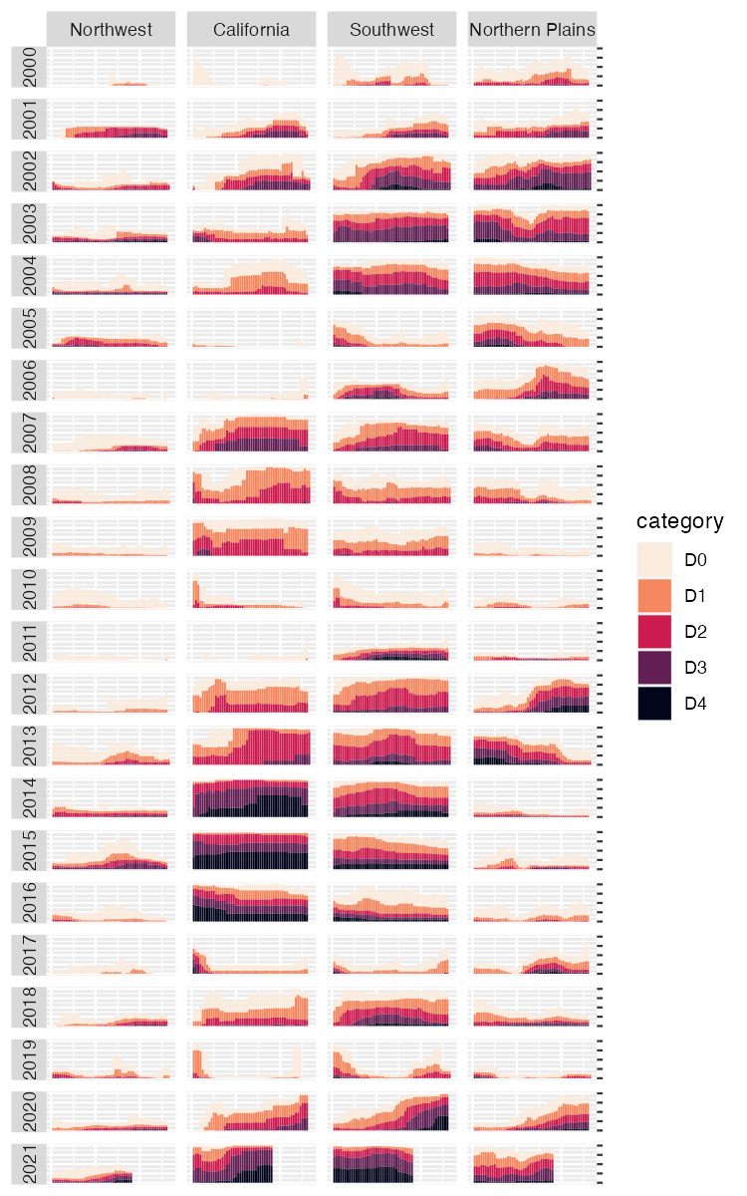

* + - * 1. The faceted version of the drought visualization. Space considerations require me to include only four regions, but you get the idea.

Incredibly, the broad outlines of the plot took us just 10 lines to create. The rest of the code falls into the category of small polishes. That’s not to minimize how important small polishes are (very) or the time it takes to create them (lots). It does show, however, that a little bit of ggplot goes a long way.

Applying Small Polishes

Let’s look at a few of the small polishes that Scherer and Karamanis made. The first is to apply a theme, as seen in Figure 2-18. They used theme_light(), which removes the default gray background and changes the font to Roboto.

The theme_light() function is what’s known as a complete theme. So-called complete themes change the overall look-and-feel of a plot. But Scherer and Karamanis didn’t stop there. They then used the theme() function to make additional tweaks to what theme_light() gave them.

dm_perc_cat_hubs %>%  
 filter(hub %in% c("Northwest",   
 "California",   
 "Southwest",   
 "Northern Plains")) %>%  
 ggplot(aes(x = week,   
 y = percentage,  
 fill = category)) +  
 geom_col() +  
 scale_fill_viridis_d(  
 option = "rocket",  
 direction = -1  
 ) +  
 scale_x_continuous(name = NULL,   
 guide = "none") +  
 scale_y_continuous(name = NULL,   
 labels = NULL,   
 position = "right") +  
 facet_grid(rows = vars(year),   
 cols = vars(hub),   
 switch = "y") +  
 theme_light(base_family = "Roboto") +  
 theme(  
 axis.title = element_text(size = 14,   
 color = "black"),  
 axis.text = element_text(family = "Roboto Mono",   
 size = 11),  
 1 axis.line.x = element_blank(),  
 axis.line.y = element_line(color = "black",   
 size = .2),  
 axis.ticks.y = element_line(color = "black",   
 size = .2),  
 axis.ticks.length.y = unit(2, "mm"),  
 2 legend.position = "top",  
 legend.title = element_text(color = "#2DAADA",   
 face = "bold"),  
 legend.text = element_text(color = "#2DAADA"),  
 strip.text.x = element_text(hjust = .5,   
 face = "plain",   
 color = "black",   
 margin = margin(t = 20, b = 5)),  
 strip.text.y.left = element_text(3 angle = 0,   
 vjust = .5,   
 face = "plain",   
 color = "black"),  
 strip.background = element_rect(fill = "transparent",   
 color = "transparent"),  
 panel.grid.minor = 4 element_blank(),  
 panel.grid.major = element_blank(),  
 panel.spacing.x = unit(0.3, "lines"),  
 panel.spacing.y = unit(0.25, "lines"),  
 5 panel.background = element_rect(fill = "transparent",   
 color = "transparent"),  
 panel.border = element_rect(color = "transparent",   
 size = 0),  
 plot.background = element_rect(fill = "transparent",   
 color = "transparent",   
 size = .4),  
 plot.margin = margin(rep(18, 4))  
 )

The code in the theme() function does many different things, but let’s take a look at a few of the most important. First, it moves the legend from the right side (the default) to the top of the plot 2. Then, an angle = 0 argument rotates the year text in the columns so that it is no longer angled 3. Without this argument, the years would be much less readable.

Next, the theme() function makes the distinctive axis lines and ticks that show up on the right side of the final plot 1. Calling element_blank() removes all grid lines 4. Finally, three lines remove the borders and make each of the individual plots have a transparent background 5.

Keen readers such as yourself may now be thinking, “Wait. Didn’t the individual plots have a gray background behind them?” Yes, dear reader, they did. Scherer and Karamanis made these with a separate geom, geom_rect():

geom_rect(  
 aes(  
 xmin = .5,  
 xmax = max_week + .5,  
 ymin = -0.005,  
 ymax = 1  
 ),  
 fill = "#f4f4f9",  
 color = NA,  
 size = 0.4  
)

They set some additional aesthetic properties specific to this geom: xmin, xmax, ymin, and ymax, which determine the boundaries of the rectangle it produces. The result is a gray background drawn behind each small multiple, as seen in Figure 2-16.

[F02021.pdf]

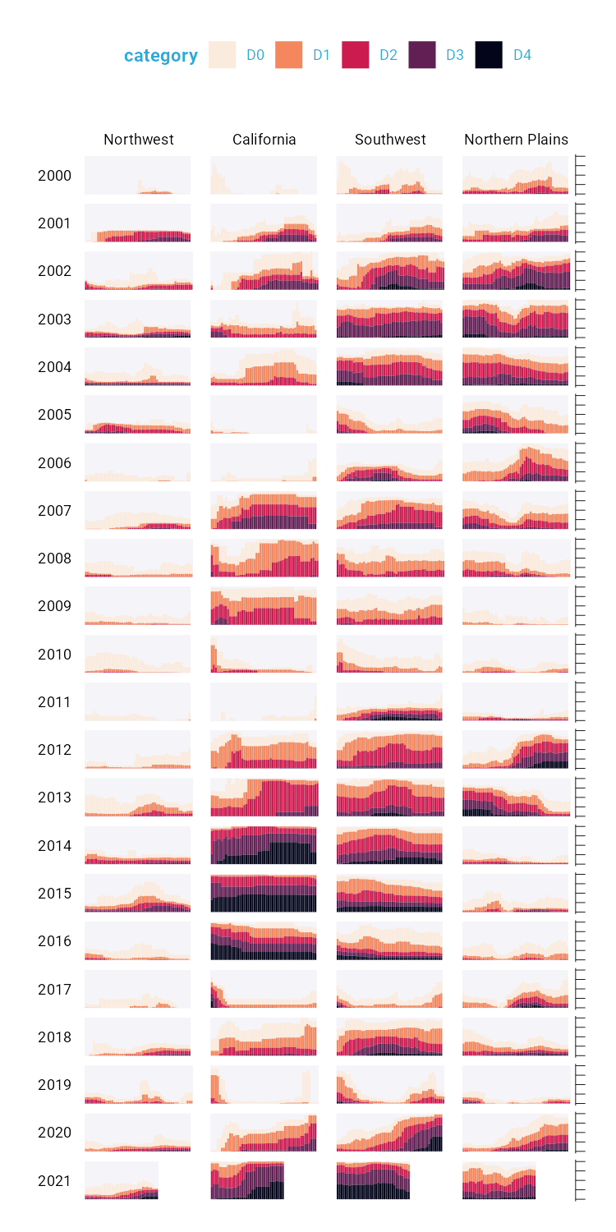

* + - * 1. Faceted version of the drought visualization with gray backgrounds behind each small multiple

Finally, consider the tweaks made to the legend. We previously saw a simplified version of the scale_fill_viridis_d() function. Here is a more complete version:

scale_fill_viridis_d(  
 option = "rocket",  
 direction = -1,  
 name = "Category:",  
 labels = c(  
 "Abnormally Dry",  
 "Moderate Drought",  
 "Severe Drought",  
 "Extreme Drought",  
 "Exceptional Drought"  
 )  
)

The name argument sets the legend title, and the labels argument determines the labels that show up in the legend. Figure 2-17 shows the result of these changes.

[F02022.pdf]



* + - * 1. Drought visualization with changes made to the legend text

Rather than D0, D1, D2, D3, and D4, we now have Abnormally Dry, Moderate Drought, Severe Drought, Extreme Drought, and Exceptional Drought.

The Complete Visualization Code

While I’ve showed you a nearly complete version of the code that Scherer and Karamanis wrote, I made some small changes along the way to make it easier to understand. If you’re curious, the full code is here:

ggplot(dm_perc_cat_hubs, aes(week, percentage)) +  
 geom_rect(  
 aes(  
 xmin = .5,  
 xmax = max_week + .5,  
 ymin = -0.005,  
 ymax = 1  
 ),  
 fill = "#f4f4f9",  
 color = NA,  
 size = 0.4,  
 show.legend = FALSE  
 ) +  
 geom_col(  
 aes(  
 fill = category,  
 fill = after_scale(addmix(darken(fill, .05,   
 space = "HLS"),   
 "#d8005a",   
 .15)),  
 color = after_scale(darken(fill, .2,   
 space = "HLS"))  
 ),  
 width = .9,  
 size = 0.12  
 ) +  
 facet_grid(rows = vars(year),   
 cols = vars(hub),   
 switch = "y") +  
 coord_cartesian(clip = "off") +  
 scale_x_continuous(expand = c(.02, .02),   
 guide = "none",   
 name = NULL) +  
 scale_y_continuous(expand = c(0, 0),   
 position = "right",   
 labels = NULL,   
 name = NULL) +  
 scale_fill_viridis_d(  
 option = "rocket",  
 name = "Category:",  
 direction = -1,  
 begin = .17,  
 end = .97,  
 labels = c(  
 "Abnormally Dry",  
 "Moderate Drought",  
 "Severe Drought",  
 "Extreme Drought",  
 "Exceptional Drought"  
 )  
 ) +  
 guides(fill = guide_legend(nrow = 2,  
 override.aes = list(size = 1))) +  
 theme_light(base_size = 18,   
 base_family = "Roboto") +  
 theme(  
 axis.title = element_text(size = 14,   
 color = "black"),  
 axis.text = element_text(family = "Roboto Mono",   
 size = 11),  
 axis.line.x = element_blank(),  
 axis.line.y = element_line(color = "black",   
 size = .2),  
 axis.ticks.y = element_line(color = "black",   
 size = .2),  
 axis.ticks.length.y = unit(2, "mm"),  
 legend.position = "top",  
 legend.title = element_text(color = "#2DAADA",   
 size = 18,   
 face = "bold"),  
 legend.text = element_text(color = "#2DAADA",   
 size = 16),  
 strip.text.x = element_text(size = 16,   
 hjust = .5,   
 face = "plain",   
 color = "black",   
 margin = margin(t = 20, b = 5)),  
 strip.text.y.left = element_text(size = 18,   
 angle = 0,   
 vjust = .5,   
 face = "plain",   
 color = "black"),  
 strip.background = element_rect(fill = "transparent",   
 color = "transparent"),  
 panel.grid.minor = element_blank(),  
 panel.grid.major = element_blank(),  
 panel.spacing.x = unit(0.3, "lines"),  
 panel.spacing.y = unit(0.25, "lines"),  
 panel.background = element_rect(fill = "transparent",   
 color = "transparent"),  
 panel.border = element_rect(color = "transparent",   
 size = 0),  
 plot.background = element_rect(fill = "transparent",   
 color = "transparent",   
 size = .4),  
 plot.margin = margin(rep(18, 4))  
 )

There are a few additional tweaks to colors and spacing, but most of the code reflects what you’ve seen so far.

In Conclusion: ggplot is Your Data visualization Secret Weapon

You may start to think of ggplot as a solution to all of your data visualization problems. And yes, you have a new hammer, but no, everything is not a nail. If you look at the version of the data visualization that appeared in Scientific American in November 2021, you’ll see that some of its annotations aren’t visible in our recreation. That’s because they were added in post-production. While you could have found ways to create them in ggplot, it’s often not the best use of your time. Get yourself 90 percent of the way there with ggplot and then use Illustrator, Figma, or a similar tool to finish your work.

Even so, ggplot is a very powerful hammer, used to make plots that you’ve seen in The New York Times, FiveThirtyEight, the BBC, and other well-known news outlets. Although not the only tool that can generate high-quality data visualization, it makes the process straightforward. The graph by Scherer and Karamanis shows this in several ways:

It strips away extraneous elements, such as grid lines, in order to keep the focus on the data itself. Complete themes such as theme_light() and the theme() function allowed Scherer and Karamanis to create a decluttered visualization that communicates effectively.

It uses well-chosen colors. The scale_fill_viridis_d() allowed them to create a color scheme that demonstrates differences between groups, is colorblind friendly, and shows up well when printed in grayscale.

It uses small multiples to break data from two decades and eight regions into a set of graphs that come together to create a single plot. With a single call to the facet_grid() function, Scherer and Karamanis created over 100 small multiples that the tool automatically combined into a single plot.

Learning to create data visualization in ggplot involves a significant time investment. But the long-term payoff is even greater. Once you learn how ggplot works, you can look at others’ code and learn how to improve your own. By contrast, when you make a data visualization in Excel, the series of point-and-click steps disappears into the ether. To recreate a visualization you made last week, you’ll need to remember the exact steps you used, and to make someone else’s data visualization, you’ll need them to write up their process for you.

Because code-based data visualization tools allow you to keep that record of the steps you made, you don’t have to be the most talented designer to make high-quality data visualization with ggplot. You can study others’ code, adapt it to your own needs, and create your own data visualization that is beautiful and communicates effectively.