

**4.1 Profit Analysis**

**4.1.1 The Concept of Revenue: TR, AR and MR**

In profit analysis, 3 types revenues are discussed. They are-

1. Total Revenue (TR)
2. Average Revenue (AR)
3. Marginal Revenue (MR)

Total Revenue:

In Economics, the income that a company or a firm receives from the sale of a good or service to the customers is called **Total Revenue.** This is the total income of a business. Total revenue is calculated as an average sales price per good or unit multiplied by the number of goods or units that were sold. That is, if a company sells a total of **q** units of a good and sells them for a price of **p** per unit, then the total revenue will be-

**Total Revenue, TR=p x q**

Where, p= price of a good per unit

q= number of units of a good sold

Average Revenue:

In Economics, **Average Revenue** is the income that is earned via per unit sell of a good or service. That is, average revenue is the ratio of total revenue (TR) and total number of units of a good sold. Mathematically,

**Average Revenue, AR= $\frac{TR}{q}$**

Where, q= number of units of a good sold

Marginal Revenue:

In Economics, for one unit change in number of goods sold, q, the change in total revenue is known as **Marginal Revenue.** This is obtained by the formula-

**Marginal Revenue, MR= $\frac{dTR}{dq}$**

**Graphical Analysis:**

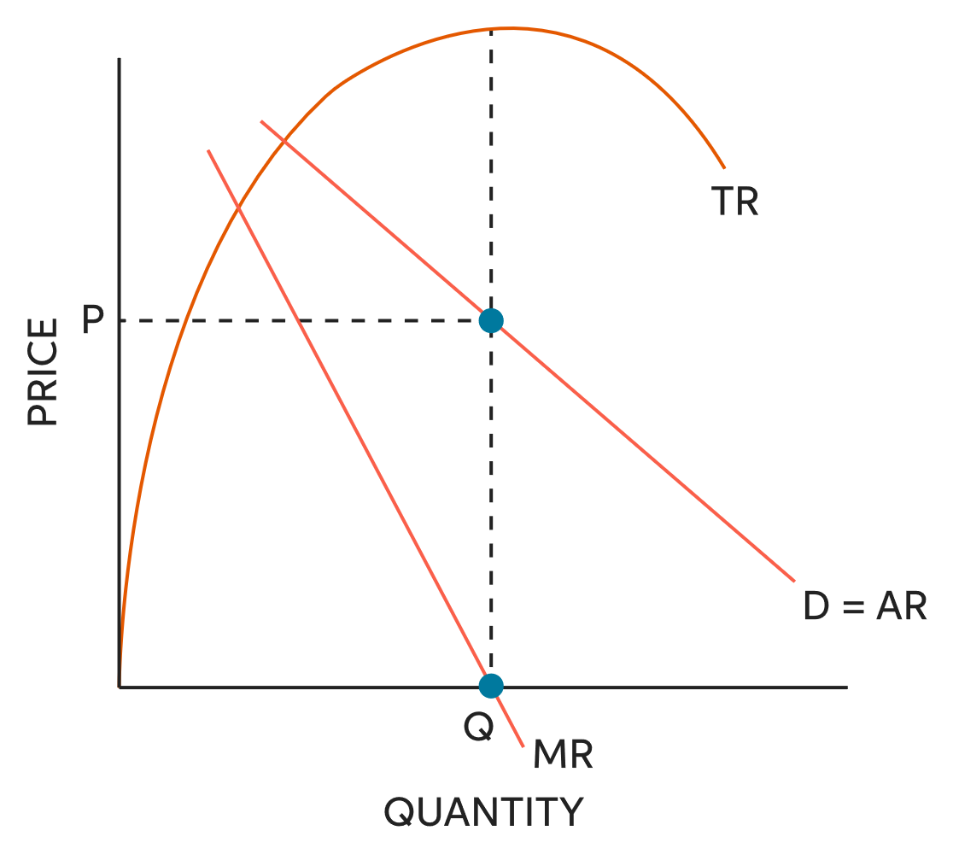

TR, MR and AR Curve

Here, both the AR and MR curve starts from the same point. For markets other than Perfectly Competitive Market (PCM), there is a relation between AR and MR curve. The relationship is:

**Slope of MR curve=2 x Slope of AR curve**

In PCM, both the AR and MR curve is the same horizontal line. This can be graphically represented as-

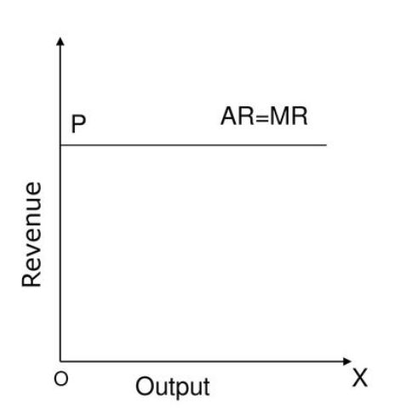

**4.1.2 Profit Maximizing Conditions**

Profit:

In Economics, Profit is the revenue remaining after all costs are paid. These costs include labor, materials, interest on debt, and taxes. Profit is usually used when describing the activity of a business. But everyone with an income has profit. It's what's left over after paying the bills.

Profit is the reward to business owners for investing. In small companies, it's paid directly as income. In corporations, it's often paid in the form of dividends to shareholders.

Profit is obtained using the following formula:

**Profit, π=Total Revenue (TR) – Total Cost (TC)**

**Graphical Analysis:**

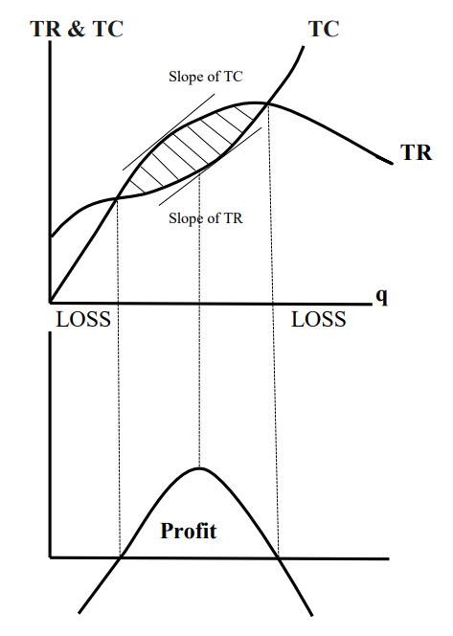

Profit Curve

Here-

* When slope of TR and slope of TC are equal, then the tangential points provide the maximum level of profit.
* There are two points at which the profit curve cuts horizontal axis. In those points, there is neither any profit nor any loss. These points are called ‘Break-Even Points’.

**Conditions for Profit Maximization:**

We know,

Profit, π=Total Revenue (TR) – Total Cost (TC)

Now, by differentiating the profit equation with respect to q (Total number of units of good sold), we get,

$\frac{dπ}{dq}$ = $\frac{dTR}{dq}-\frac{dTC}{dq}$

For maximum value of π,

$\frac{dπ}{dq}$ = 0

Or, $\frac{dTR}{dq}-\frac{dTC}{dq}$ = 0

Or, MR-MC=0 [ $\frac{dTR}{dq}$ =Marginal Revenue (MR), $\frac{dTC}{dq}$ =Marginal Cost (MC)]

∴ **MR=MC**

This condition is known as ‘First Order Condition (FOC)’ for profit maximization.

Now, by differentiating the profit equation twice with respect to q, we get,

$\frac{d^{2}π}{dq^{2}}$ = $\frac{d^{2}TR}{dq^{2}}-\frac{d^{2}TC}{dq^{2}}$

For maximum value of π,

$$\frac{d^{2}π}{dq^{2}}<0$$

Or, $\frac{d^{2}TR}{dq^{2}}-\frac{d^{2}TC}{dq^{2}}$ < 0

Or, Slope of MR – Slope of MC < 0

∴ **Slope of MR < Slope of MC**

This condition is known as ‘Second Order Condition (SOC)’ for profit maximization.

**Graphical Analysis:**

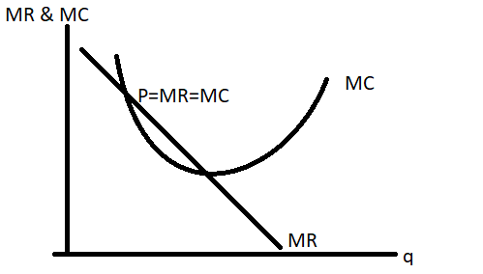

At point P, MR is equal to MC, which satisfies the FOC. Also, at point P, slope of MR is less than slope of MC, hence satisfying the SOC. So, P is the point at which profit is maximum.



**4.3 Perfectly Competitive Market (PCM)**

4.3.1 Perfect Competition

**1.** **Number of buyers & sellers:** There are *many sellers* and *many buyers*, none of which is large in relation to total sales or purchases. This assumption speaks to both demand (the number of buyers) and supply (the number of sellers). Because there are many buyers and sellers, each buyer and each seller may act independently of other buyers and sellers, respectively, and each is such a small a part of the market as to have no influence on price.

**2.Degree of product differentiation:** Each firm produces and sells a *identical/homogeneous* product. Each firm sells a product that is indistinguishable from all other firms’ products in a given industry. Consequently, buyers are indifferent to the sellers.

**3. Control Over price:** There is *no control over price*. There are many firms competing in the market. A single firm cannot influence the total market output and/or price. So, the firm is a *price-taker*.

**4. Entry barrier:** Firms have *free entry and exit*. New firms can enter the market easily, and existing firms can exit the market easily. There are no barriers to entry or exit.

**5. Shape of the demand curve:** Demand curve under PCM is *horizontal*.

4.3.2 Profit Maximization under PCM

**Profit maximization for all kinds of market:**

Economists assume that a firm’s objective in producing and selling goods is to maximize profit. Profit is the difference between total revenue and total cost.

Profit,

$π$ = Total Revenue (TR) – Total Cost (TC)

We know, TR = p×q - TC [p = Total price , q = quantity]

For profit maximization, $\frac{∂Π}{∂q}=0$

$$Or, \frac{∂TR}{∂q}-\frac{∂TC}{∂q}=0$$

$$Or,\frac{∂TR}{∂q}=\frac{∂TC}{∂q}$$

$$Or,Slope of TR=Slope of TC$$

$$Or,MR=MC$$

This is called First Order Condition for profit maximization.

**Profit maximization under PCM:**

1. Super normal Profit:

When p>AC the firm earn profit. The profit curve is shown below.

×

Profit, $π=TR-TC$

So, from the graph TR=p*×q* & TC = AC×q*

Π = Oq*× Ap* - Oq*× BC

= ABCp*

So, Super Normal profit = Area of ABCp*

For this super normal profit, other firms are want to enter in the market and super normal profit dissapear.

1. **Loss:**

When p>AC the firm earn profit. The curve concerning loss is shown below.

Profit,

Π = Oq*AP – Oq*BC

Here, Oq*BC > Oq*AC

So, Π is negative and the firm face loss

Loss area is ABCp*

Because of Loss, some existing firm will quit the market.

1. **Profit in the long-run**

In the long run, economic profit **must be zero**, which is also known as normal profit. Economic profit is zero in the long run because of the entry of new firms, which drives down the market price.

Profit, = Oq*AP - Oq*BC

As, Oq*AP = Oq*BC

So, Profit =0

This profit is called normal profit.

1 & 2 is profit in the short run. 3 is the profit for the long run.

Q1. In the long run profit is zero,why?

Ans: Because everybody gets its own price. The land gets rent, labor gets wages,capital gets interset & organization gets profit. Profit is already eaten by organizations. So, net profit is zero.

Q2. What makes a firm making supernormal profit?

Ans: Technology makes a firm making supernormal profit.Because using technology firms can minimize Average Cost and can gain more profit. It is called supernormal profit.

**4.4 Monopoly**

**Definition:** A market structure characterized by a single seller, selling a unique product in the market. In a monopoly market, the seller faces no competition, as he is the sole seller of goods with no close substitute.

**Description**: In a monopoly market, factors like government license, ownership of resources, copyright and patent and high starting cost make an entity a single seller of goods. All these factors restrict the entry of other sellers in the market. Monopolies also possess some information that is not known to other sellers.  
Characteristics associated with a monopoly market make the single seller the market controller as well as the price maker. He enjoys the power of setting the price for his goods.

**Characteristics/Assumptions of Monopoly:**

1. A monopoly is a market structure that consists of only one seller/firm or producer.
2. In monopoly, the seller sells a product which has no/close substitutes. As the product has no substitutes, the single seller/firm faces no or little competition.
3. The barriers to enter a monopoly market is extremely high. Extremely high barriers keep out new firms.

**Barriers to entry:**

Barriers to enter a monopoly market are: Government licenses, patents, and [copyrights](https://corporatefinanceinstitute.com/resources/knowledge/other/copyright/), resource ownership, decreasing total average costs, and significant startup costs are some of the barriers to entry in a monopolistic market.

When one supplier controls the production and supply of a certain product or service, other companies are unable to enter the monopolistic market. If the government believes that the product or service provided by the monopoly is necessary for the welfare of the public, the company may not be allowed to exit the market.

Generally, public utility companies, such as electricity companies and telephone companies – may be prevented from exiting the respective market.

**Key factors:**

* Single supplier.
* Profit maximization.
* Unique product.
* Barriers to entry and exit.
* Price discrimination.

**Demand and Marginal Revenue Curves**

The demand curve plots price and quantity. The marginal revenue curve plots marginal revenue and quantity. For a monopolist, *P* _ *MR*, so the marginal revenue curve must lie below the demand curve. (Note that when a demand curve is a straight line, the marginal revenue curve bisects the horizontal axis halfway between the origin and the point where the demand curve intersects the horizontal axis.)

p

q

MR

For all imperfect market, MR<AR

We Assume,

$$p=a-bq=AR$$

$$TR=pq=aq-bq^{2}$$

$$MR=\frac{dTR}{dq}=a-2bq$$

So, the slope of P is double of the slope of MR.

**4.4.2 Profit Maximization under monopoly:**

The monopolist's profit maximizing level of output is found by equating its marginal revenue with its marginal cost, which is the same profit maximizing condition that a perfectly competitive firm uses to determine its equilibrium level of output.

So, MR=MC

**Graph for Profit Maximization under Monopoly**

In the given graph,

p* denotes optimal price

q* denotes optimal quantity

Profit, π = $TR-TC$

$$TR=oq^{*}Ap^{*}$$

$$TC=oq^{*}BC$$

= $oq^{*}Ap^{*}-oq^{*}BC$

= $ABCp^{*}$

Here, the profit is not consumed by anybody because of Monopoly.

**4.5 Monopolistic Competition**

Monopolistic Competition is such a market structure where many completing producers sell a differentiated product each and there is free entry and exit in the industry in the long run. Specifically, The products have close difference to each other.  
Monopolistic competition refers to a market structure with high levels of competition among companies as they sell similar goods. Their products have slight difference.  
  
**4.5.1 Characteristics Of Monopolistic Competition:**

1. This market structure is considered more realistic than other market structures like perfect competition or monopoly.
2. In Monopolistic Competition, more than 1 production firm included, but not as many as like Perfect Competition generates. Traditionally, 10-15 firms are assumed to be connected with Monopolistic Competition.
3. Here, products are similar but not identical . To attract customer, they typically try to differentiate their products in terms of brand name, color, size or packaging etc. In a word, they have slightly different products and services.
4. There are enough flexibility in monopolistic Competition as free entry and exit are allowed here. Anyone can entry this industry at any time and can also leave according to their wish if it experiences monetary losses.
5. There are too much competition in monopolistic competition. There are many businesses within a monopolistic competition. Decisions of an individual company influenced another individual. For example, if a company increases the price of their products , the consumers may choose simply different products. If they looses the price of the products, the consumers may believe its product to be inferior and stop buying them.
6. Monopolistic competitors have slight control over their prices. But they rarely try make them too much difference with the competitors price.

**4.5.2 Profit maximization in monopolistic competition**  
  
In a monopolistic market, a firm maximizes its total profit by equating marginal cost to marginal revenue and solving for the price of one product and the quantity it must produce.  
  
 **The market demand curve and firm demand curve in monopoly is downward slopping.**

**MR = MC**

**Slope of MR > Slope of MC**

Condition for marginal revenue :-

1. MR should start to the origin AR
2. It crosses the horizontal exist through the midpoint of AR

All firms maximize profits when their marginal cost is equal to the marginal product.

P

DD Curve

Q

Monopolistic competition in short run equilibrium:-

P

C

p*

B

MC

AC

O

q*

AR=DD=P

q

A

P

p*

C

A

B

MC

AC

O

q*

AR=DD=P

q

|  |  |
| --- | --- |
| MR | MR |
| Monopolistic profit | Monopolistic Loss |
| Profit, π = TR – TC  = p*.q - AC.q  = ( OP × Oq ) - ( OC × Oq* )  = ( Oq × AP ) - ( Oq × BC )  = PABC | Loss = TR – TC  = AC.q -p*.q  = ( Oc × Oq* ) - ( OP × Oq )  = ( Oq × BC ) - ( Oq × AP )  = PABC |

**Monopolistic competition in long run equilibrium:-**

π = TR – TC

= p.q – AC.q =

OPOq* - OPOq*

= 0 (Normal profit)

P

A=B

MC

AC

O

q*

MR

AR=DD

q

P*=C

The End