PROJECT REPORT
IoT-Based Star-Delta Starter
Design and Development of a Wi-Fi Enabled Motor Starting and Monitoring System

Submitted by: Al-Nabiun
Department: Electronics Technology
Institute: Rajshahi Polytechnic Institute
Project Supervisor: ______________________________
Academic Session: ______________________________
Submission Date: ______________________________

A Diploma Engineering Project Report

Abstract
This project presents the design of an IoT-based star-delta starter for a three-phase squirrel-cage induction motor. The system combines a microcontroller-based controller, a contactor-based power circuit, and a browser-based monitoring interface. During a normal start, the motor is connected in star to reduce the voltage applied to each winding and limit starting current. After a configurable delay, the star contactor is released, a short break-before-make transition is applied, and the delta contactor is energized for normal running. The web interface can provide start/stop commands, operating-state indication, timer configuration, and fault/status display over a local Wi-Fi network. The ESP32-S3 is used as the low-voltage controller, while appropriately rated contactors, overload protection, fuses or circuit breakers, and interlocking devices handle the motor power and safety functions. The proposed design is intended as an educational prototype and must be adapted and validated by a qualified electrical professional before use with a real three-phase motor.
Keywords: IoT, ESP32-S3, star-delta starter, induction motor, contactor, web HMI, industrial automation.

Table of Contents
- 1. Introduction
- 2. Problem Statement
- 3. Objectives
- 4. Scope of the Project
- 5. Working Principle
- 6. System Architecture
- 7. Hardware and Software Requirements
- 8. Design and Implementation
- 9. Control Sequence and Interlocking
- 10. IoT Web Interface
- 11. Safety Considerations
- 12. Testing and Expected Results
- 13. Estimated Budget
- 14. Advantages and Limitations
- 15. Future Improvements
- 16. Conclusion
- References
- Appendix A: Suggested I/O Mapping

1. Introduction
Three-phase induction motors are widely used in industrial applications such as pumps, fans, compressors, conveyors, and machine tools. When an induction motor starts, it can draw a high current compared with its normal running current. This high starting current can cause voltage dips, electrical stress, and disturbance to other equipment.
A star-delta starter is a common reduced-voltage starting method for motors designed to run in delta at the supply voltage and equipped with six accessible winding terminals. The motor starts with its windings connected in star and changes to delta after a preset time. In the proposed project, an ESP32-S3 controller supervises the sequence, while a Wi-Fi web interface provides local monitoring and user commands.
The Internet of Things (IoT) element in this project means that the starter's status and controls can be accessed through a browser over a local Wi-Fi network. Internet access is not required for basic local operation. Wireless control is an additional interface, not a replacement for physical emergency-stop, overload protection, or electrical interlocking.

2. Problem Statement
Conventional star-delta starters commonly rely on hardwired push buttons and a timer. Although this arrangement is widely used, it may not provide convenient remote status visibility or easy adjustment of the transition delay. A low-cost IoT-enabled controller can make the starter easier to demonstrate, monitor, and configure in an educational laboratory. The main challenge is to add connectivity without compromising the essential electrical and mechanical safety of a motor starter.

3. Objectives
- Design a low-voltage controller using an ESP32-S3.
- Implement the star-to-delta sequence with a configurable star duration.
- Provide a responsive browser-based HMI for local start/stop commands and status monitoring.
- Use separate contactors for main, star, and delta connections.
- Provide a break-before-make transition and interlocking to prevent star and delta contactors from closing together.
- Integrate overload and emergency-stop circuits so that a fault stops the motor independently of the IoT interface.
- Document the design, testing process, limitations, and future development opportunities.

4. Scope of the Project
The project covers a prototype controller and the functional design of a conventional contactor-based star-delta starter. It includes local Wi-Fi communication, timer control, state indication, and fault reporting where suitable feedback contacts are available. The report does not specify final contactor sizes, cable sizes, overload settings, or short-circuit protection ratings because these depend on the selected motor, supply system, installation method, and applicable electrical standards. Those values must be selected by a qualified person.

5. Working Principle
In star starting, the three motor windings are connected to a common star point. For a balanced three-phase supply, each winding receives line voltage divided by the square root of three. Compared with direct-on-line delta starting at the same supply voltage, the idealized star-delta method reduces the starting line current to approximately one-third and the starting torque to approximately one-third. Actual values depend on the motor and load.
After the motor accelerates for a preset interval, the controller de-energizes the star contactor. A short dead time follows to ensure that the star contacts have opened before the delta contactor is allowed to close. The motor then operates in delta. The main contactor remains energized during the transition and normal running. If Stop, overload, emergency stop, or a detected fault occurs, the control system must drop out the contactors.
State | Main contactor | Star contactor | Delta contactor | Description
Stopped / fault | OFF | OFF | OFF | Motor isolated from the starter power path.
Star start | ON | ON | OFF | Motor accelerates in star.
Transition | ON | OFF | OFF | Break-before-make delay.
Delta run | ON | OFF | ON | Motor runs in delta.
Stop / trip | OFF | OFF | OFF | All contactors released.

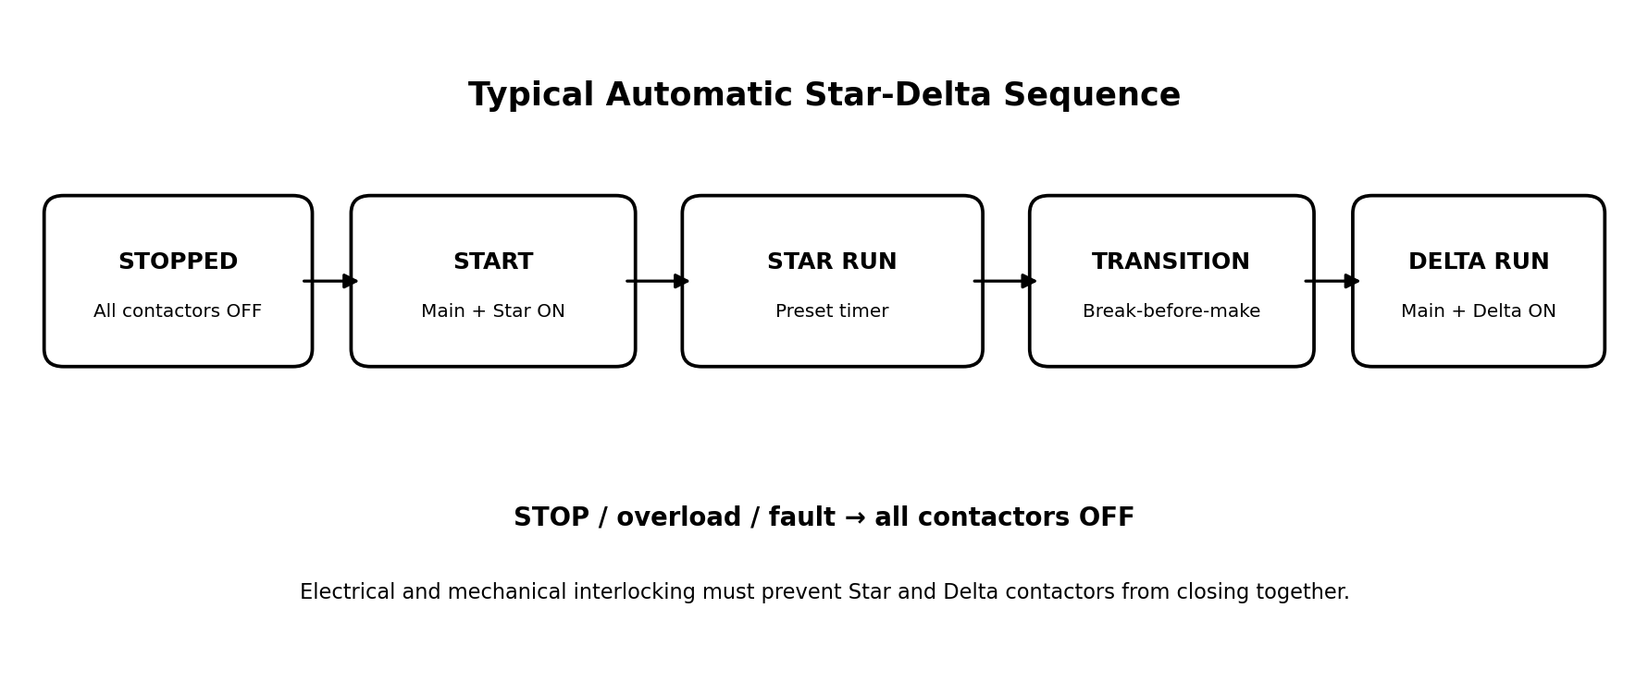

6. System Architecture
The design is divided into a low-voltage control section and a three-phase motor power section. The ESP32-S3 reads commands and status inputs, runs a non-blocking state machine, and drives an isolated interface stage. The interface stage operates the contactor coils through properly rated drivers or interposing relays. The contactors switch the motor power circuit; the ESP32 GPIO pins must never be connected directly to contactor coils or motor wiring.
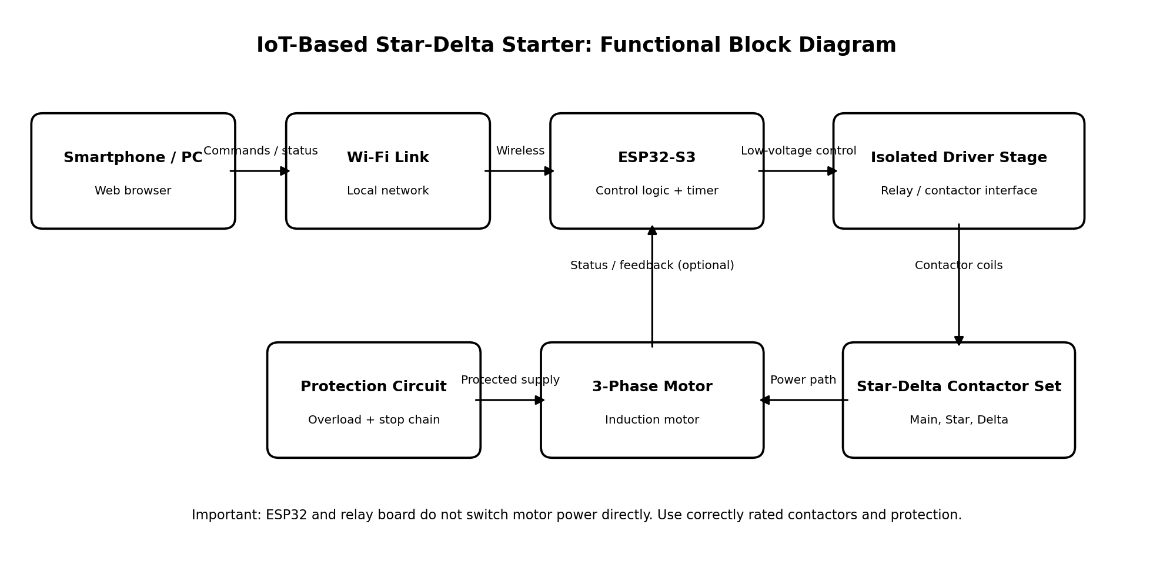

6.1 Functional Modules
- Controller: ESP32-S3 development board running the sequence and web server.
- Communication: Local Wi-Fi access point or trusted Wi-Fi network; browser-based HMI.
- Output interface: Relay/driver circuitry with appropriate isolation and coil-voltage compatibility.
- Power circuit: Main, star, and delta contactors wired for the selected motor and supply.
- Protection: Short-circuit protection, overload relay, emergency stop, and control-circuit protection.
- Feedback (recommended): Auxiliary contacts for contactor-state verification and a fault input from the overload relay.

7. Hardware and Software Requirements
Item | Purpose / selection notes
ESP32-S3 development board | Runs control logic and local web interface; use a stable, regulated low-voltage supply.
Main contactor (KM1) | Carries motor line current; size according to motor nameplate, duty category, and standards.
Star contactor (KM2) | Connects the winding ends in star during starting; size according to the approved starter design.
Delta contactor (KM3) | Connects windings in delta during normal running; size according to the approved starter design.
Mechanical/electrical interlock | Prevents KM2 and KM3 from being energized simultaneously.
Overload relay | Provides motor overload protection and trips the control circuit.
Circuit breaker/fuses | Provides appropriately coordinated short-circuit protection.
Emergency-stop push button | Hardwired, latching stop device in the control circuit, as appropriate to the design.
Isolated relay/driver interface | Matches ESP32 logic to the contactor coil circuit; verify voltage, current, polarity, and isolation.
Low-voltage power supply | Supplies the ESP32 and control electronics; keep it separate from hazardous motor power.
Enclosure, terminals, wiring | Finger-safe enclosure, labelled terminals, strain relief, earthing, and suitable cable ratings.
Software tools | Arduino IDE, ESP32 board support, C/C++, HTML/CSS/JavaScript, browser.

8. Design and Implementation

8.1 Control Logic
Use a non-blocking state machine based on a monotonic timer such as millis() rather than long blocking delays. This allows the controller to continue checking Stop, overload, emergency-stop status, and web requests during the starting interval.
- On boot, initialize all outputs to OFF and verify the controller starts in the Stopped state.
- Accept a Start request only when protection inputs are healthy and no conflicting state is active.
- Energize KM1 and KM2 for the configured star-start interval; keep KM3 OFF.
- At timer expiry, de-energize KM2 and enter the Transition state.
- Wait for the configured break-before-make interval and, if feedback is installed, confirm the star contactor is released.
- Energize KM3 to enter Delta Run; keep KM2 OFF.
- On Stop, overload, emergency stop, invalid feedback, or a controller fault, de-energize all outputs and latch a fault if appropriate.
- Require the fault condition to be cleared and a deliberate reset before restarting.

8.2 Suggested ESP32-S3 Output Mapping
The following mapping is based on the project's proposed EasyPLC-style controller mapping. Confirm the actual board pinout and ensure that selected GPIOs are safe for the exact ESP32-S3 board and boot configuration. Use active-level definitions that match the relay board and driver circuitry; do not assume that a relay input is active-high.
Signal | GPIO | Function
R1 | GPIO 1 | Main contactor command (KM1)
R2 | GPIO 2 | Star contactor command (KM2)
R3 | GPIO 42 | Delta contactor command (KM3)
Manual Start / Star-Delta input | GPIO 21 | Manual control input, if implemented
Manual Stop / mode input | GPIO 47 | Manual control input, if implemented

The GPIO mapping is a low-voltage logic assignment only. It does not define the motor power wiring. Before building, check the ESP32-S3 module's pin availability, board-specific boot/USB functions, output levels, relay-board polarity, and fail-safe behavior.

8.3 Web HMI and IoT Functions
The web HMI should show the current operating state, Star timer setting, Wi-Fi connection status, and fault condition. Start, Stop, Reset, and timer configuration controls should communicate with the ESP32 over authenticated or otherwise appropriately restricted local access. A practical initial version can run as a local access point and host a responsive webpage directly from the ESP32. The interface should clearly distinguish a requested state from a confirmed contactor state.
- Start / Stop commands with visible confirmation.
- Live state display: Stopped, Star Start, Transition, Delta Run, or Fault.
- Configurable star time and transition dead time within safe, bounded limits.
- Fault message and event log for overload or interlock-related trips, when feedback is available.
- Connection-loss behavior: loss of Wi-Fi must not prevent hardwired Stop or protection functions.
- Optional password protection and no exposure of the controller to the public internet.

9. Control Sequence and Interlocking
The starter must enforce mutual exclusion between star and delta contactors in software and in hardware. Software checks are useful but are not sufficient on their own. Use an approved mechanical interlock between the star and delta contactors and cross-wired normally closed auxiliary contacts in their coil control paths as appropriate to the contactor manufacturer’s diagram. The control design should ensure that a failure of one GPIO or a software error cannot intentionally energize both contactors together.
The Stop and protection chain should be hardwired so that pressing the emergency stop or an overload trip removes coil power regardless of whether the Wi-Fi connection, web server, or microcontroller is functioning. Where a risk assessment requires it, use a safety-rated control arrangement rather than relying on a hobby microcontroller.
A star-delta starter is suitable only for motors designed for delta running at the available line voltage and with the required six winding terminals accessible. Confirm the nameplate and terminal links before connection.

10. IoT Web Interface
The local web page can be opened from a phone or computer connected to the controller's Wi-Fi network. The page can show the current state and allow an authorized operator to request start, stop, or timer changes. The application should validate all values on both the browser and the controller. A client-side button must never be treated as proof that the motor has actually started or stopped; state confirmation should come from the controller and, preferably, contactor auxiliary feedback.
Dashboard element | Expected behavior
System status | Displays stopped, star, transition, delta, or fault.
Start / Stop | Sends a command request; Stop is also available as a physical hardwired control.
Star timer | Allows a bounded configurable delay; setting is stored only after validation.
Contactor indicators | Shows commanded state and, if wired, auxiliary-contact feedback separately.
Protection status | Displays overload and emergency-stop chain status if sensed.
Event log | Records start, transition, stop, and fault events with timestamps where available.

11. Safety Considerations
WARNING: This project involves hazardous three-phase mains voltage and rotating machinery. The report is not a substitute for an approved wiring diagram, risk assessment, or supervision by a qualified electrical professional. Do not test the motor power circuit on a breadboard or with hobby relay modules.
- Keep mains and low-voltage electronics physically separated using a suitable enclosure, barriers, creepage/clearance, and wiring practices.
- Select contactors, overload relay, protective devices, conductors, and enclosure ratings for the actual motor and installation.
- Provide appropriate earthing/grounding, short-circuit protection, overload protection, and a hardwired emergency stop.
- Use mechanical and electrical interlocking between star and delta contactors.
- Never connect ESP32 GPIO pins directly to mains, motor terminals, or contactor coils.
- Verify relay/driver isolation, coil voltage, active polarity, flyback suppression where required, and power-up default states.
- Test the sequence first with low-voltage indicator lamps or a simulated load before connecting a motor.
- Apply lockout/tagout and verify absence of voltage before wiring or servicing.
- Do not rely on Wi-Fi, software, or the web interface as the only safety mechanism.
- Ensure the motor, load, and starter are suitable for star-delta starting; the method can cause a current and torque transient during changeover.

12. Testing and Expected Results
Testing should be carried out in stages. Begin with firmware and low-voltage indicators, then verify the contactor sequence without a motor, and only proceed to a real motor after the complete power circuit has been inspected and approved.
Test | Procedure | Expected result
Power-up default | Power the controller with no start request. | All contactor outputs remain OFF.
Star sequence | Issue Start with protection chain healthy. | Main and Star commands turn ON; Delta remains OFF.
Timer transition | Wait for the configured star interval. | Star turns OFF, dead time occurs, then Delta turns ON.
Mutual exclusion | Inspect command states and interlock operation. | Star and Delta are never commanded ON together; hardware interlock prevents simultaneous closure.
Stop command | Press physical Stop and use web Stop. | All contactor coils release; state becomes Stopped.
Overload trip | Simulate the overload auxiliary contact using a safe test method. | Control circuit drops out and fault is indicated where connected.
Wi-Fi loss | Disconnect the phone or access point during a safe test. | Hardwired Stop and protection remain functional; controller behavior is deterministic.
Invalid timer input | Enter values outside the allowed range. | Input is rejected and the safe configured value remains active.
Power-cycle recovery | Restart the controller. | System returns to a safe stopped state and does not auto-start unexpectedly.

Record actual observations, measurements, firmware version, motor nameplate data, and test date in the final submitted report. Do not report unperformed tests as completed.

13. Estimated Budget
The following is a preliminary planning estimate in Bangladeshi Taka (BDT), not a supplier quotation. Prices vary by brand, rating, enclosure, and availability. Obtain local quotations and size all power components for the actual motor before purchasing.
Item | Estimated cost (BDT)
ESP32-S3 development board | 700–1,500
Isolated driver / interface components | 300–1,000
Main, Star, and Delta contactors | 3,000–8,000
Overload relay and protective devices | 1,500–4,000
Mechanical interlock, auxiliary contacts, control push buttons | 800–2,000
Low-voltage power supply | 400–900
Enclosure, terminal blocks, wiring, labels | 1,500–4,000
Miscellaneous / contingency | 700–1,500
Indicative total | 8,900–22,900

The estimate excludes the motor, fabrication, professional installation, test instruments, and any higher-cost safety-rated equipment that may be required. Safety-related components must not be selected solely on the basis of low price.

14. Advantages and Limitations

14.1 Advantages
- Provides convenient local wireless monitoring and configuration.
- Combines motor-starting fundamentals with embedded programming and IoT.
- Can display operating states and faults more clearly than a basic timer-only demonstration.
- Uses a modular architecture that can be extended with current, voltage, temperature, or vibration sensing.
- Suitable as an educational prototype for industrial automation and web-based HMI concepts.

14.2 Limitations
- Wi-Fi connectivity does not itself improve the electrical starting performance of the motor.
- Star-delta starting is not suitable for every motor or load and can produce a transition transient.
- The ESP32 is not a safety-rated motor protection controller.
- Contactor feedback and accurate fault reporting require additional auxiliary contacts or sensors.
- Real industrial deployment requires electrical design review, standards compliance, enclosure assessment, commissioning, and maintenance.

15. Future Improvements
- Add isolated current and voltage measurement for motor monitoring.
- Add auxiliary-contact feedback for main, star, and delta contactors.
- Store event history in a local database or export logs as CSV.
- Add role-based access, stronger authentication, and network security hardening.
- Integrate Modbus TCP/RTU or MQTT for a wider industrial monitoring system.
- Add a dashboard for run time, starts count, overload events, and maintenance reminders.
- Develop a simulation mode for classroom demonstration without three-phase power.
- Validate the design against applicable IEC/BNBC and local electrical requirements before any field deployment.

16. Conclusion
The IoT-based star-delta starter demonstrates how a microcontroller and local web interface can be combined with a conventional motor starter to provide accessible monitoring and configurable control. The ESP32-S3 manages the sequence, while the main, star, and delta contactors perform the power switching. The design emphasizes a safe stopped state at startup, a break-before-make transition, hardwired protection, and independent hardware interlocking. The project can be expanded into a broader industrial IoT learning platform, but any real motor installation must be designed, inspected, and commissioned by a qualified professional using correctly rated equipment.

References
1. IEC 60947 series, Low-voltage switchgear and controlgear. Consult the applicable current edition and local requirements.
2. IEC 60204-1, Safety of machinery — Electrical equipment of machines. Consult the applicable current edition.
3. Espressif Systems, ESP32-S3 Series Datasheet and ESP-IDF / Arduino documentation. Use the documentation matching the exact board and module.
4. The selected motor manufacturer's nameplate and documentation.
5. The selected contactor, overload relay, protective device, and interlock manufacturers' official datasheets and wiring instructions.

Appendix A: Suggested I/O Mapping
I/O | Suggested signal | Notes
GPIO 1 / R1 | Main contactor command | Use an isolated, properly rated driver; safe default OFF.
GPIO 2 / R2 | Star contactor command | Hardware interlock required with Delta.
GPIO 42 / R3 | Delta contactor command | Hardware interlock required with Star.
GPIO 21 | Manual Start / Star-Delta input | Optional; define pull-up/down and debounce.
GPIO 47 | Manual Stop / mode input | Optional; physical emergency stop must remain hardwired.
Digital input (available safe pin) | Overload auxiliary contact status | Use suitable isolated input conditioning.
Digital inputs (optional) | KM1/KM2/KM3 auxiliary feedback | Feedback helps detect contactor disagreement.

Pin mapping is illustrative and must be checked against the exact ESP32-S3 board. GPIO numbers are not interchangeable across all ESP32 variants. Use a documented, verified board pinout before wiring.

Appendix B: Final Submission Checklist
- Replace blank cover-page fields with the correct supervisor, session, and submission date.
- Add photographs of the actual prototype and screenshots of the working web dashboard.
- Attach the final reviewed control and power wiring diagrams.
- Record the exact motor nameplate details and selected contactor/protection ratings.
- Include only test results that were actually measured.
- Check spelling, page numbering, institutional formatting, and reference details before submission.

