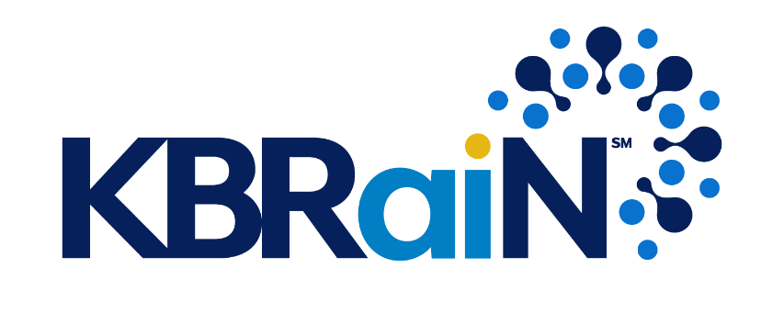

Agentpoint™: Transforming KBR IT with Integrated Enterprise Agentic AI Systems

Prepared for: John Thomson
Authors: Jeff Hawks, Al-Ebraheem Tareen
Contributors: Alex Hill
Reviewers: Joe Tello
Acknowledgements: Jenifer Pulver, Martina Schraven, Wayne Welty

January 22, 2025

Table of Contents
1 Executive Summary 4
2 Challenges and Opportunities 6
2.1 Challenges 6
2.2 Opportunities 7
2.3 Proposed Solution 8
3 Agentpoint™ 9
3.1 Agent Data Retrieval & Generation Frameworks 9
3.2 Agent Hierarchy 12
3.3 Foundational AI Agents 14
3.4 Agent-to-Agent (A2A) Observability Controls 16
3.x Agent Tools 17
3.x Agent Planning, Orchestration, & Execution 17
3.x Agent Monitoring (To Be Completed) 18
3.x Agent Evaluations (To Be Completed) 18
3.x Agent Reinforcement Learning (To Be Completed) 18
3.x Agent Failure Modes (To Be Completed) 19
3.x Agent Memory (To Be Completed) 19
3.x Agent Data Lake (To Be Completed) 19
3.x AI Governance (To Be Completed) 19
3.x AI Safety Systems (To Be Completed) 19
3.x AI Agent Resources (To Be Completed) 19
3.x Agent Domains (To Be Completed) 19
4 Execution Plan 20
4.1 Agentpoint™ Proof-of-Concept Objectives 20
4.2 Approach, Timeline and Objectives 22
5 Key Performance Indicators (KPI’s) 23
5.1 Key Performance Indicators (KPI) and Definitions 23
5.2 Key Performance Indicators (KPI) and Targets for Proof-of-Concept (POC) Scope of Work (SoW) 24
6 Cost Analysis and Budget 25
6.1 Existing GSD Direct Labor Costs 25
6.2 GSD Annual Direct and Indirect Labor Costs Summary 27
6.3 Resource Requirements for Agentpoint™ POC 28
6.4 Resource Requirements for Production-grade Agentpoint™ 1.0 29
6.5 New Estimated Annual GSD Direct and Indirect Labor Cost – Iteration 1 29
6.6 GSD Direct and Indirect Labor Cost Savings Analysis – Iteration 1 30
6.7 Agentpoint™ GSD Expected Return - Iteration 1 30
7 Risk Assessment & Mitigation Strategies 31
7.1 Risk Categories and Definitions 31
7.2 Levels of Impact 32
7.3 Levels of Probability of Occurrence 32
7.4 Risk Assessment & Mitigation Strategies 33
8 Conclusion 35
9 Metrics Annex 36
10 Financial Annex 40
11 Technical Annex 46

1 Executive Summary
To further elevate our innovation, efficiency, and excellence across our IT ecosystem, we propose developing comprehensive Agentic AI Systems , powered by KBRaiN™, and deploying AI Agents for advanced, autonomous completions of Global Service Desk (GSD) tasks.

With an initial investment of approximately $1,000,000 USD and an expected deployment timeline of 12 months, we anticipate a recurring annual cost savings of at least $1,200,000 USD when fully implemented. Prior to full implementation, we expect at least 50% of the anticipated annual cost savings to be realized from Day 1 after going live.

Our phased approach begins with the development of a Proof-of-Concept (POC) of our Integrated Enterprise Agentic AI System, coined as Agentpoint™, for the Global Service Desk. Our goal during the Proof-of-Concept phase is to validate the feasibility and technology of our Integrated Enterprise Agentic AI System. The estimated cost for our POC is approximately $100,000 USD with a completion timeline of 3 months.

We have conducted a comprehensive risk assessment and have reached the conclusion that we must move fast due to the intertwined risks of time and technology. (Technology is evolving fast, therefore, we must move fast).

Last but not least, Agentpoint™ is built with the end-goal of maximum penetration across all Business Applications, Data Sources, and IT infrastructure. Agentpoint™ ensures a scalable architecture that can be replicated as a copy-paste solution and adapted to multiple Business Units and Teams within KBR IT- driving continued automation and recurring cost savings. The aim of this proposal is developing the Enterprise of the Future

Agentpoint™, powered by KBRaiN™, is an Integrated Enterprise Agentic AI System designed to conceptualize and perform tasks autonomously across multiple verticals and systems- replicating Knowledge Workers .

AI Agents, like employees, can complete tasks by making decisions within their predefined scope . Agentic AI , on the other hand, operates more like a manager, orchestrating , adapting, learning, and self-improving across a broader set of goals and tasks.

We believe that the User Enablement business unit is the optimum choice for the initial deployment of Integrated Enterprise Agentic AI Systems and AI Agents. Our initial target to prove the validity, feasibility and impact of our technology is the Global Service Desk team. Our AI Agents will leverage existing Business Applications, Data Sources, and IT Infrastructure to address Incidents and Requests across all support channels (including voice) in real time. Our AI Agent deployment approach for the Global Service Desk is intentional and gradual, securely leading to full-scale deployment and the release of Agentpoint™ 1.0 for KBR IT. Consideration for Enterprise Security and Change Management have been provided.

Once our objectives are proven in Global Service Desk operations, we expect subsequent expansion to IT Support Teams and Business Units across KBR IT. This proposal lays out a clear roadmap for transforming KBR IT leveraging Integrated Enterprise Agentic AI Systems, Agentpoint™. Join us and provide your support, and let’s create the Enterprise of the Future!

2 Challenges and Opportunities
KBR IT’s global ecosystem naturally contains challenges and opportunities resulting from Human Resources and Business Applications.
By converting existing Systems to Integrated Enterprise Agentic AI Systems and subsequently deploying AI Agents, we can significantly reduce Operational Costs, increase Efficiency, enhance IT Service Levels, reduce Business Applications, and strengthen our Cyber Security. This initiative is expected to continuously yield measurable advantages for KBR IT in the short, medium and long term.

2.1 Challenges
- High Operational Costs: Due to the nature of the cost (Salaries & Wages, Business Applications), our ability to deliver is limited. For example, in 2024, the total Salaries & Wages cost of the Global Service Desk team was $1,686,736.33 and for the User Enablement business unit, $9,956,472.26. This does not include associated management and overhead costs.
- Human Resource Constraints: Under certain circumstances, skilled Human resources are diverted to repetitive tasks, limiting their availability for more strategic or high-value initiatives. In addition, Human resources may be unavailable for deployment during critical periods such as Major Incidents. For example, in the Global Service Desk team, during peak hours, our human resources are not able to answer support calls in a timely manner resulting in multiple end users waiting for 5+ minutes and during major incidents, over 20 minutes. Lastly, scaling Human resources requires extensive recruitment, onboarding, and training, with no guarantee of success or long-term commitment.
- Increased Dependence on Business Applications: Continued dependence on Business Applications equates to increased complexity and IT Infrastructure costs. For example, in the Global Service Desk team, this complexity obstructs the performance of Human resources. The number of Business Applications currently listed at KBR is 4,095.
- Increased Cyber Threats: With increasing forms of cyber threats, especially threats resulting from AI Agents and Agentic Systems, maintaining robust security defenses and offensive mechanisms across Business Units, Teams, Business Applications and IT Infrastructure requires continued investment towards Human resources. Our Human resources are expected to not only defend against multiple types of human-posed threats, but now also threats posed by AI Agents and Agentic AI Systems.

2.2 Opportunities
- Cost Savings: The medium-to-long-term cost savings potential for our solution is enormous, cutting operating costs across all IT Support Teams and Business Units. For example, in 2024, the Global Service Desk team of the User Enablement business unit spent $1,686,736.33 on Salaries & Wages (not including management overhead costs). In addition, in 2024, the User Enablement business unit spent a total of $9,956,472.26 on Salaries & Wages (not including management and overhead costs). Our AI Agents take over most of the existing tasks performed by Humans.
- Increased Efficiency: AI Agents are available 24/7 and can perform complex and conceptual tasks with higher precision. Our AI Agents continuously learn and self-improve through each interaction. Today, we measure the efficiency of Human resources in our IT Support Teams by established Key Performance Indicators (KPIs) per Service Level Objectives (SLO) and Service Level Agreement (SLA). Our AI Agents can easily surpass existing Key Performance Targets. For example, in the Global Service Desk team, our AI Agents can answer a call within 1 second, wrap-up a call within 1 second, and ensure there are 0 calls holding.
- Reduction of Business Applications: Our Integrated Enterprise Agentic AI System, Agentpoint™, takes over the functions and purpose of Business Applications, and as such, we expect the gradual dissolution of most 4,095 Business Applications,. This opportunity is to be explored as we complete the Production phase.
- Elevated Cybersecurity: AI-driven Monitoring and Security can increase threat detection and response-time, bolstering compliance while increasing Enterprise Security. Before, every topic required multiple meetings and discussions, but now, AI Agents will collect, collaborate, and provide the information to us, and we will be the executives and make the decision. When our end-users encounter cybersecurity issues, our AI Agents will be able to resolve incidents while also learning from each incident in real-time. This continuous cycle results in faster learning and therefore faster response times.
- Scalable Model: Our Integrated Enterprise Agentic AI System, Agentpoint™, is designed to be replicated and expanded across multiple verticals as a copy-paste solution, including IT Support Teams and Business Units with minimal effort.

2.3 Proposed Solution
- Develop Proof-of-Concept (POC) Agentpoint™ for Global Service Desk
- Allow us to prove the validity and feasibility of our technology and solution.
- Develop Enterprise-ready Agentpoint™ for Global Service Desk
- Allow us to use the Global Service Desk as a catalyst to build the foundation of our replicatable Integrated Enterprise Agentic AI System, Agentpoint™.
- Deploy AI Agents to all channels of support for Global Service Desk
- Allow us to deploy AI Agents to Global Service Desk Operations and demonstrate the impact of Agentpoint™.
- Expansion of Integrated Enterprise Agentic AI Systems across KBR IT Support Teams
- Allow us to expand Agentpoint™ to Tier 2 and Tier 3 IT Support Teams.
- Expansion of Integrated Enterprise Agentic AI Systems across KBR IT Business Units
- Allow us to continue to integrate Enterprise Agentic AI Systems, reduce Human Resources, and dissolve Business Applications.

3 Agentpoint™
Agentpoint™, powered by KBRaiN™, is an Integrated Enterprise Agentic AI System designed to conceptualize and perform services autonomously across multiple verticals and systems- replicating Knowledge Workers . During this chapter, we will highlight various product components of Agentpoint™. Agentpoint™ is built with the end-goal of maximum penetration across all Business Applications, Data Sources, and IT infrastructure. Lastly, Agentpoint™ ensures a scalable architecture that can be replicated as a copy-paste solution and adapted to multiple Business Units and Teams within KBR IT- driving robust and sustainable automation and AI Transformation.

3.1 Agent Data Retrieval & Generation Frameworks
This section will compare prominent Data Augmentation and/or Data Generation Frameworks that are utilized in Integrated Enterprise Agentic AI Systems by AI Agents depending on its objectives and use case.
 | Retrieval-Augmented Generation (RAG) | Graph-based RAG (GraphRAG) | Cache-Augmented Generation (CAG)
FOCUS | RAG enhances the generation of text via document retrieval. | GraphRAG enhances the accuracy of text generation by retrieving grounded and conceptual data from systems/documents via Knowledge Graphs in real-time. | CAG enhances RAG by generating text via pre-loaded documents/data.
DATA RETRIEVAL | RAG retrieves data/documents from data sources, fuse them together, and generate text. | GraphRAG retrieves data from knowledge graphs and multiple systems conceptually without being tied to a specific platform. | CAG preloads relevant documents/data (instead of retrieving documents dynamically.)
STRENGTHS | RAG provides rich text generation with minimal or limited data sets. | GraphRAG Improves complex query handling.  GraphRAG provides a decrease in response hallucinations .  GraphRAG provides higher accuracy.  GraphRAG retrieves, compares, and generates accurate responses in real-time from multiple systems conceptually. | CAG eliminates the delays and outpaced RAG by up to 10x.  CAG keeps sensitive data safe, ideal for privacy-critical applications.  CAG’s simplified architecture cuts down on system overhead and makes deployment easier.  CAG has low to no retrieval latency .
USE CASES | Summarization of documents.  Questions/Answers.  Report generation. | Retrieving information from complex, conceptual, and multiple systems/data sources.  Use cases where ground-truth or accurate responses are vital. | CAG provides instant responses due to pre-loaded datasets/information.  Best for secure or isolated environment such as SCIFF.  Best for edge computing or where there is no access to any external data sources or network.
CHALLENGES | Higher Latency.  Requires document Integration efforts.  Increased hallucination. | Limited contextual understanding .  Resource intensive processes. | CAG is efficient for static datasets only – limiting its applications for dynamic data .  Scenarios requiring diverse and context specific retrieval strategies are not ideal.

3.2 Agent Hierarchy
In a multi-agent system , organizing AI Agents in a hierarchical structure allows complex tasks to be subdivided and coordinated securely and efficiently. In our approach, a Supervisor AI Agent serves as the central decision-maker, receiving inputs from the end-user, delegating tasks to Expert (and specialized) AI Agents , and then synthesizing responses collectively to accomplish a task. These Expert AI Agents enable scalable task management, increased data security, and streamlined communication. This structured hierarchy not only clarifies roles and responsibilities, but also ensures each agent is optimized for its specific specialization and only has access to required data sources and tools.
Below is an example of a multi-agent system that incorporates Supervisor and Expert Agents applied to Customer Support Operations.

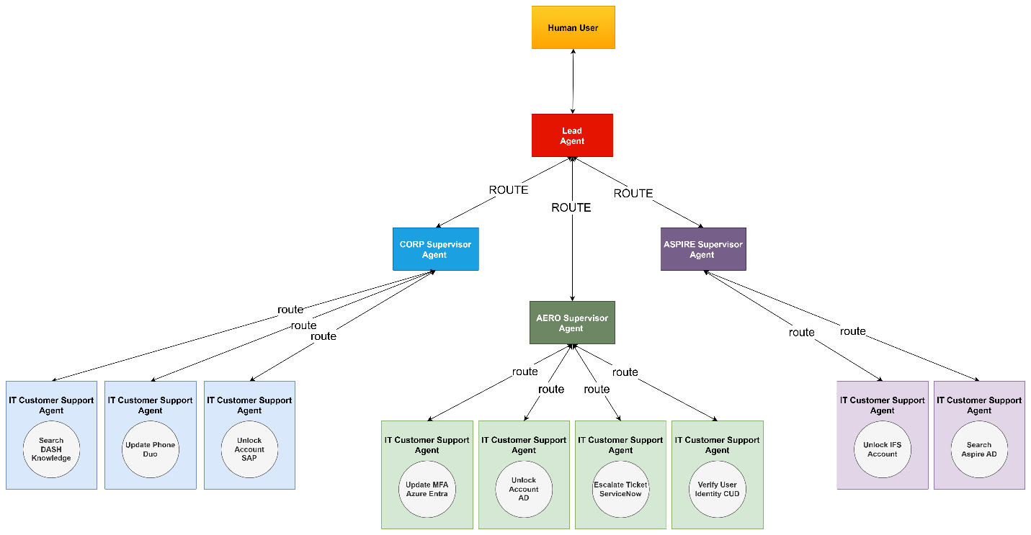
We are creating the Enterprise of the Future.

3.3 Foundational AI Agents
During this section, we will discuss the minimum (3) Types of AI Agents that are necessary in Integrated Enterprise Agentic AI Systems.
AI Agent | Agent Background and Behaviors
Security Agent | The Security Agent will continuously monitor all Supervisor Agents, Expert Agents, and the end-user concurrently in real time ensuring that KBR/KBR IT Policies & Procedures are being adhered to.  If a security incident occurs or there is a high probability that it may occur, the Security Agent may alert the Supervisor Agent, Human Manager, and/or the Enterprise Security team.  In addition, the Security Agent has the power to halt or interrupt an Agent (including Supervisor Agents) from continuing its work, depending on the severity and nature of the respective risk poses to KBR IT.  Lastly, the Security Agent may be further fine-tuned to incorporate additional policies, protocols, or guardrails based on the needs of the respective Team (or Business Unit).  Note: AI Agents will not be aware that Security AI Agents is continuously monitoring the
Supervisor Agent | The Supervisor Agent, based on its objective(s), is responsible for delegating (routing) tasks to the appropriate Expert Agent(s), with consideration to the Expert Agents specialization and level of access to tools and data sources.  The Supervisor Agent will continuously monitor all Expert Agents and the end-user concurrently in real time ensuring that KBR/KBR IT Policies & Procedures are being adhered to.  If a security incident occurs or there is a high probability that it may occur, the Supervisor Agent may alert the Expert Agent, Human Manager, and/or the Enterprise Security team.  In addition, the Supervisor Agent has the power to halt or interrupt an Expert Agent from continuing its work, depending on the severity and nature the respective risk poses to KBR IT.  Supervisor Agents may be further fine-tuned to incorporate additional policies, protocols, or guardrails based on the needs of the respective Team (or Business Unit).  Lastly, Supervisor Agents are responsible for Evaluating Expert Agents post-task execution, and if an Expert Agent does not meet Performance Goals or Metrics, they may be terminated.
Expert Agent | An Expert Agent Plans and executes tasks (Services) that have been directed or delegated to them by a Supervisor Agent.  Once the task (from the Expert Agent) has been retrieved, the Expert Agent first ensures the directive does not violate KBR IT Policies & Procedures, including additional guardrails set by the business. Continuing, the Expert Agent Plans and takes action to complete the respective tasks. Once the task has been performed and Service is completed, the Expert Agent returns the output back to the Supervisor Agent where Agent evaluation begins.  If an Expert Agent is unable to complete a task, they may request assistance from a Supervisor Agent, who may subsequently seek assistance from other Expert Agents, Supervisor Agents, and Human Agents.  An Expert Agent is at the lowest level of hierarchy and is curated to only perform a set of pre-defined Services on a particular Domain. Depending on the nature of the Service, maximum restrictions are applied including appropriate and minimum access to Environments, Data Sources and Tools.

3.4 Agent-to-Agent (A2A) Observability Controls
To control aspects of observability between multiple Agents, we have invented robust security controls coined as Agent-to-Agent (A2A) Observability Controls. The controls below can be leveraged depending on business, security, and operational requirements.
AGENT-TO-AGENT (A2A) OBSERVABILITY CONTROLS
Existence | Controls awareness of Existence to other AI Agents.
Environments | Control awareness of available Environments to other AI Agents.
Planning | Controls awareness of Planning to other AI Agents.
Communication | Controls awareness of Communication to other AI Agents.
Tools | Control awareness of available Tools to other AI Agents.
Actions | Controls awareness of available Actions to other AI Agents.
Memory | Controls awareness of Memory to other AI Agents.
Data Sources | Controls awareness of available Data Sources to other AI Agents.
Datasets | Control awareness of available Datasets to other AI Agents.
Evaluations Records | Control awareness of Evaluation records to other AI Agents.
Domains | Control AI Agent access to Environments. (CORP, AERO, Aspire, XNET)
Human Managers | Assigns Human Managers to AI Agents.

3.x Agent Tools

3.x Agent Planning, Orchestration, & Execution
Agent Planning (Task Breakdown, Execution)

3.x Agent Monitoring (To Be Completed)
Agent as a Judge, Human as a Judge, Human in the loop (Autonomous Behaviors, Approval & Interruptability)

3.x Agent Evaluations (To Be Completed)
Planning Metrics, Tool Use Metrics

3.x Agent Reinforcement Learning (To Be Completed)
How Reinforcement Learning (RL) would apply to IT Customer Service AI Agents:
Learning Through Real Interactions: The AI Agent interacts with customers and gathers feedback from each experience—such as whether the customer’s issue was resolved, how quickly it was handled, or if it needed escalation.
- Reward for Positive Outcomes: Each successful resolution or high satisfaction rating acts like a “reward.” Over time, these rewards guide the AI Agent to repeat successful strategies.
- Penalty for Negative Outcomes: If a conversation goes poorly, takes too long, or requires Human intervention, the AI Agent receives a “penalty.” This motivates it to refine its approach.
- Continuous Improvement: As more interactions occur, the Agent builds a better understanding of which actions lead to the best outcomes (faster resolutions, happier customers) and updates its behavior accordingly.
- Goal-Driven Optimization: The AI Agent’s primary goals—reducing resolution times, improving user satisfaction, and minimizing escalations—remain its focus. The RL process helps it figure out the most effective way to achieve these goals by learning from successes and mistakes in real time.
Overall, RL in this context centers on trial, feedback, and incremental improvement, ensuring the AI Agents become more efficient and effective at customer service tasks as they gain more experience.

3.x Agent Failure Modes (To Be Completed)
Planning Issues, Tool execution Problems

3.x Agent Memory (To Be Completed)
Short-term memory, Long-term memory

3.x Agent Data Lake (To Be Completed)

3.x AI Governance (To Be Completed)

3.x AI Safety Systems (To Be Completed)

3.x AI Agent Resources (To Be Completed)
Agent on Payroll, Agent Termination (Human Resources > Agent Resources)

3.x Agent Domains (To Be Completed)

4 Execution Plan
This chapter will describe our execution plan for Agentpoint™, including our Phased Approach and Objectives, Implementation Timeline, and long-term goals.

4.1 Agentpoint™ Proof-of-Concept Objectives
Our phased approach starting with Proof-of-Concept (POC). The goal of the POC Phase is to validate the feasibility and technology of our Integrated Enterprise Agentic AI System.
Phase 1: Agentpoint™ Proof-of-Concept (POC) Objectives
Deliverables | High Level Goals (Acceptance Criteria)
Agentic Voice | - The Supervisor AI Agent can conversate with Human users verbally (to be finalized – latency, single voice interaction maximum duration, accuracy of the conversion to text / excluded – languages other than American English, accents other than basic standard US English)
Agentic Information Collection and Processing | - The Supervisor AI Agent can collect, process, and store preliminary information in Service Now about an incident (to be finalized – incident form mandatory preliminary fields, and a level of accuracy x%) (Requires integration)  - The Supervisor AI Agent can continuously collect, process, and store information in memory or in Service Now (to be finalized – rest of the information exchange during a call with accuracy level of y% and 100% of accuracy on customer agreement on incident resolution).  - The Supervisor AI Agent can continuously collect, process, and store information from AI Experts in memory or in Service Now
Agentic Planning | - The Supervisor and Expert AI Agent can plan its next steps before execution (for the scope of the PoC – 100% of the tasks and/or subtask are assigned or self-assigned properly)
Agentic Orchestration | - The Supervisor AI Agent can collaborate with multiple Expert AI Agents (for the scope of the PoC – 100% of the tasks and/or subtask assigned to the AI Agents are executed and delivered coordinately, and the incident is close when the end user confirms agreement with resolution)
Agentic Execution | - The Supervisor and the Expert AI Agents can receive requests and perform a task, and communicate about completion (for the scope of the PoC – 100% of the tasks and/or subtask are completed correctly)
Agentic Knowledge | - The Supervisor and Expert AI Agent can leverage knowledge from ServiceNow (DASH) Knowledgebase (Requires integration)
Agentic Security | - The Supervisor and the Expert AI Agent(s) can work together to verify the Human user’s identity (Requires integration with Workday CUD)
Agentic Tools & Skills | - The Supervisor AI Agent can use 3C Logic via web browser (Requires integration)

4.2 Approach, Timeline and Objectives
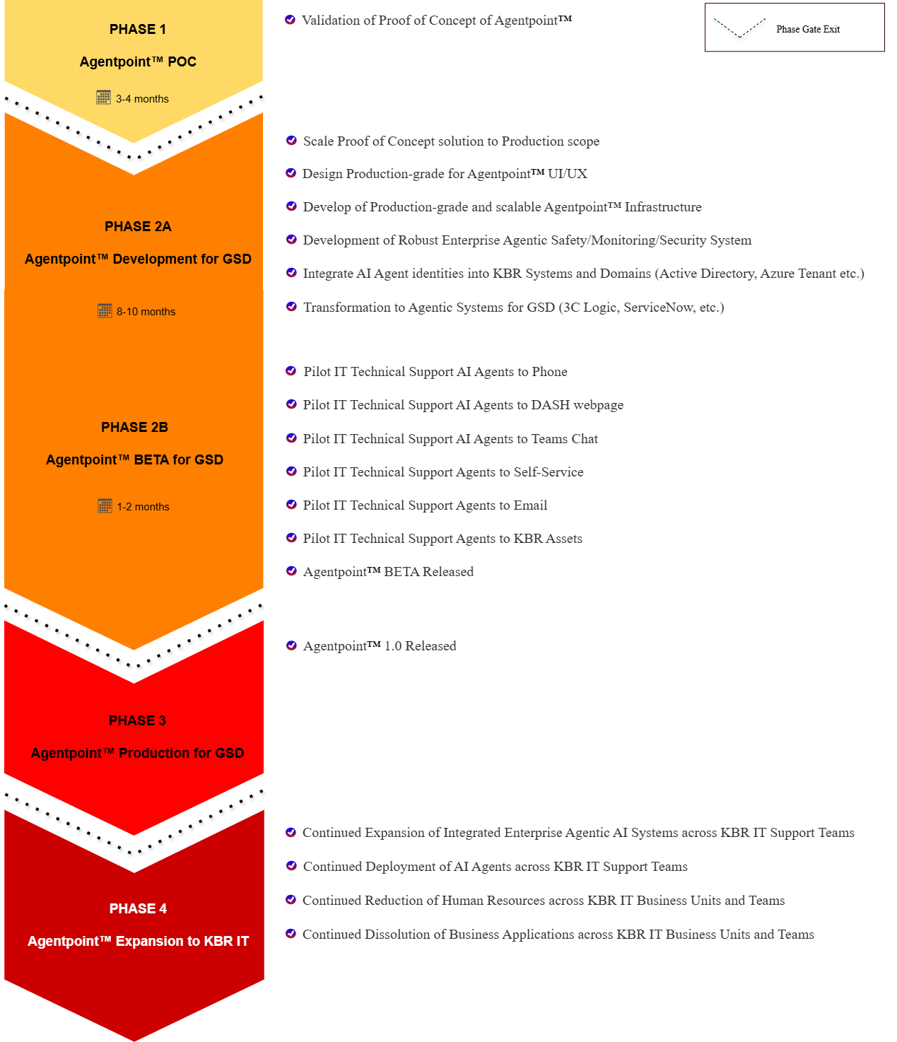

5 Key Performance Indicators (KPI’s)
This chapter will describe Key Performance Indicators (KPIs) and targets for our Integrated Enterprise Agentic AI System, Agentpoint™, for the Global Service Desk.

5.1 Key Performance Indicators (KPI) and Definitions
Key Performance Indicator | Definition
Compliance with KBR IT Service Level Agreement (SLA) | - Key Performance Indicators (KPIs) per KBR IT Service Level Agreement (SLA) . (Measured in percentage)
Call Answer Time | - The time it takes an agent to answer a call after it has been received. (Measured in seconds)
Call Active Talk Time | - The duration of the call after it has been answered before it has ended. (Measured in seconds)
Call Wrap-up Time | - The time it takes for an agent to become available for the next call after the previous call has ended. (Measured in seconds)
Calls on Hold | - The number of calls that are waiting due to agent unavailability. (Measured in natural numbers)
Incident First Contact Resolution (FCR) | - The percentage of incidents that are resolved by the first contact. (Measured in percentage)
Incident User Satisfaction | - The percentage of user satisfaction for an incident post-support. (Measured in percentage)

5.2 Key Performance Indicators (KPI) and Targets for Proof-of-Concept (POC) Scope of Work (SoW)
Key Performance Indicator | Previous Target | 2024 Metric | New Target
Compliance with Incident Service Level Agreement (SLA) | Per SLA | TBC | 100%
Call Answer Time | 20 seconds | TBC | 1 second
Call Active Talk Time | 15 minutes | TBC | 7 minutes
Call Wrap-up Time | 5 minutes | TBC | 1 second
Calls on Hold | No Target Set | TBC | 0 Calls
Incident First Contact Resolution (FCR) | No Target Set | TBC | 80%
Incident User Satisfaction | No Target Set | TBC | 80%

6 Cost Analysis and Budget
The numbers shown below are conservative estimates and were calculated from multiple sources including the 2024 User Enablement Financial Reports supplied by the Corporate Finance team and advisement from KBR IT Team members.
No consideration has been provided for Annual Salary Increases, HR Compliance, Payroll Compliance, IT Infrastructure & Networking, and/or additional Overhead expenditure. Certain discretions have been expressed.
Additional information may be found in the Financial Annex.

6.1 Existing GSD Direct Labor Costs
GSD Annual Support Team Direct Labor Cost
Country | # of Agents | Annual (Avg) Salary | Grand Total
United States | 16 | $50,000.00 | $800,000.00
United Kingdom | 2 | $40,727.87 | $81,455.74
India | 10 | $7,718.68 | $77,186.82
Total Annual Support Team Direct Labor Cost |  |  | $958,642 +

GSD Annual Management Team Direct Labor Cost
Job Title | # of Agents | Annual (Avg) Salary | Grand Total
Sr. Manager | 1 | $78,100.00 | $234,300.00
Project Coordinators | 2 | $78,100.00 | $234,300.00
Total Annual Management Team Direct Labor Cost |  |  | $234,300 +

GSD Total Annual Direct Labor Cost
Team | Grand Total
GSD Support Team Direct Labor Costs | $958,642.56
GSD Management Team Direct Labor Cost | $234,300.00
Total Annual Direct Labor Cost | $1,192,942 +
GSD Total Annual Indirect Labor Costs
Category | Total Cost Per Agent | Total Agents | Grand Total
Indirect Labor Costs (Fringes) | $15,929.52 | 31 | $493,815.12
Total Indirect Labor Costs |  |  | $493,815 +

6.2 GSD Annual Direct and Indirect Labor Costs Summary
GSD Annual Direct and Indirect Labor Cost Summary
Annual Direct Labor Costs | $1,192,942 +
Support Team | $958,642.56
(16) United States | $800,000.00
(2) United Kingdom | $81,455.74
(10) India | $77,186.82
Management Team | $234,300.00
(1) Sr. Manager | -
(2) Project Coordinator | -
Annual Indirect Labor Costs | $493,815 +
Indirect Labor Costs (Fringes) | $493,815.12
Total Annual Direct and Indirect Labor Costs | $1,686,757 +

6.3 Resource Requirements for Agentpoint™ POC
Resource Requirements for Agentpoint™ POC
Resources | Internal | External | Estimated Effort (hours)
Senior Architect / AI Expert |  | Part-time | 120
Senior Backend Engineer |  | Full-time | 360
Frontend Engineer | Part-time |  | 80
UI/UX Designer | Part-time |  | 80
Project Manager | Part-time |  | 80
User Enablement Subject Matter Expert (SME) | Part-time |  | TBD
Product Manager | Part-time |  | 80
Total Estimated Effort |  |  | 800 hours
Total Estimated Cost |  |  | $80,000 +

6.4 Resource Requirements for Production-grade Agentpoint™ 1.0
Assuming a 10x factor (based on POC costs), and applying a 20% margin, we estimate 8,000-10,000 hours of effort for a production-grade Integrated Enterprise Agentic AI System, Agentpoint™.
Resource Requirements for Production-grade Agentpoint™ 1.0
Total Estimated Effort | 8,000 – 10,000 hours
Total Estimated Cost | $800,000 – $1,000,000

6.5 New Estimated Annual GSD Direct and Indirect Labor Cost – Iteration 1
New Estimated Annual GSD Direct and Indirect Labor Cost – Iteration 1
GSD Resources | # of Agents | Annual (Avg) Salary | Grand Total
Support – US | 3 | $50,000.00 | $150,000.00
Support – UK | 2 | $40,727.87 | $81,455.74
Support – India | 3 | $7,718.68 | $23,156.04
Management | 1 | $78,100.00 | $78,100.00
Indirect Labor Costs (Fringes) | 9 | $15,929.52 | $143,365.68
New Estimated Annual GSD Direct and Indirect Labor Cost (Iteration 1) |  |  | $476,077 +

6.6 GSD Direct and Indirect Labor Cost Savings Analysis – Iteration 1
GSD Direct and Indirect Labor Cost Savings Analysis – Iteration 1
Team | 2024 Cost | Target Cost | Cost Savings
GSD Support Team | $958,642.56 | $254,611.78 | $704,030.78
GSD Management Team | $234,300.00 | $78,100.00 | $156,200.00
Indirect Labor Cost (Fringes) | $493,815.12 | $143,365.68 | $350,449.44
Grand Total | $1,686,757 + | $476,077 + | $1,210,680 +

6.7 Agentpoint™ GSD Expected Return - Iteration 1
Agentpoint™ GSD Return on Investment (ROI) Analysis – Iteration 1
Activity | Money Invested | Expected Return
Phase 1 (POC) | $80,000.00 | -
Phase 2A (Agentpoint™ Development) | $800,000.00 – $1,000,000.00 | -
Phase 2B (Agentpoint™ BETA) | $800,000.00 – $1,000,000.00 | -
Phase 3 (Agentpoint™ Production) | $800,000.00 – $1,000,000.00 | $1,210,680.22
Phase 4 (Agentpoint™ Expansion) | TBD | TBD
Grand Total | $880,000 - $1,080,000 + | $1,210,680 +

7 Risk Assessment & Mitigation Strategies
This chapter will describe our Risk Categories and Definitions, Levels of Impact, Levels of Probability of Occurrence, and identified Risks and Mitigation Strategies.

7.1 Risk Categories and Definitions
Risk Categories and Definitions
Risk Category | Definition
Cyber Security | - Potential risks resulting from cyberattacks, zero-days , and security breaches.
Financial | - Potential risks associated with finances such as project cost over-runs, scope-creep , and budget.
Technological | - Potential risks resulting from technology including rapid changes of technology.
Infrastructure | - Potential risks resulting from physical and/or digital IT infrastructure.
Operational | - Potential risks resulting from day-to-day processes and workflows, including Human resources.
Geopolitical | - Potential risks resulting from external uncertainties, political instability, and/or international conflicts.

7.2 Levels of Impact
Levels of Impact
Levels of Impact | Impact Tolerance
High Impact | Detrimental; Unacceptable to Mission
Moderate Impact | Undesirable
Low Impact | Acceptable

7.3 Levels of Probability of Occurrence
Probability of Occurrence
Likely | There is a high probability that the scenario may occur.
Uncertain | There is no visibility whether the scenario may occur.
Unlikely | There is a low probability that the scenario may occur.

7.4 Risk Assessment & Mitigation Strategies
 |  | Risk Assessment & Mitigation Strategies
Risk Category | Scenarios |  | Level  Of  Impact | Probability of Occurrence | Risk Mitigation
Cyber Security | Intentional attempt to phish AI Agents and/or breach security. |  | High  Impact | Likely | - Ensure robust Agentic Security controls.  - Ensure robust Agentic Monitoring system.
Financial | Project estimated costs exceeding budget. |  | Moderate  Impact | Uncertain | - Ensure project scope is gradually defined and increased.  - Harvest savings from gradual scope.
Operational | Limited Resources: Resources Availability (internal SME), Initiative Prioritization. |  | Moderate Impact | Uncertain | - John Thomson championing our initiative.
Technological | Technology is moving faster than us. Once we finalize the project, SaaS solution on the market runs better than our solution. |  | Moderate  Impact | Uncertain | - Reassess tech periodically ‘as we go.’
Technological | State-of-the-art technology is not able to cope with KBR GSD complexity. |  | High  Impact | Unlikely | - Ensure conservative scope.
Geopolitical | Increased demand and limited availability of supply, resulting in high energy costs. |  | Moderate  Impact | Unlikely | - Optimize software architecture to ensure AI Agents are efficient from an energy consumption point-of-view.
Infrastructure | Data Center or Network Failures, resulting in Downtime and Major Incident. |  | Moderate  Impact | Unlikely | - Ensure robust testing before deployment to Production.  - Apply phased approach to deployment of AI Agents.  - GSD Human Agents reallocated for strategic initiatives are still available for Support.  - Modify and Leverage existing GSD Disaster Recovery ‘Go Team’ .

8 Conclusion
To conclude, we propose developing an Integrated Enterprise Agentic AI System, Agentpoint™. We believe that the User Enablement Business Unit and Global Service Desk (GSD) team is the optimum choice for the initial target to prove the validity, feasibility, and impact of our technology.

Furthermore, we intend to deploy AI Agents to address Incidents and Requests across all support channels (including voice) in real time. We will begin with a phased approach—$100,000 USD and a 3-month completion timeline of our Proof-of-Concept (POC) culminating into a $1,000,000 USD Enterprise-ready solution ready-for-deployment in 12 months. We expect a recurring annual cost savings of at least $1,200,000 when fully implemented and anticipate to harvest at least 50% of the savings from Day 1 of going live.
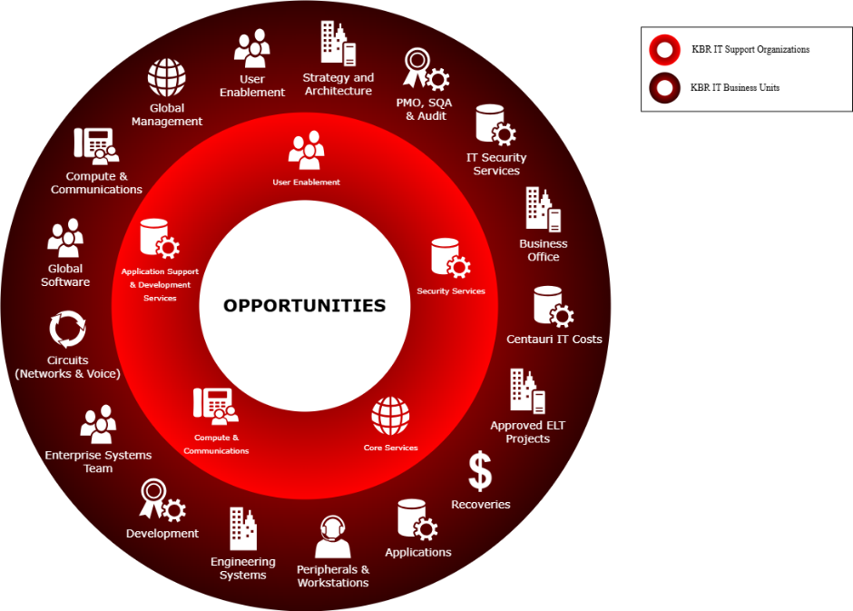
Agentpoint™, powered by KBRaiN, is built with the end-goal of maximum penetration across all Business Applications, Data Sources, and IT Infrastructure. Agentpoint™ ensures a scalable architecture that can be replicated as a copy-paste solution and adapted to multiple Business Units and Teams within KBR IT. Once our objectives have been met with the GSD, we expect continued expansion to IT Support Teams and Business Units across KBR IT.
By moving swiftly and decisively, we can stay ahead of evolving technologies and capitalize on the significant benefits of our Integrated Enterprise Agentic AI System, Agentpoint™. Please provide your support and join us in creating the Enterprise of the Future!

In United States of America on the 22nd Day of January and in the Year 2025 Endorsed By:
Jeff Hawks  Sr. Director, IT  Baltimore, Maryland | Al-Ebraheem Khan Tareen  Jr. Enterprise Generative AI Specialist  Houston, Texas

9 Metrics Annex
KBR Information Technology (IT) Service Levels for Incidents by Service Groups
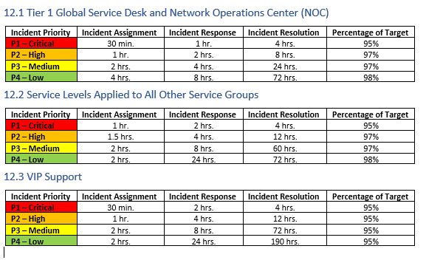

Incidents that left the GSD Last 12 Months by Assignment Group and Channel
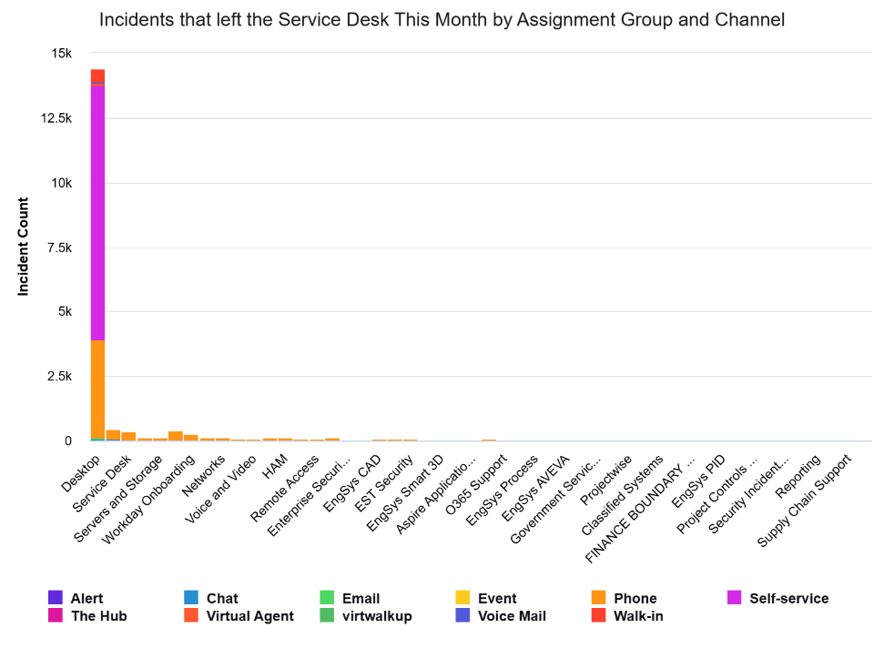
User Enablement – Service Level Objectives / Key Performance Indicators (KPIs) / Service Level Agreements (SLA)
Knowledge Article - KB0011969
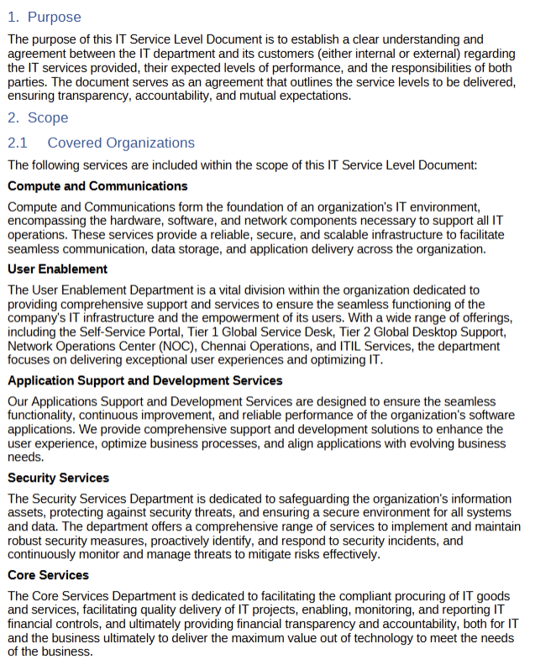

KBR Information Technology (IT) Business Units
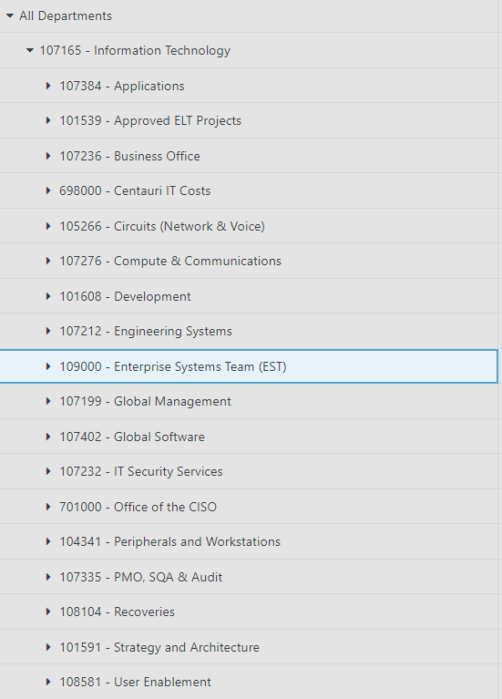

KBR Business Application List
According to Business Apps to Capabilities_Jan25, KBR has 4,905 in-use Business Applications.
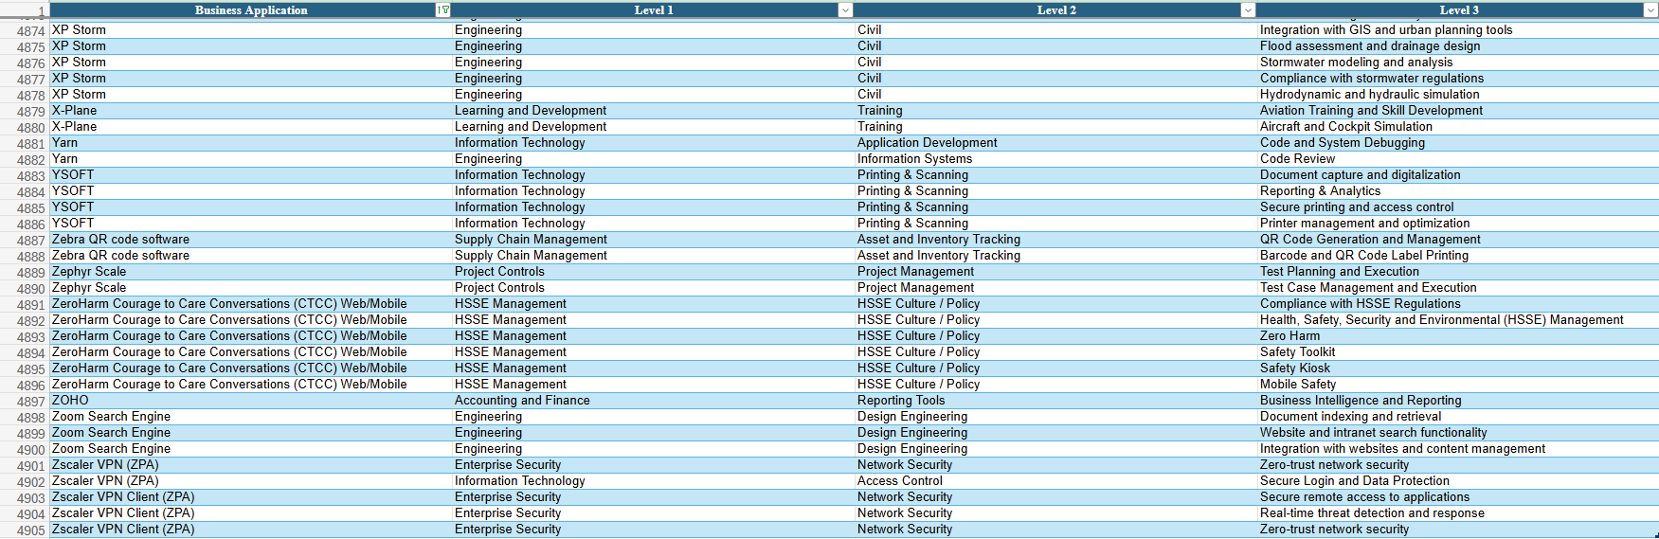

10 Financial Annex
2024 Financial Summary - User Enablement business unit
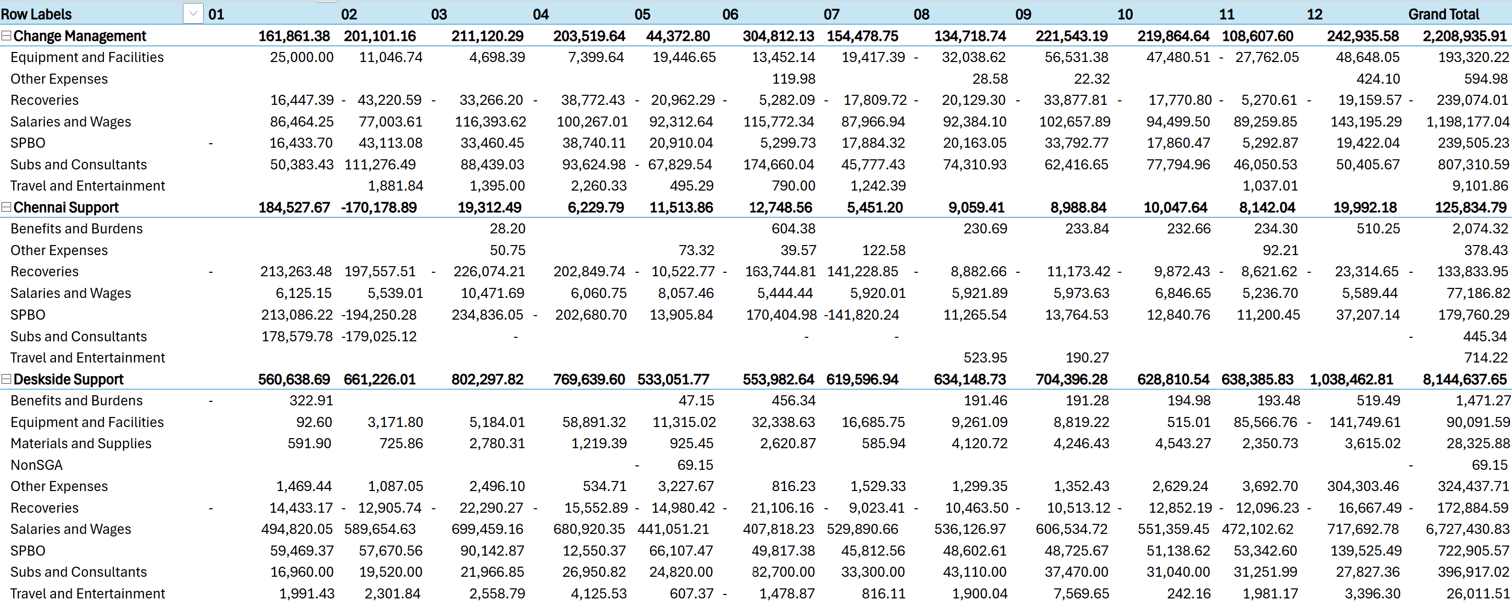
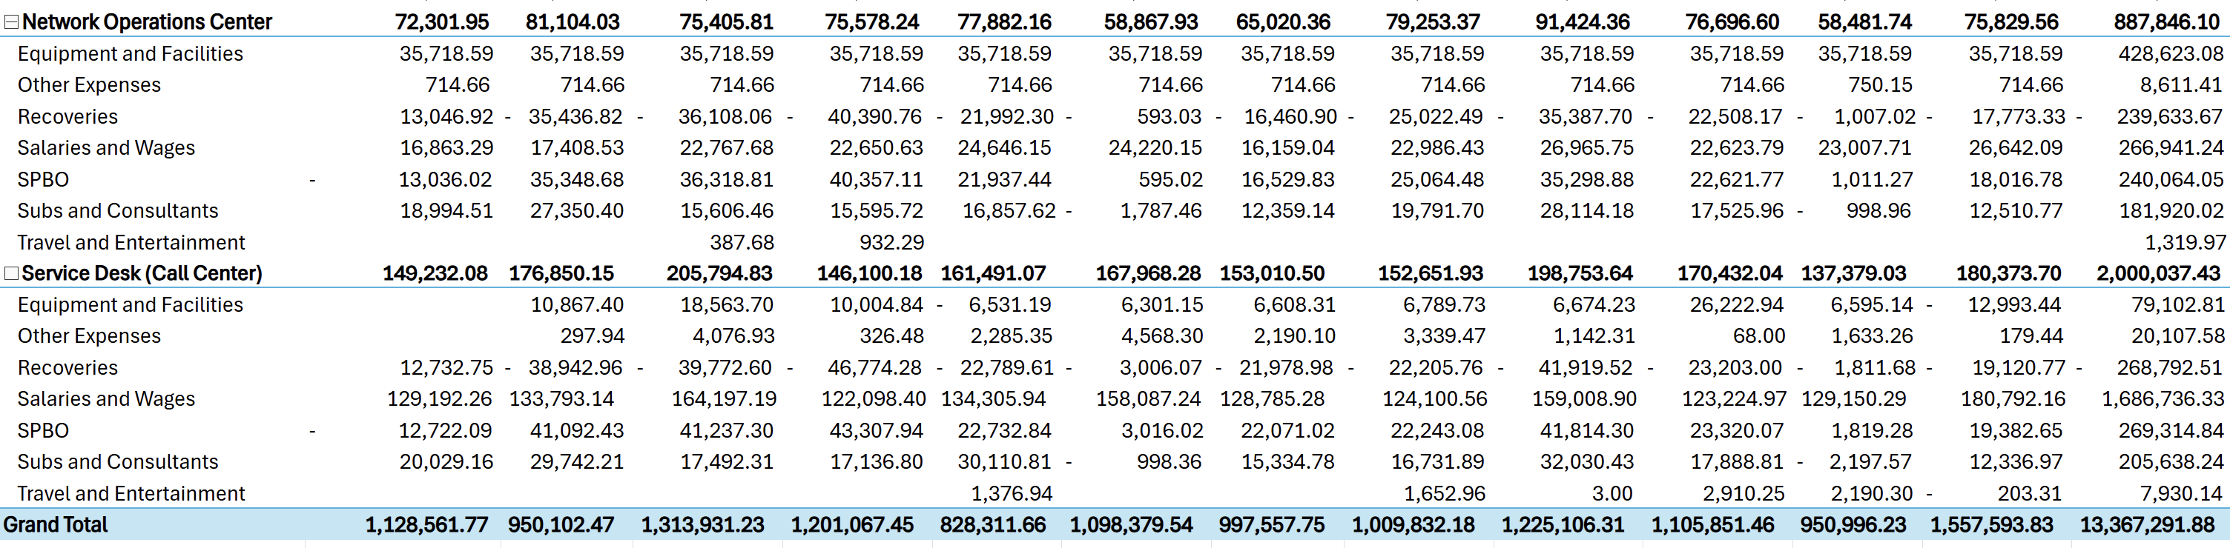

2024 Total Salaries & Wages – User Enablement business unit
2024 Total Salaries & Wages – User Enablement
Change Management | $1,198,177.04
Chennai Support | $77,186.82
Deskside Support | $6,727,430.83
Network Operations Center | $266,941.24
Service Desk (Call Center) | $1,686,736.33
Total Annual Salaries & Wages Cost | $9,956,472.26

Annual Average Salary Calculation for UK-based GSD Agent
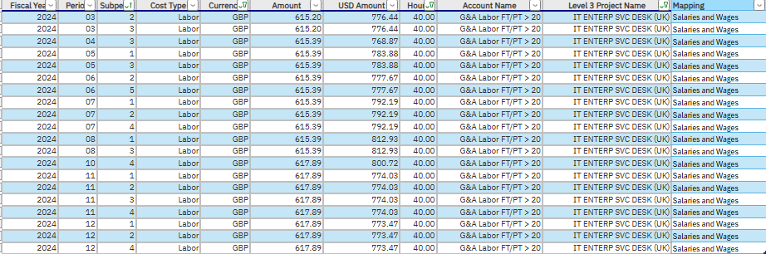
Average Annual Salary Calculation for UK-based GSD Agent
Average Salary for 40-hour Work Week: | $783.23
Average Hourly Rate | $19.58
# of Work Weeks Per Year | 52
Total Annual Salary | $40,727.87
Disclaimer: Payroll Taxes, HR Management fees, and associated Compliance costs have not been incorporated. Total Annual Salary calculation based on 2024 User Enablement Financial Report.

Annual Average Salary Calculation for India-Based GSD Agent
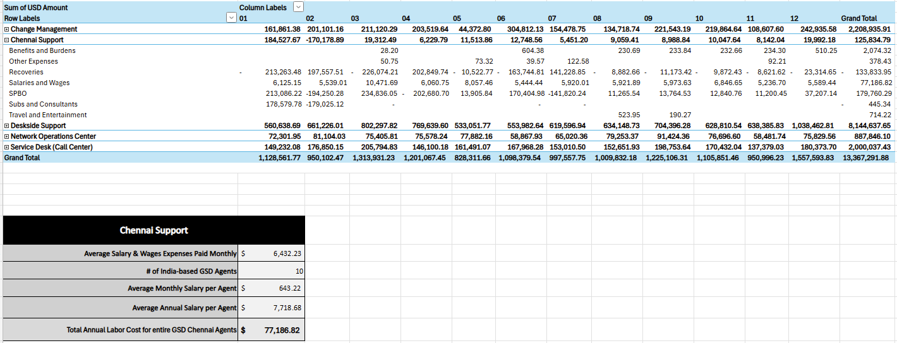
Average Annual Salary Calculation for India-based GSD Agent
Average Salaries & Wages Liabilities Outflow Monthly | $6,432.23
Average Monthly Salary | $643.22
Total Annual Salary | $7,718.68
Disclaimer: Payroll Taxes, HR Management fees, and associated Compliance costs have not been incorporated. Total Annual Salary calculation based on 2024 User Enablement Financial Report.

Annual Indirect Labor (Fringes) Cost Calculation for each GSD Agent
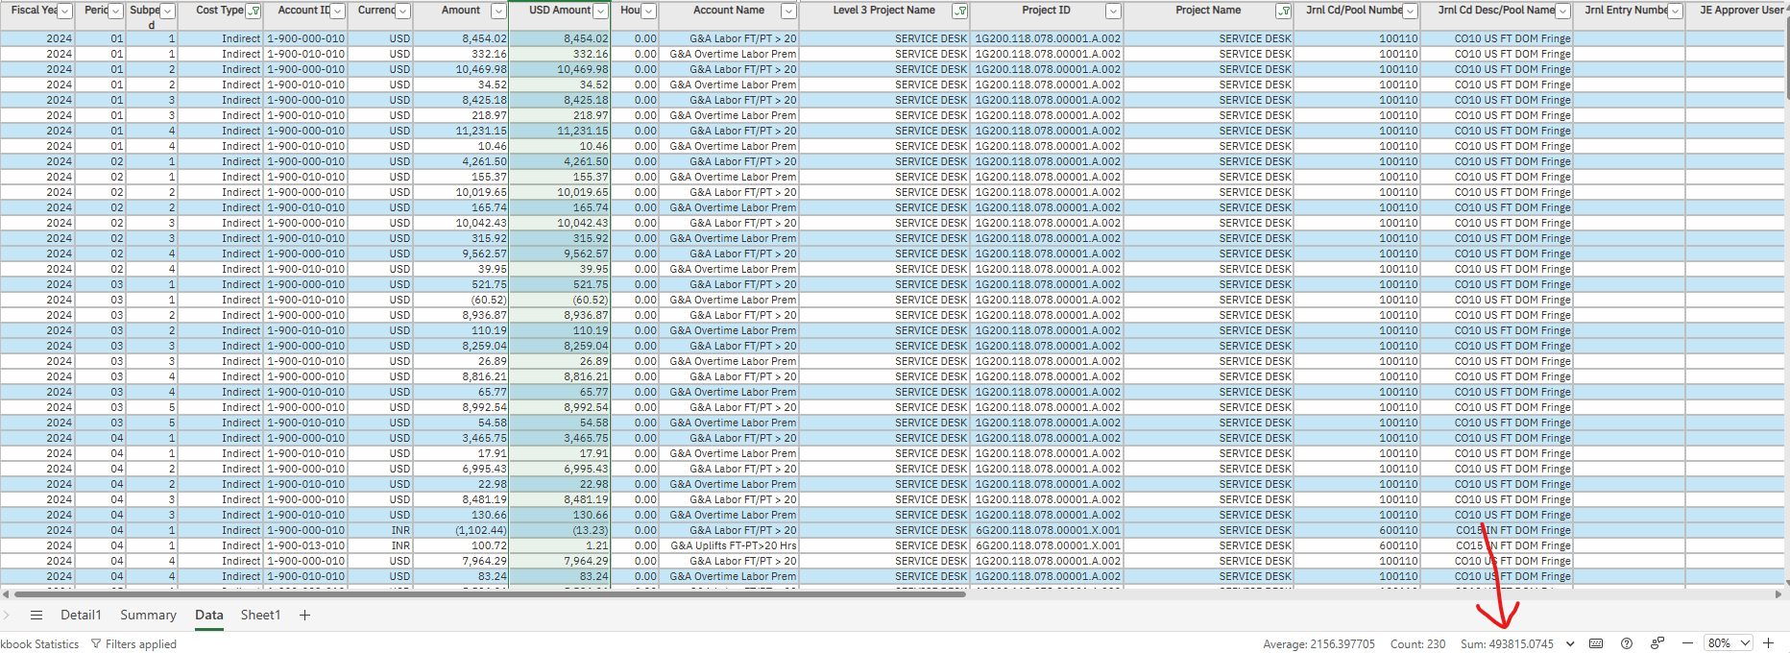
Applying the necessary filters to the User Enablement Financial Report, we have calculated the Annual Indirect Labor (Fringes) Cost for the entire GSD team at $493,815.07.
Total Annual Indirect Labor (Fringes) Cost Calculation for each GSD Agent
Total Annual Indirect Labor (Fringes) Cost for all GSD Team Members | $493,815.07
Number of GSD Agents | 31
Total Annual Indirect Labor (Fringes) Cost for each GSD Agent | $15,929.52
Disclaimer: We have rounded up the Total Annual Indirect Labor (Fringes) for each GSD Agent from $15,929.51839 to $15,929.52. In addition, we have not considered regions in our calculation.

Total Hardware Cost for GSD
Hardware Cost for GSD
Hardware | Cost | Source
Dell Latitude 5420 Laptop | $539.77 | Link
Jabra Evolve 65 Headset | $190.49 | Link
Dell 24' P2425H Monitor | $184.99 | Link
Logitech MK955 Wireless Keyboard and Mouse | $99.99 | Link
Total Hardware Cost Per Agent | $1,015.24
Total Hardware Cost for all GSD | $31,472.44
Disclaimer: The cost for each hardware has been estimated using reputable third-party sources. No Sales Tax or Shipping Fees incorporated. Hardware costs have not been used in our proposal and are for information purposes only.

Annual Software Cost for GSD
Software Cost for GSD (Annual)
Hardware | Cost | Source
Microsoft Office E5 License | $144.00 | Link
AT&T Long Distance Authorization | $50.00 | Link
Total Annual Software Cost Per Agent | $194.00
Total Annual Software Cost for GSD | $6,014.00
Disclaimer: The cost for each software license has been based on reputable third-party sources. IT Infrastructure and Networking costs have not been incorporated, including associated fees and taxes. AT&T Long Distance Authorization Code has been conservatively estimated. Software Costs have not been used in our proposal and are for information purposes only.

11 Technical Annex
What is an Agent
AI Agents, like employees, can make decisions within their predefined scope. Agentic AI, on the other hand, operates more like a manager, orchestrating, adapting, and learning across a broader set of goals and tasks.

What AI Agents Do
- Plan
- Act (Execute Code, Use Tools)
- Observe
- Reflect over multiple steps
- Call Tools to perform actions (Services)
- Collaborate with other agents (multi-Agents)
- Specialized (Fine-Tuned and Agentic Workflows)
- Reflect / Orchestration
- Memory
- Learn (Self-improving)

Agent Behaviors
- Each Agent has a Persona.
- Each Agent is specialized in a field and/or domain.
- Supervisor/Orchestrator Agent receives prompt, and routes task to a specialized agent.
- The specialized agent may collaborate with other agents to complete the task, or route back to the Supervisor to assign it to another agent.
- Agentic RAG

Building Multi-Agent Systems
Building Multi-Agent Systems

AI Agent Components
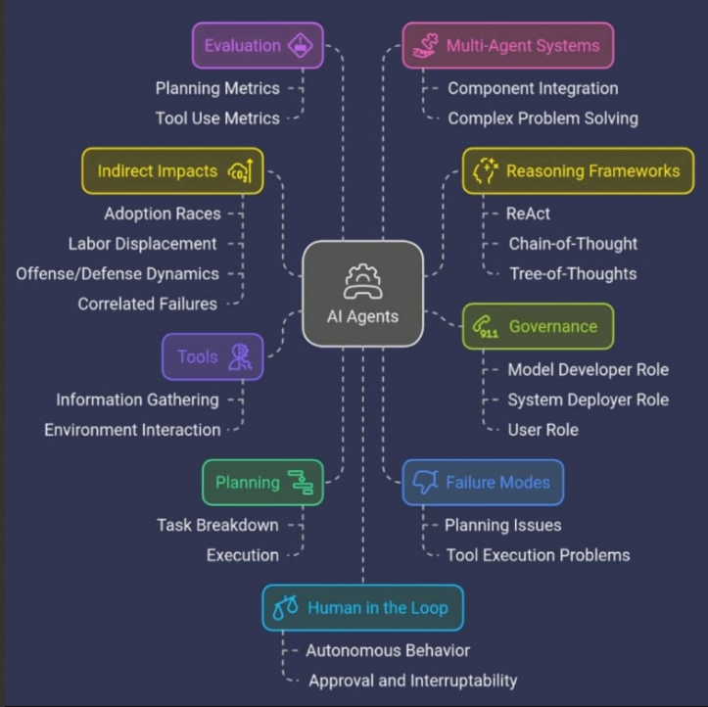
Agents Whitepaper by Google
Whitepaper_Agents.pdf

Agent Evaluations
Beginner's Guide to Agent Evaluations

Realtime API Agents
GitHub - openai/openai-realtime-agents: This is a simple demonstration of more advanced, agentic patterns built on top of the Realtime API.

Titans by Google: The Era of AI After Transformers
Titans by Google: The Era of AI After Transformers
LangGraph
LangGraph is a stateful, orchestration framework that brings added control to agent workflows.
GitHub - langchain-ai/langgraph: Build resilient language agents as graphs.

LangGraph Cloud
LangGraph Cloud is a service for deploying and scaling LangGraph applications, with a built-in Studio for prototyping, debugging, and sharing LangGraph applications.
LangGraph Cloud (beta) (langchain-ai.github.io)

LangChain
Introduction | 🦜️🔗 LangChain
LangChain is a framework for developing applications powered by large language models (LLMs).

LangSmith
LangSmith is a platform for building production-grade LLM applications. It allows you to closely monitor and evaluate your application, so you can ship quickly and with confidence.
Get started with LangSmith | 🦜️🛠️ LangSmith

Large Language Models
A large language model (LLM) is a machine learning model that uses deep learning to understand and analyze natural language. LLMs are trained on large amounts of text data, such as books and articles, to learn how language works. They can then be used to generate and translate text, answer questions, and complete text.

Large Concept Models
A "Large Concept Model" (LCM) refers to a type of artificial intelligence model that processes language at a higher level of abstraction by focusing on "concepts" (meaningful ideas or sentences) rather than individual words or tokens, allowing for more Human-like reasoning and understanding compared to traditional language models that operate on a word-by-word basis; primarily developed by Meta AI, LCMs enable better multilingual capabilities and can handle complex tasks involving multiple modalities like text and speech.

Classic Multi-Agent vs Modern GenAI Multi-Agent Architectures
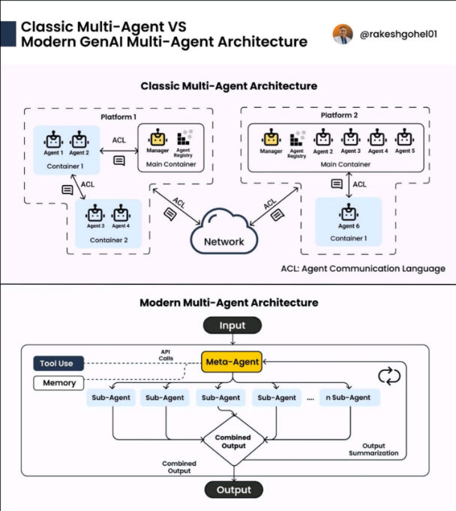
Artificial Intelligence Projected Market Size
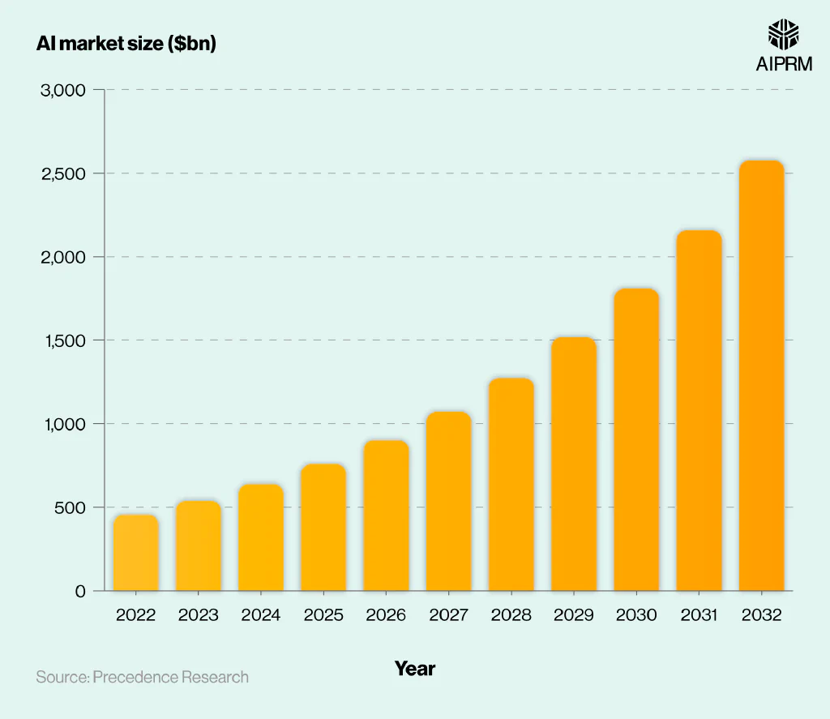

Stages of Artificial Intelligence
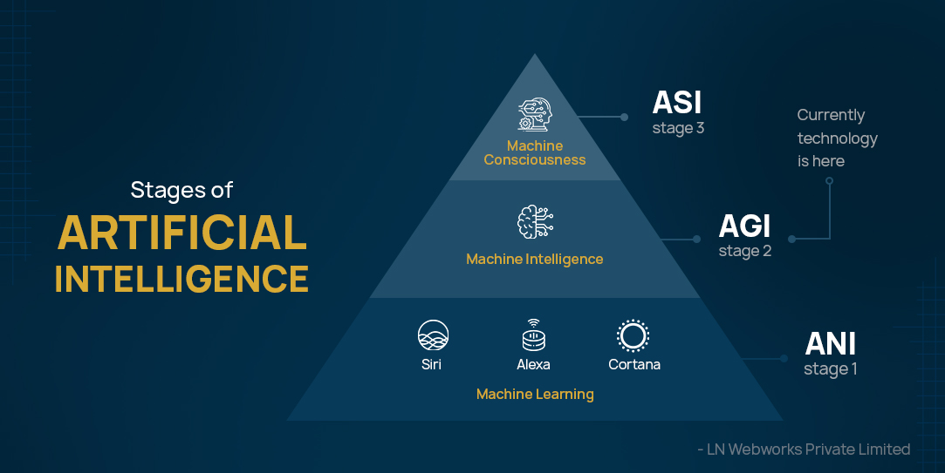
Domains of Artificial Intelligence
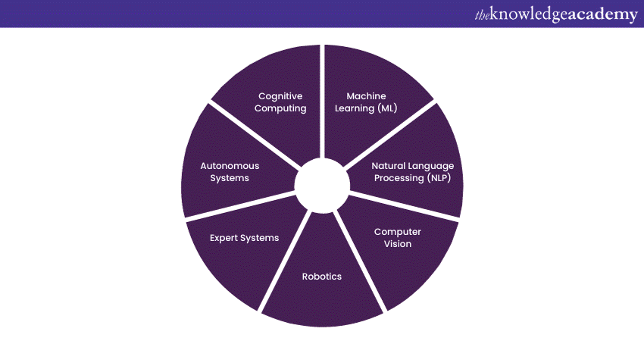

Agentic AI Systems refers to an advanced AI system that autonomously takes actions, adapts in real-time, and solves multi-step problems based on context and objectives.
AI Agents are autonomous intelligent systems performing specific tasks without human intervention.
An Integrated Enterprise Agentic AI System consolidates an organization’s existing Business Applications, Data Sources, and IT Infrastructure to an AI-driven environment allowing for the deployment of AI Agents and automation.
A Vertical in business refers to a specific niche market or industry that a company focuses on, meaning they cater their products and services to a particular customer group with specialized needs.
A Knowledge Worker is a professional who generates value for the organization with their expertise, critical thinking, and interpersonal skills.
The Scope determines what actions may be performed and measured in a system.
Agentic AI is a probabilistic technology with high adaptability to changing environments and events. It relies on patterns and likelihoods to make decisions and take actions, as opposed to deterministic systems.
Orchestration in AI is the process of managing and coordinating AI Agents and tools to work together efficiently. It's a way to streamline and automate the end-to-end process of AI applications.
A Proof-of-Concept (POC) is a realization of a certain idea, method or principle to demonstrate its feasibility, viability, or a demonstration in principle with the aim of verifying that some concept or theory has practical potential.
A Vertical in business refers to a specific niche market or industry that a company focuses on, meaning they cater their products and services to a particular customer group with specialized needs.
A Knowledge Worker is a professional who generates value for the organization with their expertise, critical thinking and interpersonal skills.
Data Augmentation is a technique used to expand or diversify the existing dataset by applying various transformations (e.g., paraphrasing, cropping, rotating, noise injection) while preserving its essential characteristics.
Data (Text) Generation Frameworks are Systems or architectures (often driven by Large Language Models) that create new, contextually relevant outputs—such as text, summaries, or full documents—based on specified prompts or input data.
RAG (Retrieval-Augmented Generation) is an AI framework that combines the strengths of traditional information retrieval systems (such as search and databases) with the capabilities of generative large language models (LLMs).
GraphRAG (Graph-based Retrieval-Augmented Generation) is a technique that uses graphs to improve the process of finding and creating information.
CAG (Cache-Augmented Generation) preloads all relevant data into the AI’s context during preprocessing instead of fetching knowledge in real-time.
Conceptual data is a first stage data that needs an interpretation for further use in business operations.
A Knowledge Graph is a knowledge base that uses a graph-structured data model or topology to represent and operate on data. Knowledge graphs allow for LLMs to understand the relationships between entities, leading to improved contextual understanding.
Hallucinations is the failure of model to correlate the intent or context of the query to the data required to generate a meaningful response.
Retrieval latency is a type of data latency, which is the delay between when data is generated and when it is received or processed.
Edge computing is a distributed computing model that processes data closer to its source, reducing latency and improving real-time analysis.
Contextual understanding involves interpretation of contexts and recognizing the factors that contribute to the significance of a situation or piece of information.
Static data refers to data that does not change frequently or remains constant over time. It acts as a reference or a guideline for other data and usually doesn’t request updates or alterations frequently.
dynamic data is information that is periodically updated, changes asynchronously over time as new information becomes available.
Multi-agent system is a system of multiple AI agents working collectively to perform tasks on behalf of a user or another system.
Hierarchical manner is a structural order in which tasks and decisions are structured in multiple layers, and each layer has an AI agent to handle a specific aspect of problem.
Expert AI agent is a tool that is operated by the supervisor AI agent to perform a specific aspect of task.
Synthesizing refers to a process of generating responses according to the user prompt.
Agentic AI is equivalent to our Executive Leadership.
Fine-tuned is a process of precisely enhancing the performance, efficiency and effectiveness.
Supervisor AI Agents are equivalent to our Middle Management.
Expert AI Agents are equivalent to our Workers and Subject Matter Experts (SME’s).
Additional information pertaining to KBR IT Service Level Agreement (SLA) and Key Performance Indicators (KPIs) can be found in the Metrics Annex.
The # of Agents have been calculated from the organizational chart in Microsoft Teams.
The Annual (Avg) Salary for a US-based GSD Support Agent was supplied by Jenifer Pulver, Sr. Manager, IT.
The Annual (Avg) Salary for a UK-based GSD Support Agent was calculated using User Enablement Financial Reports supplied by the Corporate Finance team. See Financial Annex for more information.
The Annual (Avg) Salary for an India-based GSD Support Agent was calculated using User Enablement Financial Reports supplied by the Corporate Finance team. See Financial Annex for more information.
The Annual (Avg) Salary for a GSD Management team member was estimated without any supporting data.
The Total Indirect Labor Cost (Fringes) per GSD Agent was calculated using User Enablement Financial Reports supplied by the Corporate Finance team. See Financial Annex for more information.
The Total Estimated Cost for our POC was calculated using an assumed average hourly rate of $100 per hour.
A zero-day is a software or hardware vulnerability that is unknown to the vendor and has no patch or fix available.
Scope creep is when a project's scope changes without adjusting the budget, schedule, or resources. It can lead to delays, budget overruns, and increased risk.
Software as a service (SaaS) is a way of delivering applications remotely over the internet instead of locally on machines (known as “on-premise” software).
We believe that for 2025, energy costs may not drastically increase however, there may be a risk in the long-term as the demand for energy rises.
Software architecture is the structure and design of a software system. It's a collection of principles, guidelines, and models that define how a system's components interact and how it operates.
The Disaster Recovery ‘Go Team’ is a team consisting of IT personnel whom, in the event of a natural disaster, are dispatched to a location outside of the affected area to ensure the continuance of 24/7 IT Support operations.

