Apacen™
Strategic Foresights Revealed.

Business Plan

October 6, 2025

Table of Contents
1 Executive Summary 4
2 Challenges & Opportunities 5
3 Company Description 6
3.1 Company 6
3.2 Tagline 6
3.3 Vision 6
3.4 Mission 6
3.5 Core Values 6
4 Market Analysis 8
4.1 Market 8
4.2 Potential Addressable Market (PAM) 8
4.3 Total Addressable Market (TAM) 8
4.4 Market Scope 8
4.5 Serviceable Available Market (SAM) 9
4.6 Target Industry, Firms, & Market 9
4.7 Serviceable Obtainable Market (SOM) 9
5 Organizational & Management Structure 12
6 Product & Services 13
7 Execution Plan 14
8 Expansions 15
9 Key Performance Indicators (KPI’s) 16
10 Financial Projections 17
11 Marketing Strategy 18
12 Risk Assessment & Mitigation Strategies 19
13 Appendices 20
Appendix A: Business Plan Criteria 20
Appendix B: Market Research 24
Appendix C: Technologies 25
Appendix D: Financials 26
Appendix E: Legal and Compliance 27
Appendix F: Supporting Resources 28

1 Executive Summary

2 Challenges & Opportunities
- Pain Points:
  - Speed
- Opportunities
- Proposed Solution
- Value Proposition
- Competitive Advantage:
  - No one owns 72-hour Cobalt Fusion Yet
  - Supply-chain fusion dashboard on cobalt.

3 Company Description

3.1 Company
Apacen™

3.2 Tagline
Strategic Foresights Revealed.

3.3 Vision
To provide critical, accurate, and actionable supply foresights to industry leaders.

3.4 Mission
To deliver critical supply insights that help industry leaders make strategic decisions.

3.5 Core Values
Vigilance | We identify global Supply Attacks .
Timeliness | We deliver critical 72-hour Supply Risk briefs.
Resilience | We reveal Supply Insights empowering strategic decision-making.

4 Market Analysis

4.1 Market
Defense Tech

4.2 Potential Addressable Market (PAM)
$500B

4.3 Total Addressable Market (TAM)
$320B

4.4 Market Scope
Supply Chain Threat Intelligence for Critical Minerals in US Defense-Critical Firms
- Gallium
- Lithium
- Cobalt

4.5 Serviceable Available Market (SAM)
$8B

4.6 Target Industry, Firms, & Market
Tech | - Intel  - TSMC-exposed | $2B
Infrastructure | - Exelon  - Duke | $2B
Derivative Feeds | - JP Morgan  - Goldman Sachs  - Citadel | $1B

4.7 Serviceable Obtainable Market (SOM)
$2B

- "Market Segmentation & Strategy." Use visuals (e.g., pie chart: 80% Domestic, 15% Allied, 5% Global). Back with data: Cite U.S. market dominance (~35% global share) and startup success stories. Stress agility: "Domestic focus accelerates MVP to revenue, fueling international scale."
- Next Steps: In your plan, include a SWOT for each category. If partners push international, highlight phased risks. This setup positions you as strategic, not myopic.
- Highlight alignment with current trends, regulatory advantages, and growth potential.
- Recommended Market Segmentation Categories
- "Market Analysis" or "Go-to-Market Strategy." Use a tiered approach to show thoughtful prioritization: Primary (core focus), Secondary (expansion potential), and Tertiary (long-term opportunities). This demonstrates realism while signaling scalability to partners/investors.
- Primary: Domestic Market (U.S.-Focused)
  - Definition: Target U.S.-based clients, including Department of Defense (DoD) agencies, government contractors, and Fortune 500 companies reliant on critical minerals (e.g., Tesla for lithium/cobalt in EV batteries, Intel for gallium in semiconductors, Boeing for cobalt in aerospace). Emphasize U.S. supply chain resilience, where your data fusion insights address domestic vulnerabilities like import dependencies from China.
  - Why Prioritize Here:
    - Funding & Entry Barriers: U.S. defense tech startups raised ~$38B in H12025, driven by DoD initiatives like DARPA grants and SBIR programs, which favor domestic entities. Your startup aligns with lean, domestic pilots—easier access to U.S. public data (e.g., USGS exports, FAA logs) without international compliance hurdles.
    - Regulatory Advantages: Domestic focus avoids ITAR export controls and simplifies security clearances (e.g., CMMC for DoD contracts).
    - Risks/Mitigation: Limited scale (U.S. defense market ~$320B of global $985B by 2034)
  - Presentation for Business Plan: Use a table to quantify:
Aspect | Domestic Focus Details | Projected Impact (Year 1)
Clients | DoD pilots, Tesla/Intel supply teams | 5-10 subscribers at $5k/month
Revenue | U.S.-centric subscriptions | $300k ARR
Moat | U.S. data exclusivity + compliance | 85% retention via integrations
- Secondary: Allied International Expansion (e.g., NATO Partners, Five Eyes)
  - Definition: Extend to U.S. allies like UK, Canada, Australia, Japan, or EU nations, focusing on shared supply chains (e.g., European gallium dependencies).
  - Why Categorize Here:
    - Growth Trends: European defense tech startups saw 500% investment growth (2021-2024), with expansion opportunities in AI/cyber for allies. U.S.-Japan alliances open doors for mineral insights, as Japan seeks diversification from China. Global defense spending hits $985B by 2034, with international segments (e.g., AirForce platforms) growing fastest.
    - Strategic Fit: Your insights on global chokepoints (e.g., Chinese lithium stockpiles) appeal here but start post-domestic traction to navigate export regs.
    - Risks/Mitigation: Geopolitical barriers (e.g., data privacy in EU); mitigate via partnerships (e.g., U.S.-Japan co-development)
- Tertiary: Broader Global Markets (e.g., Emerging Regions)
  - Definition: Opportunistic entry into non-allied markets like India or Middle East, where defense tech trends include AI warfare and supply chain tech. Focus on dual-use (civilian-defense) applications for minerals.
  - Why Categorize Here:
    - High growth potential (global CAGR 6.9% to 2034), but high risks like sanctions or competition from Chinese firms. Only pursue if domestic/allied saturation occurs.
- Customer Segments
- Industry Trends

5 Organizational & Management Structure

6 Product & Services
- Agentic AI
- Threat Detection
- Quantum Tech?
- Supply Chain Risks
- Agent Evaluations
- Black Box (noise filtering)
- Public x Private Datasets > Data Fusion > Fusion Engine > Fusion Dashboard
- Intellectual Property, Product Development
- Fuse ‘fund metrics with public data: ‘covalent blockchain’ streams (Gray Area)
- MOATS
  - Proprietary Data and Network Effects (Data Moat Foundation)
  - Advanced Analytics and IP Protection (Tech Differentiation)
  - Customer Lock-In and Strategic Partnerships (System Rigidity)
    - Make it painful to leave by integrating deeply and aligning with regulations/government priorities.
      - Build integrations: API hooks into client ERPs (e.g., plug into Tesla's systems for auto-alerts on cobalt delays). Charge for white labeling (~$5k/month premium).
      - Leverage state-granted edges: Monitor U.S./EU grants (e.g., via free FedRAMP-like compliance docs) and advise clients on aligning sourcing with national security mandates. Offer "audit-ready" traceability reports for ESG compliance—critical for Fortune 500 like Intel or Boeing.
      - Foster rigidity: Create a culture of rapid iteration (your team's obsessive focus); use inbound marketing to build brand as "the mineral whisperer." Run webinars (~$2k ads) on risks, pulling in leads who become loyal.
      - Moat Strength: High switching costs—clients' workflows depend on your alerts. In 6-9 months, partnerships (e.g., data brokers in India) add exclusivity, like geographic diversification for your feeds.

7 Execution Plan
- Approach, Timeline, & Objectives
- POC Objectives
- Milestones & Success Metrics
- Target Pilot
- Go-To-Market Strategy
- Target Customer
- Target Exit

8 Expansions
- Non-Profit
- Future Horizons

9 Key Performance Indicators (KPI’s)
- KPI’s and Definition
- KPIs and Targets, POC

10 Financial Projections
- Budget
- Financial Projections (Revenue Forecast, Startup Costs, P&L Statement, Break-even Analysis)

11 Marketing Strategy

12 Risk Assessment & Mitigation Strategies
- Risk Categories & Definitions
- Levels of Impact
- Levels of Probability of Occurrences
- Risk Assessment & Mitigation Strategies
  - Risks/Mitigation: IP theft, volatile geopolitics; deprioritize until $1M+ ARR.

13 Appendices

Appendix A: Business Plan Criteria
A.1: Business Plan Criteria 1
How do you prove your tech (something tangible) in the market? | ☐
How do you prove your tech makes money? (Prove with transaction) | ☐
How do you scale your customers / volume transactions? | ☐
Prove that you can do at least one deal that is a valid deal (first case). After proving this, you may proceed to repeat and scale. | ☐
Find an example where you can productize your idea> (Go to a target customer and sell) | ☐
Initial Cost: How much to create the product | ☐
Marginal Cost: How much to create the second product for target customer | ☐
If Customer does not pay above the marginal cost of your product, you have no business | ☐
May need to let the first customer to try | ☐
What is the simple use case that is manageable, and you can do it? (first bite) | ☐
How much value is generated? | ☐
What will we do next? | ☐
Where are we going to get data? | ☐
Who will we talk to sell it? | ☐
How will potential customer benefit from it | ☐
Think Tactically. Real Actions. Real Facts | ☐

A.2: Business Plan Criteria 2
GOOD AND BAD STRATEGY
Chapter 1  GOOD STRATEGY & WHY IT MATTERS | Create a simple, actionable, and coherent strategy with a robust design, and focus all your planned resources and efforts on it | ☐
Chapter 2  DISCOVERING POWER | Question traditional practices and look for advantage, opportunities, weaknesses, and threats in each component of your business individually and with one another and compare them to your competitor’s existing practice and create a coherent strategy that maximizes all your resources that are difficult to replicate. | ☐
Chapter 3  BAD STRATEGY | Bad strategy contains 1) fluff 2) failure to face the challenge and 3) mistaking goals for strategy. | ☐
Chapter 4  WHY SO MUCH BAD STRATEGY? | Bad strategy is created when one avoids the uncomfortable process and analysis required to create good strategy such as 1) using vision/mission/goal templates instead of crafting a coherent strategy 2) not making a decision to prioritize one primary objective while ignoring others and dedicate all or most resources towards achieving it and 3) believing that a positive 'mental state' is all that is required in place of a designed coherent strategy.  Crafting a good strategy is not easy, and lacks analysis, and focus. | ☐
Chapter 5  THE KERNEL OF GOOD STRATEGY | A good strategy is created through 3 steps: 1) diagnosing the specific challenge, 2) creating a guiding policy on how to navigate the challenge, and 3) executing coherent actions coordinated by the guiding policy towards the challenge. | ☐

A.3: Business Plan Criteria 3
SOURCES OF POWER
Chapter 6  USING LEVERAGE | Strategic leverage is when you 1) anticipate the actions and reactions of your competitors and market; 2) identify a pivot point where the effects from your actions are intensified; and 3) concentrate all your efforts onto a critical objective that will return a great payoff. | ☐
Chapter 7  PROXIMATE OBJECTIVES | Identify and pursue objectives that are feasible, and work towards making sure each objective lead to market dominance and business excellence. | ☐
Chapter 8  CHAIN-LINK SYSTEMS | By making sure your chains (business departments, networks, units) are robust and coherently designed and support all other chains intentionally, you will maximize your overall business impact and make your business unreplicatable.  Each business unit must understand how they impact other units and must make compromises for the business. | ☐
Chapter 9  USING DESIGN | A grand strategist focuses its efforts to design a strategy that coordinates available resources coherently to tackle a specific challenge that yields the highest value, which in turns creates a high quality and high performing competitive advantage over its' giant competitors. | ☐
Chapter 10  FOCUS | 1) Focus on all components of your business to make sure they are optimized for your value provided, and 2) once the extra value is generated, use it to target groups or prospects and create specific applications. | ☐
Chapter 11  GROWTH | Without a coherent strategy, healthy growth cannot occur. The best form of growth comes from natural demand of a company's offerings, which suggests innovation. Furthermore, one should not merge or acquire another company if there are no strategies or plans to increase the value of the company they are acquiring through increased innovation or changes. | ☐
Chapter 12  USING ADVANTAGE | Strengthen your competitive advantage. 1) Deepening Advantage 2) Broadening the Extend of Advantage 3) Creating a Higher Demand 4) and Strengthening Isolating Mechanisms. | ☐
Chapter 13  USING DYNAMICS | During waves of change in society from innovation or market shifts, a small group of individuals with foundational knowledge and expertise in an industry can rapidly disrupt the respective industry and steal market dominance by rebuilding the respective foundation utilizing newer and more innovative inventions that drastically change the industry standard, while also providing a more attractive service or product compared to the then-major competitors. | ☐
CHAPTER 14  INTERTIA AND ENTROPHY | All successful companies are created from the result of inertia- from routine, third-party, or work culture. However, the same inertia that brought success can also lead to the companies' demise if the inertia is never redirected to business evolvement or if the company infrastructure and practices remain stagnant. Entropy, whether in financial or physical form, is the result of such stagnation; however, to remain competitive, leaders must exercise voluntary entropy, that is, to dismantle and reassemble all aspects of their business constantly. Therefore, there must be a balance of inertia and entropy in a business to sustain a competitive advantage and remain successful | ☐
CHAPTER 15  PUTTING IT TOGETHER | A good strategy consists of  1) Diagnose: Define the key challenge in clear, simple terms.  2) Guiding Policy: Define a clear direction for addressing the challenge.  3) Power of leverage, identifying and pursuing proximate objectives to expand competence, focusing towards strategic goals, engineering chain-linked systems, growth by natural market demand, designing a coherent strategy using all available resources tightly that cannot be replicated, constantly increasing your advantage, riding dynamic wave of changes, understanding and utilizing inertia and entropy. | ☐

Appendix B: Market Research
B.1: Market Identification
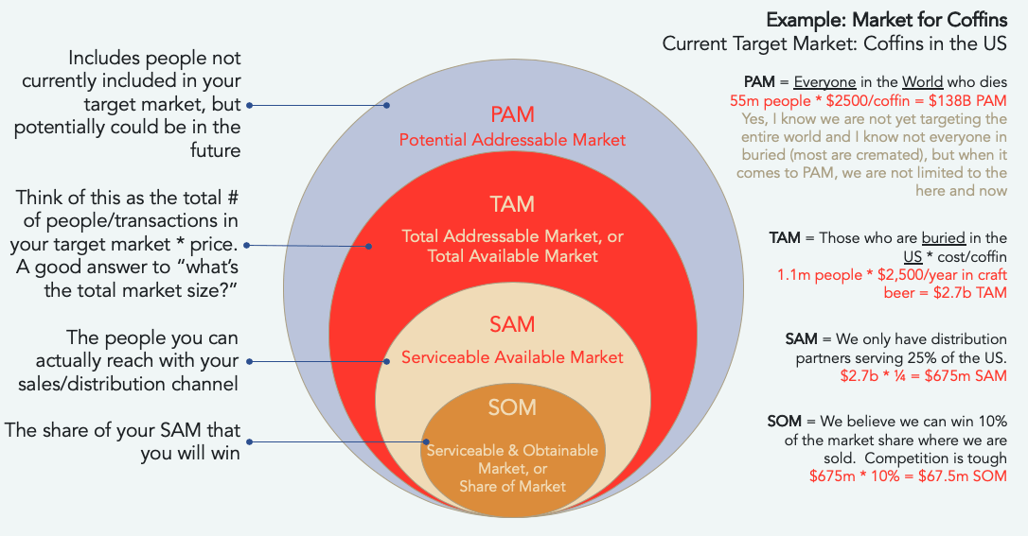

B.2: Types of Market Segmentation
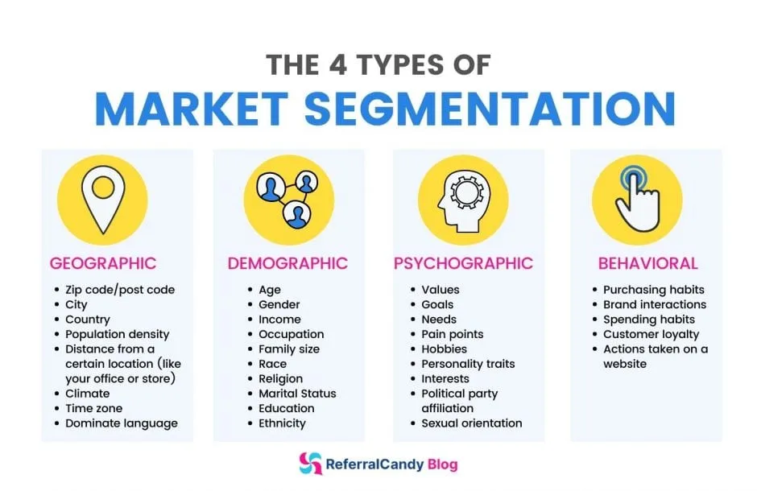

Appendix C: Technologies

Appendix D: Financials
- D.1: TAM Breakdown (e.g., $2B niche for mineral foresight)
- D.2: Pricing Models (e.g., $15k/month enterprise subscriptions)

Appendix E: Legal and Compliance
- E.1: SBIR Phase I Application Outline
- E.2: ITAR/CMMC Compliance Checklist

Appendix F: Supporting Resources
F.1: Why ‘72 Hour’ Delivery Interval for (Critical) Supply Risks Brief
According to 6 CFR Part 7 Subpart B of the Code of Federal Regulations (CFR), in emergency situations when there is an imminent threat, it is recommended to provide appropriate risk briefings to respective recipients within 72 hours.

In the fictional world of Middle-earth, ‘Apacen’ is a Quenya (Elvish language) word translating to ‘after-sight’. With ‘apa’ meaning ‘after’ and ‘cen’ referring to ‘sight’ or ‘to see’. This word reflects the concept of seeing or knowing what comes after.
This Tagline poses low-risk for potential False Advertising lawsuits.
‘Supply Insights’ refer to the deep understanding gained from analyzing supply chain data to identify patterns, trends, and key performance indicators (KPIs).
A ‘Supply Attack’ refers to a deliberate or incidental disruption in a supply chain that restricts access to critical resources, materials, or components, leading to operational halts, cost spikes, or strategic vulnerabilities; often involving chokepoints such as export bans, strikes, natural disasters, or cyberattacks on key suppliers.
According to the Code of Federal Regulations (CFR), in emergency situations when there is an imminent threat, it is recommended to provide appropriate risk briefings to respective recipients within 72 hours. See Appendix F for more information.
A ‘Supply Risk’ refers to the potential for any event to disrupt the flow of goods, services, or information within a supply chain, potentially causing delays, financial loss, or damage to a company's operations or reputation.
‘Potential Addressable Market’ (PAM) represents the broadest potential demand for a product or service, including all possible customers and use cases, irrespective of current market constraints, geography, or even product fit. See Appendix B for more information.
‘Total Addressable Market’ (TAM) is the total potential revenue or customer demand for a product or service, assuming 100% market share and no constraints, representing a business's maximum theoretical market opportunity. See Appendix B for more information.
A ‘Supply Chain’ is a system of activities involved in handling, distributing, manufacturing, and processing goods to move resources from a vendor into the hands of the final consumer.
‘Serviceable Available Market’ (SAM) represents the total market for a product or service that a business can realistically reach and serve with its current business model, resources, and geographic reach. See Appendix B for more information.
‘Serviceable Obtainable Market’ (SOM) is the realistic portion of the Serviceable Addressable Market (SAM) that a business can realistically capture and serve within a specific timeframe, considering its resources, competitive landscape, brand recognition, and practical limitations. See Appendix B for more information.

