**BUSINESS REPORT FOR KOWOPE BUSINESS ENTERPRISE**

By: **Ameenullah Ishola Abdulmumeen**

**+2348142469279**

KUAGI RESOURCES

**INTRODUCTION**

I am thrilled to present my latest data analysis business report. This report is designed to provide valuable insights into profit and losses and serve as a strategic tool to empower your decision-making process.

Throughout this report, I will delve into the data collected, analyze the key trends, and offer actionable recommendations whether the enterprise should be bought.

Thank you for entrusting me with this analysis. Let's dive into the valuable insights that awaits.

**OBJECTIVE**

I am pleased to present our data analysis business report, which aims to provide valuable insights into the profit and Loss. The objective of this report is to equip the organization with data-driven knowledge, enabling you to make informed decisions, optimize operations, and drive strategic decision.

Through thorough data collection, rigorous analysis, and actionable recommendations. This report serves as a roadmap for the decision to be made.

**Questions and Answers**

1. States with highest and lowest sales

Answer: Relating States and Sum of sales with States Lagos have the highest sales of ₦**864,361,182** with Kwara having the lowest sale of ₦**802,490,301.**

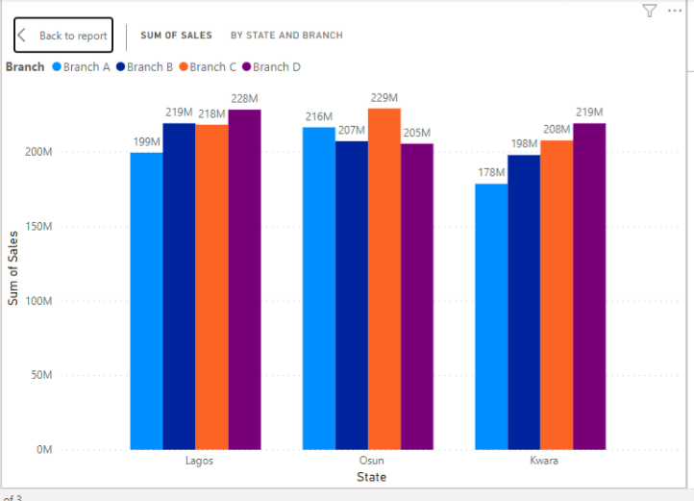

1. Branches with highest and lowest sales.

Answer: Branch C has the highest sale of ₦**654,486,220** with branch A having the lowest sale of ₦**593,989,009.**

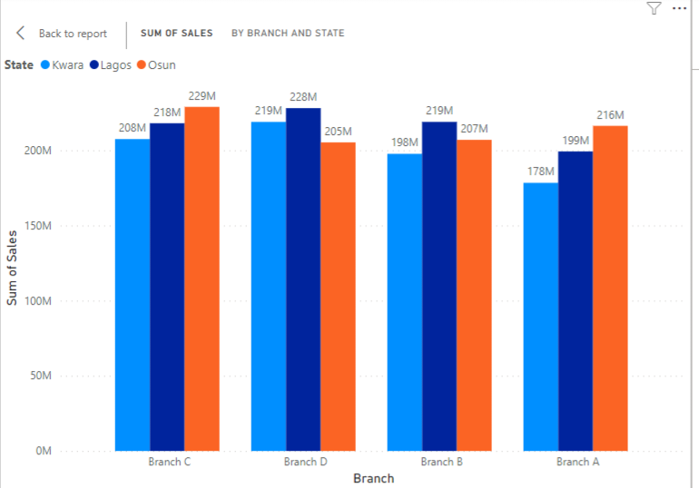

1. Profit by states.

Answer: Lagos have the highest profit of ₦**326,993,624** with kwara having the lowest profit of ₦**291,646,087.**

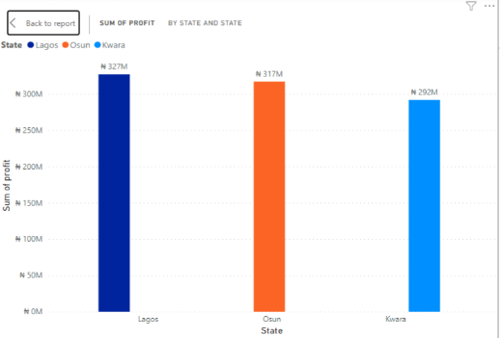

1. Profit by branches.

Answer:Rrelating Branches and sum of Profit, Branch C has the highest profit with the value ₦**242,353,083** with branch A having the lowest profit of ₦**218,269,215**.

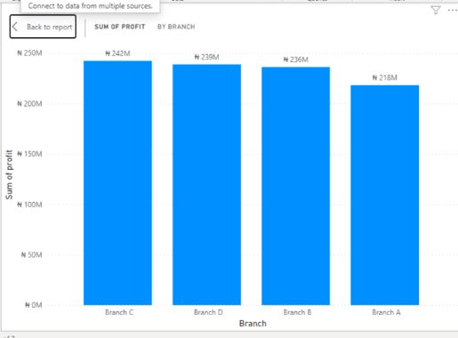

1. Month with most sales.

Answer: March has the highest sale of ₦**438,426,306**.

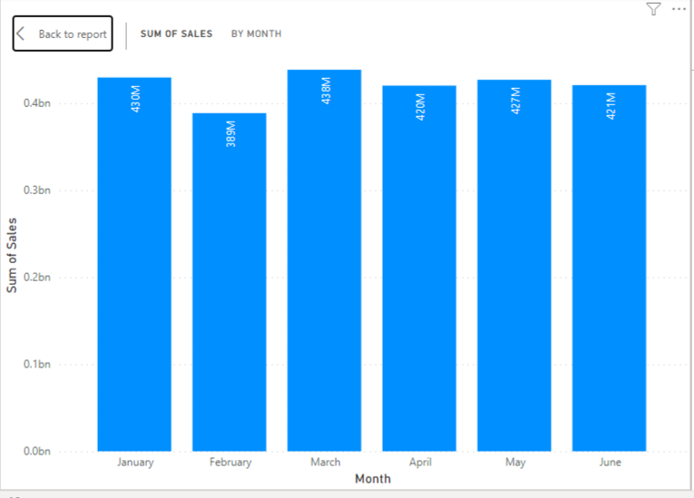

1. Day and Quarter with the most sales.

Answer: Thursday has the most sale of ₦**366,602,982** and quarter 2 also has the most sale of ₦**1,267,862,581.**

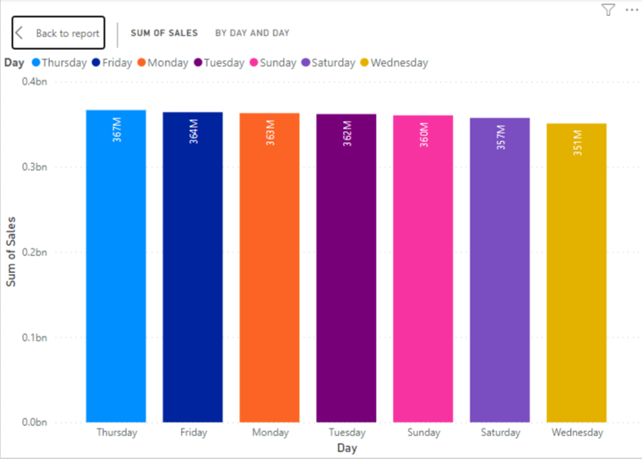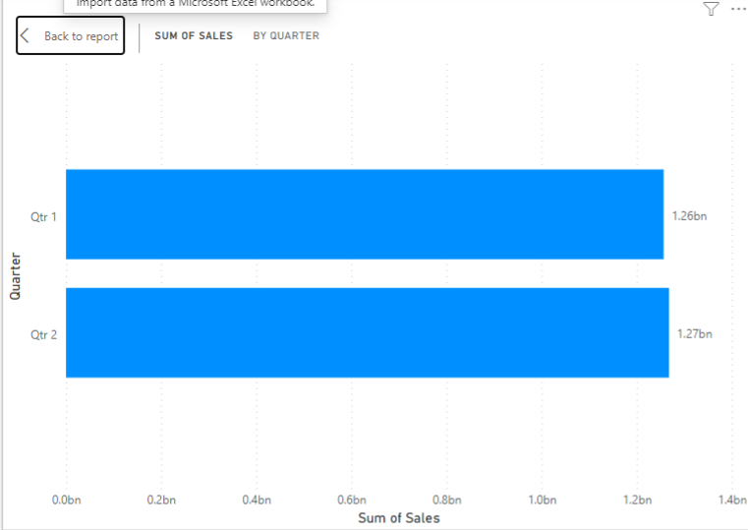

1. Report on staff and how they affect business sales and profits.

Answer: The number of staffs does not necessarily affect the sales as there is no direct variation in sales.

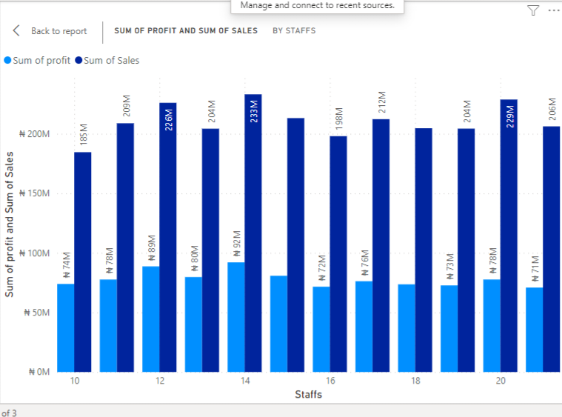

1. Report on branches based on expenses and sales.

Answer: The expenses in branch D and C does not affect the sales while Branch B and A are affected by the expenses.

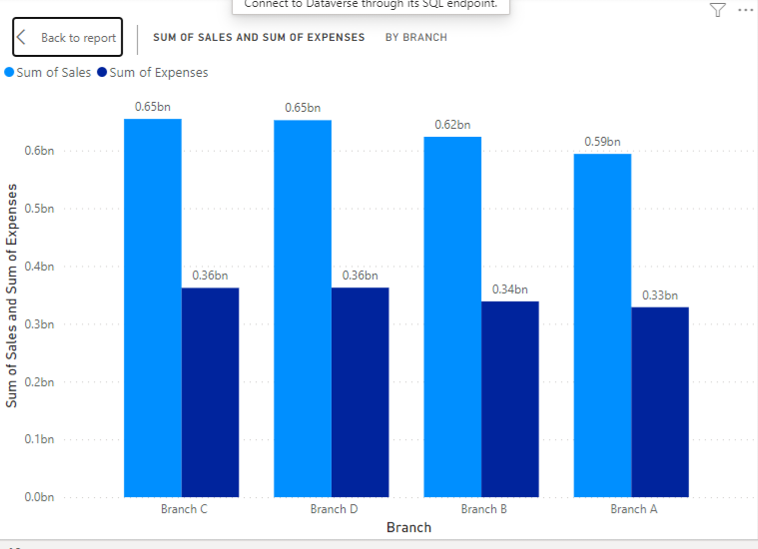

1. Should the Business enterprise be bought? With reasons.

Yes, Because there is high surge of profit in both quarters especially in quarter 2, and there’s no losses as seen in (Report on branches based on expenses and sales) because in all branches the sales are more than the expenses which makes me conclude there is little to zero loss.