L&N KITCHEN
Menu Website Upgrade Proposal
From swipeable digital menu to a full guest-to-kitchen ordering experience.
An Oasis of Pleasure — modernised for speed, control, and hospitality.
Fixed investment: ₦1,850,000 · August 2026

Executive summary

- L&N Kitchen already runs a mobile-first swipe menu with live orders, waiter assign, and admin control.
- This proposal upgrades the system into a branded public website and deeper operations tooling.
- All phases below are included in a fixed package of ₦1,850,000.
- Screenshots in this document were captured from the live Grill category menu.
Customer experience (mobile)
Grill category · swipe deck, dish detail, wish list

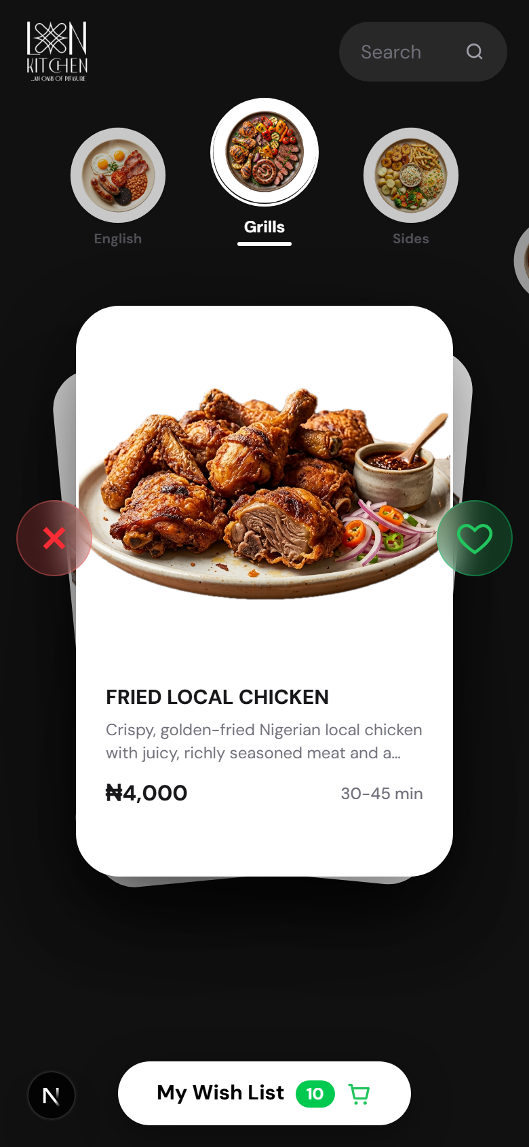 | 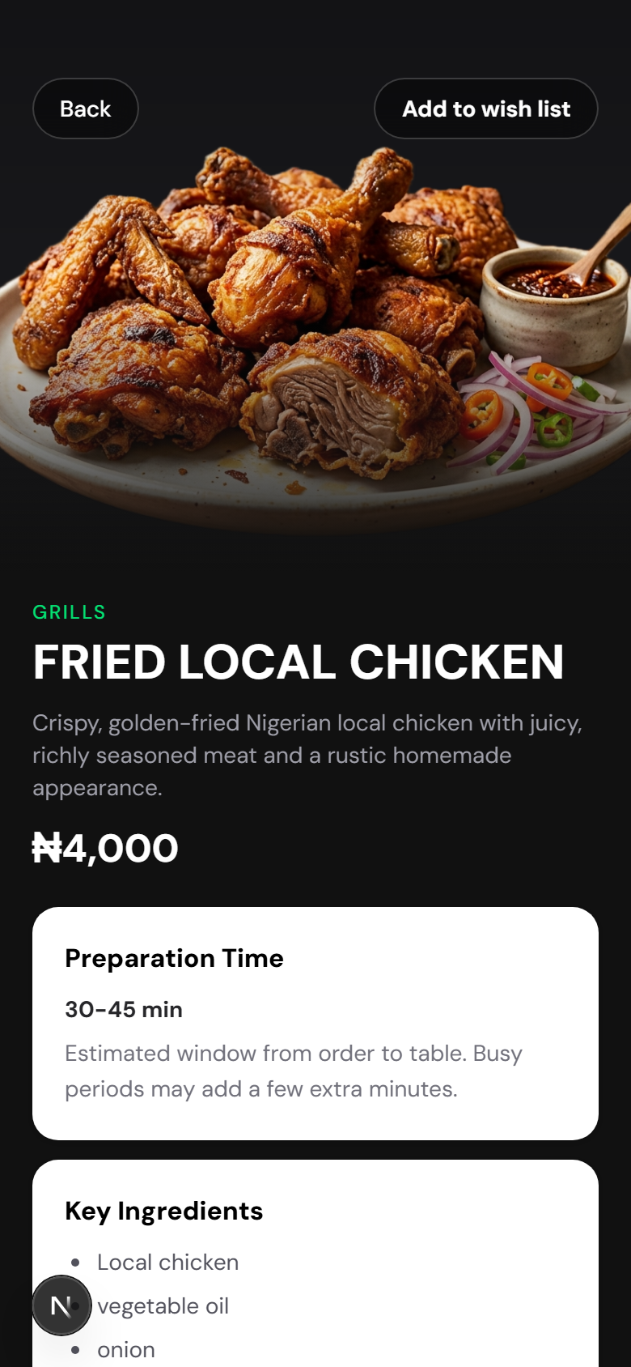 | 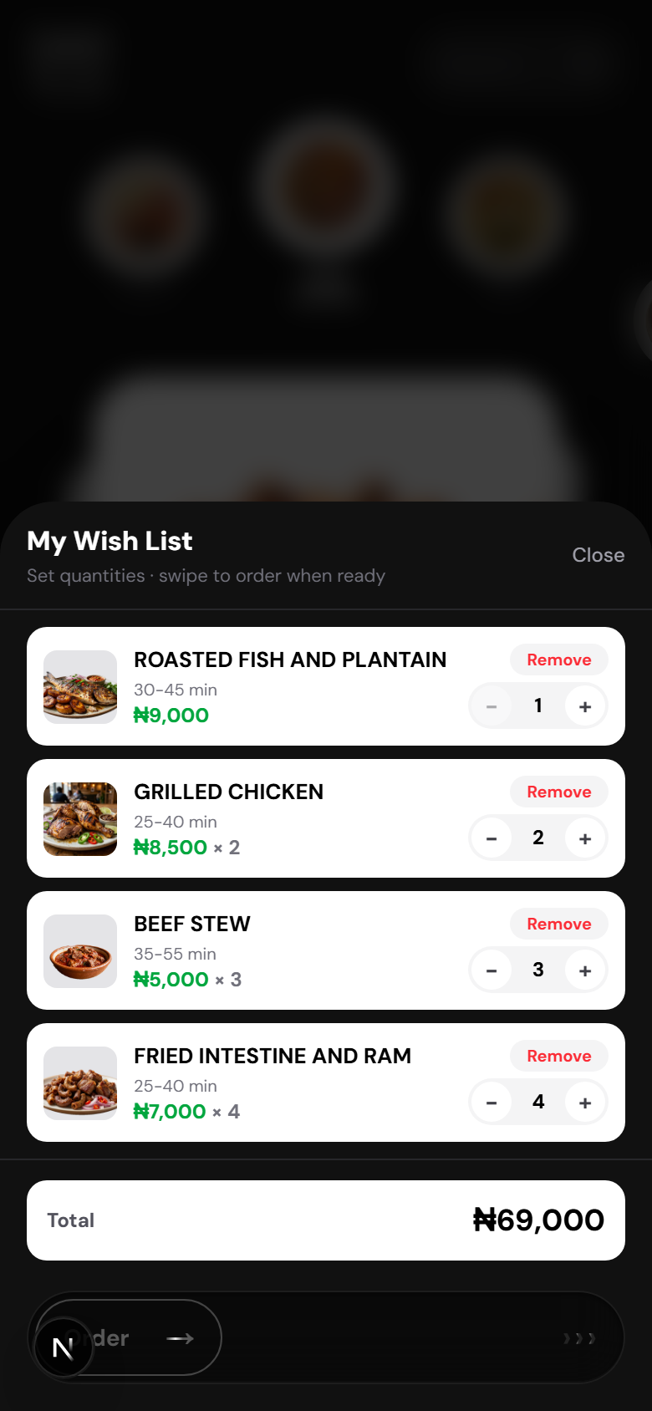
Swipe menu — Grill | Dish detail | Wish list

Admin dashboard
Login, live orders, menu CMS, and waiters

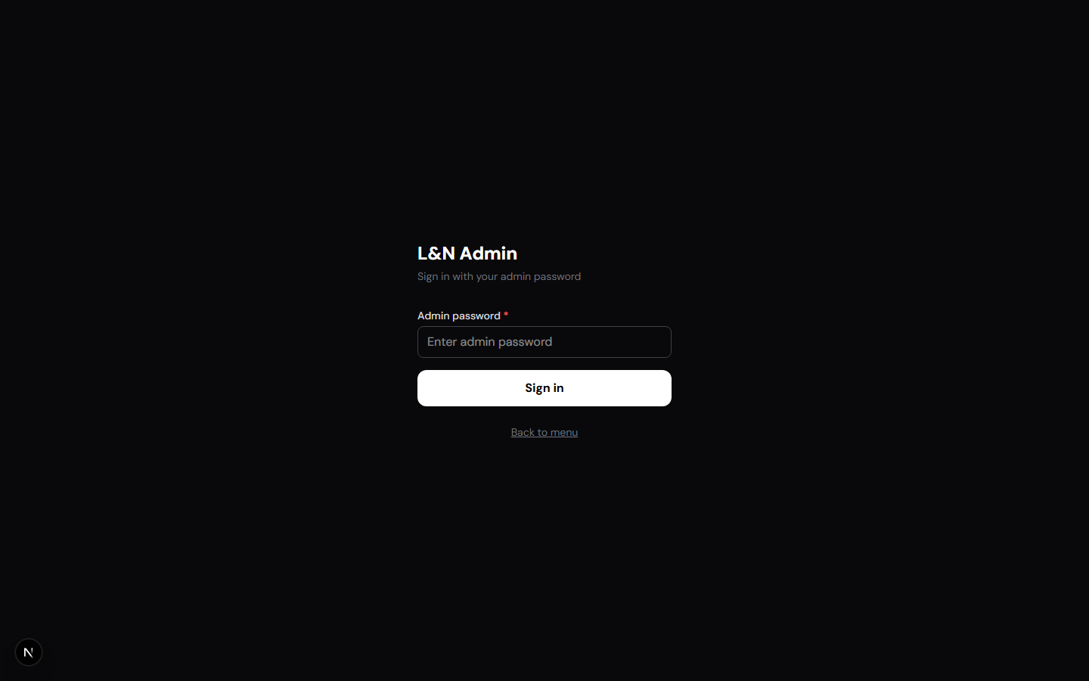 | 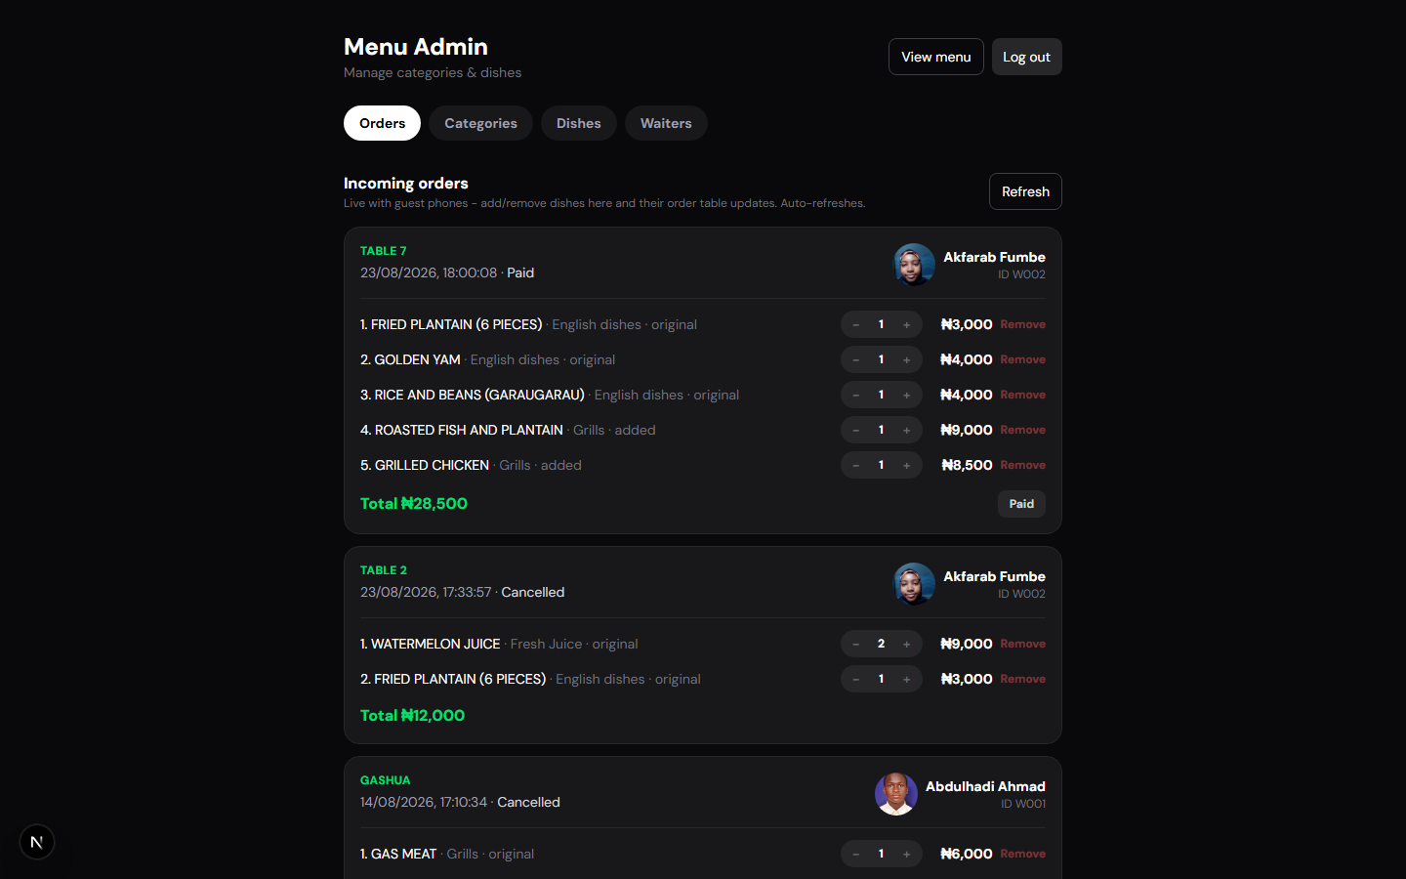
Admin login | Live orders

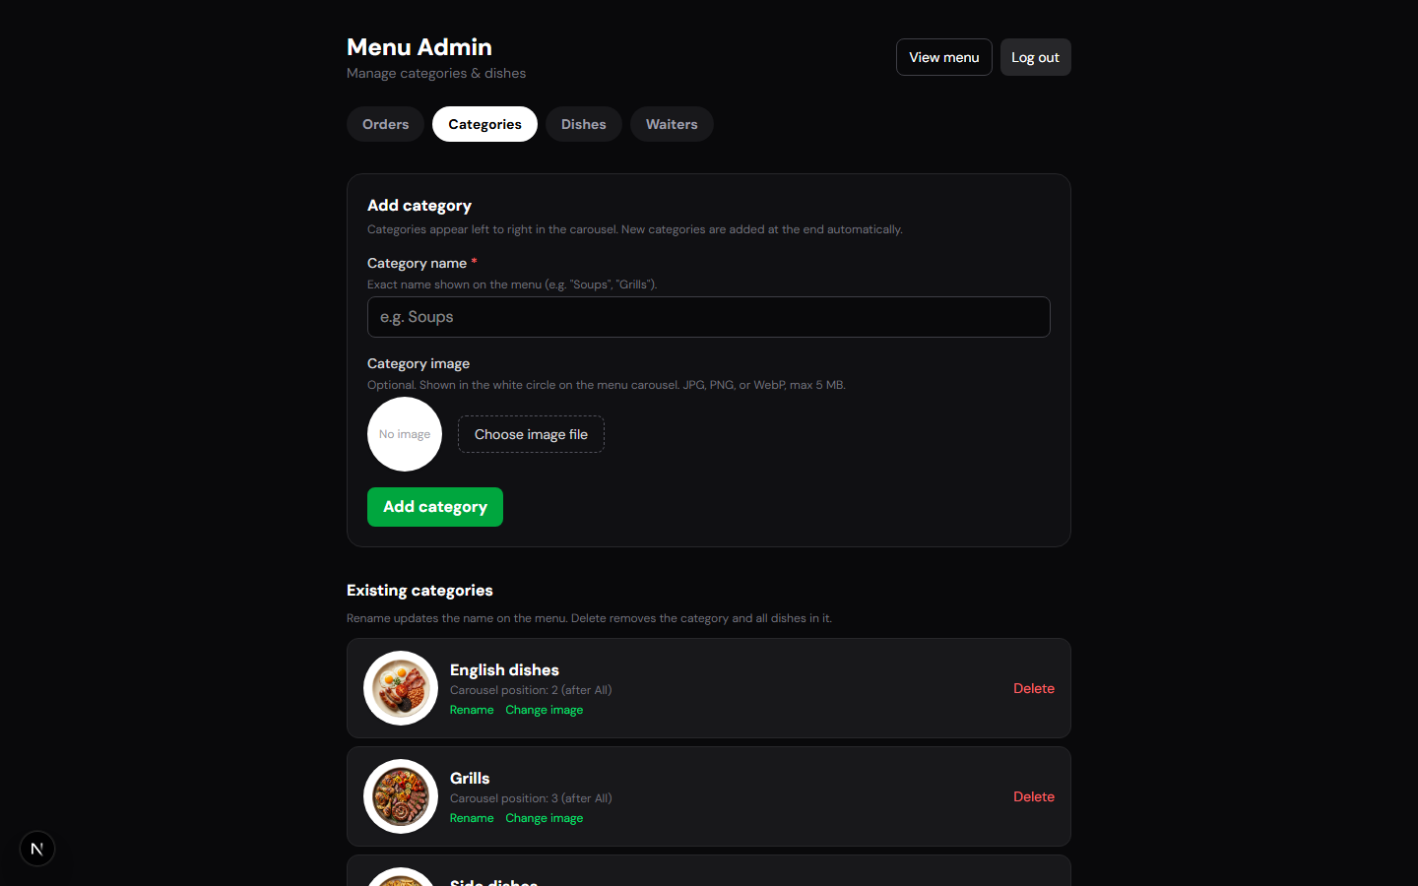 | 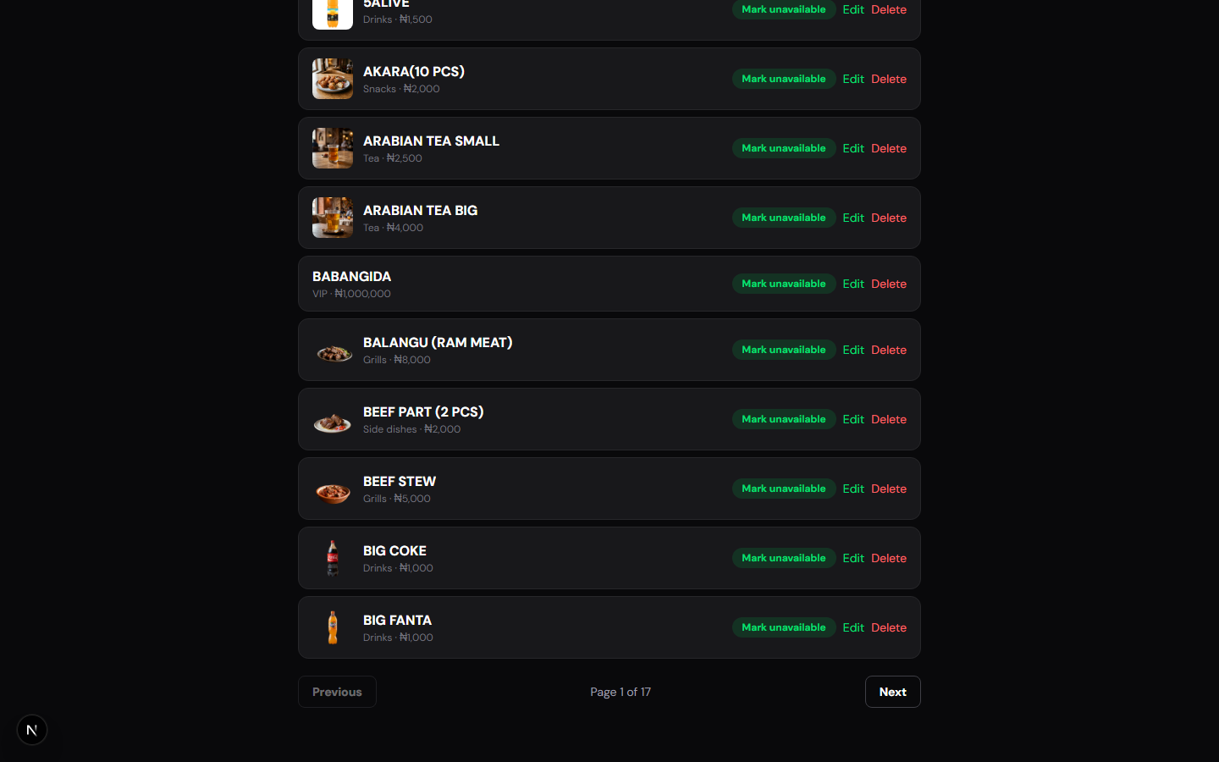 | 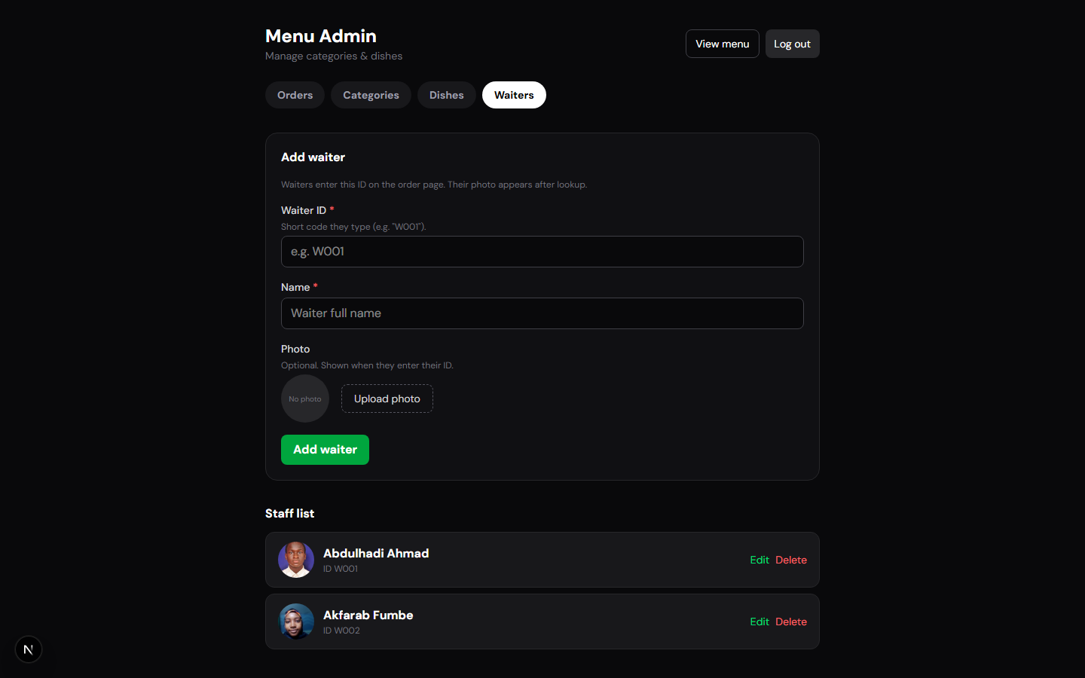
Categories | Dishes | Waiters

Current state
Already live in the L&N Kitchen system

Guest menu  Mobile swipe card deck  Category carousel & search  Wish list + trash restore  Dish detail & allergens  QR share for waiter pickup  Live sync after assign  Session reset after payment | Floor operations  Waiter scans guest QR  Table / lounge capture  Assign to admin (one-shot)  Order image download  Staff ID waiter profiles | Admin control  Orders dashboard  Accept / mark paid  Edit live order items  Categories & dishes CMS  Availability toggles  Waiter management

Opportunity & vision

- Turn the in-venue phone menu into a branded L&N web destination.
- Reduce paper and chat-order mistakes with one source of truth.
- Give kitchen and lounge shared live status from guest to paid.
- Use order data for bestsellers, peak hours, and staff insight.
- North star: digital hospitality that feels as curated as the food.
Upgrade pillars

01 Brand & web  Public landing + menu site  SEO / share previews  Desktop-friendly browse  Story & atmosphere | 02 Guest journey  Table join via QR  Multi-guest shared order  Status timeline  Receipts & feedback | 03 Ops excellence  Kitchen display (KDS)  Printer / alerts  Shift reports  Role permissions | 04 Growth  Promos & set menus  VIP / lounge packages  Analytics dashboard  Loyalty hooks

Phased roadmap
Everything below is covered by the ₦1,850,000 package

Phase 1 — Polish (Weeks 1–3)  Public brand landing  Desktop menu browse  Status UX clarity  Analytics basics | Phase 2 — Shared dining (Weeks 4–7)  Multi-guest table order  Guest status timeline  Waiter alerts  Dietary filters | Phase 3 — Kitchen (Weeks 8–12)  Kitchen display  Print / notify hooks  Roles & audit  Shift reports | Phase 4 — Growth (Weeks 12–14)  Promos & set menus  VIP packages  Loyalty hooks  SEO polish

Cost breakdown — ₦1,850,000
Fixed package investment (One Million, Eight Hundred and Fifty Thousand Naira)

Workstream | Amount (NGN) | Share
UX / UI design & brand landing page | ₦300,000 | 16%
Public website + desktop menu browse | ₦350,000 | 19%
Guest journey upgrades (shared order, status, filters) | ₦400,000 | 22%
Waiter & kitchen ops (KDS, alerts, roles, reports) | ₦450,000 | 24%
Analytics, staff training & 30-day support | ₦200,000 | 11%
Project contingency & QA buffer | ₦150,000 | 8%
TOTAL PACKAGE | ₦1,850,000

Includes delivery of Phases 1–4. Hosting and domain billed separately if not already covered.
Suggested payment schedule

On kickoff · 40%  ₦740,000  Brand assets collected, Phase 1 starts | Phase 1–2 demo · 30%  ₦555,000  Public site + shared dining live | Phase 3–4 handoff · 30%  ₦555,000  Kitchen ops + growth features + training

Expected business outcomes

Faster turns  Clearer orders and paid resets reduce dead time between guests | Fewer errors  One digital source of truth vs handwritten or chat tickets | Higher attach  Upsell-ready UI for VIP, sides, and set experiences | Brand lift  A website that feels like L&N — not a generic PDF menu | Staff clarity  Waiters and admin share the same live order state | Insight  Know what sells, when, and which tables convert wish lists

Recommended next steps

- Approve the ₦1,850,000 package and preferred payment schedule.
- Run a brand workshop — logo, photos, hours, location, VIP / lounge story.
- Kick off Phase 1 — public site and desktop browse as the first visible upgrade.
- Pilot on the floor — train waiters and capture friction notes for Phases 2–3.

L&N KITCHEN
Let’s make the menu feel like the oasis guests already love.
Fixed investment: ₦1,850,000 · Phases 1–4 included · Ready to kick off on approval

