DESIGN AND IMPLEMENTATION OF SKIN-AWARE AI: AN INTELLIGENT PERSONALIZED SKINCARE ANALYSIS AND CONSULTATION SYSTEM
PROJECT PROPOSAL
BY
NWAOZUZU EKENE

CHAPTER ONE
INTRODUCTION
1.1 Background of the Study
The increasing demand for personalized healthcare solutions has led to the rapid adoption of Artificial Intelligence in various medical and wellness domains. In the area of skincare, individuals are becoming more conscious of maintaining healthy skin due to environmental conditions, lifestyle changes, and increasing aesthetic awareness. Despite this growing interest, access to professional dermatological services remains limited due to high consultation costs, shortage of specialists, and geographical barriers, particularly in developing regions.
As a result, many individuals rely on generic skincare products or unverified online advice, which are often inaccurate and not tailored to specific skin conditions. This approach frequently leads to ineffective outcomes and, in some cases, worsens existing skin problems. Recent advancements in deep learning, particularly Convolutional Neural Networks (CNNs), have enabled machines to perform complex image recognition tasks with high accuracy. Studies such as Esteva et al. (2017) have demonstrated that deep learning models can achieve dermatologist-level performance in skin disease classification.
Modern architectures such as ResNet (He et al., 2016) and MobileNet (Howard et al., 2017) have further improved the efficiency and deployment capabilities of these models. This project builds on these advancements by proposing a Skin-Aware AI system capable of analyzing skin images and generating personalized skincare recommendations based on both visual data and user-specific information.
1.2 Problem Statement
Despite the rapid growth of the skincare industry, many individuals still lack access to reliable and affordable dermatological consultation. Professional services are often expensive and not readily available in rural or underserved areas. Consequently, users depend on social media advice, advertisements, and trial-and-error product usage, which can lead to incorrect skincare routines and adverse skin reactions.
Existing digital skincare systems are mostly questionnaire-based and lack accurate image analysis capabilities. These systems do not effectively capture the complexity of individual skin conditions and often fail to provide personalized recommendations. Furthermore, many systems lack real-time analysis and scalable architecture, limiting their usability and efficiency.
There is therefore a need for an intelligent system that combines image-based skin analysis with personalized recommendation capabilities to provide accurate, accessible, and user-friendly skincare solutions.
1.3 Aim and Objectives
The aim of this project is to design and implement a Skin-Aware AI system that provides intelligent and personalized skincare analysis and consultation using machine learning techniques.
Objectives
I. To develop a Convolutional Neural Network model capable of classifying common skin conditions from facial images.
II. To design a system architecture that integrates image processing, machine learning inference, and user interaction components.
III. To evaluate the performance of the system using metrics such as accuracy, precision, recall, and response time.
1.4 Significance of the Study
This study is significant because it demonstrates how Artificial Intelligence can be applied to improve access to skincare consultation. The system provides a cost-effective alternative to traditional dermatological services, making expert-level guidance more accessible to a wider population. It also enables early detection of skin conditions, thereby promoting preventive healthcare practices.
From a technological perspective, the project contributes to the growing field of AI-driven healthcare by integrating computer vision and machine learning into a real-world application. Empirical studies such as Brinker et al. (2019) have shown that AI systems can perform competitively with dermatologists, further supporting the relevance of this research.
1.5 Scope of the Study
This project focuses on the design and implementation of a system capable of analyzing facial skin images and providing personalized skincare recommendations. The system will detect common skin conditions such as acne, dryness, and hyperpigmentation using trained machine learning models.
It will be developed as a web or mobile-based application with a backend AI engine for processing user inputs. However, the system is limited to non-invasive analysis and does not provide medical diagnosis or treatment for severe dermatological conditions. It is intended to serve as a supportive tool rather than a replacement for professional dermatologists.
1.6 Limitations
The performance of the system depends heavily on the quality of input images, as poor lighting or low-resolution images may reduce accuracy. Additionally, the dataset used for training may not fully represent all skin types and conditions, which can affect generalization.
The system also requires computational resources for real-time processing, which may limit performance on low-end devices. Furthermore, while the system provides intelligent recommendations, it does not replace professional medical consultation in complex cases.

CHAPTER TWO
LITERATURE REVIEW
2.1 Artificial Intelligence in Healthcare
Artificial Intelligence has become a powerful tool in healthcare, enabling automated diagnosis, predictive analytics, and personalized treatment systems. Deep learning models, particularly CNNs, have shown strong performance in medical image analysis due to their ability to learn complex patterns from large datasets.
Recent studies such as Li et al. (2020) and Zhang et al. (2020) have demonstrated that deep learning significantly improves classification accuracy in medical imaging tasks. These advancements highlight the growing reliability of AI systems in real-world healthcare applications.

2.2 Skin Image Analysis Using Computer Vision
Computer vision techniques allow machines to interpret and analyze skin images by extracting features such as texture, color, and lesion patterns. CNN architectures remain the most widely used approach due to their efficiency and accuracy.
ResNet (He et al., 2016) improves deep learning performance through residual learning, while MobileNet (Howard et al., 2017) enables lightweight deployment on mobile devices. Recent studies such as Pham et al. (2020) and Albahar (2021) have further improved classification accuracy using transfer learning and enhanced model designs.
2.3 Existing Systems
Existing skincare systems range from simple rule-based applications to advanced AI-driven platforms. Most commercial applications rely on questionnaires, which limits their accuracy and personalization capabilities.
Recent research shows that deep learning-based systems outperform traditional approaches in skin disease classification (Hassan et al., 2022; Kassem et al., 2021). However, many of these systems lack real-time deployment and scalable architecture, reducing their effectiveness in practical applications.
2.4 Research Gap
Despite advancements in AI-based skincare systems, several gaps remain. Many systems focus primarily on improving classification accuracy without addressing scalability, real-time deployment, and user experience.
Studies such as Adegun and Viriri (2023) and Khan et al. (2023) highlight challenges related to dataset bias and lack of diversity, which affect model performance in real-world applications. Additionally, personalization is still limited in many systems.
This project aims to address these gaps by developing an integrated system that combines accurate image classification with scalable architecture and personalized recommendations.
2.5 Empirical Review
Empirical studies have shown that deep learning significantly improves skin disease classification performance. Esteva et al. (2017) demonstrated that CNN models can achieve dermatologist-level accuracy in controlled settings.
Recent studies such as Gessert et al. (2022) and Pham et al. (2020) have further improved performance using ensemble learning and transfer learning techniques. However, challenges such as dataset bias and generalization limitations remain, highlighting the need for improved real-world deployment systems.

CHAPTER THREE
LITERATURE METHODOLOGY
3.1 Introduction
This chapter presents the design and methodology used in the development of the Skin-Aware AI system. It explains the architecture, workflows, implementation procedures, and model design used to achieve intelligent skincare analysis and recommendation generation. The chapter also presents the system diagrams and structural design adopted during development.
3.2 System Overview
The Skin-Aware AI system integrates artificial intelligence, computer vision, and software engineering concepts to provide intelligent skincare consultation. The system accepts user images, preprocesses them, performs skin analysis using a trained Convolutional Neural Network model, and generates personalized skincare recommendations based on the analysis results. The architecture is designed to support scalability, flexibility, and real-time response.
3.3 System Architecture
The system architecture illustrates the interaction between the user interface, backend processing server, and AI model. The frontend allows users to upload images and receive recommendations, while the backend handles preprocessing and communication with the machine learning model.
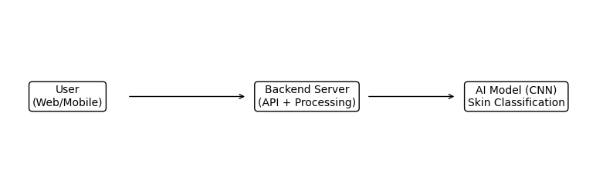
Figure 3.1: System Architecture Diagram
3.4 System Components
The system consists of the frontend layer, backend layer, and AI model layer. These components work together to process user data and generate intelligent skincare recommendations.
3.5 Data Flow Diagram
The Data Flow Diagram describes how data moves through the system, beginning from image upload to recommendation generation.
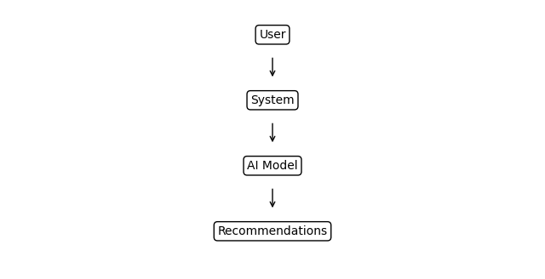
Figure 3.2: Data Flow Diagram
3.6 Use Case Diagram
The Use Case Diagram describes the interactions between the user and the system. The user uploads images, views results, and receives skincare recommendations generated by the AI system.
3.7 Activity Diagram
The Activity Diagram explains the sequential workflow of the system from image upload, preprocessing, AI analysis, recommendation generation, and final result presentation.

REFERENCES
Adegun, A. A., & Viriri, S. (2023). Deep learning techniques for skin lesion classification: A review. Applied Sciences, 13(3), 1612. https://doi.org/10.3390/app13031612
Albahar, M. A. (2021). Skin lesion classification using convolutional neural networks with novel regularizer. IEEE Access, 9, 38306–38313. https://doi.org/10.1109/ACCESS.2021.3063422
Brinker, T. J., Hekler, A., Enk, A. H., Klode, J., Hauschild, A., Berking, C., Schilling, B., Haferkamp, S., Schadendorf, D., Holland-Letz, T., Utikal, J. S., & von Kalle, C. (2019). Deep neural networks are superior to dermatologists in melanoma image classification. European Journal of Cancer, 113, 47–54. https://doi.org/10.1016/j.ejca.2019.04.005
Gessert, N., Nielsen, M., Shaikh, M., Werner, R., & Schlaefer, A. (2022). Skin lesion classification using ensembles of multi-resolution convolutional neural networks. Computer Methods and Programs in Biomedicine, 215, 106594. https://doi.org/10.1016/j.cmpb.2021.106594
Hassan, A. R., Haque, M. A., & others. (2022). Automated skin disease classification using deep learning techniques. Healthcare, 10(2), 348. https://doi.org/10.3390/healthcare10020348
He, K., Zhang, X., Ren, S., & Sun, J. (2016). Deep residual learning for image recognition. In Proceedings of the IEEE Conference on Computer Vision and Pattern Recognition (CVPR) (pp. 770–778). https://doi.org/10.1109/CVPR.2016.90
Howard, A. G., Zhu, M., Chen, B., Kalenichenko, D., Wang, W., Weyand, T., Andreetto, M., & Adam, H. (2017). MobileNets: Efficient convolutional neural networks for mobile vision applications. arXiv. https://arxiv.org/abs/1704.04861
Kassem, M. A., Hosny, K. M., Fouad, M. M., & others. (2021). Machine learning and deep learning methods for skin lesion classification: A comprehensive review. Multimedia Tools and Applications, 80(12), 17921–17950. https://doi.org/10.1007/s11042-020-10154-8
Khan, M. A., Sharif, M., Akram, T., & others. (2023). A survey on deep learning-based skin lesion classification. Diagnostics, 13(5), 870. https://doi.org/10.3390/diagnostics13050870
Li, Y., Shen, L., & others. (2020). Skin lesion analysis towards melanoma detection using deep learning network. Medical Image Analysis, 67, 101861. https://doi.org/10.1016/j.media.2020.101861
Pham, T. C., Luong, C. M., & Hoang, V. D. (2020). Deep CNN and transfer learning for skin lesion classification. Computers in Biology and Medicine, 120, 103805. https://doi.org/10.1016/j.compbiomed.2020.103805
Zhang, X., Wang, S., Liu, J., & Tao, D. (2020). Towards improving skin disease classification with deep learning. IEEE Access, 8, 135671–135686. https://doi.org/10.1109/ACCESS.2020.3011438

