Ranking Every Infinity Saga Movie

From Worst to First



23. The Incredible Hulk

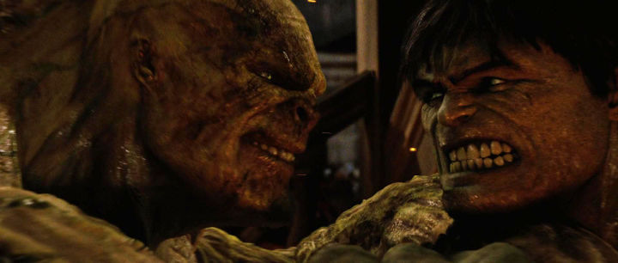

Universal Pictures - The Incredible Hulk (2008)

Release Order: 2 Chronological Order: 5 Score: 7.2/10

“Synopsis”

Main Hero Main Villain Key Character

Hulk Abomination General Thunderbolt Ross

Cameo

Infinity Stone(s): None

22. Ant-Man

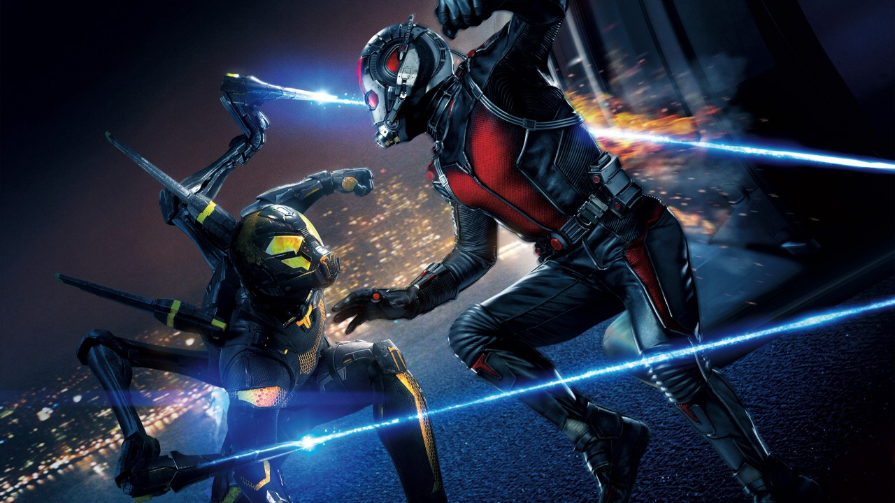

Disney – Ant-Man (2015)

Release Order: 12 Chronological Order: 14 Score: 7.4/10

“Synopsis”

Main Hero(s): Ant-Man Main Villain(s): Yellowjacket

Key Characters

Infinity Stone(s): None

21. Thor: The Dark World

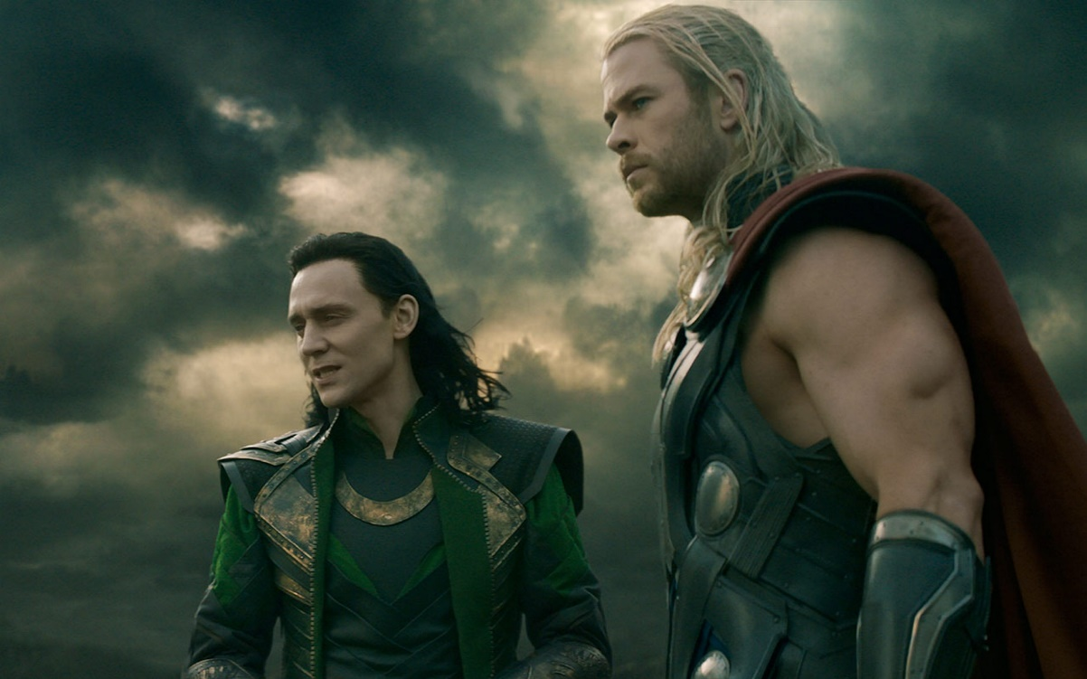

Disney – Thor: The Dark World (2013)

Release Order: 8 Chronological Order: 9 Score: 7.5/10

“Synopsis”

Main Hero Main Villains

Thor Malekith, Kursed, The Dark Elves

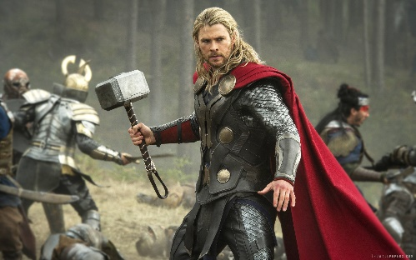

Key Characters

Odin Frigga Loki Jane Foster

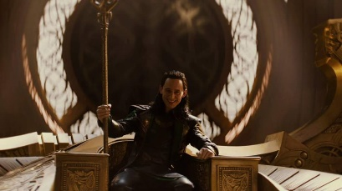 

Infinity Stone(s): Reality Stone (Aether)

20. Thor

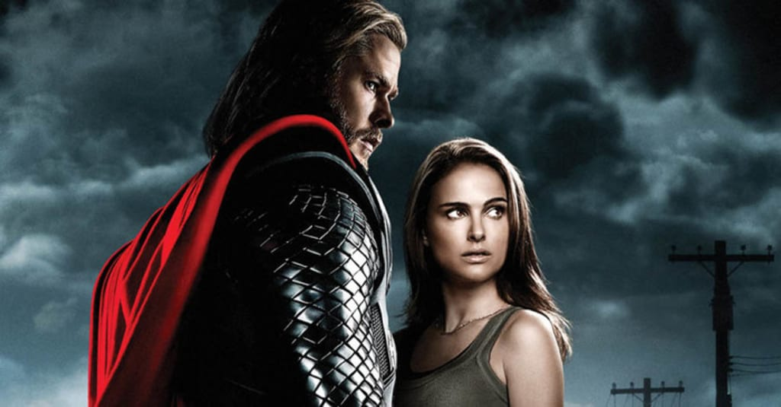

Disney - Thor (2010)

Synopsis: “”

Release Order: 4

Chronological Order: 6

Main Hero(s): Thor

Main Villain(s): Loki

Infinity Stone(s): Space Stone

Score: 7.7/10

19. Captain Marvel

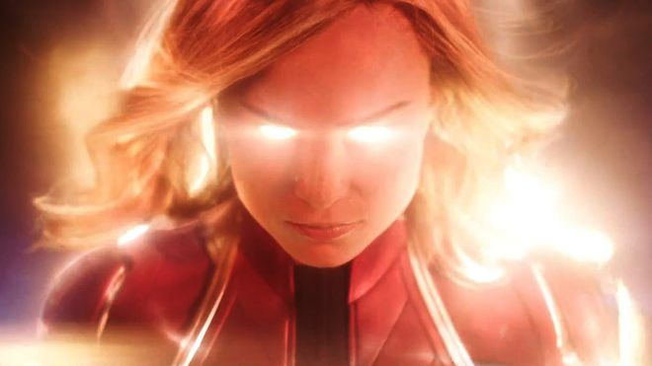

Disney – Captain Marvel (2019)

Synopsis: “”

Release Order: 21

Chronological Order: 2

Main Hero(s): Carol Danvers, Nick Fury, The Skrulls

Main Villain(s): Ronan the Accuser, The Kree

Infinity Stone(s): Space Stone (Tesseract)

Score: 7.8/10

18. Iron Man 2

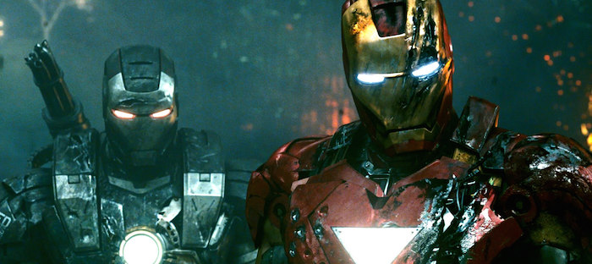

Universal Pictures – Iron Man (2010)

Synopsis: “”

Release Order: 3

Chronological Order: 4

Main Hero(s): Iron Man, War Machine, Black Widow

Main Villain(s): Whiplash

Infinity Stone(s): None

Score: 7.9/10

17. Ant-Man and The Wasp

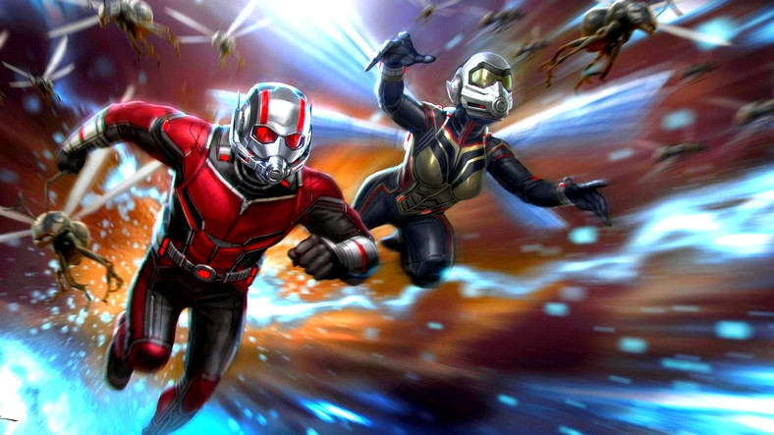

Disney – Ant-Man and The Wasp (2018)

Synopsis: “”

Release Order: 20

Chronological Order: 20

Main Hero(s): Ant-Man, The Wasp

Main Villain(s): Ghost

Infinity Stone(s): None

Score: 8.0/10

16. Spider-Man: Homecoming

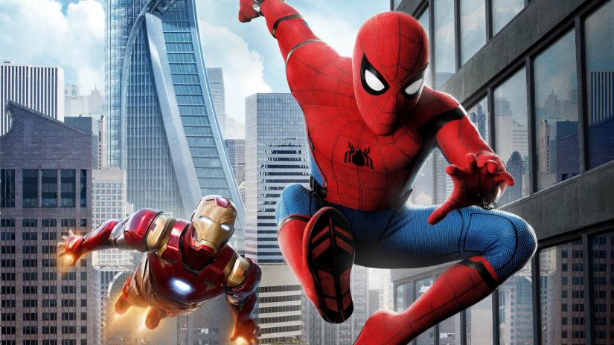

Sony Pictures – Spider-Man: Homecoming (2017)

Synopsis: “”

Release Order: 16

Chronological Order: 17

Main Hero(s): Spider-Man (Peter Parker), Iron Man

Main Villain(s): The Vulture (Adrian Tooms), Shocker (“Name”)

Infinity Stone(s): None

Score: 8.1/10

15. Iron Man

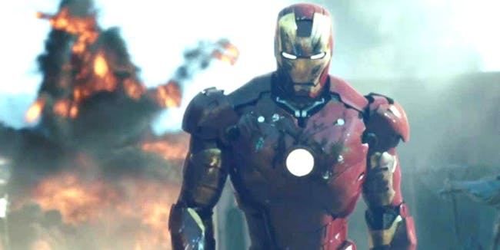

Universal Pictures – Iron Man (2008)

Synopsis: “”

Release Order: 1

Chronological Order: 3

Main Hero(s): Iron Man

Main Villain(s): Iron Monger (Obadiah Stane)

Infinity Stone(s): None

Score: 8.2/10

14. Black Panther

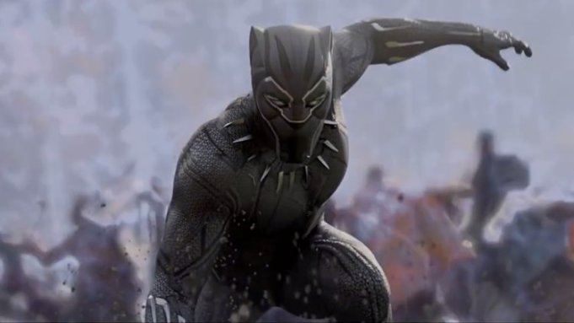

Disney- Black Panther (2018)

Synopsis: “”

Release Order: 18

Chronological Order: 16

Main Hero(s): Black Panther (T’Challa)

Main Villain(s): (Erik Killmonger), Ulysses Klaw

Infinity Stone(s): None

Score: 8.3

13. Spider-Man: Far From Home

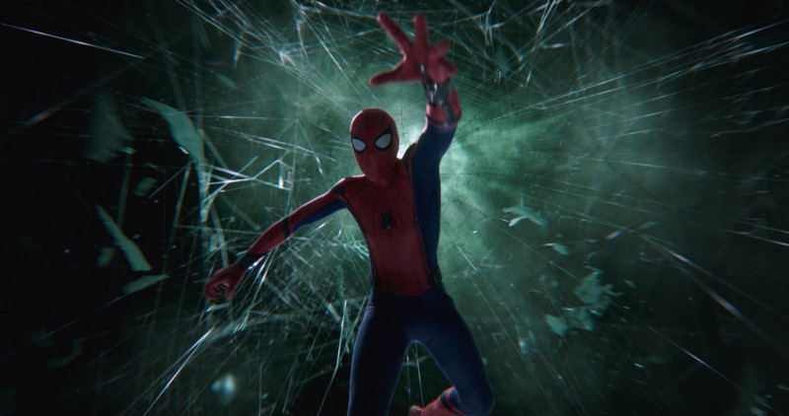

Sony Pictures – Spider-Man: Far From Home (2019)

Synopsis: “”

Release Order: 23

Chronological Order: 23

Main Hero(s): Spider-Man

Main Villain(s):

Infinity Stone(s):

Score:

12. Captain America: The First Avenger

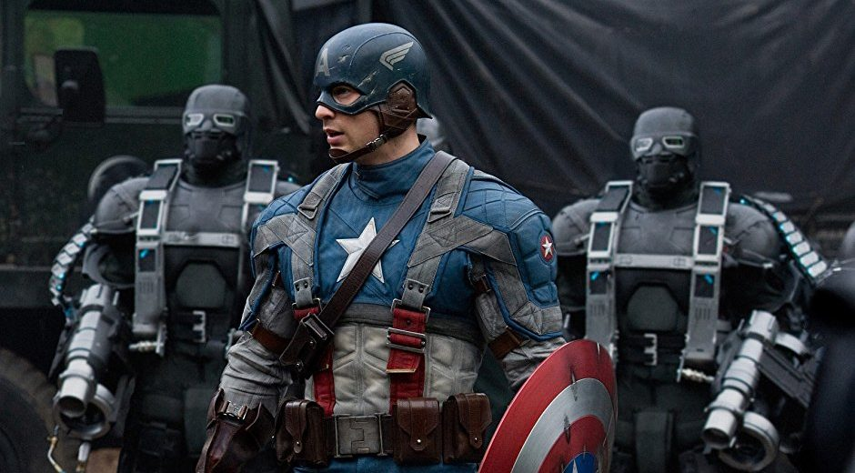

Disney – Captain America: The First Avenger (2011)

Synopsis: “”

Release Order: 5

Chronological Order: 1

Main Hero(s): Captain America

Main Villain(s): Red Skull, Arnim Zola

Infinity Stone(s): Space Stone

Score: 8.4/10

11. Doctor Strange

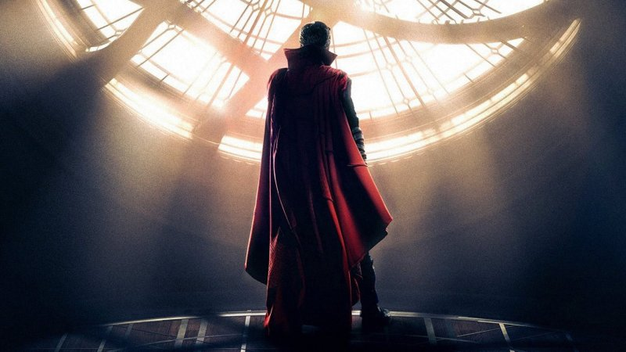

Disney – Doctor Strange (2016)

Synopsis: “”

Release Order: 14

Chronological Order: 18

Main Hero(s): Doctor Strange, The Ancient One, Wong, Baron Mordo

Main Villain(s): Kaecillius, Dormammu

Infinity Stone(s): Time Stone

Score: 8.4/10

10. Iron Man 3

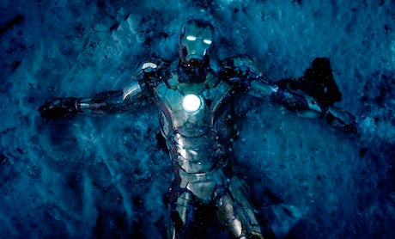

Disney – Iron Man 3 (2013)

Synopsis: “”

Release Order: 7

Chronological Order: 8

Main Hero(s): Iron Man, War Machine

Main Villain(s): Aldrich Killian, The Mandarin ?

Infinity Stone(s): None

Score: 8.5/10

9. Guardians of the Galaxy Vol. 2

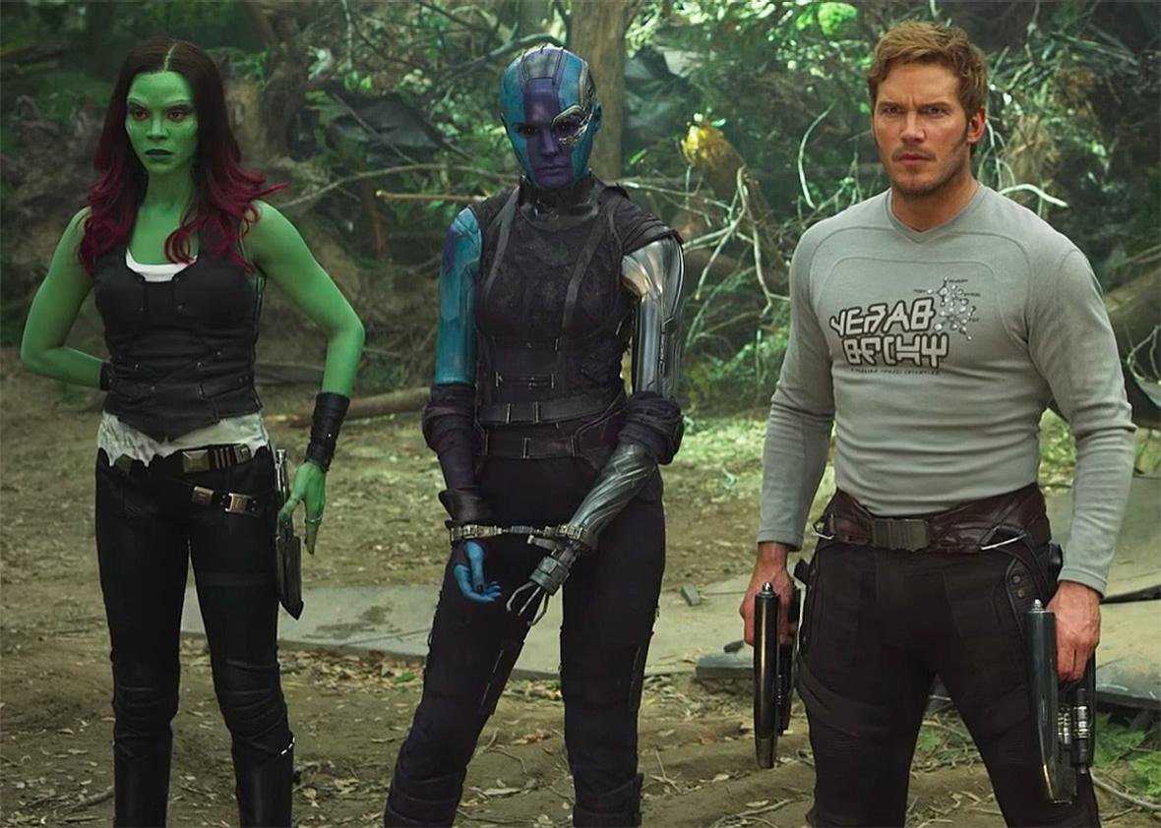

Disney – Guardians of the Galaxy (2017)

Synopsis: “”

Release Order: 15

Chronological Order: 12

Main Hero(s): Star-Lord, Gamora, Drax the Destroyer, Groot, Rocket Raccoon, Mantis, Yandu, Nebula

Main Villain(s): Ego the Living Planet, Yandu, Nebula

Infinity Stone(s): None

Score: 8.5/10

8. Guardians of the Galaxy

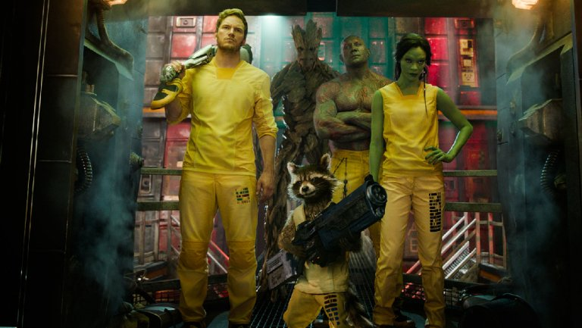

Disney – Guardians of the Galaxy (2014)

Synopsis: “”

Release Order: 10

Chronological Order: 11

Main Hero(s): Star-Lord, Gamora, Drax the Destroyer, Groot, Rocket Raccoon

Main Villain(s): Ronan the Accuser, Nebula

Infinity Stone(s): Power Stone

Score: 8.7/10

7. Thor: Ragnarok

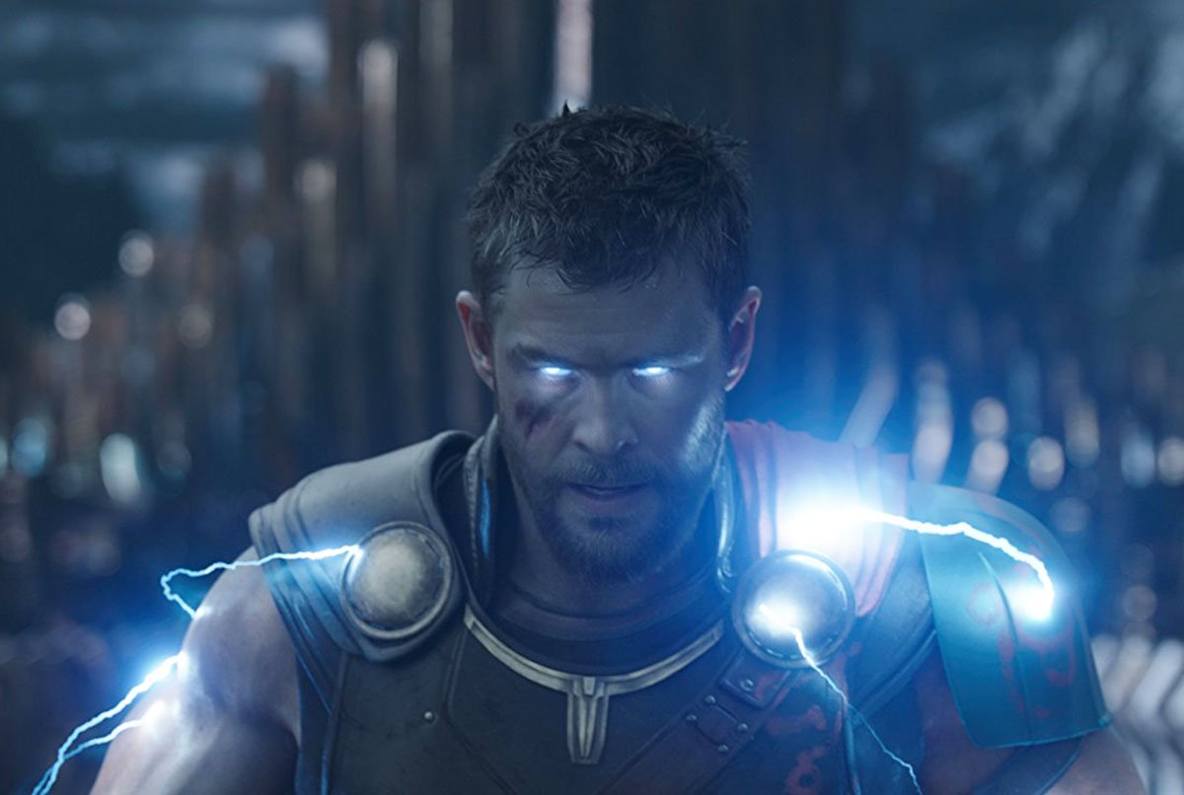

Disney – Thor: Ragnarok (2017)

Synopsis: “”

Release Order: 17

Chronological Order: 19

Main Hero(s): Thor, Hulk, Valkyrie, Loki ?

Main Villain(s): Hela, Grandmaster

Infinity Stone(s): Space Stone

Score: 8.8/10

6. Captain America: The Winter Soldier

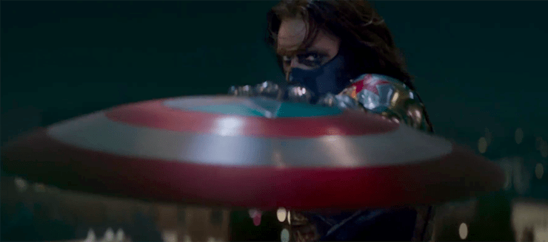

Disney – Captain America: The Winter Soldier (2014)

Synopsis: “”

Release Order: 9

Chronological Order: 10

Main Hero(s): Captain America, Black Widow, Falcon, Nick Fury

Main Villain(s): The Winter Soldier, Alexander Pierce

Infinity Stone(s): None

Score: 9.0/10

5. Avengers: Age of Ultron

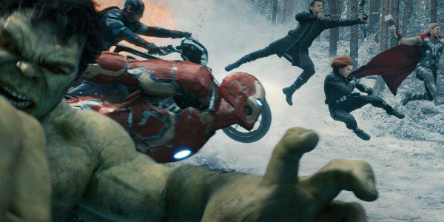

Disney – Avengers: Age of Ultron (2015)

Synopsis: “”

Release Order: 11

Chronological Order: 13

Main Hero(s): Iron Man, Captain America, Thor, Hulk, Black Widow, Hawkeye, War Machine, Vision, Scarlet Witch, Quicksilver

Main Villain(s): Ultron, Scarlet Witch, Quicksilver

Infinity Stone(s): Mind Stone

Score: 9.1/10

4. The Avengers

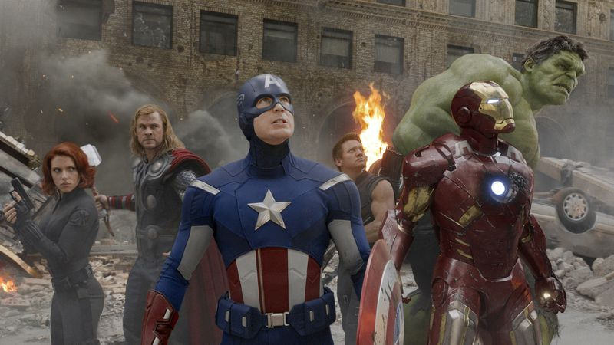

Disney - The Avengers (2012)

Synopsis: “”

Release Order: 6

Chronological Order: 7

Main Hero(s): Iron Man, Captain America, Thor, Hulk, Black, Widow, Hawkeye

Main Villain(s): Loki

Infinity Stone(s): Space Stone, Mind Stone

Score: 9.3/10

3. Captain America: Civil War

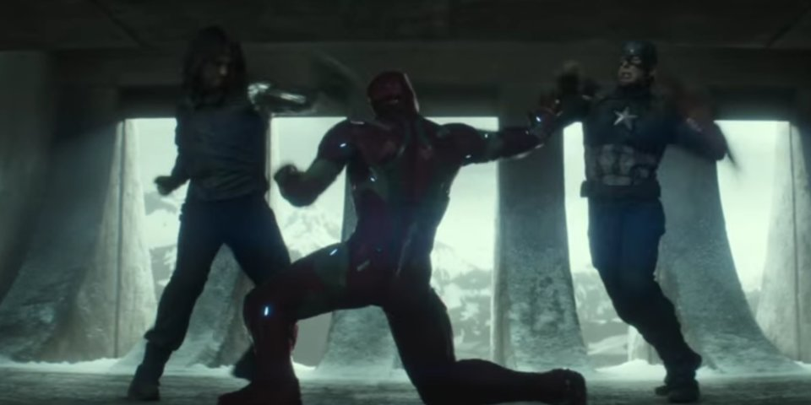

Disney – Captain America: Civil War (2016)

Synopsis: “”

Release Order: 13

Chronological Order: 15

Main Hero(s): Team Iron Man: Iron Man, War Machine, Vision, Black Widow, Black Panther, Spider-Man

Team Captain America: Captain America, Winter Soldier, Falcon, Hawkeye, Scarlet Witch, Ant-Man

Main Villain(s): Helmut Zemo

Infinity Stone(s): None

Score: 9.4/10

2. Avengers: Infinity War



Disney – Avengers: Infinity War (2018)

Synopsis: “”

Release Order: 19

Chronological Order: 21

Main Hero(s): Iron Man, Captain America, Thor, Hulk, Black Widow, Doctor Strange, Spider-Man, Black Panther, Winter Soldier, Star-Lord, Drax The Destroyer, Gamora, Nebula, Rocket Raccoon, Groot, Mantis, Wong, M’Baku, Okoye

Main Villain(s): Thanos, Ebony Maw, Cull Obsidian, Proxima Midnight, Black Dwarf, Corvus Glaive

Infinity Stone(s): Power Stone, Space Stone, Reality Stone, Soul Stone, Time Stone, Mind Stone

Score: 10/10

1. Avengers: Endgame

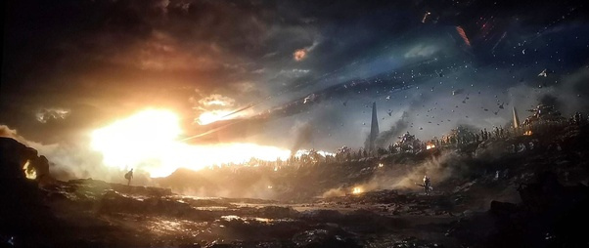

Disney – Avengers: Endgame (2019)

Synopsis: “”

Release Order: 22

Chronological Order: 22

Main Hero(s): Iron Man, Captain America, Thor, Hulk, Black Widow, Doctor Strange, Spider-Man, Black Panther, Winter Soldier, Star-Lord, Drax The Destroyer, Gamora, Nebula, Rocket Raccoon, Groot, Mantis, Wong, M’Baku, Okoye, Ant-Man, Wasp, Hawkeye, Valkyrie

Main Villain(s): Thanos, Ebony Maw, Cull Obsidian, Proxima Midnight, Black Dwarf, Corvus Glaive

Infinity Stone(s): Power Stone, Space Stone, Reality Stone, Soul Stone, Time Stone, Mind Stone

Score: 10/10