Blind text collection

Follow the links to get to the blind text generators. The image is a link, too. [Lern all about blind texts](https://www.lipsum.com/).

[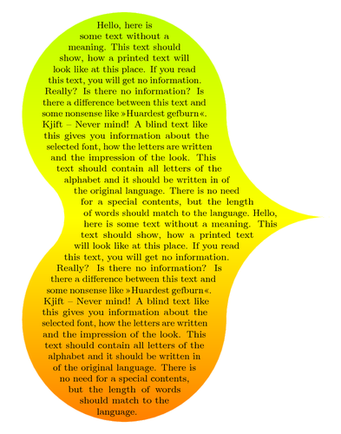](http://www.texample.net/tikz/examples/text-shape/)Far far away, behind the word mountains, far from the countries Vokalia and Consonantia, there live the blind texts. Separated they live in Bookmarksgrove right at the coast of the Semantics, a large language ocean...   
[Read the full story here](https://www.blindtextgenerator.com/lorem-ipsum)  
  
  
The European languages are members of the same family. Their separate existence is a myth. For science, music, sport, etc, Europe uses the same vocabulary… [Read the full story here](https://www.blindtextgenerator.com/lorem-ipsum)