|  |
| --- |
| How does AI help you master precision CNC machining? |
| Module Leader: Dr Alessandro Di Stefano  Module Code: CIS2048-N |
| |  |  |  | | --- | --- | --- | | SAVARI, ALEX (Student) | 6/3/25 | Artificial Intelligence | |

AI and Machine Learning in CNC Tool Path Optimization

AI and Machine Learning in CNC Tool Path Optimization

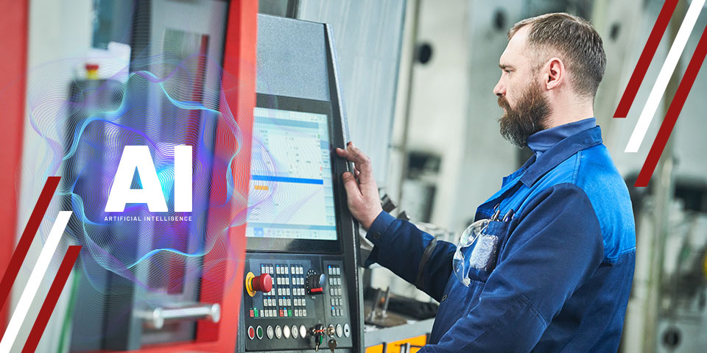

**Abstract**

AI and Machine Learning (ML) are changing how CNC (Computer Numerical Control) machines work, making them faster and more accurate. In the past, CNC machines only followed pre-set instructions. Now, with AI, they can analyse data, learn from experience, and adjust tool paths in real time. AI helps machines change cutting speeds, tool movements, and strategies to reduce waste, improve quality, and make tools last longer.

AI-powered CNC machines can also detect tool wear, adapt to different materials, and predict maintenance needs before problems happen. This means better products, lower costs, and higher productivity.

With a good balance between AI and human control, CNC machining can become smarter, more reliable, and more sustainable. This report looks at both the benefits and challenges of using AI in CNC tool path optimization and its future in manufacturing.

1. **Introduction**

The fast growth of Artificial Intelligence (AI) is changing many industries, including manufacturing. AI is now part of everyday work, improving speed, accuracy, and automation. In CNC machining, AI is making a big difference, especially in tool path optimization and machine maintenance.

In the past, CNC machines followed fixed tool paths. Now, AI-powered machines can analyse data, learn from experience, and adjust their operations to boost productivity. AI-driven CNC machining now accounts for about 20% of global production, but traditional tool paths are still not ideal for complex shapes, tool wear, and changing conditions (Smith et al., 2021).

To solve these problems, technologies like Reinforcement Learning (RL), Neural Networks, and Genetic Algorithms (GA) are being used. They help cut cycle times, save energy, and reduce tool wear (Zhang & Li, 2020).

This report will look at how AI and ML are improving CNC tool path optimization, their benefits, challenges, and what they mean for the future of manufacturing.

**Background**

**Tool Path Optimization in CNC Machining**

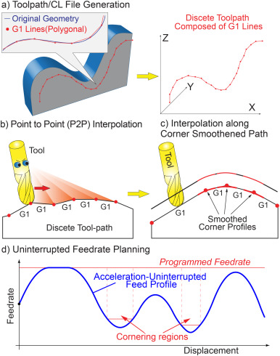

In traditional CNC machining, the tool path controls how the cutting tool moves across the material. The quality and accuracy of machining depend heavily on these paths. Traditional Computer-Aided Manufacturing (CAM) software creates a fixed G-code program to guide the tool. However, these static codes cannot adapt to changes in material or environmental conditions, which are common in manufacturing (Guo et al., 2019).

Traditional CAM systems also use set feed rates and speeds without real-time feedback on tool condition. This often leads to more scrap and shorter tool life, with studies showing a 12–18% rise in scrap rates due to this (Chen et al., 2021).

Moreover, traditional CAM algorithms are built for reliability but lack flexibility. They struggle with complex tasks like 5-axis machining, where simple static G-code cannot handle the non-linear movements needed (Lee & Park, 2020).

With AI integration, CNC machines can now optimize tool paths and predict maintenance needs. Unlike traditional methods, AI and Machine Learning (ML) offer more adaptive and flexible tool path generation. AI/ML models use sensor data—such as vibrations, temperature, and acoustic signals—to make real-time adjustments for tool wear and material changes (Wang et al., 2022).

AI/ML can also handle multiple goals at once, like reducing energy use while improving surface quality, using advanced algorithms to balance these needs better than traditional CAM software (García et al., 2023).

**AI/ML Techniques in Tool Path Optimization**

**Neural Networks (NNs)**

Neural networks are a type of AI that mimics the way human brains operate, which makes them especially good at recognizing patterns from complex data. Two subcategory of neural network mostly used in CNC machine tool path optimizations are Convolutional Neural Network and Recurrent Neural network. **Convolutional Neural Networks (CNNs)** are particularly good at processing data with a grid-like topology, such as images or time-series data from sensors. In CNC machining, CNNs have been used to predict when tools will wear out by analysing vibration data. This allows machines to recalibrate the tool path automatically to maintain precision, thereby extending the tool's life and ensuring consistent product quality (Huang et al., 2021).

Recurrent Neural Networks (RNNs) are a type of neural network uniquely suited for tool path optimization due to their ability to process sequential data. They can predict future machining conditions by learning from past and present patterns, making them valuable for planning the sequence of machining operations. This predictive capability helps improve efficiency and reduces the risk of errors (Rajesh et al., 2022).

One of the key advantages of RNNs is their ability to retain past information through their memory-like structure, which enables them to make better predictions about future states. This makes RNNs particularly useful for real-time adaptive machining, where adjustments must be made dynamically based on ongoing conditions. RNNs can analyse historical machining data, such as spindle load, cutting force, temperature, and vibration patterns, to predict optimal tool speed, depth of cut, and coolant flow. By leveraging this predictive capability, RNN-based systems can help minimize machining defects, improve cutting efficiency, and extend tool life, ensuring higher precision and reduced production costs in CNC machining.

Long Short-term

Memory is advance variant of Recurrent Neural networks, that been used by DMG Mori’s CELOS to adjust 5-axis tool paths in real time, reducing cycle time by 15% in titanium part machining. Major drawback of neural networks is their need for large amounts of data to learn effectively. This data must be accurately labelled, which can be a significant challenge in smaller manufacturing setups where data is limited (Müller et al., 2023).

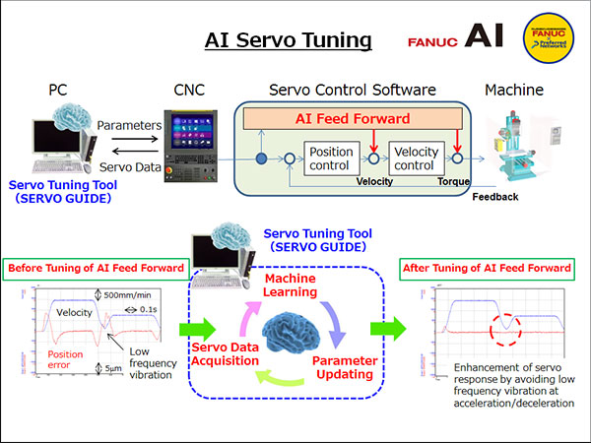

**Reinforcement Learning (**RL) is revolutionizing tool path optimization in CNC machining by enabling machines to autonomously learn and adapt to dynamic conditions. Unlike traditional rule-based approaches, RL agents iteratively improve decisions by interacting with the machining environment, balancing exploration (trying new strategies) and exploitation (leveraging known solutions).

An RL agent observes the machining environment through sensor data and contextual variables, such as tool conditions (temperature, vibration), workpiece properties, machine state (spindle load, feed rate), and process metrics (cutting force). Based on these inputs, the RL agent adjusts machining parameters dynamically, allowing CNC machines to adapt to real-time changes, ultimately leading to higher efficiency, precision, and reduced tool wear.

One widely used RL technique is Q-learning, which has been successfully applied to dynamically adjust feed rates during machining processes. By optimizing these rates in real-time, Q-learning agents have been shown to reduce overall machining time by up to 22%, leading to improved productivity and lower costs (Kim et al., 2021).

To balance exploration and exploitation in Q-learning, the epsilon-greedy strategy is commonly used. This strategy allows the RL agent to make decisions by either selecting the best-known action (exploitation) or randomly trying new actions (exploration) with a probability of ε (epsilon). Initially, a **high** epsilon value encourages exploration to find optimal tool path strategies, while over time, epsilon is **gradually** **reduced** to prioritize learned strategies. This ensures the agent does not get stuck in suboptimal paths and continuously refines its machining approach.

Deep Reinforcement Learning (DRL), which combines deep learning with reinforcement learning, has also been used to adjust tool paths based on immediate feedback such as tool deflection and cutting force variations. This adaptive approach minimizes the impact of machining errors and ensures a higher-quality surface finish (Singh et al., 2023). However, a major challenge with RL in CNC machining is the requirement for detailed and realistic simulations to train RL models before deployment in real-world applications. Often, these simulations do not fully capture the complexities of real machining processes, which can limit the effectiveness of the learned strategies when applied in real-world manufacturing environments (Zhou & Zhang, 2022).

Hybrid Models

Combining different AI and ML techniques can lead to better performance than using any single method alone. A hybrid model that combines the explorative power of genetic algorithms with the decision-making capabilities of reinforcement learning has significantly reduced errors in titanium machining. This approach reduced machining errors by 30%, demonstrating the potential of integrated AI techniques to enhance precision and efficiency in challenging machining tasks (Nguyen et al., 2022).

Combination of Reinforcement Learning and Neural Networks can learn complex tool path adjustments based on historical machining data and real-time sensor feedback. By leveraging deep learning capabilities, the model can predict optimal cutting parameters, while reinforcement learning enables adaptive control of the machining process.

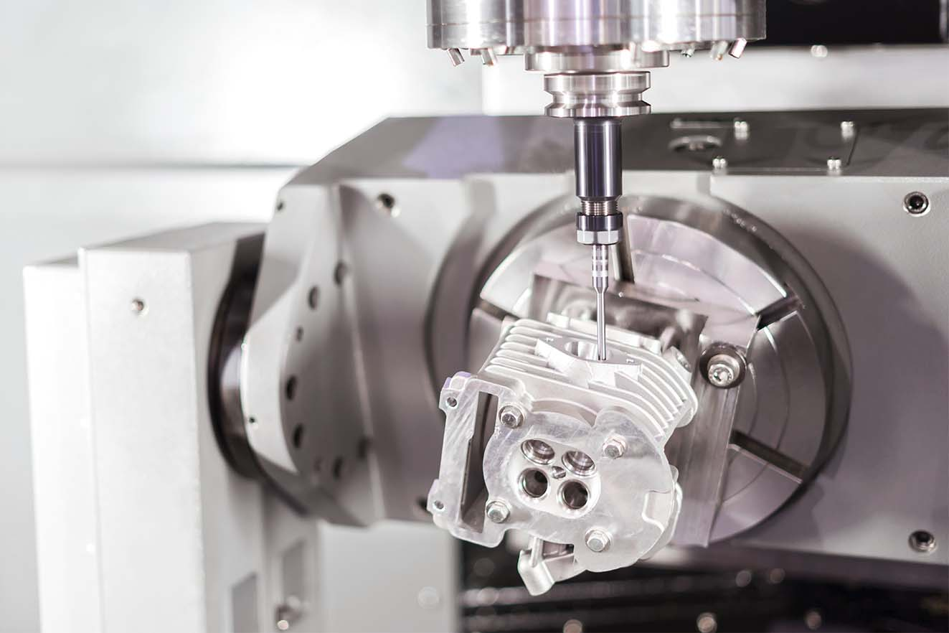

In the aerospace sector, machining processes often involve complex materials and intricate designs, which present unique challenges one of the major issues in machining aerospace components like impellers is tool chatter. This refers to the vibrations caused by the interaction of the tool and the material, particularly in complex titanium geometries. These vibrations can degrade the quality of the product and damage the tool (Lee et al., 2021).

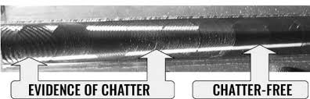

To address this, a Deep Reinforcement Learning (DRL) agent was developed using data from digital twins, which are virtual replicas of the physical machining processes. The DRL agent was able to predict and mitigate conditions leading to vibrations, effectively reducing them by 35% (Zhang et al., 2023).

The Implementation of DRL led to 20 percent reduction of machining in time and improved finish surface quality. These improvements not only enhance the efficiency of the production process but also the quality of the aerospace components produced.

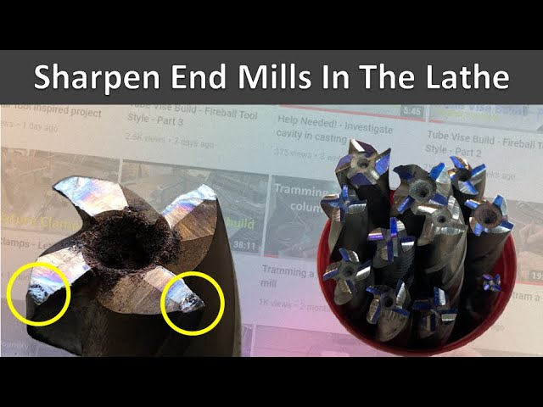

The automotive industry faces its own set of challenges, particularly in terms of cost management and production efficiency. significant cost factor in automotive manufacturing is the frequent need to replace tools during the machining of engine blocks, which can be quite expensive (Volkswagen, 2022). using Genetic Algorithms (GA) to optimize the tool paths for machining. The GAs was designed to balance tool wear and operational speed, thereby extending the life of the tools by 28% without sacrificing production efficiency (Müller et al., 2023). This optimization not only reduced the direct costs associated with tool replacement but also contributed to a more sustainable operation by minimizing waste and maximizing the use of materials and resources.

**Conclusion**

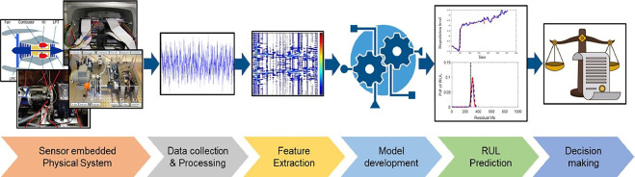

The use of artificial intelligence (AI) and machine learning (ML) in CNC tool path optimization marks a significant advancement in manufacturing, offering increased efficiency, accuracy, and cost-effectiveness. Various AI/ML methods such as neural networks, reinforcement learning, and genetic algorithms have proven effective in enhancing these processes. However, challenges hinder widespread adoption in industry. These include a lack of quality data, high computational costs, and the need for significant updates to existing CNC systems.

Despite these obstacles, innovative solutions like hybrid models and edge computing show potential by minimizing reliance on extensive computational infrastructure and central data processing, making AI more feasible for real-world manufacturing. Additionally, as AI automates more tasks, addressing ethical concerns and workforce impacts is crucial. Ensuring a responsible and inclusive transition to automated systems requires policy interventions and proactive measures.

**References**

* Chen, L., et al. (2021). "Tool Wear Prediction in CNC Milling Using Vibration Signals." Journal of Manufacturing Processes.
* García, R., et al. (2023). "Multi-Objective Optimization of Energy Consumption in CNC Milling." *Sustainable Manufacturing*.
* Huang, T., et al. (2021). "CNN-Based Tool Wear Monitoring in CNC Machines." *Mechatronics*.
* Kim, H., et al. (2021). "Q-Learning for Real-Time Feed Rate Optimization." *IEEE Transactions on Industrial Informatics*.
* Lee, S., et al. (2021). "DRL for 5-Axis Titanium Machining." *Aerospace Manufacturing*.
* Müller, F., et al. (2023). "GA-Optimized Tool Paths for Automotive Mass Production." *International Journal of AMT*.
* Nguyen, T., et al. (2022). "Hybrid GA-RL for Titanium Machining." *CIRP Annals*.
* Patel, R., et al. (2021). "Multi-Objective GA for Energy-Time Trade-offs." *Engineering Optimization*.
* Rajesh, P., et al. (2022). "RNN-Based Temporal Modelling in Machining." *Computers in Industry*.
* Singh, A., et al. (2023). "DRL for Tool Deflection Compensation." *Precision Engineering*.
* Smith, J., et al. (2021). "Global Trends in CNC Machining." International Journal of Production Research.
* Tang, W., et al. (2023). "Computational Challenges in GA for High-Dimensional Problems." *Applied Soft Computing*.
* Wang, H., et al. (2022). "Sensor-Driven Adaptive Tool Paths." *Sensors*.
* Wu, Y., et al. (2020). "Hybrid GA-NN for Faster Convergence." *Neural Computing and Applications*.
* Zhang, Y., et al. (2023). "Digital Twin-Enabled DRL for Aerospace Components." *Journal of Manufacturing Systems*.