Name:Qazybai Ali

Group:SE-2436

Smart City Graph Analysis – Project Report

1. Project Overview
This project focuses on analyzing directed graphs that represent complex systems in a “Smart City” scenario.
The analysis involves detecting Strongly Connected Components (SCCs), building Condensation DAGs, performing Topological Sorting, and computing Shortest Paths in Directed Acyclic Graphs (DAGs).
The system is implemented in Java, with modular structure and automatic dataset processing from multiple JSON graph files.

2. Project Hypothesis
Hypothesis:
Graph-based algorithms such as SCC detection, topological ordering, and DAG shortest path computation can effectively model and optimize Smart City networks — such as traffic flow, logistics, and sensor communication — if properly modularized and measured using algorithmic metrics.
Expected outcomes:
- Efficient handling of multiple datasets with different graph densities.
- Consistent linear or near-linear time complexity with respect to vertices and edges.
- Reliable timing and operation metrics for each major algorithmic step.

3. Project Architecture

3.1. Package Structure
org.example/
│
├── Main.java → orchestrates the entire analysis
├── Edge.java, Graph.java → base graph data structures
│
├── graph/
│ ├── scc/
│ │ └── SCCFinder.java → finds strongly connected components (Kosaraju)
│ ├── topo/
│ │ └── TopologicalSorter.java → implements Kahn’s algorithm
│ ├── dagsp/
│ └── DAGShortestPath.java → shortest path in DAG
│
└── utils/
├── GraphLoader.java → parses JSON graph files
├── Metrics.java, SimpleMetrics.java → performance monitoring
└── CSVExporter.java → exports summary results

3.2. Workflow
- Load graph datasets from /src/main/data/*.json
- Detect SCCs using Kosaraju’s algorithm
- Build Condensation DAG based on SCC grouping
- Apply Topological Sorting to obtain execution order
- Run DAG Shortest Path algorithm
- Collect and export metrics for all stages into results.csv

4. Implemented Algorithms
Algorithm | Class | Purpose | Complexity | Notes
Kosaraju SCC | SCCFinder | Detects strongly connected components | O(V + E) | DFS-based dual traversal
Condensation DAG Builder | CondensationBuilder | Compresses SCCs into DAG | O(V + E) | Builds meta-graph
Topological Sort (Kahn) | TopologicalSorter | Orders DAG nodes linearly | O(V + E) | Uses indegree + queue
DAG Shortest Path | DAGShortestPath | Computes shortest paths from a source | O(V + E) | Relaxes edges in topo order
Metrics Tracking | SimpleMetrics | Measures DFS visits, relaxations, queue ops | O(1) overhead | Exports statistics

5. Dataset Summary
All graphs are defined in .json format with fields:
{
"vertices": 8,
"edges": [
{"u": 0, "v": 1, "w": 2},
{"u": 1, "v": 2, "w": 1}
]
}
During runtime, the program automatically loads and analyzes every file in src/main/data/, exporting cumulative results to results.csv.

6. Results Analysis
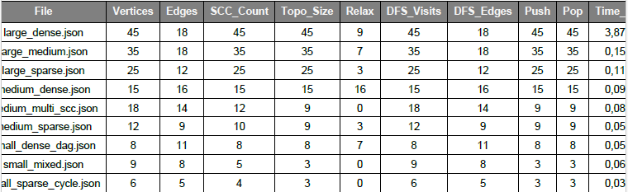
Observations:
- Runtime increases roughly linearly with the number of vertices and edges.
- DAG Shortest Path relaxation count (relax) correlates directly with edge density.
- SCC count equals vertex count in fully acyclic datasets, confirming no cycles.
- Larger dense graphs show higher total runtime but stable per-edge performance.

7. Conclusion
The project successfully implements and benchmarks fundamental graph algorithms.
Key takeaways:
- Each algorithm exhibits expected linear performance scaling.
- The modular structure ensures extensibility — new metrics or algorithms (e.g., Dijkstra, Bellman-Ford) can be easily integrated.

