CRAVE Counterfactual Value Learning for Budgeted Language Model Agents
  - Matched interventions and resource allocation in multihop question answering
Author names and affiliations to be supplied
Method and empirical pilot study October 2026

Abstract
Language model agents must allocate limited inference resources among reasoning, retrieval, verification, and termination. CRAVE learns policy-conditioned long-horizon action values through matched counterfactual branching from identical intermediate states. A frozen encoder and compact multilayer perceptron predict utility, eventual success, future resource costs, and auxiliary ordered interactions; a hard feasibility mask enforces output-token and tool limits. Training used four HotpotQA and MuSiQue tasks, two collection rounds, 156 matched branch records, and three stochastic continuations per intervention. An initial six-question feasibility pilot comprised 162 episodes. A subsequent frozen-controller test evaluated forty new questions, twenty each from HotpotQA and 2WikiMultiHopQA, with three seeds and four methods, producing 480 additional episodes. At a 512-token budget and utility weight 0.1, CRAVE achieved 55.0% and 43.3% exact match, compared with 50.0% and 46.7% for a confidence rule. CRAVE consumed 229.5 versus 51.2 and 249.7 versus 60.1 generated tokens. Its paired additional output cost was 178.3 tokens on HotpotQA and 189.6 on 2Wiki, with Holm-adjusted Monte Carlo permutation p = 0.0018 in both dataset cells. The paired accuracy differences were not significant after correction. No observed efficiency advantage over the confidence rule was established. Independent audits reconciled scores, resource counters, task partitions, and artifact identities, finding zero budget violations. Per-question figures expose cost variation and the limited concentration of accuracy differences. These are bounded, post-pilot results from raw benchmark subsets and a transductive passage pool. Full-data training, development selection, broad budget frontiers, faithful literature baselines, and cross-model validation remain unexecuted.
Keywords Language models; inference budgets; counterfactual branching; adaptive retrieval; verification; resource allocation

1 Introduction
A language model agent can often improve an answer by generating another reasoning step, retrieving a missing fact, or checking a candidate. Each operation also consumes resources and can introduce new errors. The practical allocation problem is therefore sequential: the usefulness of an action depends on what the agent already knows, what it has tried, and which resources remain. Retrieval-augmented generation combines parametric knowledge with external evidence [1], while ReAct interleaves reasoning and environment actions [2]. These capabilities create a choice about when and how much to use each resource.
Budget awareness and adaptive stopping already have substantial precedents. BudgetThinker conditions reasoning on remaining token capacity [3]. PUMA uses semantic redundancy and answer verification to identify candidate stopping points [4]. Confidence-based adaptive scaling couples confidence calibration with computation allocation [5]. TARG gates retrieval from a short retrieval-free draft [6]. These methods show that adaptive allocation is an established research area; adding a budget feature or a confidence threshold alone is insufficient to support a new contribution.
The specific question studied here is whether a small controller can learn a comparable long-horizon value for several heterogeneous actions at the same intermediate state. A retrieval step may not immediately produce an answer but may make the next reasoning step useful. Verification may preserve a correct answer or replace it with an incorrect one. Additional reasoning may use evidence effectively or repeat an existing conclusion. A controller trained only on immediate rewards can miss these delayed consequences. A controller trained on observed trajectories alone may lack outcomes for actions that its collector rarely selects.
CRAVE addresses these issues with controlled interventions within a fixed executor. For each recorded state, we restore the same state, force an eligible action, and execute a shared continuation policy. The resulting action values refer to that continuation policy and that executor. They are not policy-invariant causal effects or guaranteed values under the deployed controller. This distinction is central to the method and to the interpretation of its results.
This manuscript presents the formulation, implementation, training objectives, and observed results of a bounded pilot. The original feasibility pilot was deliberately small: four training tasks and six evaluation tasks. Its purpose is to establish that matched branching, learning, evaluation, and audit can run coherently on a local machine. Its main empirical finding is negative for efficiency: CRAVE matched the confidence baseline on answer accuracy and spent more generated tokens. The report retains this result rather than extrapolating favorable claims from the method design. A separate frozen-controller follow-up evaluates forty additional questions with a larger shared passage corpus; Section 7.6 reports that protocol and its results separately.

2 Related work

2.1 Budget control and stopping
BudgetThinker introduces control tokens and training procedures that make reasoning responsive to token limits [3]. PUMA identifies redundant reasoning and verifies proposed exits [4]. CAS uses calibrated confidence to allocate additional samples [5]. Their action families and supervision differ from CRAVE, but they constrain the novelty claim: reasoning length, answer readiness, and remaining budget are already useful allocation signals. The pilot confidence comparator is a fixed threshold rule over one candidate answer. It does not reproduce the calibration training and answer aggregation of CAS. Likewise, the implementation does not claim to reproduce the full PUMA protocol.

2.2 Retrieval and heterogeneous actions
TARG treats retrieval as a query-level decision derived from a no-context prefix [6]. DeepControl regulates information acquisition through retrieval continuation and granularity control [7]. Inference-Time Budget Control chooses search actions under token and tool limits using an operational value-of-information score and selective answer finalization [8]. These methods make adaptive information acquisition and heterogeneous budget accounting close prior work. CRAVE treats the retriever as a fixed module and asks how its estimated downstream return compares with reasoning, verification, and stopping at intermediate states.

2.3 Counterfactual tool boundaries
CoBRA learns the margin between internal and external tool-assisted experts using paired trajectories [9]. Its relevance is especially direct because the comparison is counterfactual and uses Qwen3-4B. CRAVE proposes repeated multi-action valuation within a trajectory, with common state restoration, explicit future resource costs, and auxiliary ordered interactions. This is a methodological distinction, not evidence that CRAVE outperforms CoBRA. None of these official systems was reproduced or evaluated in the completed pilot. Establishing comparative novelty and performance requires faithful implementations under a matched protocol.

2.4 Adaptive computation and sequential learning
Adaptive Computation Time learns how many recurrent computation steps to use [16], and PonderNet learns an adaptive halting distribution [17]. These establish learned computation allocation as an older principle. CRAVE applies value estimation to externally executed reasoning and tool actions while retaining a frozen language backbone. It does not learn an internal halting mechanism or reduce backbone training cost. Self-consistency samples multiple reasoning paths and aggregates their answers [20]; this is a distinct way to spend inference computation. The implemented confidence rule does not perform that aggregation, so these results do not compare CRAVE with self-consistency.
DAgger addresses the shift between training states and states induced by a learned sequential policy through iterative data aggregation [18]. CRAVE shares the motivation for collecting states under a changing controller, but its two collection rounds supervise branch returns under the same fixed continuation μ0. This procedure does not inherit DAgger guarantees and does not remove the mismatch between label continuation and deployment policy.

2.5 Retrieval context and uncertainty
Self-RAG trains a language model to retrieve and critique using reflection tokens [19]. CRAVE instead trains a separate small value controller over a frozen language model and retriever. Lost in the Middle shows that access to relevant long-context information need not ensure its effective use [21]. This distinction matters here because passage-title recall and answer correctness measure different parts of the system; the retrieval proxy cannot establish reasoning success.
Calibration concerns whether numerical confidence corresponds to correctness frequency [22]. Semantic entropy estimates uncertainty over meanings across sampled generations [23]. CRAVE uses a single verbalized confidence field and summary similarity as inexpensive monitoring features. Neither feature implements semantic entropy or establishes calibrated uncertainty, and the finite-K diagnostic proportions cannot replace a sufficiently sampled calibration study.

3 Sequential resource allocation

3.1 Observable state and actions
The executor maintains the query x, bounded public summaries H, retrieved evidence E, a verification record V, monitoring features m, and remaining budget b. The observable state at step t is
$s_{t} = (x, H_{t}, E_{t}, V_{t}, m_{t}, b_{t})$ (1)
The action set is A = {THINK, RETRIEVE, VERIFY, STOP}. THINK generates a candidate and a short public summary. RETRIEVE obtains additional passages. VERIFY checks the current candidate against available evidence using a separate instruction to the same model. STOP returns the current candidate without another answer-generation call. Verification has a distinct prompt, but its errors need not be independent of reasoning errors because the backbone is shared.
Summaries and capped evidence are lossy representations of an evolving interaction. We therefore use an observable-state control formulation; we do not prove that the representation is a sufficient Markov statistic. The environment is finite because hard resource limits and a maximum of twelve nonterminal steps bound each rollout; an additional STOP action can terminate at that limit. STOP is always eligible and can return an empty candidate; an empty output scores zero under the answer metric.

3.2 Hard feasibility and actual consumption
The feasibility mask reserves the maximum output cost of an action before execution. THINK requires at least 256 available generated tokens. VERIFY requires 192 tokens, one verification call, and a nonempty candidate. RETRIEVE requires one available retrieval call. STOP has no generated-token or tool reservation. The eligibility condition is
$A_{f}(s) = \{a ∈ A : r_{j}(a) ≤ b_{\text{t,j}}, ∀ j ∈ J\}$ (2)
Here J indexes the three hard constraints: output tokens, retrieval calls, and verification calls. The reservation rⱼ(a) is the maximum resource requirement used by the feasibility mask.
The executor deducts actual generation counts after an eligible call completes. Reserving the upper bound is conservative: a short likely response can still be masked when fewer than 256 or 192 tokens remain. This restriction guarantees the implemented output-token cap without relying on a prediction of response length. It also changes the attainable frontier and must be shared across comparable methods. Input tokens and admitted context tokens are recorded separately and are not deducted from the pilot hard output budget.
The executed budget was 512 generated tokens, one retrieval call, and one verification call per task. Latency was measured but not enforced as a hard deadline. A certified timeout executor would be required for a hard latency guarantee; the current environment explicitly rejects configurations that request one. Thus, the pilot does not implement every budget dimension of the broader proposed study.

3.3 Utility and the policy conditioned estimand
The terminal reward R is normalized answer exact match. Future cost includes all output tokens, retrieval calls, verification calls, and measured seconds from the intervention to termination. Reference scales were fixed before evaluation at 4096 tokens, four retrieval calls, two verification calls, and sixty seconds. For a continuation trajectory τ, the scalar utility is
$U_{λ}(τ) = R − λ (C_{\text{tok}}/4096 + C_{\text{ret}}/4 + C_{\text{ver}}/2 + C_{\text{lat}}/60)$ (3)
The action value is the expected utility after forcing action a from restored state s and then using continuation policy μ:
$Q^{μ}(s, a; λ) = E[U_{λ}(τ) | s, a, μ]$ (4)
Returns are undiscounted. The cost is return-to-go, so an initially inexpensive action can receive a poor value if it induces expensive unsuccessful continuation. Conversely, an action with no immediate reward can receive value through a later correct answer. The stop value reflects the current candidate and the small measured stop overhead. No reward model or deployment-time access to gold answers is used.

4 Matched counterfactual branching

4.1 Restoration and randomized continuations
A checkpoint serializes the complete observable state, resource counters, seed, step, and action log. Its content hash is verified on restoration. For each eligible intervention, the executor restores a fresh copy and checks equality with the pre-intervention checkpoint before assigning a randomized branch seed. Each replicate uses a seed derived from the recorded checkpoint hash, collector seed, and replicate index. Replicate seeds are common across alternative actions at that checkpoint, reducing unnecessary differences in randomization.
The base backend receives an explicit, stateless prompt. Its internal token cache can accelerate repeated prefixes, but it does not add conversation information beyond that prompt. The inference state contains no gold answer, aliases, supporting-fact annotations, reward, or oracle action. Such fields remain in offline scorer records. Visited states are saved before their branches are generated, so resumption reuses the recorded intervention state instead of creating a new state with slightly different measured timing.
For K stochastic continuations, the empirical target is
${Q̂}^{μ}(s, a; λ) = (1/K) ∑_{\text{k=1,…,K}} U_{λ}(τ_{k}(s, a; μ))$ (5)
K was fixed at three for this pilot. A completed stability study would compare this choice with larger K on development tasks. Sample utility means, success means, and normalized cost means are targets; they are noisy estimates rather than exact values. Checkpoint identity is necessary for the matched interpretation, but it does not eliminate sampling variance or the dependence on μ.

4.2 Label policy and visitation aggregation
The bootstrap continuation μ0 assigns weights 0.35 to THINK, 0.35 to RETRIEVE, 0.20 to VERIFY, and 0.10 to STOP, renormalized over eligible actions. The STOP weight is reduced to 0.02 when no candidate exists. Policy randomness is reproducible from the state seed and step. The same μ0 was used to generate branch labels in both collection rounds.
Round one visits the initial state and a state after THINK for each training task. A controller fitted to these labels then influences round-two visitation through a mixture that selects μ0 with probability 0.3 and the learned controller otherwise. A terminal decision can leave only an initial recorded state. The observed state counts were eight in round one and seven in round two. Changing visitation while keeping the label continuation fixed avoids silently changing the value estimand between rounds.
The pilot produced 156 matched branch records and 111 records from naturally selected observational trajectories. Records from ordered pairs and empty interventions are included in the branch total. These counts are not 156 independent training tasks: the underlying questions number four, and several branches share a checkpoint and common replicate seeds. All learned controllers were trained only on training-split records.

4.3 Ordered interactions
To examine complementary actions, the branch machinery can force a feasible ordered pair, such as retrieval followed by reasoning, and compare its continuation utility with single-action and empty-intervention utilities:
$I^{μ}(s, a→b; λ) = J^{μ}(a→b) − J^{μ}(a) − J^{μ}(b) + J^{μ}(∅)$ (6)
Jμ(z) denotes expected utility at the same state and utility weight after forcing the sequence z and then following μ. The empty sequence ∅ proceeds directly with μ without a forced action. Single-action J values coincide with the corresponding policy-conditioned Q values.
Only replicate indices shared by all four intervention families enter the contrast. An ordered pair that becomes infeasible is excluded for the affected sequence. These contrasts depend on the continuation regime and on feasibility; they are not additive decompositions of a trajectory reward. The controller uses them as auxiliary shared-trunk supervision. They are not added again to the selected Q value, because the single-action return-to-go already includes downstream consequences. Interaction supervision was limited to one selected checkpoint per collection round, so broad complementarity claims are untested.

5 Controller architecture and optimization

5.1 Features and prediction heads
The frozen all-MiniLM-L6-v2 encoder supplies 384-dimensional masked-mean-pooled and L2-normalized vectors [14]. Four vectors encode the query, the last three public summaries, accumulated evidence, and the candidate together with verification text. Encoder inputs are truncated at 256 tokens. Thirteen scalar features represent normalized remaining token, retrieval, and verification budgets; raw verbalized confidence; semantic convergence; evidence sufficiency; retrieval novelty; normalized step; utility weight λ; and a four-way previous-action indicator. The resulting input dimension is 1549.
Confidence is the bounded value verbalized by the base model, not a calibrated probability. Convergence is summary embedding similarity. Novelty compares the embeddings of previous evidence and newly admitted evidence. Evidence sufficiency uses the bounded model support signal and is zero in the absence of evidence. These inexpensive proxies are operational definitions rather than validated measures of latent uncertainty or factual support.
A two-hidden-layer ReLU multilayer perceptron has widths 512 and 256 and forty outputs. For each of four actions, six outputs encode Q, a success logit, and four future-cost logits. The success output is transformed by a sigmoid, and costs by softplus. Sixteen additional outputs represent ordered interaction contrasts. The base language model and encoder remain frozen; controller training uses NumPy analytic gradients and Adam on the CPU.

5.2 Joint supervision
The Q head uses Huber loss. The success head uses squared error against finite-K success proportions. Each resource head uses Huber loss against its normalized future cost. A pairwise logistic objective encourages ordering of actions with unequal empirical Q targets. Observed-target ties within 10⁻⁶ are excluded from the ranking objective. The overall pilot objective is
$L = L_{Q} + 0.25 L_{\text{cost}} + 0.25 L_{\text{success}} + 0.25 L_{\text{rank}} + 0.25 L_{\text{interaction}}$ (7)
The pairwise logistic loss has the form log(1 + exp(d)) − y d, where d is the predicted action-value difference divided by temperature 0.1 and y indicates which empirical target is larger. The four auxiliary weights were fixed at 0.25. Adam used learning rate 0.001, batch size 64, one hundred epochs, gradient norm cap five, and seeds 17, 29, and 43. These defaults were not selected through development optimization.
The training utility weights were 0, 0.05, 0.1, 0.25, 0.5, and 1.0. This gives the value predictor an explicit preference input, but it does not establish successful interpolation or generalization across preferences. Deployment evaluation used only λ = 0.1. A broad preference frontier cannot be inferred from this single operating point.

5.3 Feasible action selection
The deployed controller chooses the largest predicted Q among eligible actions:
$π_{θ}(s; λ) = {\text{arg max}}_{a ∈ A_{f}(s)} Q_{θ}(s, a; λ)$ (8)
The feasibility mask provides resource compliance independently of model prediction quality. A poor value estimate can still select a wasteful eligible action or stop too early. The successful budget audit therefore validates accounting and masking; it does not validate the learned allocation policy. Controller time is included in recorded latency, and LLM routing output is included in the output-token counter for the routing baseline.
Figure 1 separates offline supervision from online action selection. Gold answers enter only the offline scoring path. Deployment uses public state features, learned action values, and the hard feasibility mask; auxiliary interaction heads provide training supervision rather than additional utility bonuses.
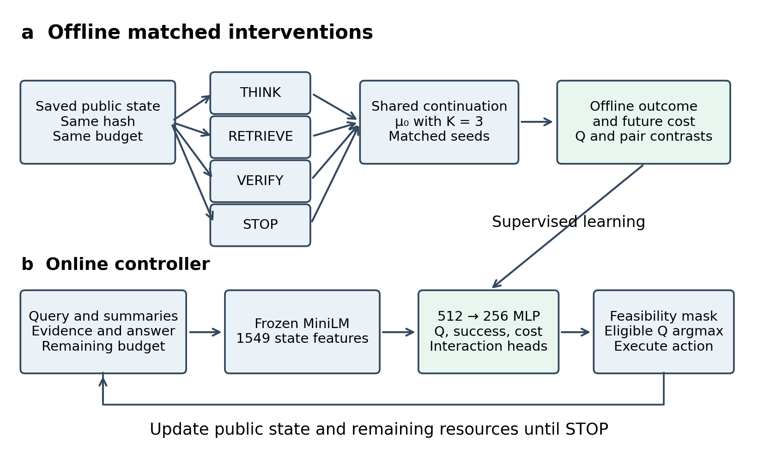
Figure 1 CRAVE training and deployment. Eligible actions share the saved state and matched continuation seeds. Offline outcomes supervise the controller. Deployment uses a frozen backbone and encoder with a hard feasibility mask. This is an algorithm schematic.

6 Experimental protocol

6.1 Data and split boundaries
HotpotQA supports multi-document factual and comparison questions with supporting facts [10]. MuSiQue composes connected single-hop questions into multihop tasks [11]. 2WikiMultiHopQA supplies reasoning-oriented questions and structured evidence [12]. The original feasibility run used small first-record subsets, rather than random samples or full benchmark releases. They were chosen before model evaluation to make execution and audit feasible.
Table 1 Disjoint tasks and their executed roles
Dataset | Training | Reserved development | Original pilot | Expanded test
HotpotQA | 2 | 6 | 3 | 20
MuSiQue raw export | 2 | 6 | 0 | 0
2Wiki raw export | 0 | 0 | 3 | 20
Total | 4 | 12 | 6 | 40

The expanded test was selected separately after the original pilot. Its forty questions are disjoint from the other roles in Table 1; Section 7.6 provides the frozen selection and evaluation protocol.
HotpotQA records were obtained through the public dataset-server representation of the HotpotQA distractor data. MuSiQue training and development records, and 2Wiki development records, came from public raw exports linked by the MuSiQue authors. The subset files retain URLs and checksums. These raw exports are not asserted to be identical to complete official release files. The exact linkage between the dataset-server snapshot and the recorded repository revision also requires further verification for a definitive study.
Task IDs, normalized questions, and available component-question identifiers were checked across partitions. The reserved development set was not used for threshold, K, hyperparameter, or loss-weight tuning in this run. The six evaluation tasks were excluded from learning and label aggregation. The 2Wiki tasks were absent from controller training, but this narrow transfer check does not establish out-of-domain robustness.

6.2 Executor and corpus
All compared policies use the official Qwen3-4B Q4_K_M GGUF checkpoint through llama.cpp release b11146 [13, 15]. Sampling uses temperature 0.7, top-p 0.8, and top-k 20. The executor requests bounded structured answers and public summaries in non-thinking mode. THINK permits at most 256 output tokens and VERIFY at most 192. This practical operation differs from unconstrained hidden-chain-of-thought continuation; results apply to this specified executor.
The original feasibility corpus pools all 300 unique passages supplied by the selected training, development, and evaluation records, without reading supporting-fact flags or answers during corpus construction. Retrieval combines BM25 and frozen dense cosine rankings with reciprocal rank fusion constant sixty. Each RETRIEVE returns up to five documents. Newly admitted passages are capped at 280 tokens each and total added evidence at 1400 tokens. The query uses the question and the most recent available summary.
Pooling supplied evaluation passages is a transductive benchmark-context setting. It is substantially easier and smaller than open retrieval over a full Wikipedia snapshot. The same pool is available to every policy, but corpus availability still limits external validity. The separate support-title evaluation reads gold annotations only after retrieval and never sends them to the agent.

6.3 Comparators and ablations
The fixed schedule requests RETRIEVE, THINK, VERIFY, THINK, and STOP, skipping masked actions. The confidence rule retrieves when no evidence exists, reasons while resources permit, and stops when a candidate has verbalized confidence at least 0.8. The LLM router uses the same backbone to select a permitted action in at most twenty-four output tokens; it reserves routing cost before executing that action. These are transparent in-house controls, not reproductions of named literature systems.
Table 2 Executed controller variants
Label | Change relative to CRAVE
CRAVE | Matched long-horizon values with joint auxiliary objectives
−CF | Observed on-policy trajectory targets instead of alternate-action labels; interaction objective disabled
−RTG | Immediate reward and immediate resource cost targets; interaction objective disabled
−Interaction | Remove ordered interaction supervision
−Budget | Zero the remaining-budget scalar features; retain the external feasibility mask
Myopic alias | Same implemented learner as −RTG; duplicate comparator label

The −CF comparison differs in action coverage and target quantity, not only in the presence of counterfactual labels. It therefore cannot isolate a clean causal-supervision effect. Myopic and −RTG have identical implementations and should not be counted as independent supporting experiments. The remaining proposed feature ablations, shuffled costs, independent-value baseline, and official TARG, PUMA, CAS, DeepControl, Budget Control, CoBRA, CATS, ATLAS, and LIMBO comparisons were not run.

6.4 Metrics and statistical unit
Answer exact match and token F1 use normalized strings and available aliases. For the raw exports, equivalence to each released benchmark evaluator and its complete alias mapping has not been established. Thus, the reported scores are pilot normalized answer metrics, not official leaderboard scores. Supporting-fact exact match or F1 is not reported as a task outcome.
Results average the three seeds within each question before averaging questions. Bootstrap intervals resample task clusters with ten thousand draws. Paired tests operate on task-level differences and use exact sign permutations for these three-question dataset cells. Holm correction was applied across twenty-eight exploratory dataset, comparator, and metric comparisons. Seeds and episode rows are not treated as independent questions. With three task clusters per dataset, inferential resolution is extremely coarse. The resampling framework follows the bootstrap principle [24], and the multiple-test adjustment follows Holm [25].
Raw output, input, and total tokens; retrieval and verification calls; logical latency; controller latency; and normalized composite cost are recorded. Cached generation results retain their original observed model latency for logical accounting, while physical request counts record work actually performed. Encoder caching, slot behavior, and action overhead prevent these logical times from being interpreted as a standardized cold end-to-end latency benchmark.

7 Results

7.1 Answer quality and generated output cost
Table 3 contains every executed method label at the single deployment setting. Each cell averages three seeds on three task clusters. CRAVE obtained exact match 0.3333 on HotpotQA and 0.6667 on 2Wiki. The confidence rule and fixed schedule obtained the same exact match. F1 equaled exact match for every method in this pilot. The LLM router returned no correct HotpotQA answers but matched the other retrieval policies on 2Wiki.
Table 3 Mean exact match and generated output tokens at a budget of 512 and utility weight 0.1
Method | Hotpot EM percent | Hotpot output tokens | 2Wiki EM percent | 2Wiki output tokens
CRAVE | 33.3 | 207.3 | 66.7 | 262.6
Confidence rule | 33.3 | 62.4 | 66.7 | 51.3
Fixed schedule | 33.3 | 211.9 | 66.7 | 192.0
LLM router | 0.0 | 53.9 | 66.7 | 76.3
-CF | 33.3 | 192.3 | 66.7 | 115.3
-RTG | 0.0 | 9.2 | 0.0 | 18.2
-Interaction | 33.3 | 163.8 | 66.7 | 262.6
-Budget | 33.3 | 182.4 | 66.7 | 237.7
Myopic alias | 0.0 | 9.2 | 0.0 | 18.2

CRAVE used 207.3 generated tokens per HotpotQA task compared with 62.4 for the confidence rule, and 262.6 per 2Wiki task compared with 51.3. These ratios are approximately 3.32 and 5.11. The confidence rule therefore attained the same observed answer quality with lower output consumption in both dataset cells. No efficiency gain over that comparator is visible at the evaluated setting. This observation does not prove that the method cannot improve with adequate training or a different prespecified setting.
Each nonzero accuracy cell has a task-bootstrap 95% interval spanning 0% to 100%. This reflects the small number of task clusters and the coarse binary outcomes. The paired accuracy difference between CRAVE and the confidence rule is exactly zero on the observed questions, giving a degenerate [0, 0] bootstrap interval for that difference. Neither interval addresses representativeness of first-record samples.

7.2 Resource accounting
Table 4 Raw resource usage for the principal controls
Dataset | Method | Input tokens | Total tokens | Verify calls | Logical seconds
Hotpot | CRAVE | 4444.7 | 4652.0 | 0.00 | 8.88
Hotpot | Confidence rule | 1159.0 | 1221.4 | 0.00 | 3.82
Hotpot | Fixed schedule | 3662.6 | 3874.4 | 1.00 | 8.20
Hotpot | LLM router | 2492.4 | 2546.3 | 0.00 | 5.50
2Wiki | CRAVE | 5906.0 | 6168.6 | 0.00 | 11.64
2Wiki | Confidence rule | 1059.0 | 1110.3 | 0.00 | 2.89
2Wiki | Fixed schedule | 3354.3 | 3546.3 | 1.00 | 9.63
2Wiki | LLM router | 3334.6 | 3410.9 | 0.00 | 6.37

Every principal control made one retrieval call per task on average. The fixed schedule made one verification call, whereas CRAVE, the confidence rule, and the LLM router made none. Input consumption was also higher for CRAVE than for the confidence rule: 4444.7 versus 1159.0 tokens on HotpotQA and 5906.0 versus 1059.0 on 2Wiki. Thus, the output-budget comparison does not conceal a compensating input-token advantage for CRAVE.
CRAVE logical latency averaged 8.88 seconds on HotpotQA and 11.64 seconds on 2Wiki, compared with 3.82 and 2.89 seconds for the confidence rule. Its controller component averaged 0.198 and 0.223 seconds. The LLM router controller averaged 2.623 and 3.453 seconds. These values include the stated cache accounting convention and are descriptive measurements of this execution, not controlled deployment latency claims.
The complete invocation executed 668 physical model requests and generated 32,184 physical output tokens. Recorded physical generation time was 1182.4 seconds and invocation time 1619.3 seconds, or about 27.0 minutes. Logical evaluation output totaled 20,941 tokens; logical branch return-to-go output totaled 19,266. The latter count overlaps cached computations and is not the physical training cost. Downloads, earlier component checks, and the backend smoke check are outside this invocation account. Monetary and energy costs were not measured.

7.3 Paired exploratory comparisons
Table 5 CRAVE minus confidence rule on task-level paired observations
Dataset | Metric | Difference | 95 percent interval | Raw p | Holm p
Hotpot | EM | 0.0000 | [0.0000, 0.0000] | 1.00 | 1.00
Hotpot | Normalized cost | 0.1197 | [0.1041, 0.1350] | 0.25 | 1.00
2Wiki | EM | 0.0000 | [0.0000, 0.0000] | 1.00 | 1.00
2Wiki | Normalized cost | 0.1975 | [0.1434, 0.2531] | 0.25 | 1.00

The normalized cost difference favors the confidence rule in both cells. Its bootstrap interval excludes zero on these observed first-record tasks, but the exact sign-permutation p value is 0.25. All twenty-eight Holm-adjusted p values equal 1.0. We therefore make no significance claim, no superiority claim, and no rejection of a broader research hypothesis. Resampling and correction cannot compensate for three task clusters or deterministic first-record selection.

7.4 Held-out value diagnostics
A separate analytical oracle branched from three held-out HotpotQA states after THINK, with K = 3 under μ0. Oracle labels were used only for diagnostics. Table 6 averages seed-level summaries at λ = 0.1. Regret is the finite-K empirical maximum utility minus the empirical utility of the action preferred by the learned Q head. Top-one agreement uses the same empirical maximum and its deterministic tie handling.
Table 6 Finite K held-out action-value diagnostics on three states
Method | Regret | Top one percent | Q RMSE | Success MSE | Success ECE
CRAVE | 0.0409 | 44.4 | 0.2286 | 0.0929 | 0.2864
-CF | 0.0652 | 11.1 | 0.2230 | 0.1216 | 0.2710
-RTG | 0.0000 | 100.0 | 0.2004 | 0.0258 | 0.1554
-Interaction | 0.0226 | 66.7 | 0.2327 | 0.0918 | 0.2839
-Budget | 0.0305 | 55.6 | 0.2190 | 0.0833 | 0.2715

CRAVE mean regret was 0.0409, lower than −CF at 0.0652 but higher than −RTG at 0.0000 and −Interaction at 0.0226. Its top-one agreement was 44.4%. This pattern does not establish the intended return-to-go or interaction advantages. Indeed, the immediate-target model agrees with the empirical oracle on these states despite having zero answer accuracy in deployment. The diagnostic states have little measured opportunity for a successful continuation, so preferring inexpensive termination can score well in that limited diagnostic. Local oracle agreement and full task performance answer different questions.
The success MSE is measured against finite-K success proportions, not individual Bernoulli outcomes. It omits the irreducible within-action success variance that an ordinary per-outcome Brier score would include. ECE likewise bins predictions against noisy finite-K proportions. These descriptive calibration proxies must not be reported as unbiased population calibration estimates. With K = 3, empirical utility maxima can be optimistic and action rankings unstable.

7.5 Retrieval component check
An independent question-only retrieval check evaluated top-five support-title coverage on the same pooled corpus. It included eleven HotpotQA tasks, eight MuSiQue tasks, and three 2Wiki tasks across their pilot roles. Gold support labels were consulted only by the offline evaluator. This component check did not change retrieval settings and did not supply targets to the deployed policy.
Table 7 Support-title recall in the separate retrieval component check
Dataset | Tasks | Recall percent | 95 percent interval | All titles percent
2WikiMultiHopQA | 3 | 83.3 | [50.0, 100.0] | 66.7
HotpotQA | 11 | 77.3 | [63.6, 90.9] | 54.5
MuSiQue | 8 | 62.5 | [50.0, 81.2] | 25.0

Mean support-title recall was 77.3% on HotpotQA, 62.5% on MuSiQue, and 83.3% on 2Wiki. All required support titles were retrieved for 54.5%, 25.0%, and 66.7% of tasks, respectively. A title match can conflate passages and does not verify that the relevant sentence was retained after token truncation. These values are a retrieval proxy, not official support-fact scores or evidence that the agent answered correctly.

7.6 Expanded frozen controller evaluation
After inspecting the feasibility pilot, we froze an expanded evaluation with twenty new HotpotQA questions and twenty new 2Wiki questions. A NumPy generator with seed 20261005 sampled without replacement from 131 eligible HotpotQA and 125 eligible 2Wiki candidates. IDs, normalized question strings, and available component-question identifiers were disjoint from training, reserved development, and the original evaluation. The candidate pools were bounded public exports: the original forty HotpotQA validation records plus one hundred additional dataset-server records at offset forty, and the first 128 records of the author-linked 2Wiki development raw export. This procedure randomizes selection within those pools; it does not establish a probability sample of a complete benchmark release.
The original CRAVE checkpoints for seeds 17, 29, and 43 were loaded without retraining. The confidence threshold, backbone, action definitions, 512 generated-token budget, one retrieval and one verification allowance, and deployment λ = 0.1 were unchanged. CRAVE, confidence, the fixed schedule, and the LLM router shared a 687-passage corpus constructed without answer labels from the original partitions and new question contexts. The larger corpus and new question set distinguish this protocol from the original pilot; the two result sets are not pooled into one estimate. No additional ablations or held-out value-oracle states were collected in this follow-up.
The test completed 480 episodes: forty questions multiplied by three seeds and four methods. Seeds were averaged within question before task-cluster bootstrap intervals were computed using ten thousand resamples. Paired comparisons used ten thousand random sign permutations with an add-one correction [26], because each dataset has twenty clusters. Holm correction covered a separate family of eighteen exploratory tests: two datasets, three comparators, and exact match, generated tokens, and normalized cost. This post-pilot follow-up was motivated by the earlier observations and is not presented as an independently preregistered confirmatory study.
Table 8 Expanded test means and 95 percent task-cluster intervals
Dataset | Method | EM percent [CI] | F1 percent | Output tokens [CI]
Hotpot | CRAVE | 55.0 [35.0, 75.0] | 62.8 | 229.5 [202.0, 253.4]
Hotpot | Confidence | 50.0 [30.0, 70.0] | 60.3 | 51.2 [47.4, 54.9]
Hotpot | Fixed | 53.3 [31.7, 75.0] | 62.0 | 172.9 [162.2, 183.9]
Hotpot | LLM router | 33.3 [13.3, 53.3] | 38.9 | 63.5 [48.7, 80.8]
2Wiki | CRAVE | 43.3 [23.3, 63.3] | 49.4 | 249.7 [230.8, 266.7]
2Wiki | Confidence | 46.7 [25.0, 66.7] | 50.0 | 60.1 [49.8, 72.0]
2Wiki | Fixed | 45.0 [25.0, 65.0] | 50.1 | 191.2 [172.3, 210.6]
2Wiki | LLM router | 38.3 [18.3, 58.3] | 42.0 | 80.5 [66.7, 96.4]

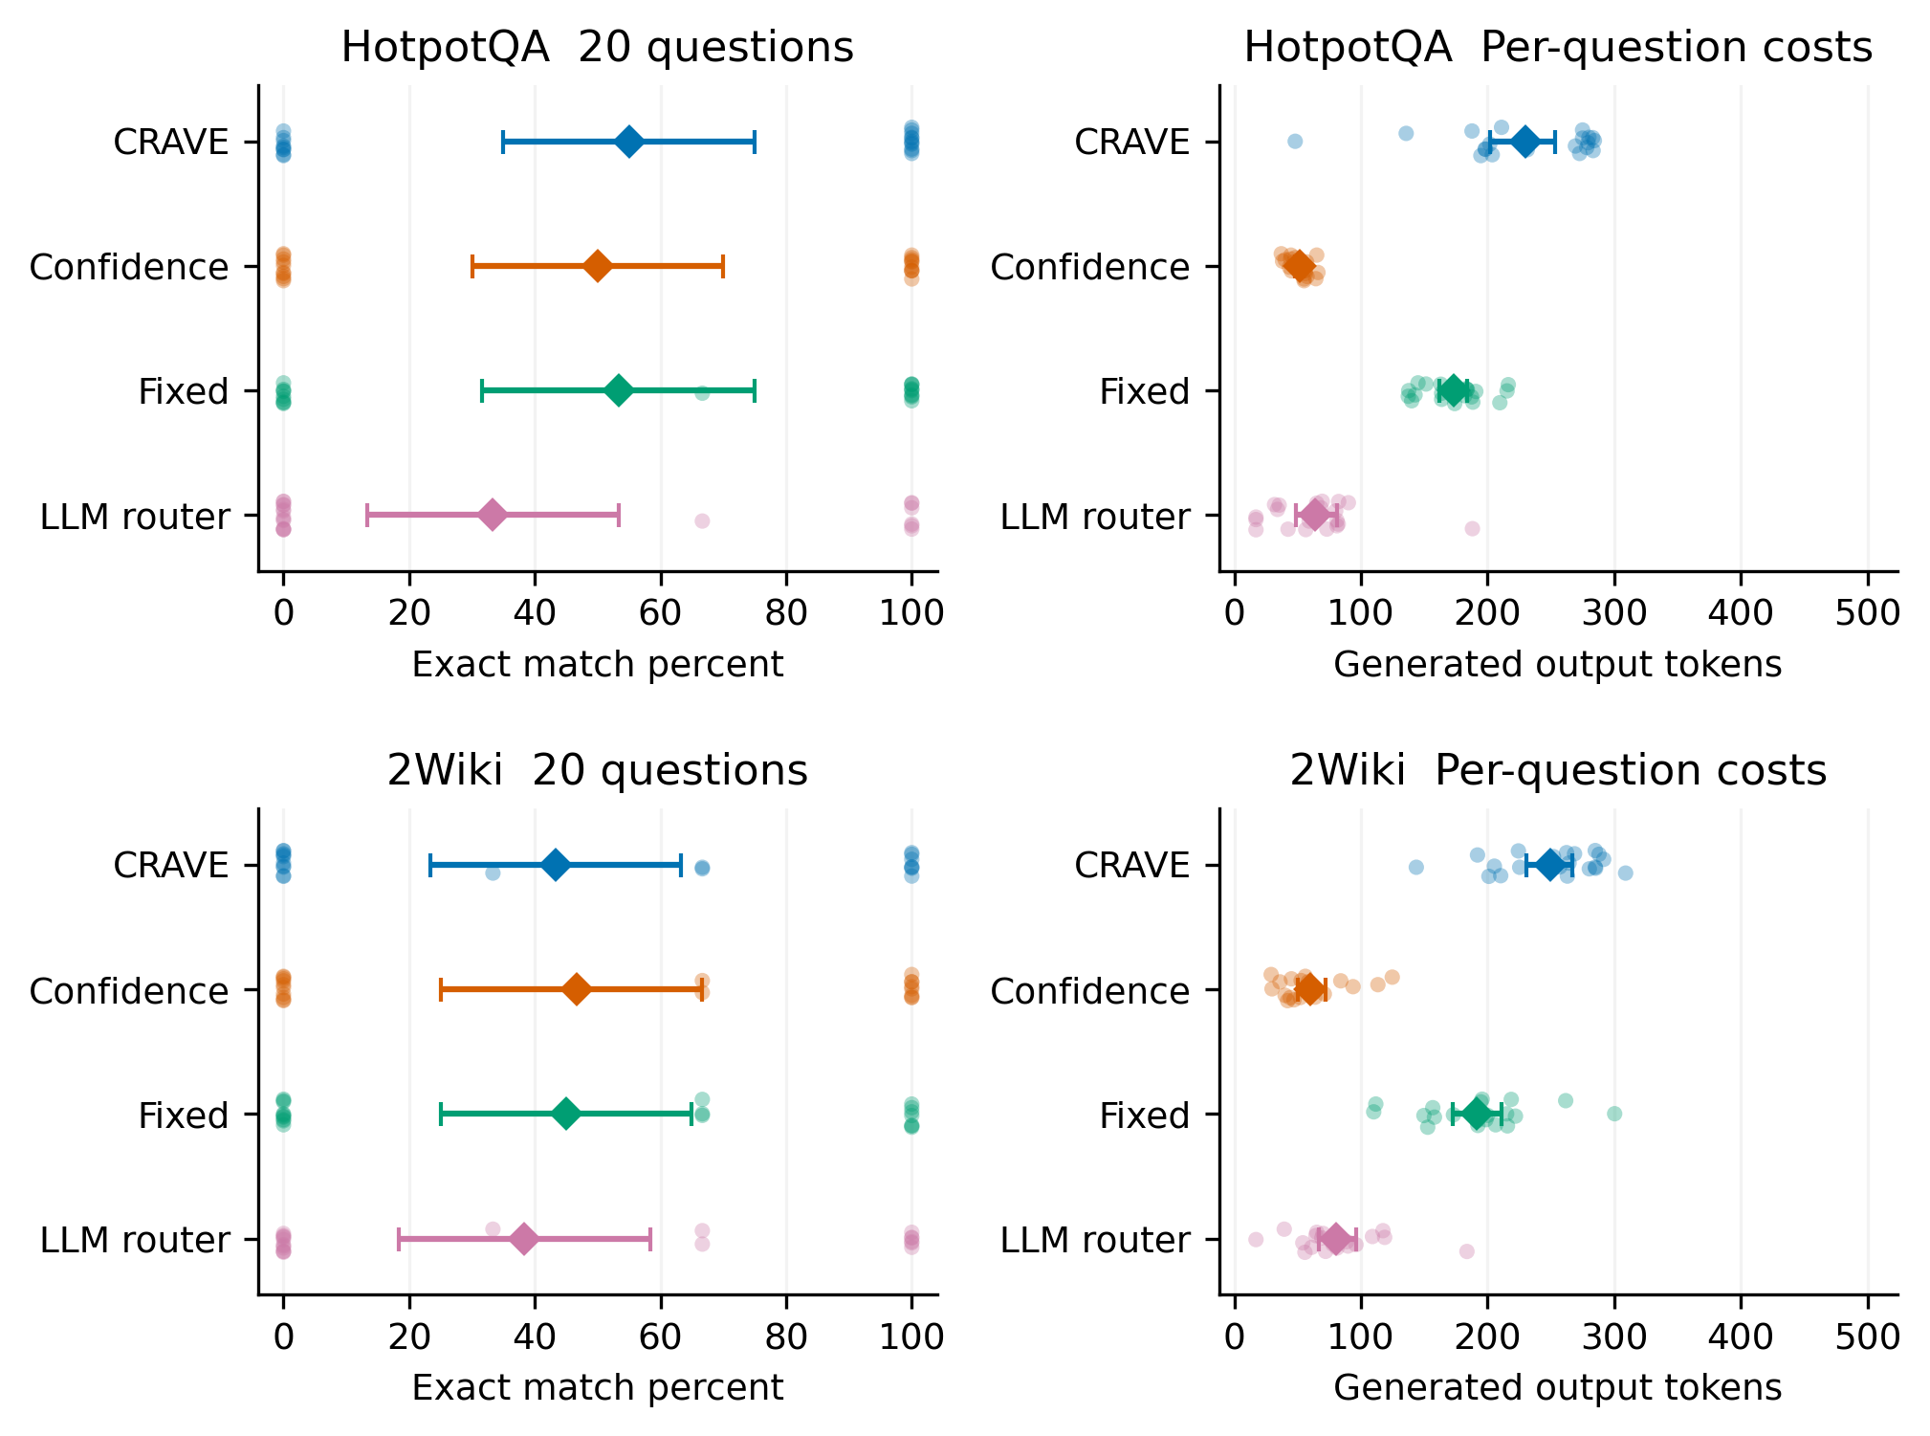
Figure 2 Expanded held-out test with twenty independent question clusters per dataset. Faint points are question-level observations after averaging the three seeds; diamonds are method means and horizontal bars are 95% task-cluster bootstrap intervals. The generated-token axis includes routing output. The points describe one deployment setting, not a budget frontier.
CRAVE exact match increased from 50.0% to 55.0% relative to confidence on HotpotQA, and decreased from 46.7% to 43.3% on 2Wiki. Its F1 was 62.8% and 49.4%, versus 60.3% and 50.0% for confidence. The paired accuracy differences were +5.0 percentage points with a [0.0, 15.0] interval on HotpotQA and −3.3 points with a [−10.0, 0.0] interval on 2Wiki. Both Holm-adjusted accuracy p values were 1.0. The descriptive point estimates therefore do not establish an accuracy improvement over confidence.
CRAVE generated 229.5 versus 51.2 tokens on HotpotQA and 249.7 versus 60.1 on 2Wiki, approximately 4.48 and 4.16 times the confidence rule. Paired additional output was 178.3 [149.1, 203.9] and 189.6 [165.9, 211.4] tokens, respectively. Both Holm-adjusted output-cost p values were 0.0018. These exploratory tests support a consistent output-cost increase in the selected pools, while broad benchmark representativeness and favorable quality-cost tradeoffs remain unestablished.
Table 9 Expanded paired comparisons with CRAVE minus each control
Dataset | Control | Metric | Difference | 95 percent interval | Holm p
Hotpot | Confidence | EM points | 5.0 | [0.0, 15.0] | 1.0000
Hotpot | Confidence | Output tokens | 178.3 | [149.1, 203.9] | 0.0018
Hotpot | Fixed | EM points | 1.7 | [0.0, 5.0] | 1.0000
Hotpot | Fixed | Output tokens | 56.6 | [24.3, 86.3] | 0.0369
Hotpot | LLM router | EM points | 21.7 | [5.0, 40.0] | 0.3582
Hotpot | LLM router | Output tokens | 166.0 | [130.2, 198.3] | 0.0018
2Wiki | Confidence | EM points | -3.3 | [-10.0, 0.0] | 1.0000
2Wiki | Confidence | Output tokens | 189.6 | [165.9, 211.4] | 0.0018
2Wiki | Fixed | EM points | -1.7 | [-5.0, 0.0] | 1.0000
2Wiki | Fixed | Output tokens | 58.5 | [31.4, 85.2] | 0.0060
2Wiki | LLM router | EM points | 5.0 | [-6.7, 20.0] | 1.0000
2Wiki | LLM router | Output tokens | 169.2 | [141.7, 195.0] | 0.0018

Relative to the fixed schedule, CRAVE used 56.6 additional output tokens on HotpotQA and 58.5 on 2Wiki, with adjusted p values 0.0369 and 0.0060. Its normalized composite cost was lower by 0.4281 and 0.4119, respectively, because the schedule incurs verification-call cost whereas CRAVE generally avoids verification. Thus, a reduction in the reference-weighted composite cost does not imply a reduction in generated tokens. Relative to the LLM router, CRAVE had higher observed exact match in both datasets but also greater output consumption; neither accuracy comparison was significant after the stated correction.
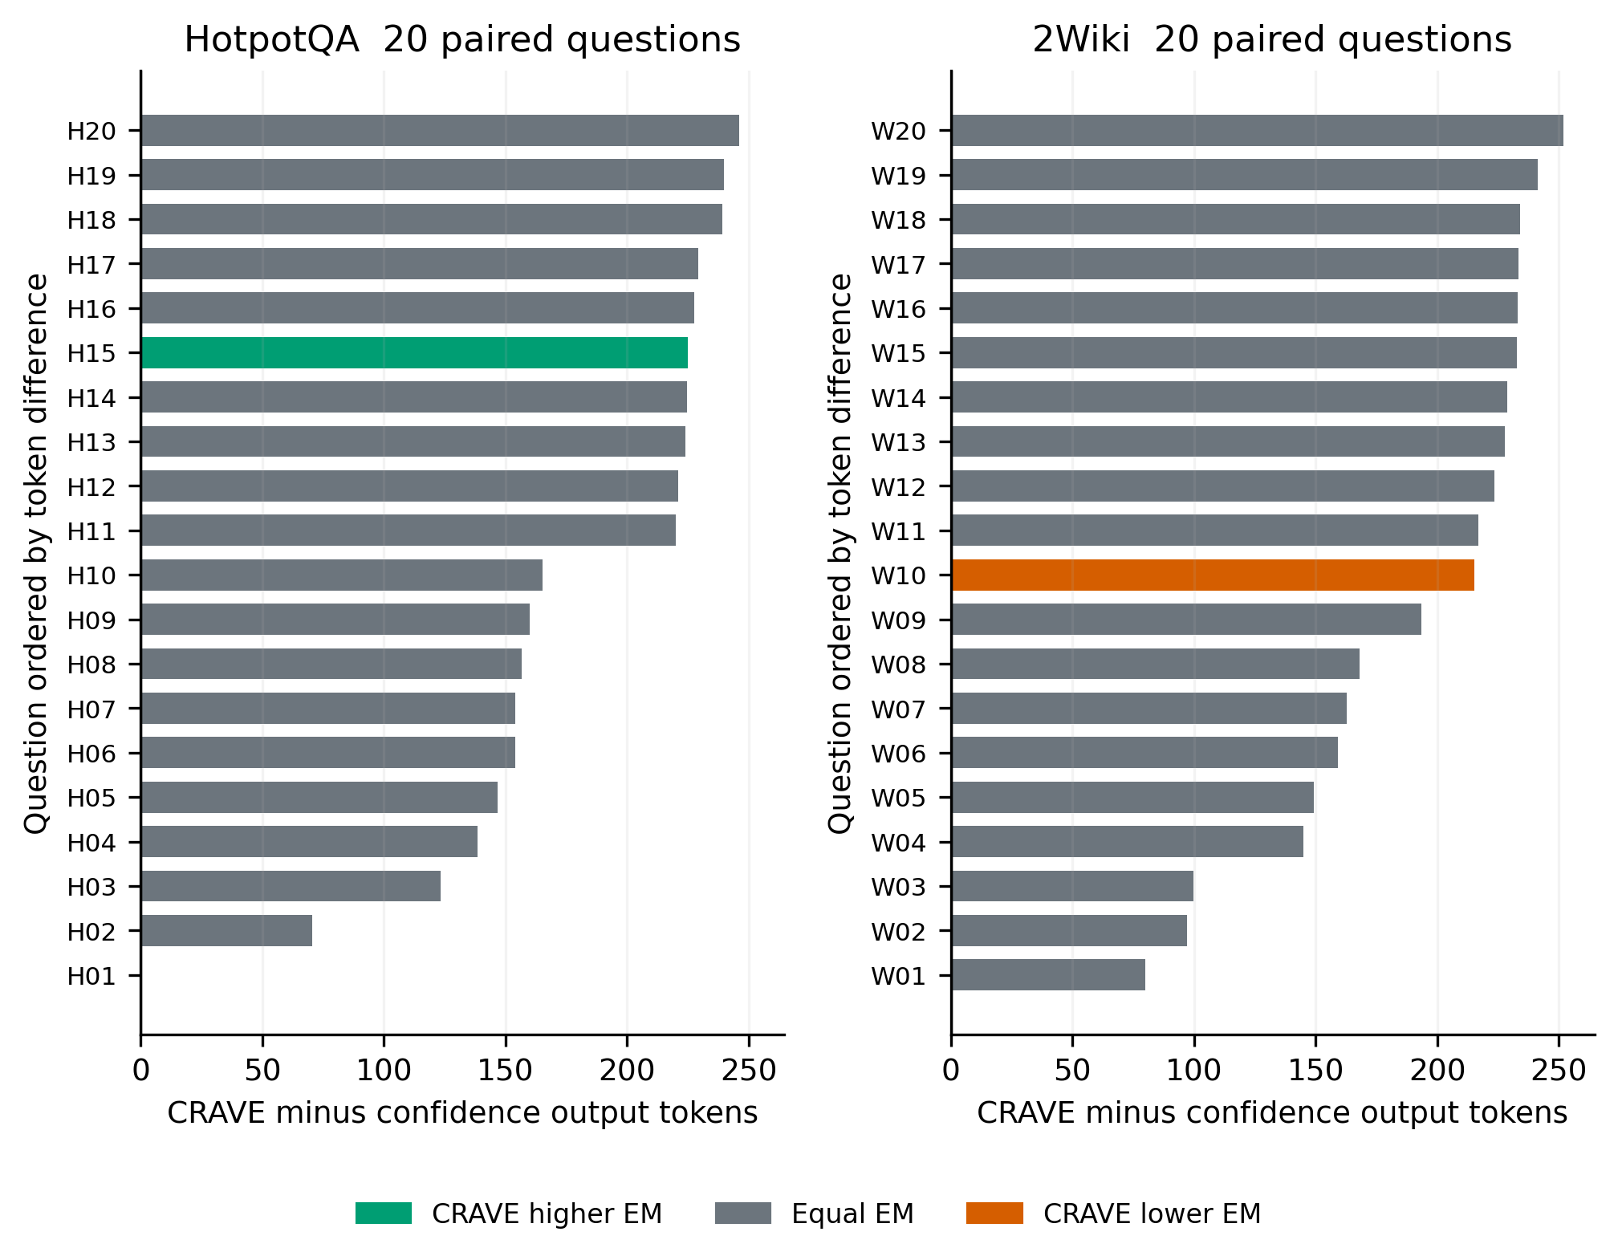
Figure 3 Per-question additional generated tokens for CRAVE relative to confidence, ordered within dataset after averaging seeds. Color records the corresponding direction of the exact-match difference. Gray means equal seed-averaged exact match. H and W labels map to exact task IDs in paired_question_key.csv. A zero-length bar is a cost tie. Ordering is visual only and did not determine task selection or statistical tests.
Nineteen of twenty HotpotQA questions and all twenty 2Wiki questions incurred a positive CRAVE output-cost difference; one HotpotQA question was tied. Seed-averaged accuracy differed on only one question per dataset: higher for CRAVE on HotpotQA and lower on 2Wiki. The per-question display therefore reveals that higher spending was widespread, whereas the observed accuracy changes were concentrated in individual questions. It provides substantially more task-level information than the original three-cluster plot.
The expanded invocation made 1,185 physical model requests and generated 47,275 physical output tokens in 46.3 minutes. Logical evaluation output was 65,916 tokens and input was 1,499,369; cached computation accounts for the difference between physical and logical generation. Model generation time was 2707.2 seconds. These counts exclude data download and the earlier pilot. No cold-latency or monetary-cost estimate is inferred.
The extension validation and a separate audit both passed. Independent checks verified the configuration, source, corpus, selected tasks, and frozen checkpoint hashes; exact episode completeness and pairing; disjointness from all original partitions; all 480 answer scores and resource counters; and thirty-two independently reconstructed summary means and bootstrap intervals. There were zero budget violations. The larger sample strengthens the descriptive negative cost finding, but training remains limited to four questions, official evaluator equivalence remains unverified for raw exports, and the full study gate remains unmet.

7.7 Action allocation and resource components
We reconstructed action frequencies and cost components from the same 480 expanded-test episodes. For action counts, seeds were averaged within each question before averaging the twenty questions per dataset. Figure 4 uses ten thousand question-cluster bootstrap resamples with visualization seed 20261007. These analyses describe the completed test; they introduce no new controller tuning or independent observations.
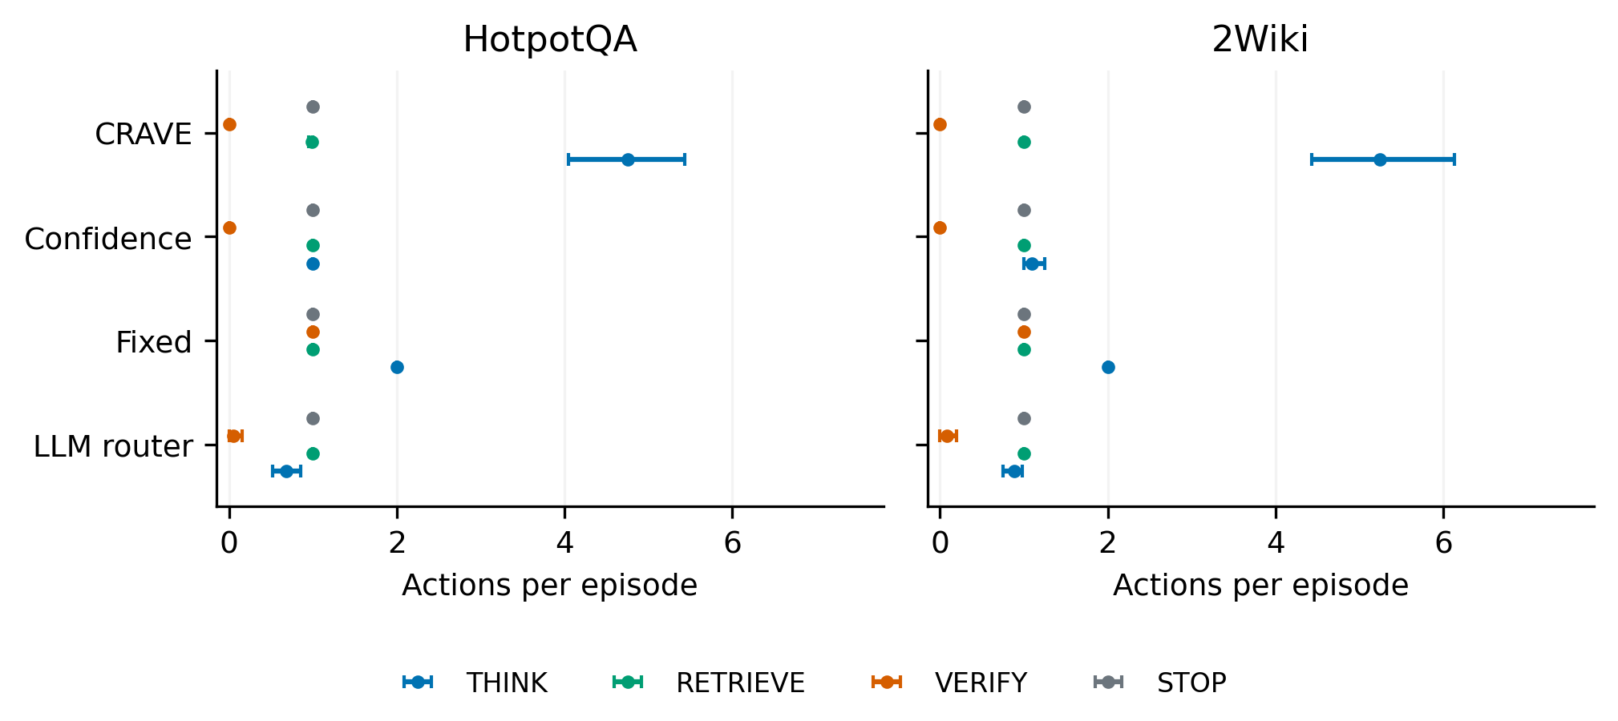
Figure 4 Mean executed actions per episode in the expanded test. Points are task means and horizontal bars are 95% question-cluster bootstrap intervals. Each dataset contains twenty questions with three seeds per question. Counts include the terminal STOP action. A zero count is plotted at the origin; it does not represent missing data.
CRAVE executed 4.75 THINK actions per HotpotQA episode and 5.25 per 2Wiki episode, compared with 1.00 and 1.10 for confidence. This action-level accounting locates the observed additional generation in repeated reasoning calls. It is a description of behavior, not a causal identification of why the learned controller preferred those calls.
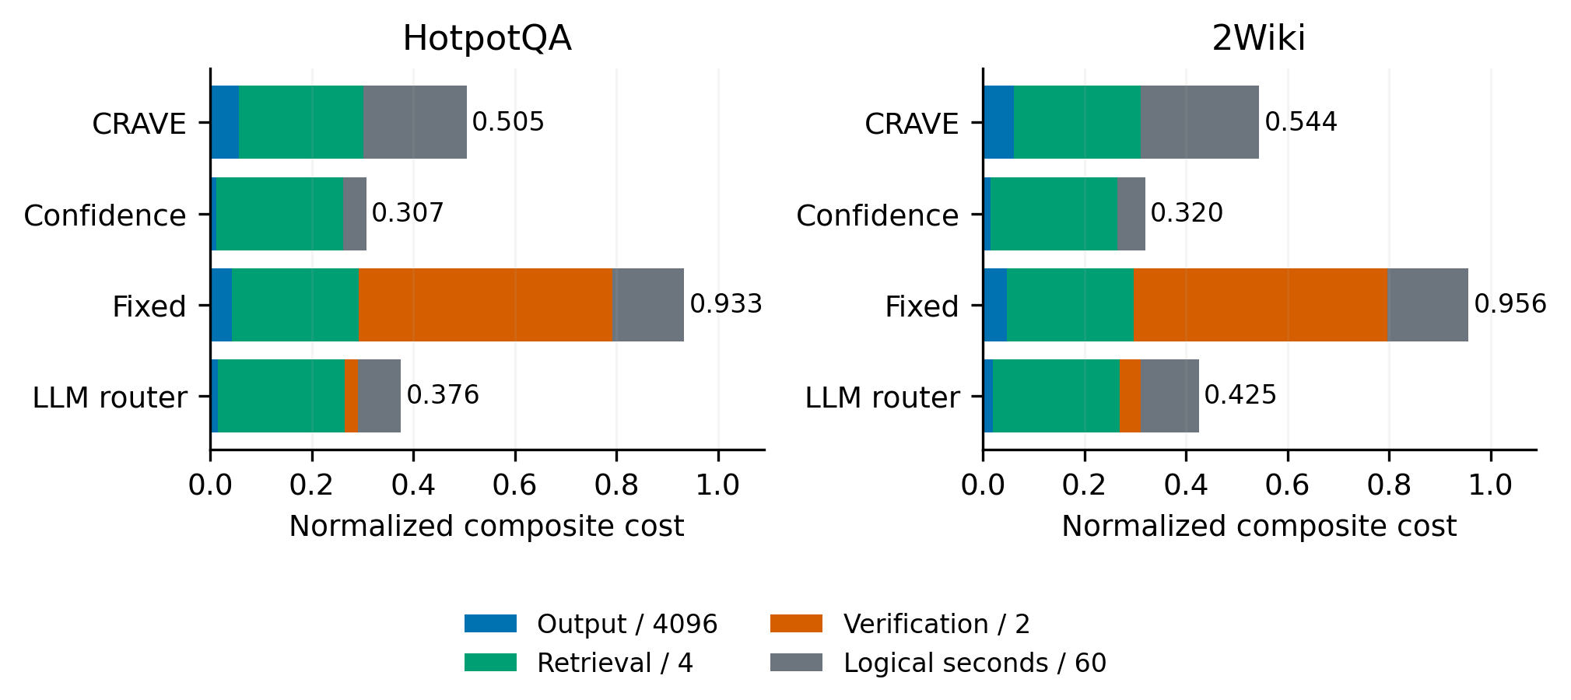
Figure 5 Decomposition of mean normalized composite cost. Stacks show output tokens divided by 4096, retrieval calls divided by 4, verification calls divided by 2, and recorded logical seconds divided by 60. Stack totals equal the recorded normalized cost for all 480 episodes before averaging. The display uses the implemented reference scales rather than monetary prices or a cold-latency benchmark; it shows means without uncertainty intervals.
Figure 5 explains why token cost and composite cost can rank policies differently. The fixed schedule pays a verification component of 0.5 per episode, whereas CRAVE avoids verification in this test. The logical-time term also contributes to the composite total. These reference-weighted terms should be inspected alongside raw output tokens; their sum is not a direct estimate of deployment price or energy use.
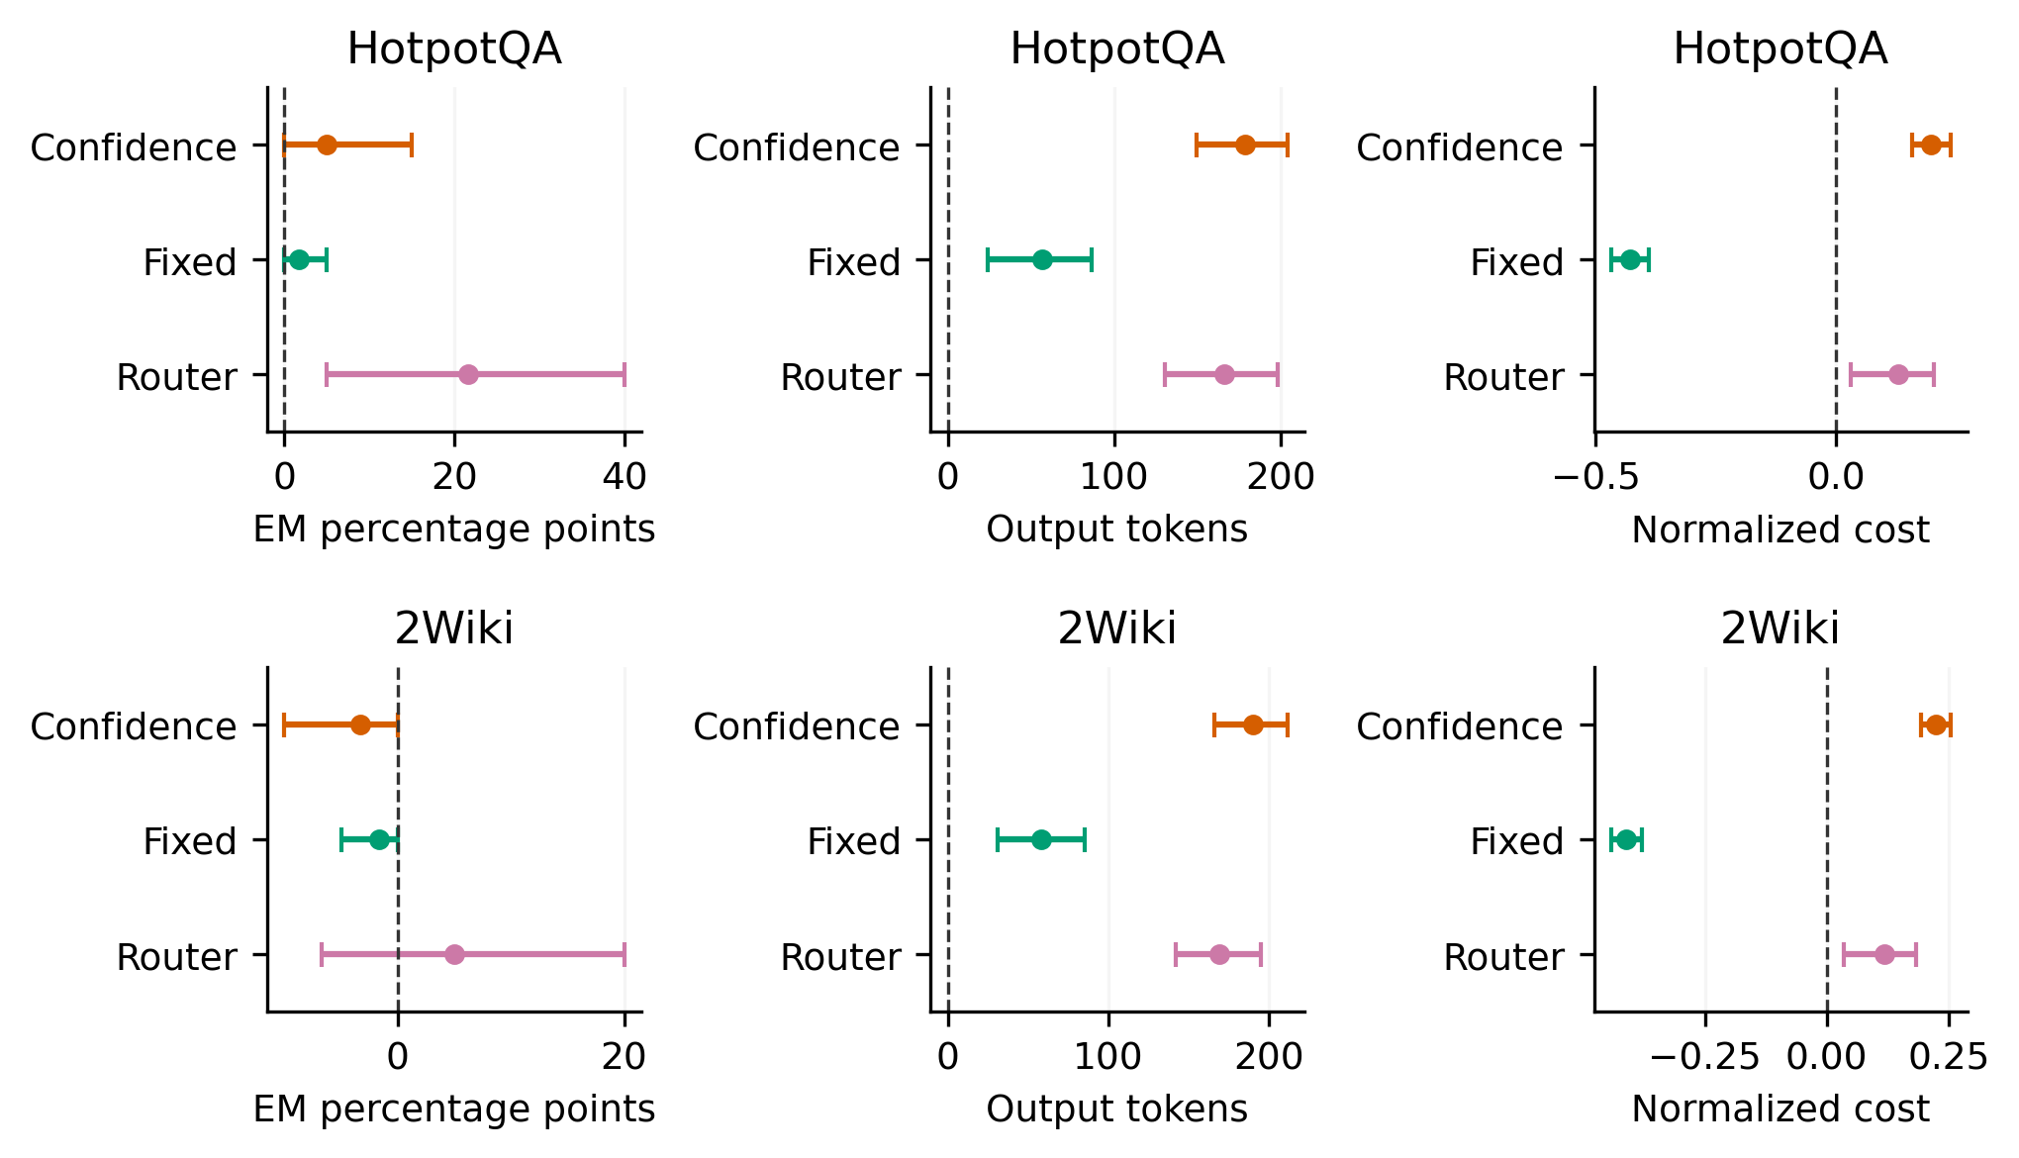
Figure 6 Paired CRAVE minus comparator effects in the expanded test. Points and 95% task-cluster bootstrap intervals use the already frozen statistics output. Units remain separate: exact-match percentage points, generated output tokens, and normalized composite cost. Positive accuracy differences favor CRAVE; positive cost differences favor the comparator. Vertical dashed lines mark zero. Bootstrap intervals are not simultaneous intervals; Holm-adjusted permutation p values govern the reported exploratory tests.
Figure 6 retains the paired comparison for each control rather than inferring a difference from overlapping marginal intervals. The output-token intervals are positive for all six comparisons, while the composite-cost intervals are negative against the fixed schedule. Accuracy intervals can touch or exclude zero even when the discrete paired permutation test is not significant after multiplicity correction. Both uncertainty summaries must therefore be read with the stated task counts and statistical family.

8 Audit and reproducibility
Seventeen core tests passed, including atomic resource accounting, randomized budget safety, restore isolation, corrupt-checkpoint rejection, matched branch seeds, private-label exclusion, split checks, normalized metrics, analytic gradient finite differences, loss reduction, and statistical routines. Fixtures were used only in tests; research results came from the verified Qwen checkpoint and real dataset records.
A separate audit recomputed configuration, source, stage, task, and corpus hashes; checked all 156 branch payloads and the 111 observational records; verified the fixed μ0 label regime; rejected duplicate records and private fields in inference states; recomputed held-out answers from gold records; reconciled output and total token counters; and checked token, retrieval, and verification bounds. It found no critical errors and zero budget violations in the 162 evaluation episodes.
Artifact checks establish that the reported outputs correspond to the implemented pilot. They do not certify dataset release equivalence, official baseline fidelity, population-level effects, cross-model robustness, or cold latency. The immutable pilot configuration and source hash should be retained with any extension; a new experiment requires a new configuration and an explicit report of changed data or executor semantics.

9 Discussion and limitations

9.1 Interpreting the negative result
The most direct comparison in the original six-question pilot was against the confidence rule. It achieved the same answer accuracy with fewer input and output tokens in both dataset cells. More sophisticated action valuation did not produce better resource allocation at this pilot scale. Four training questions, fifteen visited states, noisy three-replicate targets, raw confidence features, and a fixed continuation regime provide plausible mechanisms for limited learning, but this experiment does not identify which mechanism caused the inefficiency. Explaining it requires prespecified development analysis and a larger independent evaluation.
The framework may assign excessive value to continued reasoning when noisy training successes are not representative of held-out states. The original three-state diagnostic is consistent with optimistic predictions, but it does not establish a general overestimation mechanism. Similarly, a fixed λ and sparse budget support can leave a learned utility surface insufficiently constrained. The appropriate response is to test these explanations on development data rather than change evaluation settings after observing the held-out outcome.

9.2 Statistical and data limitations
The original six-question pilot cannot support a general benchmark conclusion. The expanded test adds forty fresh questions selected randomly from bounded record pools, but it remains a small post-pilot study rather than a representative full-benchmark evaluation. First-record selection is not a probability sample; three seeds do not increase the number of questions. Wide accuracy intervals and coarse permutation tests make population-level effects unidentifiable here. The raw exports and incomplete evaluator equivalence further restrict comparability. Pretraining contamination of the base model cannot be excluded from public factual QA data.
The pooled corpus contains benchmark passages from evaluation questions. This avoids answer-label leakage into the policy but creates transductive evidence availability. A full Wikipedia retrieval study could yield different costs, support coverage, and action preferences. Multi-hop answer correctness alone also does not demonstrate connected reasoning, a concern that motivates the MuSiQue dataset design [11].

9.3 Executor and estimand limitations
Quantization, non-thinking mode, bounded public summaries, a single same-model verifier, capped evidence, and conservative token reservations define a particular action system. A controller evaluated with hidden-state features, longer internal reasoning, independent verification, or another backbone would face different transitions and costs. The pilot provides no invariance result across these choices.
The learned values refer to μ0 continuation, whereas deployment uses the learned controller. This continuation mismatch is deliberate to preserve one label estimand across collection rounds, but it can limit policy improvement. Two rounds of changed visitation do not prove convergence. Ordered interaction targets use feasible common replicates and sparse checkpoint coverage; missing or ineligible pairs constrain what the auxiliary head can learn.
Latency includes measured action and controller overhead together with the cache convention. It is useful for tracing this execution but is not a strict service deadline or a standardized hardware comparison. Neither deployment amortization of offline labels nor net financial savings has been established. The physical cost of generating labels remains relevant even when a learned policy eventually reduces online cost.

10 Status of the broader study
The broader design asks whether matched long-horizon values improve quality-cost frontiers, reduce regret compared with observational targets, capture delayed rewards, represent action complementarity, generalize to unseen budgets, and transfer across domains and backbones. Table 10 records the evidential status without treating successful execution as successful hypothesis confirmation.
Table 10 Research hypotheses and remaining evidence
Hypothesis | Status and required evidence
H1 Quality and cost frontier | No efficiency gain over confidence at the tested point; full preference and budget frontier not run
H2 Counterfactual targets | Pilot diagnostics only; coverage-matched observational comparison and adequate task sample needed
H3 Delayed return | Immediate model performs poorly in task answers but well on three local oracle states; controlled delayed-benefit tasks needed
H4 Ordered interactions | Sparse auxiliary labels; no demonstrated gain; pair coverage and interaction analyses needed
H5 Unseen budgets | Not tested; one deployment budget executed
H6 Transfer | Twenty-three 2Wiki questions across two separate corpus protocols; full domain and cross-family model studies not run

A definitive follow-up should use complete, checksummed data releases and disjoint development-only selection of K, thresholds, loss weights, and hyperparameters. It should freeze a full retrieval snapshot, reproduce the closest literature baselines faithfully, match action availability and resource accounting, declare primary statistical comparisons, and evaluate adequate task counts across unseen budget combinations. Cross-model and larger-domain transfer should report calibration shift and failures, not just answer averages. These experiments are proposed requirements, not observations reported in this manuscript.

11 Conclusion
CRAVE implements matched, policy-conditioned long-horizon valuation of reasoning, retrieval, verification, and stopping under resource constraints. The pilot demonstrates reproducible collection, controller training, masked execution, real-data evaluation, and independent artifact auditing. It does not demonstrate an efficiency advantage: a simple confidence rule matched CRAVE accuracy with substantially fewer tokens on the six held-out questions. The contribution presently consists of the executable method and its transparent feasibility evidence. Claims about broad performance, causal-supervision benefits, interaction learning, budget generalization, and transfer remain open until the larger study is executed. The expanded test preserves this limitation: a five-percentage-point HotpotQA accuracy increase and a 3.3-point 2Wiki decrease relative to confidence were each concentrated in one question and were not significant after correction, whereas the additional generated-token cost was consistently positive. Frozen controllers, fresh questions, and task-level plots strengthen the descriptive evidence without establishing a favorable full quality-cost frontier.

Data and code availability
Code, pinned configuration files, dataset subset provenance, raw branch and episode records, learned checkpoints, CSV summaries, statistical outputs, and validation artifacts are retained in the local CRAVE project. The principal result directory is crave/runs/bdd2b8a990571bb1. The repository is https://github.com/Al1ranger/CRAVE. A permanent archival identifier and complete full-release dataset manifest have not been established. Public dataset and model sources are identified below and in Appendix B. Redistribution should follow the applicable upstream licenses; the 2Wiki raw-export license requires verification before a public artifact release. The expanded test is saved separately in crave/runs/expanded_8484164aef776a12. It reuses the original seeded CRAVE checkpoints and retains an independently frozen extension configuration, random selection manifest, per-question means, paired statistical outputs, and two replacement figures.

References
[1] Patrick Lewis et al. Retrieval-Augmented Generation for Knowledge-Intensive NLP Tasks. NeurIPS, 2020. https://arxiv.org/abs/2005.11401
[2] Shunyu Yao et al. ReAct: Synergizing Reasoning and Acting in Language Models. ICLR, 2023. https://arxiv.org/abs/2210.03629
[3] Hao Wen et al. BudgetThinker: Empowering Budget-aware LLM Reasoning with Control Tokens. arXiv:2508.17196v2, 2025. https://arxiv.org/abs/2508.17196v2
[4] Dehai Min, Giovanni Vaccarino, Huiyi Chen, Yongliang Wu, Gal Yona, and Lu Cheng. Stop When Reasoning Converges: Semantic-Preserving Early Exit for Reasoning Models. arXiv:2605.17672, 2026. https://arxiv.org/abs/2605.17672
[5] Xuqing Yang, Yi Yuan, Shanzhe Lei, and Xuhong Wang. Scaling with Confidence: Calibrating Confidence of LLMs for Adaptive Test Time Scaling. arXiv:2607.01612, 2026. https://arxiv.org/abs/2607.01612
[6] Yufeng Wang, Lu Wei, and Haibin Ling. Retrieval as a Decision: Training-Free Adaptive Gating for Efficient RAG. arXiv:2511.09803v2, 2026. https://arxiv.org/abs/2511.09803v2
[7] Siheng Xiong, Oguzhan Gungordu, James C. Kerce, and Faramarz Fekri. Adaptive Information Control for Search-Augmented LLM Reasoning. arXiv:2602.01672v2, 2026. https://arxiv.org/abs/2602.01672v2
[8] Zhengru Fang et al. Inference-Time Budget Control for LLM Search Agents. arXiv:2605.05701, 2026. https://arxiv.org/abs/2605.05701
[9] Wenhao Zou, Xianglong Liu, Wendong Bi, Hanjie Wang, Simin Zhao, and Gong Zhi. CoBRA: Learning Tool-Use Boundaries via Counterfactual Margins. arXiv:2609.00967, 2026. https://arxiv.org/abs/2609.00967
[10] Zhilin Yang et al. HotpotQA: A Dataset for Diverse, Explainable Multi-hop Question Answering. EMNLP, pages 2369–2380, 2018. DOI 10.18653/v1/D18-1259. https://aclanthology.org/D18-1259/
[11] Harsh Trivedi, Niranjan Balasubramanian, Tushar Khot, and Ashish Sabharwal. MuSiQue: Multihop Questions via Single-hop Question Composition. TACL, 10:539–554, 2022. DOI 10.1162/tacl_a_00475. https://aclanthology.org/2022.tacl-1.31/
[12] Xanh Ho, Anh-Khoa Duong Nguyen, Saku Sugawara, and Akiko Aizawa. Constructing A Multi-hop QA Dataset for Comprehensive Evaluation of Reasoning Steps. COLING, pages 6609–6625, 2020. DOI 10.18653/v1/2020.coling-main.580. https://aclanthology.org/2020.coling-main.580/
[13] Qwen Team. Qwen3-4B-GGUF official model repository. Revision bc640142c66e1fdd12af0bd68f40445458f3869b. https://huggingface.co/Qwen/Qwen3-4B-GGUF
[14] Sentence Transformers. all-MiniLM-L6-v2 model card and implementation documentation. Revision 1110a243fdf4706b3f48f1d95db1a4f5529b4d41. https://huggingface.co/sentence-transformers/all-MiniLM-L6-v2
[15] ggml-org. llama.cpp server documentation and Windows Vulkan release b11146. https://github.com/ggml-org/llama.cpp/tree/b11146/tools/server
[16] Alex Graves. Adaptive Computation Time for Recurrent Neural Networks. arXiv:1603.08983, 2016. https://arxiv.org/abs/1603.08983
[17] Andrea Banino, Jan Balaguer, and Charles Blundell. PonderNet: Learning to Ponder. arXiv:2107.05407, 2021. https://arxiv.org/abs/2107.05407
[18] Stephane Ross, Geoffrey J. Gordon, and J. Andrew Bagnell. A Reduction of Imitation Learning and Structured Prediction to No-Regret Online Learning. AISTATS, PMLR 15:627–635, 2011. https://proceedings.mlr.press/v15/ross11a.html
[19] Akari Asai, Zeqiu Wu, Yizhong Wang, Avirup Sil, and Hannaneh Hajishirzi. Self-RAG: Learning to Retrieve, Generate, and Critique through Self-Reflection. arXiv:2310.11511, 2023. https://arxiv.org/abs/2310.11511
[20] Xuezhi Wang et al. Self-Consistency Improves Chain of Thought Reasoning in Language Models. arXiv:2203.11171, 2022. https://arxiv.org/abs/2203.11171
[21] Nelson F. Liu et al. Lost in the Middle: How Language Models Use Long Contexts. TACL, 12:157–173, 2024. DOI 10.1162/tacl_a_00638. https://aclanthology.org/2024.tacl-1.9/
[22] Chuan Guo, Geoff Pleiss, Yu Sun, and Kilian Q. Weinberger. On Calibration of Modern Neural Networks. ICML, PMLR 70:1321–1330, 2017. https://proceedings.mlr.press/v70/guo17a.html
[23] Sebastian Farquhar, Jannik Kossen, Lorenz Kuhn, and Yarin Gal. Detecting hallucinations in large language models using semantic entropy. Nature, 630:625–630, 2024. DOI 10.1038/s41586-024-07421-0. https://www.nature.com/articles/s41586-024-07421-0
[24] Bradley Efron. Bootstrap Methods: Another Look at the Jackknife. The Annals of Statistics, 7(1):1–26, 1979. DOI 10.1214/aos/1176344552. https://doi.org/10.1214/aos/1176344552
[25] Sture Holm. A Simple Sequentially Rejective Multiple Test Procedure. Scandinavian Journal of Statistics, 6(2):65–70, 1979. https://www.jstor.org/stable/4615733
[26] Belinda Phipson and Gordon K. Smyth. Permutation P-values Should Never Be Zero: Calculating Exact P-values When Permutations Are Randomly Drawn. Statistical Applications in Genetics and Molecular Biology, 9(1), Article 39, 2010. DOI 10.2202/1544-6115.1585. https://gksmyth.github.io/pubs/PermPValuesPreprint.pdf

Appendix A Executable procedure
Algorithm 1 specifies the labeling and deployment procedure used in the pilot. Gold labels are confined to the training scorer and held-out evaluator. The analytical oracle follows the labeling procedure on held-out states only after training.
1 Construct and checksum task partitions and the common label-free passage corpus. Define action caps, budget rules, utility reference scales, and μ0 before evaluation.
2 For each training task, save an initial checkpoint and selected collector-visited checkpoints. Persist them before starting branch generation.
3 For each saved state and eligible action, restore and hash-check the full state, assign a common replicate seed, force the action, and continue with μ0 until STOP or the finite executor limit.
4 Score the terminal candidate offline and record actual future resource consumption. Repeat for K = 3. Generate feasible pair and empty-intervention records for selected interaction checkpoints.
5 Average branch targets for each state and action at each training λ. Create masks for missing actions and pair contrasts. Fit the shared controller on training records only.
6 Collect another visitation round with the μ0 and learned-controller mixture while retaining μ0 for every label continuation. Aggregate both rounds and fit the final seeded variants.
7 Evaluate fixed settings on held-out tasks. Select only feasible actions. Log all output, input, tool, and timing counters, final candidates, and action histories.
8 Recompute task metrics, pair observations by task, bootstrap task clusters, apply exploratory corrections, verify artifact checksums, and report negative as well as positive findings.

Appendix B Artifact identity and execution details
The pilot configuration SHA256 is bdd2b8a990571bb1a262e7b42d929bdec057bea80242161b27ca811accd88040. The source SHA256 is b2342343149286617236b081b6a947bda53d72cfff26112c8db25f514e6eb27e. These identities describe the executed software and settings, not the later editorial manuscript builder. The expanded test configuration SHA256 is 8484164aef776a1227cd80dc6b92903e7da77e245361206a83dc2548386dcbea. It retains the same framework source identity and frozen controller checkpoint identities while changing the held-out questions and shared corpus.
The Qwen file is Qwen3-4B-Q4_K_M.gguf with SHA256 7485fe6f11af29433bc51cab58009521f205840f5b4ae3a32fa7f92e8534fdf5. Its size was independently verified as 2,497,280,256 bytes before loading. The encoder ONNX SHA256 is 6fd5d72fe4589f189f8ebc006442dbb529bb7ce38f8082112682524616046452. The runtime archive SHA256 is 55a378aa095b466979d85075234f66d7655c7a7483222af0c006c0e55b4d7bd6.
The pooled passage corpus SHA256 is 8f451d423e23b7346624764a9335858fb9a7254c6c47a98d20c2f5b44b49ead5. The official source model and encoder revisions are listed in References 13 and 14. The raw export provenance points to https://raw.githubusercontent.com/StonyBrookNLP/musique/main/.all_data_information.json. Subset files record the author-linked public download URLs, subset checksums, and that full-file checksums were not obtained.
Execution used Windows, Python 3.12.14, an RTX 3060 Laptop GPU with 6 GB dedicated memory, the Vulkan backend for Qwen generation, and CPU ONNX encoding. Dependency versions and the hardware setup record accompany the frozen run. The original pre-experimental Word manuscript is a separate preserved file. Reproduction commands and precise file formats are recorded in crave/RUNBOOK.md.

Appendix C Interpreting the saved outputs
per_instance.csv is the primary evaluation record. summary.csv contains seed-averaged task summaries and cluster-bootstrap intervals. statistics.csv contains paired differences, raw permutation probabilities, and Holm adjustments. counterfactual_diagnostics.csv retains action-level predictions, empirical utilities, and finite-K standard errors. value_diagnostic_summary.csv and success_reliability_bins.csv summarize diagnostic proxies. independent_audit.json and validation.json record distinct integrity checks. compute_accounting.json distinguishes physical inference during this invocation from logical token consumption.
Checkpoint and raw trajectory files are essential for reviewing matched interventions. Learned model files are not evidence of generalization by themselves. The complete pilot record supports the numerical tables in this manuscript; unexecuted hypotheses, methods, domains, or budgets have no empirical result cells. For the expanded test, task_means.csv contains seed-averaged question observations, task_manifest.json retains the selected questions and original partition boundaries, and results/figures/paired_question_key.csv maps each chart label to its exact task ID. The extension runner is tmp/expanded_evaluation.py; its frozen SHA256 is af98b3badee0fe206ed078966730f9d09d72528c9be0a7abeb150d2991189574.

