CausalFed-TGNN: Invariant Heterogeneous Temporal Graph Learning for Open-Set Federated Financial Fraud Detection
Article type: Original research article
Manuscript status: Blinded for peer review
Author names, affiliations, ORCID identifiers, acknowledgements, funding, and contribution metadata are omitted for double-anonymous review.

Abstract
Financial fraud detection across institutions combines heterogeneous relations, temporal shift, and fraud mechanisms absent from training. We operationalise CausalFed-TGNN as a finite-history heterogeneous graph transformer with invariant/environment branches and independent novelty scores. Fifteen immutable synthetic streams at 50,000, 100,000, and 500,000 events use five seeds and chronological 50/20/30 partitions; D/E are excluded from fitting and calibration. The recorded screening study contains 180 centralized neural fits, 20 clean federated simulations, and 30 attacked simulations, alongside independently verified historical logistic baselines. At 500,000 events, the full variant achieves known-class AUROC 0.506 ± 0.014, AP 0.022 ± 0.001, and F1 0.037 ± 0.002; its energy novelty AUROC is 0.635 ± 0.019 (mean ± sample SD, five seeds). FedAvg, FedProx, SCAFFOLD, and coordinate-median aggregation are compared at 50,000 events with matched attack conditions. These are measured screening results, not evidence of causal identification, predictive superiority, or privacy. Fixed daily bank timing, eight-epoch/round budgets, synthetic-only evaluation, and the restricted snapshot architecture limit interpretation. Public-data and continual-adaptation evaluations remain incomplete.

Keywords
Federated Learning; Heterogeneous Temporal Graphs; Invariant Representation Learning; Open-Set Recognition; Financial Fraud Detection; Continual Learning

1. Introduction
Financial fraud detection is a high-stakes, highly imbalanced decision problem in which adversaries adapt, transaction behaviour evolves, and labels may arrive only after an operational decision has been made. Detection systems must identify suspicious activity while controlling false alarms that disrupt legitimate customers and consume investigation capacity [1-5]. These characteristics make temporal evaluation, precision-recall analysis, and explicit operating thresholds more informative than random-split accuracy alone.
Tabular or isolated-transaction modelling can miss repeated entity reuse, coordinated behaviour, and cross-transaction context. A merchant, device, or account may appear benign in isolation yet become suspicious when viewed through shared neighbours or evolving interaction patterns. This motivates relational modelling in which transactions are embedded in an interaction graph rather than treated as independent observations.
Temporal and heterogeneous graph learning addresses two additional properties of financial streams: relations have different semantics, and their predictive relevance can change over time. Heterogeneous graph encoders preserve typed interactions among accounts, transactions, devices, merchants, and locations [6-12,50-52], while dynamic and temporal models represent event order and evolving connectivity [13]. The methodological challenge is to exploit this context without leaking information from future events into model development or evaluation.
Institutional fragmentation introduces a separate systems constraint. Banks and payment providers often cannot centralise raw transaction records, while each institution observes a partial and non-identically distributed view of customers, merchants, devices, and attack patterns. Federated learning enables parameter-based coordination without raw-record pooling [14-19,42-44], but non-IID client distributions, heterogeneous participation, communication cost, malicious updates, and information leakage from gradients must be addressed explicitly [20-23,45,46].
Fraud models must also operate under distribution shift. New mechanisms can emerge after deployment, known mechanisms can change in prevalence or behaviour, and client populations can drift at different rates. Closed-set classification alone cannot distinguish a low-confidence known class from a genuinely novel event; open-set or out-of-distribution (OOD) detection therefore requires a separate decision object and calibration protocol [32-35,56-58]. Continual learning introduces an additional stability-plasticity trade-off under persistent change [24-30].
These research streams are often evaluated under different assumptions, data partitions, and metrics. This creates an integration gap: known-class fraud classification, unknown-event detection, temporal generalisation, institutional heterogeneity, and federated robustness are difficult to compare within one leakage-controlled and provenance-aware protocol. The present work addresses that gap as a methodological and reproducibility framework rather than as a completed claim of predictive superiority.
The present execution evaluates a finite-history implementation of the proposed graph framework, matched representation ablations, independent novelty scores, and four-bank federated simulations. Results are traceable to saved predictions and checkpoints. This implementation narrows the conceptual architecture: continual adaptation, unrestricted temporal memory, and public-data validation remain pending.
The contributions distinguish the broader methodological proposal from the implemented screening study:
- A heterogeneous temporal graph formulation that represents transactions jointly with customer/account, merchant, device, and location entities and augments event order with explicit elapsed-time features.
- An invariant/environment-specific representation decomposition with IRM-inspired multi-environment regularisation, intended to separate cross-institution predictive structure from institution-specific variation; its utility is reserved for empirical ablation testing.
- A separate open-set recognition layer that evaluates energy, maximum-logit-margin, and prototype-distance novelty scores under validation-only threshold calibration, thereby keeping novelty detection distinct from the known-class fraud decision.
- A federated stress-test protocol covering non-IID clients, label flipping, backdoor updates, Sybil/collusion behaviour, temporal drift, continual adaptation, calibration, and explanation sensitivity under matched experimental conditions.
- An executed evidence package containing 180 centralized neural fits, 20 clean federated simulations, 30 attacked simulations, five-seed summaries, paired ablation differences, per-bank metrics, checkpoints, and independently verified historical logistic evidence.

2. Related Work

2.1 Financial fraud detection
Financial fraud detection combines rare-event classification, delayed feedback, non-stationary behaviour, and asymmetric operational costs. Classical and sequential approaches have therefore emphasised class imbalance, temporal evaluation, and practitioner-oriented error analysis [1-5]. These studies motivate precision-recall measures, temporal holdouts, and explicit operating thresholds rather than overall accuracy as the principal measure of deployment quality.

2.2 Graph-based fraud detection
Graph-based fraud detectors model interactions among accounts, users, transactions, devices, and counterparties, enabling neighborhood information to complement transaction-level features [6-12]. Heterogeneous graph methods can preserve relation semantics rather than forcing all edges into a single interaction type [6,10,11]. These models motivate the relation-aware backbone used here, but graph structure alone does not address temporal holdout design, institution-level non-IID variation, or unknown fraud mechanisms.

2.3 Temporal and dynamic graph learning
Dynamic and temporal graph learning models evolving connectivity and time-dependent interactions [13]. In fraud detection, elapsed time, event recency, and changing neighbourhoods can encode behaviour that is not recoverable from a static graph. The present framework therefore combines typed graph structure with explicit elapsed-time features and temporal evaluation, while requiring strict prevention of future-information leakage when histories and features are constructed.

2.4 Federated learning under non-IID institutional data
Federated learning coordinates distributed optimisation while raw records remain local to participating clients [14-19,42-44]. This architecture is relevant to cross-institution modelling, but non-IID client data can affect convergence and client contribution, and model updates can leak information in the absence of additional protection [20-22]. Optimisation methods such as FedProx and SCAFFOLD, adaptive aggregation, robust aggregation, privacy mechanisms, and security controls address different failure modes and should therefore not be described interchangeably.

2.5 Domain generalization and invariant representation learning
Domain generalisation seeks representations that preserve predictive structure across environments with changing nuisance factors [31,49]. Here, invariant representation learning is used in that predictive sense: an IRM-inspired multi-environment penalty encourages a shared branch to retain fraud-relevant information, while an environment-specific branch can absorb institution-dependent variation. This design does not establish causal invariance; its value must be demonstrated through cross-environment evaluation and targeted ablation.

2.6 Open-set and out-of-distribution recognition
Open-set recognition and OOD detection identify samples that are poorly explained by the closed training label set [32-35,56-58]. In fraud screening, an unseen mechanism should not be forced into a known fraud subtype solely through the closed-set classifier. The present protocol therefore calibrates novelty independently of the fraud-decision threshold and excludes the held-out unknown mechanism from novelty-threshold selection.

2.7 Continual learning and concept drift
Continual-learning and concept-drift methods address changes in the data-generating process after deployment [24-30]. Replay and stability regularisation can reduce forgetting, but adaptation can also reinforce noisy or adversarial observations. CausalFed-TGNN therefore treats drift detection, replay, and adaptation as separately ablatable components with pre-specified triggers and evaluation windows.

2.8 Robust/adversarial federated learning and explainable decision support
Federated systems are vulnerable to data poisoning, label manipulation, malicious updates, and coordinated clients; robust aggregation can mitigate some attack effects but does not provide privacy or a universal security guarantee [20-23,45,46]. In parallel, high-stakes fraud screening benefits from calibrated uncertainty and decision-support explanations such as feature attribution, graph-substructure explanation, and counterfactual analysis [36-41,47,48,53,55,56]. The framework therefore treats robustness, privacy, security, uncertainty, and explainability as distinct evaluation dimensions.

2.9 Research gap
The contribution is an integrated, leakage-controlled evaluation contract and its finite-history implementation. The new neural and federated records permit measured comparisons within this scope; they do not validate every conceptual component or establish predictive superiority, causal invariance, privacy, or real-world generalisation.

3. Problem Formulation and Claim Boundary

3.1 Federated heterogeneous temporal graph
Let the B participating institutions be indexed by b = 1, …, B. At time t, client b constructs a heterogeneous temporal graph from its local transaction stream. The graph contains typed customer/account, transaction, device, merchant, and location nodes; typed forward and reverse relations; and observed node, edge, and temporal attributes. The institution defines the client boundary: raw records remain local, whereas only model-update information is eligible for server exchange.
For each transaction, the heterogeneous temporal encoder produces a d-dimensional representation from its typed neighbourhood, attributes, and recent event history. A decomposition module then maps this representation into invariant and environment-specific components. The invariant branch is intended to preserve fraud-relevant structure shared across environments, whereas the environment-specific branch is intended to represent institution-dependent nuisance variation. These roles are architectural hypotheses and require empirical verification through targeted ablations.

3.2 Separate known-class and unknown-event decisions
For the binary known-class task, the prediction head produces logits ℓ₀ and ℓ₁ for legitimate and fraud outcomes. The fraud probability is computed from their logit difference (Equation 1). Unknown-event detection is evaluated separately through a novelty score s(x) (Equation 2); a novelty score is not interpreted as a fraud probability.
p(fraud) = σ(ℓ₁ − ℓ₀) | (1)
E(x) = −log Σₖ exp(ℓₖ), s(x) ∈ {energy, margin, prototype distance} | (2)
Novelty thresholds are selected using validation data that exclude the held-out unknown mechanism used for final open-set testing. Score direction, calibration population, and operating-point selection must be fixed before test evaluation. This prevents threshold leakage and preserves the distinction between known-class classification error and unknown-event detection error.

3.3 Scientific claim boundary
CausalFed-TGNN is a predictive representation-learning framework. The historical term “Causal” in the project name does not imply causal discovery, intervention modelling, causal-effect identification, or a formal guarantee of causal invariance. Likewise, federated parameter exchange is not equivalent to differential privacy or secure aggregation, and robust aggregation is an operational robustness mechanism rather than a privacy mechanism. Explanation outputs describe model behaviour and must not be interpreted as causal explanations.

4. Proposed CausalFed-TGNN Framework

4.1 System overview
The architecture is organised into three layers: (i) client-local transaction processing and heterogeneous temporal graph construction; (ii) representation learning, known-class prediction, open-set recognition, and drift-aware adaptation; and (iii) federated coordination with auditable risk output. Figure 1 summarises the conceptual information flow and should be interpreted as an architecture diagram rather than an empirical result.
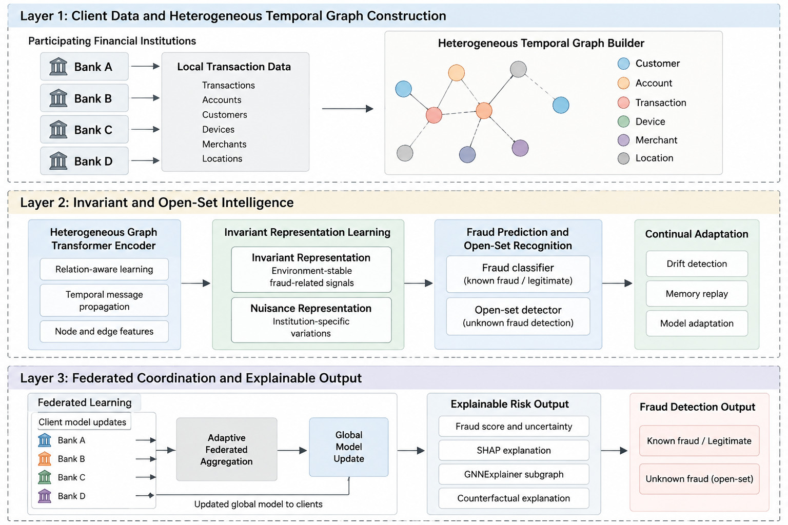
Fig. 1 Conceptual architecture of CausalFed-TGNN. Client-local multi-entity transactions are converted to heterogeneous temporal graphs; learned representations are decomposed into invariant and environment-specific components; federated coordination supports known-class prediction, open-set scoring, adaptation, and explanation output. The figure is illustrative and does not report measured performance.

4.2 Heterogeneous temporal graph construction
The implemented prediction graph has one transaction and four bank-local entity snapshots: account, merchant, device, and location. Customer/account identifiers are redundant aliases and are collapsed. Entity-to-transaction context_for edges and reverse uses edges are retained. Each snapshot contains the mean log amount of at most eight previous same-entity events, normalized prior frequency, log elapsed days since the last event, and a history indicator. Snapshots are read before appending the current event. Separate snapshots prevent future entity states from leaking between predictions; earlier unlabelled held-out events may update history prequentially.
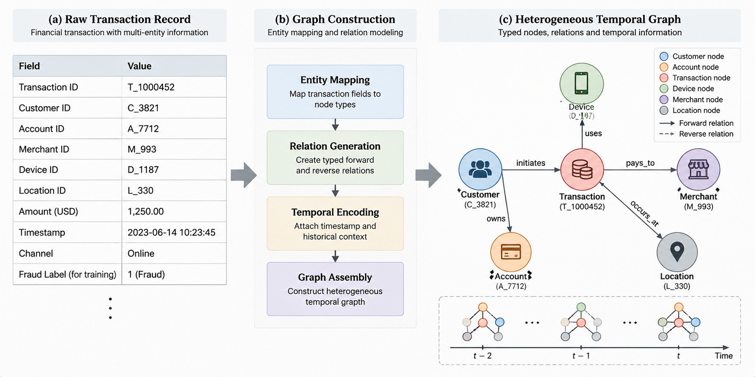
Fig. 2 Conceptual heterogeneous temporal graph construction. A raw multi-entity transaction is mapped to typed nodes, directed relation types, and temporal context to form relation-aware graph snapshots. The diagram specifies representation structure and is not an experimental result.

4.3 Temporal encoding and invariant representation decomposition
The implemented encoder uses one PyTorch Geometric HGTConv with width 24 and two attention heads, a residual transaction projection, and ReLU. It reads deterministic finite-history summaries rather than a learned recurrent memory. Reverse-edge outputs do not feed the current transaction in this one-layer readout. Elapsed time is the entity revisit interval, not a variable bank-arrival process; original bank event spacing remains fixed daily. Training-only standardization and event-specific histories prevent held-out information from entering preprocessing.
The representation-decomposition module separates the HGT output into invariant and environment-specific branches. Multi-environment batches provide the variation required for an invariant risk minimisation (IRM)-inspired regulariser; a cross-environment alignment term encourages shared fraud-relevant structure, while the environment-specific branch models institution-dependent variation. This is a predictive multi-environment design hypothesis and does not estimate interventions or causal effects.
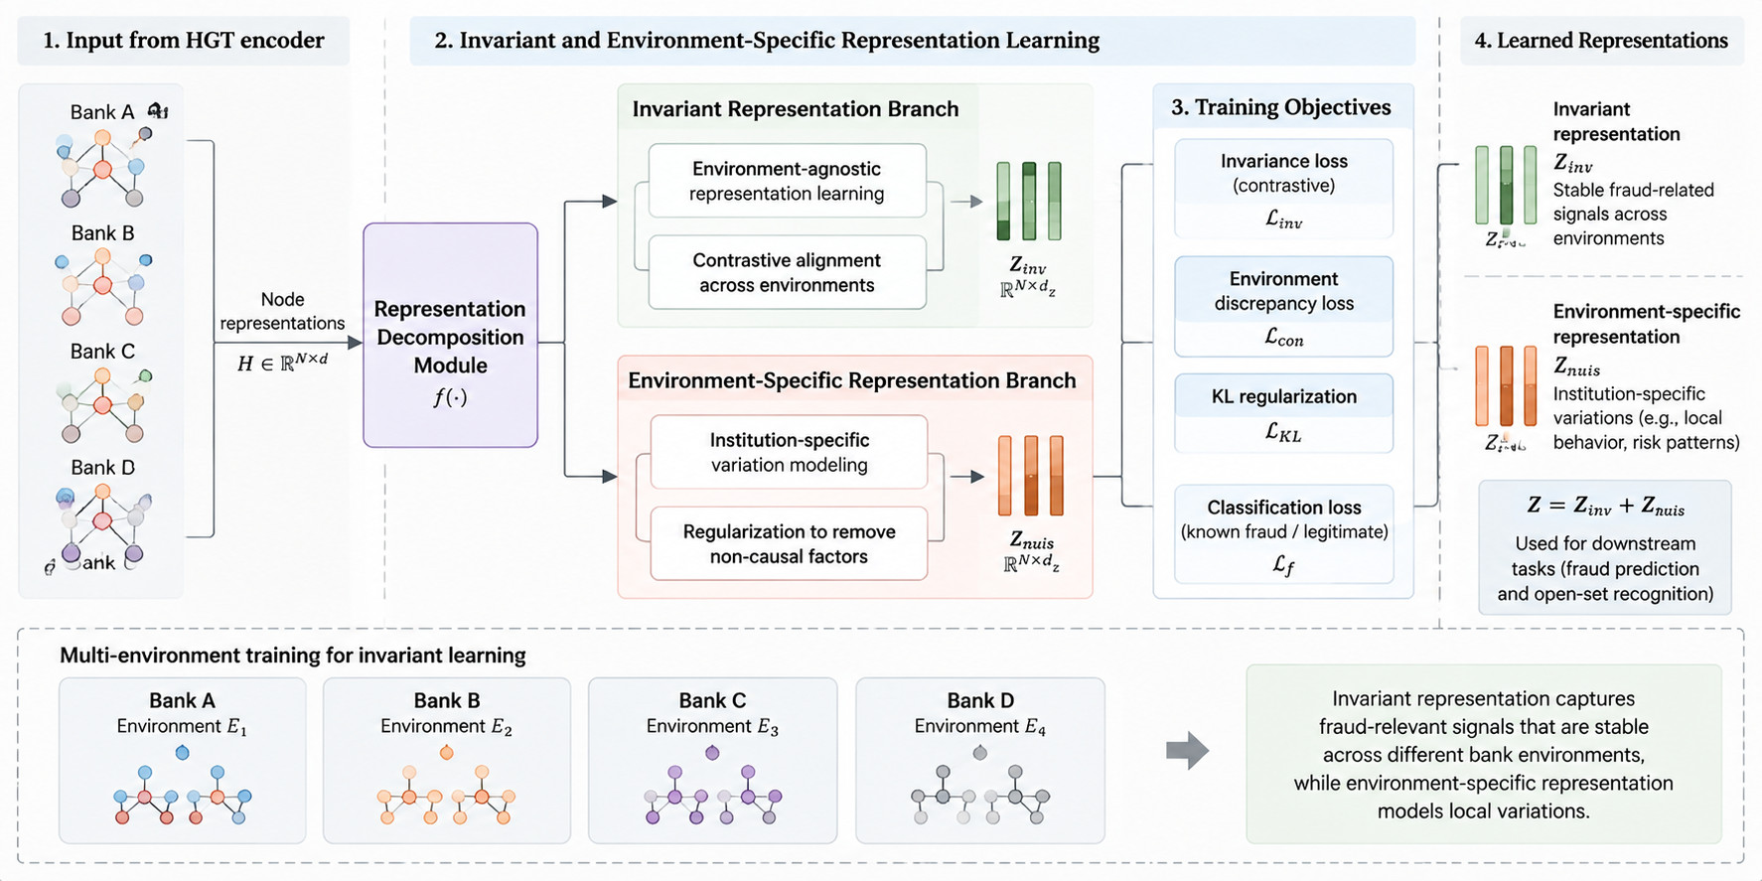
Fig. 3 Conceptual invariant/environment-specific representation decomposition. HGT representations are separated into shared and institution-specific components and optimized with supervised and multi-environment objectives. The intended separation must be validated empirically by ablation.
The executed objective is mean fraud cross entropy plus 0.1 times an IRMv1-inspired scale-gradient penalty, 0.01 times supervised cross-bank contrastive loss, and 0.1 times bank-classification loss on the environment branch. Contrastive temperature is 0.2 with at most 128 anchors per shuffled batch. Replay and KL coefficients are zero. IRM and contrastive terms are explicitly disabled for single-bank local batches. The fraud head reads only the invariant branch. Exact formulas and ablation definitions are supplied in EXPERIMENTAL_METHODS.md.
L = Lsup + λinv Linv + λcon Lcon + λenv Lenv + λreplay Lreplay + λKL LKL | (3)

4.4 Open-set recognition
Energy is negative logsumexp of the two logits at temperature one. The classifier-only margin comparator is the negative absolute logit difference; prototype distance is minimum Euclidean distance to two training-only class centroids. Every score increases toward unknown, without normalization. Thresholds are the linear 95th percentile of known validation scores, using score ≥ threshold. FPR95 is a descriptive test ROC statistic, not a threshold calibrated on unknown test labels. Amount is retained as an untrained, population-matched novelty comparator.
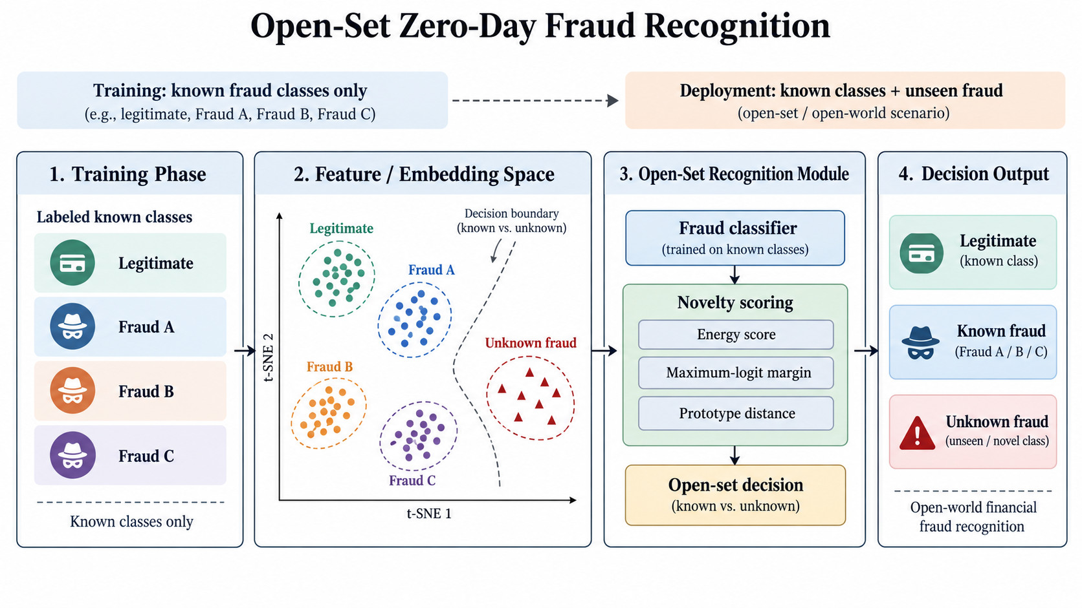
Fig. 4 Conceptual open-set evaluation protocol. Known classes are used for model fitting, late fraud mechanisms are withheld from training, and novelty thresholds are calibrated independently of the known-class boundary using energy, maximum-logit-margin, or prototype-distance scores.

4.5 Drift detection and continual adaptation
The deployment protocol monitors feature drift through distributional tests such as Kolmogorov-Smirnov or maximum mean discrepancy, graph drift through structural or community change, and prediction drift through error, uncertainty, and calibration signals. A pre-specified trigger can activate memory replay and model updating under a stability regulariser. Trigger definitions, replay capacity, update frequency, and rollback criteria must be fixed before evaluation. The benefit of this adaptation loop remains a planned ablation and is not a completed empirical result.
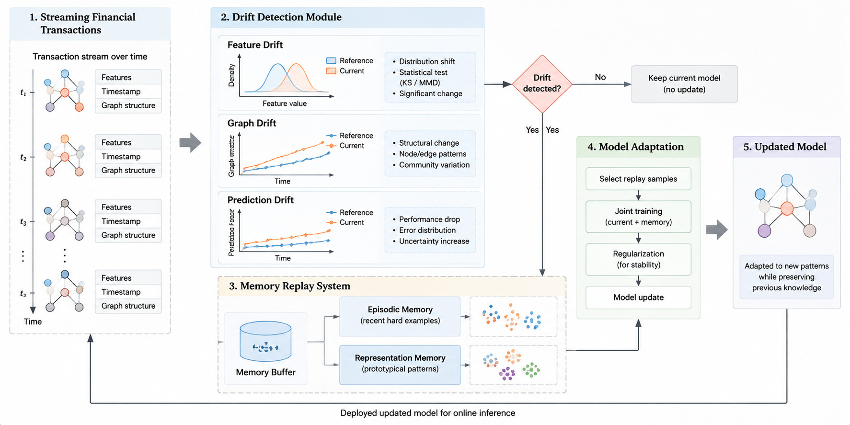
Fig. 5 Conceptual drift-monitoring and continual-adaptation loop. Feature, graph, and prediction monitors can trigger memory-replay-based updating before redeployment; no adaptation-performance result is encoded in the diagram.

4.6 Explainable risk output
For each suspicious event, the proposed interface reports known-class fraud probability, an uncertainty summary, and an open-set score together with complementary explanation objects: SHAP feature attributions [55], a GNNExplainer subgraph [53], and a counterfactual explanation [38-40]. Explanation quality is itself an evaluation target, including stability and sensitivity under context or relation deletion. These methods describe model behaviour; they do not establish causal explanations.

4.7 Federated optimization and adversarial robustness
The executed federated experiment simulates four banks in one process with full participation, eight communication rounds, and one local SGD epoch per round at learning rate 0.03. FedAvg uses sample-weighted averaging; FedProx adds a proximal coefficient of 0.01; SCAFFOLD uses local/server control variates; coordinate median averages the middle two coordinates. Checkpoints use lowest pooled validation cross entropy. The server-side validation and different optimizer schedule constrain comparisons with pooled Adam. Single-bank local training disables IRM and cross-bank alignment, so it is not the identical centralized invariant objective.
The threat model includes local label flipping, backdoor update injection, Sybil/collusion behaviour, and temporally evolving fraud. Attack strength, malicious-client fraction, trigger construction, and attacker knowledge must be specified for each scenario. Robust aggregation is evaluated only as an operational mitigation. Clean and attacked runs use matched seeds and retain per-round client-participation and update logs so that robustness degradation can be attributed to the attack condition.
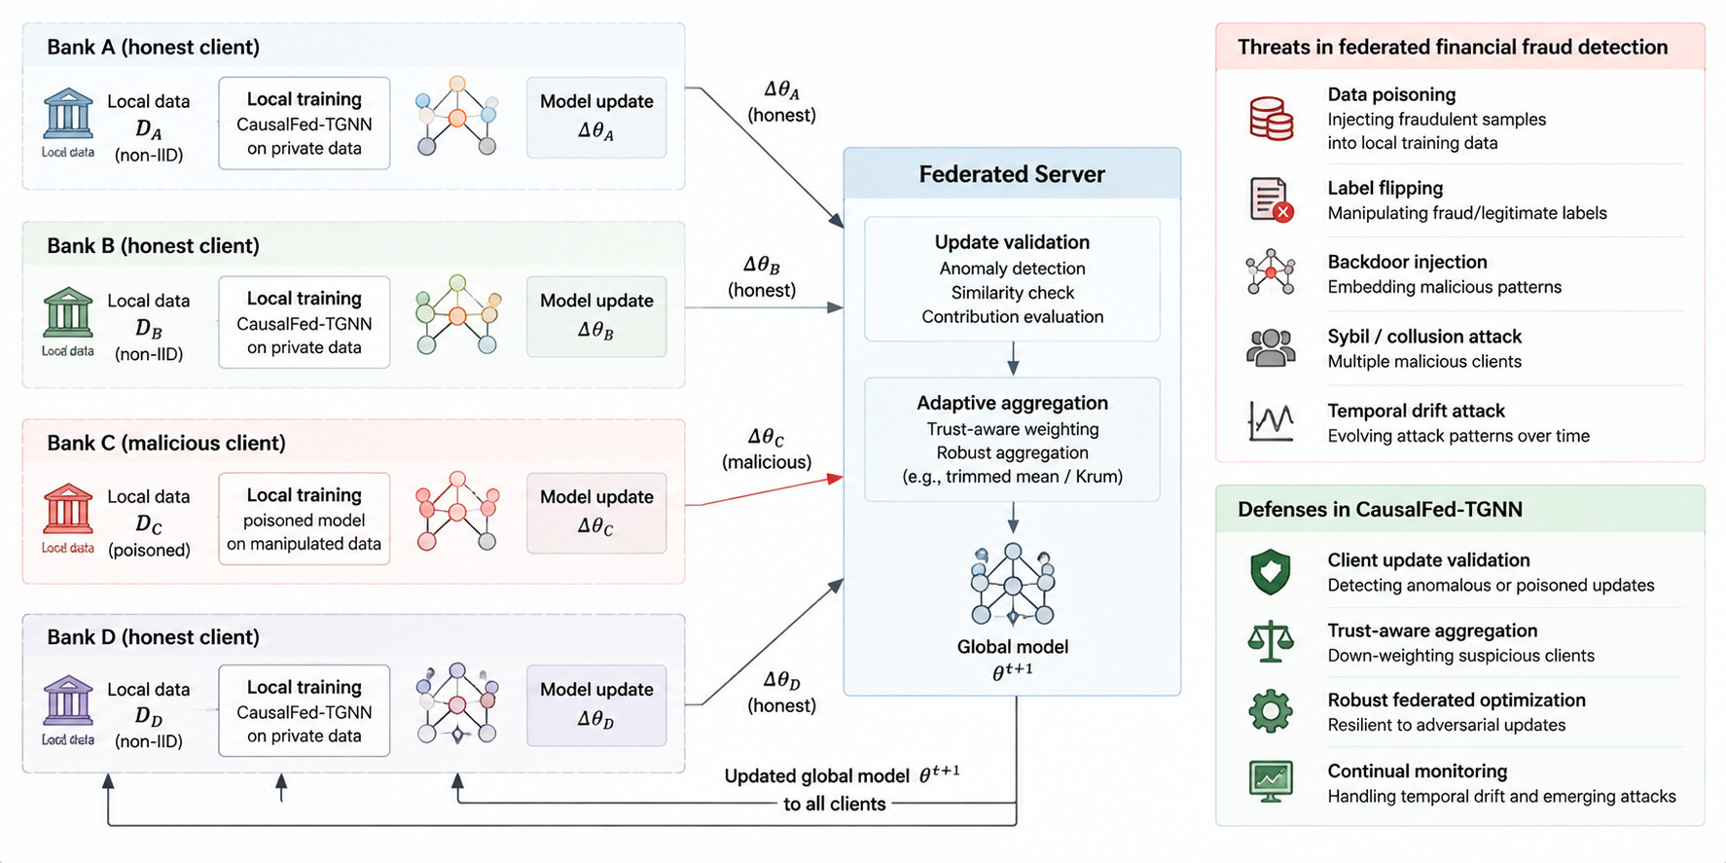
Fig. 6 Conceptual federated threat model and evaluation controls. Honest and malicious clients, update-level attacks, server-side diagnostics, robust aggregation, and continual monitoring are separated explicitly. The diagram specifies evaluation scope and does not imply verified robustness.

5. Experimental Methodology

5.1 Datasets, client environments, and temporal splitting
The controlled protocol creates four bank environments with configurable device reuse, merchant concentration, burstiness, label delay, and institutional heterogeneity. Known mechanisms A/B/C are eligible for model development, whereas late mechanisms D/E are withheld from training and reserved for open-set evaluation. The principal split preserves event time; random row shuffling is not used to create train/test partitions. Scale audits are complete at 50,000, 100,000, and 500,000 events, with five deterministic seeds (42-46) per scale. PaySim and IEEE-CIS remain separate evidence blocks until acquisition, schema, temporal, entity-mapping, and leakage checks pass.
Table 1 Deterministic scale-audit design and evidence status.
Events per run | Seeds | Runs | Banks | Evidence status
50,000 | 42–46 | 5 | 4 | complete
100,000 | 42–46 | 5 | 4 | complete
500,000 | 42–46 | 5 | 4 | complete
Note. Completed scale-audit records validate data generation and provenance only; they are not trained-model results.

5.2 Evaluation metrics and threshold policy
Known-class discrimination is evaluated with area under the receiver operating characteristic curve (AUROC), average precision (AP), F1, precision, recall, and balanced accuracy, with the positive class stated explicitly. Accuracy is secondary under severe imbalance [4,5]. Unknown-event detection is reported separately using unknown AUROC, AP, unknown F1, and the false-positive rate at 95% true-positive rate (FPR95). Known-class and novelty thresholds are selected on validation data only; the held-out unknown-test mechanism must not contribute to score selection, calibration, prototype construction, or operating-point choice. Calibration reporting includes expected calibration error (ECE) and score distributions where available [48].
Table 2 Reporting contract for known-class, open-set, calibration, and robustness evaluation.
Evaluation object | Primary measures | Threshold / comparison policy
Known fraud vs legitimate | AUROC, AP, F1, precision, recall, balanced accuracy | Threshold selected on validation data; positive class explicitly stated
Unknown-event detection | Unknown AUROC, AP, F1, FPR95 | Novelty threshold calibrated without the held-out unknown test mechanism
Calibration / uncertainty | ECE, score distribution, uncertainty summary | Measured on temporal validation/test splits; no post-hoc tuning on test
Adversarial robustness | Clean-to-attack performance gap; trigger success / degradation | Matched clean and attacked seeds with per-round logs
Note. Every empirical table must identify the evaluation population, positive class, number of seeds, threshold policy, evidence status, and whether values are trained-model outputs or diagnostic proxies. Variation estimates must be reported only when actually available.

5.3 Baselines and ablations
Executed neural comparators are a six-feature Context MLP, a history-matched MLP, homogeneous GraphSAGE, temporal GraphSAGE, static HGT, temporal HGT, and the decomposed full variant. The history-matched MLP receives the same entity summaries as graph models. Static here means no elapsed-time input, while causal histories remain available. Centralized training uses Adam at 0.001, batch size 2048, width 24, and eight epochs. Random forest and boosted-tree candidates remain unexecuted. Historical Amount LR and Context LR evidence is independently verified rather than silently treated as new fits.
Ablations are defined by the scientific question they test: removing L_inv tests multi-environment regularisation; removing the environment-specific branch tests explicit nuisance capacity; removing elapsed-time encoding tests temporal-gap information; collapsing relation types tests heterogeneity; removing L_con tests cross-environment alignment; removing explicit open-set scoring tests the value of a separate novelty decision; disabling replay/drift adaptation tests continual updating; and replacing robust/adaptive aggregation with FedAvg tests the aggregation contribution. Each ablation should report both metric change and the associated failure mode.

5.4 Adversarial stress tests
Table 3 Federated threat matrix and required audit artifacts.
Threat | Injection point | Primary outcome | Required audit artifact
Label flipping | Local labels | Known-class F1 / AUROC degradation | Attack manifest
Backdoor update | Parameter delta | Clean-vs-trigger performance gap | Per-round update log
Sybil / collusion | Client population | Robustness degradation under coordinated clients | Client roster and participation trace
Temporal drift | Late mechanisms | Unknown AUROC / FPR95 and adaptation effect | Time split and drift log
Note. Label flipping, sign-scaled update poisoning, and Sybil/collusion are executed under the controlled 50k protocol reported below. Backdoor trigger evaluation remains pending. Outcomes establish neither universal attack resistance nor privacy.

5.5 Public-data protocol
PaySim is the first public-data target because its mobile-money schema can be mapped to a reproducible transaction-graph adapter [54]. The current package records an expected checksum for the designated source, but the available transfer is incomplete and therefore cannot be treated as a verified dataset. IEEE-CIS requires authenticated Kaggle access and acceptance of the competition terms. Consequently, neither public dataset contributes a model-performance result to the current evidence set.
Table 4 Public-dataset acquisition and validation status.
Dataset | Acquisition status | Graph run | Current claim
PaySim | Partial mirror transfer; checksum not verified | pending | not reported as empirical result
IEEE-CIS Fraud Detection | Authenticated Kaggle access required | pending | not reported as empirical result
Note. Public-data results may enter comparative tables only after checksum, schema, missingness, temporal-ordering, entity-construction, client-assignment, label, and leakage checks are documented.

5.6 Reproducibility and artifact provenance
The canonical RESULTS_MANIFEST.json links each run to its source snapshot, configuration, dataset and split hashes, checkpoint, saved predictions, epoch/round log, environment, and runtime scope. Historical manifests and raw inputs remain unchanged. Known and open-set metrics are independently reconstructed from saved predictions. Source hashes are used because no Git commit is available; no commit identifier is fabricated.

5.7 Statistical reporting and leakage controls
Summaries report mean and sample SD only for five completed distinct seeds at the same scale and configuration. Paired ablation differences retain seed matching. No confidence intervals, p-values, or statistical-significance claims are made. Checkpoints minimize validation cross entropy; classification thresholds maximize validation F1 with highest-threshold tie breaking. Eight epochs or rounds is a fixed screening budget, not evidence of convergence. Model and generator randomness use the same seed and are not disentangled.

6. Results and Current Evidence Status

6.1 Scale and provenance audit
The current analysis verifies the SHA-256 hashes of all 15 available streams against the historical manifest and evaluates each stream independently. It does not rerun data generation or reinterpret historical generation time as model-training cost. Table 5 replaces the legacy amount diagnostics with freshly computed, tie-aware metrics on the late test partition. Table 6 reports exact partition sizes and measured positive support, while Figure 7 characterises institutional heterogeneity and the late prevalence shift. These checks establish input integrity and split separation for the present analysis; they do not establish realism of the synthetic process.
Table 5 Recomputed amount-based unknown-event diagnostics on the late 30% test partition. Mean ± sample SD across five seeds; D/E are positive.
Events | Unknown n | AUROC | AP | F1 | FPR95 | Test FPR
50,000 | 581.4 ± 20.7 | 0.537 ± 0.010 | 0.046 ± 0.003 | 0.064 ± 0.010 | 0.953 ± 0.007 | 0.062 ± 0.003
100,000 | 1151.0 ± 20.7 | 0.538 ± 0.014 | 0.046 ± 0.002 | 0.069 ± 0.002 | 0.949 ± 0.006 | 0.064 ± 0.001
500,000 | 5726.4 ± 101.5 | 0.544 ± 0.005 | 0.046 ± 0.002 | 0.072 ± 0.006 | 0.942 ± 0.002 | 0.063 ± 0.001
Note. AP is non-interpolated average precision; FPR95 is the minimum false-positive rate at a distinct score threshold attaining at least 95% unknown recall. F1 and Test FPR use the 95th percentile of validation amounts, with larger amounts indicating greater novelty. The final test set is never used to choose this operating threshold. FPR95 is a descriptive test-curve statistic rather than a deployed threshold. These values are untrained amount diagnostics, not CausalFed-TGNN outputs.
Legacy full-stream AUROC values were incorrect because the implementation combined descending ranks with an ascending-rank formula and did not assign tied scores equal credit. Holding the full-stream population fixed, the corrected mean AUROC values are 0.558, 0.559, and 0.564 at the three scales. These repair-only values are distinct from Table 5, which also changes the evaluation population to a disjoint late holdout. The corrected metric implementation passes known-answer and tie-permutation checks, while the analysis package retains the original records unchanged.
Table 6 Chronological split support per stream. Counts are exact for train, validation, and test; known/unknown test counts are mean ± sample SD over five seeds.
Events | Train | Validation | Test | Known test | Unknown D/E
50,000 | 25,000 | 10,000 | 15,000 | 14418.6 ± 20.7 | 581.4 ± 20.7
100,000 | 50,000 | 20,000 | 30,000 | 28849.0 ± 20.7 | 1151.0 ± 20.7
500,000 | 250,000 | 100,000 | 150,000 | 144273.6 ± 101.5 | 5726.4 ± 101.5
Note. Each stream contains four equally sized banks. The known-test population includes legitimate events and mechanisms A/B/C; the unknown-test population contains D/E. Their sum equals total test support in every run. No transaction ID overlaps the temporal partitions.
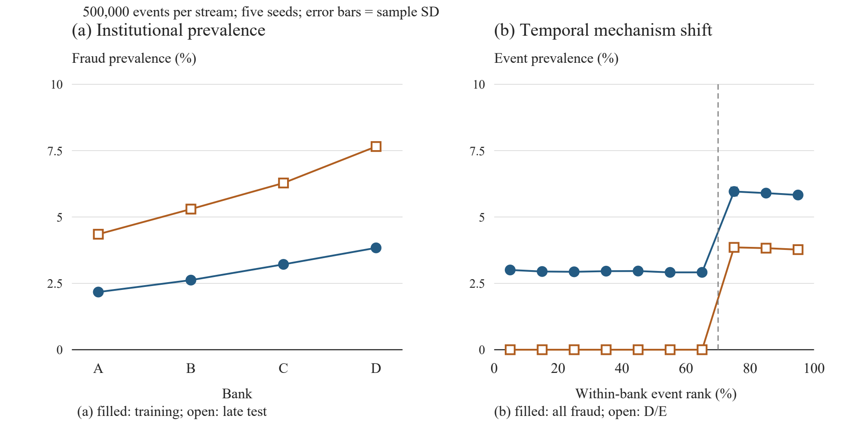
Fig. 7 Measured synthetic distribution shift at 500,000 events per stream. (a) Fraud prevalence by bank in training and late test. (b) All-fraud and D/E prevalence by event-rank decile; the dashed line marks the 70% boundary. Points are means and error bars are sample SD across five seeds. These describe the generator, not model performance.

6.2 Executed pooled logistic-regression baselines
We fitted two centralised logistic-regression model specifications to each synthetic stream; neither is federated nor graph-based. Amount LR uses log(1 + amount). Context LR adds past merchant and device frequencies computed within each bank and three bank indicators. The history features use log[1 + 1,000c/(r + 1)], where c counts prior occurrences of the entity and r counts prior bank events. Current and future events are excluded; earlier unlabelled validation/test events may update history in chronological order. Labels, fraud_type, period, and label-availability fields are excluded from model features. Bank identity is observed context rather than a learned graph representation.
Within each bank, the first 50% of events form the training partition, the next 20% validation, and the final 30% test. Features are standardised using training means and standard deviations. Both models minimise mean binary cross-entropy plus an L2 penalty of 0.001/2 times the squared non-intercept coefficients. Damped Newton optimisation uses at most 60 iterations and a maximum absolute gradient tolerance of 10^-8; all 30 fits satisfy the recorded convergence check. Hyperparameters and feature sets are fixed across runs. The classification threshold maximises validation F1, choosing the larger threshold in a tie. The known-class test excludes D/E by design; supplementary outputs retain all-late fraud evaluation. Predictions, fitted coefficients, normalisation parameters, and thresholds are saved for every fit.
Table 7 Trained pooled logistic-regression results for late known fraud A/B/C versus legitimate events. Mean ± sample SD over five seeds.
Events | Model | AUROC | AP | F1 | Brier
50,000 | Amount LR | 0.553 ± 0.027 | 0.027 ± 0.003 | 0.054 ± 0.014 | 0.0207 ± 0.0011
50,000 | Context LR | 0.539 ± 0.006 | 0.024 ± 0.002 | 0.041 ± 0.006 | 0.0208 ± 0.0011
100,000 | Amount LR | 0.541 ± 0.014 | 0.026 ± 0.002 | 0.056 ± 0.006 | 0.0207 ± 0.0010
100,000 | Context LR | 0.506 ± 0.017 | 0.021 ± 0.002 | 0.033 ± 0.007 | 0.0208 ± 0.0010
500,000 | Amount LR | 0.548 ± 0.006 | 0.027 ± 0.001 | 0.060 ± 0.002 | 0.0212 ± 0.0004
500,000 | Context LR | 0.515 ± 0.009 | 0.022 ± 0.001 | 0.037 ± 0.003 | 0.0213 ± 0.0004
Note. Larger AUROC, AP, and F1 and smaller Brier scores indicate better performance under their respective definitions. The models use identical data partitions, and F1 uses validation-selected thresholds. The Brier score is mean squared probability error without post-hoc recalibration. SD describes between-stream variation and is not a confidence interval. These results evaluate the pooled logistic-regression baselines, not CausalFed-TGNN.
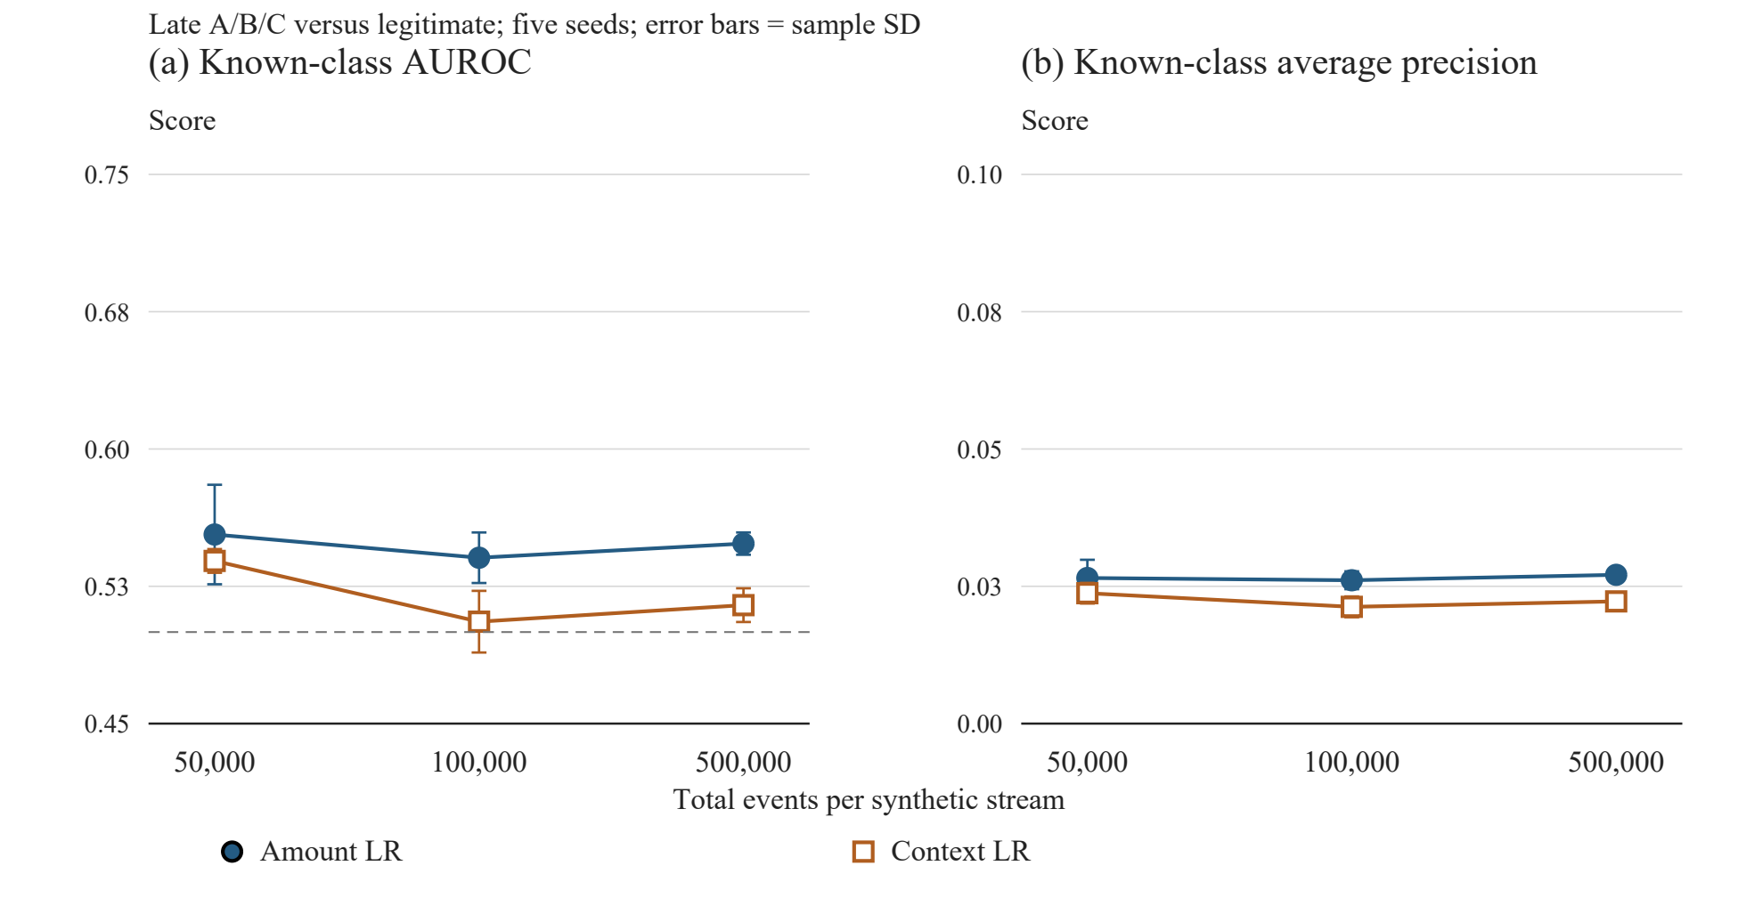
Fig. 8 Executed known-class baseline performance across synthetic scales. Points show seed means; error bars show sample SD (five seeds per scale). The dashed AUROC reference is 0.5. Scales are categorical conditions. Context LR adds past entity frequencies and bank indicators; no graph, invariant, federated, or continual-learning module is trained.
Amount LR has a higher mean AUROC and AP than Context LR at every tested scale (Table 7). At 500,000 events, mean F1 is 0.060 for Amount LR and 0.037 for Context LR. Under this synthetic shift and the specified feature construction, the additional history and bank indicators therefore do not improve the mean discrimination of this reference model. The comparison does not isolate individual context features and does not test graph representation learning. No significance claim is made from five generated streams, and results across scales reuse seed identifiers rather than constituting independent replications of real financial populations.

6.3 Unknown-event operating characteristics
The original amount novelty diagnostic remains a weak reference on the same late-event population. Trained energy, negative-margin, and prototype-distance scores are now evaluated independently on all test events, with D/E positive and known validation-only thresholds. Table 11 reports their five-seed ranking and operating characteristics. A favorable ranking metric must not be interpreted as an operational detection guarantee; unknown recall and known false-positive rate at the fixed threshold are retained in the machine-readable records.
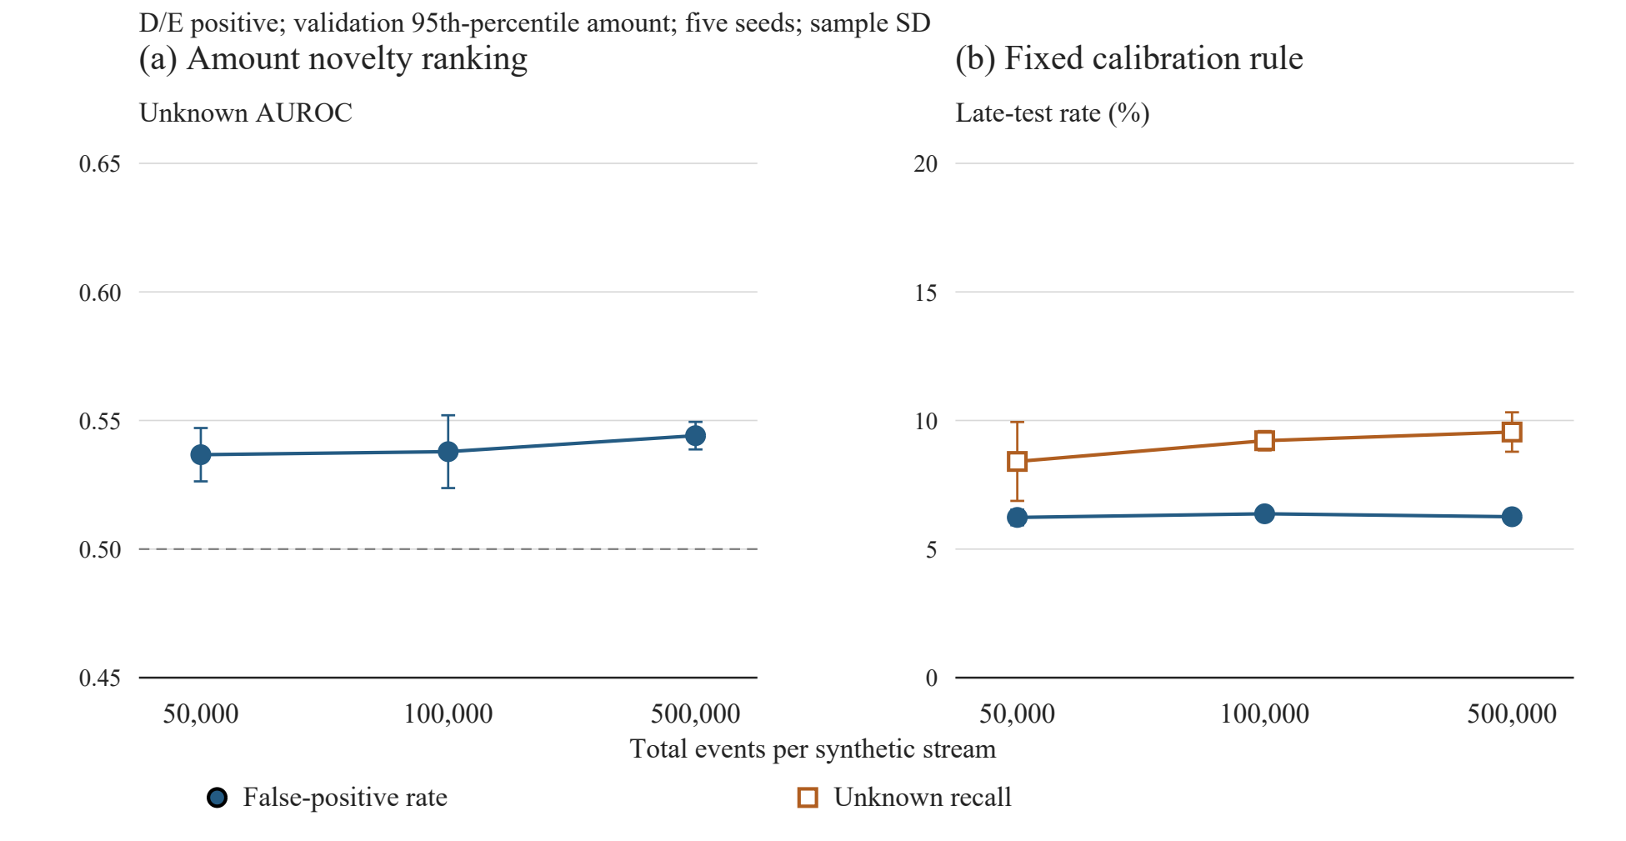
Fig. 9 Corrected amount-based novelty diagnostics on the late test partition. (a) Unknown AUROC with a 0.5 reference. (b) False-positive rate among non-D/E events and recall of D/E at the threshold fixed from validation amounts. Points show means and error bars sample SD across five seeds. All score ties are evaluated together.

6.4 Generator validity and reproducibility checks
Table 8 Executed data checks and scope of the synthetic evidence.
Check | Observed result | Scientific implication
Input integrity | 15/15 CSV hashes match the existing manifest | Identifies the exact analysed data; does not certify realism
Split leakage | No D/E in train or validation; unique transaction IDs; strictly separated timestamps | Supports the temporal partition used in these new runs
Event spacing | 1,440 minutes between consecutive events within every bank | Current data cannot test sensitivity to varying elapsed-time gaps
Source row order | Bank-major; not globally chronological | Explicit bank/time sorting is required before analysis
Fraud-rate control | Observed prevalence near 3.83%; generator argument defaults to 1.2% | Argument is an offset to risk, not an achieved prevalence target
Note. All 15 original streams pass hash, support, chronological separation, unique-ID, and D/E-exclusion checks. Source generator and historical manifests are unchanged. Historical logistic convergence is recorded separately; neural and federated runs complete a fixed screening budget without a convergence claim.
The timestamp construction advances each bank by exactly one day per event, even though the generator includes a parameter named burstiness. That parameter affects the amount-generating process rather than inter-event timing. The present experiment therefore measures a controlled event-rank shift, not realistic burst timing or elapsed-time robustness. The four synthetic bank identities are explicit experimental environments rather than independently sampled financial institutions. Generator redesign and external data are required before claims about operational temporal-graph behaviour can be evaluated.

6.5 Evidence completion and remaining gates
New recorded evidence comprises 180 centralized neural fits, 20 clean four-bank federated simulations, and 30 attacked simulations. Each completed run retains a reload-tested checkpoint and saved predictions. Graph comparisons, representation ablations, elapsed-time removal on original streams, and trained novelty scores are now evaluated. Continual adaptation, realistic temporal-stress generation, public-data performance, and unseen-bank transfer remain pending. Consequently, the broader project remains experimentally partial.
Table 9 Empirical completion gates and current evidence status.
Evidence block | Completion criterion | Current state
Scale and provenance | 15 immutable streams | PASS
Centralized graph models | Five seeds at three scales | 180 recorded fits
Representation and novelty | Matched ablations and separate scores | EXECUTED within snapshot scope
Federated methods | Four methods; 50k; five seeds | 20 clean fits
Controlled attacks | Two aggregators; three attacks; five seeds | 30 fits
Public data and continual adaptation | Validated datasets and prequential adaptation | PENDING / BLOCKED
Unseen-bank transfer and temporal stress | Separate experiments | PENDING
Note. Completion applies only to the specific recorded configuration and scope. The output filename is not a scientific completion claim. Pending modules require separate traceable experiments.

6.6 Recorded neural, federated, and attack screening
The following tables are generated from the canonical manifest. COMPLETE means that a defined screening run finished and produced traceable outputs; it does not establish convergence, optimal tuning, or completion of the broader framework.
Table 10 Executed centralized neural comparison
Events | Model | AUROC | AP | F1
50,000 | Full variant | 0.490 ± 0.022 | 0.021 ± 0.001 | 0.040 ± 0.005
50,000 | Static HGT | 0.503 ± 0.041 | 0.021 ± 0.004 | 0.042 ± 0.003
50,000 | HGT | 0.498 ± 0.034 | 0.022 ± 0.003 | 0.042 ± 0.004
50,000 | History MLP | 0.489 ± 0.029 | 0.022 ± 0.002 | 0.039 ± 0.005
50,000 | MLP | 0.510 ± 0.041 | 0.022 ± 0.004 | 0.045 ± 0.006
50,000 | GraphSAGE | 0.502 ± 0.043 | 0.022 ± 0.004 | 0.040 ± 0.010
50,000 | Temporal SAGE | 0.496 ± 0.034 | 0.021 ± 0.004 | 0.040 ± 0.009
100,000 | Full variant | 0.504 ± 0.015 | 0.021 ± 0.003 | 0.035 ± 0.006
100,000 | Static HGT | 0.458 ± 0.024 | 0.019 ± 0.000 | 0.032 ± 0.006
100,000 | HGT | 0.470 ± 0.017 | 0.019 ± 0.001 | 0.034 ± 0.007
100,000 | History MLP | 0.487 ± 0.007 | 0.021 ± 0.001 | 0.037 ± 0.003
100,000 | MLP | 0.488 ± 0.019 | 0.021 ± 0.002 | 0.038 ± 0.005
100,000 | GraphSAGE | 0.484 ± 0.019 | 0.020 ± 0.002 | 0.038 ± 0.007
100,000 | Temporal SAGE | 0.483 ± 0.023 | 0.021 ± 0.002 | 0.037 ± 0.006
500,000 | Full variant | 0.506 ± 0.014 | 0.022 ± 0.001 | 0.037 ± 0.002
500,000 | Static HGT | 0.509 ± 0.011 | 0.022 ± 0.001 | 0.038 ± 0.003
500,000 | HGT | 0.507 ± 0.011 | 0.022 ± 0.001 | 0.037 ± 0.006
500,000 | History MLP | 0.509 ± 0.010 | 0.022 ± 0.001 | 0.038 ± 0.004
500,000 | MLP | 0.513 ± 0.011 | 0.022 ± 0.001 | 0.037 ± 0.004
500,000 | GraphSAGE | 0.510 ± 0.010 | 0.022 ± 0.001 | 0.038 ± 0.005
500,000 | Temporal SAGE | 0.510 ± 0.009 | 0.022 ± 0.001 | 0.037 ± 0.005
Note. Five seeds per row; mean ± sample SD. Positive class A/B/C fraud versus legitimate known test events. F1 uses validation maximum-F1 thresholds. Evidence: completed eight-epoch screening. History MLP controls access to entity summaries; capacity is not identical.
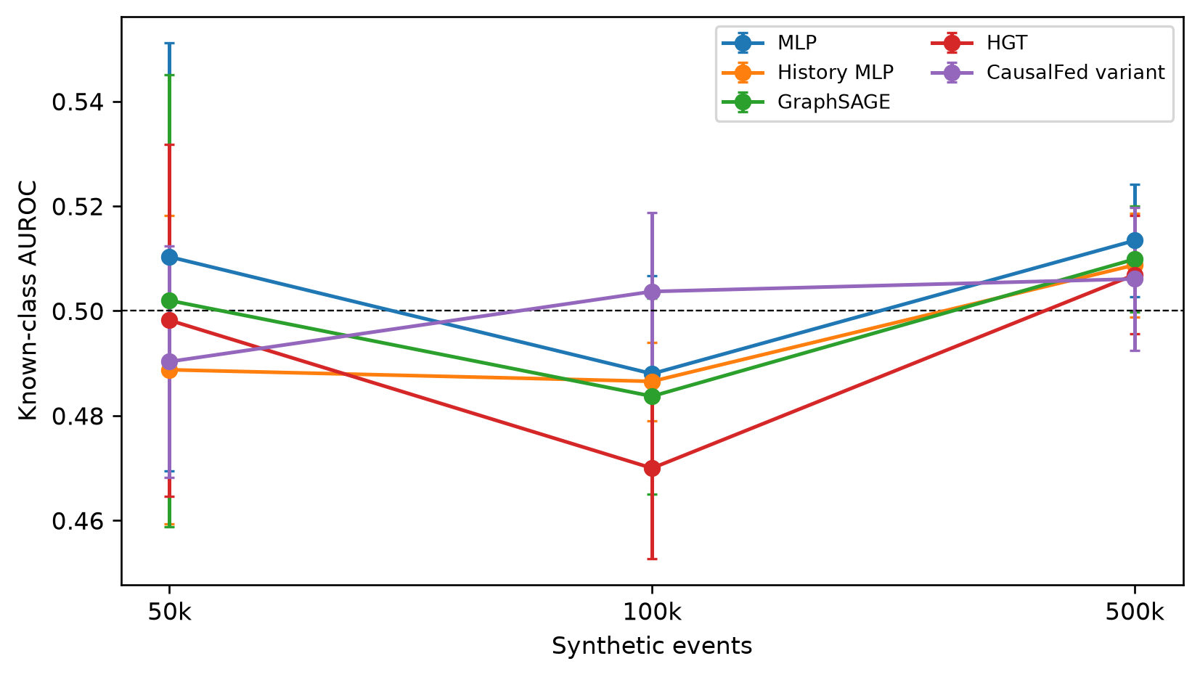
Fig. 10 Measured known-class AUROC across synthetic scales. Five-seed means and sample SD; fixed eight-epoch screening budget. The dashed line denotes AUROC 0.5.
Table 11 Independent novelty scores for the full variant
Events | Score | AUROC | AP | FPR95
50,000 | amount | 0.537 ± 0.010 | 0.046 ± 0.003 | 0.953 ± 0.007
50,000 | energy | 0.500 ± 0.024 | 0.040 ± 0.004 | 0.950 ± 0.016
50,000 | negative margin | 0.494 ± 0.032 | 0.038 ± 0.003 | 0.948 ± 0.018
50,000 | prototype distance | 0.508 ± 0.030 | 0.041 ± 0.003 | 0.941 ± 0.011
100,000 | amount | 0.538 ± 0.014 | 0.046 ± 0.002 | 0.949 ± 0.006
100,000 | energy | 0.576 ± 0.035 | 0.054 ± 0.005 | 0.932 ± 0.017
100,000 | negative margin | 0.581 ± 0.017 | 0.054 ± 0.001 | 0.931 ± 0.013
100,000 | prototype distance | 0.525 ± 0.026 | 0.041 ± 0.003 | 0.927 ± 0.025
500,000 | amount | 0.544 ± 0.005 | 0.046 ± 0.002 | 0.942 ± 0.002
500,000 | energy | 0.635 ± 0.019 | 0.063 ± 0.006 | 0.868 ± 0.029
500,000 | negative margin | 0.647 ± 0.007 | 0.067 ± 0.002 | 0.866 ± 0.012
500,000 | prototype distance | 0.506 ± 0.013 | 0.038 ± 0.002 | 0.941 ± 0.011
Note. Five seeds; mean ± sample SD; D/E positive among all late test events. Higher score means unknown. Operating thresholds use only the known validation 95th percentile; FPR95 is a descriptive test ROC point. Evidence: completed. Negative margin is the classifier-only scoring ablation; amount is untrained.
Table 12 Paired representation ablation differences
Events | Ablation | ΔAUROC | ΔAP | ΔF1
50,000 | Collapsed HGT | -0.002 ± 0.023 | -0.000 ± 0.002 | -0.003 ± 0.007
50,000 | No contrastive | -0.000 ± 0.001 | -0.000 ± 0.000 | 0.001 ± 0.003
50,000 | No environment | 0.012 ± 0.020 | 0.001 ± 0.002 | 0.002 ± 0.004
50,000 | No IRM | -0.001 ± 0.001 | -0.000 ± 0.000 | 0.001 ± 0.003
50,000 | No elapsed time | 0.002 ± 0.010 | -0.000 ± 0.000 | 0.000 ± 0.001
100,000 | Collapsed HGT | -0.015 ± 0.021 | -0.001 ± 0.002 | 0.002 ± 0.006
100,000 | No contrastive | 0.002 ± 0.001 | 0.000 ± 0.000 | -0.000 ± 0.003
100,000 | No environment | -0.012 ± 0.005 | -0.001 ± 0.000 | -0.003 ± 0.005
100,000 | No IRM | -0.000 ± 0.001 | -0.000 ± 0.000 | -0.001 ± 0.003
100,000 | No elapsed time | 0.002 ± 0.009 | 0.000 ± 0.001 | -0.003 ± 0.006
500,000 | Collapsed HGT | 0.004 ± 0.007 | 0.000 ± 0.001 | -0.001 ± 0.004
500,000 | No contrastive | 0.004 ± 0.008 | 0.000 ± 0.000 | 0.001 ± 0.005
500,000 | No environment | -0.000 ± 0.005 | 0.000 ± 0.001 | -0.000 ± 0.004
500,000 | No IRM | 0.000 ± 0.002 | 0.000 ± 0.000 | 0.001 ± 0.001
500,000 | No elapsed time | -0.002 ± 0.005 | -0.000 ± 0.000 | -0.003 ± 0.005
Note. Ablation minus full variant, paired by five seeds; mean ± sample SD. A/B/C versus legitimate known test events; each run uses validation maximum-F1 calibration. Evidence: completed screening. Small differences do not establish significance; same-bank results do not demonstrate unseen-bank transfer.
Table 13 Clean four-client federated simulation at 50k
Method | AUROC | AP | F1
fedavg | 0.495 ± 0.056 | 0.022 ± 0.003 | 0.043 ± 0.005
fedprox | 0.495 ± 0.056 | 0.022 ± 0.003 | 0.043 ± 0.005
median | 0.497 ± 0.060 | 0.022 ± 0.004 | 0.044 ± 0.005
scaffold | 0.495 ± 0.056 | 0.022 ± 0.003 | 0.043 ± 0.005
Note. Five seeds; mean ± sample SD; A/B/C fraud versus legitimate known test events. Pooled validation selects checkpoints and F1 thresholds. Evidence: completed eight-round simulation. Single-bank IRM/alignment are disabled. This is not a private deployment benchmark.
Table 14 Controlled attack outcomes at 50k
Method | Attack | AUROC | AP | F1
fedavg | label flip | 0.482 ± 0.049 | 0.021 ± 0.002 | 0.038 ± 0.007
fedavg | poison | 0.481 ± 0.073 | 0.021 ± 0.004 | 0.038 ± 0.013
fedavg | sybil | 0.479 ± 0.082 | 0.021 ± 0.005 | 0.038 ± 0.010
median | label flip | 0.481 ± 0.054 | 0.022 ± 0.005 | 0.035 ± 0.008
median | poison | 0.478 ± 0.052 | 0.022 ± 0.005 | 0.036 ± 0.010
median | sybil | 0.481 ± 0.082 | 0.021 ± 0.005 | 0.037 ± 0.010
Note. Five matched seeds; mean ± sample SD; known A/B/C-versus-legitimate test population. Attack begins at round one: bank 0 flips 50% of labels or sends −5 times its update; Sybil adds two poisoned identities. Pooled validation determines the checkpoint and F1 threshold separately per attacked run. Evidence: completed controlled simulation; no universal robustness claim.
Table 15 Recorded computational cost
Events | Model | Train s | Evaluation s | Parameters
50,000 | Full variant | 18.8 ± 7.4 | 1.0 ± 0.2 | 18,627
50,000 | HGT | 14.3 ± 3.7 | 1.0 ± 0.2 | 17,327
50,000 | MLP | 1.3 ± 0.3 | 0.3 ± 0.1 | 818
50,000 | GraphSAGE | 2.8 ± 1.0 | 0.4 ± 0.1 | 1,514
100,000 | Full variant | 35.1 ± 4.4 | 2.1 ± 0.2 | 18,627
100,000 | HGT | 32.3 ± 3.6 | 2.2 ± 0.3 | 17,327
100,000 | MLP | 2.1 ± 0.4 | 0.6 ± 0.1 | 818
100,000 | GraphSAGE | 5.6 ± 0.6 | 0.7 ± 0.0 | 1,514
500,000 | Full variant | 167.1 ± 23.3 | 11.3 ± 1.2 | 18,627
500,000 | HGT | 149.1 ± 2.5 | 11.6 ± 1.3 | 17,327
500,000 | MLP | 12.4 ± 3.1 | 2.8 ± 0.2 | 818
500,000 | GraphSAGE | 27.3 ± 2.6 | 4.0 ± 0.5 | 1,514
Note. Five seeds; mean ± sample SD except architecture parameter count. Training includes setup and validation; evaluation includes training prototypes, predictions, and metrics. CPU workers run concurrently. Evidence: measured runtime and deterministic parameter counts. No target class or operating threshold applies to cost. Lifetime memory peaks and tensor-payload communication counts are retained with their scope in CSV records.

7. Discussion
The current revision separates evaluation objects that are otherwise easy to conflate. Known-class fraud probability and unknown-event novelty use different scores and threshold policies; invariant learning is treated as a predictive regulariser rather than causal identification; federated robustness is separated from privacy and security guarantees; and protocol diagnostics are separated from trained-model evidence. This distinction is important because an improvement in one objective cannot be assumed to transfer to another.
OBSERVED: The recorded tables quantify discrimination, novelty detection, ablation differences, and attack effects under one compact training budget. Completion of a graph run does not establish that message passing improves on tabular modeling. The history-matched MLP is needed to distinguish extra input information from architecture. Negative and near-chance outcomes are retained; the protocol does not support a state-of-the-art or significance claim.
HYPOTHESIZED: Limited optimization, low predictive signal, class imbalance, and generator-defined mechanism selection may contribute to weak discrimination. These explanations are not established by the present runs. Invariant-loss ablations evaluate temporal generalization within the same four banks; they do not test unseen-bank transfer or identify a causal representation. Changes in branch or relation capacity are also potential confounders and are documented.
Open-set deployment introduces a direct false-alarm trade-off. Increasing sensitivity to novel fraud can route more legitimate but unusual transactions for review, and threshold choices may behave differently across institutions with different prevalence and investigation costs. Reporting FPR95, score distributions, per-client performance, and calibrated operating points is therefore necessary to determine whether novelty detection is operationally useful rather than merely rank-consistent.
Synthetic-to-real transfer is the principal external-validity risk. Controlled synthetic data are useful for deterministic mechanism holdouts and attack injection, but real transaction datasets introduce missingness, schema ambiguity, incomplete entity linkage, label noise, institution-specific prevalence, and computational constraints that are difficult to reproduce synthetically. Public-data validation is therefore required before generalising beyond the controlled protocol.
Deployment conclusions must also keep robustness, privacy, and security distinct. A robust aggregation rule may reduce the effect of some malicious updates yet still leak information or fail under collusion; similarly, keeping raw data local does not establish differential privacy. Future deployment studies should report these dimensions independently, together with institution-specific thresholds, investigation capacity, and rollback procedures.

8. Limitations
The evidence is synthetic-only and uses four generator-defined bank environments, five seeds, and eight-epoch/round screening budgets without a hyperparameter search. The implemented one-layer finite-history snapshot architecture is narrower than the conceptual framework. Customer/account redundancy is collapsed; histories are summarized deterministically. Fixed daily bank timing prevents realistic arrival-gap and burst-timing claims. Known-class evaluation excludes D/E and must not be confused with all-fraud screening. Public-data acquisition and authorization remain incomplete.
Sixth, the method does not implement causal discovery, intervention modelling, or causal-effect estimation despite the historical project name. Seventh, no differential-privacy accountant or secure-aggregation implementation is present, and parameter exchange alone does not establish privacy. Eighth, robust aggregation can fail under adaptive or coordinated attacks and should not be described as a universal security defence. Ninth, explanation methods can be unstable, incomplete, or sensitive to perturbation and should be treated as summaries of model behaviour rather than ground truth.
Energy, negative margin, and learned prototype scores are evaluated only under the synthetic holdout protocol. Continual adaptation and explanation-quality evaluation remain pending. The federated simulation disables multi-environment regularization in single-bank local batches and uses pooled validation. Attack assumptions are fixed and limited; sign-flipped updates need not degrade every metric when clean models are weak. Sample SD across five seeds is not a confidence interval or real-world replication guarantee. Conceptual figures remain labelled as such.
The expanded package provides verifiable screening evidence while retaining incomplete gates. Longer-budget validation, held-out-bank experiments, variable-arrival stress tests, public data, and continual/explanation evaluations are needed before stronger architectural or deployment claims.

9. Conclusion
The finite-history CausalFed-TGNN implementation was evaluated through 180 centralized fits, 20 clean federated simulations, and 30 attacked simulations with saved provenance. At 500,000 events its known AUROC is 0.506 ± 0.014 and energy novelty AUROC is 0.635 ± 0.019. These measured outcomes and matched ablations support a reproducible screening comparison, not a general superiority claim. Synthetic dependence, fixed timing, limited optimization, same-bank evaluation, and missing public/continual validation keep the broader project incomplete.

Data, Code, and Reproducibility Statement
The experimental_validation package supplies source files, pinned dependencies, DATA_AUDIT, RESULTS_MANIFEST.json, individual run records, source snapshots, reload-tested checkpoints, saved late-event predictions, epoch/round logs, generated CSV tables, vector figures, and exact commands in REPRODUCTION.md. Historical ANALYSIS_MANIFEST.json and all raw streams remain unchanged. Source and output hashes permit independent verification. Public-data adapters are schema-tested on artificial fixtures only; no empirical public-data result is included.

Ethics and Privacy Statement
The executed study uses synthetic records in a single-machine simulation. Client partitioning is an experimental boundary, not a deployed privacy mechanism. Model updates can expose information; no differential privacy or secure aggregation is implemented or claimed. Explanation outputs, if added in future, must describe model behavior rather than causal effects.

References
[1] Andrea Dal Pozzolo, Giacomo Boracchi, Olivier Caelen, Cesare Alippi, Gianluca Bontempi. Credit Card Fraud Detection: A Realistic Modeling and a Novel Learning Strategy. IEEE Transactions on Neural Networks and Learning Systems, 2018.
[2] Johannes Jurgovsky, Michael Granitzer, Konstantin Ziegler, Sylvie Calabretto, Pierre-Edouard Portier et al. Sequence classification for credit-card fraud detection. Expert Systems with Applications, 2018.
[3] Andrea Dal Pozzolo, Olivier Caelen, Yann-Aël Le Borgne, Serge Waterschoot, Gianluca Bontempi. Learned lessons in credit card fraud detection from a practitioner perspective. Expert Systems with Applications, 2014.
[4] Kushankur Ghosh, Colin Bellinger, Roberto Corizzo, Paula Branco, Bartosz Krawczyk et al. The class imbalance problem in deep learning. Machine Learning, 2022.
[5] Takaya Saito, Marc Rehmsmeier. The Precision-Recall Plot Is More Informative than the ROC Plot When Evaluating Binary Classifiers on Imbalanced Datasets. PLOS ONE, 2015.
[6] Ziniu Hu, Yuxiao Dong, Kuansan Wang, Yizhou Sun. Heterogeneous Graph Transformer. Proceedings of The Web Conference 2020, 2020.
[7] Yingtong Dou, Zhiwei Liu, Li Sun, Yutong Deng, Hao Peng et al. Enhancing Graph Neural Network-based Fraud Detectors against Camouflaged Fraudsters. Proceedings of the 29th ACM International Conference on Information & Knowledge Management, 2020.
[8] Yang Liu, Xiang Ao, Zidi Qin, Jianfeng Chi, Jinghua Feng et al. Pick and Choose: A GNN-based Imbalanced Learning Approach for Fraud Detection. Proceedings of the Web Conference 2021, 2021.
[9] Daixin Wang, Jianbin Lin, Peng Cui, Quanhui Jia, Zhen Wang et al. A Semi-Supervised Graph Attentive Network for Financial Fraud Detection. 2019 IEEE International Conference on Data Mining (ICDM), 2019.
[10] Fengzhao Shi, Yanan Cao, Yanmin Shang, Yuchen Zhou, Chuan Zhou et al. H2-FDetector: A GNN-based Fraud Detector with Homophilic and Heterophilic Connections. Proceedings of the ACM Web Conference 2022, 2022.
[11] Mingxuan Lu, Zhichao Han, Susie Xi Rao, Zitao Zhang, Yang Zhao et al. BRIGHT - Graph Neural Networks in Real-time Fraud Detection. Proceedings of the 31st ACM International Conference on Information & Knowledge Management, 2022.
[12] Jie Zhou, Ganqu Cui, Shengding Hu, Zhengyan Zhang, Cheng Yang et al. Graph neural networks: A review of methods and applications. AI Open, 2020.
[13] Aldo Pareja, Giacomo Domeniconi, Jie Chen, Tengfei Ma, Toyotaro Suzumura et al. EvolveGCN: Evolving Graph Convolutional Networks for Dynamic Graphs. Proceedings of the AAAI Conference on Artificial Intelligence, 2020.
[14] Peter Kairouz, H. Brendan McMahan. Advances and Open Problems in Federated Learning. Foundations and Trends® in Machine Learning, 2021.
[15] Sudipan Saha, Tahir Ahmad. Federated transfer learning: Concept and applications. Intelligenza Artificiale: The international journal of the AIxIA, 2021.
[16] Pushpa Singh, Murari Kumar Singh, Rajnesh Singh, Narendra Singh. Federated Learning: Challenges, Methods, and Future Directions. EAI/Springer Innovations in Communication and Computing Federated Learning for IoT Applications, 2022.
[17] Fengxia Liu, Zhiming Zheng, Yexuan Shi, Yongxin Tong, Yi Zhang. A survey on federated learning: a perspective from multi-party computation. Frontiers of Computer Science, 2023.
[18] Qinbin Li, Zeyi Wen, Zhaomin Wu, Sixu Hu, Naibo Wang et al. A Survey on Federated Learning Systems: Vision, Hype and Reality for Data Privacy and Protection. IEEE Transactions on Knowledge and Data Engineering, 2023.
[19] Hangyu Zhu, Jinjin Xu, Shiqing Liu, Yaochu Jin. Federated learning on non-IID data: A survey. Neurocomputing, 2021.
[20] Keith Bonawitz, Vladimir Ivanov, Ben Kreuter, Antonio Marcedone, H. Brendan McMahan et al. Practical Secure Aggregation for Privacy-Preserving Machine Learning. Proceedings of the 2017 ACM SIGSAC Conference on Computer and Communications Security, 2017.
[21] Martin Abadi, Andy Chu, Ian Goodfellow, H. Brendan McMahan, Ilya Mironov et al. Deep Learning with Differential Privacy. Proceedings of the 2016 ACM SIGSAC Conference on Computer and Communications Security, 2016.
[22] Ligeng Zhu, Song Han. Deep Leakage from Gradients. Lecture Notes in Computer Science Federated Learning, 2020.
[23] Kaushal Kishor. Personalized Federated Learning. EAI/Springer Innovations in Communication and Computing Federated Learning for IoT Applications, 2022.
[24] Matthias Delange, Rahaf Aljundi, Marc Masana, Sarah Parisot, Xu Jia et al. A continual learning survey: Defying forgetting in classification tasks. IEEE Transactions on Pattern Analysis and Machine Intelligence, 2021.
[25] Liyuan Wang, Xingxing Zhang, Hang Su, Jun Zhu. A Comprehensive Survey of Continual Learning: Theory, Method and Application. IEEE Transactions on Pattern Analysis and Machine Intelligence, 2024.
[26] Andrea Cossu, Antonio Carta, Vincenzo Lomonaco, Davide Bacciu. Continual learning for recurrent neural networks: An empirical evaluation. Neural Networks, 2021.
[27] James Kirkpatrick, Razvan Pascanu, Neil Rabinowitz, Joel Veness, Guillaume Desjardins et al. Overcoming catastrophic forgetting in neural networks. Proceedings of the National Academy of Sciences, 2017.
[28] Zhizhong Li, Derek Hoiem. Learning without Forgetting. IEEE Transactions on Pattern Analysis and Machine Intelligence, 2018.
[29] João Gama, Indrė Žliobaitė, Albert Bifet, Mykola Pechenizkiy, Abdelhamid Bouchachia. A survey on concept drift adaptation. ACM Computing Surveys, 2014.
[30] Jie Lu, Anjin Liu, Fan Dong, Feng Gu, Joao Gama et al. Learning under Concept Drift: A Review. IEEE Transactions on Knowledge and Data Engineering, 2018.
[31] Kaiyang Zhou, Ziwei Liu, Yu Qiao, Tao Xiang, Chen Change Loy. Domain Generalization: A Survey. IEEE Transactions on Pattern Analysis and Machine Intelligence, 2022.
[32] W. J. Scheirer, A. de Rezende Rocha, A. Sapkota, T. E. Boult. Toward Open Set Recognition. IEEE Transactions on Pattern Analysis and Machine Intelligence, 2013.
[33] Abhijit Bendale, Terrance E. Boult. Towards Open Set Deep Networks. 2016 IEEE Conference on Computer Vision and Pattern Recognition (CVPR), 2016.
[34] Atefeh Mahdavi, Marco Carvalho. A Survey on Open Set Recognition. 2021 IEEE Fourth International Conference on Artificial Intelligence and Knowledge Engineering (AIKE), 2021.
[35] Jingkang Yang, Kaiyang Zhou, Yixuan Li, Ziwei Liu. Generalized Out-of-Distribution Detection: A Survey. International Journal of Computer Vision, 2024.
[36] Jiaxing Zhang, Zhuomin Chen, Hao Mei, Longchao Da, Dongsheng Luo et al. RegExplainer: Generating Explanations for Graph Neural Networks in Regression Tasks. Advances in Neural Information Processing Systems 37, 2024.
[37] Marco Ribeiro, Sameer Singh, Carlos Guestrin. “Why Should I Trust You?”: Explaining the Predictions of Any Classifier. Proceedings of the 2016 Conference of the North American Chapter of the Association for Computational Linguistics: Demonstrations, 2016.
[38] Sandra Wachter, Brent Mittelstadt, Chris Russell. Counterfactual Explanations Without Opening the Black Box: Automated Decisions and the GDPR. SSRN Electronic Journal, 2017.
[39] Junqi Jiang, Francesco Leofante, Antonio Rago, Francesca Toni. Robust Counterfactual Explanations in Machine Learning: A Survey. Proceedings of the Thirty-Third International Joint Conference on Artificial Intelligence, 2024.
[40] Alejandro Barredo Arrieta, Natalia Díaz-Rodríguez, Javier Del Ser, Adrien Bennetot, Siham Tabik et al. Explainable Artificial Intelligence (XAI): Concepts, taxonomies, opportunities and challenges toward responsible AI. Information Fusion, 2020.
[41] Chirag Agarwal, Owen Queen, Himabindu Lakkaraju, Marinka Zitnik. Evaluating explainability for graph neural networks. Scientific Data, 2023.
[42] McMahan, Brendan, Moore, Eider, Ramage, Daniel, Hampson, Seth, Arcas, Blaise Aguera y. Communication-Efficient Learning of Deep Networks from Decentralized Data. Proceedings of Machine Learning Research, 2017.
[43] Karimireddy, Sai Praneeth, Kale, Satyen, Mohri, Mehryar, Reddi, Sashank, Stich, Sebastian U. et al. SCAFFOLD: Stochastic Controlled Averaging for Federated Learning. Proceedings of Machine Learning Research, 2020.
[44] Hsieh, Kevin, Phanishayee, Amar, Mutlu, Onur, Gibbons, Phillip B.. The Non-IID Data Quagmire of Decentralized Machine Learning. Proceedings of Machine Learning Research, 2020.
[45] Yin, Dong, Chen, Yudong, Kannan, Ramchandran, Bartlett, Peter. Byzantine-Robust Distributed Learning: Towards Optimal Statistical Rates. Proceedings of Machine Learning Research, 2018.
[46] El Mhamdi, El Mahdi, Guerraoui, Rachid, Rouault, Sebastien. The Hidden Vulnerability of Distributed Learning in Byzantium. Proceedings of Machine Learning Research, 2018.
[47] Gal, Yarin, Ghahramani, Zoubin. Dropout as a Bayesian Approximation: Representing Model Uncertainty in Deep Learning. Proceedings of Machine Learning Research, 2016.
[48] Guo, Chuan, Pleiss, Geoff, Sun, Yu, Weinberger, Kilian Q.. On Calibration of Modern Neural Networks. Proceedings of Machine Learning Research, 2017.
[49] Krueger, David, Caballero, Ethan, Jacobsen, Jörn-Henrik, Zhang, Amy, Binas, Jonathan et al. Out-of-Distribution Generalization via Risk Extrapolation. Proceedings of Machine Learning Research, 2021.
[50] Hamilton, William L., Ying, Rex, Leskovec, Jure. Inductive Representation Learning on Large Graphs. Advances in Neural Information Processing Systems, 2017.
[51] Kipf, Thomas N., Welling, Max. Semi-Supervised Classification with Graph Convolutional Networks. International Conference on Learning Representations, 2017.
[52] Veličković, Petar, Cucurull, Guillem, Casanova, Arantxa, Romero, Adriana, Liò, Pietro et al. Graph Attention Networks. International Conference on Learning Representations, 2018.
[53] Ying, Rex, Bourgeois, Francois, You, J., Zitnik, Marinka, Leskovec, Jure. GNNExplainer: Generating Explanations for Graph Neural Networks. Advances in Neural Information Processing Systems, 2019.
[54] Lopez-Rojas, Edgar, Elmir, Ahmad, Axelsson, Stefan. PaySim: A Financial Mobile Money Simulator for Fraud Detection. European Symposium on Research in Computer Security Workshops, 2016.
[55] Lundberg, Scott M., Lee, Su-In. A Unified Approach to Interpreting Model Predictions. Advances in Neural Information Processing Systems, 2017.
[56] Ovadia, Yaniv, Fertig, Emily, Ren, Jie, Nado, Zachary, Sculley, D. et al. Can You Trust Your Model’s Uncertainty? Evaluating Predictive Uncertainty Under Dataset Shift. Advances in Neural Information Processing Systems, 2019.
[57] Hendrycks, Dan, Gimpel, Kevin. A Baseline for Detecting Misclassified and Out-of-Distribution Examples in Neural Networks. International Conference on Learning Representations, 2017.
[58] Ren, Jie, Liu, Peter J., Fertig, Emily, Snoek, Jasper, Popovsky, S. et al. Likelihood Ratios for Out-of-Distribution Detection. Advances in Neural Information Processing Systems, 2019.

