Overview of HIV-1 LTEE genomic data (EXPIII)
Ali Movasati
Oct 3rd, 2023

Introduction
In this document I will analyse the data for EXPIII of HIV-1 LTEE dataset. Some of the analyses are reproduction of what has already been published and throughtout the report I will compare our findings with them. The link to the two paper’s that have already been published are below:
- Fredrick’s paper: https://academic.oup.com/mbe/article/36/11/2400/5524887?login=false
- Eva’s paper: https://academic.oup.com/mbe/article/36/11/2400/5524887?login=false
EXPIII dataset includes genomic sequencing data of HIV-1 NL4-3 passages up to 570. There are four independent lines that have been passaged in two different host-cell lines, MT2 and MT4.
# read in the data
variants_ann <- read.table(file = "/Users/alimos313/Documents/studies/phd/hpc-research/genome-evo-proj/results/tables/3-p/all_annotated_variants.tsv",
sep = "\t", stringsAsFactors = FALSE, header = TRUE)
# set correct data types
variants_ann$exp_line <- as.integer(variants_ann$exp_line)
# set host cell line info
variants_ann$host_line <- ifelse(variants_ann$exp_line %in% c("13", "14","17", "18", "19", "20"), "MT2", "MT4")
# account for the switched experimental lines
variants_ann$exp_line[variants_ann$exp_line == 15 & variants_ann$passage > 360] <- "A"
variants_ann$exp_line[variants_ann$exp_line == 16 & variants_ann$passage > 360] <- "B"
variants_ann$exp_line[variants_ann$exp_line == "A"] <- "16"
variants_ann$exp_line[variants_ann$exp_line == "B"] <- "15"
# add a field containing pos, ref, and alt info of muts
variants_ann$mut_info <- paste(variants_ann$genomic_pos, variants_ann$ref_allele, variants_ann$alt_allele, sep = "_")
## only keep the EXPIII data
variants_ann_expiii <- variants_ann[variants_ann$exp_line %in% 13:16,]
end_passage <- 560
variants_ann_expiii <- variants_ann_expiii %>%
mutate(exp_line = case_when(exp_line==13 ~ "MT2_1", exp_line==14 ~ "MT2_2", exp_line==15 ~ "MT4_1", exp_line==16 ~ "MT4_2"))

Overview

Minority Mutations
category <- "Minority"
min_threshold <- 0.05
max_threshold <- 0.50
# get numbers for in-text reporting
variants_ann_expiii_subset <- variants_ann_expiii %>%
filter(allele_freq >= min_threshold & allele_freq <= max_threshold)
a <- nrow(variants_ann_expiii_subset)
b <- length(unique(variants_ann_expiii_subset$mut_info))
# prepare the data for statistical test
counts <- variants_ann_expiii_subset %>%
group_by(passage, host_line) %>%
count()
# store the statistical test result
t_test_result <- t.test(counts$n[counts$host_line == "MT2"], counts$n[counts$host_line == "MT4"], paired = TRUE, alternative = "two.sided")
We observe a total of 49921 Minority mutations across the four evolution lines of EXP III (3112 unique mutations).
Minority mutations are the mutations that became reliabely detectable in the population (a.k.a, allele frequency above 0.05 and below 0.5)!
Of note, we observe slight deceleration of mutation accumulation towards the end of the experiment. Also we can see an overall higher number Of Minority mutations in MT4 host cell lines compared to MT2 (p_val of 1.199467e-19)
# prepare data for visualization
counts <- variants_ann_expiii %>%
filter(allele_freq >= min_threshold & allele_freq < max_threshold) %>%
group_by(exp_line, passage) %>%
count() %>%
# rename("mut_count" = "n") %>%
mutate(host_line = ifelse(exp_line %in% c("MT2_1","MT2_2"), "MT2", "MT4")) %>%
mutate_at(c(1,4), as.factor) %>%
mutate_at(2:3, as.numeric)
# visualize using plotly
fig <- plot_ly(as.data.frame(counts), x = ~passage, y = ~n,
type = 'scatter', mode = "lines", color = ~exp_line, linetype= ~host_line)
fig <- fig %>% layout(title = paste0(category, " Mutations Accumulation"),
xaxis = list(title = 'Passage'),
yaxis = list(title = 'Count'))
fig
The mutations spectra of all 4 lines look similar for minority mutations! Therefore, even though it has previously been shown that environment impacts the mutational profile of HIV-1, that affect does not change the overall mutational spectrum.
# prepare data for visualizzation
counts <- variants_ann_expiii %>%
filter(allele_freq >= min_threshold & allele_freq <= max_threshold) %>%
filter(mut_type=="M") %>%
mutate(mut_subtype=paste0(ref_allele, ">", alt_allele)) %>%
group_by(exp_line, passage, mut_subtype) %>%
count() %>%
# rename(count=n) %>%
group_by(exp_line,passage) %>%
mutate(pct = 100 *n/sum(n)) %>%
ungroup() %>%
mutate_at(2:3, as.factor)
# visualize using ggplot
fig <- as.data.frame(counts) %>% ggplot(aes(x=passage, y = pct, fill = mut_subtype)) +
geom_bar(position="stack", stat="identity") +
facet_wrap(~exp_line) +
labs(x="Passage", y= "Percentage", fill = "Base Subsitution")+
theme_bw() +
theme(axis.title = element_text(size = 20),
axis.text.x = element_blank(),
axis.text.y = element_text(size = 10),
strip.text.x = element_text(size = 25),
legend.title = element_text(size=15),
legend.text = element_text(size = 10))
fig
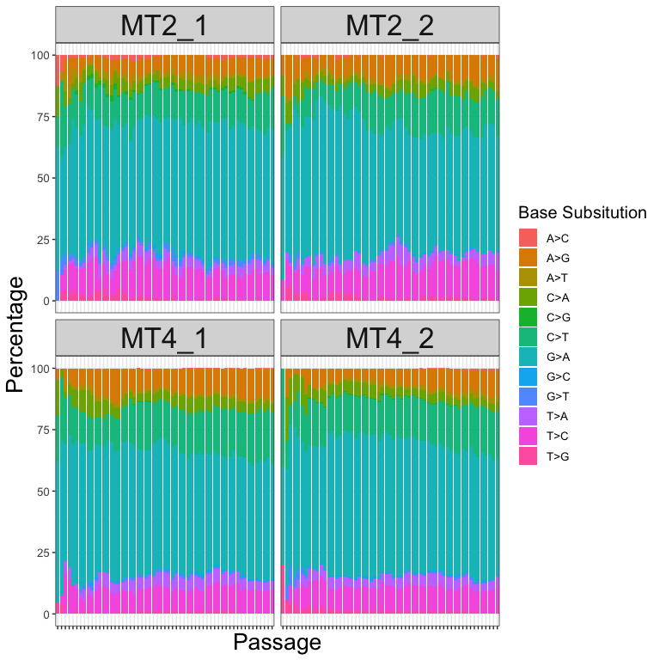

Majority Mutations
category <- "Majority"
threshold <- 0.5
# get numbers for in-text reporting
a <- nrow(variants_ann_expiii[variants_ann_expiii$passage == end_passage,])
b <- length(unique(variants_ann_expiii$mut_info[variants_ann_expiii$passage == end_passage]))
# prepare the data for statistical test
counts <- variants_ann_expiii %>%
filter(allele_freq >= threshold) %>%
group_by(passage, host_line) %>%
count()
# store the statistical test result
t_test_result <- t.test(counts$n[counts$host_line == "MT2"], counts$n[counts$host_line == "MT4"], paired = TRUE, alternative = "two.sided")
We observe a total of 4016 Majority mutations across the four evolution lines of EXP III (2398 unique mutations).
Majority mutations are the mutations that became more frequent in the population than the wild-type nucleotide (a.k.a, allele frequency above 0.5)!
Of note, we do observe deceleration of mutation accumulation towards the end of the experiment compared to first 100 passages. Another observation is the overall higher number of Majority mutations in MT2 host cell lines compared to MT4 (p_val of 9.793245e-18). This is while we see opposite trend for Minority mutations.
# prepare data for visualization
counts <- variants_ann_expiii %>%
filter(allele_freq >= threshold) %>%
group_by(exp_line, passage) %>%
count() %>%
# rename(mut_count = n) %>%
mutate(host_line = ifelse(exp_line %in% c("MT2_1", "MT2_2"), "MT2", "MT4")) %>%
mutate_at(c(1,4), as.factor) %>%
mutate_at(2:3, as.numeric)
# visualize using plotly
fig <- plot_ly(as.data.frame(counts), x = ~passage, y = ~n,
type = 'scatter', mode = "lines", color = ~exp_line, linetype= ~host_line)
fig <- fig %>% layout(title = paste0(category, " Mutations Accumulation") ,
xaxis = list(title = 'Passage'),
yaxis = list(title = 'Count'))
fig

If we plot the accumulation of Majority mutations based on the effect type, we can visualize the trends for S (synonymous), N (non-synonomous), and U (untranslated) mutations.
# prepare data for visualization
counts <- variants_ann_expiii%>%
filter(allele_freq >= threshold) %>%
mutate(effect_simplified = case_when(effect == "synonymous_variant" ~ "S", effect == "untranslated_region" ~ "U")) %>%
mutate(effect_simplified = replace_na(effect_simplified, "N")) %>%
group_by(exp_line, passage, effect_simplified) %>%
summarise(nr_majority = n()) %>%
mutate_at(c(2,4), as.numeric) %>%
mutate_at(c(1,3), as.factor)
# visualize using plotly
fig <- plot_ly(as.data.frame(counts), x = ~passage, y = ~nr_majority,
#text = ~paste("Car: ", car),
type = 'scatter', mode = "lines", color = ~effect_simplified, linetype= ~exp_line)
fig <- fig %>% layout(title = paste0(category, " Mutation Accumulation Based on Translational Effect") ,
xaxis = list(title = 'Passage'),
yaxis = list(title = 'Count'))
fig
Alternatively, we can plot the same accumulation for different effect types but corrected for the genomic length that each mutation can occur in. As you can see eventhough the absolute number of synanymous and non-synanymous mutations are higher than mutations in untranslated regions per passage, the density of mutations in untranslated regions is initially higher than protein-coding regions, while the difference decreases towards the end of evolution.
# prepare data for visualization
counts_df <- variants_ann_expiii%>%
filter(allele_freq >= threshold) %>%
mutate(effect_simplified = case_when(effect == "synonymous_variant" ~ "S", effect == "untranslated_region" ~ "U")) %>%
mutate(effect_simplified = replace_na(effect_simplified, "N"))
t_test_res <- c()
for (host_line in c("MT2", "MT4")){
u <- c()
s_n <- c()
for (passage in seq(10, 570, by=10)){
counts <- table(counts_df$effect_simplified[counts_df$passage == passage & counts_df$host_line == host_line])
u <- append(u, as.numeric(counts["U"]))
s_n <- append(s_n, sum(as.numeric(counts["S"]),as.numeric(counts["N"])))
}
# normalize for length
u <- u*100/(9709-9407+790)
s_n <- s_n*100/(9407-790)
t_test_result <- t.test(u, s_n, paired = TRUE, alternative = "two.sided")
t_test_res <- append(t_test_res, t_test_result$p.value)
}
names(t_test_res) <- c("MT2", "MT4")
Overall the higher frequency of Majority mutations in LTRs compared to protein-coding regions of the HIV-1 genome is significant in both host cell environments of MT2 (p.value of 1.940707e-05) and of MT4 (p.value of 9.998745e-29).
# prepare data for visualization
counts <- variants_ann_expiii %>%
filter(allele_freq >= threshold) %>%
mutate(effect_simplified = case_when(effect == "synonymous_variant" ~ "S", effect == "untranslated_region" ~ "U")) %>%
mutate(effect_simplified = replace_na(effect_simplified, "N")) %>%
mutate(effect_simplified2 = ifelse(effect_simplified %in% c("S","N"), "S/N", "U")) %>%
group_by(exp_line, passage, effect_simplified2) %>%
summarise(nr_majority = n()) %>%
mutate_at(c(2,4), as.numeric) %>%
mutate_at(c(1,3), as.factor) %>%
mutate(nr_majority_density = ifelse(effect_simplified2 == "S/N", nr_majority*100/(9407-790),nr_majority*100/(9709-9407+790)))
# make the visualization
fig <- plot_ly(as.data.frame(counts), x = ~passage, y = ~nr_majority_density,
#text = ~paste("Car: ", car),
type = 'scatter', mode = "lines", color = ~effect_simplified2, linetype= ~exp_line,
colors = "Set1")
fig <- fig %>% layout(title = paste0("Normalized ", category, " Mutation Accumulation Based on Translational Effect") ,
xaxis = list(title = 'Passage'),
yaxis = list(title = 'Normalized Count'))
fig

Next we take a look at the number of majority mutations of passage 560 in different features of the HIV-1 genome:
# prepare data for visualization
counts <- variants_ann_expiii %>%
filter(allele_freq >= threshold) %>%
mutate(mut_type = case_when(effect == "synonymous_variant" ~ "S", effect == "untranslated_region" ~ "U")) %>%
mutate(mut_type = replace_na(mut_type, "N")) %>%
filter(passage == end_passage) %>%
group_by(exp_line, feature, mut_type) %>%
summarise(count = n()) %>%
mutate_at(c(1,2,3), as.factor)
# make the visualization
fig <- ggplot(counts) +
geom_bar(aes(x = mut_type, y = count, fill = exp_line),
position = "stack",
stat = "identity") +
labs(x = "Genomic Features", y = "Count", fill = "Line")+
facet_grid(~ feature, switch = "x") +
theme(strip.placement = "outside",
strip.background = element_rect(fill = NA, color = "white"),
panel.spacing = unit(-.01,"cm"))+
theme(axis.title = element_text(size = 20),
axis.text.x = element_text(size = 10),
axis.text.y = element_text(size = 10),
strip.text.x = element_text(size = 15, angle=90),
legend.text=element_text(size=15),
legend.title = element_text(size=10))
fig
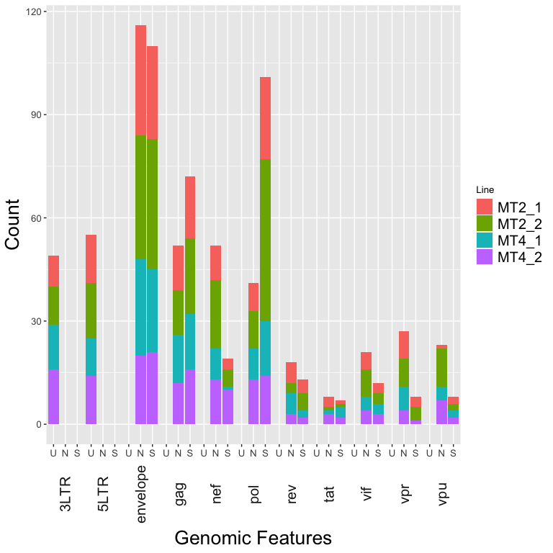
Looking at the frequency of different mutations types in the genomic regions (normalized for the length of the genome):
# based on feature range
feature_length <- data.frame(feature = c("5LTR", "gag", "pol", "vif","vpr", "tat","rev","vpu","envelope","nef","3LTR"),
feature_length = c(789,1503,3012,579,291,261,351,246,2565,621,302))
# prepare data for visualization
counts <- variants_ann_expiii %>%
filter(allele_freq >= threshold) %>%
mutate(mut_type = case_when(effect == "synonymous_variant" ~ "S", effect == "untranslated_region" ~ "U")) %>%
mutate(mut_type = replace_na(mut_type, "N")) %>%
filter(passage == end_passage) %>%
group_by(exp_line, feature, mut_type) %>%
summarise(count = n()) %>%
mutate_at(c(1,2,3), as.factor) %>%
left_join(feature_length, by = join_by(feature == feature)) %>%
mutate(normalized_count = count*100/feature_length)
# make the visualization
fig <- ggplot(counts) +
geom_bar(aes(x = mut_type, y = normalized_count, fill = exp_line),
position = "stack",
stat = "identity") +
labs(x = "Genomic Features", y = "Normalized Count", fill = "Line")+
facet_grid(~ feature, switch = "x") +
theme(strip.placement = "outside",
strip.background = element_rect(fill = NA, color = "white"),
panel.spacing = unit(-.01,"cm"))+
theme(axis.title = element_text(size = 20),
axis.text.x = element_text(size = 10),
axis.text.y = element_text(size = 10),
strip.text.x = element_text(size = 15, angle=90),
legend.text=element_text(size=15),
legend.title = element_text(size=10))
fig
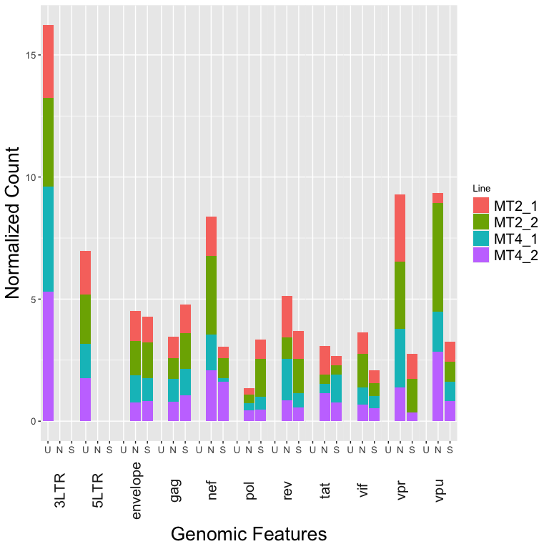

Mutational profile
In the chart below you can see the mutation subtypes of all/unique majority and minority mutations of all 4 lines of EXPIII.
# add subtype info
variants_ann_expiii_sub <- variants_ann_expiii %>% mutate(mut_type_sub = ifelse(mut_type == "M", paste0(ref_allele,">",alt_allele), mut_type))
# minority
subset_name <- "Minority"
min_threshold <- 0.05
max_threshold <- 0.50
# prepare data for visualization (unique mutations)
mut_profile_min_unique <- variants_ann_expiii_sub %>% filter(allele_freq >= min_threshold & allele_freq <= max_threshold) %>%
select(mut_info, mut_type_sub) %>%
distinct() %>%
group_by(mut_type_sub) %>%
summarise(count = n())
# rename(mut_sub_type = mut_type_sub)
# prepare data for visualization (all mutations)
mut_profile_min_all <- variants_ann_expiii_sub %>% filter(allele_freq >= min_threshold & allele_freq <= max_threshold) %>%
group_by(mut_type_sub) %>%
summarise(count = n())
# rename(mut_sub_type = mut_type_sub)
# make the visualization
fig <- plot_ly()
fig <- fig %>% add_pie(data = mut_profile_min_unique, labels = ~mut_type_sub, values = ~count, title = paste0("All Mutations", " (", sum(mut_profile_min_all$count),")"),
name = "Cut", domain = list(x = c(0, 0.4), y = c(0.4, 1.4)))
fig <- fig %>% add_pie(data = mut_profile_min_all, labels = ~mut_type_sub, values = ~count, title = paste0("Unique Mutations", " (", sum(mut_profile_min_unique$count),")"),
name = "Color", domain = list(x = c(0.6, 1), y = c(0.4, 1.4))) %>%
layout(title=paste0('Mutation Sub-Types _ ', subset_name))
fig
# majority
subset_name <- "Majority"
threshold <- 0.5
# prepare data for visualization
mut_profile_maj_unique <- variants_ann_expiii_sub %>% filter(allele_freq >= threshold) %>%
select(mut_info, mut_type_sub) %>%
distinct() %>%
group_by(mut_type_sub) %>%
summarise(count = n())
# rename(mut_sub_type = mut_type_sub)
# prepare data for visualization
mut_profile_maj_all <- variants_ann_expiii_sub %>% filter(allele_freq >= threshold) %>%
group_by(mut_type_sub) %>%
summarise(count = n())
# rename(mut_sub_type = mut_type_sub)
# make the visualization
fig <- plot_ly()
fig <- fig %>% add_pie(data = mut_profile_maj_unique, labels = ~mut_type_sub, values = ~count, title = paste0("All Mutations", " (", sum(mut_profile_maj_all$count),")"),
name = "Cut", domain = list(x = c(0, 0.4), y = c(0.4, 1)))
fig <- fig %>% add_pie(data = mut_profile_maj_all, labels = ~mut_type_sub, values = ~count, title = paste0("Unique Mutations", " (", sum(mut_profile_maj_unique$count),")"),
name = "Color", domain = list(x = c(0.6, 1), y = c(0.4, 1))) %>%
layout(title=paste0('Mutation Sub-Types _ ', subset_name))
fig
# read in ancestral reference sequence
fastaFile <- readDNAStringSet("/Users/alimos313/Documents/studies/phd/hpc-research/genome-evo-proj/data/reference/plasmid/hiv_plasmid_ref_genome.fasta")
seq_name = names(fastaFile)
sequence = paste(fastaFile)
# get the guanine composition of the reference genome
g_percent <- str_count(sequence, pattern = "G")/nchar(sequence)

APOBEC3G
subset_name <- "Minority"
min_threshold <- 0.05
max_threshold <- 0.50
variants_ann_expiii_sub <- variants_ann_expiii %>%
filter(allele_freq >= min_threshold & allele_freq <= max_threshold)
mt2_g2a <- nrow(variants_ann_expiii_sub[variants_ann_expiii_sub$ref_allele == "G" & variants_ann_expiii_sub$alt_allele == "A" & variants_ann_expiii_sub$passage == end_passage & variants_ann_expiii_sub$exp_line %in% c("MT2_1", "MT2_2"),])
mt2_g2a_percent <- mt2_g2a/nrow(variants_ann_expiii_sub[variants_ann_expiii_sub$passage == end_passage & variants_ann_expiii_sub$exp_line %in% c("MT2_1", "MT2_2"),])
mt4_g2a <- nrow(variants_ann_expiii_sub[variants_ann_expiii_sub$ref_allele == "G" & variants_ann_expiii_sub$alt_allele == "A" & variants_ann_expiii_sub$passage == end_passage & variants_ann_expiii_sub$exp_line %in% c("MT4_1", "MT4_2"),])
mt4_g2a_percent <- mt4_g2a/nrow(variants_ann_expiii_sub[variants_ann_expiii_sub$passage == end_passage & variants_ann_expiii_sub$exp_line %in% c("MT4_1", "MT4_2"),])
We also analyzed the effect of APOBEC3G on the accumulation of Majority mutations. G-to-A mutations in the HIV-1 viral genome are mainly induced by APOBEC3G/F which is only expressed in MT-2 T-cells and not in MT-4 T-cells (Borman et al. 1995). Expectedly, even though the absolute number of G to A Majority mutations at the end of the experiment is slightly lower in HIV-1 growing in MT-2 T-cells than in HIV-1 growing in MT-4 T-cells (232 and 374 G to A mutations, respectively), the percentage of G-A mutations in MT2 lines are slighly higher than in MT4 (0.5076586% and 0.4825806% G to A mutations, respectively) .
mt2_context <- table(variants_ann_expiii_sub$mut_context[variants_ann_expiii_sub$ref_allele == "G" & variants_ann_expiii_sub$alt_allele == "A" & variants_ann_expiii_sub$passage == 160 & variants_ann_expiii_sub$exp_line %in% c("MT2_1", "MT2_2")])
mt4_context <- table(variants_ann_expiii_sub$mut_context[variants_ann_expiii_sub$ref_allele == "G" & variants_ann_expiii_sub$alt_allele == "A" & variants_ann_expiii_sub$passage == 160 & variants_ann_expiii_sub$exp_line %in% c("MT4_1", "MT4_2")])
(as.numeric(sum(mt2_context[str_sub(names(mt2_context),1,1) == "T"])))/sum(mt2_context)
(as.numeric(sum(mt4_context[str_sub(names(mt4_context),1,1) == "T"])))/sum(mt4_context)
counts <- variants_ann_expiii_sub %>%
filter(variants_ann_expiii_sub$ref_allele == "G" & variants_ann_expiii_sub$alt_allele == "A") %>%
group_by(passage, host_line) %>%
mutate(count_all = n()) %>%
ungroup() %>%
mutate_at(c("passage", "host_line"), as.factor) %>%
filter(mut_3_context %in% c("GGG", "AAG")) %>%
group_by(passage, host_line, count_all, .drop=FALSE) %>%
summarise(count_g2a = n()) %>%
mutate(percentage_g2a = count_g2a/count_all) %>%
arrange(passage, host_line)
mt2_pct <- counts$percentage_g2a[counts$host_line == "MT2"]
mt4_pct <- counts$percentage_g2a[counts$host_line == "MT4"]
t_test_result <- t.test(mt2_pct, mt4_pct, paired = TRUE, alternative = "two.sided")
According to this article, G-A mutations caused by APOBEC3G/F are mainly in GGG or AAG context, therefore we can expect more proportion of G-A mutations in MT2 compared to MT4 to be in those contexts. As opposed to our expectation, proportion of G-A mutations occurring in GG[G]/AA[G] context in MT2 is not significantly higher than in MT4 (p_val of 0.3741098). That said, it might be of interest to compare the fequency and context of G-A mutations that are hypermutants (2 or more G-A mutations in in the same read pair). Also based on that we might be able to define hotspot regions for these mutations as well. These are some extra analyses that I will do in the future to further delineate the impact of APOBEC mutagenesis on the mutational profile of HIV-1 virus.

