University Advisor System

Project Diagrams & System Models

───────────────────────────────────────────────────────

This document contains all system diagrams referenced in Chapter 2
of the University Advisor System Final Project Report.
Diagrams include Use Case Diagrams, Flowcharts,
Role-Based Behavior Diagrams, and the Project Schedule.

Academic Year 2025 – 2026

Table of Contents

Figure 2.1: Use Case Diagram – University Advisor System Front-End ............................................................ 3
Figure 2.2: Flowchart – Scientific Journal Section Workflow ............................................................ 4
Figure 2.4: Role-Based System Behavior Diagram ............................................................ 5
Figure 2.5: Use Case Diagram – Administrative Dashboard ............................................................ 6
Figure 2.6: System Workflow Flowchart – Dashboard Data Pipeline ............................................................ 7
Project Schedule – University Advisor System ............................................................ 8

Figure 2.1: Use Case Diagram – University Advisor System Front-End

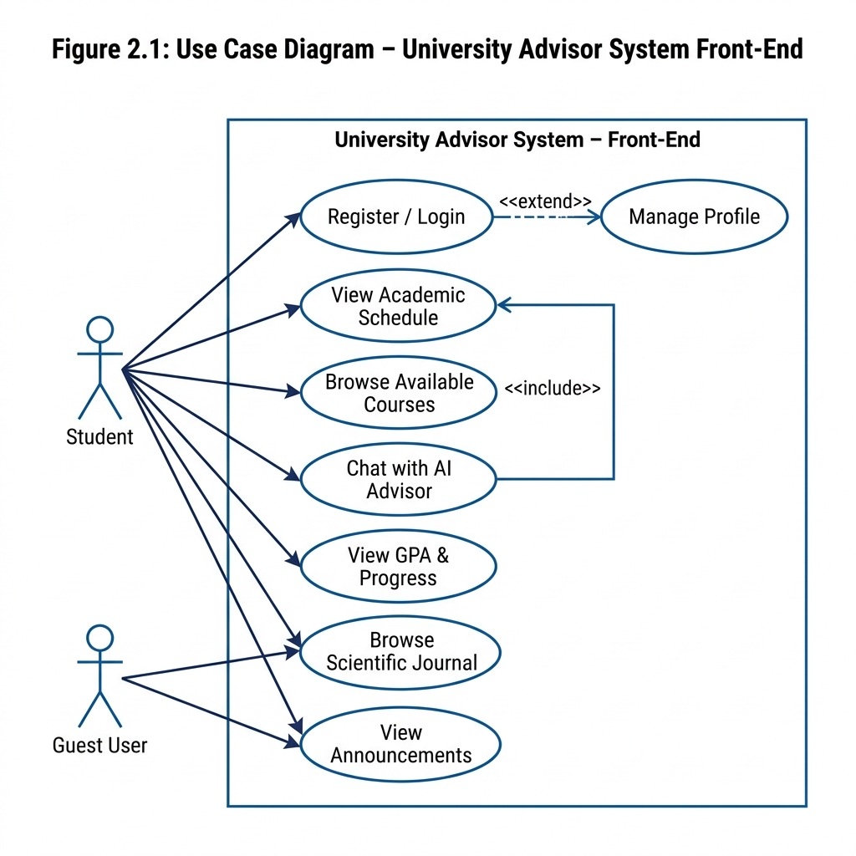

This diagram illustrates the functional interactions between system actors (Student and Guest User) and the University Advisor System's front-end modules. It captures all primary use cases including authentication, course browsing, AI chat, GPA tracking, and journal access.

Figure 2.2: Flowchart – Scientific Journal Section Workflow

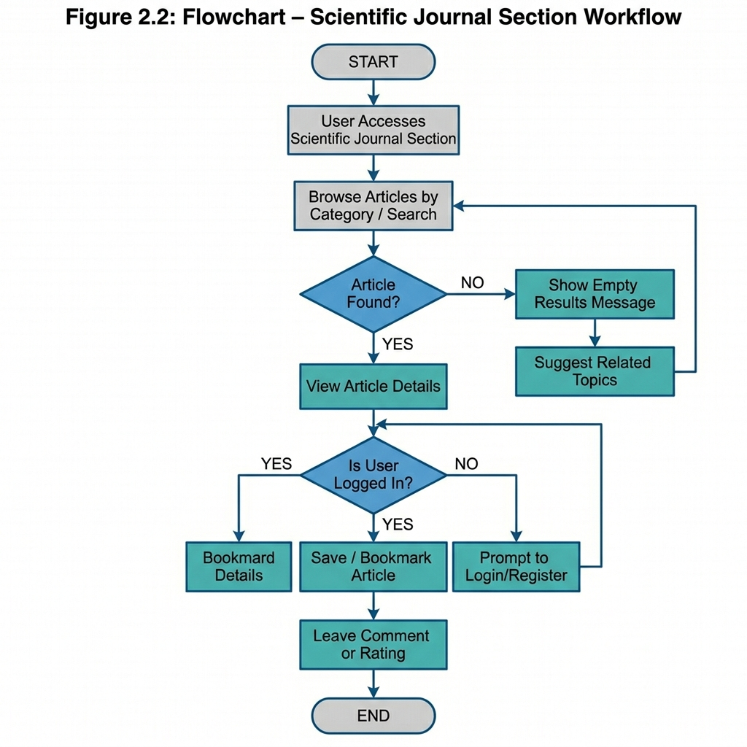

This flowchart details the step-by-step process a user follows when interacting with the Scientific Journal section, including article search, authentication checks, bookmarking, and commenting functionality.

Figure 2.4: Role-Based System Behavior Diagram

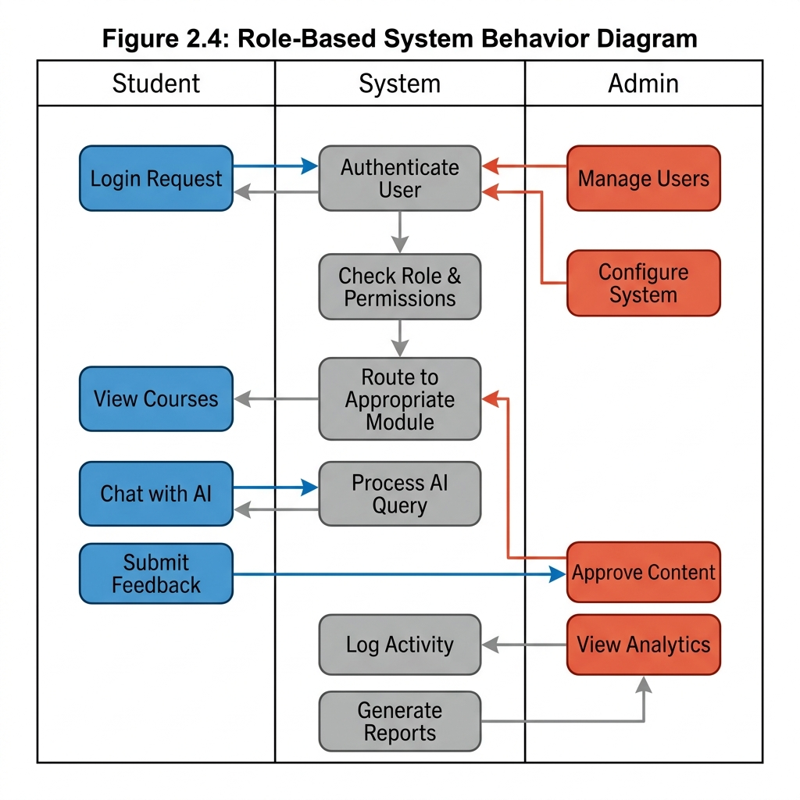

A swimlane diagram depicting the distinct behavioral responsibilities of each system role (Student, System, Admin). It highlights how requests are routed and processed based on role-based access control (RBAC) logic.

Figure 2.5: Use Case Diagram – Administrative Dashboard

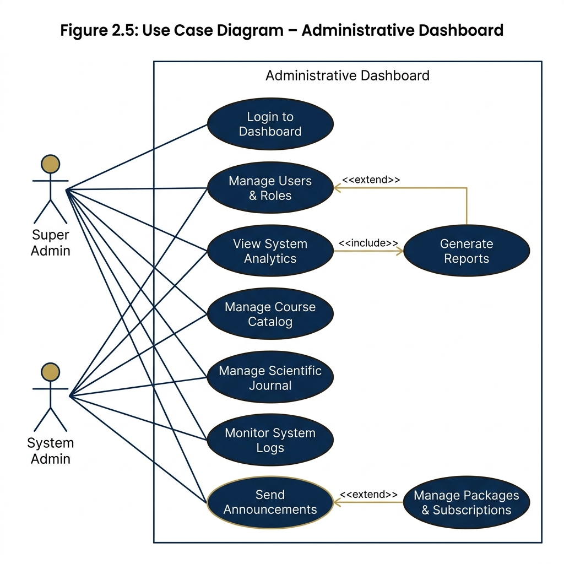

This diagram maps the administrative use cases available to Super Admin and System Admin roles within the Administrative Dashboard, covering user management, analytics, content control, and system configuration.

Figure 2.6: System Workflow Flowchart – Dashboard Data Pipeline

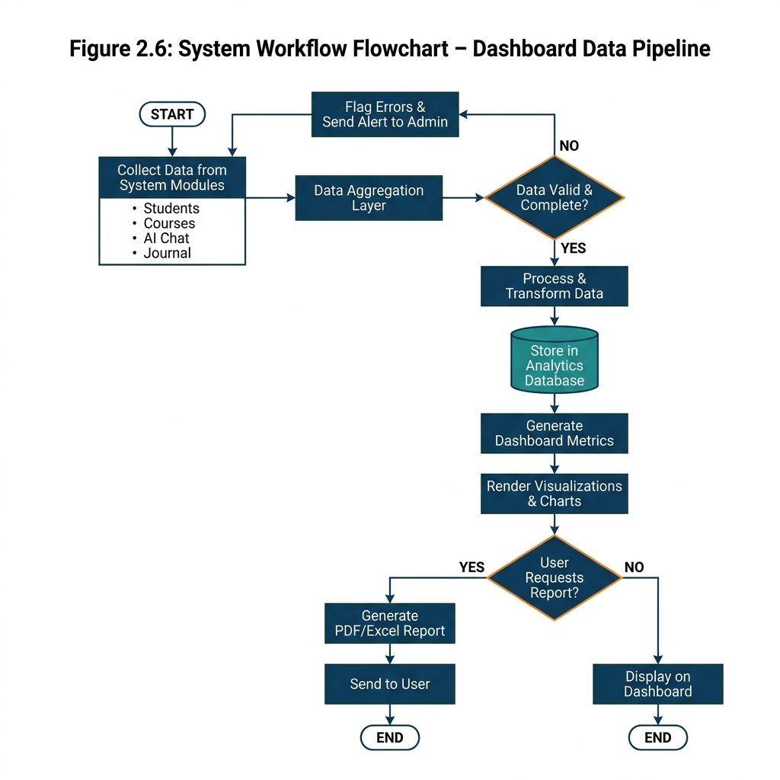

This flowchart illustrates the end-to-end data pipeline powering the Administrative Dashboard, from raw data collection across system modules, through aggregation and validation, to final rendering of analytics and exportable reports.

Project Schedule – University Advisor System

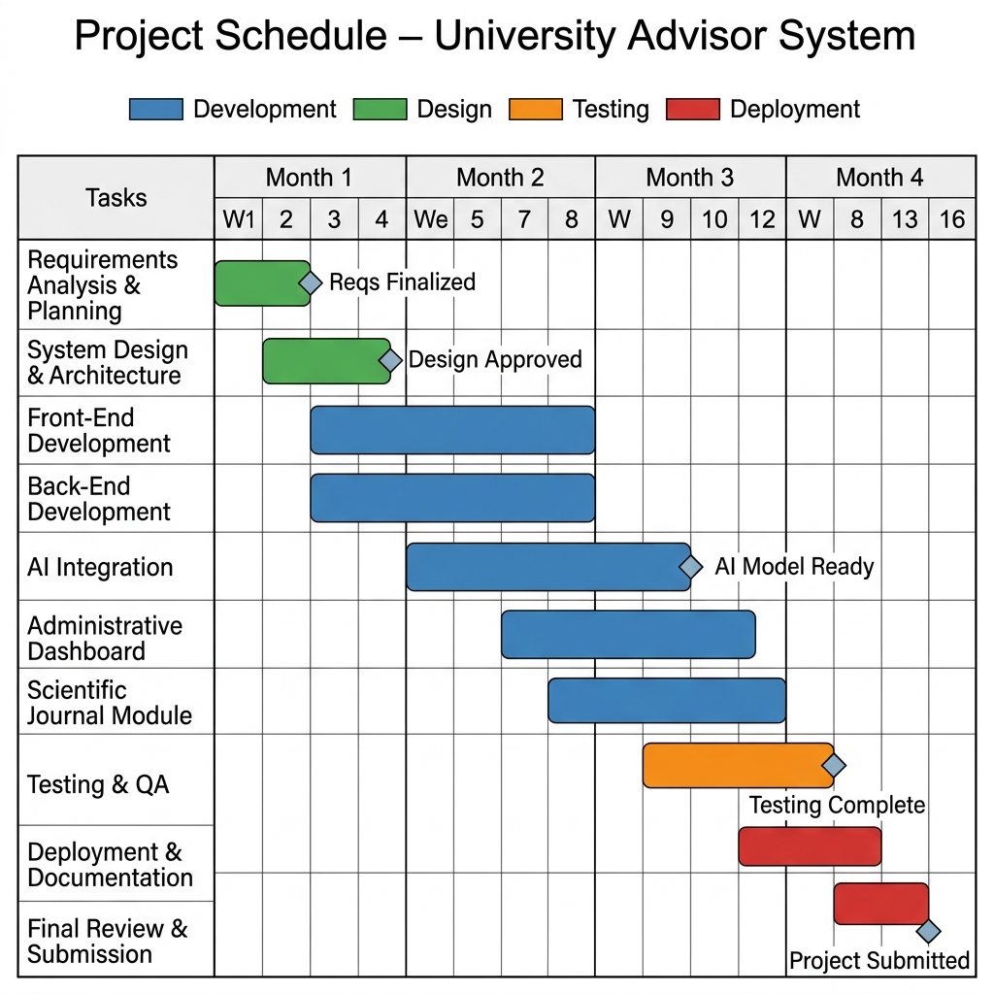

A Gantt chart representing the planned project timeline across 16 weeks, covering all phases from requirements analysis and system design through development, testing, deployment, and final submission.

