**Md.Al-Abid. (05-002-007)**

**Project**

**Launch Transport Management System**

**Step 1: Identify the Attributes and Primary key for each Entity**

**Launch** ( launch_id, name, capacity, launch_type)

**Route** ( route_id, start_location, end_location, distance, duration )

**Customer** ( customer_id, first_name, last_name, contact_number, email )

**Booking** ( booking_id, customer_id, launch_id, route_id, booking_date, seats, status)

**Staff** ( staff_id, name, role, contact_number, launch_id )

**Payment** ( payment_id, booking_id, amount, payment_date, payment_method )

**Step 2: Identify the Relationship**

Entities have some relationships with each other. Relationships define how entities are associated with each other.

Let’s Establishing Relationships between them are:

* Customer has booking
* Payment has booking
* Booking associated with route
* Launch has booking
* Saff works in launch

**Step 3: Identify the Cardinality Ratio and Participation**

1. Customer-Booking

Relationship: One-to-Many



1. Payment-Booking

Relationship: One-to-One



1. Booking-Route

Relationship: Many-to-One



1. Launch-Booking

Relationship: One-to-Many



1. Staff-launch

Relationship: Many-to-One



**Step 4: ER Diagram Representation**

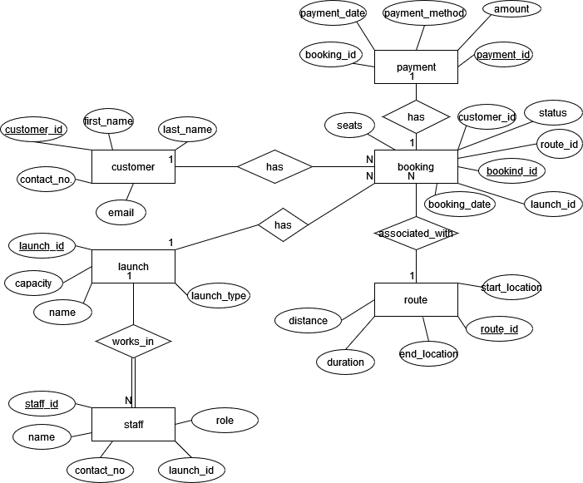

**Step-5: Implementing the schema Diagram**

