Workshop: Supabase

Introduction
In this workshop, you will connect to a Supabase PostgreSQL database, create tables, insert data, and explore views and triggers using plain SQL.

What is Supabase?
Supabase is a development platform that provides a full PostgreSQL database for every project. It includes real-time functionality, database backups, extensions, and more.

1.2. Workshop Live Demo
You will create a mini project: Student Attendance Tracker
Important: This workshop does not require knowledge of APIs or web development. You will use SQL only.

Create a Supabase Project
- Go to https://supabase.com/dashboard/sign-up
- Log in with GitHub or create an account
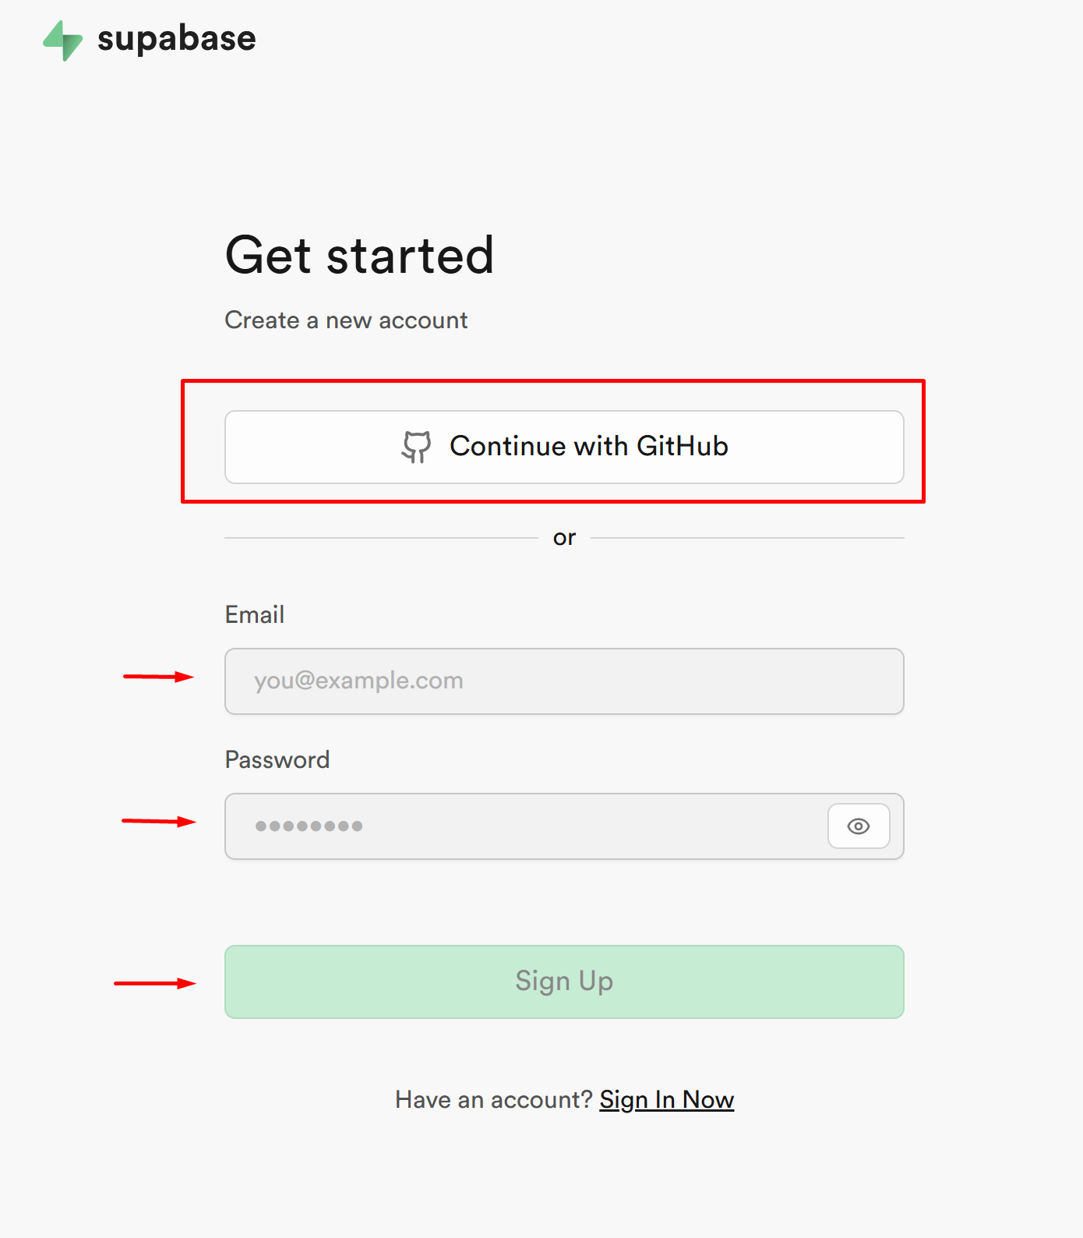
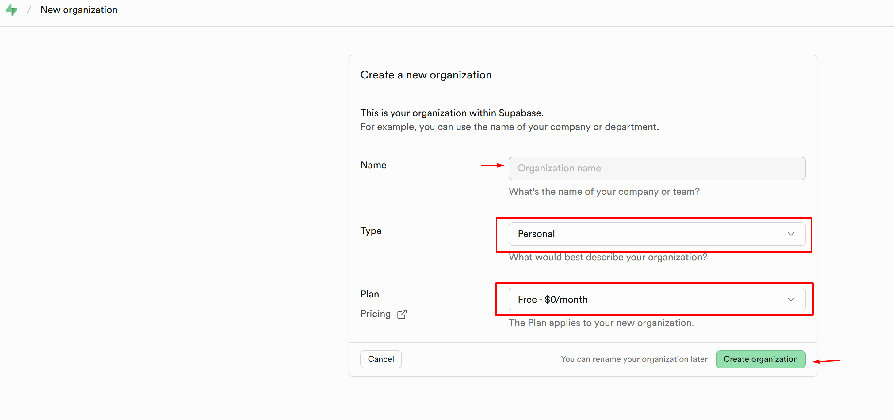
- Start a new project. Name it (for instance, "Test project"), and save your database password securely
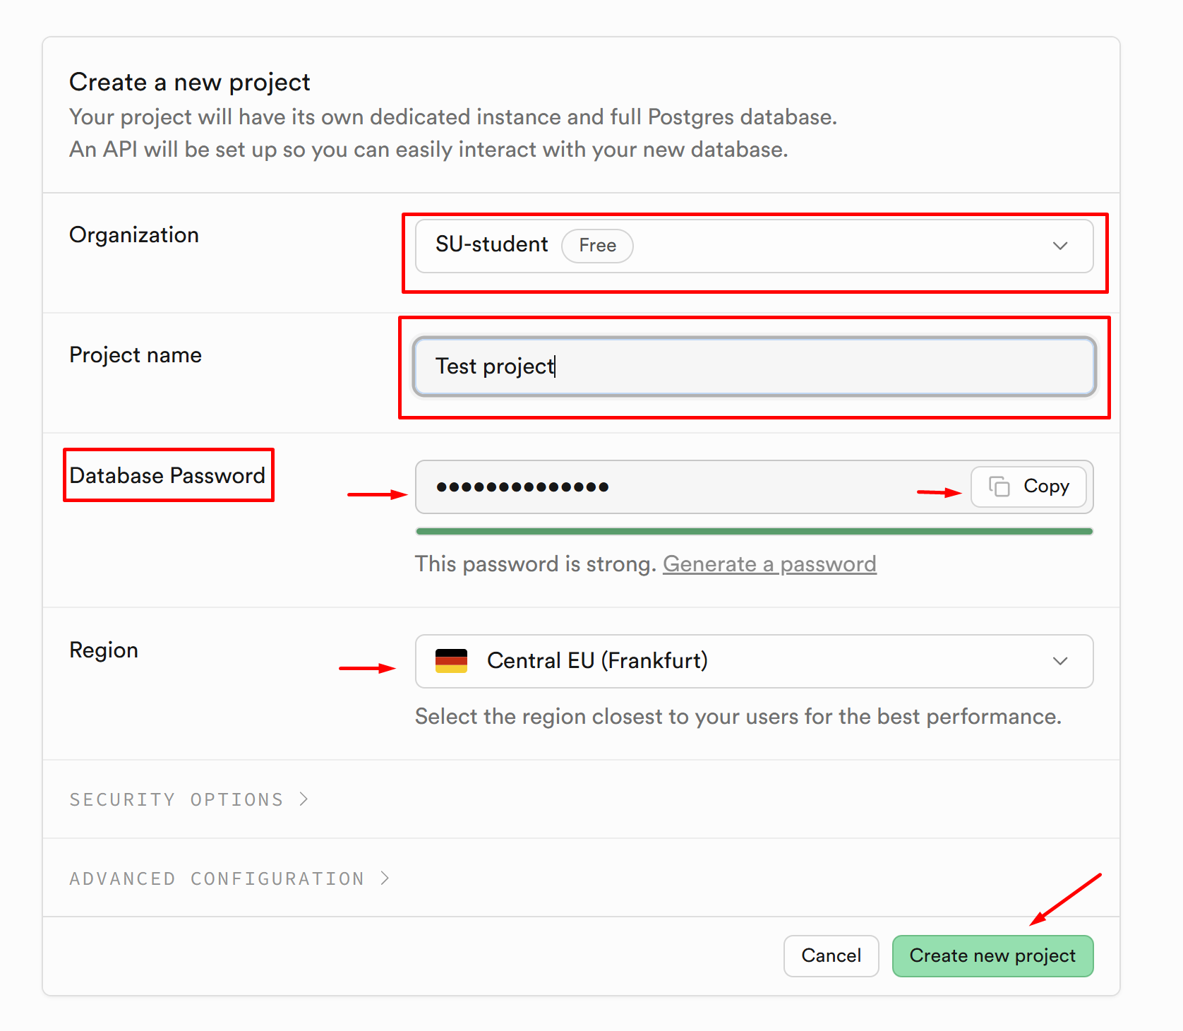
- Once the project is created, open the SQL Editor tab from the main window or left-hand menu
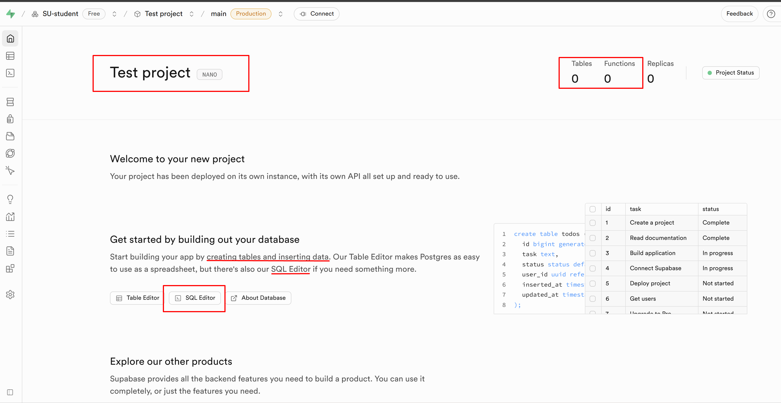
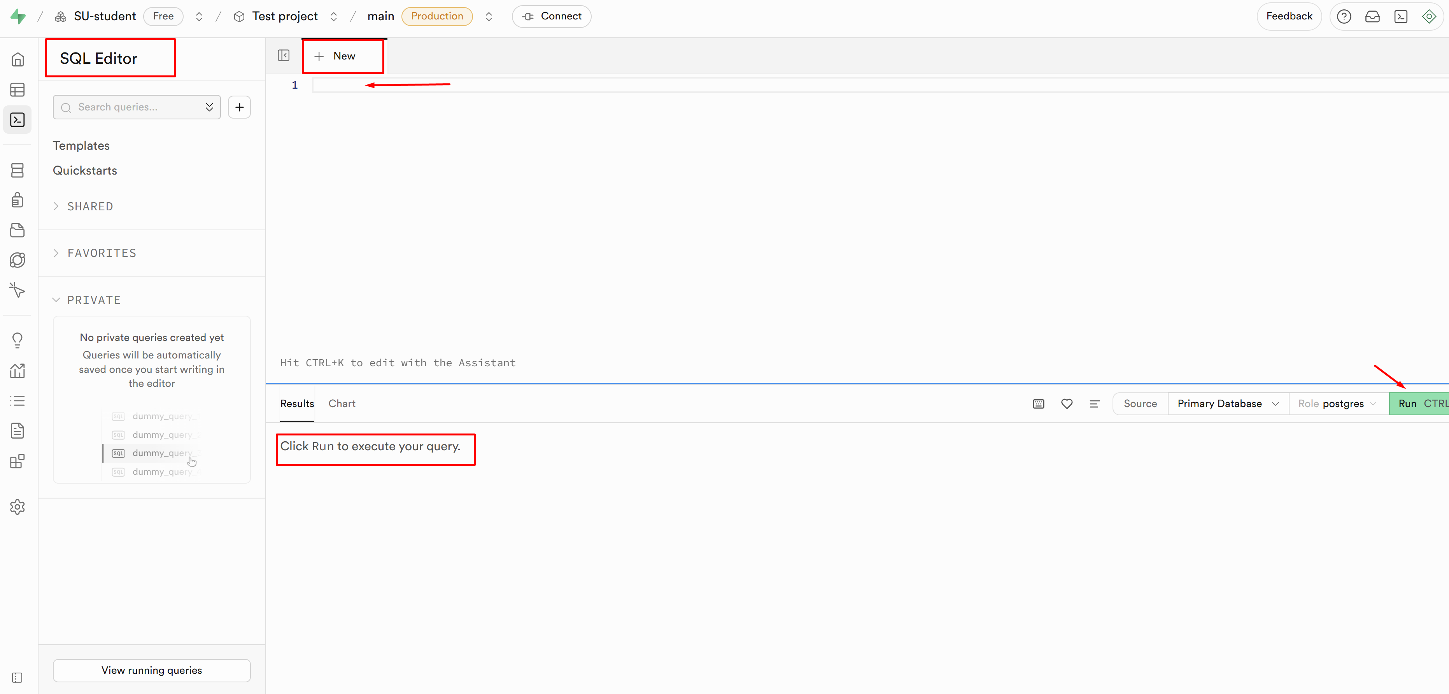

Create the Tables
- Use the SQL Editor to create three tables for your attendance tracking system
- You can add extra columns later if needed
CREATE TABLE students (
id SERIAL PRIMARY KEY,
name TEXT NOT NULL
);

CREATE TABLE sessions (
id SERIAL PRIMARY KEY,
session_date DATE NOT NULL
);

CREATE TABLE attendance (
student_id INT REFERENCES students(id),
session_id INT REFERENCES sessions(id),
attended BOOLEAN DEFAULT FALSE,
PRIMARY KEY (student_id, session_id)
);
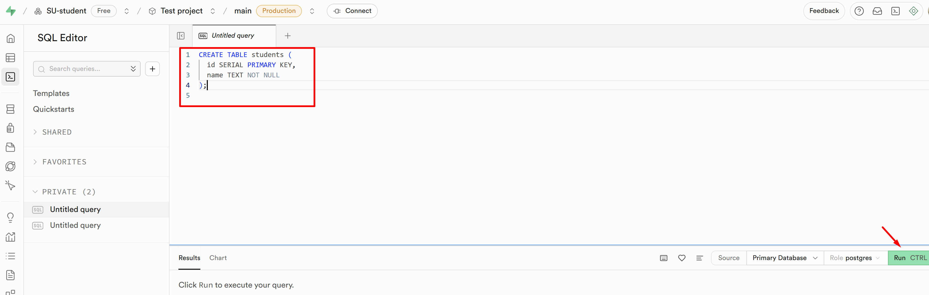
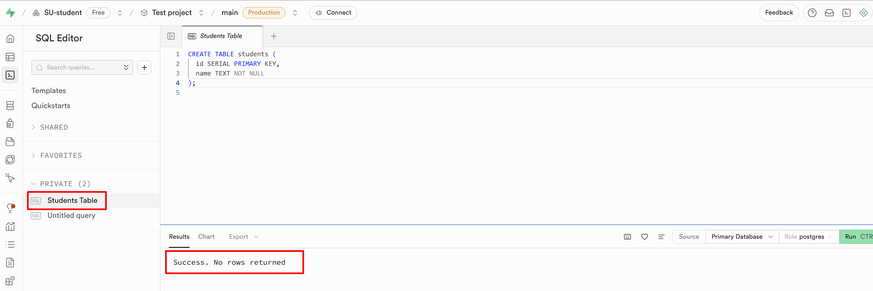
- After running, go to Table Editor to verify that the tables were created.
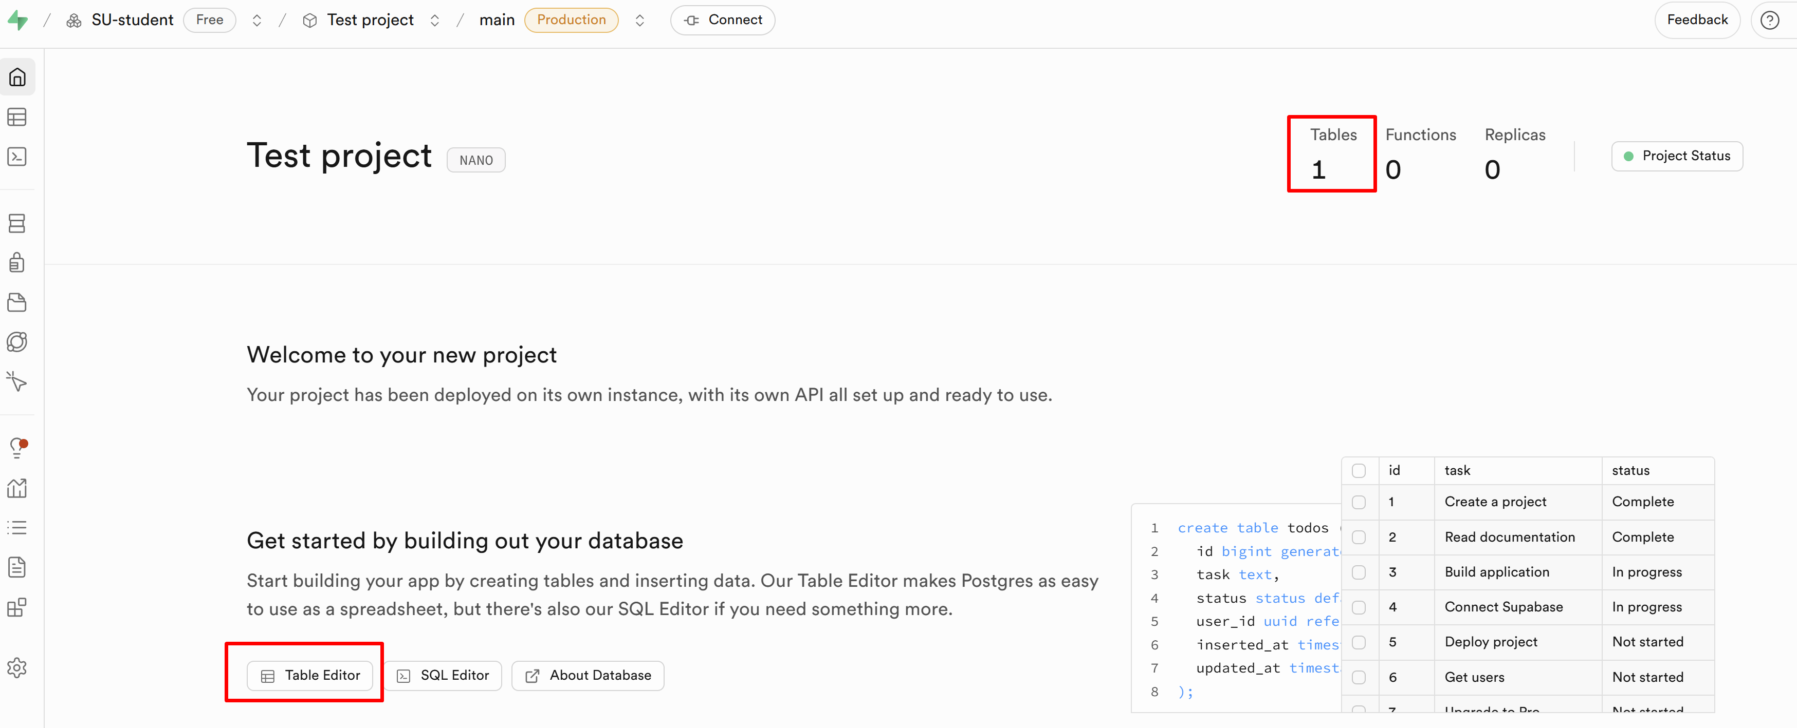
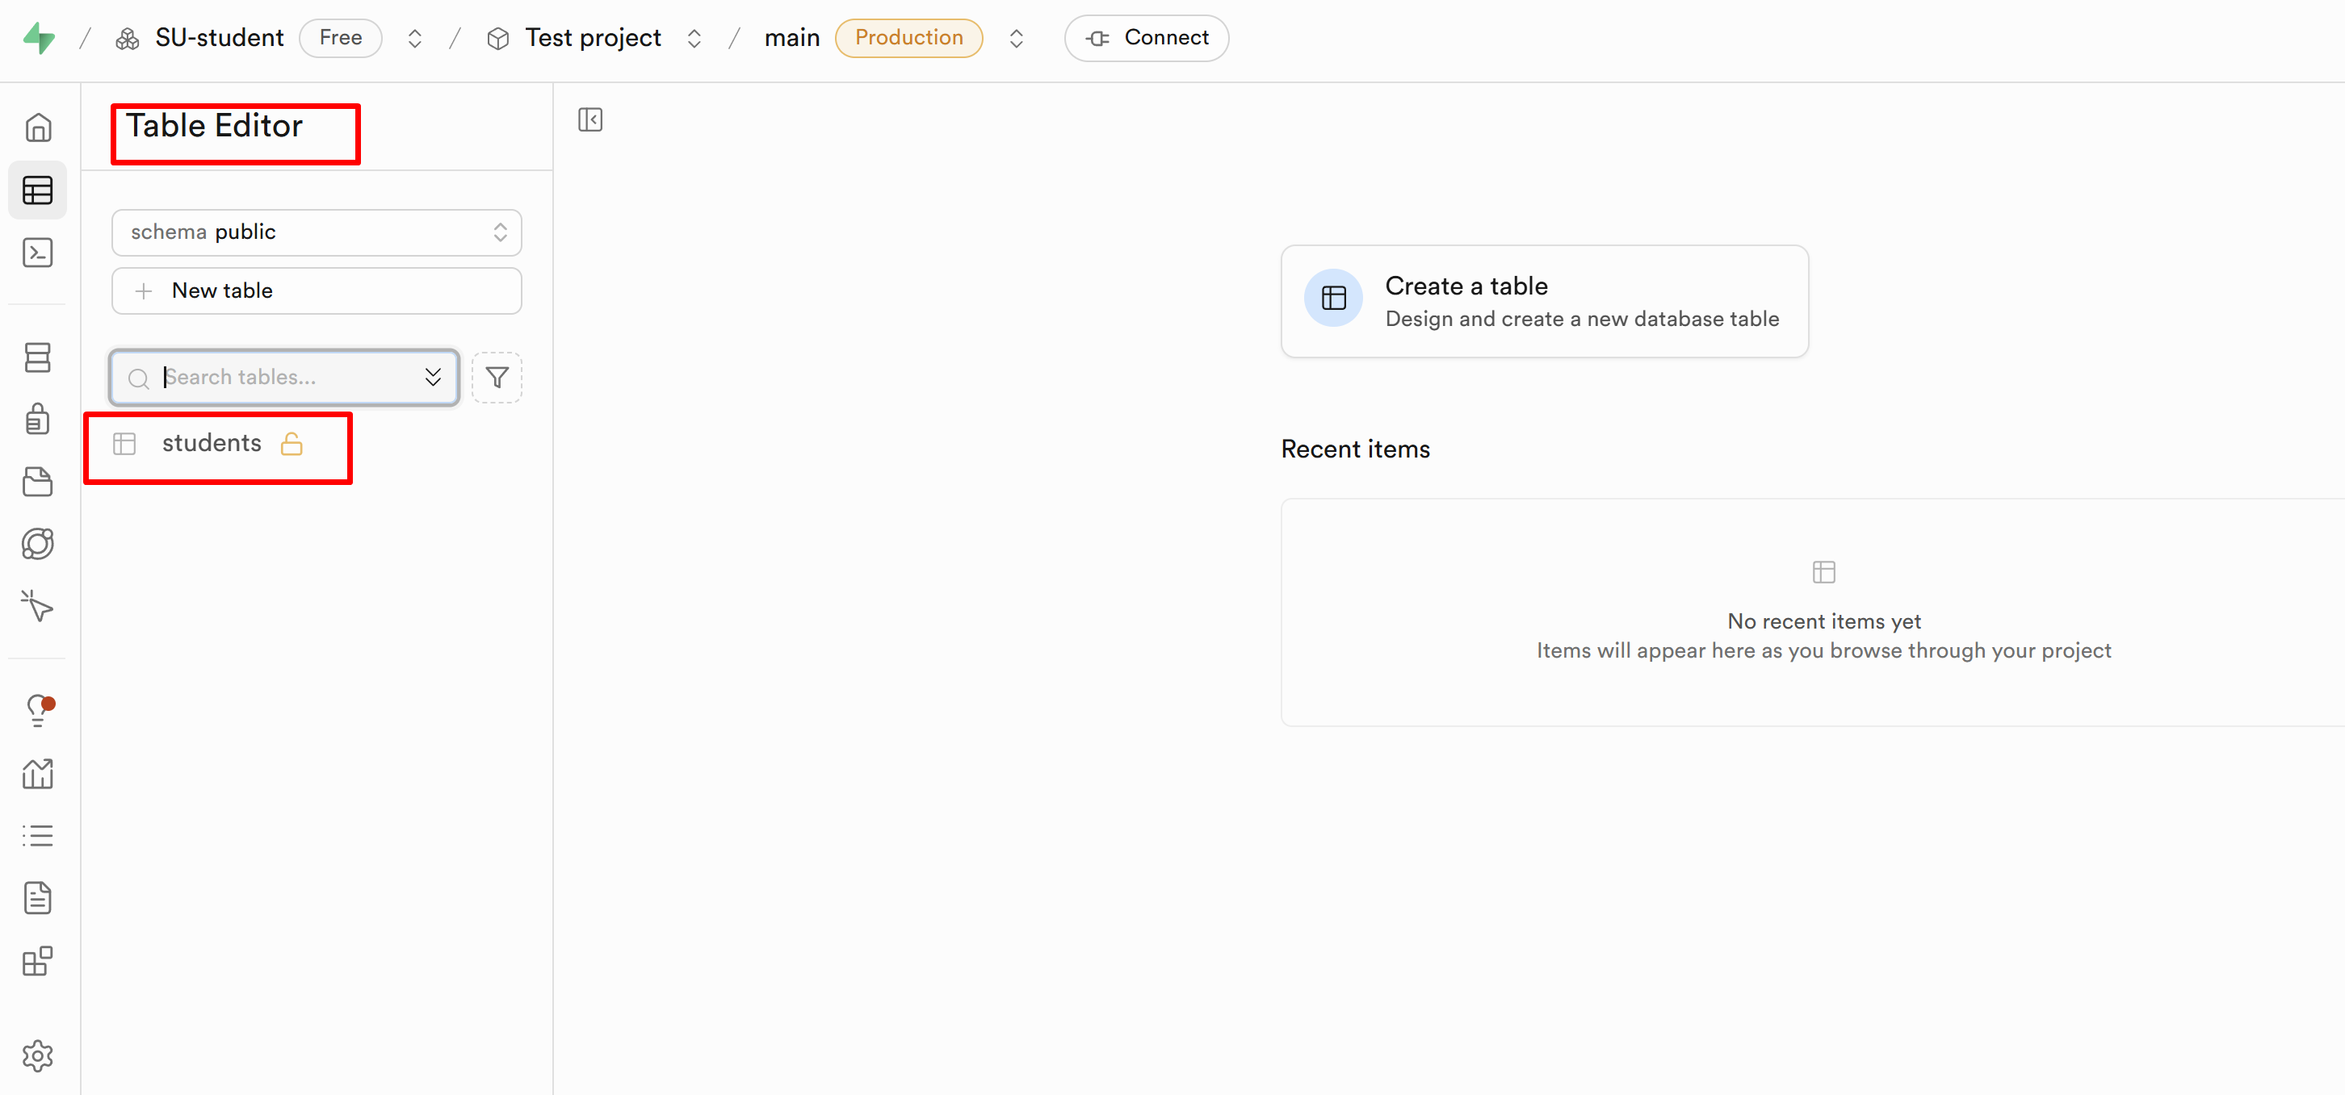
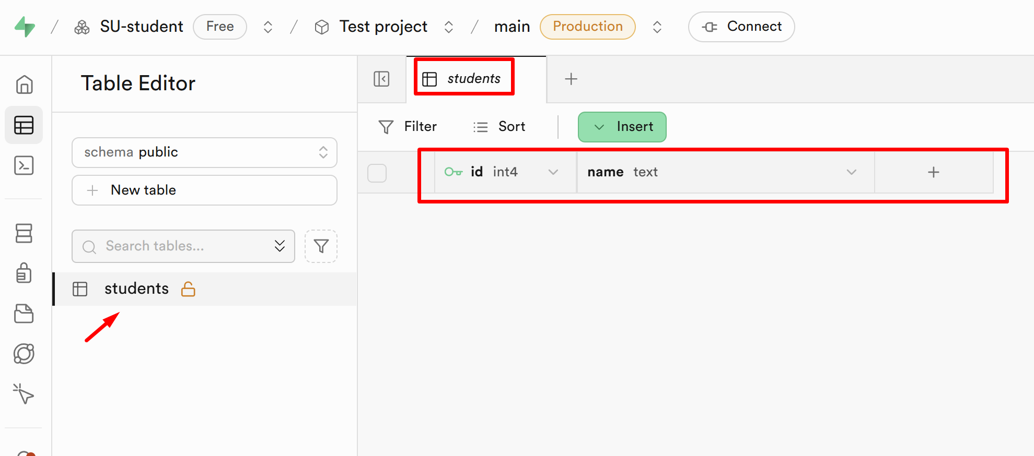

Insert Sample Data
- Write SQL queries to insert some example rows. Feel free to add more data:
INSERT INTO students (name) VALUES
('Alice'),
('Bob'),
('Charlie');

INSERT INTO sessions (session_date) VALUES
('2025-07-20'),
('2025-07-21');

INSERT INTO attendance (student_id, session_id, attended) VALUES
(1, 1, TRUE),
(2, 1, FALSE),
(3, 1, TRUE),
(1, 2, TRUE),
(2, 2, TRUE);
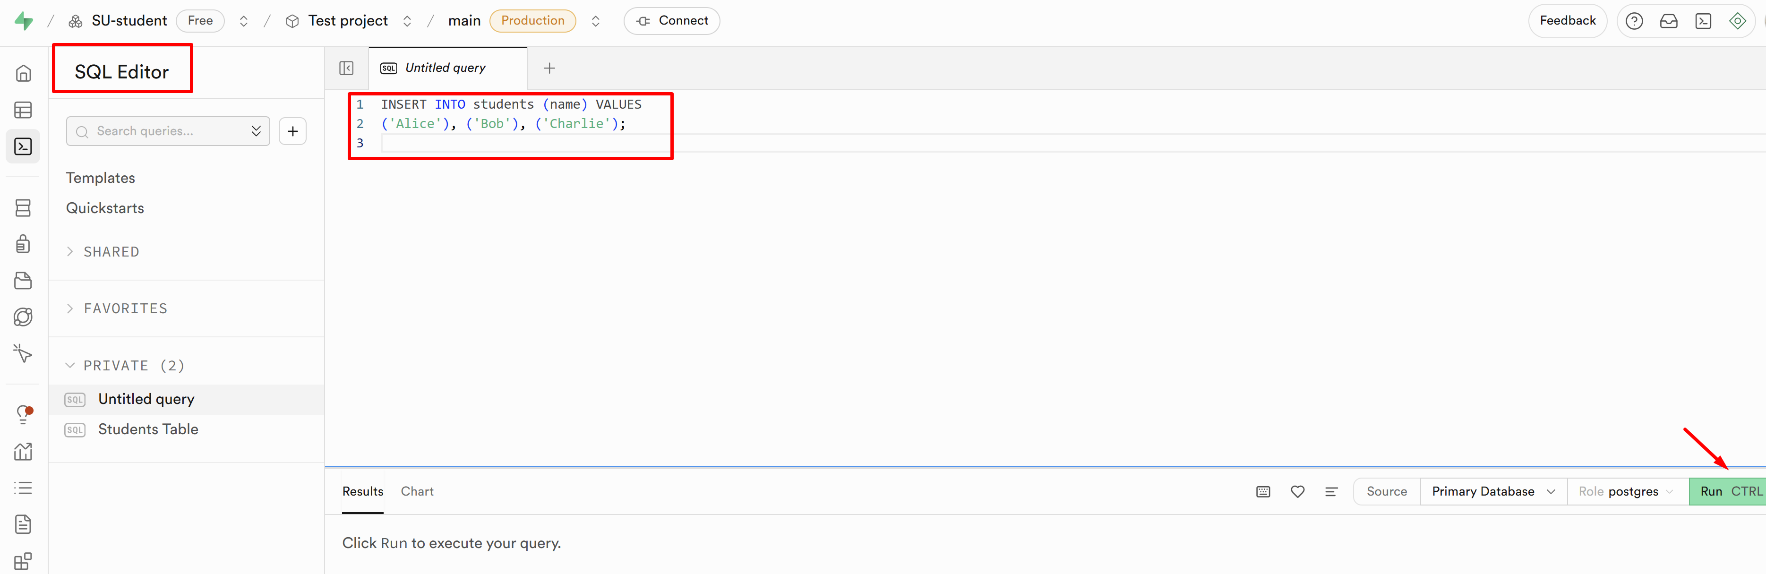
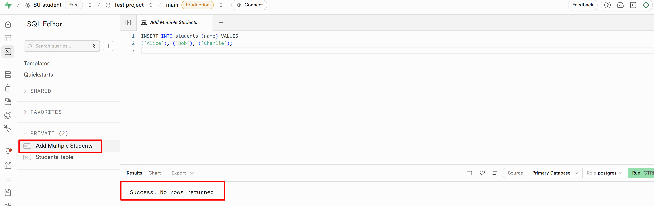
- Check the populated data using the Table Editor or run SELECT queries to verify insertions:
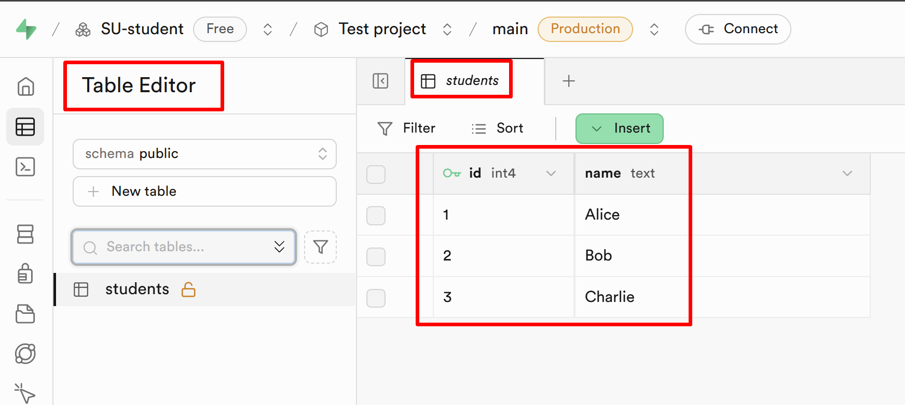
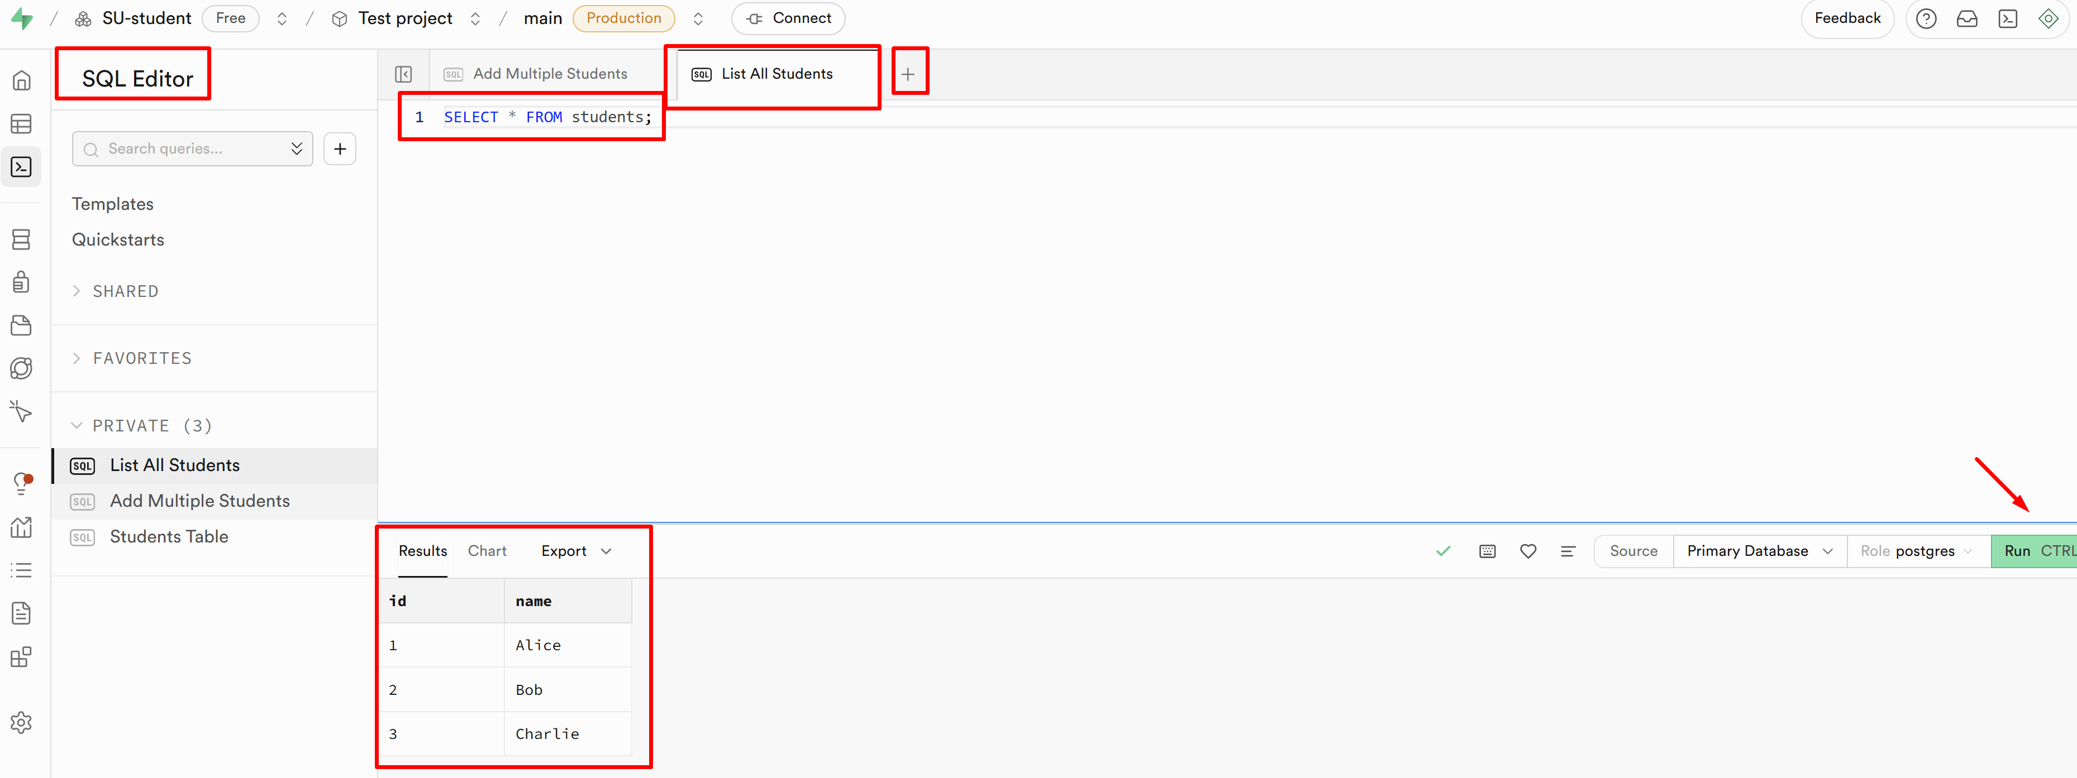
- You can use the left-hand menu for quick access:
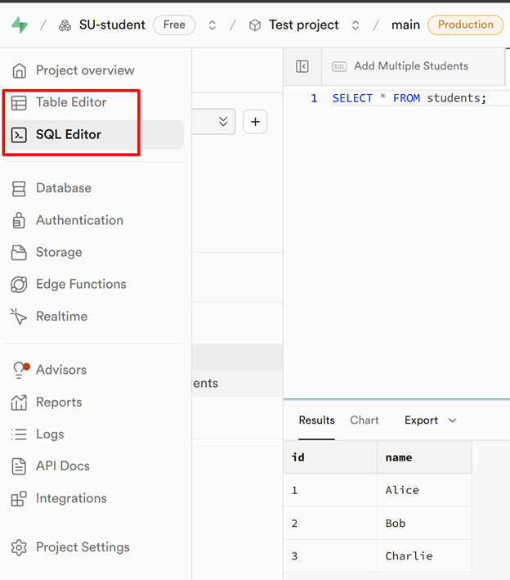
- You can also try the Schema Visualizer:
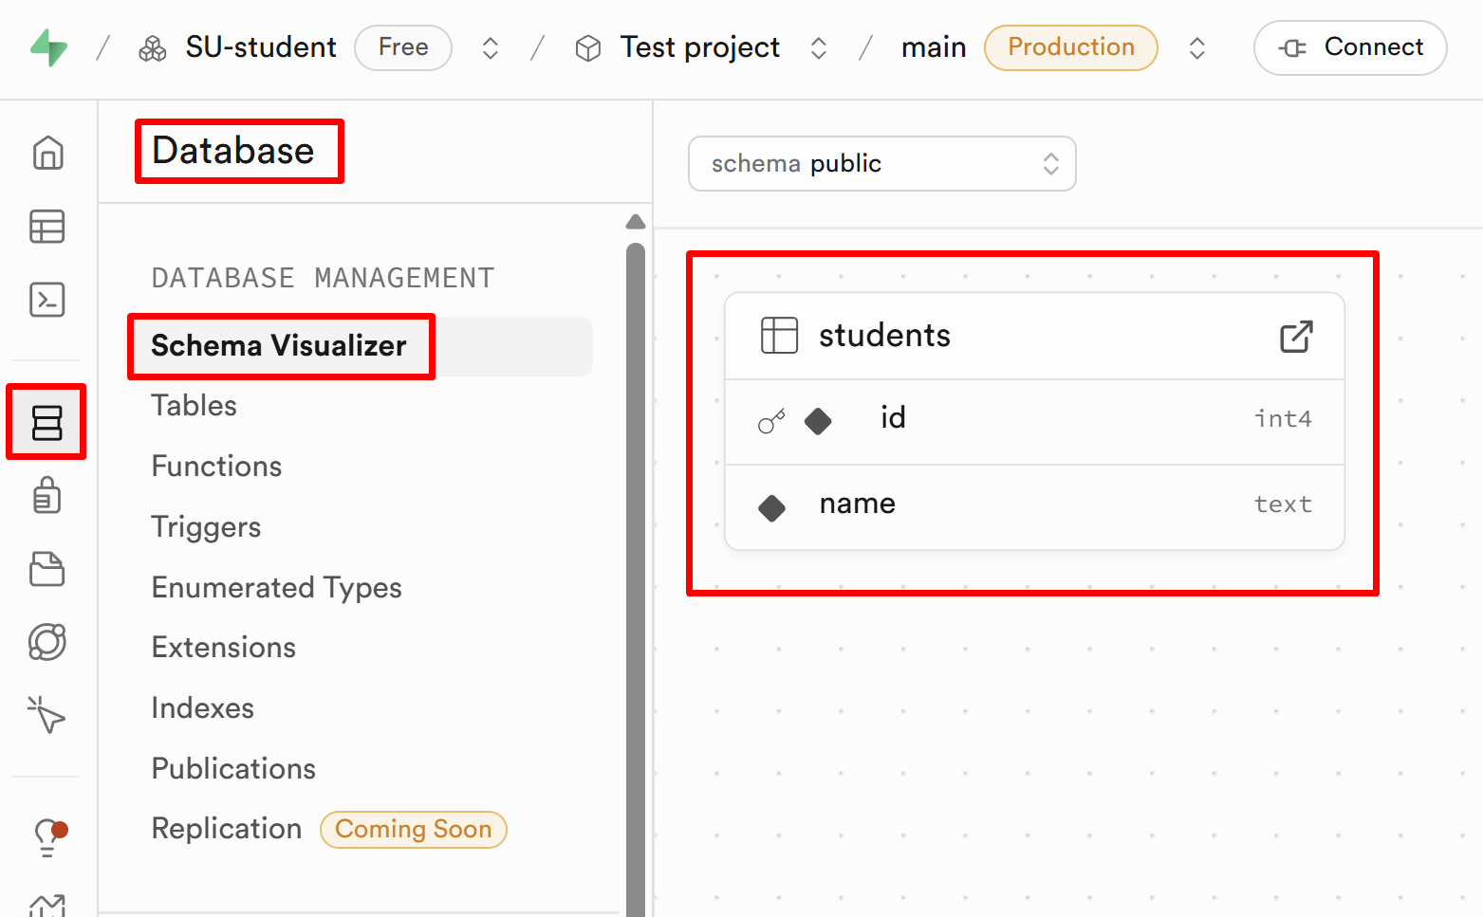

Query the Data
- Write a query to view attendance:
SELECT * FROM attendance;
- Join tables to display which student attended which session:
SELECT s.name, a.attended, sess.session_date
FROM attendance a
JOIN students s ON a.student_id = s.id
JOIN sessions sess ON a.session_id = sess.id;

Create a Summary View
- Write an SQL query to create a view that shows how many sessions each student attended:
CREATE VIEW student_attendance_summary AS
SELECT s.id, s.name, COUNT(a.attended) FILTER (WHERE a.attended) AS attended_count
FROM students s
LEFT JOIN attendance a ON s.id = a.student_id
GROUP BY s.id, s.name;
- See the result:
SELECT * FROM student_attendance_summary;
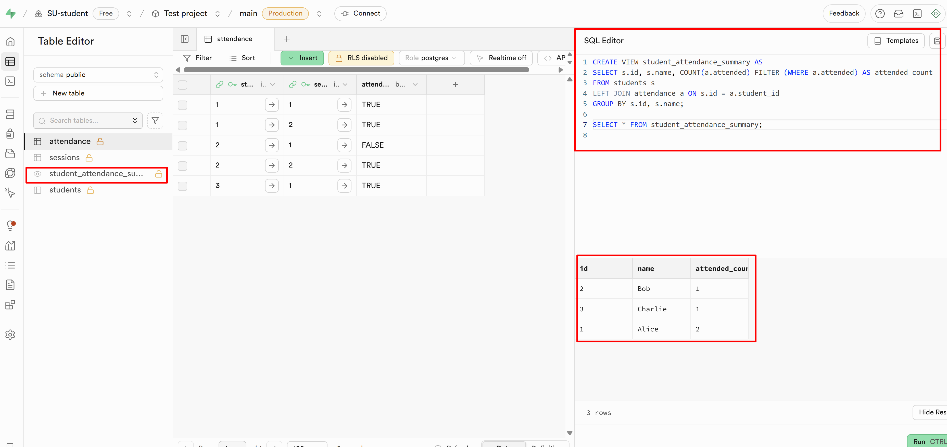

Track Absences Automatically with a Trigger
- Log every absence automatically

Create the Log Table
- Write an SQL query to create the new table:
CREATE TABLE absences (
id SERIAL PRIMARY KEY,
student_id INT,
session_id INT,
logged_at TIMESTAMP DEFAULT now()
);

Create the Trigger Function
- Write an SQL query to create the trigger function:
CREATE OR REPLACE FUNCTION log_absence()
RETURNS TRIGGER AS $$
BEGIN
IF NEW.attended = FALSE THEN
INSERT INTO absences(student_id, session_id)
VALUES (NEW.student_id, NEW.session_id);
END IF;
RETURN NEW;
END;
$$ LANGUAGE plpgsql;
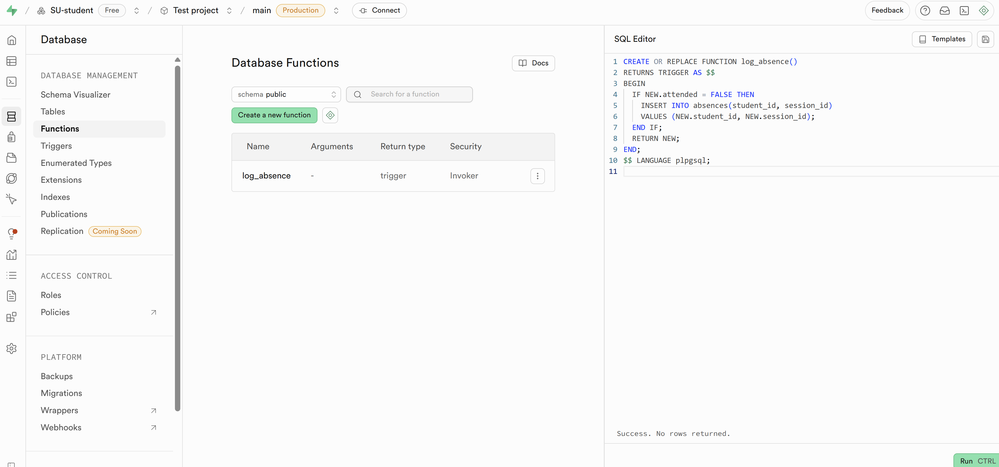

Create the Trigger
- Write an SQL query to create the trigger
CREATE TRIGGER trigger_log_absence
AFTER INSERT ON attendance
FOR EACH ROW EXECUTE FUNCTION log_absence();
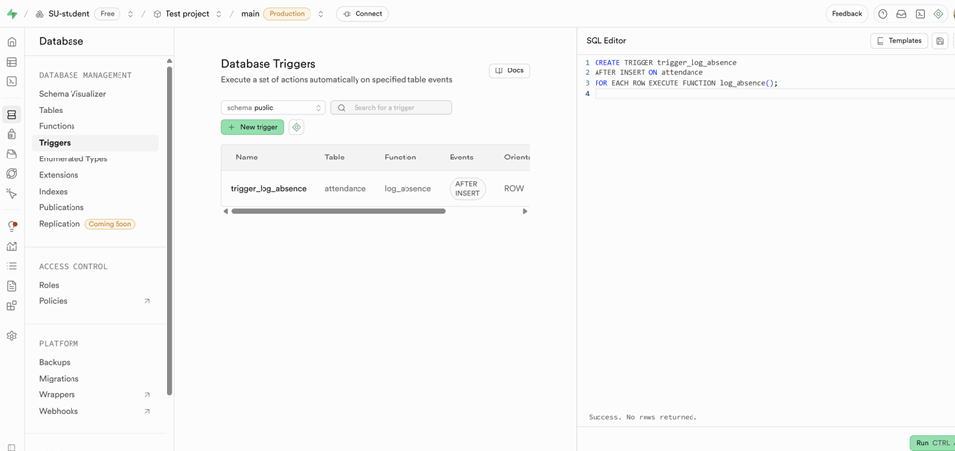

Test the Trigger Functionality
- Insert a new FALSE-attended record and check the absences table:
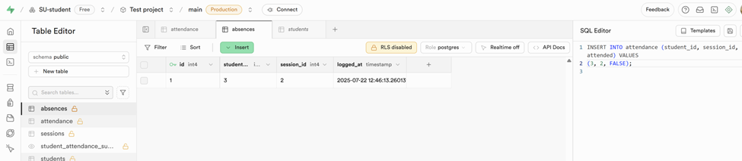

Database Overview
- Database Simple Overview
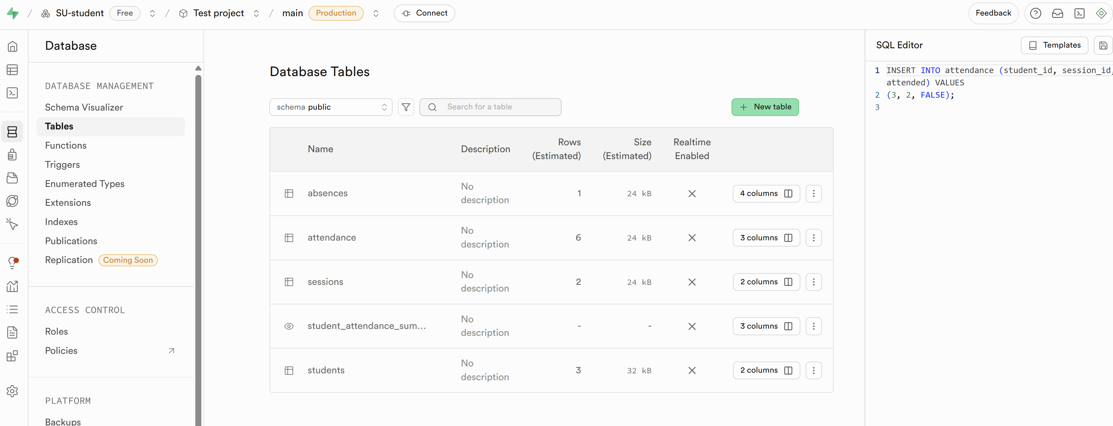
- E/R diagram
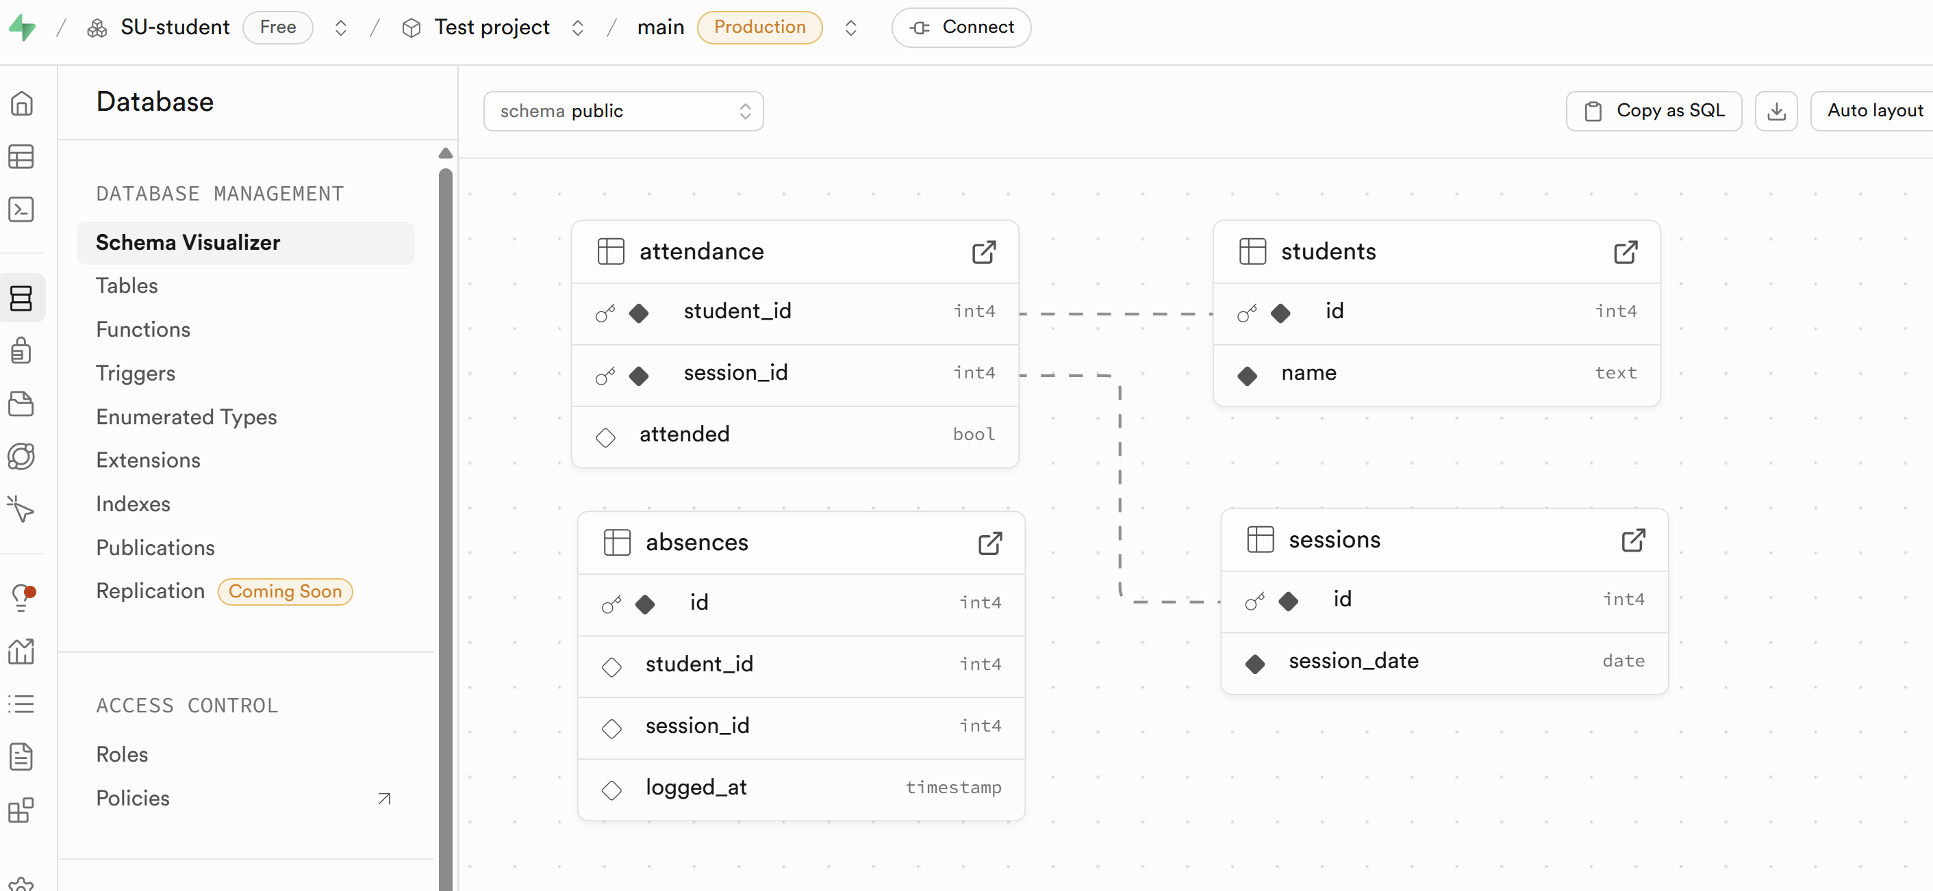

Extra Challenges
- Add a constraint to prevent duplicate student names.
- Add a new column to the "attendance" table to store notes or comments (e.g., "comment" text field)
- Create a function that returns absent students for a given session:
  - Takes session_id as input
  - Returns all students marked as absent in that session
- Create a procedure that marks a student as absent for a specific session and updates both the "attendance" and "absences" tables:
  - Takes student_id and session_id as input
  - Inserts a record into the "absences" table (only if not already present)
  - Updates the "attendance" table to mark the student as absent
  - Includes error handling: if the student or session ID doesn't exist, the procedure should raise a notice/exception, return a message, or exit silently
- Create an index on a column that would significantly improve performance for large datasets:
  - For example, indexing the "session_date" column in the "sessions" table to speed up time-based queries

Notes on Future Use of Supabase
- As you progress and become familiar with APIs, HTTP requests, and RESTful applications, Supabase will become even more powerful and relevant
- While in this workshop we focused on SQL, triggers, and database logic using the Supabase Studio UI, in real-world scenarios, Supabase is typically used to:
  - Connect databases to front-end applications (e.g., React, Vue, Angular)
  - Send API requests to Supabase
  - Handle responses in your front-end
  - Integrate authentication and real-time updates seamlessly
- As your understanding of web development and client-server communication grows, Supabase will support you beyond SQL, into building full-stack, production-ready apps

Summary
With this foundational knowledge and a glimpse into future possibilities, you are now ready to review what you have accomplished in this workshop. By completing it, you have learned to:
- Use Supabase as a hosted PostgreSQL platform
- Write and execute SQL queries in a cloud-based environment
- Create views and triggers to manage business logic
- Observe data changes using Supabase Studio in real time

