Lab: Table Relations

Submit your solutions to the SoftUni Judge System.
Create a database called camp. Import camp_db.sql file, using camp's query tab, and run all queries. Get familiar with all tables. You will use them in the following exercises.

Mountains and Peaks
Write a query to create two tables – mountains and peaks and link their fields properly by setting Foreign Key Constraint (fk_peaks_mountains). Tables should have:
- Mountains:
- id
- name, max-length = 50
- Peaks:
- id
- name, max-length = 50
- mountain_id
Submit your queries in the Judge system.

Trip Organization
Write a query to retrieve information about SoftUni camp's transportation organization. Get information about people who are drivers (driver_name and driver_id) and their vehicle type. The driver’s name field represents the full name of a driver.
Submit your queries in the Judge system.

Example
driver_id | vehicle_type | driver_name
1 | bus | Simo Sheytanov
2 | van | Roli Dimitrova
1 | van | Simo Sheytanov
… | … | …

SoftUni Hiking
Get information about the hiking routes (start_point and end_point) and their leaders (leader_name and leader_id).
Submit your queries in the Judge system.

Example
start_point | end_point | leader_id | leader_name
Hotel Malyovitsa | Malyovitsa Peak | 3 | RoYaL Yonkov
Hotel Malyovitsa | Malyovitsa Hut | 3 | RoYaL Yonkov
Ribni Ezera Hut | Rila Monastery | 3 | RoYaL Yonkov
Borovets | Musala Peak | 4 | Ivan Ivanov

Delete Mountains
Drop tables from Task 1.
Write a query to create a one-to-many relationship between table mountains (id, name) and table peaks (id, name, mountain_id). Set a Foreign Key Constraint (fk_mountain_id) and On Delete rule.
When a mountain is removed from the database, all its peaks are also deleted.
Submit your queries in the Judge system.

Project Management DB*
*This task is excluded from Judge System.
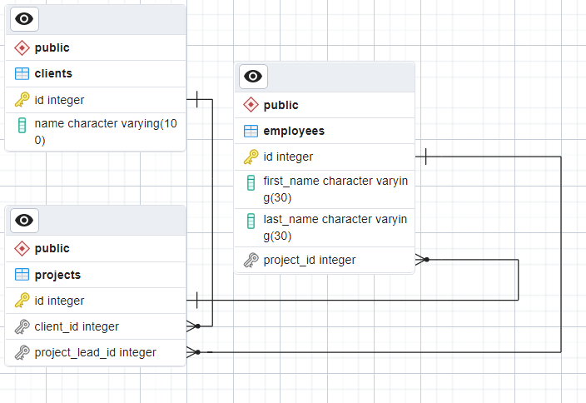
Write a query to create a project management database, according to the following E/R Diagram:

