

TomatoCare
Capstone Project 1
Student Name | Student ID
AlBaraa AlOlabi | 202210405
Ahmed Saeed Ahmed Mohamed | 202211615
Kazi Mahir Al Wafi | 202211829
Iyad El Boussi | 202111261
Fares Muaatasem Awda | 202211410

College of Engineering
Al Ain University, UAE
Spring - 2026
The copyright of this report belongs to the authors under the terms of the copyright as qualified by the Intellectual Property Policy of Al Ain. Due acknowledgement shall always be made of the use of any material contained in, or derived from, this report.

ABSTRACT

TomatoCare is an artificial intelligence (AI) powered Android application that is used by home gardeners and small scale tomato growers in the United Arab Emirates. It deals with a diagnosis dilemma unique to the arid climate of the UAE: the visual symptoms of biotic diseases the symptoms of pathogens such as Alternaria solani, Phytophthora infestans are often impossible to distinguish between the symptoms of abiotic stress responses caused by sunscald, heat injury, and chlorosis due to salinity. Misdiagnosis of the diseases results in improper treatment, wastage of pesticides, and loss of crops. TomatoCare addresses this by offering entirely offline, on-gadget image examination and prescriptions of therapeutic actions tailored to UAE growing circumstances.

The system is trained on a MobileNetV3-Large Convolutional Neural Network (CNN) based on the PlantVillage dataset that is supplemented with images that recreate the UAE-specific environmental conditions such as high-brightness sunlight, dust haze, and heat glare. The model is a ten-category (1 healthy and 9 disease) model on a UAE-specific held-out test set, aiming to achieve at least 90% classification accuracy. Sub-diagnoses are labelled with colour-coded badges of biotic or abiotic stress, a severity indicator (Low, Medium, High, or Critical), and treatment suggestions filtered by the growing method of the user greenhouse, open-field, hydroponic, or saline-soil cultivation. A Low Confidence Warning will be issued by the system instead of giving an uncertain result when diagnostic confidence is less than 60%. The trained model is exported to TensorFlow Lite with float16 quantisation to inference on the device, without compromising the accuracy.

TomatoCare is currently written in Kotlin along with Jetpack Compose, using CameraX to capture images and Kotlin Serialization to store scan history locally in a localized form, as a localized JSON. All the processing is done on-device without the need to be connected to the internet. The application supports both English and Arabic with full right-to-left layout support, and export and import scan history via the Android Storage Access Framework.

Table of Contents
ABSTRACT 2
1 CHAPTER 1: INTRODUCTION 7
1.1 Introduction 7
1.2 Background and Motivation 8
1.2.1 The UAE National Food Security Strategy 2051 and the Digital Divide 8
1.2.2 The Knowledge Gap: Biotic vs. Abiotic Stress 8
1.2.3 The Accessibility Imperative: Offline Edge Computing 9
1.2.4 Growing Method Context 9
1.3 Proposed System 10
1.4 Problem Statement 10
1.5 Aims and Objectives 11
1.5.1 Aim 11
1.5.2 Objectives 11
1.6 Scope and Delimitations 12
1.6.1 Scope 12
1.6.2 Delimitations 12
1.7 Significance of Study 12
1.8 Expected Outputs 12
1.9 Report Outline 13
2 CHAPTER 2: LITERATURE REVIEW 13
2.1 Introduction 13
2.2 CNN-Based Detection of Plant Diseases: Basics. 13
2.3 Lightweight CNN Architectures for Mobile Deployment 14
2.4 PlantVillage Dataset and Domain Gap. 14
2.5 Transfer Learning and Fine-Tuning Strategies. 15
2.6 TensorFlow Lite and On-Device Inference. 15
2.7 Biotic vs. Abiotic Stress in Tomato Plants. 16
2.8 Existing Plant Diagnostic Applications: Comparative Review 17
2.8.1 Farmonaut 17
2.8.2 Flora Incognita 18
2.8.3 Plantix Overview 19
2.8.4 Agrio Overview 20
2.8.5 Comparative Analysis 21
2.9 Privacy, Ethical and Localisation considerations. 21
2.10 Research Gaps and Conclusion 22
3 CHAPTER 3: METHODOLOGY 23
3.1 Introduction 23
3.2 Team Roles and Responsibilities 23
3.3 Software Development Lifecycle 24
3.4 Methodology Comparison and Selection 25
3.5 Agile Artifacts 27
3.6 Sprint Timeline and Breakdown 27
3.7 Gantt Chart 29
3.8 AI Model Development Methodology 29
3.8.1 Dataset 29
3.8.2 Image Preprocessing 30
3.8.3 CNN Architecture: MobileNetV3-Large 30
3.8.4 Training Process 31
3.8.5 Model Evaluation 31
3.8.6 Mobile Integration 32
3.9 Data Persistence: JSON File Storage 32
3.10 Development Tools and Environment 33
3.11 Conclusion 33
4 CHAPTER 4: REQUIREMENTS AND SPECFICATIONS 34
4.1 Introduction 34
4.2 Functional Requirements 34
4.3 Non-Functional Requirements 36
4.4 Domain Requirements 37
4.5 Constraint Requirements 37
4.6 Stakeholder Perspective 38
4.7 Use Case Diagram 39
5 CHAPTER 5: DESIGN 40
5.1 System Architecture 40
5.1.1 Layer 1 – Presentation Layer (UI) 40
5.1.2 Layer 2 – Application Logic Layer (Inference Engine) 40
5.1.3 Layer 3 – Data Layer (Local Persistence) 40
5.1.4 Concerns Among Layers 41
5.2 Sequence Diagram 42
5.3 State Chart Diagram 43
5.4 Entity-Relationship Diagram (ERD) 44
5.1 JSON Schema Tree 45
5.2 Class Diagram 46
5.3 Activity Diagram 47
6 CHAPTER 6: CONCLUSION 48
REFERENCES 50

LIST OF FIGURES
Figure 1: UAE Temperatures vs Optimal Tomato Growth 8
Figure 2: Visual Similarities Sunscald (Abiotic) vs Early Blight (Biotic) 9
Figure 3: Farmonaut application interface. 17
Figure 4: Flora Incognita application interface. 18
Figure 5: Plantix application interface. 19
Figure 6: Overview of Agrio application. 20
Figure 7: Agile SDLC Cycle. 25
Figure 8 TomatoCare Project Gantt Chart 29
Figure 9 Use Case Diagram 39
Figure 10: Layered Architecture Diagram 41
Figure 11: Diagnose Leaf 42
Figure 12: View Past Sca 42
Figure 13 State Chart Diagram 43
Figure 14 ERD 44
Figure 15 JSON Schema Tree 45
Figure 16 Class Diagram 46
Figure 17 Activity Diagram for Run Diagnosis 47

LIST OF TABLES
Table 1 Problem Statement 10
Table 2: Comparative Feature Analysis. 20
Table 3: Team Roles and Responsibilities. 23
Table 4: Comparison of SDLC Methodologies 25
Table 5: Sprint Timeline and Breakdown 27
Table 6: CNN Architecture Comparison for Mobile Deployment 30

CHAPTER 1: INTRODUCTION

Introduction
One of the most grown vegetables in the UAE which is widely grown by home gardeners, small scale farmers and the commercial greenhouse operators is tomato (Solanum lycopersicum). There are, however, several challenges when it comes to tomato production in the Gulf region which, however, are fundamentally different to the challenges encountered in the temperate agricultural environment. The extreme temperatures during summer exceeding 45c, high salinity of groundwater and intense solar radiation subject tomato plants to severe physiological stress, which not only has a direct negative effect on the crop but also impairs the natural defences of the plant against biotic infections such as fungal pathogens, bacteria and viruses [1].
One of the unsolved issues of UAE growers is primarily the correct definition of these threats. Symptoms of biotic diseases such as leaf yellowing, wilting and necrotic spots due to Alternaria solani (Early Blight) or Phytophthora infestans (Late Blight) are not visually distinguishable by an untrained observer compared to abiotic stress symptoms due to sunscald, heat injury, or chlorosis due to salinity. The misidentification caused by this diagnostic ambiguity subsequently results in incorrect application of treatments, wastage of resources and more often failure of crops completely.
The current diagnostic instruments fail to effectively tackle this issue. Commercial products like Plantix and Agrio need to have a constant internet connection, which is not always accessible in rural or outdoor agricultural environments. All these platforms have not been trained on UAE specific patterns of stress and none of these platforms offer Arabic language support; which is a big challenge considering that a good percentage of the agricultural workforce in the UAE is made up of Arabic speaking individuals. There are also professional agricultural consultants, out of reach of small-scale growers due to cost and geographic considerations.
TomatoCare is proposed to fill this gap. It is a native Android application that is offline, AI-powered and allows any grower, irrespective of their technical expertise, connectivity or economic status, to photograph a tomato leaf and receive an instant, precise diagnosis and treatment recommendations tailored to the UAE growing conditions. TomatoCare is a socially responsible venture in line with the UAE National Food Security Strategy 2051 [2], which seeks to democratise precision agriculture to those who have traditionally not enjoyed the benefits of precision agriculture.
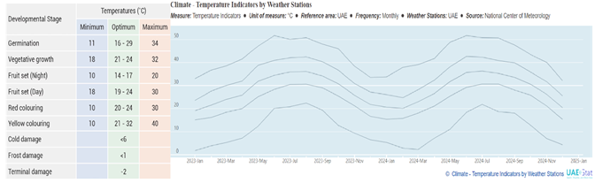
Figure 1: UAE Temperatures vs Optimal Tomato Growth

Background and Motivation

The UAE National Food Security Strategy 2051 and the Digital Divide
The United Arab Emirates has made food security a national strategic priority, with the government acting as a long-term goal of achieving a significant improvement in the sustainability of local agriculture. The UAE National Food Security Strategy 2051 is the voice that manifests this commitment in three pillars of operations; developing local production capability, improving production efficiency, and using new technologies to enhance agricultural productivity [2]. The final vision will be to enable farmers with data-driven decision-making solutions that will reduce the reliance on imported food and enhance the agricultural resilience of the country.
Although such policy ambition, there is still a significant difference between the governmental intent and ground level practice. Big-scale commercial producers have the financial capability to finance precision agriculture technologies, but small-scale growers and home gardeners, who comprise a large and growing proportion of the UAE food-producing population, remain largely out of the advances. This imbalance leads to a largely reactive method of crop management: by the time a small-scale grower becomes aware of a disease problem by simply looking at the crop, the condition has typically escalated to a point where the grower is bound to lose a significant portion of his crop. TomatoCare responds to this knowledge gap by putting a specialised agronomic diagnostic tool directly in the hands of all growers with a smartphone, irrespective of their economic size and technical understanding.

The Knowledge Gap: Biotic vs. Abiotic Stress
The visual similarity between biotic stress, caused by living pathogens like the fungi that cause Early Blight and Leaf Mold, the bacterium that causes Bacterial Spot and viruses such as Tomato Yellow Leaf Curl Virus, and abiotic stress caused by environmental factors such as excessive heat, intense sunlight radiation, salinity induced chlorosis, and drought is one of the most significant diagnostic challenges facing UAE tomato growers. To the layman, the processes of yellowing, wilting and browning of leaf tissue can be observed as the same process, regardless of the actual cause.
This difference is of huge importance in practice. Not only is the application of a copper-based fungicide to a plant with sunscald not cost effective, but it is also detrimental: it introduces unwanted chemicals to the soil, postpones the implementation of the appropriate corrective action (shading or irrigation adjustment), and promotes the development of pathogen resistance in the larger agricultural ecosystem. The development of global diagnostic models has been carried out with predominantly temperate climate in North America and Europe as a basis, where the abiotic stress patterns are substantially different as compared to the Arabian Gulf. These models thus do not have training data it needs to differentiate UAE-specific abiotic symptoms and actual pathological conditions. To help overcome this limitation, TomatoCare explicitly trains its model on augmented data that includes images that simulate UAE conditions of light, heat, and dust, and tags each result on diagnosis with a biotic or abiotic stress-level classification to help the user select the correct type of intervention.
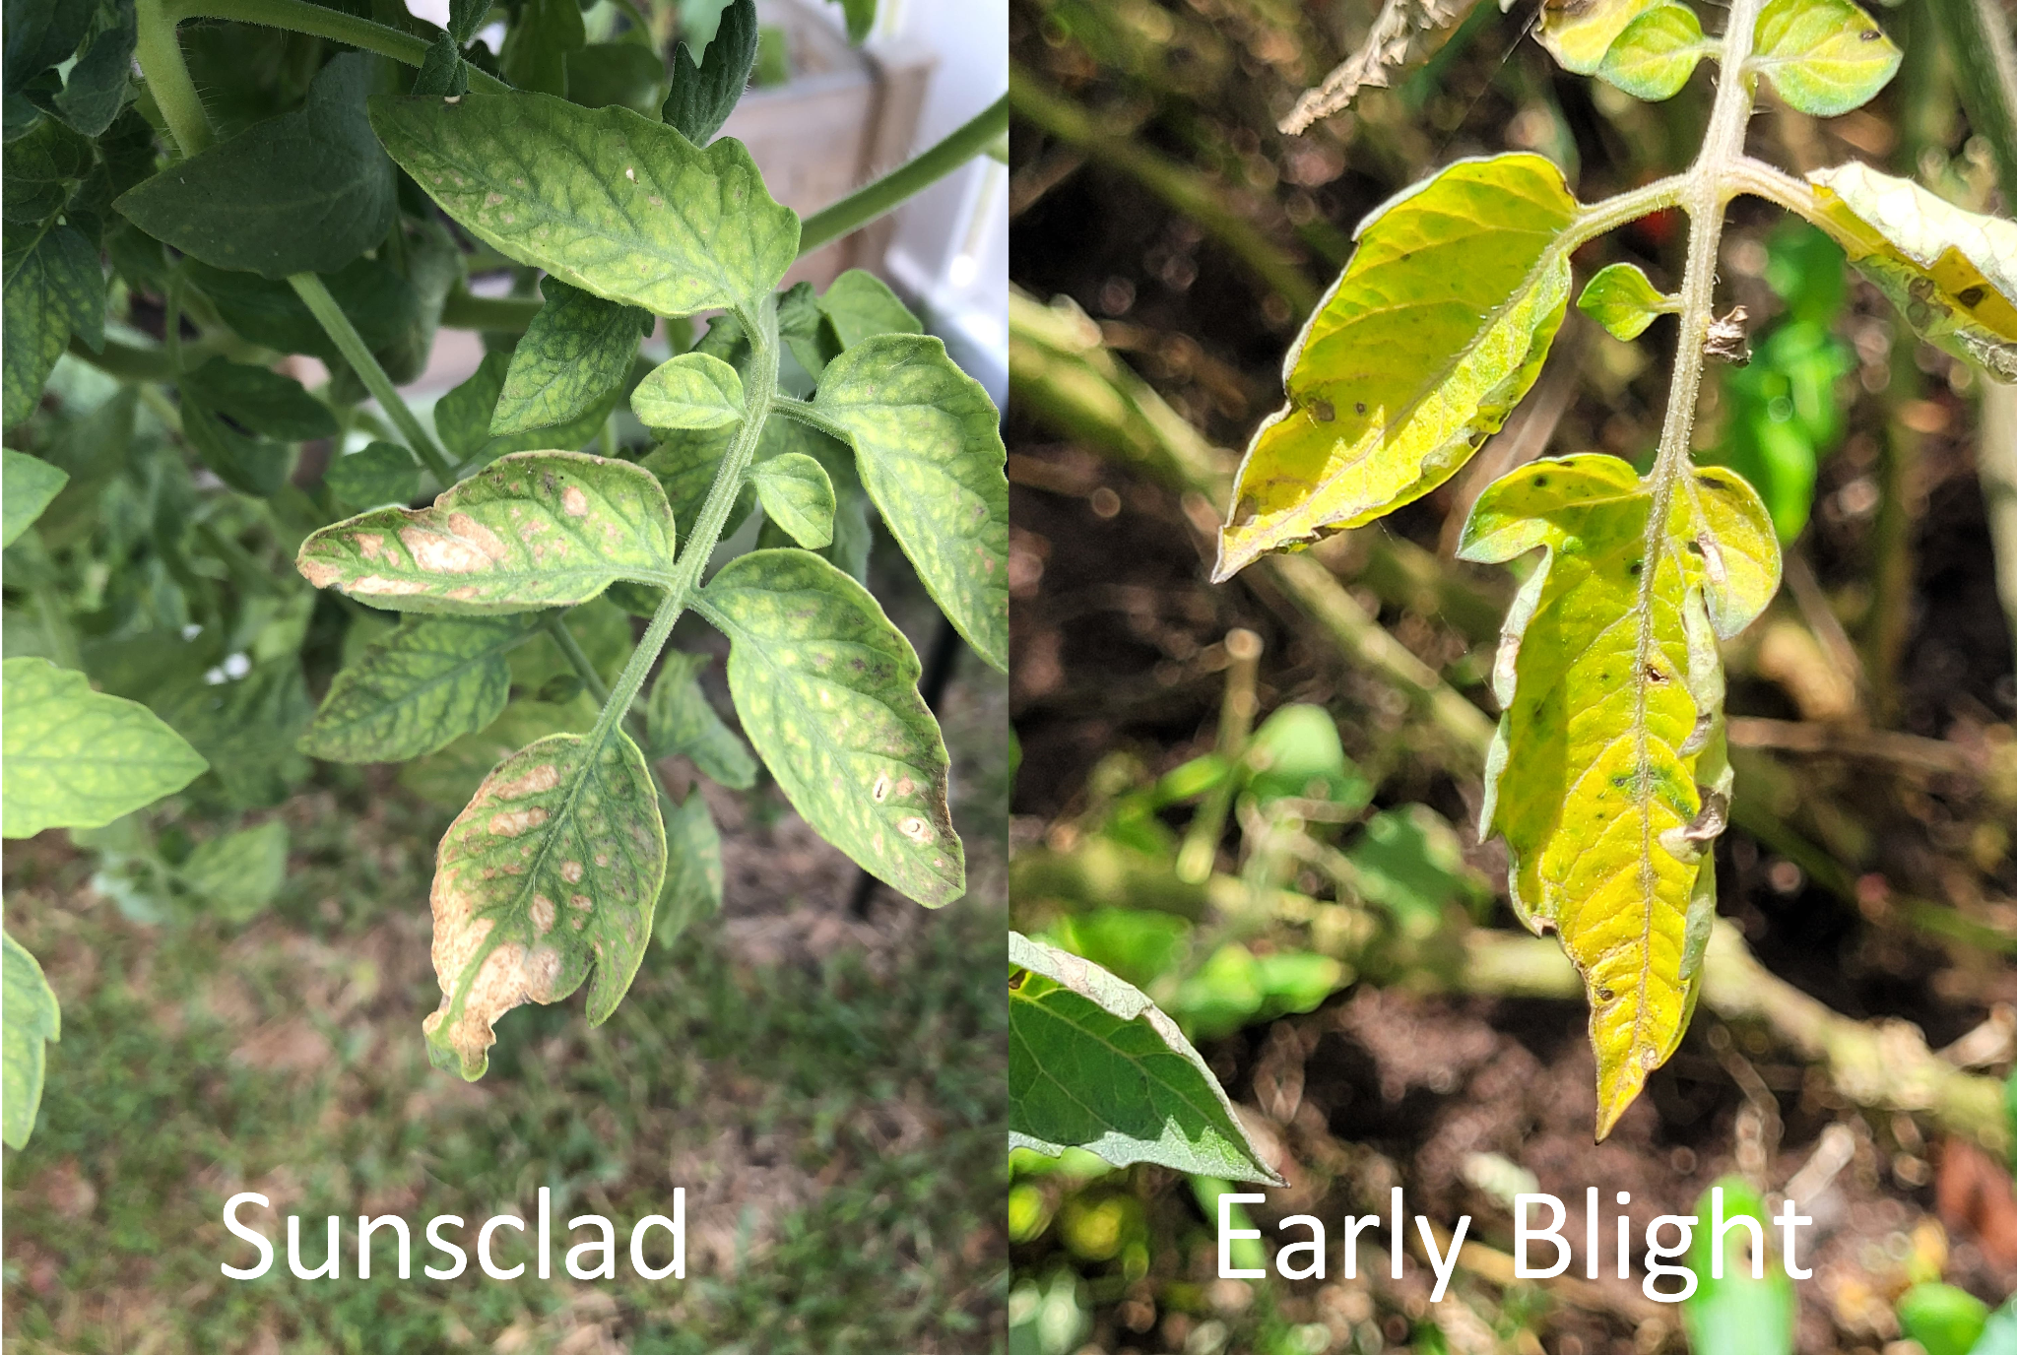
Figure 2: Visual Similarities Sunscald (Abiotic) vs Early Blight (Biotic)

The Accessibility Imperative: Offline Edge Computing
TomatoCare is based on an offline, edge computing platform. The processing of images and inference is all done on the device, and no network request is made anywhere during the process. This is not just a technical choice of architectural preference, but rather a need based on the realities of the proposed deployment environment. Mobile data coverage of rural farming areas in the UAE is quite unreliable or even not present at all, so cloud-dependent diagnostic tools cannot be reliably used in the field.
TomatoCare uses float16 quantisation to reduce the size of the trained MobileNetV3-Large model into a TensorFlow Lite format to achieve on-device inference, without compromising diagnostic accuracy. This process minimizes the memory footprint and run-time of the model to a level compatible with low-end Android devices with API level 26 (Android 8.0 Oreo) and higher, and as little as 2 GB of RAM. The outcome is a diagnostic tool that is equally available to a grower working in a greenhouse in Abu Dhabi and one who is tending a home garden in a remote desert community, without any dependence on connection, subscription charges, or specialist hardware.

Growing Method Context
The scope of growing practices in tomato cultivation in the UAE has a variety of growing techniques, each of which presents different disease dynamics and treatment needs. The advantages of greenhouse cultivation include being able to provide environmental control but the condition in which fungal pathogens such as Leaf Mold thrive. Open-field farming is exposed to the full blast of UAE sun rays and wind-carried pathogen. The root-zone bacterial infection is susceptible to hydroponic systems, which is increasingly becoming common in urban UAE settings. The abiotic stress patterns generated by saline-soil farming, simulate closely the symptoms of biotic disease, practised where the salinity of groundwater is elevated. To rank the most relevant treatment recommendations to that particular cultivation environment, TomatoCare captures the growing approach used by the user at the point of scan and uses this contextual information to rank the most relevant treatment recommendations to that specific cultivation environment.

Proposed System
TomatoCare is designed to be developed using Kotlin and Jetpack Compose. Its main purpose is to take a photograph of a tomato leaf (taken live with CameraX or selected in the device gallery), and classify it as one of ten categories: one healthy category and nine disease categories, specifically Tomato Early Blight, Tomato Late Blight, Tomato Bacterial Spot, Tomato Septoria Leaf Spot, Tomato Spider Mites (Two-spotted Spider Mite), Tomato Target Spot, Tomato Yellow Leaf Curl Virus, Tomato Mosaic Virus and Tomato Leaf Mold.
After an image is uploaded, the application preprocesses it, resizing the image to 224 x 224 pixels and normalising the pixel values, and then forwards the image to an on-device TensorFlow Lite model based on the MobileNetV3-Large convolutional neural network architecture. The model was trained on the PlantVillage dataset with transferred learning and augmented with images which simulates UAE-specific environmental conditions such as high-brightness lights, dust haze, and heat glare. The model is quantised with float16 to minimise its size without compromising diagnostic accuracy.
The inference engine gives a prioritized list of the class probabilities. When the top confidence score meets or exceeds the 60% threshold, the application displays the primary diagnosis to the user, with the name of the condition in both English and Arabic, the percentage of the confidence, a colour-coded biotic or abiotic stress badge, a level of severity indicator (Low, Medium, High, or Critical), and localised treatment suggestions, taking into consideration the growing method chosen by the user. When the top confidence score is below 60% a threshold will justify on ethical grounds in section 4.6 and the system will issue a Low Confidence Warning and prompt the user to re-take the photograph even in a better lighting environment.
Scan records are stored locally in a JSON file via Kotlin Serialisation (kotlinx.serialization) and there is no dependency on the cloud anywhere. Users can view all scan history, past-diagnoses, and can export their history as a JSON file to any device location via the Android Storage Access Framework, and can import a previously exported file to restore their data. The application is available in both English and Arabic and fully right-to-left layout in the case of Arabic. The complete application - the embedded model, treatment database, and all UI strings can be run without an internet connection.

Problem Statement
Element | Description
The Problem Of | Incorrect visual diagnosis of the condition of tomato leaves in the UAE, due to three compounding failures: the visual similarity between biotic infection (Early Blight, Late Blight, Tomato Yellow Leaf Curl Virus) and abiotic stress symptoms (sunscald, heat injury, salinity-induced chlorosis); the inability of available diagnostic tools to work without an internet connection in rural and outdoor agricultural settings; and the lack of support on all available platforms in Arabic, excluding a significant portion of the UAE agricultural workforce.
Affects | Small-scale farmers, home gardeners and low-income agricultural workers in the UAE who grow tomatoes as a primary or supplementary food source and who do not have access to professional agronomic advice.
The Impact Is | Loss of crop yields, financial waste due to the inappropriate use of treatments, environmental harm due to unnecessary use of pesticides, acceleration of the resistance of the pathogen to treatment, and the consolidation of food insecurity in vulnerable populations.
A Successful Solution | It is a user-friendly, open-source, fully offline diagnostic program, which is explicitly designed to run on low-end Android devices, and which specifically distinguishes between biotic disease and abiotic stress.
Table 1 Problem Statement

Aims and Objectives

Aim
This project will develop and test TomatoCare, a native Android application that can recognize tomato leaf diseases and environmental stress situations with the classification accuracy of at least 90% and operate entirely offline and on low-end Android devices (API 26 and above).

Objectives
To achieve this purpose, seven important goals have been formulated:
- Create a Specialized CNN Model: Train a MobileNetV3-Large CNN on an augmented version of the PlantVillage dataset that includes UAE-specific lighting and climate simulation, with the goal of reaching a classification accuracy of 90% or higher on a held-out test set.
- Introduce On-Device Inference: Export the trained model to the TensorFlow Lite format using float16 quantisation and incorporate it into the Android application to allow real-time, offline diagnosis without any network dependency.
- Develop an Accessible Mobile App: Build a lightweight native Android application with Kotlin and Jetpack Compose that supports Android 8.0 and above, and uses a bilingual interface in English and Arabic.
- Localise Treatment Recommendations: Include treatment guidance that is specific to UAE growing conditions, including hydroponic, saline-soil, open-field, and greenhouse cultivation environments, in both supported languages.
- Label Biotic and Abiotic Stress: See to it that each diagnosis outcome must be explicitly labeled as biotic (pathogen-caused) or abiotic (environment-caused).
- Introduce Data Backup and Restore: Add export and import capability to scan history using Android Storage Access Framework, without cloud or network access.
- Test System Performance: Functional testing and performance validation should be done on low-end target devices to ensure that the application is meeting all specified non-functional requirements, such as inference speed, APK size, and stability.

Scope and Delimitations

Scope
TomatoCare has its area covered along four dimensions. In terms of crop type, it is limited to tomato (Solanum lycopersicum) only. In terms of geographic context, the system is specified and optimized to growing conditions characteristic of the UAE and the Gulf region, in general, such as high temperatures, intense sunlight, and salinity. Concerning platform, the application targets native Android devices only. Full implementation details of the technology stack are documented in Chapter 3. In terms of language, the user interface comes in both English and Arabic with complete RTL layout support.

Delimitations
The following are specifically outside the scope of this project. No type of cloud synchronisation is included in the application; all data is always stored on the device of the user. Multi crop is not supported the model is only trained on tomato leaf images and is not generalised to other species. It does not support integration with Internet of Things sensors or environmental monitoring hardware, and the system can pull in only smartphone camera input. The application merely gives treatment recommendations and is not a legally binding agrochemical prescription. This version does not implement any user accounts or authentication mechanisms.

Significance of Study
There are several contributions that TomatoCare makes that go beyond the scope of the immediate project. It first illustrates that it is possible to deliver precision agricultural diagnostics to low-end, offline devices without compromising the accuracy of the results, directly addressing the digital divide between large-scale commercial farming and smallholder agriculture in the UAE. Second, TomatoCare fills a gap, which no currently available mobile application addresses, that leads to unnecessary application of pesticides and the environmental harm that it causes. Third, the project can directly support the UAE National Food Security Strategy 2051 by providing the local growers with a tool that can minimize crop losses and enhance the sustainability of local food production. Lastly, the fact that the codebase and dataset contributions are open-source, means that the work can be extended by the global research community, especially researchers working on arid-climate agricultural AI.

Expected Outputs
A successful completion of this project will result in the following deliverables: a trained MobileNetV3-Large model with no less than 90% classification accuracy, trained on a UAE-specific test set; a fully functional bilingual Android application compatible with devices running Android 8.0 and higher; a quantised TensorFlow Lite model file embedded within the application to perform fully offline inference; an open-source GitHub repository licensed under the MIT License containing all source code, training scripts, dataset augmentation pipelines, and documentation; and a comprehensive technical report covering system architecture, design decisions, and evaluation results.

Report Outline
The rest of this report is organized in the following manner. Chapter 2 describes a literature review of the existing AI-based plant diagnostic tools namely Farmonaut, Flora Incognita, Plantix and Agrio and establishes the gaps that drive the development of TomatoCare. Chapter 3 explains the project methodology, including the Agile development method, sprint design, and the technical pipeline to train the model, quantise it, and integrate it into the mobile platform. In chapter 4, the system requirements are defined, consisting of functional and non-functional requirements, domain and constraint specifications, use case diagram. Chapter 5 introduces the layered architectural design and full suite of UML diagrams which includes the class diagram, state chart, activity diagram, ERD diagram, sequence diagram and data schema (JSON). Chapter 6 provides the final chapter of the report with a summary of findings, a recognition of existing limitations, and recommendations on how this can be improved upon.

CHAPTER 2: LITERATURE REVIEW

Introduction
This chapter provides the academic and technical context of the design choices of TomatoCare and lays out the context of the system within the existing landscape of AI-based tools of diagnosing the plant. The recent developments in artificial intelligence, computer vision and mobile computing have revolutionized the process of plant disease detection, turning it into a more automated and image-based discipline [3, 4]. Despite this development, the literature indicates that there are still significant gaps in the literature when these tools are compared against the needs of small scale tomato production in is extremely dry climates such as the UAE.
The chapter is organised into nine substantive sections. In Section 2.2 to Section 2.7, the technical and academic backgrounds underpinning each of the major design choices in TomatoCare the use of convolutional neural networks to classify image based plant disease, the selection of a lightweight architecture suitable to be deployed on a mobile device, the choice of training data and augmentation strategy, the application of transfer learning, the role of TensorFlow Lite and quantisation in enabling on-device inference, and the academic basis of distinguishing between biotic and abiotic stress. Section 2.8 gives a comparative analysis of four exemplary existing applications Farmonaut, Flora Incognita, Plantix and Agrio versus the functional requirements of TomatoCare. Section 2.9 explores the privacy, ethical and localisation issues pertinent to the implementation of AI-based diagnostic tools in the UAE setting. Section 2.10 provides a synthesis of the research gaps identified, and the technical justification of the development of the TomatoCare.

CNN-Based Detection of Plant Diseases: Basics.
Deep learning in plant disease classification application has evolved fast in the last decade. The early image-based diagnostic systems were based on conventional computer vision methods, like colour histogram analysis and feature extraction by hand, which performed reasonably well under controlled laboratory conditions but were much poorer at generalising to real-world field imagery. Convolutional neural networks provided a fundamental change in this paradigm as they made available the ability to learn hierarchical visual features directly and automatically based on labelled images [3].
Recent peer-reviewed investigations report that the state-of-the-art CNN designs can obtain classification accuracies of over 98 percent in the controlled plant disease datasets, with the corresponding F1 scores reaching the same level [3, 4]. Field deployments, where lighting, background and image quality differ significantly, usually report lower but still good accuracies in the range of 90% to 95% [3]. This is a well-documented phenomenon and has a direct implication on the evaluation methodology utilised by TomatoCare that aims at achieving at least 90 percent accuracy on a test set that factors in the UAE-specialized environmental conditions to ensure that the deployed model performs reliably in real application and not just in an idealised picture.
The CNNs are especially well adapted to the plant disease classification problem, since the diagnostic features that distinguish one pathology form another in the geometry of the necrotic lesions, the color transitions of the chlorotic tissue, the morphological patterns of the fungal mycelium, etc. are precisely the kind of localized visual patterns that CNN architectures are designed to detect through their convolutional and pooling layers [3, 4]. This fits between the architectural capability and the problem structure that informs the adoption of CNN-based approach to TomatoCare.

Lightweight CNN Architectures for Mobile Deployment
Although CNNs have the diagnostic capacity that TomatoCare needs, the deployment environment low-end Android devices with a full-offline operating environment puts strict constraints on model size, memory footprint, and inference latency. Existing CNN architectures designed to run on a cloud-based inference, e.g., ResNet-50 and InceptionV3, cannot be used in this deployment case. An example is ResNet-50, which has about 25.6 million parameters and occupies around 98 MB on disk, which does not fit in the target APK size and the memory constraints of devices in the API 26 / 2 GB RAM category [5].
MobileNet family of architectures was included to overcome this limitation. MobileNet models significantly reduce both the number of parameters and the cost of computation by an order of magnitude compared to traditional CNNs whilst maintaining most of their classification accuracy. The architecture used by TomatoCare, MobileNetV3-Large, is based on this architecture but with additions of Neural Architecture Search to optimise the layer structure to match the mobile hardware, the hard-swish activation function to improve gradient flow at a low computational cost, and squeeze-and-excitation blocks to enhance feature representation [6]. The resulting model has a size of about 5.4 million parameters; it is of size about 22 MB before quantisation and the best top 1 ImageNet accuracy of 75.2%.
The decision of MobileNetV3-Large over MobileNetV2 (lower accuracy at similar size) and EfficientNet-B0 (slightly higher accuracy but slower inference on mobile hardware) can be explained by the fact that it was an intentional engineering decision to maximise diagnostic accuracy within the latency and storage constraint imposed by the offline, low-end-device deployment setting. Chapter 3, Section 3.6.3 makes a direct comparison of the relevant architectures.

PlantVillage Dataset and Domain Gap.
PlantVillage dataset, initially gathered and published by Hughes and Salathé, has become a de facto standard benchmark in research on plant disease classification [9, 10]. The dataset comprises more than 54,000 labelled images across 38 classes and 14 crop species with ten classes specific to tomato one healthy and nine diseased classes specifically matching the diseases targeted by TomatoCare. The close match between the available data and the classification taxonomy of the project predetermined the selection of the primary source of training PlantVillage.
Despite that, there is a well-documented limitation of PlantVillage that is commonly cited in the literature: all the images are taken in controlled laboratory conditions with uniform backgrounds and uniform lighting [9, 10]. When trained on images of plant life in the field, and with variable lighting, and cluttered backgrounds, or at non-standard camera angles, models trained only on PlantVillage typically have a sharp decrease in accuracy. This is also referred to as the domain gap, especially when models that have been trained on temperate-climate laboratory images are deployed to environments with very different visual properties such as the high-brightness, dust-affected, heat-saturated conditions characteristic of UAE outdoor and greenhouse agriculture.
To overcome this shortcoming, TomatoCare adds the tomato subset of PlantVillage with synthetic transformations that are specifically designed to provide a simulation of UAE field conditions. These augmentations, described in Chapter 3, include brightness and contrast adjustment to emulate strong solar radiation, controlled colour-channel shifts to emulate dust haze, geometric transformations to reflect varied camera angles, and compound background variation to reduce reliance on the uniform backgrounds that are present in the source data. The reasons behind this augmentation strategy are that it is rooted in the existing literature on diversifying dataset training deep learning, which has repeatedly demonstrated that data variety training deep learning is a more significant determinant of actual performance than the amount of raw training data alone [10].

Transfer Learning and Fine-Tuning Strategies.
The datasets needed to train a CNN when starting with random initialisation are large datasets containing millions of labelled images and large amounts of computational resources, both of which are impractical within the limits of a typical academic capstone project. Transfer learning offers an established alternative: a model that has been pre-trained on a large, general-purpose dataset (typically ImageNet, with over a million labelled images in a thousand categories) is adapted to a specialised task by replacing its classification head and fine-tuning a subset of its layers on the target dataset.
It is confirmed in the literature that transfer learning provides considerable performance benefits in the classification of plant diseases in particular [9, 10]. ImageNet Pre-training the lower convolutional layers of a network with ImageNet pre-training gives the network general-purpose visual feature detectors edges, colour transitions, textures and basic shape primitives which are effectively transferred to the plant disease domain. The top levels, which combine more feature combinations specific to the task, are then re-trained on the target data to learn the visual representations of the conditions under classification.
TomatoCare implements two-stage transfer learning strategy. During the first stage, all layers of the MobileNetV3-Large base model are frozen and only the new classification head is trained, which allows the classification head to adapt to the ten tomato classes without disrupting the pre-trained feature representations. At the second stage, the top thirty layers of the original model are unfrozen and fine-tuned at a lower learning rate, allowing the model to adjust the higher-level feature combinations to the unique visual properties of tomato leaf conditions. These two phase methods which are further elaborated in Chapter 3 agrees with the current best practice in the transfer learning literature [6].

TensorFlow Lite and On-Device Inference.
The fact that TomatoCare is designed to be operated entirely offline, without incurring any cloud inference, no network calls, no remote dependencies, etc. is a fundamental factor in the technical architecture of TomatoCare. There are four benefits of on-device inference that are directly applicable to the context of the UAE deployment: it does not rely on network availability, avoids latency of inference due to network roundtrips, ensures complete privacy of user data, and incurs no continuing operational cost.
TensorFlow Lite is a framework by Google to deploy machine learning models on mobile and embedded devices. It takes as input a TensorFlow SavedModel and produces a small file (.tflite) in FlatBuffer format optimised to load quickly and run on mobile hardware. The framework supports a variety of quantisation strategies each with a different trade-off between model size, inference speed, and accuracy retention. Float32 (no quantisation) is the most accurate but yields the largest models. Int8 quantisation is the smallest and fastest but may introduce a significant amount of accuracy degradation, especially when fine-grained classification tasks are important. The Float16 quantisation, which TomatoCare adopted, is intermediate: it not only halts the model size but also preserves accuracy within a fraction of a percent of the unquantized baseline, making it the option of choice when the accuracy of the classification is of primary concern [11].
When float16 quantisation is used to create the model, the model loads fast, fits in the available memory without a major issue, and runs within the latency budget that is available to support an interactive diagnostic experience. The joint operation of MobileNetV3-Large and float16 quantisation, therefore, constitutes a coordinated set of decisions: each of them is necessary, and they allow the offline, on-device operation that defines the architectural identity of TomatoCare.

Biotic vs. Abiotic Stress in Tomato Plants.
One of the biggest distinguishing factors of TomatoCare as compared to other current plant diagnostic applications is its clear division of conditions as either biotic or abiotic. This distinction has long been recognised as a key to proper choice of treatment in the agricultural and plant pathology literature. The biotic stresses are induced by living agents, which include fungicides, bactericides, viruses, and arthropod pests, and they must be interfered with solutions to the responsible organism such as application of fungicides, bactericides, viruses, and arthropod pests. Non-living environmental factors, extreme heat, intense sun radiation, water deficit, salinity, and nutrient imbalance cause abiotic stresses and require fundamentally different interventions, such as shading, adjustment of irrigation, amendment of soil, or correction of fertiliser.
The visual symptoms of biotic and abiotic stress can be strikingly similar especially at the early stage when both may exhibit as leaf yellowing, browning, or wilting. The environmental factors in the UAE which result in abiotic stress patterns that are not common in temperate climates only exacerbate this diagnostic ambiguity. Direct exposure of the developing leaf to the sun causes sunscald (necrotic lesions) that visually resembles fungal Early Blight lesions. The chlorosis that results due to high levels of salt in the soil or groundwater resembles the yellowing of viral infection. Leaf curl due to heat, which is prevalent during UAE summer months, can be confused with Tomato Yellow Leaf Curl Virus, which is a real virus [26].
There are grave practical implications of misclassification between these categories. The use of copper based fungicide to treat a plant that has been stressed by sunscald is not only ineffective but is counterproductive to the application of the proper corrective measure (shading or irrigation) in the future. Although this distinction has operational significance, no operational mobile diagnostic application reviewed in Section 2.8 explicitly categorizes their results in the biotic/abiotic axis. TomatoCare fills this gap by directly attaching a colored biotic or abiotic badge to every diagnosis, such that even in cases where the underlying visual symptoms are ambiguous, users are still guided to the correct category of intervention.

Existing Plant Diagnostic Applications: Comparative Review
Four exemplary AIs based plant diagnostic systems were chosen to undergo a thorough analysis: Farmonaut, Flora Incognita, Plantix, and Agrio. The four of them represent the full range of the current state of the art the large scale satellite-based commercial agriculture (Farmonaut), the citizen science species identification (Flora Incognita), and the smallholder-centered disease diagnosis (Plantix and Agrio) - and collectively can be seen as demonstrating both the capabilities and the shortcomings of the current state of the art.

Farmonaut
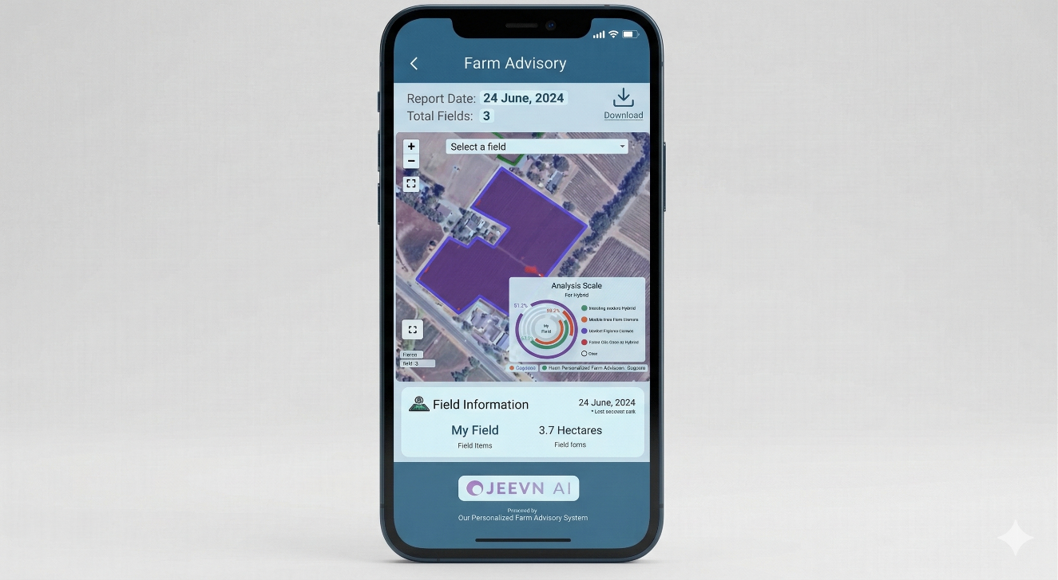
Figure 3: Farmonaut application interface.
Farmonaut is a precision agriculture platform that integrates satellite spectral tracking with smartphone-based image analysis by its Jeevn AI subsystem. The platform uses multispectral satellite data in the near-infrared and red-edge bands to detect large-scale crop anomalies, computing vegetation indices including NDVI, NDRE, EVI, SAVI, NDWI, and NDMI to measure the health of plants, their water status, and soil conditions across entire fields [15]. The satellite imagery is presented at a 10 metre resolution at 3 to 5 day intervals with synthetic aperture radar images provided in any case regardless of cloud cover.
The Jeevn AI component uses CNNs to analyse images of crops captured by the smartphone to identify the presence of a disease based on the geometry of necrotic lesions, colour variation of the chlorotic colour, and the morphology of the fungal mycelium. Diagnostic accuracy is reported to be 98.32% in laboratory with F1 scores of 97.99 and about 90 percent to 95 percent in the field of deployment [16].
Limitations and Applicability to TomatoCare. Although technically speaking, Farmonaut is simply out of place in terms of TomatoCare target users. The platform is a paid subscription platform and is designed to serve large commercial grade agricultural operations with satellite based monitoring requiring fields large enough to be meaningfully resolved at 10 metre resolution a scale not compatible with the home gardens and small plots typical of UAE smallholder cultivation [16]. Jeevn AI has not been trained on UAE-specific abiotic stressors (sunscald, salinity induced chlorosis, or heat damage) and as such is not capable of reliably discriminating these conditions and biotic disease [26]. Farmonaut does not provide an Arabic language interface, no offline capabilities, and no UAE specific treatment recommendations [14]. Its model operation presupposes the extremely type of cloud connective and economical scale with which TomatoCare is planned to work without.

Flora Incognita
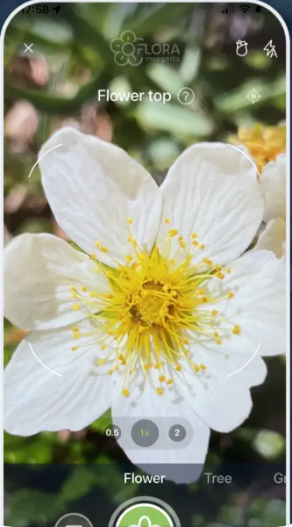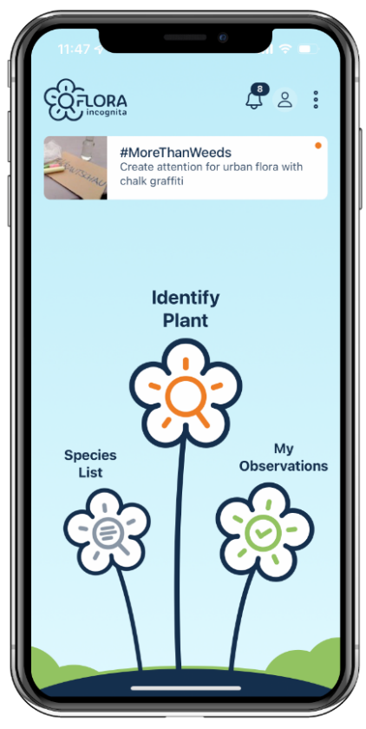
Figure 4: Flora Incognita application interface.
A free scholarly plant identification software with research grant funding by the Max Planck Institute for Biogeochemistry and the Technical University of Ilmenau, is known as Flora Incognita [17]. The system employs hierarchical deep learning method whereby several CNNs sequentially process plant images, starting with low-level features (such as geometric form and texture) and progressing to high-level botanical structures (such as flowers and fruits). When the diagnostic confidence is small, the application requests more images of the specimen in order to refine its identification and the final classification is made on a dedicated server cluster.
Over 30,000 vascular plant species have been identified in over 20 supported languages by Flora Incognita. A 2024 validation study conducted by a peer-reviewed study on the use of an independent reference dataset in ecological survey work reported a true positive rate of 98.8, establishing the platform as a scientifically credible tool in ecological survey work [18]. It is also capable of offline mode, game-based citizen science interactions via the Flora Capture programme, and fact sheets of information including plant toxicity data [19].
Limitations and Applicability to TomatoCare. The main limitation of Flora Incognita as seen through the lens of TomatoCare is a category error: the application is only useful in identifying species, not diagnosing diseases. An accurate identification of the species (Solanum lycopersicum) would be obtained, but no data about the observed pathological condition would be provided [17, 18]. The training data is all images of wild, non cultivated ecosystems and contains no diseased crop samples. The site does not provide any treatment advice, no support in the Arabic language, no agronomic advice that can be applied to UAE methods of cultivation. Like Farmonaut, Flora Incognita does not differentiate between biotic and abiotic stresses a limitation also presents in all four of the reviewed applications and that defines a rather clear gap in the current toolset.

Plantix Overview
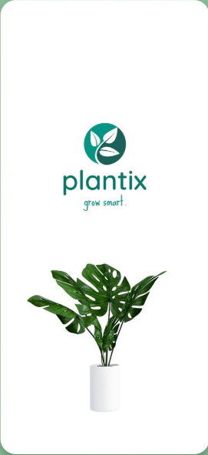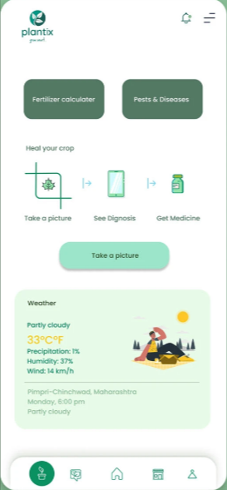
Figure 5: Plantix application interface.
Plantix, made by PEAT GmbH, is one of the most actively implemented smartphone applications to identify plant diseases and pests all over the world. It uses CNN-based image recognition to identify diseases and pest damage on photographs uploaded by the user, supplemented by a peer-to-peer discussion forum that permits users to share their findings and seek community feedback. Plantix claims a reported identification accuracy of over 90 percent on diseases and pests across a wide variety of crop species in the field using an accumulated user-contributed image dataset to continuously optimize its models [16].
Constrained and Relevant to TomatoCare. Although Plantix has a global presence, it has several features that constrain its use by tomato growers in the UAE. It is an inherently cloud-based application and requires a stable internet connection to operate - a limitation that rules out users in rural farming communities with poor connectivity [16]. In the UAE, heat-induced and salinity-induced symptoms often resemble disease presentation, and Plantix does not differentiate between biotic disease and abiotic environmental stress which is most problematic in the UAE [26]. The application does not have an Arabic language interface, which puts a significant barrier to accessibility of the program to the very large proportion of the agricultural workforce in the UAE that are Arabic speakers. Treatment suggestions are not localised to the UAE cultivation practice e.g. hydroponics or saline soils operation that minimises its practical applicability to the intended users of the project.

Agrio Overview
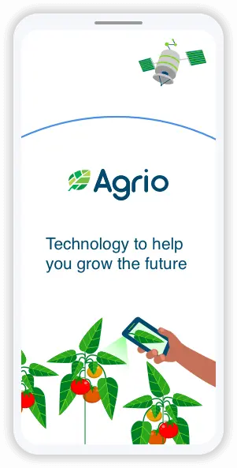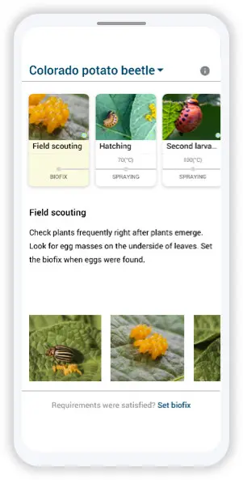
Figure 6: Agrio application interface.
Agrio is a commercial AI-based crop protection platform, which combines image-based disease detection with a curated agronomy database, weather-based predictive alerts, and Integrated Pest Management advisory services. The platform records the real-world diagnostic accuracy of about 91% [16]. It is based on paid subscription.
Restrictions and Applicability to TomatoCare. Agrio is also limited by the cloud-dependency aspect of Plantix: the platform cannot be used without constant internet connectivity and is rendered virtually unusable in areas with weak network coverage [16]. The platform is ill-equipped to identify UAE-specific abiotic stress patterns like salinity damage or heat injury [26]. Agrio does not provide any support in Arabic language and does not offer treatment recommendations adjusted to the cultivation methods specific to the UAE, i.e. hydroponic growing or sand-medium cultivation. The subscription pricing model brings in a monetary barrier that further restricts the access of the low-income smallholders that form the core user base of TomatoCare.

Comparative Analysis
Feature | TomatoCare | Farmonaut | Flora Incognita | Plantix | Agrio
Disease Detection via Image AI | ✓ | ✓ | ✗ | ✓ | ✓
Offline / On-Device Processing | ✓ | ✗ | Partial | ✗ | ✗
Bilingual Interface (English/Arabic) | ✓ | ✗ | ✗ | ✗ | ✗
UAE-Specific Abiotic Stress Detection | ✓ | ✗ | ✗ | ✗ | ✗
Biotic vs. Abiotic Stress Distinction | ✓ | ✗ | ✗ | ✗ | ✗
Free to Use | ✓ | ✗ | ✓ | ✓ | ✗
Compatible with Low-End Android Devices | ✓ | ✗ | ✓ | ✓ | ✓
Localized Treatment Recommendations (UAE) | ✓ | ✗ | ✗ | ✗ | ✗
Open Source | ✓ | ✗ | ✓ | ✗ | ✗
Table 2: Comparative Feature Analysis.
Field accuracies of CNN-based agricultural diagnostics of about 95% (Farmonaut) 91% (Agrio) 90% (Plantix) are significantly higher than the 60% to 75% accuracy that growers usually obtain with unaided visual inspection. These accuracies should be however viewed with care. None of the three platforms present the performance of their systems on test sets that are specifically dependent on UAE-relevant abiotic stress patterns. Lack of region oriented benchmarking is one of the basic methodological gaps in the existing literature. TomatoCare directly fills this gap by targeting at least 90% accuracy on a test set that explicitly includes both biotic stressors (Early Blight, Late Blight, Bacterial Spot, Septoria Leaf Spot, Spider Mites, Target Spot, Yellow Leaf Curl Virus, Mosaic Virus, and Leaf Mold) and abiotic stress patterns (sunscald, heat stress, salinity-induced chlorosis) typical of Gulf agricultural environments [26].

Privacy, Ethical and Localisation considerations.
The usage of AI-based diagnostic tools in agricultural environments brings about a group of privacy, ethical, and localisation-related considerations, which are especially pertinent to the UAE environment. The offline-first architecture of TomatoCare offers a structural solution to many of these issues: since all image processing, scan storage, and diagnostic inference are performed solely on the device of the user, no user data, including images, scan history or device identifiers, is transmitted to any external server at any point during operation. This design complies with the principle of data minimisation of UAE Federal Decree-Law No. 45 of 2021 on the Protection of Personal Data [13], which requires that the information collected and processed should be strictly necessary to perform the diagnostic function, and it eliminates the cross-border data transfer issues that affect competitors in cloud-based solutions.
Ethically, the application will be crafted to deliver diagnostic suggestions, as opposed to the clinical judgments. The 60 percent confidence level, below which the system will issue a Low Confidence Warning instead of a confident diagnosis, is an artificial ethical constraint that is meant to ensure that the system does not encourage users to act on an uncertain result. All the treatment recommendations are introduced as guidance to support rather than to replace professional agronomic advice, and the implementation has a clear disclaimer to this effect on its results screen.
In this regard, localisation goes beyond translation. Bilingual support needs to be effective, meaning that in addition to the provision of Arabic-language strings to all interface text and treatment recommendations, the full right-to-left layout adaptation, mirrored navigation elements and culturally appropriate usage of agricultural and botanical terminology should be provided. TomatoCare meets these needs by building on the native RTL support of Jetpack Compose, by providing full dual-language resources of strings and by sourcing Arabic terms to established agricultural sources. The resulting implementation, ensuring that the application is both functionally and culturally accessible to the significant Arabic-speaking proportion of the UAE agricultural workforce, instead of treating Arabic support as an overlay of translation onto an underlying product based on the English language.

Research Gaps and Conclusion
The literature review outlines 5 research and product gaps that intersect to establish the design rationale behind TomatoCare:
- There is diagnostic uncertainty between biotic and abiotic stress. None of the reviewed applications explicitly categorizes the outcomes along the biotic/abiotic axis, although the operational importance of the distinction to the choice of treatment is probably crucial - and the acute nature of the problem in the case of cultivation in arid climates is likely to be extreme.
- Cloud-1.0 architectures that do not support low-connectivity users. Three of four reviewed apps (Farmonaut, Plantix, Agrio) need constant internet connection, making them essentially unusable in the rural and outdoors environments of small-scale UAE agriculture [14, 16].
- Lack of support of Arabic language. All the applications reviewed do not have an Arabic interface, even though Arabic speakers represent a significant percentage of the agricultural workforce in the UAE.
- Lack of UAE-localised treatment recommendations. In the plates reviewed, we can find recommendations on the temperate-climate cultivation practices and do not address UAE-specific conditions such as hydroponic systems, saline-soil farming, or extreme heat management [26].
- The training data were restricted to temperature-climate imagery. None of the reviewed platforms report training or evaluation outcomes of datasets that include UAE-relevant abiotic stress patterns, leaving an untested gap between reported accuracy measures and likely actual performance in Gulf agricultural conditions [26].
TomatoCare has been structured in a manner that will generate solutions to all these discrepancies. The application combines an augmented with UAE-specific features PlantVillage training pipeline with explicit biotic/abiotic classification, an offline-first MobileNetV3-Large architecture quantised to float16 to enable inference on the device, full support of bilingual English/Arabic with right-to-left layout adaption and a treatment knowledge base localised to the four cultivation methods (greenhouse, open-field, hydroponic, saline-soil) prevalent in the UAE. These design choices are supported by the literature-supported rationale behind them, which is found in Sections 2.2 through 2.7 convolutional neural networks to classify images, lightweight architectures to deploy on mobile, transfer learning, TensorFlow Lite quantisation, and the scholarly basis of biotic/abiotic distinction.
This chapter has shown that the combination of features offered by TomatoCare is unparalleled among the current platforms, that each technical decision has its basis in the current state of the art, and that the gaps that the application is designed to address are real, documented, and consequential. Chapter 3 is about the methodology through which TomatoCare implements these decisions.

CHAPTER 3: METHODOLOGY

Introduction
This chapter outlines the methodology that has been followed in the planning, development and validation of TomatoCare, following the problem definition provided in Chapter 1 and literature review provided in Chapter 2. The chapter is organised into eight substantive sections. In Section 3.2, the team structure, as well as the allocation of responsibilities among different team members, is outlined. Section 3.3 explains the overall approach of software development lifecycle and reasons why the Agile methodology is chosen. Section 3.4 contrasts Agile with other methodologies and justifies the reason why it would be most suitable to TomatoCare. Section 3.5 will explain the Agile artefacts that the team will adopt. The breakdown and timeline of the sprint are given in section 3.6. The project Gantt chart is outlined in section 3.7. Section 3.8 outlines the methodology of AI model development and includes preparing the datasets, preprocessing the images, selecting the architecture, training the model, evaluating the model, and integrating the model into a mobile application. Section 3.9 is on the data persistence strategy and Section 3.10 is the list of development tools and environment.
The two technical fields that are combined in a single iterative process in the methodology outlined in this chapter are machine learning model development and native Android application development. The methodology adopted is a direct reflection of the technical realities of the project: model training is inherently experimental and involves repeated cycles of training, evaluation and refinement, whereas mobile application development enjoys the benefits of incremental delivery and continuous testing on physical hardware.

Team Roles and Responsibilities
The project of TomatoCare is presented by the team of five members. Although Agile methodology focuses on collective ownership and shared accountability, individual primary responsibilities have been placed on each member basis on technical strengths and to make sure that there is no critical area of the project that lacks an accountable owner. The role distribution will be summarised in Table 3.
Team Member | Student ID | Primary Role | Key Responsibilities
AlBaraa AlOlabi | 202210405 | Computer Vision Engineer | Dataset preparation and augmentation, MobileNetV3 Large training, model evaluation, TFLite export and float16 quantisation
Ahmed Saeed Ahmed Mohamed | 202211615 | Android Developer (UI/UX) | Jetpack Compose UI implementation, screen design, RTL layout, language toggle, biotic/abiotic badge component
Kazi Mahir Al Wafi | 202211829 | Android Developer (Backend) | CameraX integration, image preprocessing pipeline, TFLite inference engine, JSON storage, Storage Access Framework export/import
Iyad El Boussi | 202111261 | System Architect & Documentation | Requirements specification, UML diagrams, architecture design, academic report authorship
Fares Muaatasem Awda | 202211410 | QA & Integration Lead | Functional testing, device compatibility testing, integration testing, bug tracking, Arabic localisation review
Table 3: Team Roles and Responsibilities.
Every member of the team is involved in sprint planning, sprint reviews and retrospectives. Any merge to the main branch is subject to mandatory code reviews, and a minimum of one team member who did not write the change must approve the code review. The task of documentation is shared, and the System Architect is the keeper of the canonical version of the report and incorporates the efforts of all the members.

Software Development Lifecycle
The Software Development Lifecycle (SDLC) is a formal model of the activities involved in producing a software system, starting with the requirements gathering process and culminating with final deployment and validation [24]. SDLC models vary in how they order these activities, some following a linear, phase-by-phase sequence, and others utilizing iterative or incremental cycles, but the selection of model has major practical implications on projects where there is uncertainty, experimentation or changing requirements.
TomatoCare uses an SDLC that is based on Agile. In contrast to linear models, like the Waterfall approach, where each phase must be finished before the next one begins, Agile breaks down the project into a sequence of short time-boxed iterations called sprints. In a sprint, a working increment of the system is produced, which is then assessed and utilized to inform planning of the next sprint. This iterative design enables the project team to adapt to findings - such as realizing that a certain augmentation plan is yielding overfitting, or that a particular user interface element is unintuitive on an Arabic RTL layout by adjusting the plan without necessarily re-initiating the entire process.
There are three reasons why Agile approach fits best at TomatoCare. First, the development of machine learning models is inherently experimental: the accuracy of the model depends on a complex interaction of the quality of the dataset, the methods of its augmentation, the architecture determined, and hyperparameter settings, and the most effective combination is impossible to know in advance. Repeat training and assessment of the model are essential to achieve a model that fulfils the 90 percent accuracy criterion. Second, there needs to be a strong coordination of the machine learning and mobile development streams with the Android application, which must be managed by frequent synchronisation and incremental integration as opposed to a single big-bang integration at the end. Third, the offline-first architecture introduces constraints, such as APK size, memory footprint, inference latency, which must only be validated by testing on actual target devices, and which Agile manages to remind developers of by having them write software at the end of each sprint.
Figure 7 shows the iterative cycle that constitutes Agile SDLC, where planning, design, development, testing, and review feedback on each other across sprints.
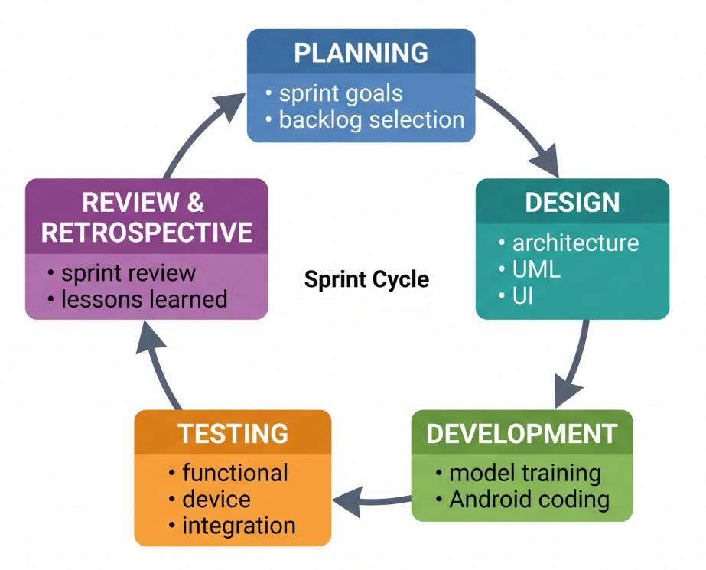
Figure 7: Agile SDLC Cycle.

Methodology Comparison and Selection
While several established SDLC methodologies could be applied to TomatoCare, each carries distinct trade-offs [24, 25]. Table 4 compares the four most considered options against the criteria most relevant to this project.
Criterion | Waterfall | Spiral | Scrum | Agile (Selected)
Development Approach | Sequential, linear progression through fixed phases | Iterative with explicit risk analysis at each cycle | Agile framework with strict roles and ceremonies | Iterative and incremental with flexible structure
Flexibility | Low changes after development starts are difficult | Moderate supports change but management overhead is high | High within sprint cycles | Very high adapts continuously
Risk Management | Limited risks surface late | Strong risk evaluation built into each spiral | Risks addressed in sprint reviews | Risks minimised through continuous iteration
Suitability for ML Projects | Poor cannot accommodate experimental nature of model training | Adequate but operationally heavy | Good when team can adopt full Scrum ceremony | Excellent directly supports experiment-driven development
Feedback Integration | At end of each phase | At end of each spiral | At end of each sprint | Continuous, throughout each iteration
Documentation Overhead | High | High | Moderate | Light to moderate
Suitability for Five-Person Team | Workable but rigid | Excessive structure | Workable but ceremony-heavy | Well-matched to team size
Overall Suitability for TomatoCare | Low | Moderate | High | Very High (Selected)
Table 4: Comparison of SDLC Methodologies
The Waterfall model was rejected due to its inflexibility being incompatible with the experimental nature of model training and the iterative refinement that is required to develop offline-first mobile development. When a Waterfall project has passed beyond the requirements phase, accommodating a discovered need such as an additional augmentation strategy needed to bridge the field-versus-laboratory accuracy gap requires one to ignore the need or recycle the affected stages.
The Spiral model is more comprehensive with respect to risk management but introduces too much operational overhead to fit into a fixed academic schedule of a student team of five people. The structured risk-analysis cycles of Spiral are worthwhile in safety critical or high cost projects but do not justify the scope of a project of the scope of TomatoCare.
Scrum, which is a particular framework of Agile, was taken into account. Its strengths, such as fixed-length sprints, the clear roles (Product Owner, Scrum Master, Development Team), and prescribed ceremonies (Sprint Planning, Daily Standup, Sprint Review, Sprint Retrospective) are well aligned with the needs of the project. But the lines of formal role separation, which Scrum prescribes, are not realistic in the case of a group of five individuals, each with a variety of fields to which to contribute. The team thus opts to use a lightweight Agile process with the inclusion of the most valuable Scrum artefacts (sprint planning, sprint review, sprint retrospective) without imposing the full ceremonial structure of canonical Scrum.

Agile Artifacts
To ensure transparency, progress tracking, and the ability to ensure every iteration is delivering a measurable value, the team uses a set of defined Agile artifacts.
The canonical list of all features and tasks needed to deliver the project is called the Product Backlog. In the case of TomatoCare, the Product Backlog has the following data: dataset collection and augmentation, CNN architecture selection and training, conversion of the trained model to TensorFlow Lite with float16 quantisation, integration of the offline inference pipeline, implementation of all UI screens (Home, Scan, Results, History, Settings), implementation of bilingual English and Arabic support with full RTL layout, implementation of confidence-score display and the 60% threshold warning, and implementation of scan history export and import using the Storage Access Framework.
The Sprint Backlog is the part of the Product Backlog to be completed within a particular sprint. Sprint planning involves the selection of items based on dependencies, team capacity and sprint goal.
Sprint Planning is performed at the start of every sprint in order to set a sprint goal and choose the respective items on the backlog. An example is the sprint goal of Sprint 3, which is to create a trained, evaluated, and quantised TFLite model with an accuracy of at least 90% on the held-out test set.
Daily standups are brief synchronisation conferences where every team member reports on progress since the last standup, the next steps to be undertaken, and any blockers that require the support of the team. These sessions are maintained concise and oriented towards coordination as opposed to status report.
Sprint Review is a meeting that takes place at the end of every sprint and presents the deliverables of the sprint to the project supervisor. In the case of TomatoCare, sprint reviews would consist of demonstrations of working software - e.g., the live offline diagnosis pipeline running live on a physical Android device - and artefacts such as model training curves and confusion matrices.
The Sprint Retrospective is the next step to the Sprint Review and aims at the process improvement. The team recognizes what has been successful, what can be done better and what concrete steps will be carried out in the following sprint. Revisions to the data augmentation strategy to minimize overfitting, additions to the JSON storage format to support export/import more, and the device testing matrix have all been revised.
The Increment at the end of each sprint is tangible, working progress toward the final system. The evaluation of each increment against the sprint goal is a basis of the next sprint.

Sprint Timeline and Breakdown
The TomatoCare Project is a two-semester project that involves Capstone 1 in spring 2026 and Capstone 2 in fall 2026. While Capstone 1 is focused on project planning, requirements engineering, system design, and academic writing, Capstone 2 will focus on the technical implementation of the project. The sprint schedule considers the split by having three sprints allocated for each Capstone.
Each sprint lasts approximately two to three weeks and produces a defined increment of work. Table 5 presents the full sprint plan across both semesters.
Sprint | Phase | Duration | Focus | Key Deliverables
Sprint 1 Planning and Literature Review | Capstone 1 | Jan 20 – Feb 16, 2026 | Project initiation, backlog creation, problem definition, literature review of existing platforms, identification of research gaps, dataset and CNN architecture selection | Chapters 1 and 2 of the report; initial product backlog; PlantVillage dataset and MobileNetV3-Large confirmed as baseline choices
Sprint 2 Methodology and System Design | Capstone 1 | Feb 17 – Mar 21, 2026 | Documentation of Agile methodology, definition of the AI training pipeline, design of the Android application architecture, requirements specification, production of all UML diagrams, JSON data schema design | Chapters 3 and 4 of the report; full UML diagram suite (use case, sequence, activity, class, state chart, ERD); requirements list
Sprint 3 Final Design and Report Consolidation | Capstone 1 | Mar 22 – Apr 20, 2026 | UI mockup design, architectural design, integration of all chapters, internal review, citation verification, formatting and submission | Chapter 5 of the report; UI mockups for all screens; architectural diagram; final consolidated Capstone 1 report and presentation
Sprint 4 Dataset Preparation and Model Training | Capstone 2 (planned) | ~3 weeks | Implementation of the dataset preprocessing pipeline, application of UAE-specific augmentations, two-stage transfer learning training, model evaluation against the target metrics established in Section 3.8.5 | Trained MobileNetV3-Large model achieving ≥90% accuracy on the test set; quantised TFLite file under 15 MB; training curves and confusion matrix
Sprint 5 Android Application Development | Capstone 2 (planned) | ~3 weeks | CameraX integration, embedded TFLite inference pipeline, JSON-based scan history storage, bilingual interface implementation with full Arabic RTL support, scan history export and import via the Android Storage Access Framework | Functional APK with offline diagnosis pipeline; complete bilingual UI; working JSON export and import
Sprint 6 Testing, Validation, and Release | Capstone 2 (planned) | ~3 weeks | Functional testing on low-end target devices (API 26, 2 GB RAM), verification of all non-functional requirements (inference speed, APK size, cold start time, full offline operation), bug fixes, RTL layout review, and final Capstone 2 report | Release-ready APK with all NFRs verified; open-source GitHub repository; final Capstone 2 report and project demonstration
Table 5: Sprint Timeline and Breakdown
The deliverables of Sprints 1, 2 and 3 which will form the foundation of Capstone 2 will form the full planning, design and documentation foundation upon which Capstone 2 will be based. The work in Sprints 4, 5, and 6 is the planned implementation phase, which is presented in this report to communicate the entire scope of the project, as opposed to describing the work already accomplished by the time this report was prepared.

Gantt Chart
Figure 8 shows the Gantt chart of the Capstone 1 sprints in the project timeline between January and April 2026. The chart indicates the sequencing of activities, the parallelism between report writing and design work and the dependencies between sprints. The visual layout adheres to the structure of the report itself, with the authorship of each chapter corresponding to the sprint in which the respective planning and design work is being done.
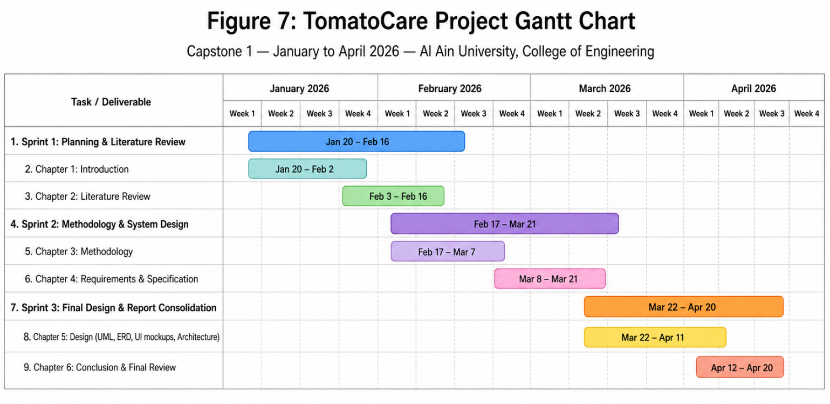
Figure 8: Gantt Chart
The Gantt chart has three effective purposes of undertaking a project. First, it provides the expectations of the timelines to all the team members giving them a clear picture of when their major contributions are expected. Second, it reveals dependencies such as that Capstone 1 design artefacts generated during the Sprint 3 phase must be finalised and approved before the Capstone 2 implementation in the Sprint 4 phase can commence so that delays in the upstream activities can be detected and managed before they propagate to the implementation phase. Third, it offers an anchor against which real progress will be measured at the end of sprints, enabling the team to notice that it is falling behind schedule early, and adjust scope or effort accordingly.

AI Model Development Methodology
The convolutional neural network that lies at the heart of TomatoCare is the element that will either make or miss the application meet its diagnostic accuracy goal. The model development process is a rigorous, reproducible pipeline that goes through dataset preparation, image preprocessing, architecture selection, training, evaluation and mobile export.

Dataset
PlantVillage, a publicly available database of more than 54,000 labelled images of plant leaves across 38 classes and 14 crop species [9, 10] is the primary training dataset. Only the tomato-specific subset of PlantVillage is used by TomatoCare; it has approximately 18,000 images distributed across ten classes: one healthy and nine disease classes corresponding to Early Blight, Late Blight, Bacterial Spot, Septoria Leaf Spot, Tomato Yellow Leaf Curl Virus, Tomato Mosaic Virus, Target Spot, Spider Mites (Two-spotted Spider Mite), and Leaf Mold.
As mentioned in Chapter 2, Section 2.4, the images of PlantVillage are taken under controlled laboratory conditions and with uniform backgrounds and consistent lighting. Although such homogeneity simplifies the reproducible benchmarking of models trained on only PlantVillage data, it generates a domain gap when models trained only on PlantVillage data are applied to real-world field imagery, especially imagery captured under the high-brightness, dust-affected, heat-saturated conditions characteristic of UAE outdoor and greenhouse cultivation. The main mechanism through which TomatoCare will fill this domain gap is the augmentation strategy described in Section 3.8.2.
Stratified random sampling is used to divide the dataset into three disjoint subsets to preserve the proportions of classes: training set (70 percent of the data), used to update the model weights during training; validation set (15 percent of the data), used to monitor performance during training and trigger early stopping; and test set (15 percent of the data), not used during the entire training process and only used in the final accuracy evaluation reported in this project.

Image Preprocessing
Each image is run through a standardised preprocessing pipeline before it can be supplied to the CNN. Images are initially resized to 224 x 224 pixels, the input size of MobileNetV3-Large [6]. Then, the integer range [0, 255] is normalised to the floating-point range [0, 1] by dividing by 255, which enhances the numerical stability of the model and speeds up training convergence.
To make sure that the performance evaluation is based on the behaviour of the model on images that are unknown and not modified, data augmentation is applied to the training set alone, not to the validation or test sets. Augmentation pipeline: The augmentation pipeline includes horizontal and vertical flipping, random rotation within the range of 30 degrees, random zoom up to 20 percent, adjusting brightness and contrast specifically optimized to mimic the high-intensity sunlight present in UAE outdoor cultivation, and shearing transformations to provide geometric variability. The stochastic application of these augmentations during training causes the model to be trained on a different transformation of each source image on each epoch, which increases the effective size of the training set and decreases overfitting.

CNN Architecture: MobileNetV3-Large
A convolutional neural network is chosen due to the fact that the architectural type is specifically designed to process image data: instead of processing each pixel as an independent input, CNNs process images through a hierarchy of convolutional and pooling layers that gradually combine the local pixel patterns (edges, colour transitions) into higher-level features (lesion shapes, leaf discolouration patterns) and eventually into predictions of the class.
The base architecture used at TomatoCare is MobileNetV3-Large based on the reasons that were outlined in Chapter 2, Section 2.3: its parameter-efficient design, built on depth wise separable convolutions, its mobile-friendly features, including hard-swish activation and Neural Architecture Search-tuned layers, as well as its favourable balance of accuracy and inference speed on low-end Android hardware. Table 6 compares the candidate architectures that are discussed in the context of TomatoCare.

Architecture | Params | Size | Top 1 Acc. | Suitability
ResNet-50 [5] | 25.6M | 98 MB | 76.1% | Too large for low-end devices
EfficientNet-B0 [8] | 5.3M | 20 MB | 77.1% | Good accuracy but slower inference
MobileNetV2 [7] | 3.4M | 14 MB | 72.0% | Fast but lower accuracy
MobileNetV3-Large | 5.4M | 22 MB | 75.2% | Best accuracy efficiency trade-off
Table 6: CNN Architecture Comparison for Mobile Deployment
The entire model architecture is made up of three components. It uses MobileNetV3-Large pre-trained on ImageNet, and removes the original classification head, leaving only the layers of the feature-extraction part. It is followed by a Global Average Pooling layer that is used to compress the final feature maps into a single feature vector, which in turn reduces the number of parameters of the next dense layers and enhances generalisation. It is then followed by a dropout layer with a rate of 0.4 to reduce overfitting when doing fine-tuning. The last dense output layer has ten neurons (one per class) and a SoftMax activation, which transforms the raw output scores into a probability distribution whose sum is one.

Training Process
The process of training is implemented in TensorFlow through the Keras API, on hardware which is accelerated by a graphics card. It is optimised using the Adam optimiser with an initial learning rate of 0.001, categorical cross-entropy loss and a batch size of 32. The first stage consists of training that continues up to 30 epochs, with early stopping being initiated in case the validation accuracy does not increase over five consecutive epochs. To make sure that the model saved is the best-performing snapshot and not necessarily the weights of the last epoch, ModelCheckpoint is configured to only save the weights that result in the highest validation accuracy.
The two-step transfer learning model developed in Chapter 2, Section 2.5 will be used to carry out the training process. The first stage involves freezing all layers of MobileNetV3-Large and only training the new classification head, which will only learn to map extracted features to tomato disease classes without changing the pre-trained feature representations. In the second step, the first thirty layers of the base model are unfrozen and fine-tuned to up to ten more epochs with a lower learning rate of 0.0001 to allow the model to adapt its high-level combinations of feature to the specific visual characteristics of tomato leaf conditions without compromising on the general-purpose visual features in the lower layers.

Model Evaluation
The held-out test set is used to assess model performance on using five complementary measures. Accuracy is the number of correct classifications of test images out of the ten possible classes; the project target is at least 90%. Precision, which is computed per class, is the proportion of images which are predicted to belong in a class, and which belong in a class. Recall, which is also calculated per class, is the percentage of images that fall into a particular class that are correctly identified as such. F1-score is the harmonic mean of the precision and recall, which gives a single balanced measure, which is most useful when there are uneven distributions of classes. The confusion matrix is a 10 x 10 table that visualises all the classes that are most frequently mistaken with which others, providing diagnostic information about what the model does not do well, such as whether Early Blight is better or worse than Late Blight.

Mobile Integration
Once training finishes and evaluation criteria is achieved, the model is exported out of TensorFlow into the TensorFlow Lite (.tflite) format. Quantisation Float16 is used in this conversion to make the storage footprint of the model smaller by approximately half the size of the unquantised float32 representation without compromising accuracy by more than a fraction of a percent. The quantised .tflite file is then directly packaged into the assets of the Android application, such that the model is installed with the application and immediately available without needing a post-installation download.
The model is loaded at runtime in an instance of a TFLite Interpreter as part of initialisation. When the user submit an image to be diagnosed, the application does the same preprocessing as when training (resize to 224 x 224, normalise to [0, 1]) and then packages the result to be a ByteBuffer and invokes the Interpreter. The Interpreter gives the probability distribution of the ten classes, one of which the application takes the top score in and also the confidence score to display.

Data Persistence: JSON File Storage
TomatoCare stores scan history and diagnosis result and user settings in a JSON file in the application internal storage directory (context).filesDir) [20]. The data classes representing scans, results and treatments are serialised and deserialised using Kotlin Serialisation [21].
A storage in JSON files is chosen instead of a relational database, like Room or SQLite, due to six tangible reasons. First, the data model is conceptually simple an unstructured sequential list of scan records nothing more and does not need the relational joins, aggregate operations, or complex queries that justify the operational overhead of a relational database. Second, the project does not incur the schema migration expenses that would be incurred by changing data structures with time; updating the data model only requires reworking a Kotlin data class, as opposed to writing database migration scripts. Third, JSON fits perfectly with the export and import capabilities of the current application, as the storage format on the device and the export format are identical: since the on-device format and the format to be exported are the same, no separate serialisation layer is needed to back up and restore information. Fourth, the atomic write pattern (write to a temporary file, then rename to the target file) is crash safe because there is no possibility of leaving the JSON file in a corrupted state in the event of the application being interrupted during a write. Fifth, the volume of data is modest -a typical user produces a small number of scans per day, each occupying about 500 bytes, so even a thousand scans only occupies a little under one megabyte, well within the range of performance of file-based I/O. Sixth, Android internal storage security guarantees of the sandboxed per-application access and on-device encryption on Android 10 and above are automatically applied to the JSON file without any further cryptographic effort on the part of the application.
The structure of a JSON file is that of an array of scan records, each containing an integer scan identifier, the path to the image, an ISO 8601 timestamp, the growing method selected by the user, the version of the model used when the scan was made, and an array of diagnosis results. Each result includes the most probable condition name, a primary-result flag, a confidence measure, a stress-type (BIOTIC versus ABIOTIC) and an array of treatment objects containing treatment type, urgency level, and bilingual recommendation strings. Chapter 5 provides and discusses the entire schema.

Development Tools and Environment
The project is released with a specified toolchain, including machine learning, Android development, version control, and design.
The deep learning framework based on TensorFlow is applied to the construction, training, and evaluation of the CNN model. All model development and dataset preparation work is in Python. PlantVillage dataset is obtained as publicly available repositories on Kaggle. The native Android app is created using Kotlin and Jetpack Compose [23], which combined give a modern declarative UI toolkit with an inbuilt support of a right-to-left layout necessary to localise the app to Arabic. To convert the trained model to a format that is mobile-compatible and uses float16 quantisation, TensorFlow Lite is used. Kotlin Serialisation [21] deals with the transformation between data classes in memory and in persistent storage in JSON. They use GitHub to manage versions and collaborate with other teams, but also to explicitly define security measures like branch protection and code review on the main branch. Figma is an interface design tool, wireframe and interactive prototyping tool before implementation. Android Studio is an integrated development environment (IDE) that is used to develop, debug, and test native Android applications.

Conclusion
This chapter has laid down the methodology through which TomatoCare will be developed. Agile SDLC was chosen since its iterative design is the only one that is particularly effective when applied to a project that combines experimental machine learning with the development of mobile applications. Six sprints over about two to three weeks each, three of which will be part of Capstone 1, and three of which will be planned as part of Capstone 2, will provide the operational rhythm of the project, which will be supported by Agile artefacts that will ensure transparency and constant improvement during the two semesters. The five-member team works with well-defined primary roles and jointly with shared collective ownership, balancing responsibility with the collaborative working style that is necessitated by the scope and timeline of the project.
The AI model, including the design of the technical methodology, is direct implementation of the design decisions in Chapter 2, such as the quantisation of the inputs and outputs to float16, and the use of two-stage transfer learning on MobileNetV3-Large, followed by the evaluation against many other complementary metrics, and finally the export of the TFLite model to float16 quantisation, and two-stage transfer learning on MobileNetV3-Large. This methodology has been developed in Capstone 1 and will be implemented in Capstone 2. The data persistence strategy (also designed during Capstone 1) will be based on the storage of data in the form of JSON files and Kotlin Serialisation instead of using a relational alternative, because the data model and operational requirements do not warrant the complexity of a database. The toolchain is uniform, current and well supported such that the project can be delivered within the academic timeline of Capstone 1 and Capstone 2.
With the methodology in place, Chapter 4 defines the system requirements which include functional, non-functional, domain, and constraint requirements. Chapter 4 also defines the use case descriptions which define what TomatoCare must do.

CHAPTER 4: REQUIREMENTS AND SPECIFICATIONS

Introduction
This chapter defines the requirements specification for TomatoCare, translating the problem definition from Chapter 1 and the design choices justified in Chapter 2 into concrete, testable statements of what the system must do and how well it must do it. The chapter is organised into eight substantive sections. Section 4.2 presents the functional requirements that define the behavioural capabilities of the system. Section 4.3 presents the non-functional requirements that define the quality attributes the system must exhibit. Section 4.4 defines the domain requirements that arise from the agricultural and UAE-specific context in which TomatoCare operates. Section 4.5 specifies the constraint requirements that bound the design space. Section 4.6 presents the stakeholder perspectives that informed the requirements selection. Section 4.7 presents the use case diagram and detailed use case descriptions. Sections 4.8 and 4.9 present the sequence diagrams and the activity diagram that describe system behaviour at the interaction and workflow levels respectively.
The requirements documented in this chapter were elicited through three complementary activities: analysis of the problem domain as described in Chapter 1, comparative review of existing solutions and identification of their gaps as documented in Chapter 2, and consideration of the technical constraints imposed by an offline-first, on-device inference architecture targeting low-end Android hardware. The resulting requirements are intended to be sufficient for the design phase that follows in Chapter 5 and for the implementation phase planned for Capstone 2.

Functional Requirements
Functional requirements define the behaviours the TomatoCare system has to exhibit in response to user behaviours and internal events. They specify the actions that the system should perform, regardless of the way it performs the actions. All requirements are represented as a single declarative statement using the modal verb ‘shall’, uniquely identified for traceability, and written to a level of detail to support the derivation of test cases.
FR-01: The system shall operate fully offline. All processing, storage, and retrieval shall be done on-device without the need to connect to a network at any point during normal operation.
FR-02: The system shall enable the user to take a photograph of a tomato leaf with the use of the device camera within the Framework of the camera [22].
FR-03: The system shall allow the user to select an existing tomato leaf image from the device gallery as an alternative to live capture.
FR-04: The system shall validate the input image before inference. It shall not accept files that do not have PNG or JPEG file formats and files larger than 10 MB in size and shall show a descriptive error message to the user.
FR-05: The system will preprocess all input images before inference by resizing the image to 224 x 224 pixels and normalisation of pixel values in the integer range [0, 255] to the floating-point range [0, 1].
FR-06: The system shall categorize the input image by performing on-device inference using the embedded TensorFlow Lite model and shall have no reliance on an internet or network connection at any point in the process.
FR-07: The system shall show the diagnosis result to the user and include the name of the identified condition in both English and Arabic, the confidence score as a percentage, a colour-coded biotic or abiotic stress badge and the level of severity.
FR-08: The system shall show a Low Confidence Warning when the highest-scoring class returned by the model has a confidence score of less than 60 percent, to alert the user that they need to re-photograph under better conditions.
FR-09: The system shall use localised treatment guidelines based on the condition identified. Recommendations shall be fetched out of the embedded JSON treatment database and shall be displayed in the language of an interface that is chosen by the user.
FR-10: The system shall be used to screen treatment recommendations, based on the type of growing method selected by the user, supporting at least the following categories of growing methods: greenhouse, open-field, hydroponic, and saline-soil cultivation.
FR-11: The system shall store every scan record that has been completed locally to a Kotlin Serialisation JSON file. Each record shall contain the scan identifier, image path, timestamp, identified condition, confidence score, type of stress, level of severity, and any related treatment information.
FR-12: The system shall enable the user to access the entire history of past scans, in date order.
FR-13: The system shall enable the user to choose a past scan in the history view to view all its details, including the original diagnosis and treatment recommendations.
FR-14: The system shall have a dashboard that summarises scan activity of the user, which is stored in local storage of the JSON format.
FR-15: The system shall support the ability of the user to delete all their locally stored scan history with the help of a dedicated control which is available in the Settings menu, presenting the user with a confirmation dialog when they are about to perform the deletion.
FR-16: The system shall enable the user to export all scan history data as a JSON file to a path chosen by the user, using the Android Storage Access Framework.
FR-17: The system will enable the user to import an already exported JSON file to recover scan history information. The system will check the file format prior to importing and will reject files that do not match the expected schema.
FR-18: The system shall support both English and Arabic as the interface languages and will allow the user to switch between them at any time via the Settings menu.
FR-19: When Arabic is chosen as the active language, the system shall render the entire application layout in the right-to-left mode, with mirrored navigation elements, text orientation, and positioning of UI components.
FR-20: The system shall generate clear and descriptive error messages to the user in the event of an anticipated failure that includes but is not limited to failure to support image formats, model loading failure, and local storage error. In all such cases, the system will be in a stable state, and it will not crash.

Non-Functional Requirements
Non-functional requirements define the quality attributes that the system must exhibit. They constrain how the system performs the behaviours specified by the functional requirements. Each non-functional requirement is expressed as a measurable, testable property of the system.
NFR-01 Connectivity: The system shall function without requiring an internet connection. No network call shall be initiated by the application during normal operation.
NFR-02 Inference Performance: The system shall complete on-device inference for a single submitted image within three seconds on a target device meeting the minimum specification (Android API 26, 2 GB RAM, mid-range processor of approximately Snapdragon 660 class or equivalent).
NFR-03 Diagnostic Accuracy: The deployed model shall achieve a minimum classification accuracy of 90% on a held-out test set that incorporates UAE-specific environmental conditions including high-brightness lighting and dust haze.
NFR-04 Application Size: The complete size of the application, including the embedded TensorFlow Lite model and all assets, shall not exceed 50 MB. The quantised model file alone shall not exceed 15 MB.
NFR-05 Usability: The user interface shall be operable by a user with no prior technical or agricultural training. Core functions including scanning, viewing results, and reviewing history shall each be reachable within two taps from the home screen. Text shall be presented at minimum size and contrast suitable for outdoor reading in bright sunlight.
NFR-06 Reliability: The application shall not crash when used under normal conditions. The handling of all the anticipated failure modes such as corrupt images, model loading failures and storage I/O errors shall be addressed with grace through descriptive error messages with leaving the application in a stable recoverable condition.
NFR-07 Portability: The application shall run on Android devices with API level 26 (Android 8.0 Oreo) and above.
NFR-08 Data Privacy: No user image, scan record, or device-identifying information shall be transmitted outside the device under any circumstances. The application shall comply with the principles of data minimisation set out in UAE Federal Decree-Law No. 45 of 2021 on the Protection of Personal Data [13].
NFR-09 Maintainability: The application's source code shall be organised into modular components (presentation layer, business logic layer, persistence layer, inference engine, localisation resources) such that the AI model, language resources, or treatment database can be updated independently without requiring modifications to unrelated parts of the application.
NFR-10 Localisation Quality: All user-facing strings, including disease names, treatment recommendations, error messages, and navigation labels, shall be available in both English and Arabic. Arabic terminology shall use established botanical and agricultural usage rather than literal translation

Domain Requirements
Domain requirements arise from the specific operational context in which TomatoCare is deployed agricultural diagnosis in the UAE and from the academic and ethical norms that govern AI-based diagnostic tools. They differ from functional requirements in that they reflect rules imposed by the domain itself rather than features chosen by the design team.
DR-01: The system shall classify only tomato (Solanum lycopersicum) leaves. Diagnostic claims about other plant species are explicitly outside the system's domain of validity.
DR-02: The system shall distinguish between biotic stress (caused by living pathogens) and abiotic stress (caused by environmental factors) and shall communicate this distinction to the user through a clearly visible badge on the result screen. This requirement reflects the operational importance of the distinction in selecting an appropriate intervention, as established in Chapter 2, Section 2.7.
DR-03: The treatment advice shall be specific to the UAE growing conditions, considering the high heat tolerance, salinity tolerance, and the agricultural inputs and practices available in the area.
DR-04: The system will have a disclaimer on the results screen that tells the user that TomatoCare does not give professional agronomic advice, but only diagnostic recommendations.
DR-05: Disease and treatment terminology shall use formal botanical and agricultural language in both English and Arabic. Common-name simplifications shall not replace the standard terminology used in agricultural extension materials.
DR-06: The confidence threshold below which the system displays a Low Confidence Warning shall be set at 60%. This threshold reflects an ethical safeguard against misleading users with uncertain diagnoses and shall be a configurable parameter in future releases.
DR-07: The system shall not infer or display claims about the user's identity, location, or behaviour. Diagnostic outputs shall be limited to observable visual properties of the submitted leaf image.

Constraint Requirements
Constraint requirements bound the design space within which the system must be implemented. They reflect technical, operational, and academic constraints that the project must respect regardless of design preferences.
CR-01: The application shall be able to run without the need for any network connectivity. The application may not use any cloud-based API, model serving endpoint, or remote database.
CR-02: The TensorFlow Lite model shall be included in the APK during the build time, and it shall not be downloaded afterwards.
CR-03: The application is designed to work on Android only. The project scop does not involve any iOS or cross-platform implementation.
CR-04: Scan history persistence shall use a JSON flat file accessed through Kotlin Serialisation. Relational database systems including Room and SQLite shall not be used in the Capstone 1 / Capstone 2 deliverable.
CR-05: The convolutional neural network model shall be trained exclusively on tomato leaf images. The model is not required to generalise to other plant species or non-leaf imagery.
CR-06: The minimum target device specification is Android API level 26 (Android 8.0 Oreo) with at least 2 GB of RAM. Devices below this specification are explicitly outside the support envelope.
CR-07: Advanced features including IoT sensor integration, multi-crop classification, gaze-based usability tracking, user accounts, and cloud synchronisation are out of scope for Capstone 1 and Capstone 2 and are documented as future work.
CR-08: The application shall not provide legally binding agrochemical prescriptions. Treatment outputs are advisory recommendations and shall be presented as such.

Stakeholder Perspective
The needs outlined above are in relation to the needs and the interests of several groups of stakeholders. It is important to understand these views since each group applies varying priorities to the system, and the requirements specification is a compromise between them.
Primary stakeholders: home gardeners and small-scale tomato growers in the UAE. This is the group of the main end users of TomatoCare. Members generally lack formal training in agriculture and may have primary languages other than English such as Arabic, and unreliable internet connectivity. Their main expectations of the system include ease of use, accessibility in their native language, quick and dependable diagnosis and guidance on treatment that is practical in the context of their cultivation.
Secondary stakeholders: UAE agricultural extension officers and professional agronomists. The representatives of these groups are the officers of the UAE Ministry of Climate Change and Environment as well as other institutional advisors who will interact with the primary stakeholders. They can refer TomatoCare to growers who are under their care and can use the application as a pedagogical device. They have their expectations based on agronomic correctness in the treatment recommendations, in line with the UAE agricultural policy, and appropriate framing of the system as advisory and not authoritative.
Indirect stakeholders: The environmental regulators and food security policy agencies. They have an indirect interest in tools that can minimize unnecessary application of pesticides and provide support to local food production which is sustainable. This interest is expressed at the policy level in the UAE National Food Security Strategy 2051, discussed in Chapter 1. These expectations include compliance with data privacy, transparency regarding the possible diagnostic limitations, and contribution towards quantifiable changes in the sustainability of agriculture.
Development team. The project team of five members is also a stakeholder, where the team is expected to ensure that the requirements are technically feasible and within the time frame of the Capstone 1 and Capstone 2 and must be both specific enough to support implementation, and testable so that the team can verify completion against measurable standards.
The requirements specification balances these perspectives by prioritizing simplicity, accessibility, and offline operation for primary stakeholders; agronomic appropriateness and clear advisory framing for secondary and indirect stakeholders; and feasibility and testability for the development team.

Use Case Diagram
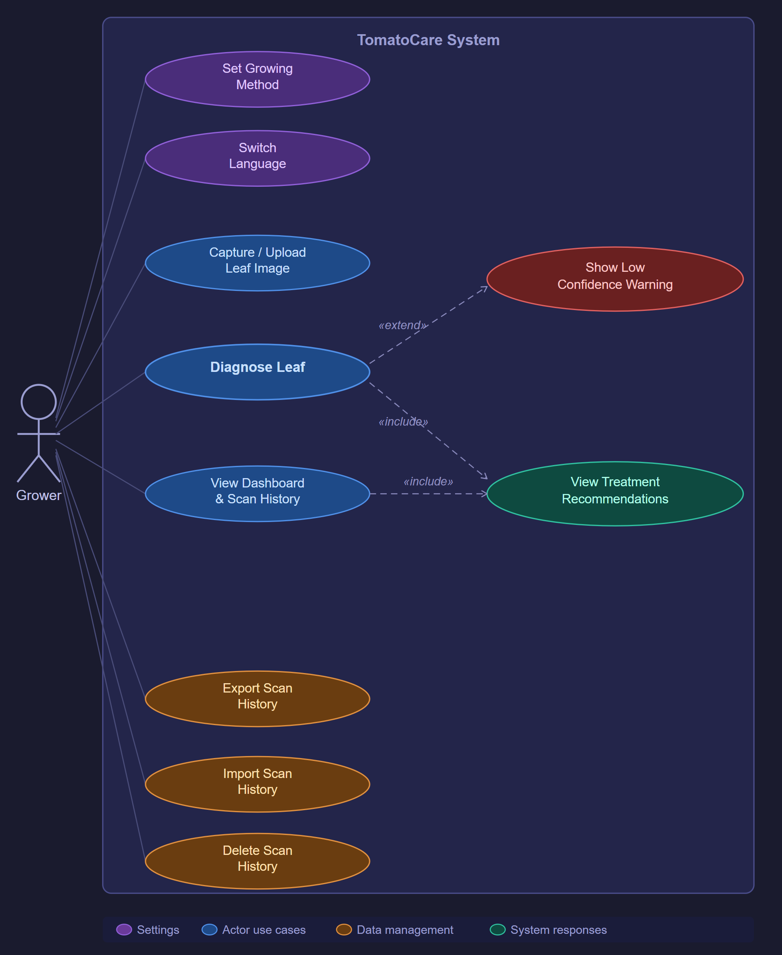
Figure 9 Use Case Diagram

CHAPTER 5: DESIGN

System Architecture
It was decided that a layered architecture will be used for TomatoCare. It will be a three-layer offline-first architecture that divides the system into 3 parts: a Presentation Layer, an Application Logic Layer, and a Data Layer. This architecture was chosen because:
- It provides modularity. where each component can be separately tested and replaced without affecting the rest of the layers. This is important in TomatoCare because testing or replacing the model, for example, would become nearly impossible to do independently if the design was monolithic.
- It’s offline-first because it enables farmers who work in remote, rural areas to use the application. Internet connection in these areas is not guaranteed, which makes architectures such as cloud-based designs useless.

Layer 1 – Presentation Layer (UI)
For the presentation layer, Kotlin was used for implementation through Jetpack Compose. This layer creates what the user sees, from the home screen, camera capture screen, diagnosis results screen, etc. Jetpack Compose over XML-based layouts because of the declarative nature that reduces boilerplate, its built-in LayoutDirection.RTL support handles Arabic right-to-left text without needing a parallel XML hierarchy, and it is the current recommended Android UI toolkit. CameraX is part of this layer and provides a unified camera API that abstracts away different camera differences between devices, and results in a consistent image capture across all of them.

Layer 2 – Application Logic Layer (Inference Engine)
The Application Logic Layer can be divided into 2 core parts: the image preprocessing pipeline and the TensorFlow Lite inference engine. The preprocessing pipeline takes the image from the presentation layer and resizes it to 224 × 224 pixels and normalises pixel values to the [0, 1] floating-point range as required by the model. The result is a tensor that is passed to the TensorFlow Lite inference engine. which loads the quantized model and performs the on-device inference.
The engine then returns a ranked list of class probabilities across the ten output classes. If the confidence rate of the top prediction is greater than or equal to 60%, it is passed to the Data Layer for storage, and to the Presentation Layer for display. Else, the engine returns a low-confidence flag that causes the UI to ask the user to either proceed or retake the photo. This is done to balance between precision against usability for the users.

Layer 3 – Data Layer (Local Persistence)
The Data Layer, which is responsible for reading and writing operations, takes the scan record and serialize it to a JSON file format using Kotlin’s ‘kotlinx.serialization’ library. The Android Storage Access Framework (SAF)is responsible for enabling the exporting and importing of scan history. This framework allows the user to read from and write to any location accessible to the device file picker (internal storage, SD card, or USB-OTG drive) without requiring legacy WRITE_EXTERNAL_STORAGE permissions that are restricted on Android 10 and above. This is done to make sure that the app is compatible with older devices with API 26-34 while meeting the Android permission model enforced from API 29 and upwards. No data is transmitted outside the device, and it’s out of the scope of the project as mentioned in section 1.6.2.

Concerns Among Layers
There are three issues that occur across all the three layers:
First, localisation: the UI string resources and the bundled treatment database is stored in parallel English and Arabic versions. The active locale is determined at runtime based on the language preference of the user, which is saved in SharedPreferences. The RTL layout is automatically generated when Arabic is selected. Second, privacy: because no network calls are made anywhere in the system, personal diagnostic data never leaves the device. This complies with the principle of data minimisation of the UAE Federal Decree-Law No. 45 of 2021 on the Protection of Personal Data. Third, performance: the inference pipeline is implemented on a background coroutine (Kotlin Coroutines) to ensure the application is responsive when the inference pipeline is running on a slow piece of hardware.
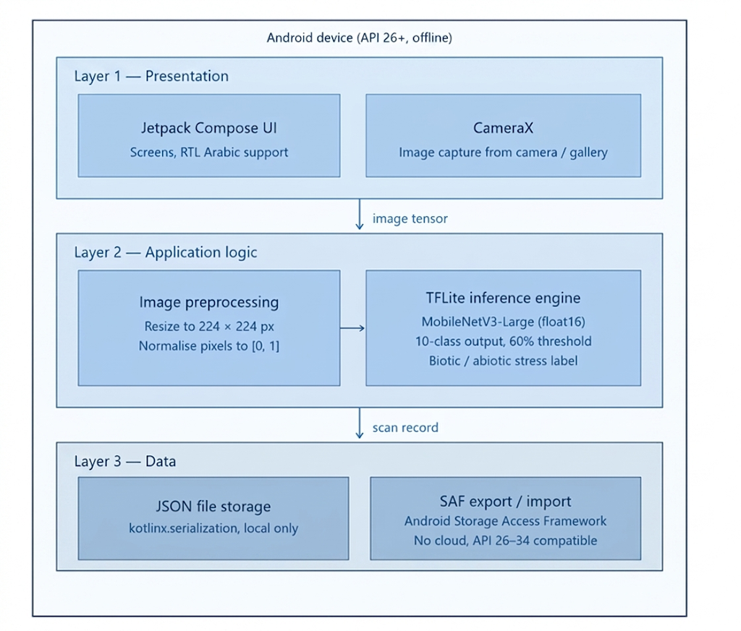
Figure 10: Layered Architecture Diagram

Sequence Diagram
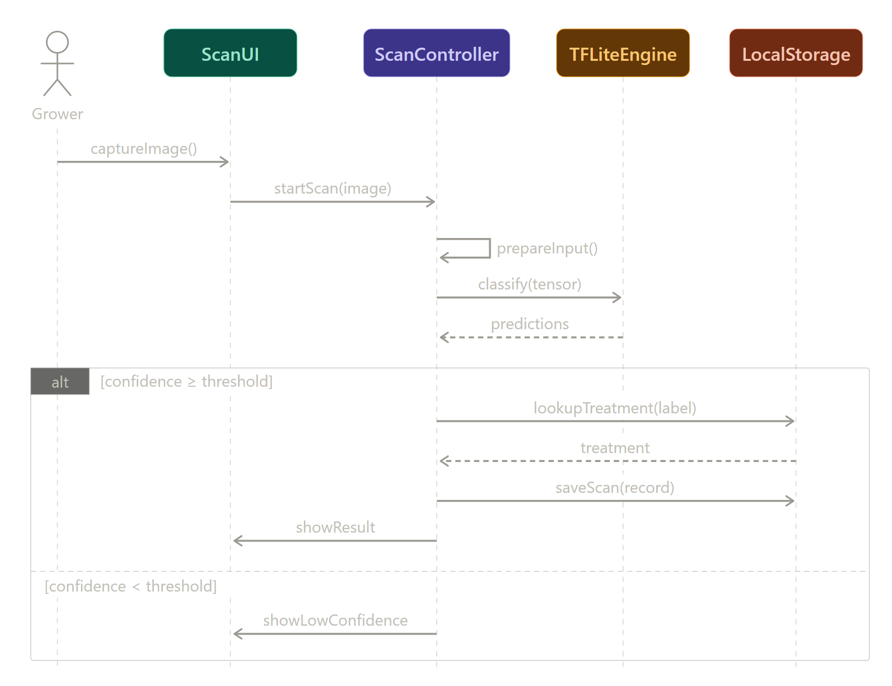
Figure 11: Diagnose Leaf
Diagnose Leaf. The Grower triggers captureImage() on the ScanUI, which delegates the work to ScanController via startScan(image). The controller prepares the image internally, then calls classify(tensor) on the TFLiteEngine and receives a probability vector. An alt fragment splits on the configured confidence threshold: above threshold, the controller fetches treatment from LocalStorage, persists the scan, and returns the result to the UI; below threshold, the UI is told to surface a low-confidence warning so the Grower can retake the image.
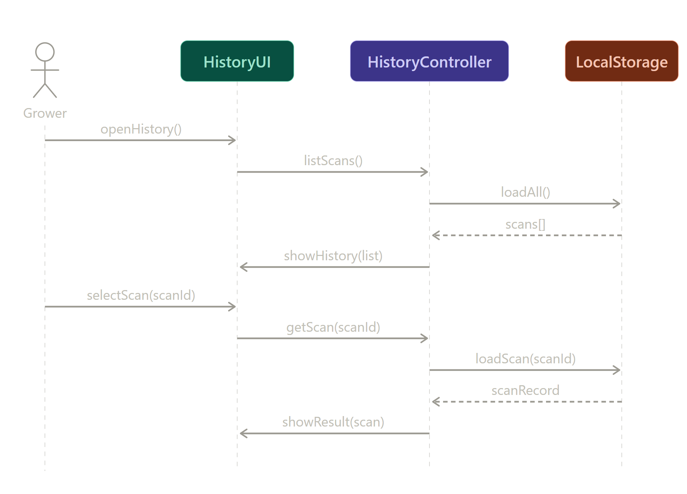
Figure 12: View Past Scan
View Past Scan. The Grower opens the history screen; HistoryController loads the full scan list from LocalStorage and asks HistoryUI to display it. When the Grower selects a specific scan, HistoryController loads that record from storage and returns the diagnosis and treatment to the UI for display.

State Chart Diagram
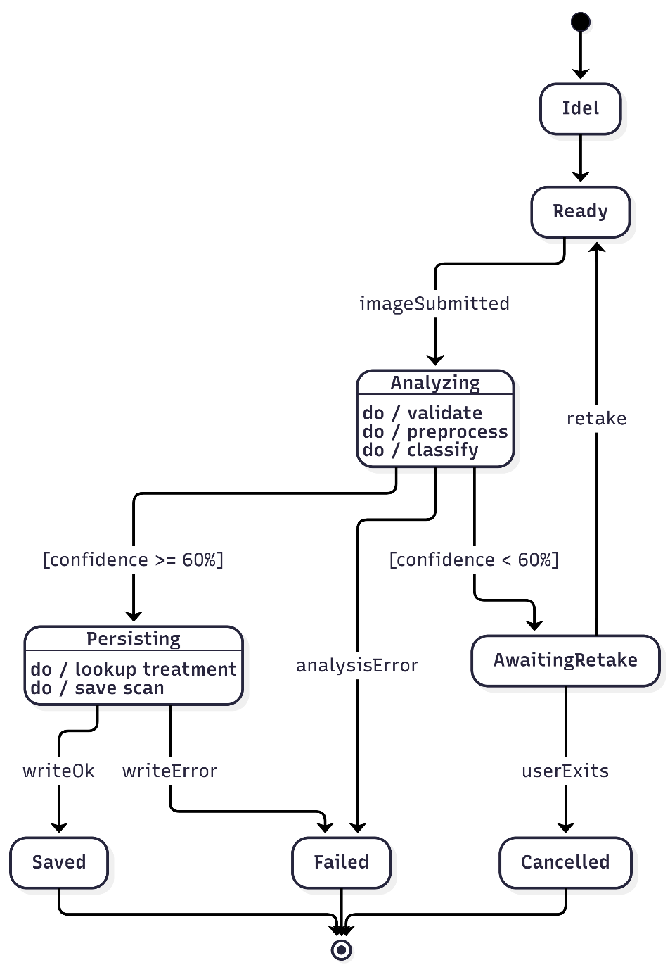
Figure 13 State Chart Diagram
The ScanSession lifecycle has four non-terminal states (Ready, Analyzing, AwaitingRetake, Persisting) and three terminal states (Saved, Cancelled, Failed). The pipeline operations of validation, preprocessing, and classification are modelled as internal do/ activities of the Analyzing state rather than as separate states, since they are computations performed while the session is in that state, not durable conditions of the session itself. The same convention applies to Persisting, which contains treatment lookup and scan persistence as internal activities. Errors during analysis or persistence both lead to Failed but are distinguished by the trigger label so the recovery path is unambiguous.

Entity-Relationship Diagram (ERD)
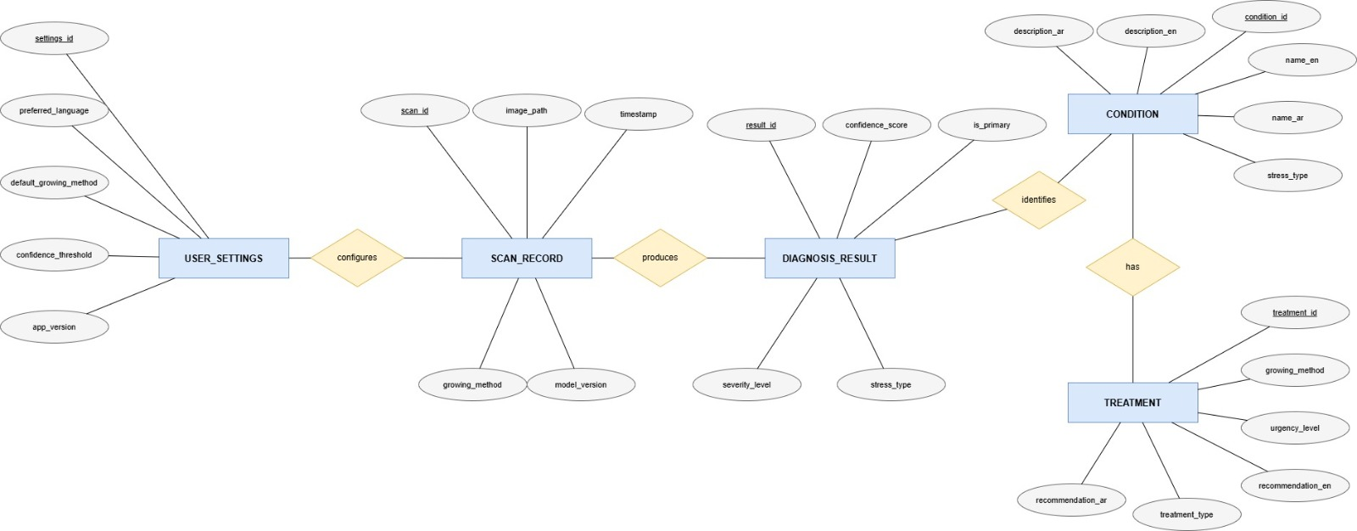
Figure 14 ERD
The Entity-Relationship Diagram of the TomatoCare application was created using Chen notation and modeled conceptual data structure of the application across five entities: USER_SETTINGS, SCAN_RECORD, DIAGNOSis_Result, CONDITION and TREATment.
The entity USER_SETTINGS contains the preferences of the user in the application as well as the attributes: settings_id (primary key), preferred language, default growing method, confidence threshold and app version. It is involved in a one-to-many relationship called configures with SCAN_RECORD, i.e. a single user configuration could be linked to multiple scan records.
SCAN_RECORD entity is used to depict every diagnostic session that was carried out by the user. Its properties are: scan id (primary key), image path, time, growing method and model version. It is involved in one-to-many relationship called produces with DIAGNOSIS_RESULT where a single scan can produce more than one diagnosis result and ranked by confidence.
The DIAGNOSIS_RESULT entity records the result of the on-device TensorFlow Lite inference based on a particular scan. Its attributes are: result_id (primary key), confidence score, is primary, severity level and stress type. The stress type attribute is a clear cut attribute that captures whether the identified condition is biotic or abiotic, which stands out as one of the key distinguishing characteristics of TomatoCare. The DIAGNOSIS_RESULT is involved in a many-to-one relationship with the identifies with CONDITION relationship since multiple diagnosis results on a single scan may identify the same condition.
The CONDITION entity is the internalised knowledge base of the ten tomato leaf types that the model is trained to identify. Its attributes are: condition id (primary key), name en, name ar, description en, description ar and stress type. The bilingual name and description attribute are a result of the English and Arabic language support that is integrated into the application.
The TREATMENT entity contains the localised treatment advice that is related to each condition. It has the following attributes: treatment id (primary key), growing method, treatment type, urgency level, recommendation en, and recommendation ar. It is involved in a many-to-one relationship with CONDITION where each condition could have a variety of treatment records depending on the growing method used such as greenhouse, open-field, hydroponic, and saline-soil growing methods.
All the primary key attributes are indicated with an underline in the diagram according to the conventions of the Chen notation. The foreign keys are not included in the ERD since they are a physical implementation issue and as such it is a part of the relational schema and not a part of the conceptual data model.

JSON Schema Tree
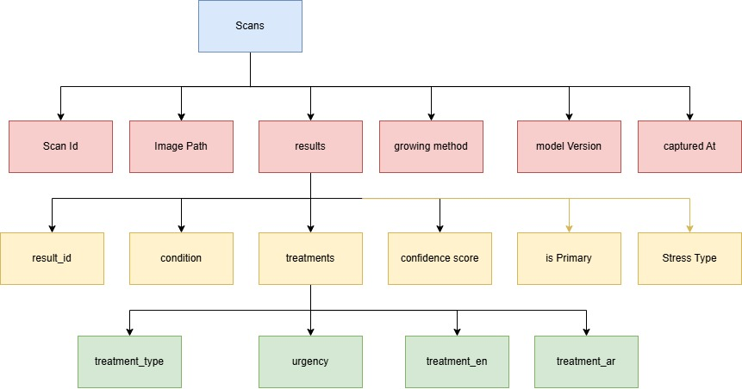
Figure 15 JSON Schema Tree

Class Diagram
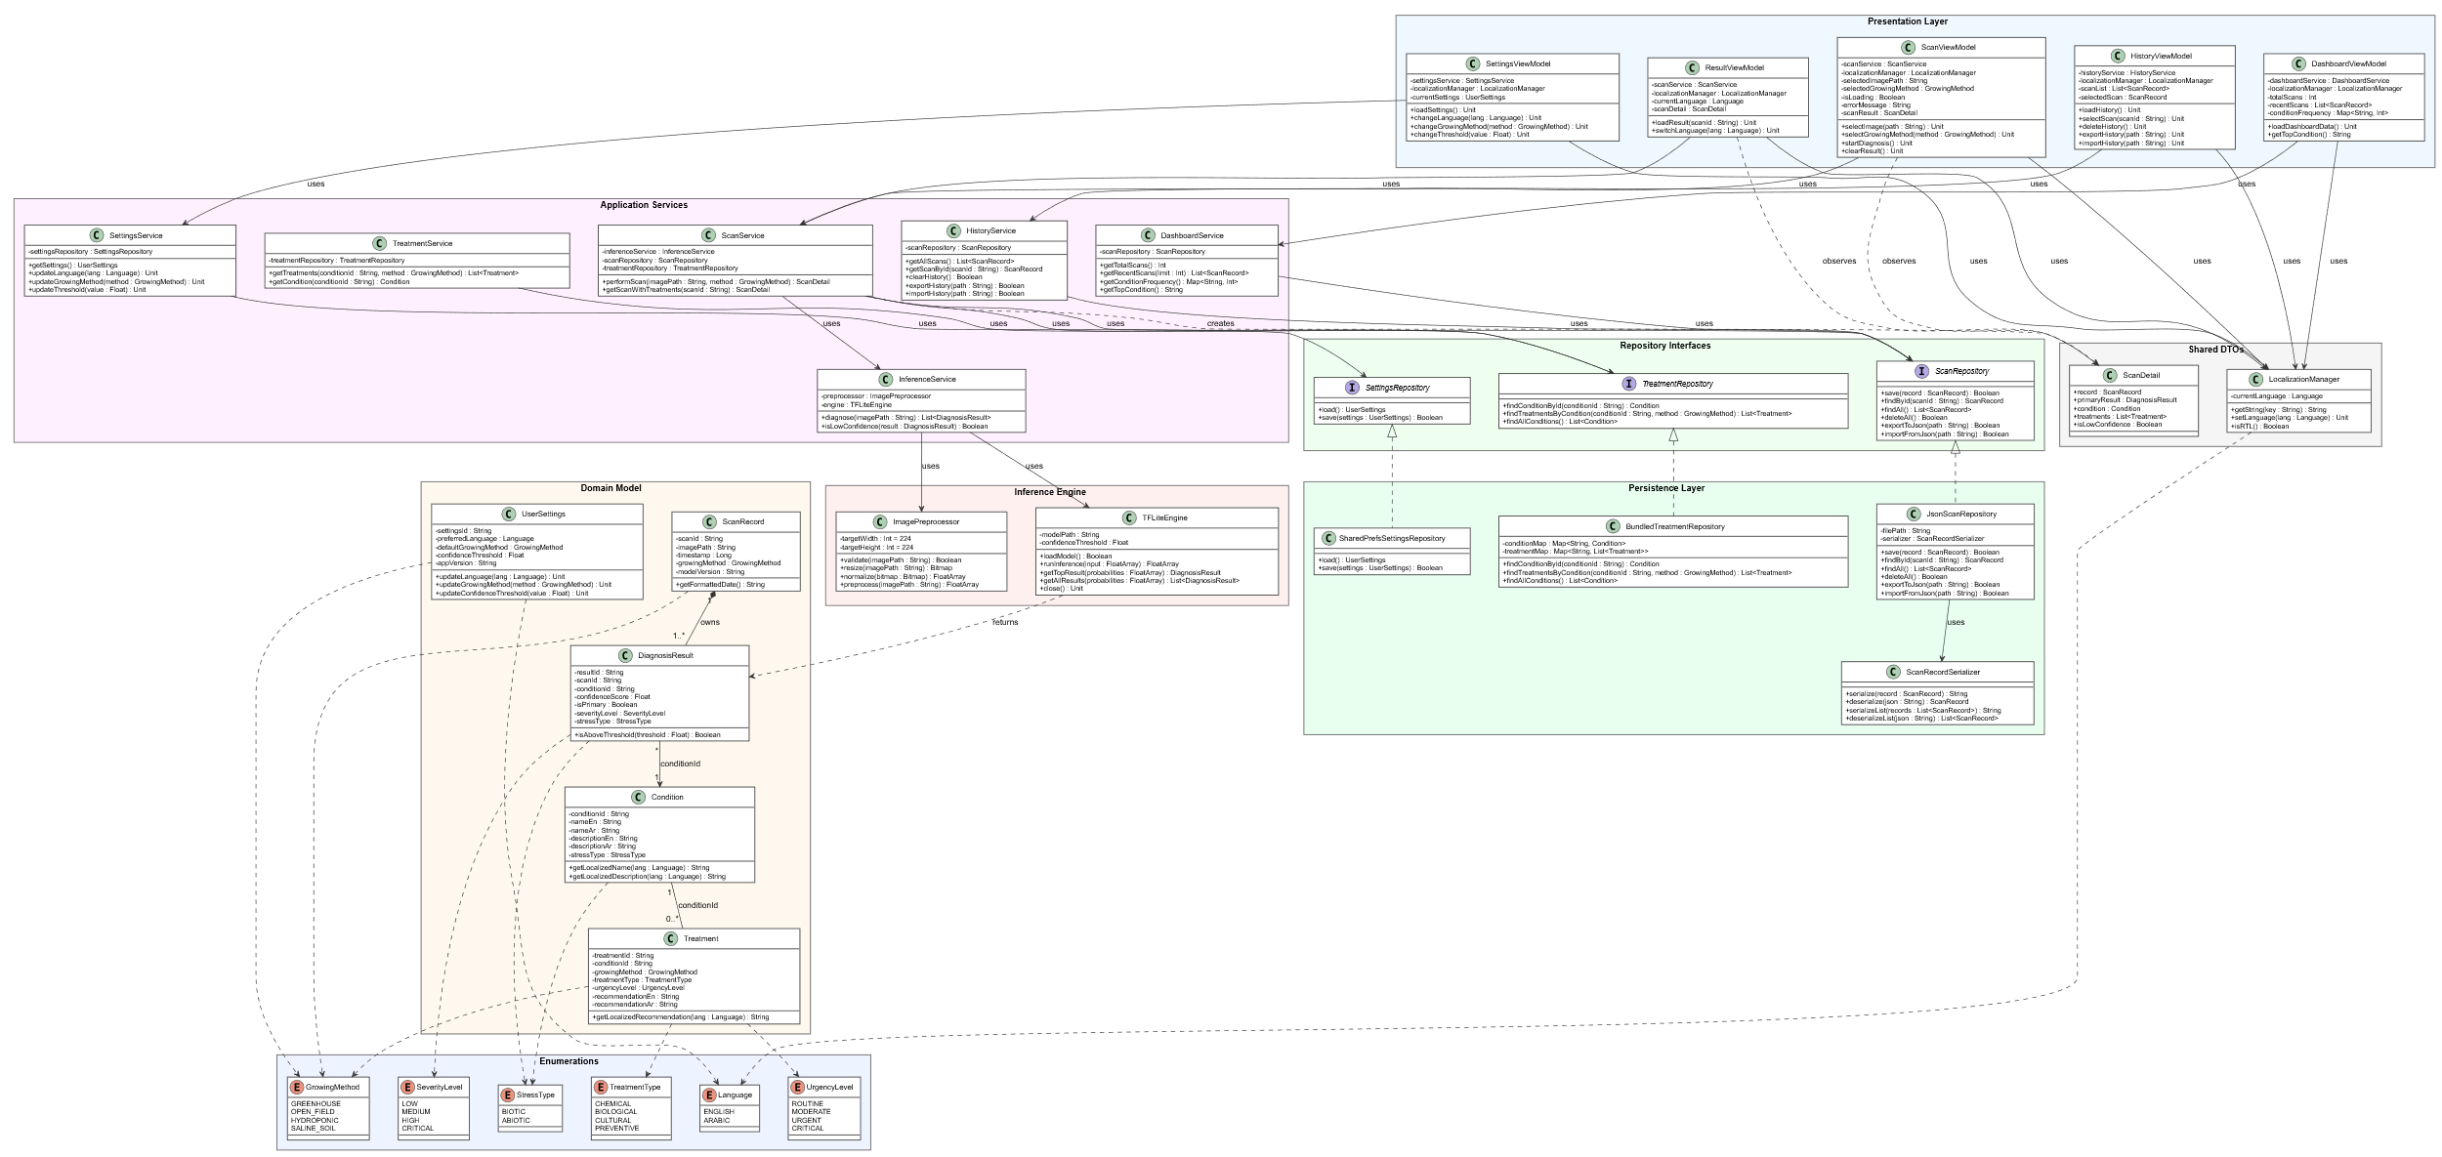
Figure 16 Class Diagram

Activity Diagram
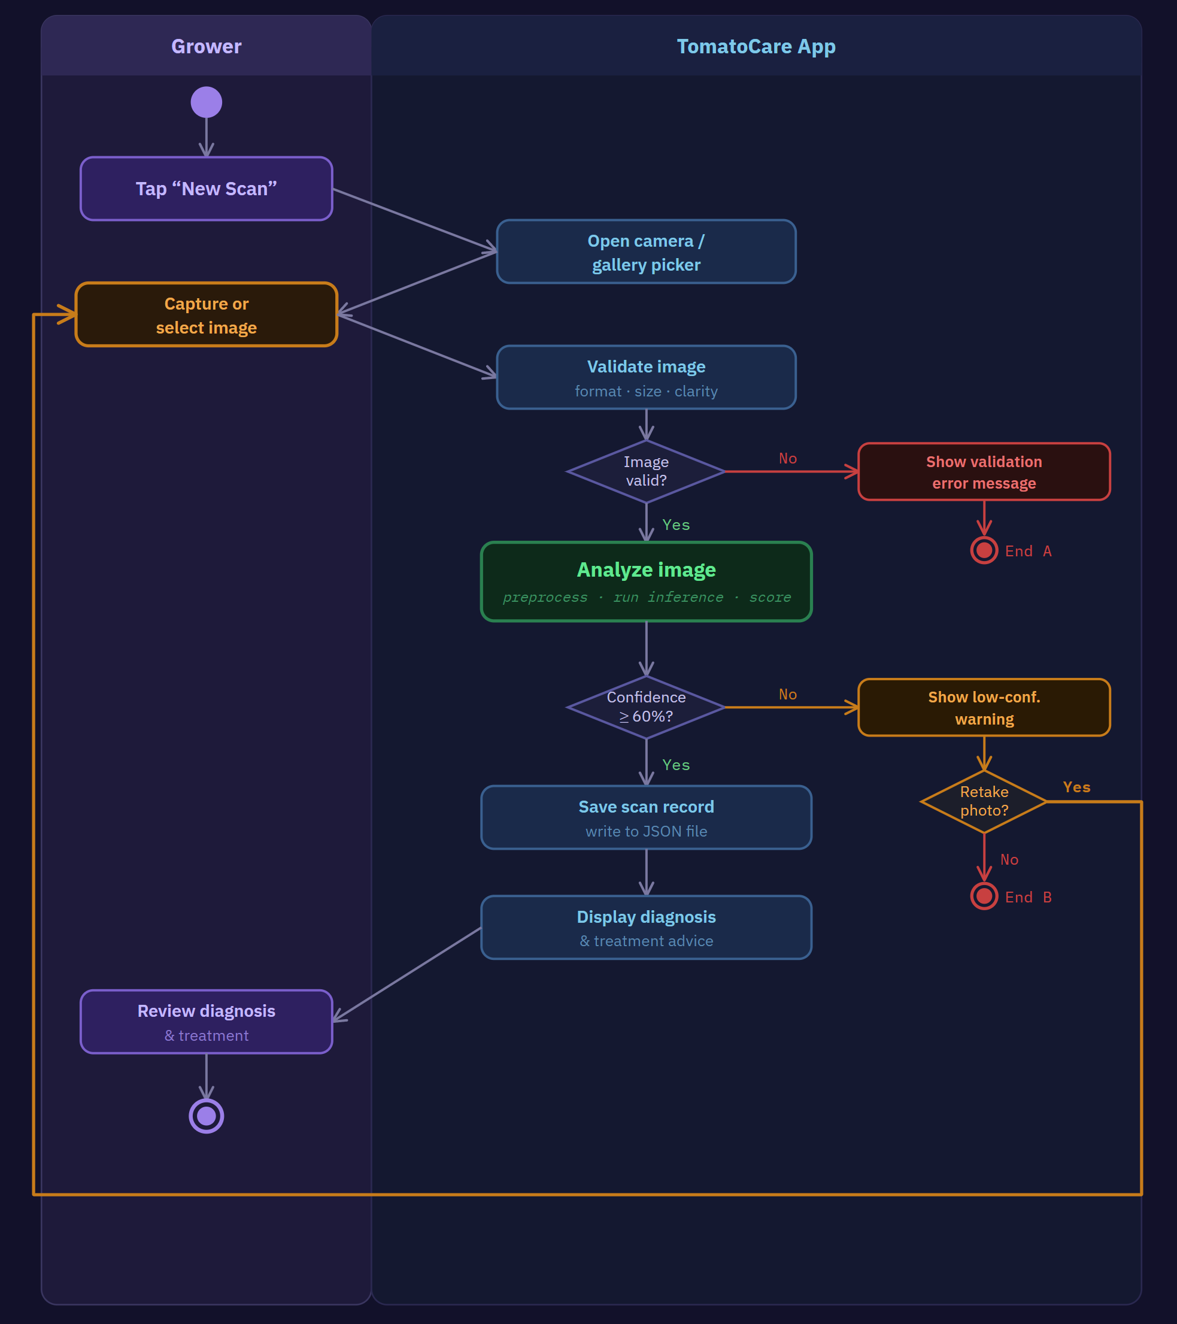
Figure 17 Activity Diagram for Run Diagnosis

CHAPTER 6: CONCLUSION
The challenges related to tomato production in the United Arab Emirates have an entirely different nature as compared with the issues of the temperate agricultural landscape. The extreme dry climate, where the summer temperatures are above 45C, the soil is highly salty and the soil is extremely exposed to the sun, subjects the tomato plants to severe patterns of abiotic stress that closely resembles the visual symptoms of biotic infections like the Early Blight, Late Blight and the Tomato Yellow Leaf Curl Virus. This diagnostic vagueness results in the incorrect use of treatments, unnecessary use of pesticides, increased costs of production and in most cases, failure of the crop.

TomatoCare was created to directly fill this gap. The app is a native Android diagnostic tool, which was built completely offline, allowing any growing in the UAE with a smartphone to take a photo of a tomato leaf and get an instant and accurate diagnosis depending on the growing conditions in the UAE. Most importantly, this did not just need the adaptation of an existing plant disease classifier. The combination of abiotic stressors in the UAE setting (sunscald, heat stress, and chlorosis induced by salinity) is not reflected in the current training data sets (such as PlantVillage) that were collected under controlled laboratory conditions and in temperate climate conditions. This limitation was in the focus of the design of TomatoCare in the first place.

The literature review presented in Chapter 2 has revealed five different research and product gaps, which when combined will define the problem space. To begin with, no reviewed applications, such as Farmonaut, Flora Incognita, Plantix, or Agrio explicitly distinguish between biotic and abiotic stress in their diagnostic output, despite the crucial significance of that distinction to the selection of treatment. Second, three out of four platforms reviewed require a consistent internet connection, and are therefore virtually unusable in the rural and outdoor agriculture setting of the UAE smallholder cultivation. Third, all the applications reviewed do not offer an interface in Arabic language, which creates a serious barrier to accessibility of a large portion of the UAE agricultural workforce. Fourth, none of the reviewed platforms provide treatment recommendations based on their cultivation methods in the UAE, including, but not limited to, greenhouse, open-field, hydroponic, or saline-soil cultivation conditions. Fifth, there is an unreported gap in the reported accuracy values and the likely real-world performance in Gulf agricultural environments in all reviewed platforms report training or evaluation outcomes on any dataset that includes UAE-relevant abiotic stress patterns.

The TomatoCare has been developed to address all the five gaps. The AI model is trained based on the MobileNetV3-Large convolutional neural network model, with the tomato subset of the PlantVillage dataset as the input. The model is trained under a two-stage transfer learning strategy and tested against a held-out test set, which explicitly includes the biotic disease classes as well as the UAE-relevant abiotic stress patterns, and a target classification accuracy of at least 90%. After training, the model can be exported to the TensorFlow Lite format with float16 quantisation to minimise the storage footprint of the model to less than 15 MB without losing diagnostic accuracy of the model.

Each diagnosis in the application has the name of the condition in English and Arabic, a confidence score, a colour-coded stress badge, biotic or abiotic, and a severity indicator of Low, Medium, High, or Critical. To avoid the display of what may be misconstrued as a result, the system will not show a possibly misleading result but will provide a Low Confidence Warning instead. Recommendations are provided based on an embedded bilingual knowledge base and filtered by the growing method that is selected by the user and ensures the advice is relevant to the cultivation situation.

The software development lifecycle of Agile was used to develop the project, being organized into six sprints that will run throughout Capstone 1 and planned Capstone 2. The reason behind the choice of the Agile approach is that it is more suitable to the experimental nature of machine learning model development and the need to integrate and test across streams of machine learning and Android development. The project planning, literature review, requirements specification, system architecture and design were covered in capstone 1 which this report documents. All the artefacts of the design were created at this stage, such as use case, sequence, activity, class, state chart, entity-relationship diagram, the JSON schema tree and the layered architecture diagram. These artefacts give the full technical and conceptual background to the implementation step which is planned to be implemented in Capstone 2.

It should be noted that TomatoCare as it will be implemented has its restrictions. The application is only scoped to tomato (Solanum lycopersicum) leaf and not generalised to other crop species. It does not come with cloud synchronisation, user accounts, integration of IoT sensors, and integration of iOS. The outputs of treatment are under the form of advisory recommendations and are not legally binding prescription of agrochemicals. These limits are premeditated and suitable to a Capstone 1 and Capstone 2 deliverable; some of them, such as multi-crop support and IoT integration, are defined as the future development directions.

On successful completion of Capstone 2, TomatoCare will provide a release-ready, bilingual Android application that will be able to perform full offline tomato leaf diagnostics on low-end devices with the support of a trained and quantised MobileNetV3-Large model and an open-source, GitHub repository. By doing so, the project will directly contribute to the goals of the UAE National Food Security Strategy 2051 by putting a specialised, accessible and accurate diagnostic tool into the hands of growers, who were historically underserved by precision agriculture technologies.

REFERENCES
- UAE National Center of Meteorology, "Climate Temperature Indicators," Federal Competitiveness and Statistics Centre, 2025. [Online]. Available: https://uaestat.fcsc.gov.ae.
- UAE Government, "National Food Security Strategy 2051," United Arab Emirates, 2023. [Online]. Available: https://u.ae/en/about-the-uae/strategies-initiatives-and-awards/strategies-plans-and-visions/environment-and-energy/national-food-security-strategy-2051.
- D. Devarajan, R. Allafi, M. Obayya, and N. Nemri, "AI based real time disease diagnosis in plants using deep learning driven CNNs," Scientific Reports, vol. 16, Art. no. 4587, Jan. 2026, doi: 10.1038/s41598-025-34681-1.[Online].Available: https://pmc.ncbi.nlm.nih.gov/articles/PMC12868782/
- M. Shafay, T. Hassan, M. Owais, I. Hussain, S. G. Khawaja, L. Seneviratne, and N. Werghi, "Recent advances in plant disease detection: challenges and opportunities," Plant Methods, vol. 21, Art. no. 140, Oct. 2025, doi: 10.1186/s13007-025-01450-0. [Online]. Available: https://pmc.ncbi.nlm.nih.gov/articles/PMC12570820/.
- K. He, X. Zhang, S. Ren, and J. Sun, "Deep Residual Learning for Image Recognition," in Proceedings of the IEEE Conference on Computer Vision and Pattern Recognition (CVPR), 2016, pp. 770–778.
- A. Howard, M. Sandler, B. Chen, W. Wang, L.-C. Chen, M. Tan, G. Chu, V. Vasudevan, Y. Zhu, R. Pang, H. Adam, and Q. Le, "Searching for MobileNetV3," in Proceedings of the IEEE/CVF International Conference on Computer Vision (ICCV), 2019, pp. 1314–1324.
- M. Sandler, A. Howard, M. Zhu, A. Zhmoginov, and L.-C. Chen, "MobileNetV2: Inverted Residuals and Linear Bottlenecks," in Proceedings of the IEEE Conference on Computer Vision and Pattern Recognition (CVPR), 2018, pp. 4510–4520.
- M. Tan and Q. V. Le, "EfficientNet: Rethinking Model Scaling for Convolutional Neural Networks," in Proceedings of the 36th International Conference on Machine Learning (ICML), 2019, pp. 6105–6114.
- D. P. Hughes and M. Salathé, "An open access repository of images on plant health to enable the development of mobile disease diagnostics," arXiv preprint, arXiv:1511.08060, 2016.
- S. P. Mohanty, D. P. Hughes, and M. Salathé, "Using deep learning for image-based plant disease detection," Frontiers in Plant Science, vol. 7, p. 1419, 2016.
- B. Jacob et al., "Quantization and training of neural networks for efficient integer-arithmetic-only inference," in Proceedings of the IEEE Conference on Computer Vision and Pattern Recognition (CVPR), 2018, pp. 2704–2713.
- Google AI Edge, "LiteRT: High-Performance On-Device Machine Learning Framework," 2024. [Online]. Available: https://ai.google.dev/edge/litert.
- UAE Federal Decree-Law No. 45 of 2021, "On the Protection of Personal Data," United Arab Emirates, 2021.
- Farmonaut, "App That Tells You What's Wrong With Your Plant," Farmonaut Blog, 2024. [Online]. Available: https://farmonaut.com/precision-farming/app-that-tells-you-whats-wrong-with-your-plant.
- Farmonaut, "How To Monitor Crop Health Using Satellite Crop Systems," 2024. [Online]. Available: https://farmonaut.com/satellite-based-crop-health-monitoring.
- Farmonaut, "Best Apps To Diagnose Plant Diseases: 2025's Ultimate Guide," Farmonaut Blog, 2025. [Online]. Available: https://farmonaut.com/blogs/best-apps-to-diagnose-plant-diseases-2025s-ultimate-guide
- Flora Incognita, "Structure and functionality of the Flora Incognita app," 2024. [Online]. Available: https://floraincognita.com/flora-incognita-app/.
- Flora Incognita, "Study on identification accuracy: Flora Incognita reaches 98.8%," Oct. 2024. [Online]. Available: https://floraincognita.com/blog/2024/10/24/study-on-identification-accuracy-flora-incognita-reaches-98-8/.
- Flora Incognita, "Flora Incognita++ Citizen Science Project," 2024. [Online]. Available: https://floraincognita.com/flora-incognita-plusplus/.
- Android Developers, "Data and file storage overview," Google, 2024. [Online]. Available: https://developer.android.com/training/data-storage.
- JetBrains, "Serialization," Kotlin Documentation, 2024. [Online]. Available: https://kotlinlang.org/docs/serialization.html.
- Android Developers, "CameraX Overview," Google, 2024. [Online]. Available: https://developer.android.com/training/camerax.
- Android Developers, "Jetpack Compose," Google, 2024. [Online]. Available: https://developer.android.com/jetpack/compose.
- I. Sommerville, Software Engineering, 10th ed. Pearson Education Limited, 2016.
- R. S. Pressman and B. R. Maxim, Software Engineering: A Practitioner's Approach, 9th ed. McGraw-Hill, 2020.
- F. Abbas and S. Al-Naemi, "Managing salinity stress through microclimate control to enhance tomato productivity in arid regions," Scientific Reports, vol. 16, Art. no. 13042, Mar. 2026, doi: 10.1038/s41598-026-42022-z. [Online]. Available: https://www.nature.com/articles/s41598-026-42022-z.

