**General Telescope Research**

**1. Aperture – Buckets Of Light**

* The most important specification of any telescope is the aperture, the diameter of the main lens or mirror of the telescope. More aperture makes for a brighter image.
* The light collecting ability of a telescope is directly proportional to area of the lens or mirror, which is in turn related to the square of the aperture.
  + So a telescope with an objective mirror of 200 mm aperture collects four times as much light as a scope with a 100 mm mirror.

**2. Focal Length – Show Me The Image**

* Once light falls onto a mirror or through a lens, it’s directed by the curvature of the optic to come to a focus at a plane some distance away. The length over which this happens is called the focal length of the objective.
  + At the focal plane of a lens or mirror, you can actually see a real image of a distant object.

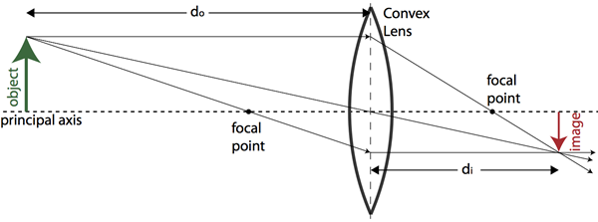

**3. Magnification – Far And Away, Up Close**

* To get an image suitable for observing with our eyes, a telescope uses a second lens, or collection of lenses, called an eyepiece at the focal plane.
* The eyepiece magnifies the image from the objective. The eyepiece also has a focal length.
* The magnification of a telescope and eyepiece is very simple to calculate. If the focal length of the objective is “F” and the focal length of the eyepiece is “f”, then the magnification of the telescope/eyepiece combination is F/f.
  + - * For example, if a telescope has an objective lens with focal length of 1200 mm (about 48”) and it has an eyepiece of focal length 25 mm (about 1”), then it will have a magnification of 1200/25=48x.
* Another rule of thumb… the maximum useful magnification of a telescope is about 50x the aperture in inches. Any higher and the image gets too dim and fuzzy to be useful.
  + - * So a 4-inch scope can get you about 200x before the image gets too fuzzy and dim, a 6-inch scope gets you 300x, and so on. Sometimes, when the atmosphere is unsteady, you can only get to 20x or 30x per inch of aperture. With high-quality optics and steady seeing, you might get to 70x or even 100x per inch of aperture, so for example, up to 400x with a 4-inch scope. But this is rare.

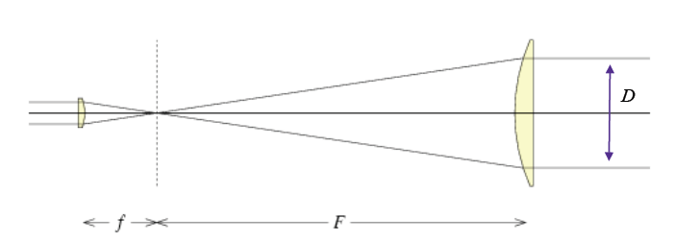

*The aperture of the objective lens of this simple telescope is D. The focal length of the objective lens if F. The focal length of the eyepiece is f. So the magnification is F/f. The focal ratio is F/D.*

**4. Focal Ratio – Faster, Brighter, Smaller**

* The fourth key specification of a telescope is the ***focal ratio***, which is the focal length divided by the objective diameter.
  + A long focal ratio implies higher magnification and narrower field of view with a given eyepiece, which is great for observing the moon and planets and double stars.
  + For such objects, a focal ratio of f/10 or more is ideal. But if you want to see wide views of star clusters, galaxies, and the Milky Way, a lower focal ratio is better. You get less magnification, but you see more of the sky. Wide field telescopes have a focal ratio of f/7 or less.
* Focal ratio also influences the brightness of extended objects like a nebula or galaxy.
  + For example, a telescope with focal ratio of f/5 will show an image of four times the brightness as a telescope with focal ratio of f/10, all other things being equal. But the image at f/5 will be only half as large. However, the brightness of stars, which are point sources of light, is influenced only by the telescope aperture.

**5. Resolving Power – Sorting One Star From Another**

* Finally, the last important number of any telescope: the ***resolution***. The resolution of a telescope is a measure of its ability to distinguish small details of an object or to distinguish two very closely spaced objects from each other.
  + Resolution is important when you’re trying to separate two closely-spaced stars, for example, or fine detail on the Moon or a planet. The resolving power of a telescope with an objective of aperture D (in millimeters) is:

**Resolving Power = 116/D (in arcseconds)**

* + Resolution is directly proportional to the aperture of a telescope. A 200 mm scope can resolve details as close as 0.58 arcseconds, twice as well as a 100 mm scope, all other things being equal. (One arcsecond is 1/3600 of a degree). But the motion and instabilities in the Earth’s atmosphere often limit the practical resolution of any telescope to 1″ or more.