Kingdom of Saudi Arabia

Ministry of Education

Shaqra University

College of Computing and Information Technology

Computer and Network Engineering Department

صورة تحتوي على رمز, دائرة, الرسومات, شعار

تم إنشاء الوصف تلقائياً

**Supervisor:** Dr. Saeed Alshahrani.

**Co-Supervisor:** Dr. Nayyar Ahmed Khan.

**Students: ID:**

Abdulrahman Abdullah Al-Duaij. 441460545

Fahad Mathker Al-Otaibi. 441420307

441460545

Fahad Mathker Al-Otaibi. 441420307

441460545

Fahad Mathker Al-Otaibi. 441420307

441460545

Fahad Mathker Al-Otaibi. 441420307

441460545

Fahad Mathker Al-Otaibi. 441420307

441460545

Fahad Mathker Al-Otaibi. 441420307

441460545

Fahad Mathker Al-Otaibi. 441420307

441460545

Fahad Mathker Al-Otaibi. 441420307

**Magic Wheelchair: Voice-Activated Wheelchair**

**Graduation project REPORT**

**2023-2024**

**Magic Wheelchair: Voice-Activated Wheelchair.**

**Graduation project REPORT.**

**2023-2024**

**Magic Wheelchair: Voice-Activated Wheelchair.**

**Graduation project REPORT.**

**2023-2024**

**Magic Wheelchair: Voice-Activated Wheelchair.**

**Graduation project REPORT.**

**2023-2024**

*Table 1.2: Time line of the project(term2)***Magic Wheelchair: Voice-Activated Wheelchair**

**Graduation project REPORT**

**2023-2024**

**Magic Wheelchair: Voice-Activated Wheelchair.**

**Graduation project REPORT.**

**2023-2024**

**Magic Wheelchair: Voice-Activated Wheelchair.**

**Graduation project REPORT.**

**2023-2024**

**Magic Wheelchair: Voice-Activated Wheelchair.**

**Graduation project REPORT.**

**2023-2024**

Abstract

Many people with disabilities usually depend on others in their daily lives, especially in moving from one place to another. For wheelchair users, they constantly need someone to help them move the wheelchair. By having a wheelchair control system, they become more independent. This project aims to design and implement a voice-controlled wheelchair for people with physical disabilities. A wheelchair control system that uses voice to operate and control all of its movements. It includes a Microcontroller, L293D motor, and Bluetooth module that connects the wheelchair to the mobile application in which commands are issued through specific voice commands (forward, backward, right, left, SOS). Additionally, an integrated safety system comprises two vital elements: The first element is an environmental obstacle detection system, employing ultrasonic sensors. second element: The "SOS" voice command acts as a safety lifeline, ensuring that assistance can be swiftly summoned in emergencies. This voice-controlled wheelchair enhances accessibility for individuals with physical disabilities marking a significant advancement in assistive technology.

موجز المشروع باللغة العربية

العديد من الأشخاص ذوي الإعاقة الجسدية يعتمدون عادة على الآخرين في حياتهم اليومية، خاصة في التنقل من مكان إلى آخر. بالنسبة لمستخدمي الكراسي المتحركة، فإنهم بحاجة مستمرة إلى شخص يساعدهم في تحريك الكرسي المتحرك. من خلال وجود نظام صوتي لتحكم في الكرسي المتحرك، يصبحون أكثر استقلالية. يهدف هذا المشروع إلى تصميم وتنفيذ كرسي متحرك يتم التحكم فيه بواسطة الصوت خصيصًا للأشخاص ذوي الإعاقة الجسدية. النظام يستخدم الاوامر الصوتية لتشغيل والتحكم في جميع حركات الكرسي ويتضمن وحدة تحكم دقيقة ومحرك L293D ووحدة Bluetooth تربط الكرسي المتحرك بتطبيق الهاتف المحمول الذي من خلاله تصدر الأوامر الصوتية وتكون الأوامر الصوتية محددة مثل: (الامام، الخلف، اليمين، اليسار، الطوارئ "SOS"). بالإضافة إلى ذلك، يتكون نظام السلامة المدمج في نظام الصوتي للكرسي المتحرك من عنصرين أساسيين: العنصر الأول هو نظام الكشف عن العوائق البيئية، الذي يستخدم أجهزة استشعار بالموجات فوق الصوتية. العنصر الثاني: هو الامر الصوتي "SOS"ويعمل الأمر الصوتي "SOS" كسلامة حيوية، أنه يمكن من خلاله استدعاء المساعدة بسرعة في حالات الطوارئ. يعزز مشروعنا الكرسي المتحرك الذي يتم التحكم به بالصوت إمكانية الوصول للأفراد ذوي الإعاقة الجسدية مما يمثل تقدمًا كبيرًا في تكنولوجيا المساعدة.

Table of Contents

Abstract 2

موجز المشروع باللغة العربية 2

1. Introduction 5

**1.1** Background 6

**1.2** Problem Description and Motivation. 10

**1.3** Digitization and Vision 2030 11

2. Literature Review 12

3. Requirements 13

**3.1** Hardware 13

**3.2** System & Software 14

**3.3** User Level 14

**3.4** Data and Contents 15

4. Project Management Strategies Involved in the Project 16

**4.1** Project Scope 16

**4.2** Role of each project team member (if any): 16

**4.3** Time Plan of the Project 17

**4.4** Suggested Business Modal 18

5. Materials and Methods 19

**5.1** Use Case diagram. 19

**5.2** Block diagram. 20

**5.3** Interfaces. 21

**5.4** Database Schema 22

**5.5** Flowchart 23

23

6. Results and Discussion. 24

7. Conclusions and Future Work 25

8. Biography 26

**8.1** Student Profile 26

**8.2** Advisor Profile 26

9. References 27

Table of Figure

Figure 1, Assistive Technology.[3] 5

Figure 2, U.S. Wheelchair Market.[4] 6

Figure 3, Smart Wheelchair. [7] 7

Figure 4, Wheelchair Movement Paths.[10] 9

Figure 5, Overall system architecture. [11] 9

Figure 6, Type of Incident/% of individuals injured.[13] 10

Figure 7, Percentage of people with disabilities in the Kingdom.[16]. 11

Figure 8, Use Case Diagram Wheelchair System 19

Figure 9, Block Diagram Voice-Controlled Wheelchair 20

Figure 10, Home Page 21

Figure 11, Command Page. 21

Figure 12, Bluetooth page 21

Figure 13, Database Schema Voice-Controlled Wheelchair 22

Figure 14, Flowchart Voice-Controlled Wheelchair 23

Figure 15, Project representation 24

1. **Introduction**

The rapid advancement of modern technology has given rise to a myriad of machines, profoundly transforming various aspects of our daily lives. Among these transformative innovations, assistive technologies play a pivotal role in enhancing the quality of life for individuals with disabilities. Automated wheelchairs, in particular, stand out as a crucial development in the realm of assistive technology, offering newfound independence and mobility to those in need.[1]

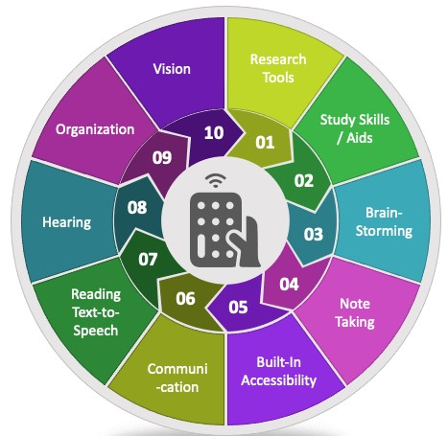

Figure 1, Assistive Technology.[3]

For those with lower-limb disabilities, wheelchairs serve as indispensable tools, offering a semblance of mobility and independence in navigating daily social activities. However, the majority of wheelchairs available today are manual or come with limited motorized options. Custom-made solutions, while effective, tend to be prohibitively expensive, leaving many individuals with severe lower and upper disabilities with limited choices. Those who do opt for electronically controlled wheelchairs often face high costs and a lack of tailored options, especially for individuals with upper extremity disabilities.[2]

Statistics reveal that the global active wheelchair market is projected to reach USD 2.3 billion by 2027, with a forecasted compound annual growth rate (CAGR) of 4.4%. Despite this, the World Health Organization estimates that only 5% to 15% of the 75 million people in need of assistive technology, including wheelchairs, have access to these crucial devices.[2]

*صورة تحتوي على نص, لقطة شاشة, الخط, تصميم الجرافيك

تم إنشاء الوصف تلقائياً*

Figure 2, U.S. Wheelchair Market.[4]

This project aims to address these challenges by introducing a Voice-Activated Wheelchair, leveraging cutting-edge technology to enhance accessibility and independence. Beyond mere convenience, voice activation represents a paradigm shift in assistive technology, offering a more inclusive and user-friendly approach. In addition to its potential to transform the lives of individuals with disabilities, this project aligns with the broader goals of societal inclusivity, echoing the vision outlined in Saudi Arabia's Vision 2030.As we embark on this innovative journey, the Voice-Activated Wheelchair project seeks to bridge the gap in the current market, offering a cost-effective, technologically advanced solution that empowers individuals with disabilities to navigate their world with greater autonomy.

* 1. Background

Independent mobility is very critical for individuals of any age. Thousands of children who lack an independent means of locomotion are placed at developmental disadvantages relative to their self-ambulation peers [5]. Even adults without self-ambulation are less self-sufficient and suffer from a negative self-image. Although standard power wheelchairs satisfy the needs of many individuals with disabilities, some members of the disabled community (up to 40% [6]) find it difficult or impossible to operate a standard power wheelchair. To accommodate this population, researchers have explored several types of technology to create “smart wheelchair” systems an example is shown in Figure 3. A smart wheelchair typically consists of a standard power wheelchair base to which a collection of high-tech devices has been added. The types and number of added devices depend mainly on the desired needs of the wheelchair user. [5]

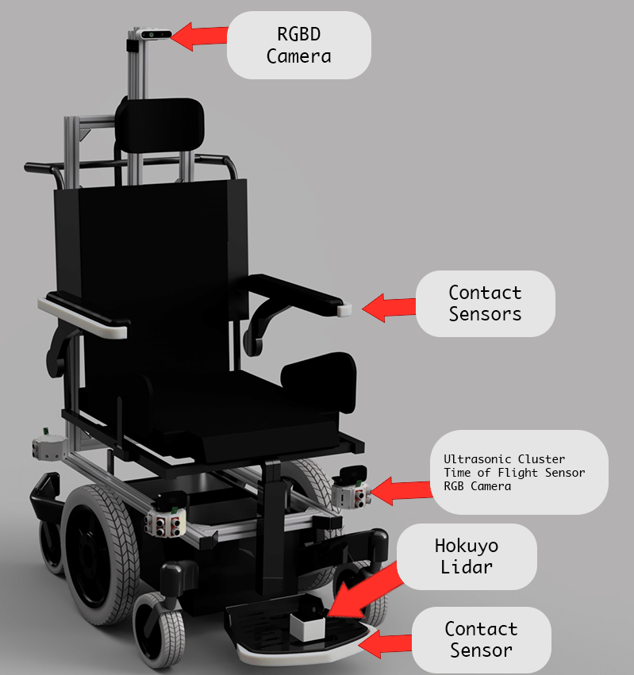

Figure 3, Smart Wheelchair. [7]

Rehabilitation science concerns mainly about the relationship between the handicapped persons and the devices that can help them in daily life. The aim of the rehabilitation technology is to improve the functions of the handicapped people by developing efficient devices that can be equipped with wheelchair systems. The ideal set-up would be to provide each user with a system that exactly meets his or her individual requirements. Most of the wheelchair users, however, face difficulties every day because of the huge effort exerted to move the manual wheelchair. In addition, the embarrassment for the constant need of personal assistants restrict their privacy by enforcing the need of accompany wherever they move. Although automated wheelchairs that moved with a joystick are available in markets, most of the handicapped people cannot afford buying them due to their high price. Moreover, many paralyzed people cannot even move their arms to move the wheelchair with a joystick. Thus, they urgently need a convenient alternative way to steer their wheelchairs and move around easily and independently. The number of physically handicapped people in the Middle East region is considerably large. Thus, finding a solution to solve their problem would be extremely useful, appreciable, and beneficial to both the users and the producers.[8]

A voice-controlled wheelchair is a type of wheelchair that is designed to be operated using voice commands. Instead of relying on manual controls or physical interfaces, users can control the movement and functions of the wheelchair by speaking specific commands. The wheelchair is equipped with a voice recognition system that interprets spoken words or phrases and translates them into actionable instructions for the wheelchair's navigation and other features.[9].

Voice commands for a wheelchair are spoken instructions that users can use to control the movement and functionality of the wheelchair through a voice-controlled system. These commands are typically recognized and interpreted by a speech recognition system, which then translates them into actionable instructions for the wheelchair. Here are voice commands used for controlling a voice-activated wheelchair:

* Forward: Instructs the wheelchair to move in a forward direction.
* Backward: Commands the wheelchair to move in a backward direction.
* Turn Left: Directs the wheelchair to turn to the left.
* Turn Right: Instructs the wheelchair to turn to the right.
* SOS: Triggers an emergency response, which may include stopping the wheelchair and alerting caregivers or emergency services. These movement paths are illustrated in Figure4.[9]

صورة تحتوي على رسم, عجلة

تم إنشاء الوصف تلقائياً

Figure 4, Wheelchair Movement Paths.[10]

Figure 5 illustrates the implementation of the system architecture of the proposed system.

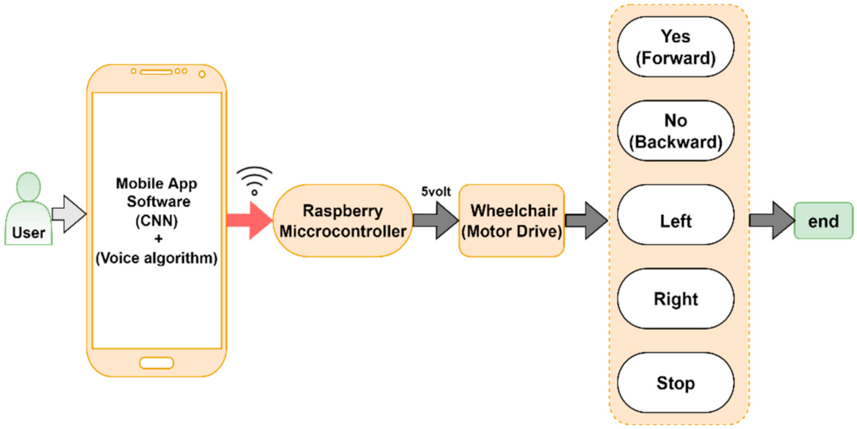

Figure 5, Overall system architecture. [11]

* 1. Problem Description and Motivation.

Individuals with mobility impairments face challenges in operating traditional wheelchairs, especially when they have limited or no control over their upper limbs. Conventional wheelchairs rely on manual input, requiring users to manipulate a joystick or other physical controls, which can be impractical or impossible for some individuals. This limitation hinders the independence and quality of life for people with severe motor disabilities, restricting their ability to move freely and engage with their surroundings. [12]

The motivation behind developing a voice-activated wheelchair with a safety system stems from the urgent need to enhance the autonomy and safety of individuals with mobility impairments. By implementing voice control technology, we aim to provide a more intuitive and accessible means for users to navigate their environment. Moreover, integrating a robust safety system is crucial to prevent accidents and ensure the well-being of the wheelchair user he Figure 6 shows the types of injuries for wheelchair users. [13]

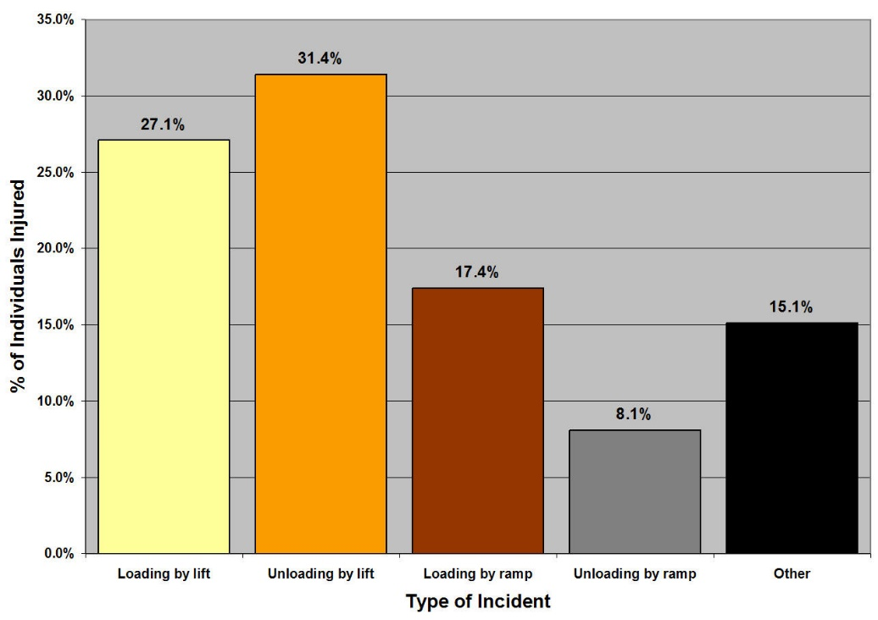

Figure 6, Type of Incident/% of individuals injured.[13]

* 1. Digitization and Vision 2030

Saudi Arabia created Vision 2030 to help the nation forge a progressive future. Saudi Vision 2030 is a strategic plan to diversify the economy of Saudi Arabia, reduce its dependence on oil, and expand public service areas such as health, education, infrastructure, entertainment, and tourism.[14]. Through the Quality-of-Life Program, Saudi Arabia’s Vision 2030 emphasizes social inclusion and improving livelihoods. This project promotes inclusivity by empowering people with physical disabilities and providing them with the means to live a more independent life.[15]. Our project is aligned with Vision 2030 goals of inclusivity, innovation, well-being, and global competitiveness. It justifies the concept of digitization in Saudi Arabia by showing how digital technology can improve the lives of citizens, especially those with disabilities, and contribute to technological progress and economic diversification in the country.[15]

Figure 7, the percentage of people with disabilities in the Kingdom is 7.1%, which amounts to 1,445,723 individuals out of the total population of 32.94 million.[16]

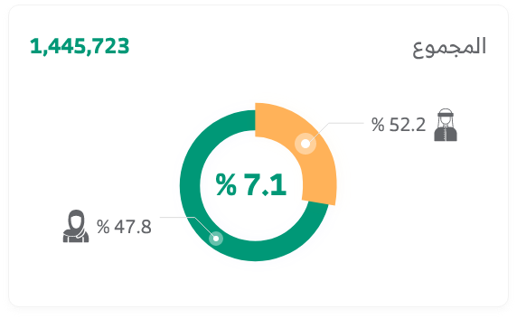

Figure 7, Percentage of people with disabilities in the Kingdom.[16].

1. **Literature Review**

As per the study, given by [17]. The user can control the wheelchair by voice commands, such as "susume (run forward)" in Japanese. A grammar-based recognition parser named "Julian" is used in our system. Three types of commands, the basic reaction command, the short-moving reaction command, and the verification command, are given. the experimented speech recognition by Julian, and obtained a successful recognition rate of 98.3%, 97.0% for the movement command and the verification command, respectively.

According to [18] - This study provides inspiration for to process of analog voice signals. The theme is implemented for the parallelized persons by voice-activated wheelchair through speech processing using a digital signal processor (DSP). The Texas Instruments TMS320C6711 DSP starter kit (DSK) is connected to the wheelchair for processing the voice signal. The DSK calculates the energy, zero crossing, and standard deviation of the spoken word. It also generates different desired analog signals according to the spoken words which are further amplified and converted into digital. These digital signals are used to operate the stepper motor. Five words are recognized which are forward, reverse, left, right, and stop. The results at the end show the efficiency of the system.

According to [19] - the current study provides proposes an Intelligent Home Navigation System (IHNS) which comprises a wheelchair, voice module, and navigation module. This system can be used by an elderly or physically challenged person to move inside the home without any difficulty. In general, the elders may forget the way to the different rooms in the house and the physically challenged people find it hard to move the wheelchair without external aid. In the proposed system the wheelchair is operated automatically or manually by turning the wheels using hands or external aids. the system is a voice-controlled wheelchair robot. The voice of the person is detected by the voice capture module and compared with predefined voices loaded in the system by the voice recognition module. According to the received voice, the destination is automatically understood and the wheelchair moves according to the route which is predefined. The system is also equipped with an obstacle avoidance technique, where the person may not be able to provide a proper voice at the right time. The wheelchair can automatically navigate from one point to another in the home as per command from the voice module.

1. **Requirements**
   1. Hardware
      1. Arduino UNO Board.

it is a microcontroller board which consists of fourteen digital pins used as input/output (six pins can be used as PWM outputs), six analog inputs, a sixteen MHz ceramic resonator, a USB port for connection needs five volts to operate.

* + 1. L293D Motor Shield.

L293D is a standard Motor driver or Motor Driver IC which enables DC motor to drive on either way. L293D is a 16-pin IC that can command a set of two DC motors concurrently in any way.

* + 1. Bluetooth Module HC-05.

a class 2 Bluetooth module designed for transparent wireless serial communication.

* + 1. Ultrasonic Sensor HC-SR-04.

 uses sonar to determine distance to an object like bats or dolphins do.

* + 1. 18650 Holder and Battery.

integrated or separate cavity to hold cells.

* + 1. 2 DC Geared Motors.

A geared motor is a component whose mechanism adjusts the speed of the motor, leading them to operate at a certain speed.

* + 1. Jumper Wires.

simply wires that have connector pins at each end, allowing them to be used to connect two points to each other.

* + 1. Caster wheel.

A caster (or castor) is an undriven wheel that's designed to be attached to rock bottom of a bigger object (the "vehicle") to enable that object to be moved.

* + 1. Wheel

Wheels are that operate around the area` practicing motorized wheels to drive themselves.

* 1. System & Software
     1. Arduino Software IDE.

Arduino Software (IDE) - contains a text editor for writing code, a message area, a text console, a toolbar with buttons for common functions and a series of menus. It connects to the Arduino hardware to upload programs and communicate with them.

* + 1. Android Application.

An application in the Android operating system written in java and C++.

* 1. User Level
     1. User Side
* represents the perspective and interface designed for the end-users of the voice-controlled wheelchair.
* The User Side typically includes features and controls that allow the wheelchair user to interact with the system using voice commands.
* Using voice commands for fundamental movements like forward, backward, left, right and SOS.
  + 1. Admin Side
* Represent the perspective and interface designed for administrators or system administrators who are responsible for managing and overseeing the operation of the voice-controlled wheelchair system.
* The Admin Side includes functionalities related to system configuration, monitoring, and maintenance. Administrators may have access to features such as setting up user profiles, configuring voice recognition parameters, monitoring system performance, and addressing any technical issues that may arise.
  1. Data and Contents

Dataset is a collection of information or data that can be worked on by machine learning to help create a predicting model. We will use two datasets:

* + Voice Data: The primary input for the wheelchair is voice commands from the user. This voice data is processed by a speech recognition system to understand the user's instructions. [20]
  + Sensor Data: ultrasonic sensors for obstacle detection, it collects data about the wheelchair's surroundings. This data is essential for making decisions about navigation and avoiding obstacles. [21]

1. **Project Management Strategies Involved in the Project** 
   1. Project Scope

Our project's scope is to develop a voice-activated wheelchair that will allow users to move independently without the Our project's scope extends to providing accessibility in businesses, government agencies, educational institutions, and public spaces across the Kingdom of Saudi Arabia, ensuring safe access for people with disabilities. Aligned with the Vision 2030 of the Kingdom of Saudi Arabia, which emphasizes the digitization of diverse processes for the improved lifestyle of citizens and residents, our project takes a pioneering step toward realizing these aspirations. By implementing a voice-controlled system for wheelchairs, we contribute to the digitization of essential services, ensuring inclusivity and convenience for individuals with mobility impairments. For manual or external assistance. The wheelchair will be equipped with a variety of safety features to ensure the safety of the user and others around them. The project will also be aligned with the Kingdom of Saudi Arabia's Vision 2030, which aims to digitize various processes to improve the lifestyle of citizens and residents.

* 1. Role of each project team member (if any):
* Abdulrahman Abdullah Al-Duaij.

Searching for software to design and implement the application with the Android operating system that issues commands that control the wheelchair.

Search for Unified Modeling Language (UML) for design that explain how the project works.

Searching for an algorithm suitable for controlling my wheelchair using voice commands.

Writing the code that moves the chair (Arduino code)

Design and write mobile application code.

3D printable wheelchair design

* Fahad Mathker Al-Otaibi.

Searching about for the best suitable the hardware and ensuring hardware compatibility with software to implement the project.

Ensure that the project is consistent with the objectives set for it.

Building the project's physical components

Design mobile application

* 1. Time Plan of the Project

*Table 1.1: Timeline of the Project (term1)*

|  |  |  |  |  |  |  |  |  |  |  |  |  |  |  |  |  |  |
| --- | --- | --- | --- | --- | --- | --- | --- | --- | --- | --- | --- | --- | --- | --- | --- | --- | --- |
| Tasks | SEPTEMBER | | | | OCTOBER | | | | | NOVEMBER | | | | December | | | |
| W1 | W2 | W3 | W4 | W1 | | W2 | W3 | W4 | W1 | W2 | W3 | W4 | W1 | W2 | W3 | W4 |
| **Planning Phase:** |  |  |  |  |  | |  |  |  |  |  |  |  |  |  |  |  |
| Choose the topic of the project |  |  |  |  |  | |  |  |  |  |  |  |  |  |  |  |  |
| Search about the topic |  |  |  |  |  | |  |  |  |  |  |  |  |  |  |  |  |
| Prepared Proposal |  |  |  |  |  | |  |  |  |  |  |  |  |  |  |  |  |
| **Chapter 1: Introduction** |  |  |  |  |  | |  |  |  |  |  |  |  |  |  |  |  |
| Write the background |  |  |  |  |  |  | |  |  |  |  |  |  |  |  |  |  |
| Write the problem and motivation |  |  |  |  |  | |  |  |  |  |  |  |  |  |  |  |  |
| Write digitization and vision 2030 |  |  |  |  |  | |  |  |  |  |  |  |  |  |  |  |  |
| **Chapter 2: Literature review** |  |  |  |  |  | |  |  |  |  |  |  |  |  |  |  |  |
| Write the Literature review |  |  |  |  |  | |  |  |  |  |  |  |  |  |  |  |  |
| Analysis phase: |  |  |  |  |  | |  |  |  |  |  |  |  |  |  |  |  |
| **Chapter 3: Requirements** |  |  |  |  |  | |  |  |  |  |  |  |  |  |  |  |  |
| Write the hardware and Software |  |  |  |  |  | |  |  |  |  |  |  |  |  |  |  |  |
| Write the user level and data |  |  |  |  |  | |  |  |  |  |  |  |  |  |  |  |  |
| **Chapter 4: Project Management Strategies** |  |  |  |  |  | |  |  |  |  |  |  |  |  |  |  |  |
| **Design phase:** |  |  |  |  |  | |  |  |  |  |  |  |  |  |  |  |  |
| Chapter 5: Materials and Methods |  |  |  |  |  | |  |  |  |  |  |  |  |  |  |  |  |
| Design Overview (UI/ UX) |  |  |  |  |  | |  |  |  |  |  |  |  |  |  |  |  |
| Results and Discussion |  |  |  |  |  | |  |  |  |  |  |  |  |  |  |  |  |
| Conclusion and Future work |  |  |  |  |  | |  |  |  |  |  |  |  |  |  |  |  |

|  |  |  |  |  |  |  |  |  |  |  |  |  |  |  |  |  |  |  |  |
| --- | --- | --- | --- | --- | --- | --- | --- | --- | --- | --- | --- | --- | --- | --- | --- | --- | --- | --- | --- |
| Tasks | February | | | | March | | | | | | April | | | | | May | | | |
| W1 | W2 | W3 | W4 | W1 | | W2 | W3 | W4 | W1 | | W2 | W3 | W4 | W1 | | W2 | W3 | W4 |
| **Implementation Phase:** |  |  |  |  |  | |  |  |  |  | |  |  |  |  | |  |  |  |
| **Chapter 5: Implementation** |  |  |  |  |  | |  |  |  |  | |  |  |  |  | |  |  |  |
| Selection of project components |  |  |  |  |  | |  |  |  |  | |  |  |  |  | |  |  |  |
| Design and print a 3D chair |  |  |  |  |  | |  |  |  |  | |  |  |  |  | |  |  |  |
| Interface design for mobile applications |  |  |  |  |  | |  |  |  |  | |  |  |  |  | |  |  |  |
| Writing code for a mobile application |  |  |  |  |  |  | |  |  |  | |  |  |  |  | |  |  |  |
| Write code to move the chair |  |  |  |  |  | |  |  |  |  | |  |  |  |  | |  |  |  |
| **Test phase:** |  |  |  |  |  | |  |  |  |  | |  |  |  |  | |  |  |  |
| **Chapter 6: Testing** |  |  |  |  |  | |  |  |  |  | |  |  |  |  | |  |  |  |
| Check all coding |  |  |  |  |  | |  |  |  |  | |  |  |  |  | |  |  |  |
| Testing and evaluation |  |  |  |  |  | |  |  |  |  | |  |  |  |  | |  |  |  |
| **Chapter 7: Conclusion** |  |  |  |  |  | |  |  |  |  | |  |  |  |  | |  |  |  |

*Table 1.2: Time line of the project(term2)*

* 1. Suggested Business Modal

Our system enhances accessibility in various environments and can be implemented in healthcare facilities, rehabilitation centers, educational institutions, and public spaces.

To ensure the security and safety of these locations, the wheelchair employs voice commands for navigation and integrates a robust safety system. The voice recognition software allows users to control the wheelchair seamlessly, providing a more intuitive and accessible means of movement.

Our vision extends to future applications, envisioning the integration of this technology in airports and other transportation hubs to cater to the unique mobility needs of individuals with physical disabilities.

1. **Materials and Methods**

In this section we’ll visualize our system design by modeling it into several diagrams that explains what you're producing and how users will interact with it. Including ER, Use Case, Activity, class diagrams and each diagram will focus on a different aspect of the system.

* 1. Use Case diagram.

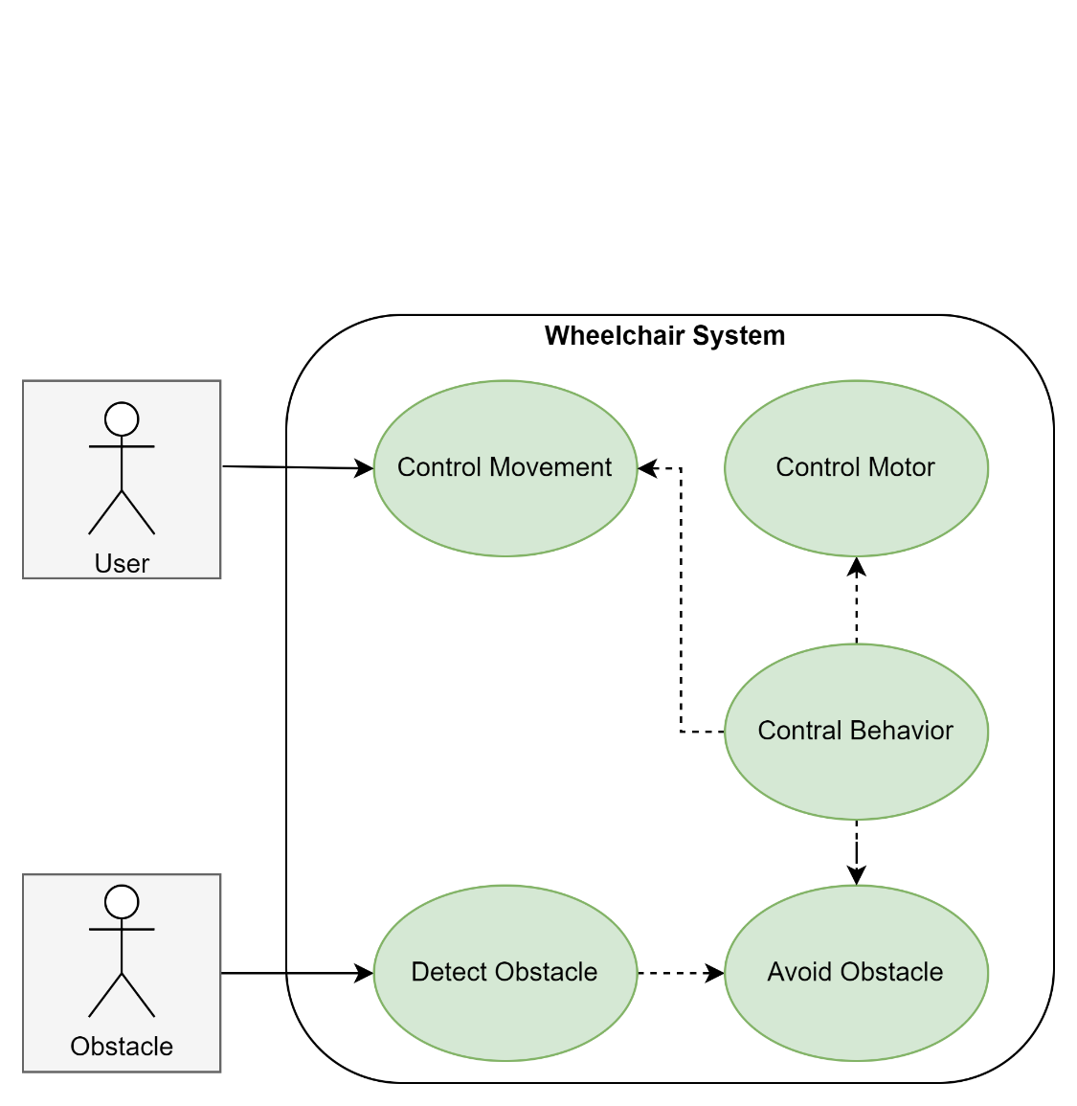

Figure 8, Use Case Diagram Wheelchair System

In Figure 8, The actor User initiates the task of controlling the Wheelchair movement whereby the actor Obstacle initiates the task of avoiding an obstacle around its environment. Control Movement and View Status use cases is controlled by User actor. Meanwhile, Detect Obstacle use case is controlled by Obstacle actor and extended by Avoid Obstacle use case.

* 1. Block diagram.

صورة تحتوي على نص, لقطة شاشة, الخط, رقم

تم إنشاء الوصف تلقائياً

Figure 9, Block Diagram Voice-Controlled Wheelchair

Figure 9 shows the block diagram of the voice-controlled wheelchair. There are three main parts in the wheelchair: (1) wireless communication, (2) a microcontroller, and (3) a motor controller.

* 1. Interfaces.

صورة تحتوي على نص, لقطة شاشة, الخط, شعار

تم إنشاء الوصف تلقائياً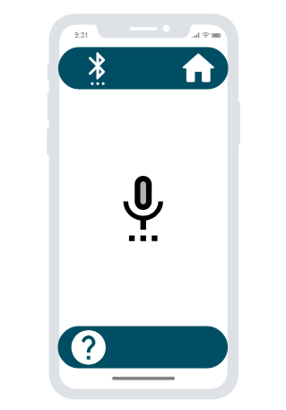

Figure , Home Page

Figure , Command Page.

صورة تحتوي على نص, لقطة شاشة, رقم

تم إنشاء الوصف تلقائياً

Figure , Bluetooth page

* 1. 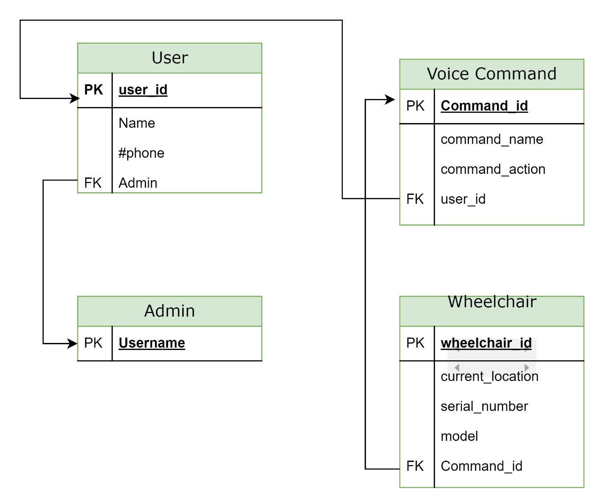Database Schema

Figure , Database Schema Voice-Controlled Wheelchair

In figure 13, allows for storing user information, voice commands, command. It can be used to track user interactions, monitor wheelchair performance, and provide insights into user behavior patterns.

* 1. Flowchart

صورة تحتوي على نص, لقطة شاشة, الخط, التصميم

تم إنشاء الوصف تلقائياً

Figure , Flowchart Voice-Controlled Wheelchair

We have two parts in our project. i) Wheelchair using user’s voice and ii) Wheelchair using android app. The first flowchart shows the functioning of the wheelchair using voice commands. Firstly, the user voice application is connected with the wheelchair Bluetooth device. Then user is supposed to speak specific commands through the application. Then using the Google voice service, the word is checked and then gives specific instruction to the motor drivers for Its movement towards left, right, straight, backward otherwise stop.

1. **Results and Discussion.**

صورة تحتوي على نص, لقطة شاشة, رسم بياني, التصميم

تم إنشاء الوصف تلقائياً

Figure , Project representation

An expected working for the project under consideration is shown in Figure. 14. We designed an application using Android phones to control the wheelchair that is available for the project. The wheelchair is controlled with the help of an Arduino UNO 3, we used L293D Motor Shield to connect a of two DC motors to control 2 Wheel in the chair and other electrical connections. We used the Arduino IDE to write commands for Arduino UNO 3 to build the application.

1. **Conclusions and Future Work**

In the end, the problems and challenges facing people with special needs were the basis for this system. The development of a voice-controlled wheelchair system presents a promising solution to address the challenges faced by individuals with limited mobility. The system's intuitive voice-based interface and user-friendly design empower users to control their wheelchair with simple voice commands, enhancing their independence and ease of movement.

In the future, we will implement the system on a large scale to be a comprehensive system and make improvements to ensure that the system works easily and smoothly, as voice commands are recognized quickly.

1. **Biography** 
   1. Student Profile

صورة تحتوي على لقطة شاشة, برمجيات, نص, برامج الوسائط المتعددة

تم إنشاء الوصف تلقائياً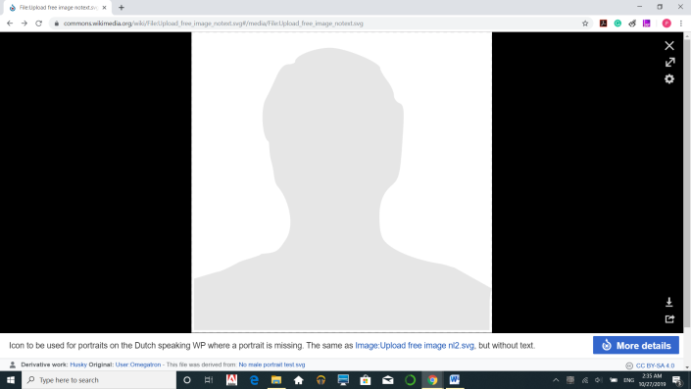

Abdulrahman Abdullah Al-Duaij. Fahad Mathker Al-Otaibi.

Computer and Network Engineering. Computer and Network Engineering.

* 1. Advisor Profile

|  |  |
| --- | --- |
| صورة تحتوي على الوجه الإنساني, تلبيس, شخص, اللحية البشرية  تم إنشاء الوصف تلقائياً | صورة تحتوي على الوجه الإنساني, قميص, شخص, ربطة عنق  تم إنشاء الوصف تلقائياً |
| Dr. Saeed M. Alshahrani | Dr. Nayyar Ahmed Khan |
| Supervisor | Co-Supervisor |
| Dr. Saeed, is an Assistant Professor, and the Vice Dean for Educational Affairs in the College of computing and information technology at Shaqra University, Saudi Arabia. Dr. Saeed has got his Ph.D in Computer Science at Flinders University in Australia. He received his master's degree in Computer Science at La Trobe University in Australia, and BSc in Computer Science at King Khalid University in Saudi Arabia. He is a member of the Saudi Computer Society, IEEE Computer Society and Review member NCAAA. Dr. Saeed has over 10 years of working experience  in the academic sector. | Dr. Khan is a long time Software Engineer, Apple Certified Trainer, AWS Educator and a Mentor. He is certified with various industry level achievements and digital accolades. His experience is enriched with Patents, Books, Publications and Software system design and deployment. His experience with Open-Source technologies used by E-Learning industry empowers him towards Society level contributions and digitization. He is a programmer too with an experience towards full stack development of software systems. |

1. **References**

[1] V. Shwetha, Vaibhav Mani and Aditya Kumaran 2018 Voice Controlled Wheelchair International Journal of Engineering & Technology7(4.41) 105-109

[2] C.A. Priya, Saadiya, Bhagyashree, S.D. Pranjala and H.S.G. Supreeth May 2018Voice Controlled Wheelchair for Physically Disabled People International Journal for Research in Applied Science & Engineering Technology (IJRASET)vol. 62375-2380

[3] Mohammad Ilyas Malik, Tanveer Bashir and Omar Farooq Khan June 2017Voice Controlled Wheel Chair System International Journal of Computer Science and Mobile Computingvol. 6411419

[4] Khyati Meena, Shubham Gupta and Vijay Khare April 2017 Voice Controlled WheelchairInternational Journal of Electronics, Electrical and Computational Systemvol. 6 23-27

[5] R. Simpson et al. The smart wheelchair component system Journal of Rehabilitation Research and Development (2004)

[6] L. Fehr et al. Adequacy of power wheelchair control interfaces for persons with severe disabilities: a clinical survey Journal of Rehabilitation Research and Development (2000)

[7] Manuel Mazo et al. 1995Wheelchair for Physically Disabled People with Voice, Ultrasonic and Infrared Sensor ControlAutonomous Robots2, 203-224

[8] https://www.who.int/news-room/fact-sheets/detail/assistive-technology. © 2019 WHO, Assessed on 17 June 2019.

[9] U. N. P. GOV.SA. (2022). *Vision 2030*. Available: <https://www.my.gov.sa/wps/portal/snp/content/saudivision/?lang=en>

[10] Argaam. (2022). *Crown Prince expects Saudi Arabia’s population to reach 50-60 million by 2030*.Available: <https://www.argaam.com/en/article/articledetail/id/1576399>

[11] A. News. (2022). *Saudi crown prince unveils plan to make Riyadh one of world’s 10 largest city economies*. Available: <https://www.arabnews.com/node/1800231/business-economy>

[12] <https://apd.gov.sa/> هيئة رعاية الأشخاص ذوي الإعاقة

[13] Masato Nishimori, Takeshi Saitoh and Ryosuke Konishi, "Voice Controlled Intelligent Wheelchair," SICE Annual Conference 2007, Takamatsu, Japan, 2007, pp. 336-340, doi: 10.1109/SICE.2007.4421003. URL: <https://ieeexplore.ieee.org/stamp/stamp.jsp?tp=&arnumber=4421003&isnumber=4420928>

[14] M. T. Qadri and S. A. Ahmed, "Voice Controlled Wheelchair Using DSK TMS320C6711," *2009 International Conference on Signal Acquisition and Processing*, Kuala Lumpur, Malaysia, 2009, pp. 217-220, doi: 10.1109/ICSAP.2009.48.

URL: <https://ieeexplore.ieee.org/stamp/stamp.jsp?tp=&arnumber=5163858&isnumber=5163805>

[15] M. S. Sivakumar, J. Murji, L. D. Jacob, F. Nyange and M. Banupriya, "Speech controlled automatic wheelchair," *2013 Pan African International Conference on Information Science, Computing and Telecommunications (PACT)*, Lusaka, Zambia, 2013, pp. 70-73, doi: 10.1109/SCAT.2013.7055093.

URL: <https://ieeexplore.ieee.org/stamp/stamp.jsp?tp=&arnumber=7055093&isnumber=7055074>

[16] Azam, G., and M. T. Islam. "Design and Fabrication of a Voice Controlled Wheelchair for Physically Disabled People"

[17] Anusha, S., M. Madhavi, and R. Hemalatha. "HOME AUTOMATION USING ATmega328 MICROCONTROLLER AND ANDROID APPLICATION." (2015).

[18] Rajini, Gangadhari and Lr Siva. "Android Mobile Phone Controlled Bluetooth Robot Using Arm7 Microcontroller." (2015).

[19] Megalingam, Rajesh Kannan et al. "'Gest-BOT'-A Highly Convenient Locomotive Solution for the Elderly and Physically Challenged." Global Humanitarian Technology Conference (GHTC), 2012 IEEE. IEEE, 2012.

[20] Skraba, Andrej, et al. "Prototype of speech controlled cloud based wheelchair platform for disabled persons." Embedded Computing (MECO), 2014 3rd Mediterranean Conference on. IEEE, 2014.

[21] Sobia, M. Carmel, V. Brindha, and A. Abudhahir. "Facial expression recognition using PCA based interface for wheelchair." Electronics and Communication Systems (ICECS), 2014 International Conference on. IEEE, 2014.